UNITED STATES

SECURITIES AND EXCHANGE COMMISSION

Washington, D.C. 20549

FORM 8-K

CURRENT REPORT

PURSUANT TO SECTION 13 OR 15(d) OF THE

SECURITIES EXCHANGE ACT OF 1934

Date of Report (Date of earliest event reported): January 11, 2006

0-15898

(Commission File Number)

CASUAL MALE RETAIL GROUP, INC.

(Exact name of registrant as specified in its charter)

Delaware

04-2623104

(State of Incorporation)

(IRS Employer
Identification Number)

555 Turnpike Street, Canton, Massachusetts 02021

(Address of registrant’s principal executive office)

(781) 828-9300

(Registrant’s telephone number)

Check the appropriate box below if the Form 8-K filing is intended to simultaneously satisfy the filing obligation of the registrant under any of the following provisions (see General Instruction A.2. below):

- Written communications pursuant to Rule 425 under the Securities Act (17 CFR 230.425)

- Soliciting material pursuant to Rule 14a-12 under the Exchange Act (17 CFR 240.14a-12)

- Pre-commencement communications pursuant to Rule 14d-2(b) under the Exchange Act (17 CFR 240.14d-2(b))

- Pre-commencement communications pursuant to Rule 13e-4(c) under the Exchange Act (17 CFR 240.13e-4(c))

ITEM 7.01 - REGULATION FD DISCLOSURE

The Company is scheduled to present at the SG Cowen Fourth Annual Consumer Conference on January 11, 2006. A copy of the slides to be presented are attached to this report as Exhibit 99.1, which slide presentation is incorporated by reference herein.

The slide presentation contained in the exhibit includes statements intended as “forward-looking statements,” which are subject to the cautionary statement about forward-looking statements set forth in the exhibit. The slide presentation is being furnished, not filed, pursuant to Regulation FD. Accordingly, the slide presentation will not be incorporated by reference into any registration statement filed by the Company under the Securities Act of 1933, as amended, unless specifically identified therein as being incorporated therein by reference. The furnishing of the slide presentation is not intended to, and does not, constitute a determination or admission by the Company that the information in the slide presentation is material or complete, or that investors should consider this information before making an investment decision with respect to the Company.

ITEM 9.01 - FINANCIAL STATEMENTS AND EXHIBITS

- Exhibits

Exhibit No. |  | Description
99.1 |  | Presentation dated January 11, 2006

SIGNATURES

Pursuant to the requirements of the Securities Exchange Act of 1934, the registrant has duly caused this report to be signed on its behalf by the undersigned, thereunto duly authorized.

CASUAL MALE RETAIL GROUP, INC.

By: | /s/ DENNIS R. HERNREICH
Name: | Dennis R. Hernreich
Title: | Executive Vice President
 | and Chief Financial Officer

Date: January 11, 2006

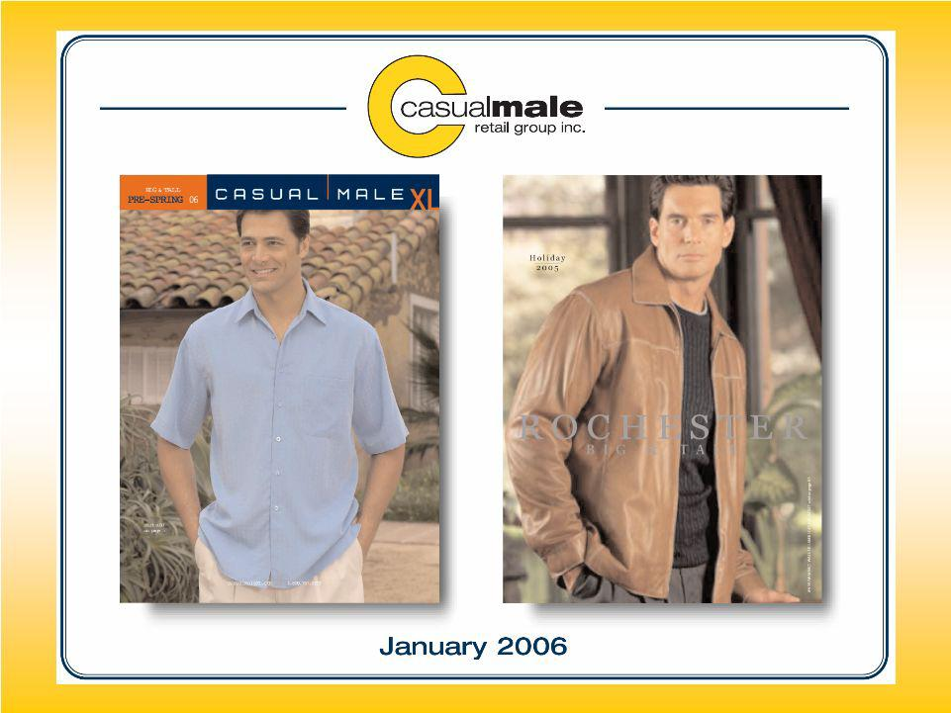
Exhibit 99.1

1


’06 & ’07 Initiatives

- Redefine Casual Male image to increase market share

- Store growth – expansion of Rochester Clothing

- Continued accelerated growth of internet and catalog

- Gross margin improvement

2



Redefine Casual Male Image

3

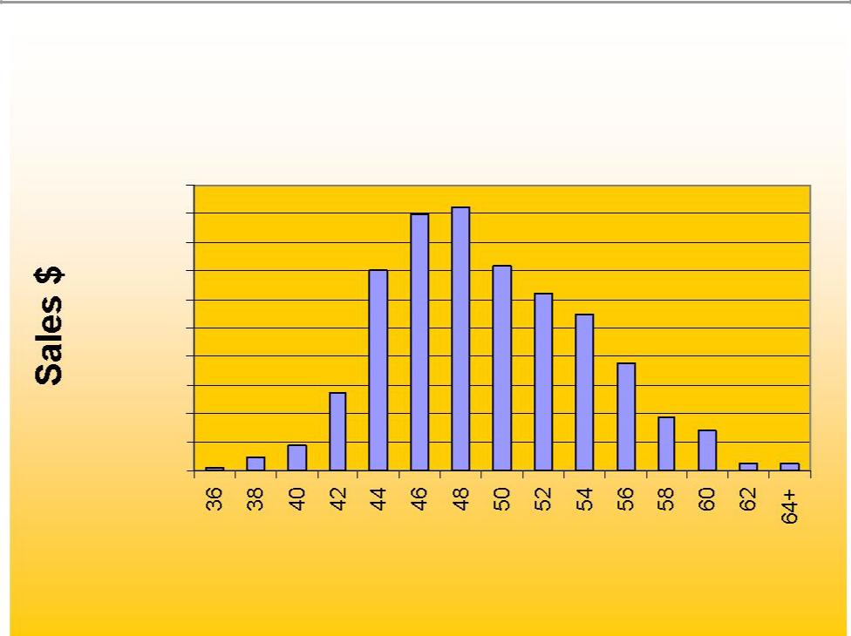
Market Share Size Opportunity

Casual Male Sales by Size

$200,000

$180,000

$160,000

$140,000

$120,000

$100,000

$80,000

$60,000

$40,000

$20,000

$0

Data based on ’04 sales of Casual Pants, Dress Pants and Jeans

Waist Size

4

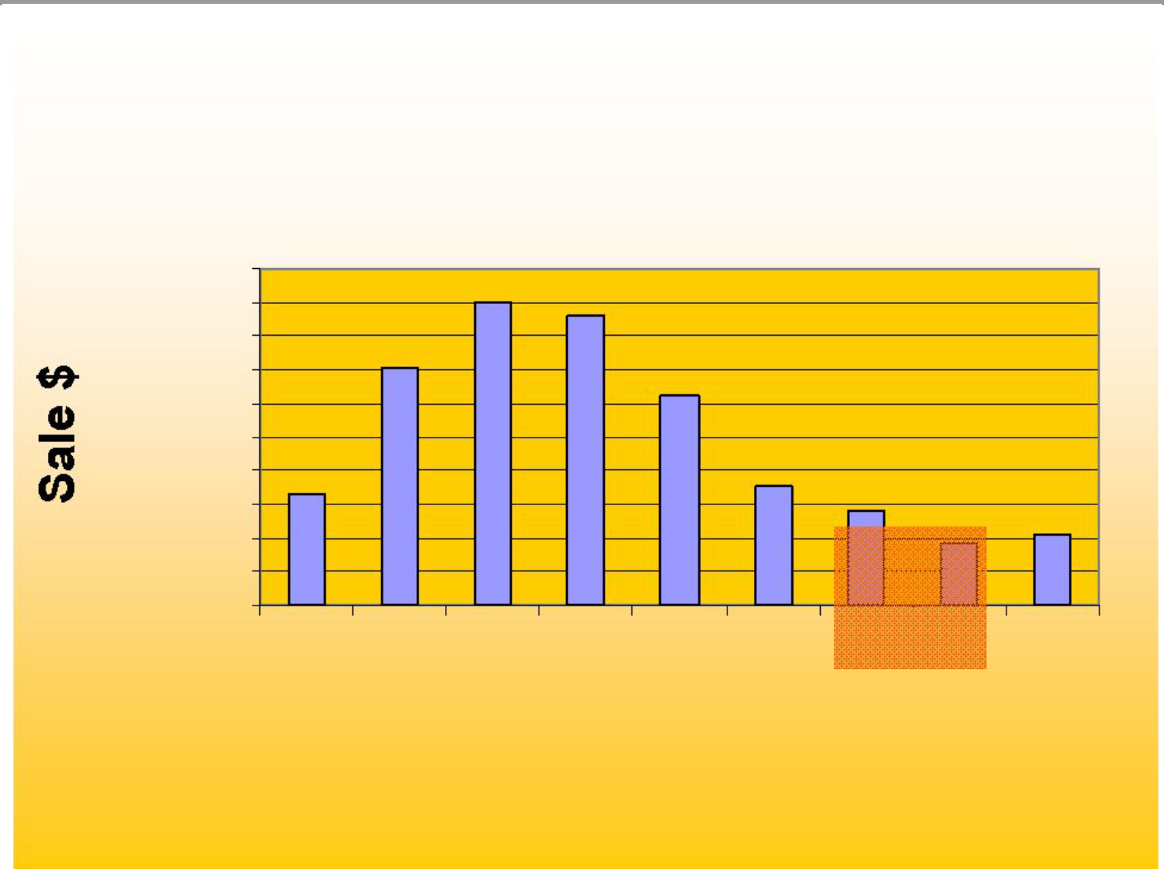
National Sales by Size

$2,000,000

$1,800,000

$1,600,000

$1,400,000

$1,200,000

$1,000,000

$800,000

$600,000

$400,000

$200,000

$0

30 32 34 36 38 40 42 44 46+

Waist

5

Customer Research

Least favorite aspect of clothing shopping was “difficulty finding items in my size”

– They were shopping at “the end of the rack”

– Stigma with “big and tall”store

– “big and tall” stores were consistently referred to as places where “fat guys” shop

Current image associated with Casual Male
– A degree of discomfort with shopping at the store for “big and tall”

– Belief that the clothing started around a 48” waist

– Merchandise and selection lacked a sense of style

– Had unattractive, inconvenient locations

– Casual Male was a place of necessity rather than a destination of choice

6

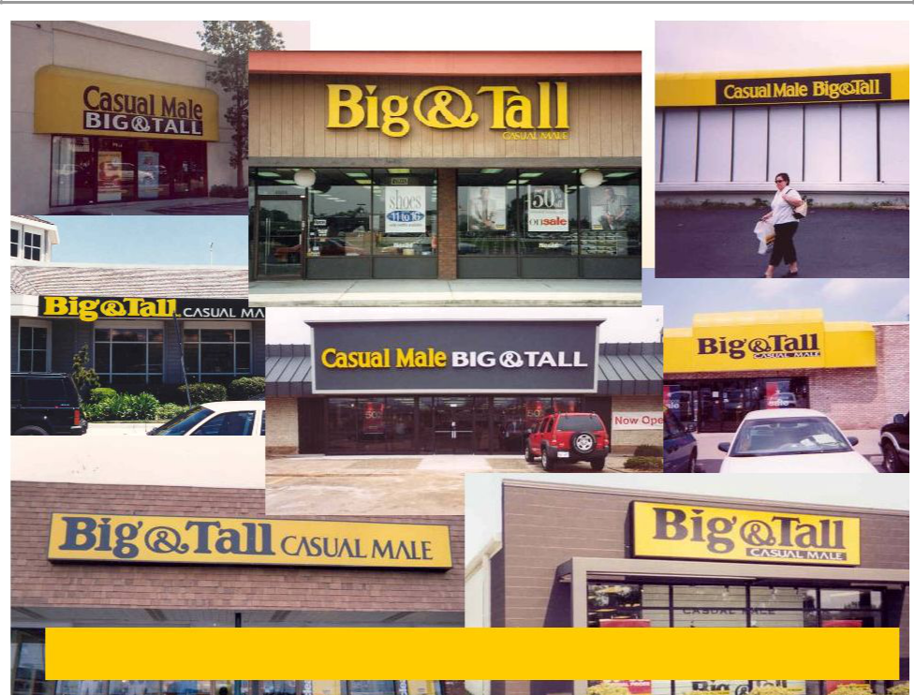

50% of customers refer to Casual Male as the “Big & Tall” store
7

Objectives

- Change the consumer perception of Casual Male to increase awareness of brands, sizes and comfort carried in all channels and appeal to the younger, smaller and taller B&T consumers.

- Re-engineer the look and feel of the Casual Male brand in all communications including in-store experience, web & catalog

8



New Design

9

Reactions to “XL” logo concept

Majority of respondents reacted positively to these concepts:

– “Yes, that’s my size.” / “That’s what I’m looking for.”

– “XL” seen as “manly, powerful” rather than overweight

– Appeared to create a sense of distinctiveness for brand

– Would communicate “change” at Casual Male

– Seen as youthful by some respondents

10

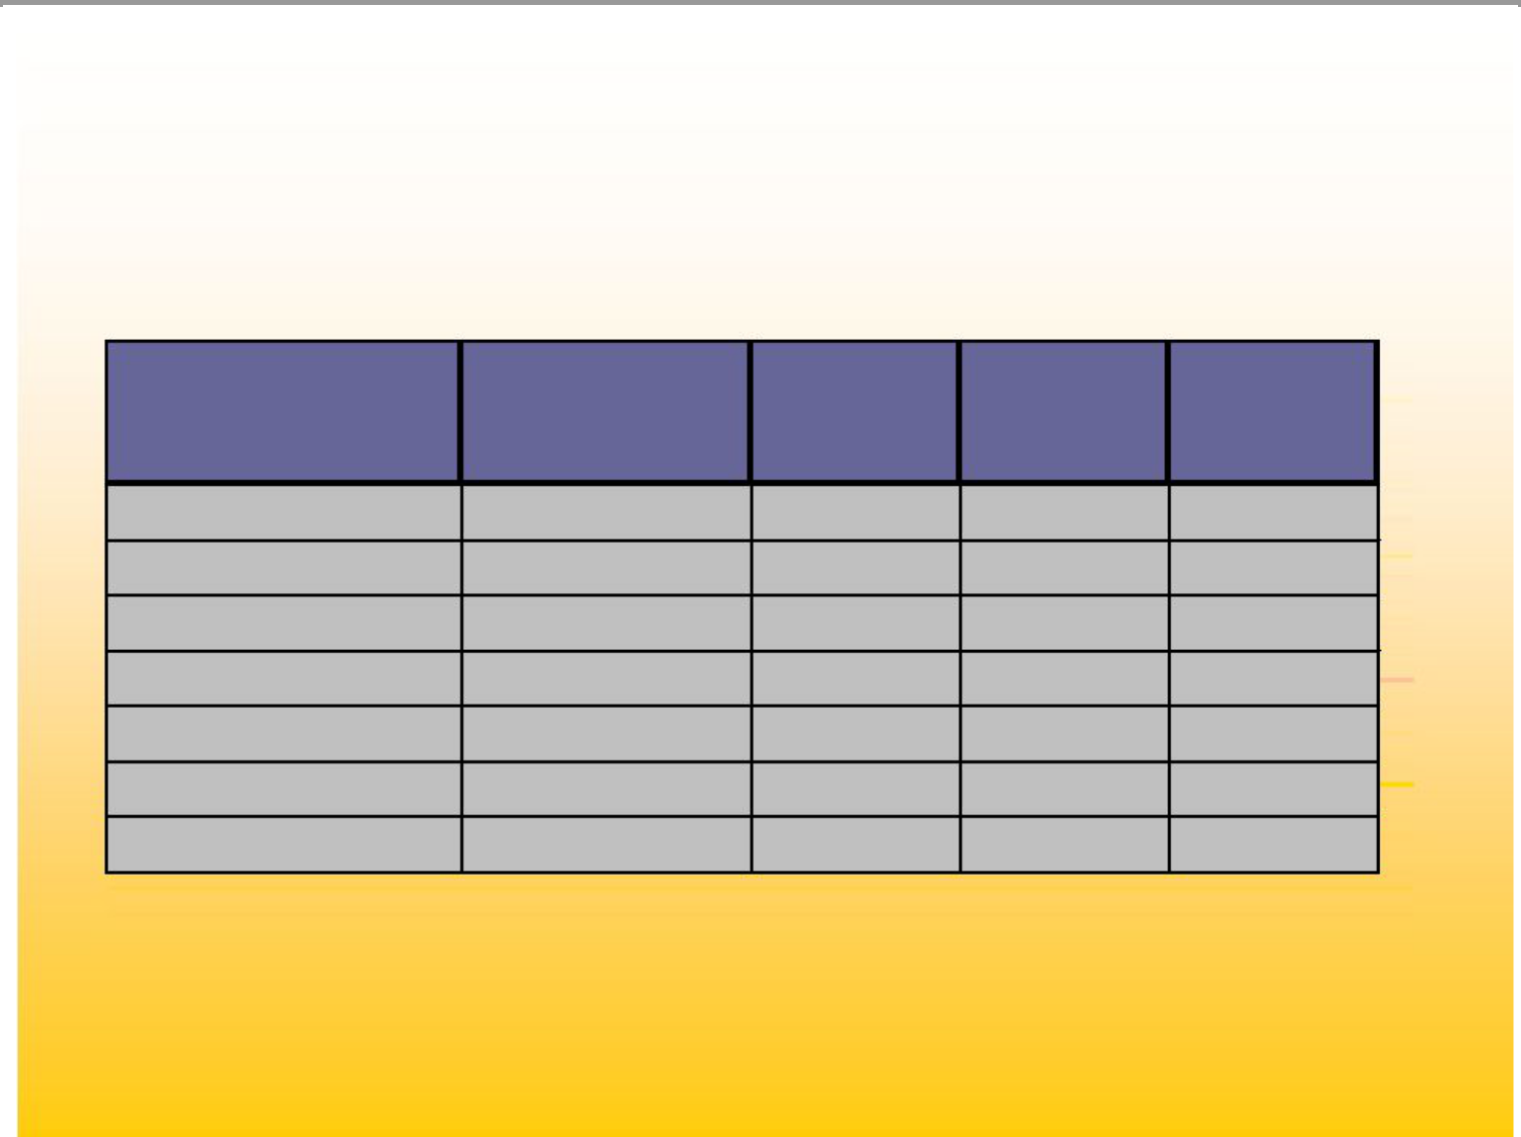
Developmental Markets

DMA | Population | Market | Anchor | Outlet
DMA | Population | Rank | Stores | Stores
Phoenix, AZ | 2017.3 | 15 | 5 | 1
Columbus, OH | 630.1 | 34 | 4 | 2
Grand Rapids, MI | 683.5 | 38 | 3 | 0
Indianapolis, IN | 589.6 | 25 | 6 | 1
Rochester, NY | 392.6 | 74 | 4 | 0
San Antonio, TX | 643.6 | 37 | 4 | 0
Total: | 4956.7 |  | 26 | 4

11

Effected Change

- Exterior store

- Interior of store, visual presentation, signage, POS package

- Bags

- All communications

– Direct mail

– Email

– Catalog version

– Website

– New Private label credit card

- Associate training

12

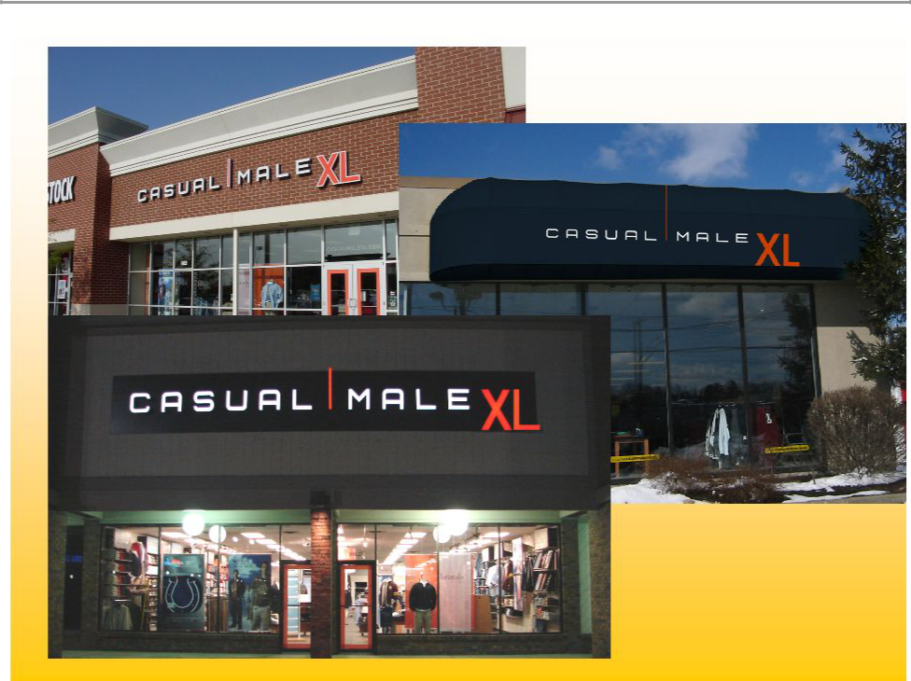

13

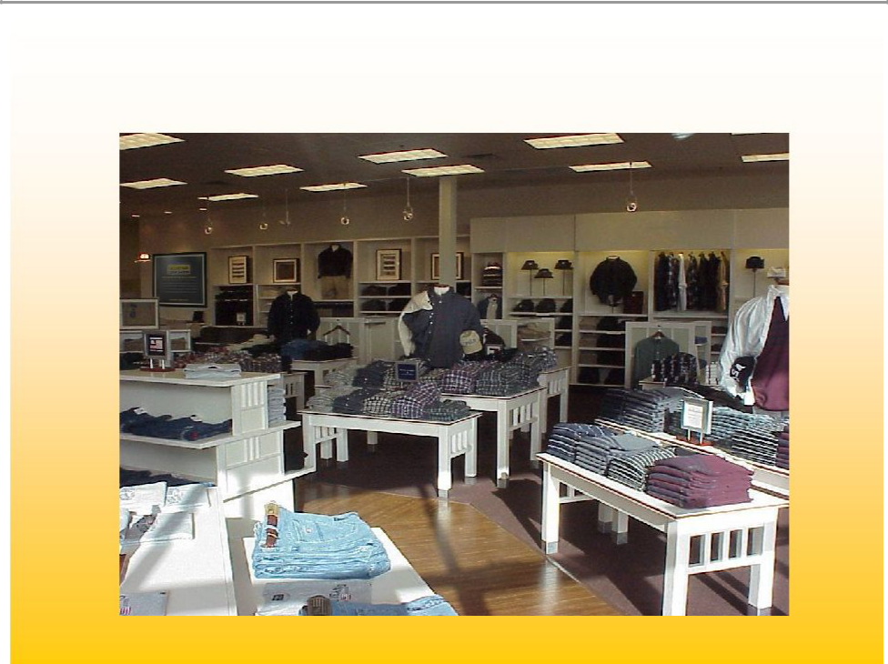
Before

14

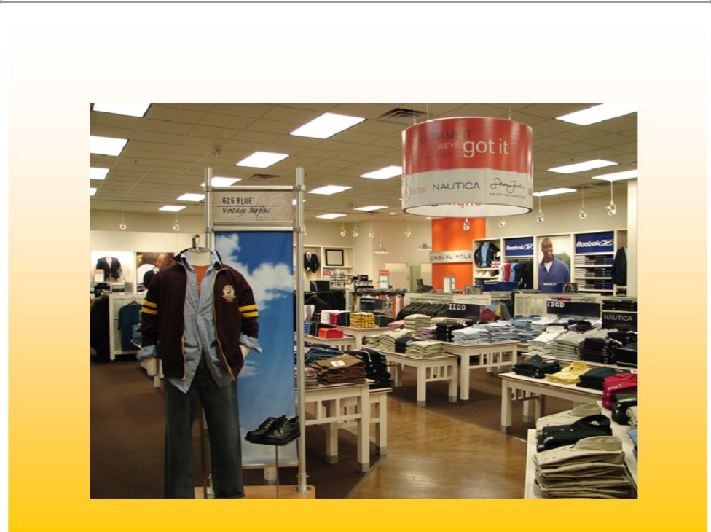
After

15

16

Developmental Market Results

- Increase in traffic

- Increase in transactions

- Higher % of sales in smaller sizes as compared to chain

- Increase in comp sales

17

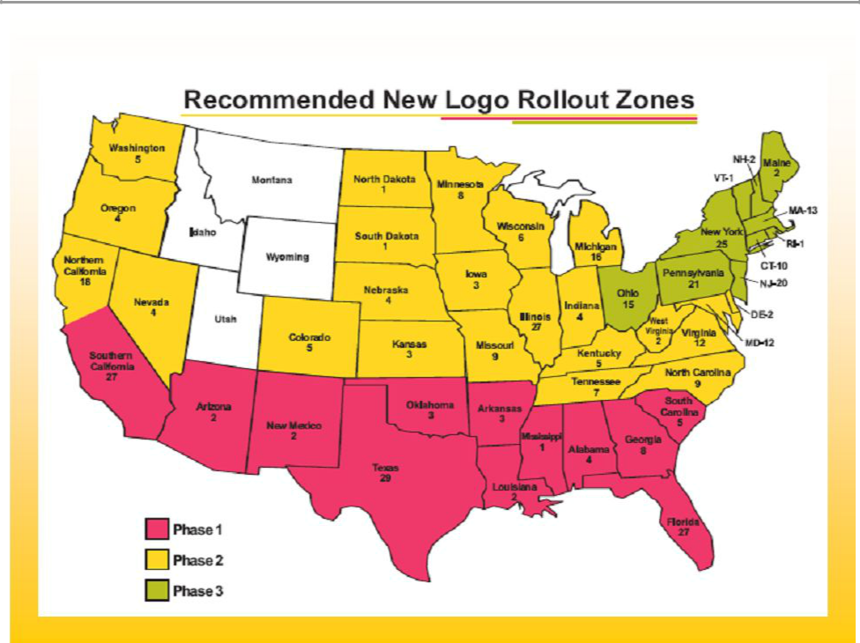

18

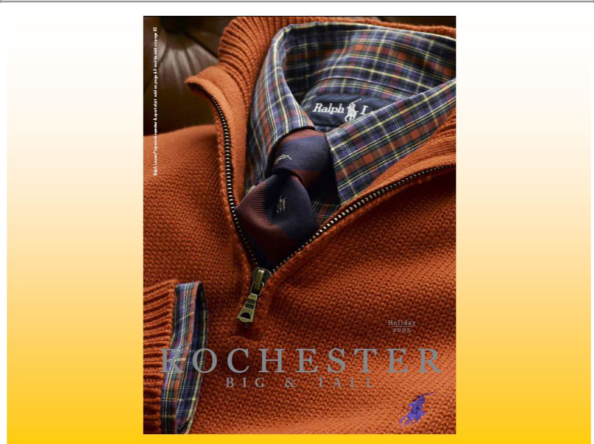

19

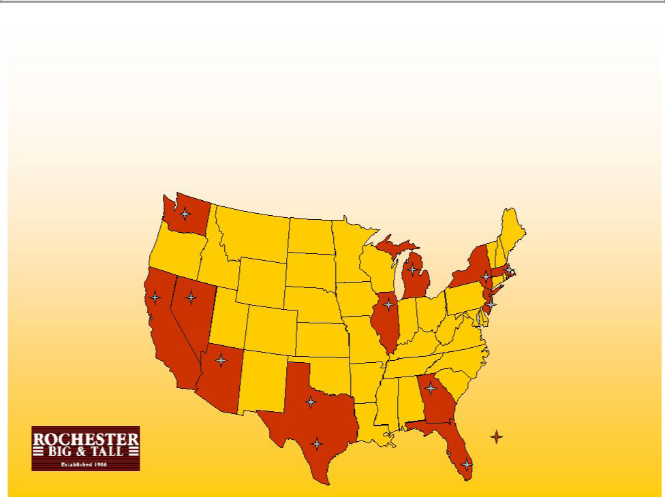
Rochester Overview

- Major growth for next 5 years. We will be in expanding Rochester from 24 stores to 40 more stores

2

9

Rochester
2 | * 1 London, United Kingdom
 | 20

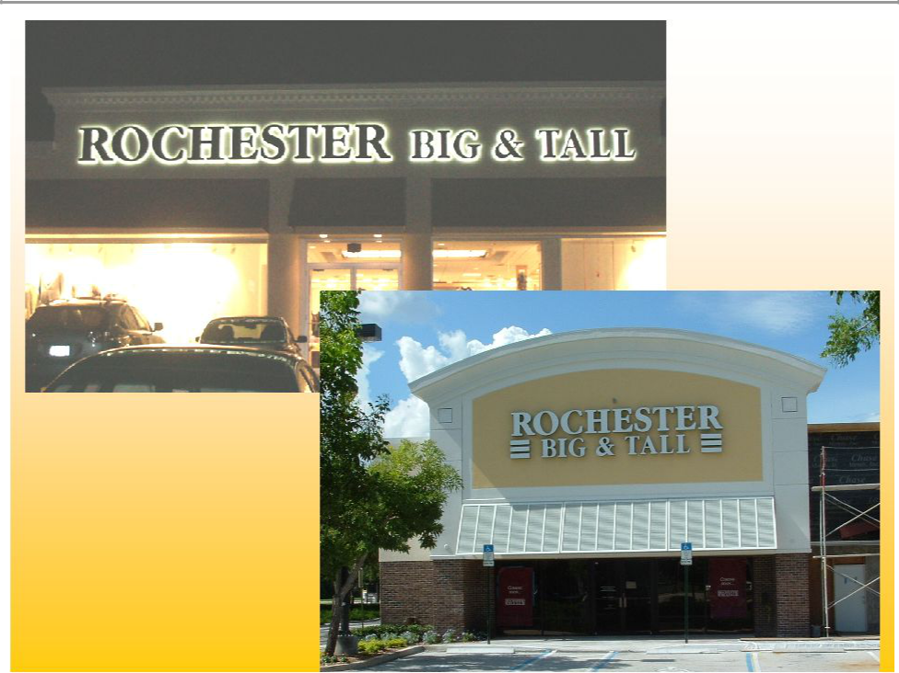

21


Rochester Brands

22

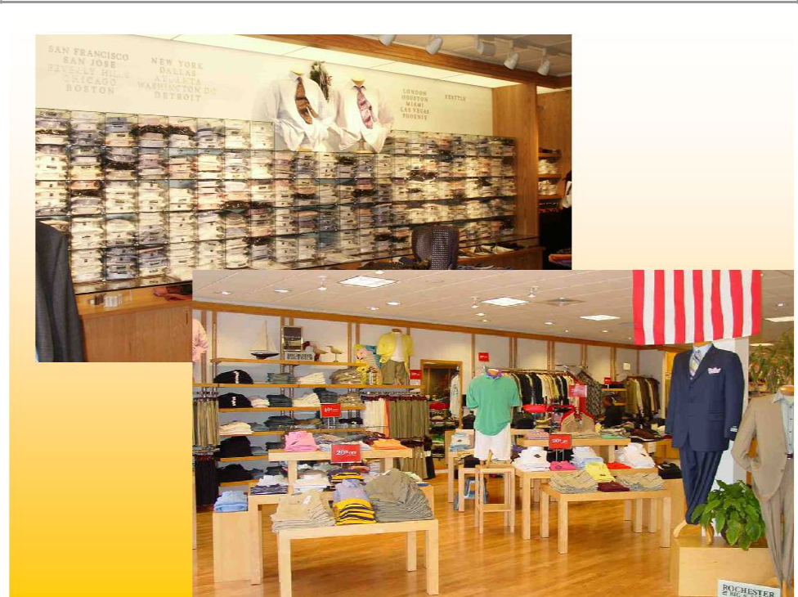

23


Benefits to CMRG

- Combined entities give CMRG 65% market share of specialty retail sector

- Not a turn around – accretive to earnings in year one

- Senior management continues with incentive contracts

- Synergies will increase gross margin, reduce overhead costs (warehouse, administration, insurance, etc.)

- Comparable multi-channel opportunities to Casual Male

– Internet/catalog over 20% of sales in less than 3 years

- Store growth opportunities

– Underserved markets

– Growth of 5 – 7 stores/yr

– International opportunities

24


Rochester Big & Tall Transaction

• 21 U.S. stores; 1 in London

• Total revenue $65.0M

• Audited EBIDTA of $3.3M

• Potential for an additional 3 million dollar savings through integration

– Average sales per store | $2.3M | vs | CM $650,000
– Average transaction | $400 | vs | CM $75
– Average store sq. footage | 5,000-6,000 sq. ft. | vs | CM 3,500 sq. ft.
– Average income of customer | $100,000+ | vs | CM $71,000
– Cost to open new store | $100 sq. ft. | vs | CM $36 sq. ft.
– Inventory needed | $375,000 | vs | CM $125,000

25



26

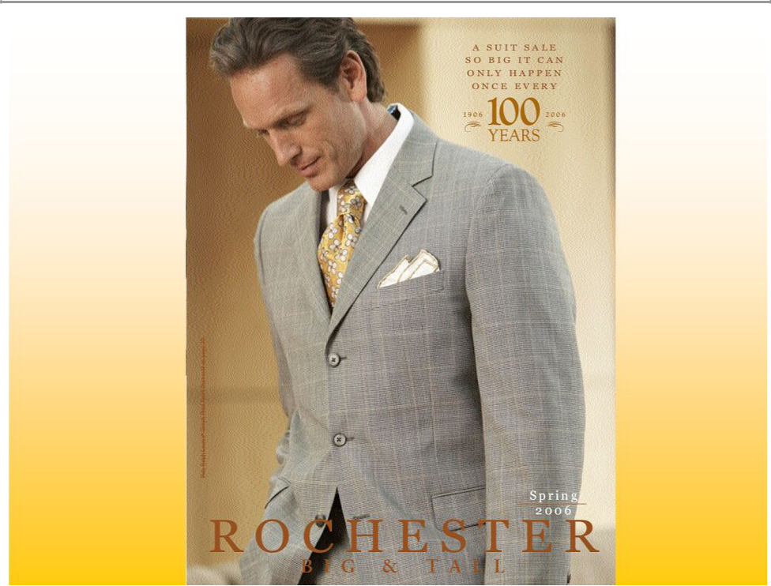

27



Continued accelerated growth of internet and catalog

28

10.0%

8.0%

6.0%

4.0%

2.0%

0.0% -2.0% -4.0% -6.0%

Comp Store Trend
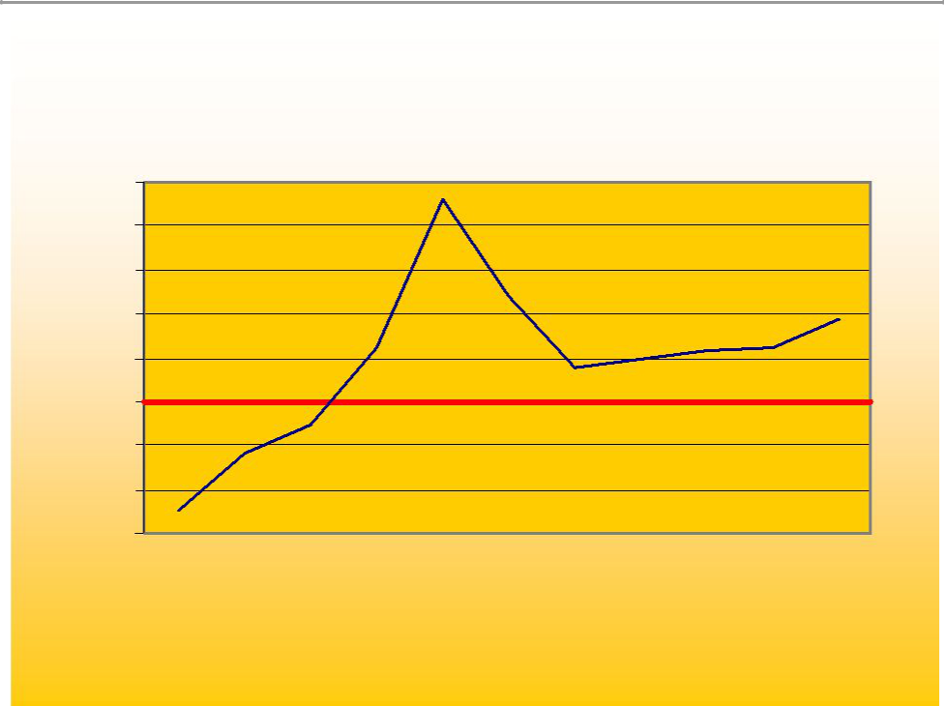

 |  |  |  |  | 9.2% Launch of George Foreman
 |  |  |  |  |  | collection and TV campaign
 |  |  |  |  |  | 4.8% |  |  |  | 3.70%
 |  |  |  | 2.4% |  | 2.0% |  | 2.3%2.5%
 |  |  | Stores change to |  |  | 1.6%
 |  |  | lifestyle presentation |  |  | 1.6%
 |  |  | -1.1%
 |  | -2.3%
 | -5.0%
Q1 | Q2 | Q3 | Q4 | Q1 | Q2 | Q3 | Q4 | Q1 | Q2 | Q3
 | 2003 |  |  |  |  | 2004 |  |  | 2005

29

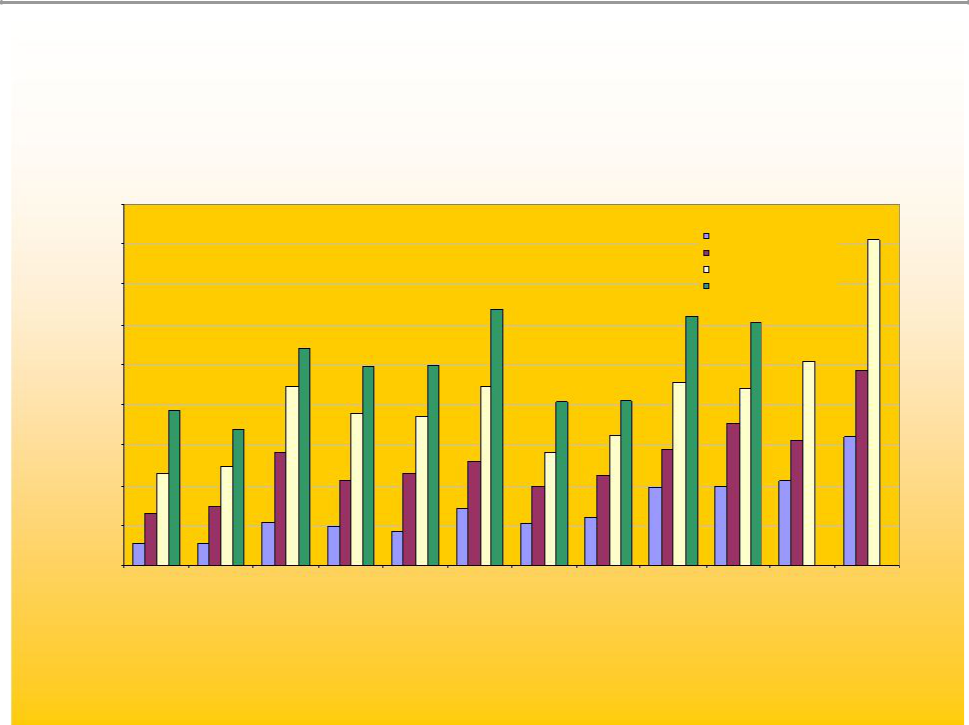
Internet Sales by Month

$1,800,000

$1,600,000

$1,400,000

$1,200,000

$1,000,000

$800,000

$600,000

$400,000

$200,000

$0

2002 - $3,357,447

2003 - $6,229,617 +46.1%

2004 - $9,874,481 +194.1%

2005

Jan Feb Mar Apr May Jun Jul Aug Sep Oct Nov Dec

30

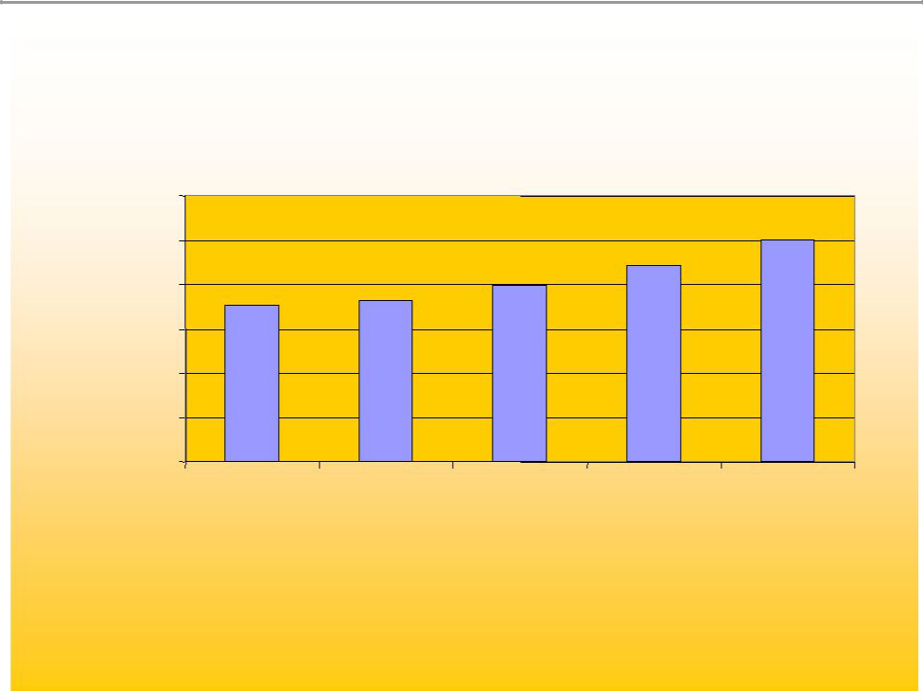
Store Catalog Sales
 |  | Catalog Sales
$12,000,000 |  |  |  |  | $10,056,800
$10,000,000 |  |  |  | $8,814,100 | $10,056,800
$10,000,000 |  |  | $7,968,900 | $8,814,100
$8,000,000 | $7,053,300 | $7,283,100 | $7,968,900 | $8,814,100
$6,000,000
$4,000,000
$2,000,000
$-
 | 2001 | 2002 | 2003 | 2004 | 2005

* % gains over FYE02
31

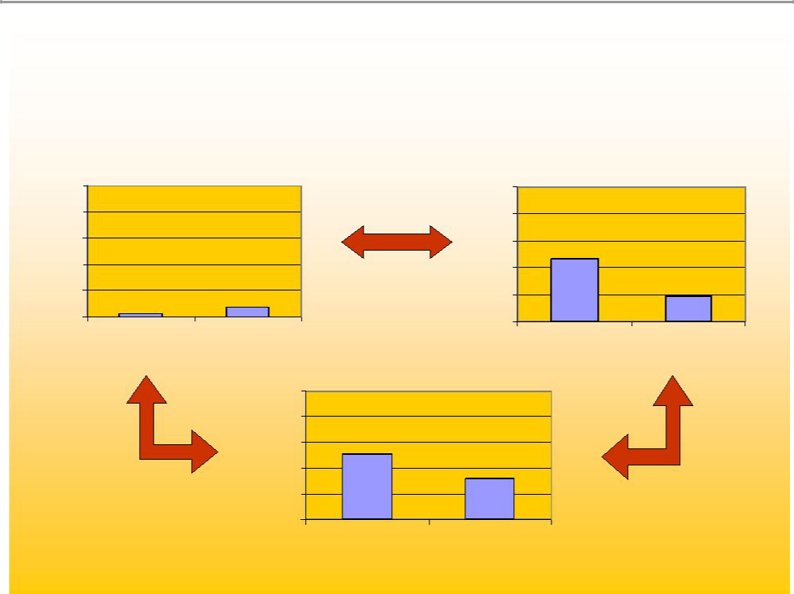
Multi-Channel

Store

100%

80%

60%

40%
^{20%} 2.9%

0%

online

7.4%

catalog

100%

80%

60%

40%

20%

0%

100%

80%

60%

40%

20%

0%

Online

51.1%

32.1%

store catalog

Catalog

46.6%

18.6%

store online

32

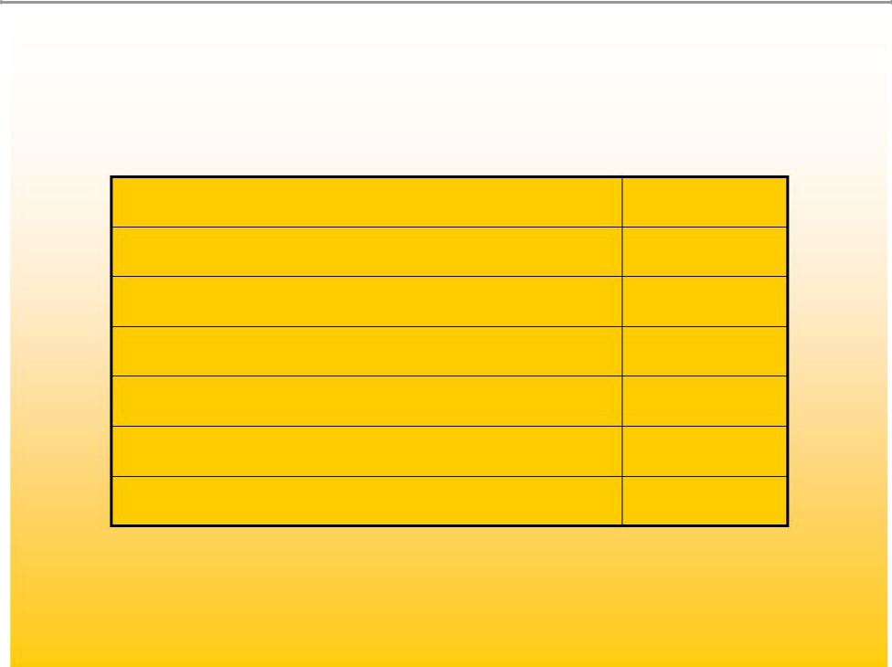
Customer Sales by Channel

Retail only | 100
Catalog Only | 123
E-commerce Only | 104
Retail & Catalog | 276
Retail & E-commerce | 290
Catalog & E-commerce | 286
Retail & Catalog & E-commerce | 455

* Indexed to retail only shoppers

33

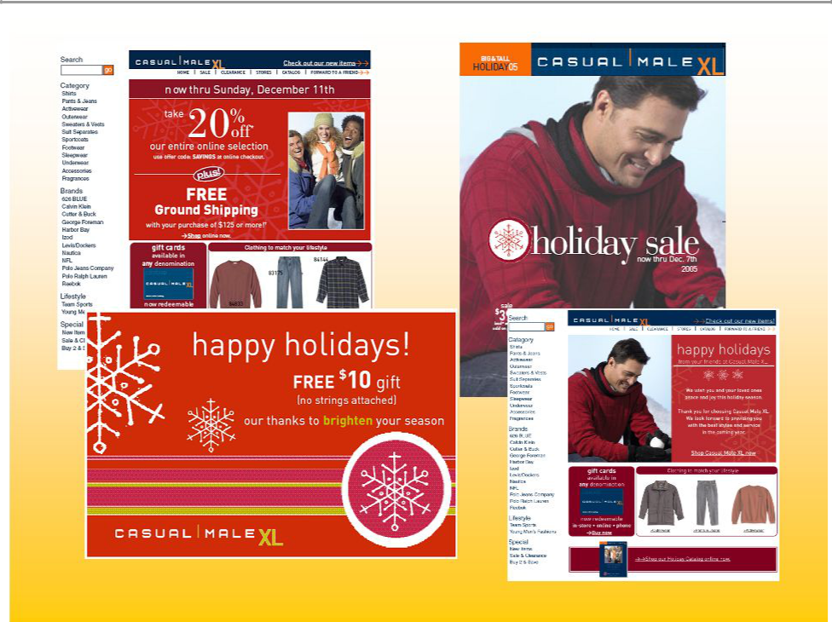

34

Gross Margin Improvements

- Inventory management

- Direct sourcing

- Building proprietary brands

35

Gross Margin Opportunity

- Core vs. seasonal/fashion – core year round basic stock items (5 pocket jean, pique polo, pocket tee, underwear, etc.)

- Implementation of E3 (replenishment system) determined that we were 25% out of stocks on core items – demand exceeded supply

– Better margins on core products than seasonal/fashion

36


Guaranteed In-stock Program

- 7 key items – 12% of sales

- GIS Program – Bottoms 49 sizes, delivery in 5 working days or FREE

- 8/21 launch

- Sold 449,405 units

- Units 26% increase

- 4,564 units fulfilled through catalog

- 9 pieces of free items given away

37

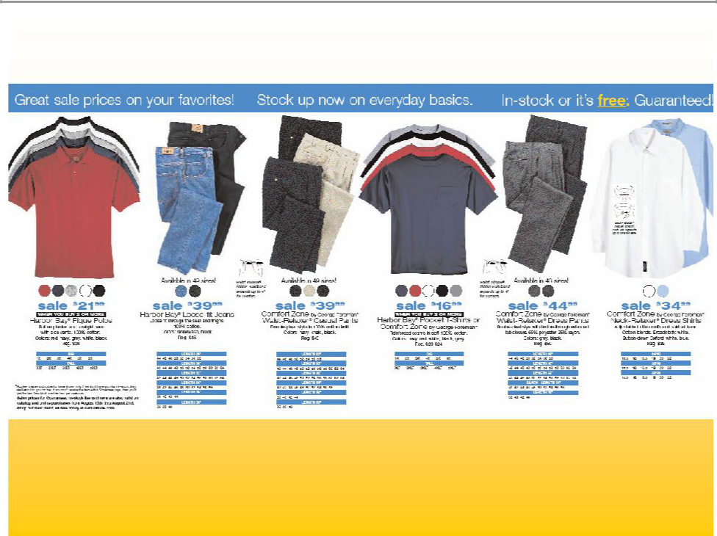

38

Direct Sourcing

- Direct Sourcing of goods through Li & Fung, as agent beginning in 2006

- New Department created, hiring of industry veteran

- Potential for 40% of Casual Male Inventory to go Direct

- Cost saving of up to 15%

- Better sourcing (reduction of # of Vendors)

- Rochester has very little private label, potential for 20%

- Cost savings of up to 20% for Rochester

39

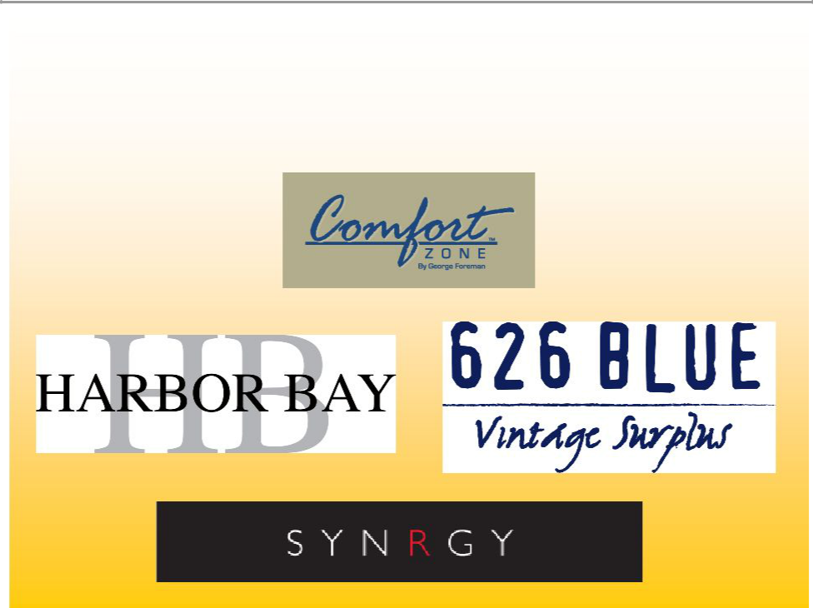
Proprietary Brands

40

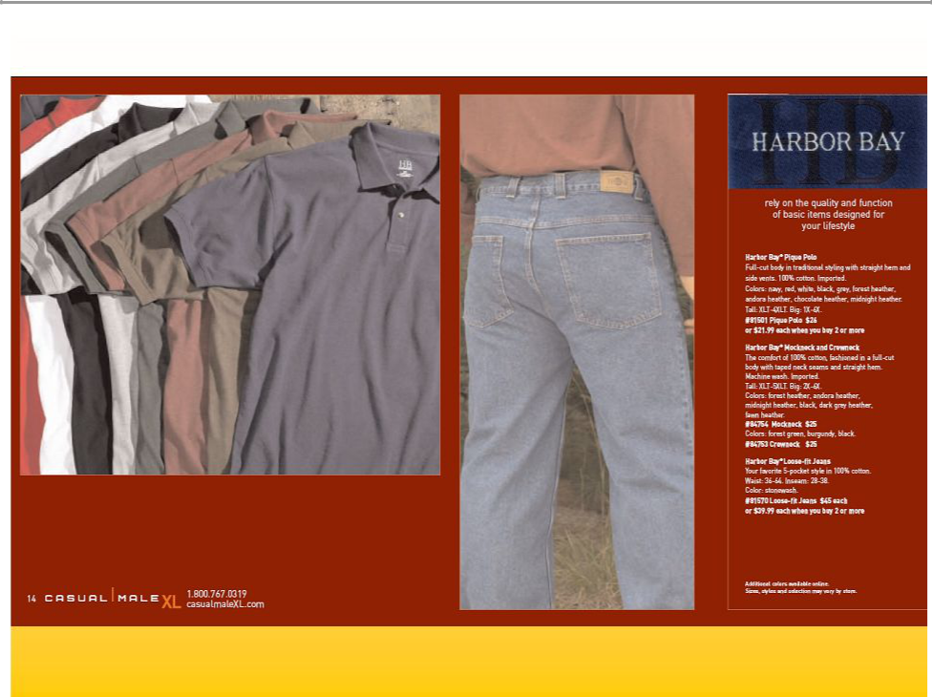

41

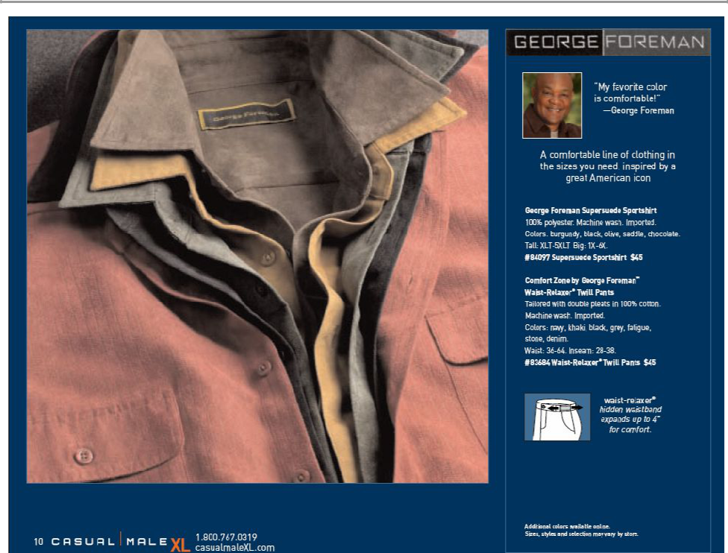

42

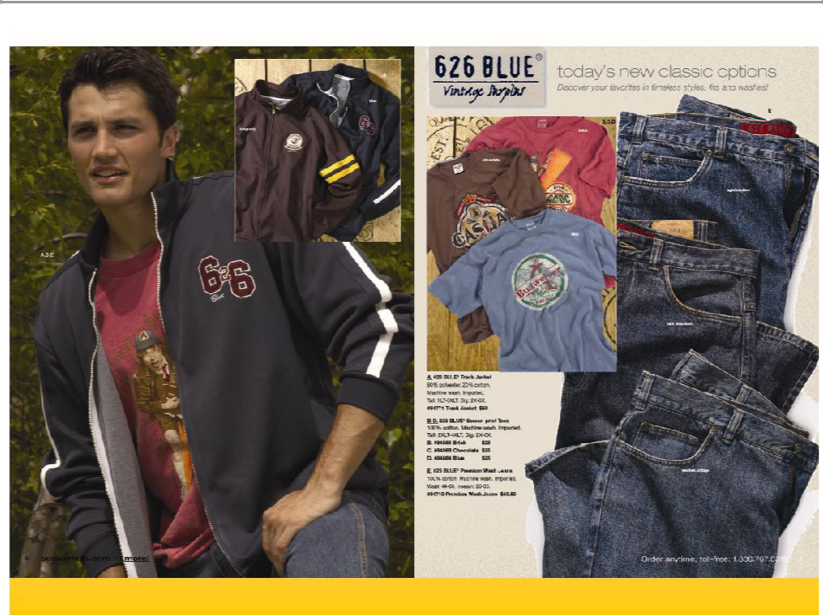

43

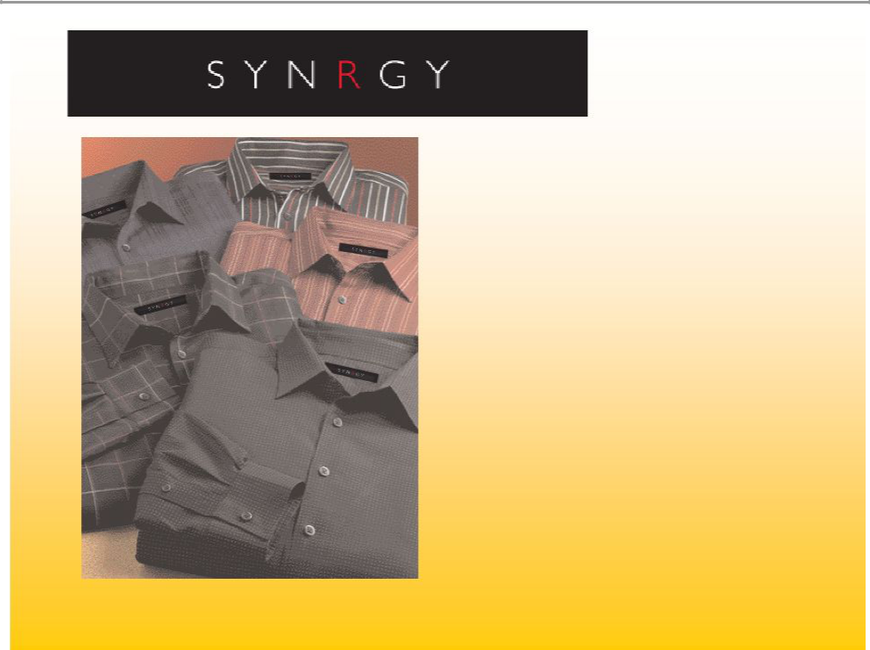

Collection will consist of Wovens, Casual Pant, and Knits

Assortment will reflect items/attitude and overall look of successful contemporary brands such as George Foreman Signature, Perry Ellis, I.N.C., etc.

44

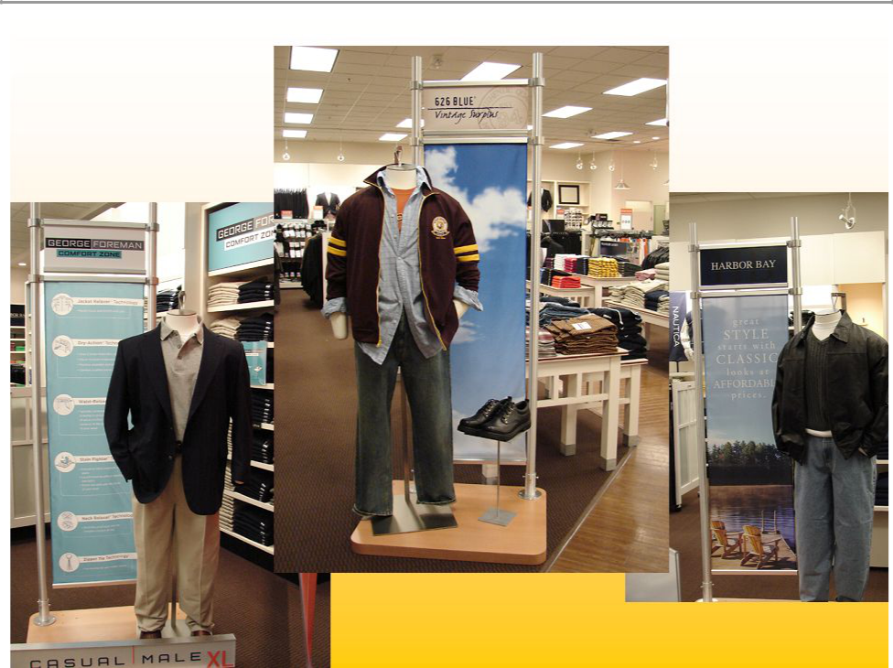

45

2 Year Goal

- 4% comp annually

- 100 basis point improvement annually

- 100 basis point improvement in SG&A annually

2007 = 9 to 10% operating income

46

Forward - Looking Statement

Any remarks that we make today about future expectations, plans and prospects for Casual Male Retail Group, Inc. which are not historical facts, are forward-looking statements that involve risks and uncertainties. For a discussion of such risks and uncertainties, which could cause the Company’s actual results to differ from those contained in the forward-looking statements, please read the section entitled “Forward-Looking Statements” in the Company’s most recent Form 10-K and Form 10-Q and the Form 8-K filed on April 8, 2005 with the Securities and Exchange Commission.

47



Casual Male Retail Group 555 Turnpike Street Canton, MA 02021

- 828-9300 x 2004 jeffunger@usa.net clinsky@cmal.com

48

