UNITED STATES

SECURITIES AND EXCHANGE COMMISSION
WASHINGTON, D.C. 20549

FORM 8-K

CURRENT REPORT

Pursuant to Section 13 or 15(d)
of The Securities Exchange Act of 1934

Date of Report (Date of earliest event reported): May 21, 2014

DESTINATION XL GROUP, INC.

(Exact Name of Registrant as Specified in its Charter)

Delaware

01-34219

04-2623104

(State or Other Jurisdiction
of Incorporation)

(Commission
File Number)

(I.R.S. Employer
Identification No.)

555 Turnpike Street, Canton, Massachusetts

02021

(Address of Principal Executive Offices)

(Zip Code)

(Registrant’s telephone number, including area code)

Check the appropriate box below if the Form 8-K filing is intended to simultaneously satisfy the filing obligation of the registrant under any of the following provisions (see

General Instruction A.2. below):

- Written communications pursuant to Rule 425 under the Securities Act (17 CFR 230.425)

- Soliciting material pursuant to Rule 14a-12 under the Exchange Act (17 CFR 240.14a-12)

- Pre-commencement communications pursuant to Rule 14d-2(b) under the Exchange Act (17 CFR 240.14d-2(b))

- Pre-commencement communications pursuant to Rule 13e-4(c) under the Exchange Act (17 CFR 240.13e-4(c))

Item 7.01 -Regulation FD Disclosure

The Company will be presenting a slide presentation to various investment groups at upcoming investor conferences beginning May 22, 2014. The Company has updated its forward-looking information slide to add information regarding non-GAAP financial measures and has added two new slides to its current presentation. A copy of the slides is attached to this report as Exhibit 99.1 and is incorporated by reference herein.

One of the slides includes financial information not prepared in accordance with generally accepted accounting principles (“Non-GAAP Financial Measures”). The Company believes that the non-GAAP measures are useful as an additional means for investors to evaluate the Company’s operating results, when reviewed in conjunction with the Company’s GAAP financial statements.

A reconciliation of the Non-GAAP Financial Measures to financial information prepared in accordance with generally accepted accounting principles (“GAAP”), as required by Regulation G, is included as Appendix A to the investor presentation. A copy of the Appendix A slide is attached to this report as Exhibit 99.2 and is incorporated by reference herein.

The full slide presentation is available on the investor relations page of the Company’s website at www.destinationxl.com.

The slides contained in the exhibit include statements intended as “forward-looking statements,” which are subject to the cautionary statement about forward-looking statements set forth in the exhibit. The additional slides are being furnished, not filed, pursuant to Regulation FD. Accordingly, the slides will not be incorporated by reference into any registration statement filed by the Company under the Securities Act of 1933, as amended, unless specifically identified therein as being incorporated therein by reference. The furnishing of these slides is not intended to, and does not, constitute a determination or admission by the Company that the information in the slide presentation is material or complete, or that investors should consider this information before making an investment decision with respect to the Company.

Item 9.01 Financial Statements and Exhibits.

- Exhibits

Exhibit
No. | Description
99.1 | Supplemental or Updated Slides to Investor Presentation dated May 2014.
99.2 | Appendix A Slide –Reconciliation of Non-GAAP Financial Measures.

SIGNATURE

Pursuant to the requirements of the Securities Exchange Act of 1934, the Registrant has duly caused this report to be signed on its behalf by the undersigned hereunto duly authorized.

 | DESTINATION XL GROUP, INC.
Date: May 21, 2014 | By: | /s/ Robert S. Molloy
 | Name: | Robert S. Molloy
 | Title: | Senior Vice President, General Counsel
 |  | and Secretary

Exhibit 99.1

FORWARD LOOKING STATEMENTS AND NON- GAAP MEASURES


Forward Looking Statements:

Certain information contained in this presentation, including, but not limited to, sales, cash flows, operating margins and store counts for fiscal 2014, constitute forward-looking statements under the federal securities laws. The discussion of forward-looking information requires management of the Company to make certain estimates and assumptions regarding the Company's strategic direction and the effect of such plans on the Company's financial results. Such forward-looking statements are subject to various risks and uncertainties that could cause actual results to differ materially from those indicated. Such risks and uncertainties may include, but are not limited to: the failure to implement the Company's business plan for increased profitability and growth in the Company's retail stores sales and direct-to-consumer business, the failure to achieve improvement in the Company's competitive position, changes in or miscalculation of fashion trends, extreme or unseasonable weather conditions, economic downturns,a weakness in overallconsumer demand, trade and security restrictions and political or financial instability in countries where goods are manufactured, increases in raw material costs from inflation and other factors, the interruption of merchandise flow from the Company's distribution facility, competitive pressures, and the adverse effects of natural disasters, war, acts of terrorism or threats of either, or other armed conflict, on the United States and international economies. These, and other risks and uncertainties, are detailed in the Company's Annual Report on Form 10-K filed with the Securities and Exchange Commission for the fiscal year ended February 1, 2014 filed on March 17, 2014 and other Company filings with the Securities and Exchange Commission. The Company assumes no duty to update or revise its forward-looking statements even if experience or future changes make it clear that any projected results expressed or implied therein will not be realized.

Non-GAAP Measures:

EBITDA, Adjusted EBITDA, EBITDA Margin and Adjusted EBITDA Margin are non-GAAP measures. The Company believes that these non-GAAP measures are useful as additional means for investors to evaluate the Company's operating results, when reviewed in conjunction with the Company's GAAP financial statements. Please see Appendix A for additional information concerning these non-GAAP measures and a reconciliation to their respective GAAP measures.

Destination XL Group, Inc. | 2

*Average store
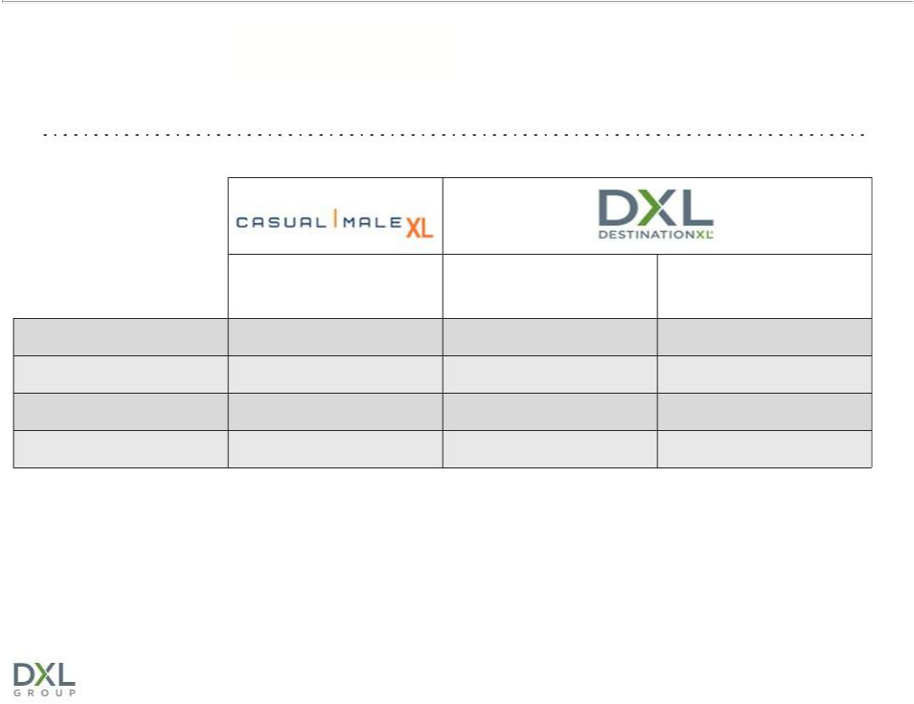
SALES MODEL–CMXL vs. DXL

Pro-Forma

 | Pre-DXL | Current Annualized | At Maturity
 | Pre-DXL | Figures | At Maturity
Store Size (sq. ft.) | 3,600 | 8,100 | 8,100
Sales/Sq.ft. | $174 | $147 | $220
Total Store count | 445 | 99 | 230
Store Sales (in millions) | $279 | $118 | $410

•DXL provides a high growth model that will drive shareholder value; whereas, the Casual Male XL stores were a low growth business model.

Destination XL Group, Inc. | 10

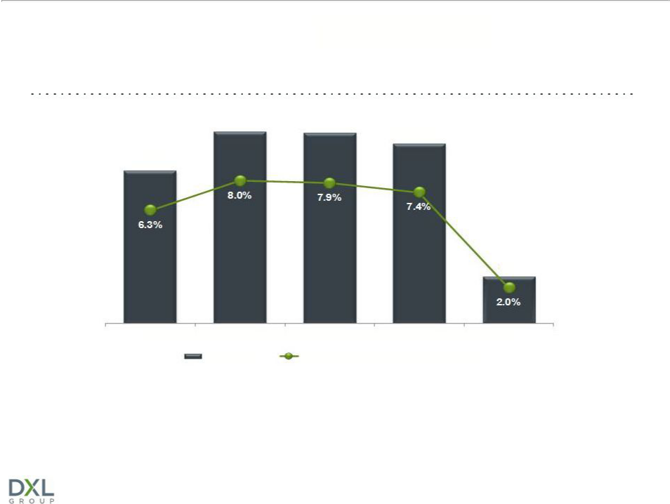
EBITDA & EBITDA MARGIN | (1)

($MM)

$31.4 $31.2

$29.4

$25.0

$7.7

2009 | 2010 | 2011 | 2012 | 2013
 | EBITDA (1) | EBITDA as a Percentage of Sales (1)

- EBITDA, Adjusted EBITDA, EBITDA Margin and Adjusted EBITDA Margin are non-GAAP measures. The above Adjusted EBITDA for fiscal 2011 excludes a trademark impairment charge of $23.1 million. For additional information about these non-GAAP measures, including a reconciliation to their respective GAAP measures, see Appendix A attached to this presentation.

Destination XL Group, Inc. | 21

RECONCILIATION OF NON-GAAP FINANCIAL MEASURES
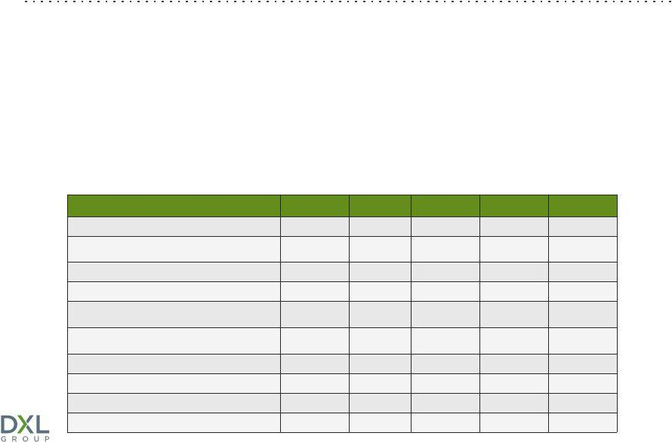

Exhibit 99.2

Appendix A

- In addition to Operating Income (Loss) determined in accordance with United States Generally Accepted Accounting Principles (GAAP), the Company uses certain non-GAAP financial measures, such as “EBITDA,” “Adjusted EBITDA,”EBITDA Margin” and “Adjusted EBITDA Margin” in assessing its operating performance. The Company believes that these non-GAAP measures serve as appropriate measures to be used in evaluating the performance of its business.

- The Company defines EBITDA as Operating Income (Loss) before Depreciation and Amortization. In addition, Adjusted EBITDA for fiscal 2011 excludes the impact of a non-recurring trademark impairment charge. The Company defines EBITDA Margin and Adjusted EBITDA Margin as EBITDA or Adjusted
EBITDA divided by Sales.
.

- EBITDA and Adjusted EBITDA as defined by the Company may not be comparable to similarly titled measures reported by other companies. The Company does not intend for non-GAAP financial measures to be considered in isolation or as a substitute for other measures prepared in accordance with GAAP.

- The following table provides a reconciliation of Operating Income (Loss), on a GAAP basis, to EBITDA and Adjusted EBITDA, on a non-GAAP basis (in millions, except percentages)

Fiscal year: | 2009 |  | 2010 |  | 2011 |  | 2012 |  | 2013
Sales | $ | 393.9 | $ | 392.0 | $ | 395.9 | $ | 399.6 | $ | 388.0
Operating Income (Loss), GAAP Basis | $ | 9.5 | $ | 18.2 | $ | (4.4) | $ | 13.9 | $ | (13.1)
Add back:
Depreciation and Amortization | $ | 15.5 | $ | 13.2 | $ | 12.5 | $ | 15.5 | $ | 20.8
EBITDA | $ | 25.0 | $ | 31.4 | $ | 8.1 | $ | 29.4 | $ | 7.7
Adjustment for Trademark Impairment |  | - |  | - | $ | 23.1 |  | - |  | -
ADJUSTED EBITDA |  | - |  | - | $ | 31.2 |  | - |  | -
EBITDA MARGIN |  | 6.3% |  | 8.0% |  | 2.0% |  | 7.4% |  | 2.0%
ADJUSTED EDITDA MARGIN |  |  |  |  |  | 7.9%

