UNITED STATES

SECURITIES AND EXCHANGE COMMISSION
WASHINGTON, D.C. 20549

FORM 8-K

CURRENT REPORT

Pursuant to Section 13 or 15(d)
of The Securities Exchange Act of 1934

Date of Report (Date of earliest event reported): September 9, 2014

DESTINATION XL GROUP, INC.

(Exact Name of Registrant as Specified in its Charter)

Delaware

01-34219

04-2623104

(State or Other Jurisdiction

of Incorporation)

(Commission

File Number)

(I.R.S. Employer
Identification No.)

555 Turnpike Street, Canton, Massachusetts

02021

(Address of Principal Executive Offices)

(Zip Code)

(781) 828-9300

(Registrant’s telephone number, including area code)

Check the appropriate box below if the Form 8-K filing is intended to simultaneously satisfy the filing obligation of the registrant under any of the following provisions (see General Instruction A.2. below):

- Written communications pursuant to Rule 425 under the Securities Act (17 CFR 230.425)

- Soliciting material pursuant to Rule 14a-12 under the Exchange Act (17 CFR 240.14a-12)

- Pre-commencement communications pursuant to Rule 14d-2(b) under the Exchange Act (17 CFR 240.14d-2(b))

- Pre-commencement communications pursuant to Rule 13e-4(c) under the Exchange Act (17 CFR 240.13e-4(c))

Item 7.01 -Regulation FD Disclosure

The Company will be presenting a slide presentation to various investment groups at upcoming investor conferences beginning September 9, 2014. A copy of the slides is attached to this report as Exhibit 99.1 and is incorporated by reference herein.

One of the slides includes financial information not prepared in accordance with generally accepted accounting principles (“Non-GAAP Financial Measures”). The Company believes that the non-GAAP measures are useful as an additional means for investors to evaluate the Company’s operating results, when reviewed in conjunction with the Company’s GAAP financial statements. A reconciliation of the Non-GAAP Financial Measures to financial information prepared in accordance with generally accepted accounting principles (“GAAP”), as required by Regulation G, is included as Appendix A to the investor presentation.

The full slide presentation is available on the investor relations page of the Company’s website at www.destinationxl.com.

The slides contained in the exhibit include statements intended as “forward-looking statements,” which are subject to the cautionary statement about forward-looking statements set forth in the exhibit. The additional slides are being furnished, not filed, pursuant to Regulation FD. Accordingly, the slides will not be incorporated by reference into any registration statement filed by the Company under the Securities Act of 1933, as amended, unless specifically identified therein as being incorporated therein by reference. The furnishing of these slides is not intended to, and does not, constitute a determination or admission by the Company that the information in the slide presentation is material or complete, or that investors should consider this information before making an investment decision with respect to the Company.

Item 9.01 Financial Statements and Exhibits.

- Exhibits

Exhibit
^{No.} Description

99.1 Investor Presentation dated September 2014.

SIGNATURE

Pursuant to the requirements of the Securities Exchange Act of 1934, the Registrant has duly caused this report to be signed on its behalf by the undersigned hereunto duly authorized.

 | DESTINATION XL GROUP, INC.
Date: September 9, 2014 | By: | /s/ Robert S. Molloy
 | Name: | Robert S. Molloy
 | Title: | Senior Vice President, General Counsel
 |  | and Secretary


Exhibit 99.1

September 2014

Investor Presentation

Destination XL Group, Inc.

FORWARD LOOKING STATEMENTS AND NON-GAAP MEASURES


Forward Looking Statements:

Certain information contained in this presentation, including, but not limited to, future store projections of sales per square foot, gross margin, occupancy and selling, general administrative expenses as well four-wall cash flow, constitute forward-looking statements under the federal securities laws. The discussion of forward-looking information requires management of the Company to make certain estimates and assumptions regarding the Company's strategic direction and the effect of such plans on the Company's financial results. Such forward-looking statements are subject to various risks and uncertainties that could cause actual results to differ materially from those indicated. Such risks and uncertainties may include, but are not limited to: the failure to implement the Company's business plan for increased profitability and growth in the Company's retail stores sales and direct-to-consumer business, the failure to achieve improvement in the Company's competitive position, changes in or miscalculation of fashion trends, extreme or unseasonable weather conditions, economic downturns, a weakness in overall consumer demand, trade and security restrictions and political or financial instability in countries where goods are manufactured, increases in raw material costs from inflation and other factors, the interruption of merchandise flow from the Company's distributionfacility, competitive pressures, and the adverse effects of natural disasters, war, acts of terrorism or threats of either, or other armed conflict, on the United States and international economies. These, and other risks and uncertainties, are detailed in the Company's Annual Report on Form 10-K filed with the Securities and Exchange Commission for the fiscal year ended February 1, 2014 filed on March 17, 2014 and other Company filings with the Securities and Exchange Commission. The Company assumes no duty to update or revise its forward-looking statements even if experience or future changes make it clear that any projected results expressed or implied therein will not be realized.

Non-GAAP Measures:

Adjusted Net Loss, Adjusted Net Loss Per Diluted Share, EBITDA, Adjusted EBITDA, EBITDA Margin and Adjusted EBITDA Margin are non-GAAP measures. The Company believes that these non-GAAP measures are useful as additional means for investors to evaluate the Company's operating results, when reviewed in conjunction with the Company's GAAP financial statements. Please see Appendix A for additional information concerning these non-GAAP measures and a reconciliation to their respective GAAP measures.

Destination XL Group, Inc. | 2

LARGEST MEN’S B&T SPECIALTY RETAILER


354

Total stores

80% - 85%

Retail sales

15% - 20%

Direct sales

40 million

Addressable market

1.4 million

Active customers

90%

Enrolled in

loyalty program

Destination XL Group, Inc.

15

Private label brands

40

Name brands

20

Exclusive brands

3

UNIQUE CUSTOMER


Not determined by demographic

Males of all ages with a waist

size 40” and greater

Values convenience, comfort,

selection and fit over price

Desires a good, better, best

array of product assortments in

all primary lifestyles

Destination XL Group, Inc. | 4

TRANSFORMING OUR BRAND
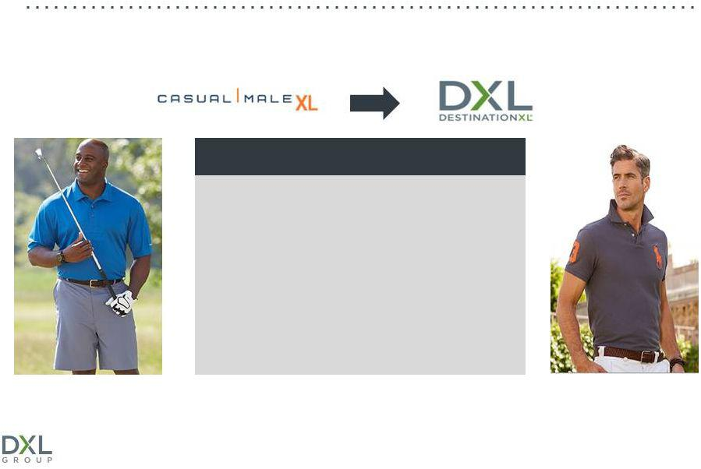

Began transformation to DXL brand in 2010 to provide customers with a one-stop shopping destination and grow the business

Opportunity for Growth

Capture greater wallet share

Attract broader customer audience

Target end-of-rack ¹ customers

Leverage website to drive sales

- Waist sizes 40 to 46 inches

Destination XL Group, Inc. | 5

ONE-STOP SHOPPING AT ITS BEST
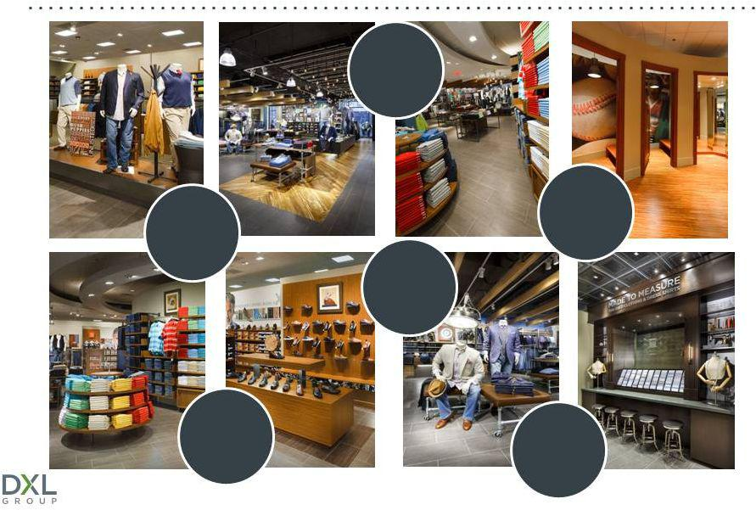

Wide
aisles

 | Large
Highly | changing
Highly | rooms
Trained | rooms
Staff
 | More
 | brands

Bright
Atmosphere Onsite
tailoring

Destination XL Group, Inc. | 6

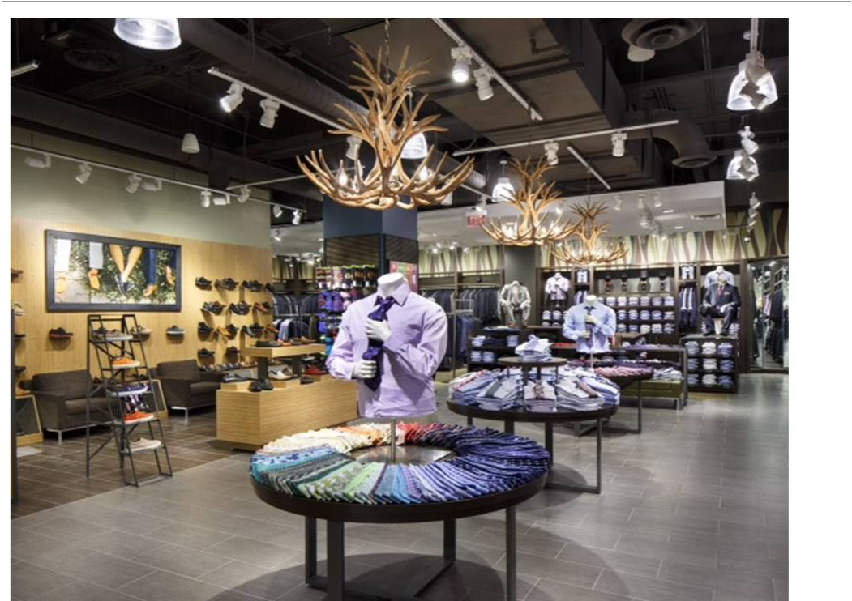

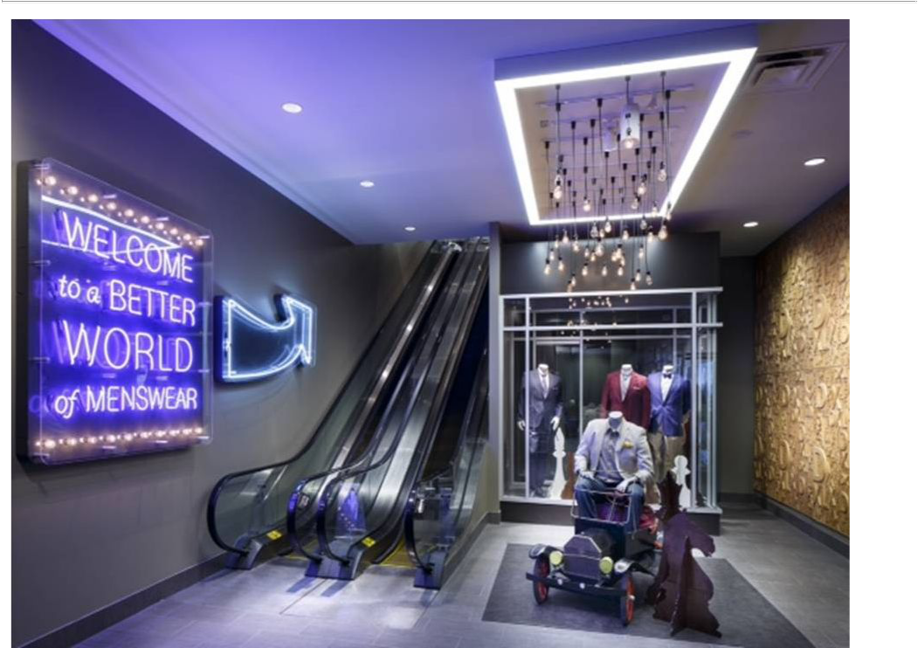

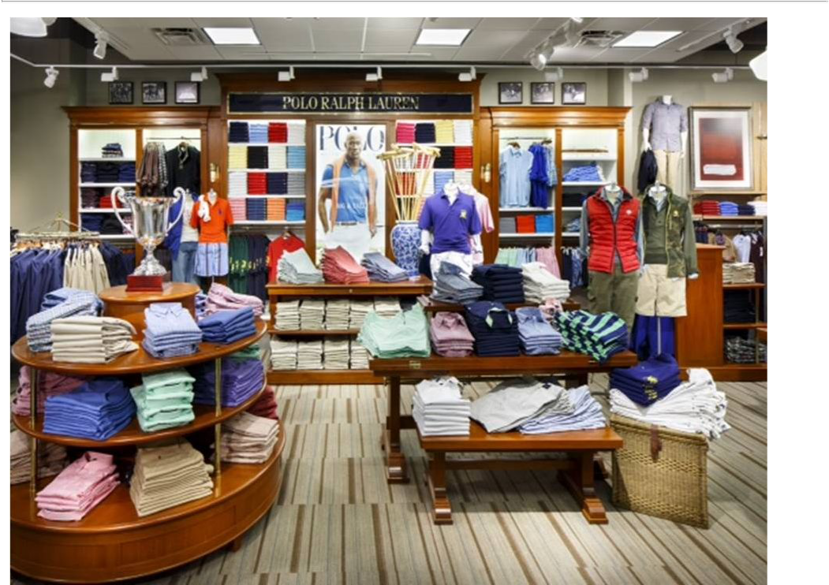

LARGE SELECTION OF NAME BRANDS


Destination XL Group, Inc. | 10

COMPLETE DXL STORE ROLL-OUT IN 2017
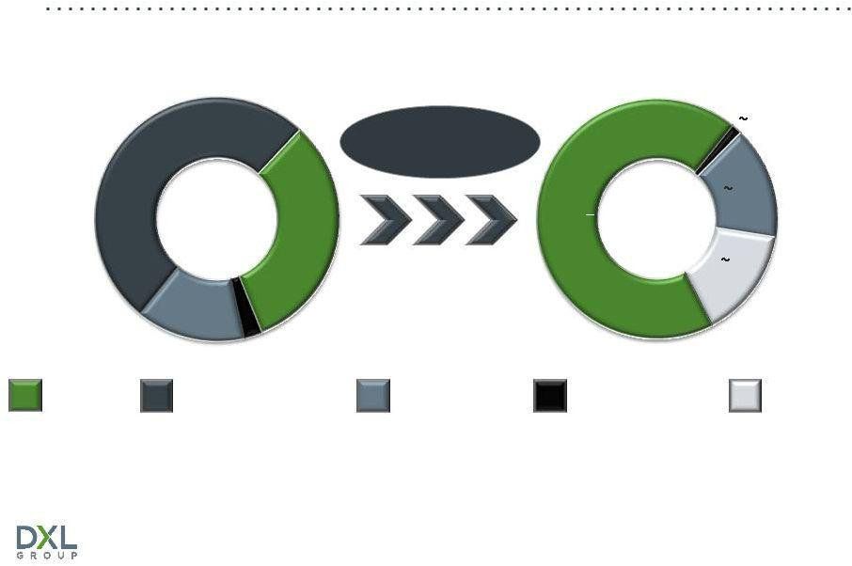

 | August 2, 2014 |  |  | 2017 Estimate
 |  |  | Open ~40/year |  | 3
181 |  |  | Close ~40/year
 |  |  |  |  | 50
 |  | 113 |  | 220
 |  | 113 |  | 250
 |  |  |  |  | 50
 | 51 | 9
DXL Stores | Casual Male XL Retail |  | CM Outlet Stores | Rochester Clothing | Additional Stores

Majority of store openings are timed prior to the holiday shopping

season to maximize profitability

Destination XL Group, Inc. | 11

SQUARE FOOTAGE COMPOSITION
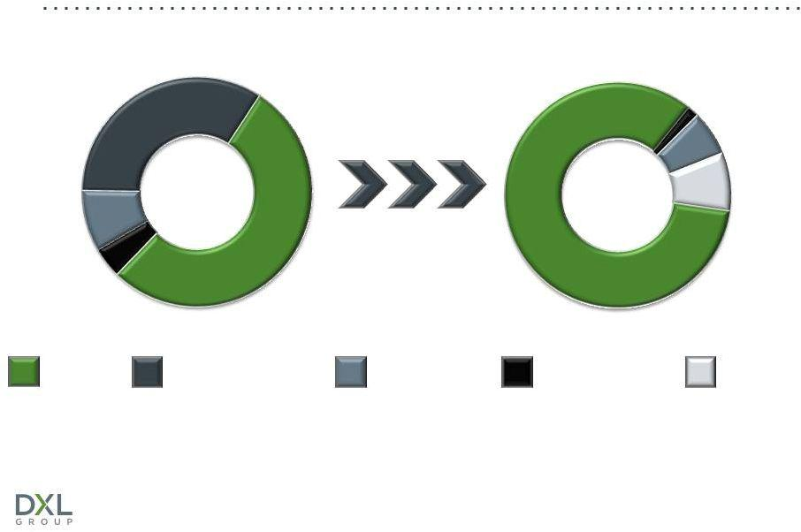

 | August 2, 2014 |  | 2017 Estimate
 |  | Sq. Ft. (000’s) |  | ~40
 | 643 |  |  | ~40
 | 643 |  |  | ~155
 |  |  | 1,700 – | ~200
164 | 1,003 |  | 2,000
83
 | 1,893 sq. ft. |  | ~2,095 – 2,395 sq. ft.
DXL Stores | Casual Male XL Retail | CM Outlet Stores | Rochester Clothing | Additional Stores

DXL stores will account for the majority of square footage by end of fiscal 2017 Total square footage to increase 10% to 25% by end of fiscal 2017

Destination XL Group, Inc. | 12

IMPROVED PROFITABILITY AT MATURITY
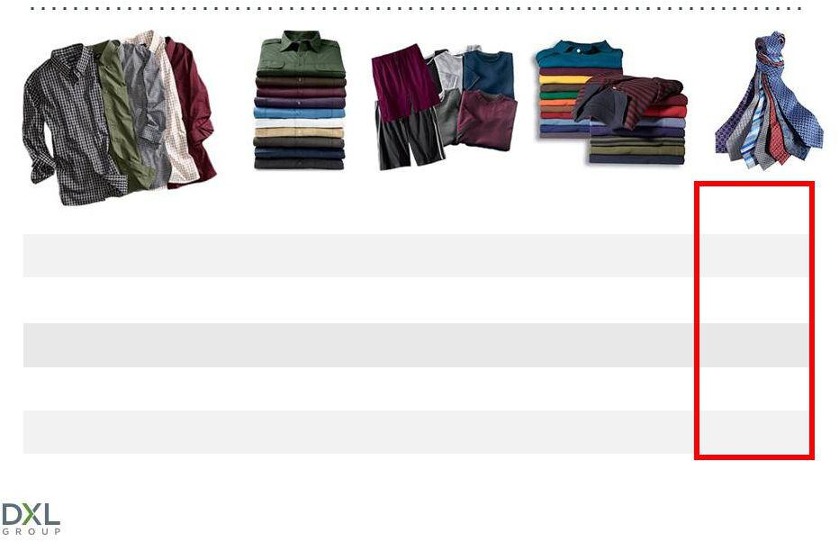

Sales per square foot

Gross margin, net of occupancy costs

SG&A as a % of sales

Four-wall cash flow

Build out costs

¹Average store results
²Average store pro forma

DXL |  | DXL | DXL | DXL
Year 1 | 1 | Year 2¹ | Year 3¹ | Year 4 | 2
$150 |  | $170 | $190 | $205
42.0% |  | 44.0% | 45.0% | 46.0%
26.0% |  | 22.0% | 21.0% | 21.0%
16.0% |  | 22.0% | 24.0% | 25.0%
$75

Destination XL Group, Inc.

_{Year}^{DXL}₅2

$220

47.0%

20.0%

27.0%

13

DXL 5K STORES DRIVE PROFITABILITY
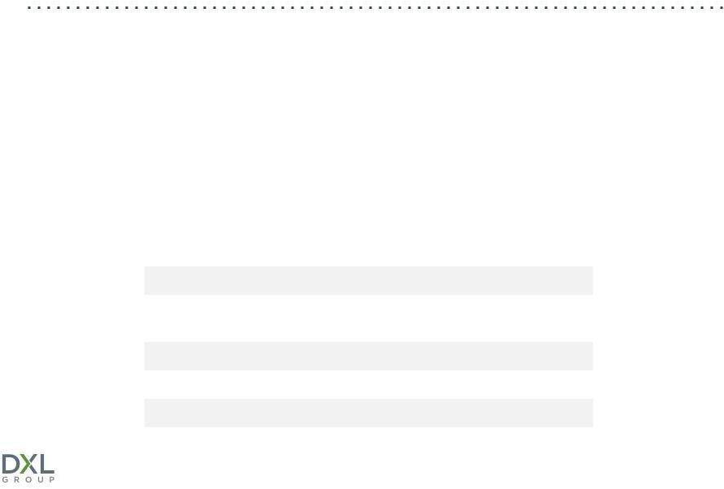

Introduced 5,000 square foot store concept in Q2 2014, which increased opportunity for continued store growth by ~50 more stores

Lowers cap ex and occupancy costs by 25% as compared to a 7,000 sq. ft. store

Penetrate smaller markets, where the economics of a full-size DXL would not work, and certain larger markets that warrant an additional presence due to geographical considerations

Economics of a 5,000 square foot DXL in year one in a sample market with expected annual sales of ~$800K:

Sales per square foot | $160
Gross margin, net of occupancy costs | 45.5%
SG&A as a % of sales | 30.5%
Four-wall cash flow | 15.0%
Build out costs | $80
Destination XL Group, Inc. | 14

INCREASING RETURN ON INVESTMENT
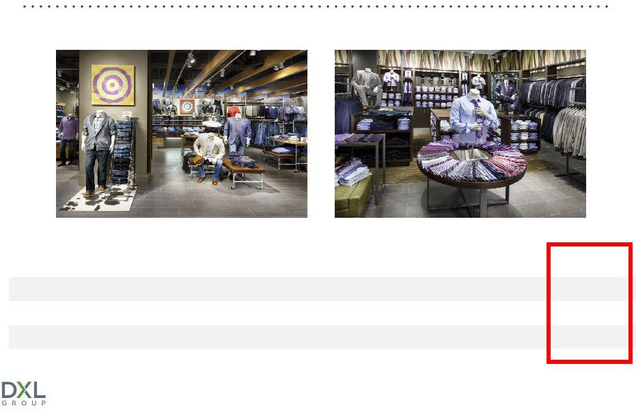

Achieving stronger return on investment in first year with smaller store sizes

 |  |  | Per Square Foot
 |  | Average Sq. Ft.¹ | Year One | Year One | ROI^{1,2}
 |  | Average Sq. Ft.¹ | Sales¹ | 4-Wall Cash Flow ¹ | ROI^{1,2}
2010 | – 2012 (48 stores) | 9,590 | $151 | $22 | 30.0%
2013 | (51 stores) | 8,441 | $145 | $25 | 38.0%
2014 | (40 stores) | 7,428 | $153 | $26 | 42.0%
¹Average store results
²ROI is defined as the internal rate of return calculated on a store four-wall basis over 5 years

Destination XL Group, Inc. | 15

SUCCESSFUL DXL MARKETING CAMPAIGNS


You’re Looking Good

Since first flight launched (Q2 2014 vs. Q2 2013):

+6.5% | +13.1% | +7.6%
Traffic | Transactions | End-of-Rack
+6.2% | +5.6% | +11.0%
Retail Conversion | Web Conversion | Customer Count
 | Destination XL Group, Inc. | 16

DRIVING TRAFFIC TO DXL STORES
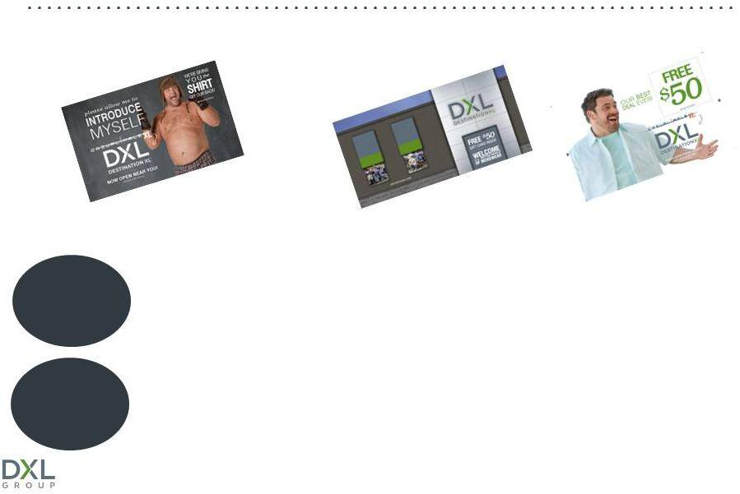

Free Polo Offer Experience Book & $50 Gift Card

22% Response Rate 35% Response Rate

+65%

+26%

More customers in an average DXL store’s active database than at the average Casual Male XL store

Higher retention rate at an average DXL store compared with an average Casual Male XL store

Destination XL Group, Inc. | 17

CONVERTING THE CASUAL MALE CUSTOMER

Begin promoting new DXL store at ambassador Casual Male XL stores 6 months prior to closing

+24% | Greater conversion rate of Casual Male XL
 | customers in Spring 2014 than Spring 2013

Extending leases at certain Casual Male XL locations

Destination XL Group, Inc. | 18

FALL 2014 MARKETING CAMPAIGN


Commence campaign two weeks later than prior year Will run from mid-October through mid-December

Aligned with peak holiday selling season and targeting gift givers Greater quality of program for ad placement (NFL, ESPN, Prime Time) Increased media presence for Thanksgiving week to mid-December Implement a “lead into the weekend” strategy

Destination XL Group, Inc. | 19

GREATER PRESENCE IN METRO MARKETS
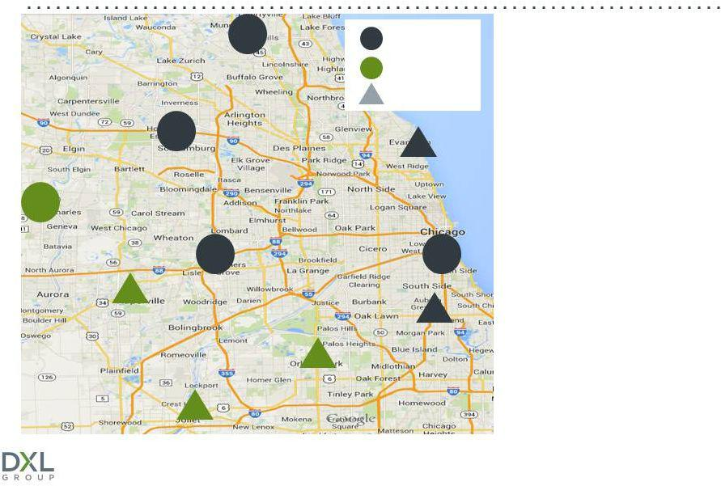

Full size DXL

5K DXL

Future DXL

Customers typically willing to drive up to 20 miles to shop at DXL

Chicago metro market large enough for multiple full-sized and 5K DXL stores

Prior to conversion, there were 19 Casual Male XL stores that serviced this market

Destination XL Group, Inc. | 20

IMPRESSIVE DOUBLE-DIGIT COMP SALES
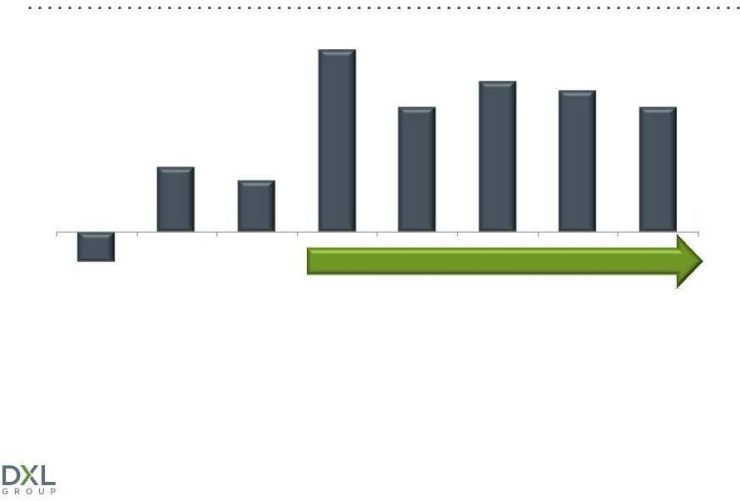

16.5%

13.6%
12.8%

11.3% ^{11.3%}

5.9%

4.7%

(2.7)% |  |  | 5 quarters of double-digit comp sales increases
Q3 2012 | Q4 2012 | Q1 2013 | 1 | 1 | 2 | Q1 2014 | 3
Q3 2012 | Q4 2012 | Q1 2013 | Q2 2013 | Q3 2013 | Q4 2013 | Q1 2014 | Q2 2014
(11 stores) | (16 stores) | (23 stores) | (29 stores) | (36 stores) | (48 stores) | (52 stores) | (61 stores)

¹Spring marketing campaign ran from 5/5/13 to 6/14/13
²Fall marketing campaign ran from 9/28/13 to 11/23/13
³Spring marketing campaign ran from 4/27/14 to 6/14/14

Destination XL Group, Inc. | 21

IMPROVING DIRECT BUSINESS


Eliminated catalog

circulation in May 2013

Improved website

functionality

Omnichannel retailer

•Ship to store

•Preferred delivery
•Store inventory available online
•Free shipping on orders above $100

•Mobile coming soon

Increased digital display

marketing

Stronger promotional

cadence

Destination XL Group, Inc. | 22



FINANCIAL PERFORMANCE

Destination XL Group, Inc.

Q2 2014 SALES HIGHLIGHTS
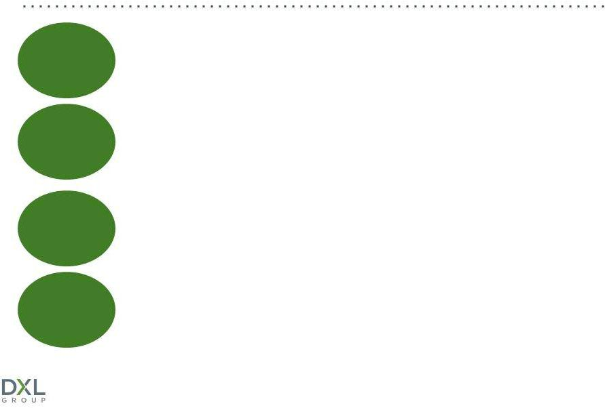

+5.8% Total sales (Retail and Direct)

+7.0% Comparable sales (all stores)

+11.3% DXL comparable store sales

+7.1% Casual Male XL and Rochester Clothing stores

Destination XL Group, Inc. | 24

SALES AND GROSS MARGINS
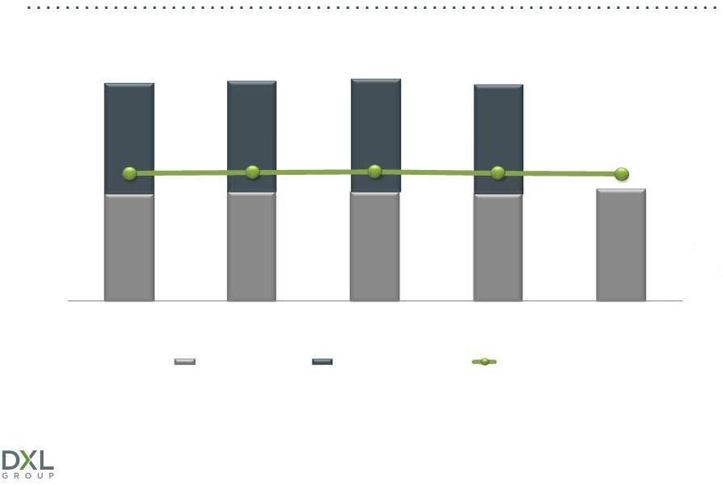

($MM)

$392.0 | $395.9 | $399.7 | $388.0
45.9% | 46.3% | 46.5% | 46.0% | 45.6%
$192.2 | $195.8 | $196.0 | $192.0 | $200.5
2010 | 2011 | 2012 | 2013 | 2014 YTD
 | Sales Q1 & Q2 | Total Annual Sales | Gross Margin

Strong gross margins provide opportunity for significant sales leverage

Destination XL Group, Inc. | 25

EBITDA & EBITDA MARGIN
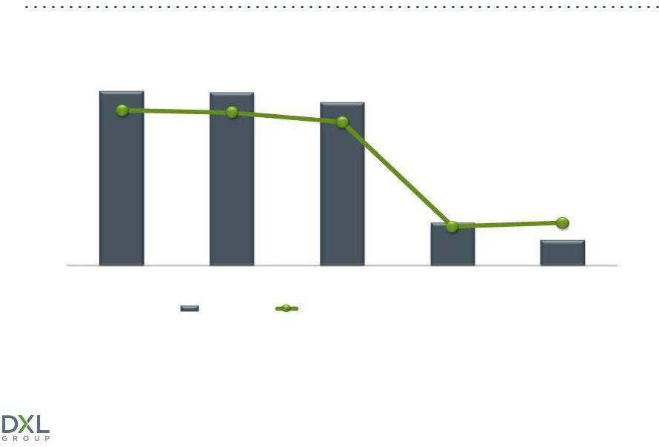

($MM)

$31.4 $31.2
$29.4

8.0% _{7.9%}

7.4%

 |  |  | $7.7 | 2.2%
 |  |  | 2.0% | $4.5
2010 | 2011 | 2012 | 2013 | 2014 YTD
 | EBITDA¹ | EBITDA as a Percentage of Sales¹

¹EBITDA, Adjusted EBITDA, EBITDA Margin and Adjusted EBITDA Margin are non-GAAP measures. The above Adjusted EBITDA for fiscal 2011 excludes a trademark impairment charge of $23.1 million. For additional information about these non-GAAP measures, including a reconciliation to their respective GAAP measures, see Appendix A attached to this presentation.

Destination XL Group, Inc. | 26

OPERATING MARGIN & COMPARABLE SALES
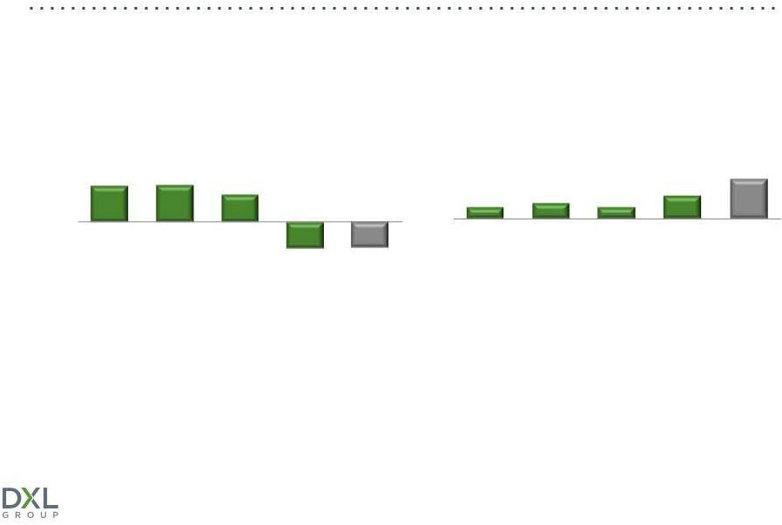

(continuing operations)

 | Total DXLG Operating Margin |  |  | Total DXLG Comp Sales
4.6% | 4.7% | 3.5% | 1.5% | 2.1% | 1.5% | 3.0% | 5.2%
 |  | (3.4)% | (3.3)%

2010 | 2011 | 2012 | 2013 2014 YTD | 2010 | 2011 | 2012 | 2013 2014 YTD

¹Before impairment charge of $23.1 million

Focus on improving operating margins through greater DXL sales

Destination XL Group, Inc. | 27

INCREASING SG&A WITH DXL ROLL-OUT

($MM)

 |  |  | $170.7
$148.4 | $152.0 | $156.4
 |  |  |  | 43.3%
 |  |  | 44.0%
 |  |  |  | $86.8
 | 38.4% | 39.1%
37.9% | 38.4%
$19.0 | $19.6 | $18.5 | $27.8 | $14.3
2010 | 2011 | 2012 | 2013 | 2014 YTD
Marketing Expense |  | Total SG&A | SG&A as a Percentage of Sales
 |  | Destination XL Group, Inc. |  | 28

SOLID BALANCE SHEET
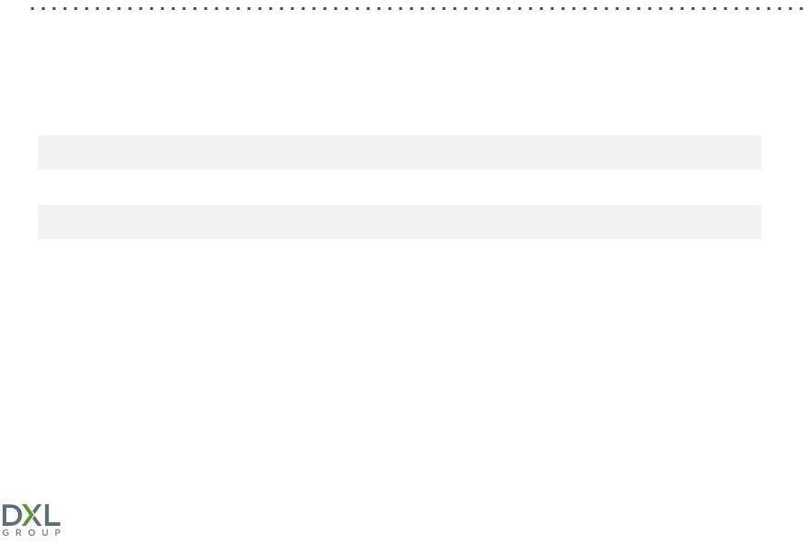

($MM)
 |  |  |  |  | Q2
 | 2010 | 2011 | 2012 | 2013 | 2014
Inventory | $92.9 | $104.2 | $104.2 | $105.6 | $116.0
Net borrowings under revolver | $0 | $0 | $0 | $9.0 | $25.7
Cash on hand | $4.1 | $10.4 | $8.2 | $4.5 | $5.6
Fixed term loan | $0 | $0 | $0 | $16.7 | $22.6

Unused excess availability under credit facility

at August 2, 2014 was $71.0 million

Destination XL Group, Inc. | 29

CASH FLOW & CAPITAL EXPENDITURES
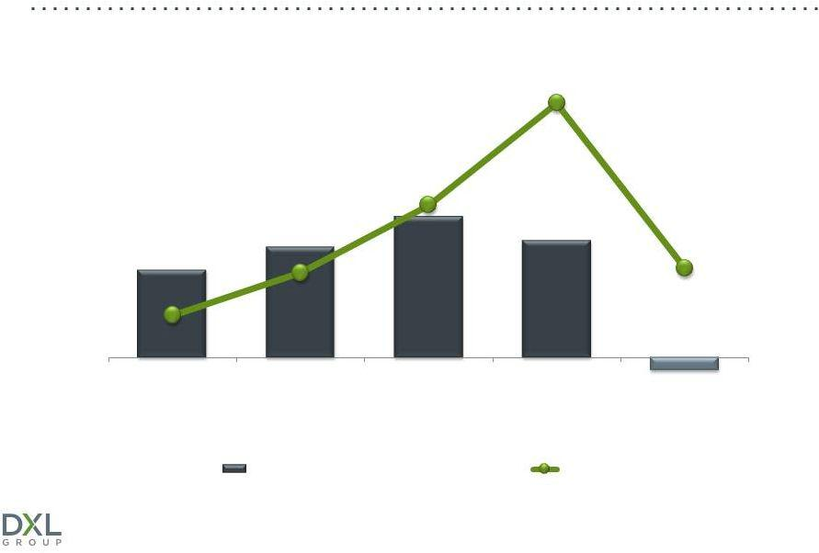

($MM)

$54.1

 | $32.4
 | $29.9
 | $24.9
 | $23.4
$18.7 | $18.9
$9.0 | $18.0

 |  |  |  | $(2.7)
2010 | 2011 | 2012 | 2013 | 2014 YTD
 | Cash Flow from Operating Activities |  | CAPEX¹
¹Before tenant allowances
 |  | Destination XL Group, Inc. |  | 30

DXLG INVESTMENT HIGHLIGHTS


Transformation to DXL concept creates compelling investment opportunity

Significant market share/sales growth opportunity Strong gross margins

Ability to significantly improve operating margins Solid balance sheet with borrowing capacity

Destination XL Group, Inc. | 31

Appendix A

NON-GAAP RECONCILIATION
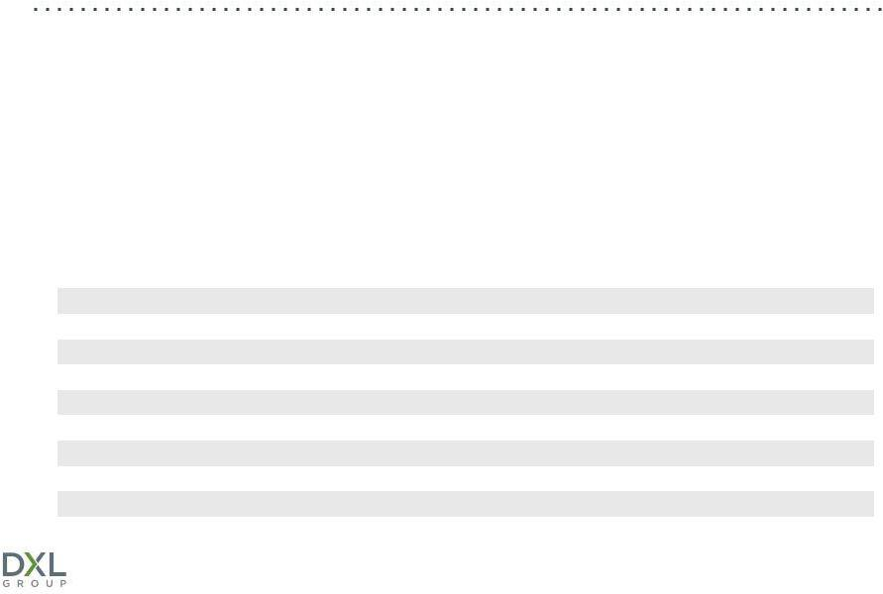

- In addition to Operating Income (Loss) determined in accordance with United States Generally Accepted Accounting Principles (GAAP), the Company uses certain non-GAAP financial measures, such as “EBITDA,” “Adjusted EBITDA,”EBITDA Margin” and “Adjusted EBITDA Margin” in assessing its operating performance. The Company believes that these non-GAAP measures serve as appropriate measures to be used in evaluating the performance of its business.

- The Company defines EBITDA as Operating Income (Loss) before Depreciation and Amortization. In addition, Adjusted EBITDA for fiscal 2011 excludes the impact of a non-recurring trademark impairment charge. The Company defines EBITDA Margin and Adjusted EBITDA Margin as EBITDA or Adjusted EBITDA divided by Sales.

- EBITDA and Adjusted EBITDA as defined by the Company may not be comparable to similarly titled measures reported by other companies. The Company does not intend for non-GAAP financial measures to be considered in isolation or as a substitute for other measures prepared in accordance with GAAP.

- The following table provides a reconciliation of Operating Income (Loss), on a GAAP basis, to EBITDA and Adjusted EBITDA, on a non-GAAP basis (in millions, except percentages)

 |  |  |  |  |  |  |  |  | 2014
Fiscal year: | 2010 |  | 2011 |  | 2012 |  | 2013 |  | YTD
Sales | $ | 392.0 | $ | 395.9 | $ | 399.6 | $ | 388.0 | $ | 200.5
Operating Income (Loss), GAAP Basis | $ | 18.2 | $ | (4.4) | $ | 13.9 | $ | (13.1) | $ | (6.6)
Add back:
Depreciation and Amortization | $ | 13.2 | $ | 12.5 | $ | 15.5 | $ | 20.8 | $ | 11.1
EBITDA | $ | 31.4 | $ | 8.1 | $ | 29.4 | $ | 7.7 | $ 4.5
Adjustment for Trademark Impairment |  | - | $ | 23.1 |  | - |  | - |  | -
ADJUSTED EBITDA |  | - | $ | 31.2 |  | - |  | - |  | -
EBITDA MARGIN |  | 8.0% |  | 2.0% |  | 7.4% |  | 2.0% |  | 2.2%
ADJUSTED EBITDA MARGIN |  |  |  | 7.9%

Destination XL Group, Inc.

INVESTOR CONTACT


Jeffrey Unger

V. P. Investor Relations

Destination XL Group, Inc.

jeffunger@usa.net

561-482-9715 (o)561-543-9806 (c)

www.DestinationXL.com

Destination XL Group, Inc. | 33

