UNITED STATES

SECURITIES AND EXCHANGE COMMISSION

Washington, D.C. 20549

FORM 8-K

CURRENT REPORT

PURSUANT TO SECTION 13 OR 15(d) OF THE
SECURITIES EXCHANGE ACT OF 1934

Date of Report (Date of earliest event reported): September 7, 2006

0-15898

(Commission File Number)

CASUAL MALE RETAIL GROUP, INC.

(Exact name of registrant as specified in its charter)

Delaware

04-2623104

(State of Incorporation)

(IRS Employer
Identification Number)

555 Turnpike Street, Canton, Massachusetts 02021

(Address of registrant’s principal executive office)

(781) 828-9300

(Registrant’s telephone number)

Check the appropriate box below if the Form 8-K filing is intended to simultaneously satisfy the filing obligation of the registrant under any of the following provisions (see General Instruction A.2. below):

- Written communications pursuant to Rule 425 under the Securities Act (17 CFR 230.425)

- Soliciting material pursuant to Rule 14a-12 under the Exchange Act (17 CFR 240.14a-12)

- Pre-commencement communications pursuant to Rule 14d-2(b) under the Exchange Act(17 CFR 240.14d-2(b))

- Pre-commencement communications pursuant to Rule 13e-4(c) under the Exchange Act(17 CFR 240.13e-4(c))

ITEM 7.01 - REGULATION FD DISCLOSURE

The Company will be presenting a slide presentation to various investment groups as part of its upcoming road show. A copy of the slides to be presented at those meetings is attached to this report as Exhibit 99.1, which slide presentation is incorporated by reference herein.

The slide presentation contained in the exhibit includes statements intended as “forward-looking statements,” which are subject to the cautionary statement about forward-looking statements set forth in the exhibit. The slide presentation is being furnished, not filed, pursuant to Regulation FD. Accordingly, the slide presentation will not be incorporated by reference into any registration statement filed by the Company under the Securities Act of 1933, as amended, unless specifically identified therein as being incorporated therein by reference. The furnishing of the slide presentation is not intended to, and does not, constitute a determination or admission by the Company that the information in the slide presentation is material or complete, or that investors should consider this information before making an investment decision with respect to the Company.

ITEM 9.01 - FINANCIAL STATEMENTS AND EXHIBITS

- Exhibits

Exhibit No. |  | Description
99.1 |  | Presentation dated September 7, 2006

SIGNATURES

Pursuant to the requirements of the Securities Exchange Act of 1934, the registrant has duly caused this report to be signed on its behalf by the undersigned, thereunto duly authorized.

CASUAL MALE RETAIL GROUP, INC.

By: /S/ DENNIS R. HERNREICH

Name: Dennis R. Hernreich

Title: Executive Vice President

and Chief Financial Officer

Date: September 7, 2006

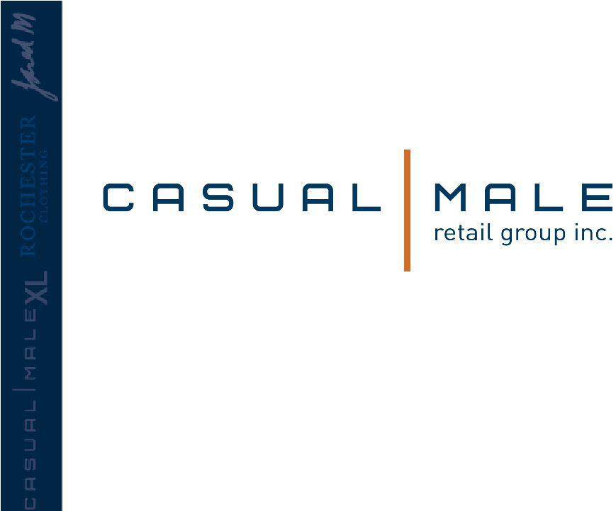
Exhibit 99.1

September 2006



Casual Male Retail Group properly positioned to increase market share to 12% of the big & tall market


Big & Tall Market

- Market defined as:

– big = waist size between 40” and 70”

– tall = height over 6’2”

- Big and tall men account for approximately 11% of the male population.

- Big and tall market size is approximately $6 billion and growing at almost twice the rate of the regular size men’s apparel market.

– Big & tall apparel market is highly fragmented; characterized by many small, local operators.

Market is growing as a percent to total menswear sales

Obesity Trends* Among U.S. Adults

(*BMI 30, or about 30 lbs overweight)
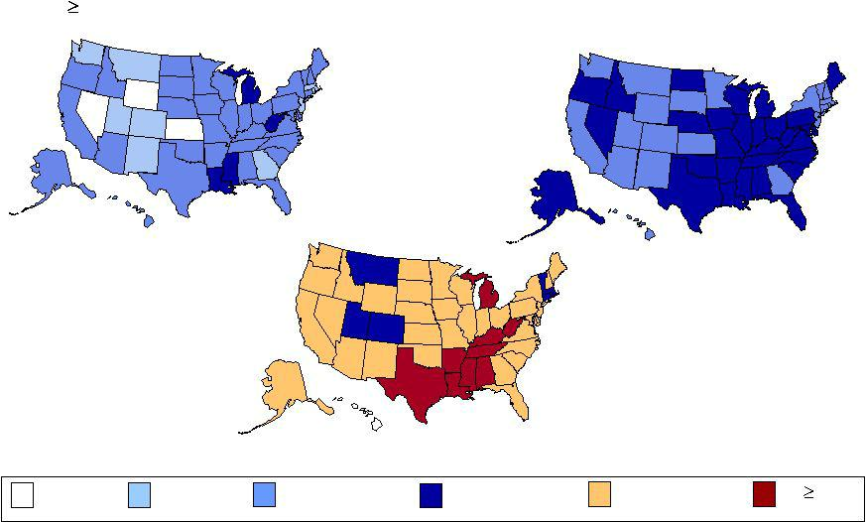

1991
1996

In 2004, 7 states had |  |  | 2004
obesity prevalence
rates of 15–19
percent; 33 states had
rates of 20–24
percent; and 9 states
had rates more than
25 percent
No Data | <10% | 10%–14% | 15%–19% | 20%–24% | 25%

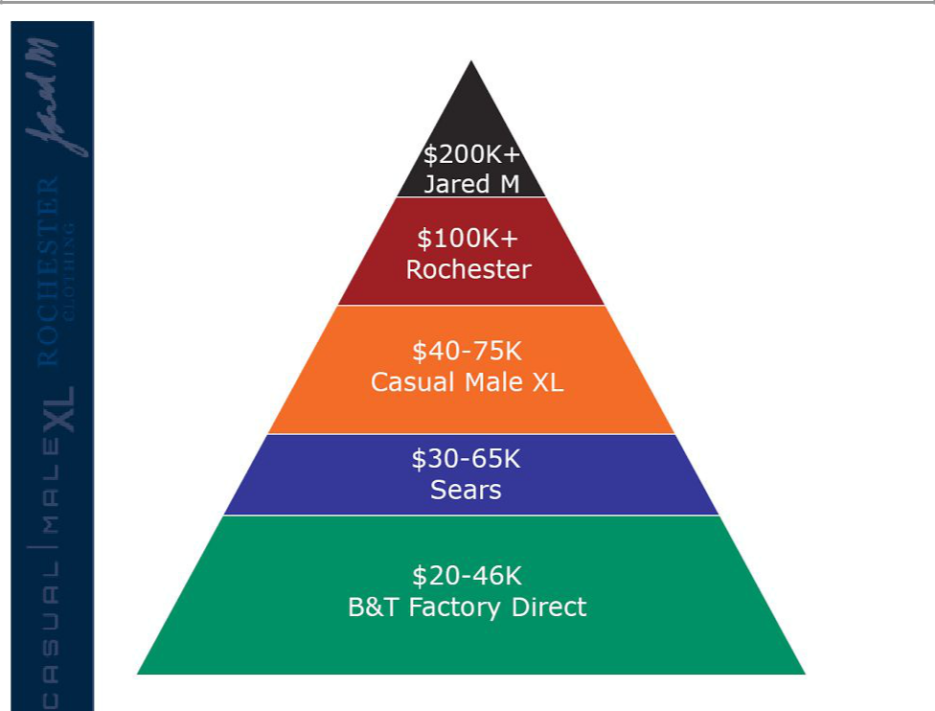
Casual Male Retail Group

has divisions which

support all demographics

within the big & tall

market

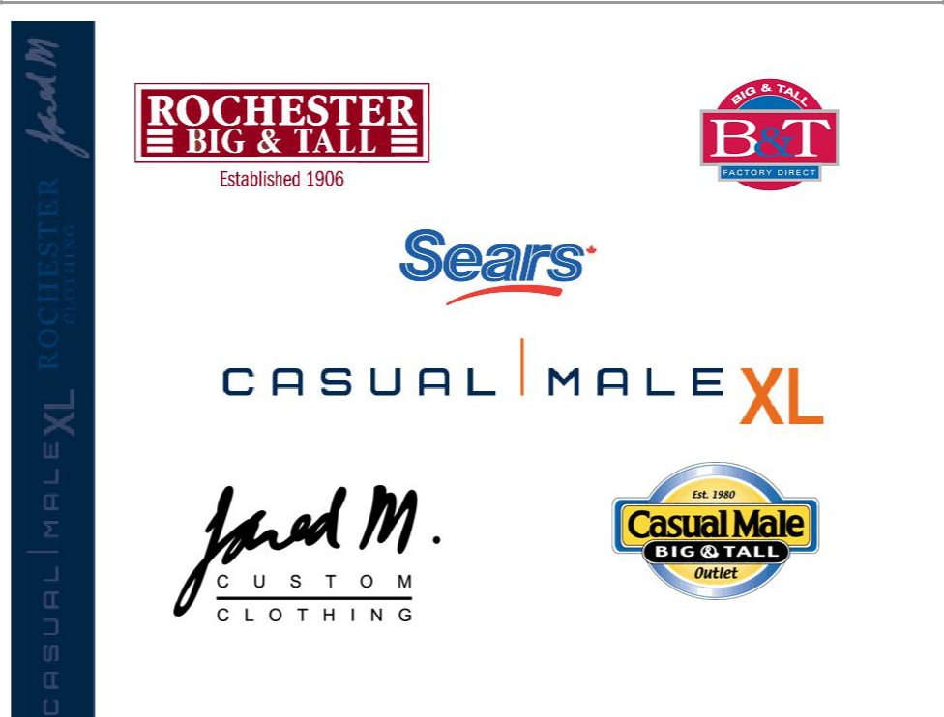

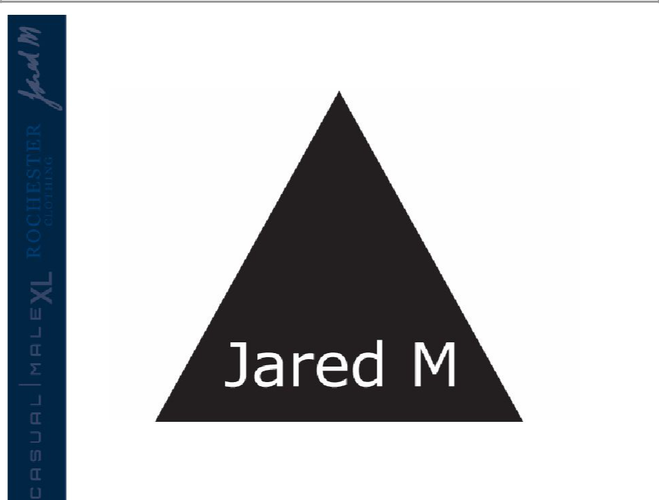

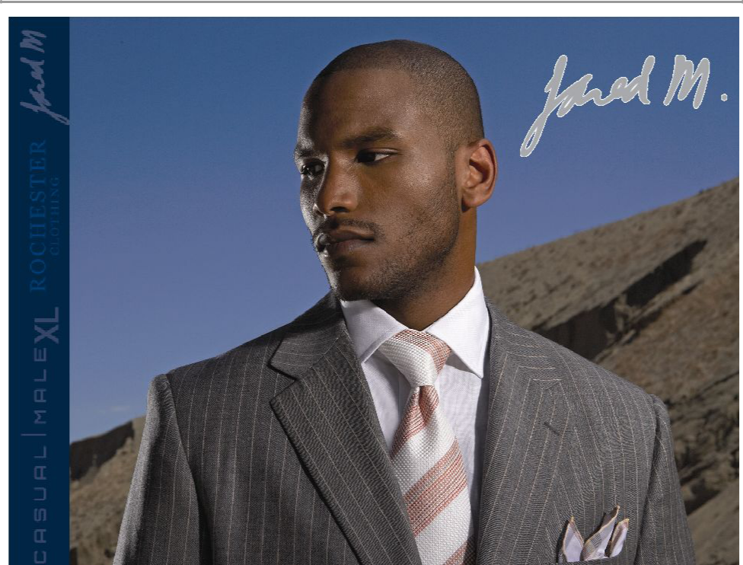

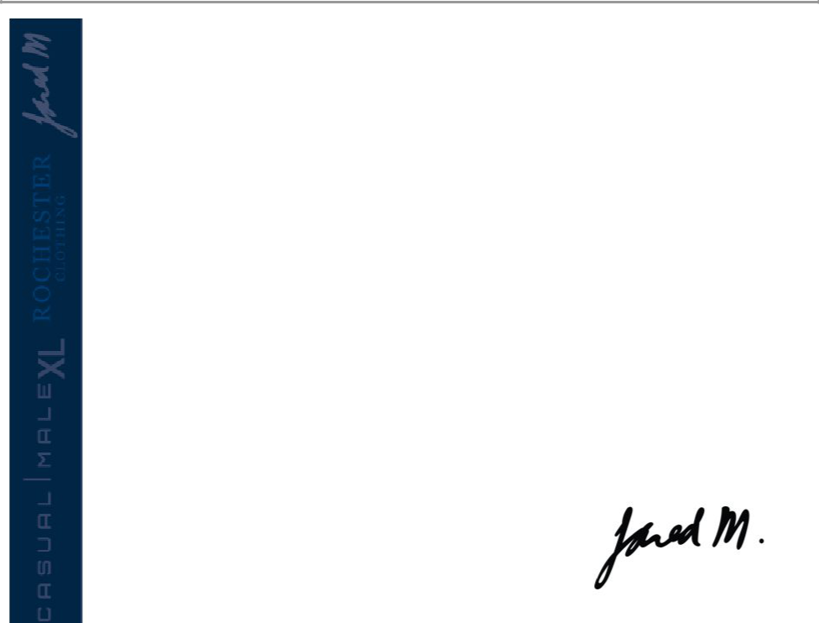
Jared M.

- Custom clothing continues to be growing in the higher-end men’s business

- Spring ’07 launch

– Jared M. shops in high profile Rochester markets

– Jared M. catalog

– Jared M. website

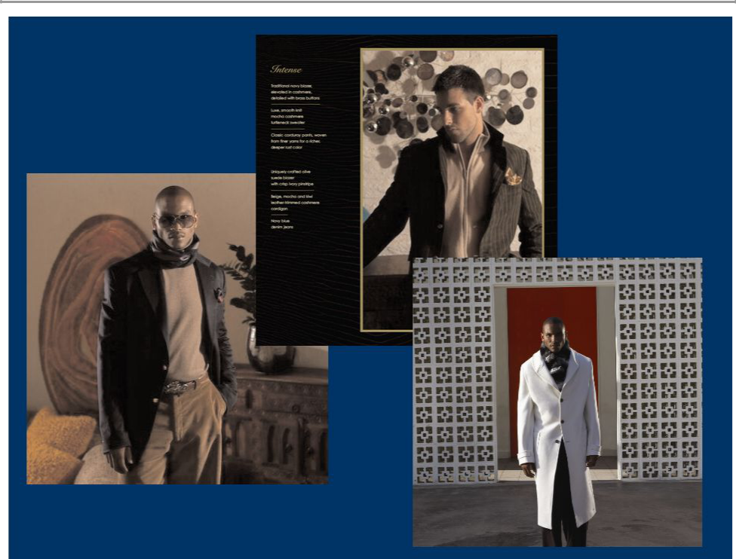

Jared M.

Three areas of opportunity for growth of
Jared M. concept

- Custom Clothing

– Rochester is underdeveloped in custom clothing (3.5% of sales)

– Jared M. custom shops will contribute to the contemporary portion of this opportunity

– New Showroom/Production facility in lower Manhattan will also support custom clothing

- Athlete clientele growth

– Jared M. has solid NBA athlete clientele

– Project other athlete clientele opportunities in NFL, MLB, NHL, etc.

- Exclusive Collection for Rochester Big & Tall

– Store, catalog and web channels

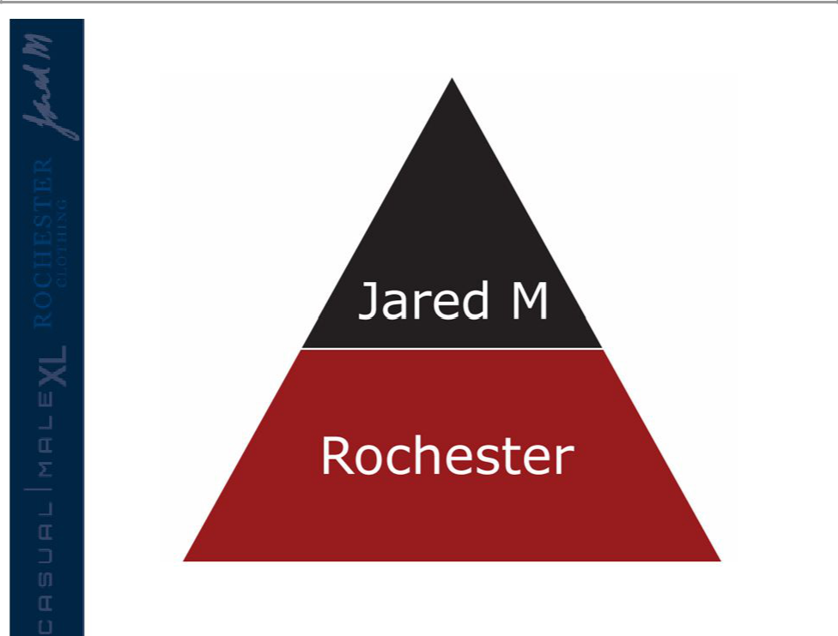


Rochester Brands

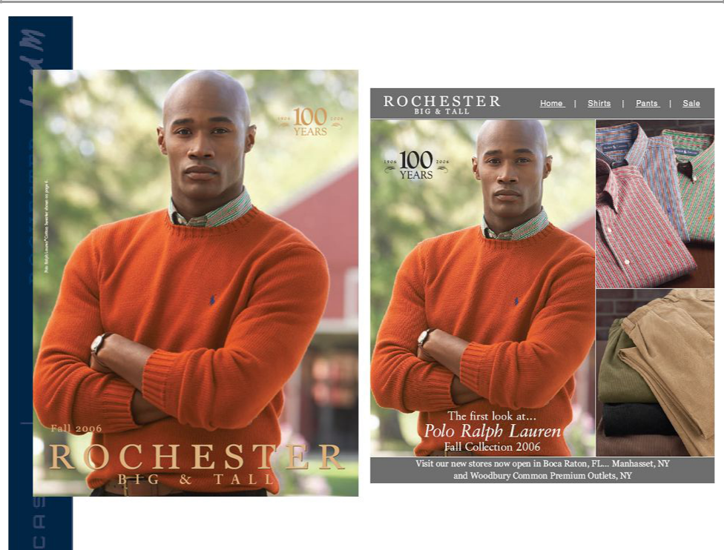

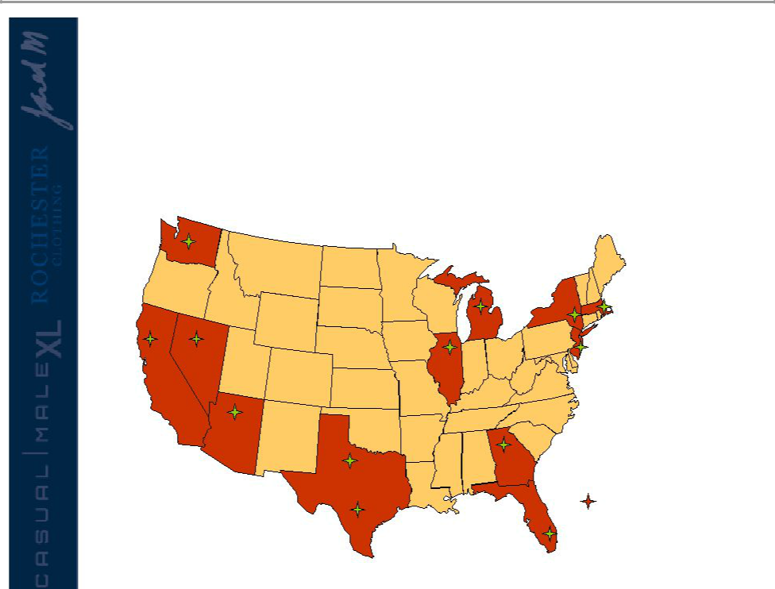
Rochester Overview

- Rochester currently with 23 US stores

- 1 store in United Kingdom.

3

8

2 Rochester

* 1 London, United Kingdom

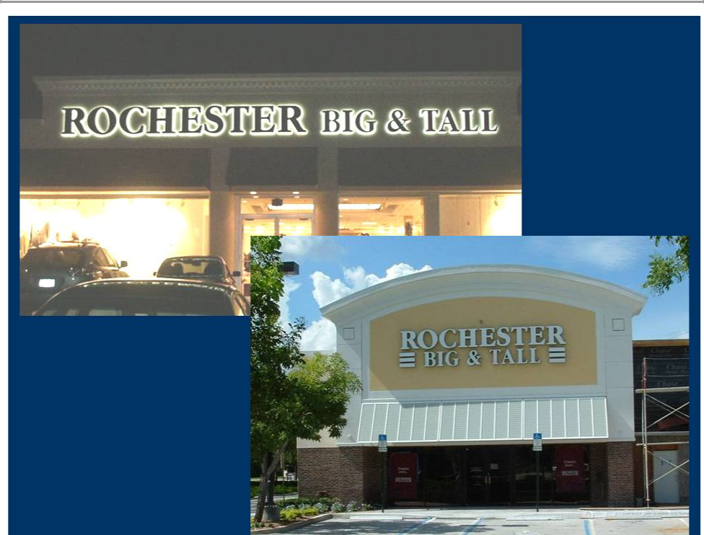

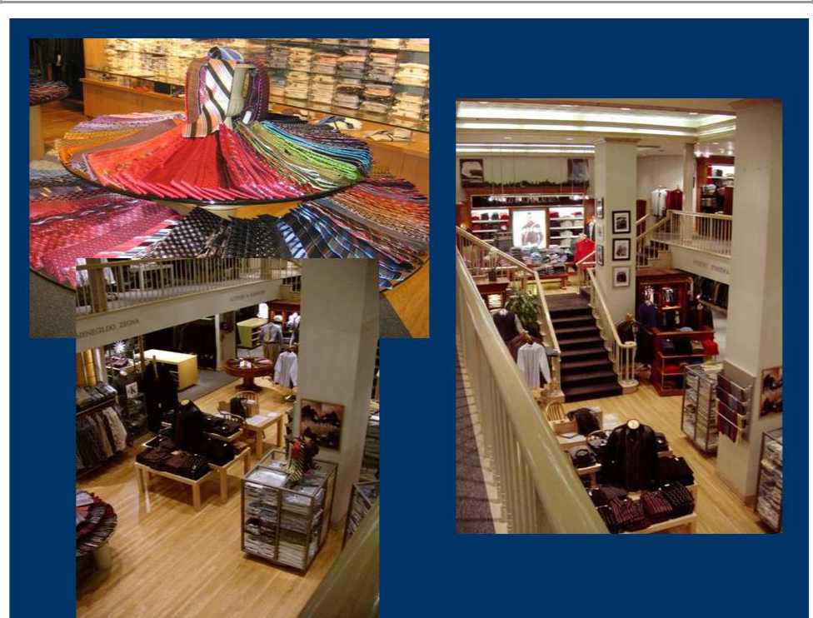

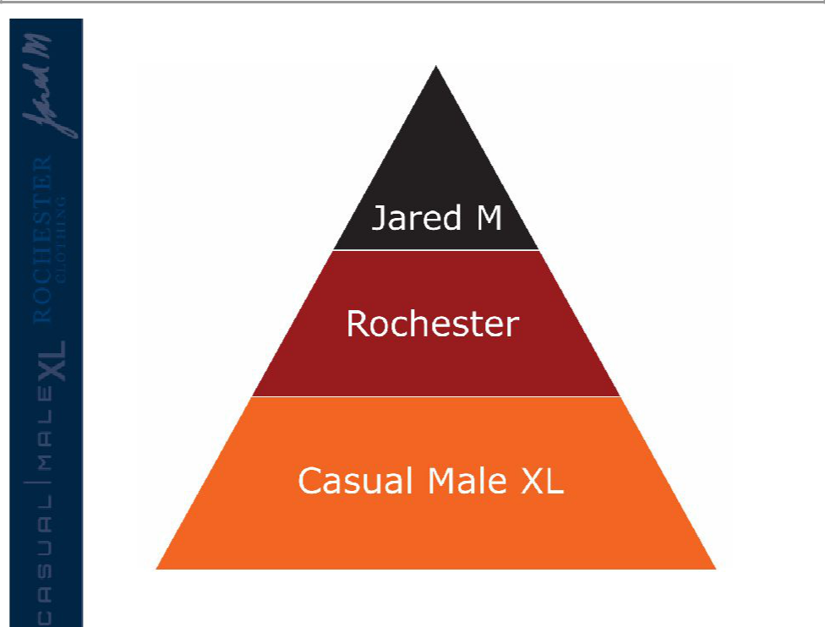


Casual Male Objectives to Increase Market Share

- Raise productivity sales per square foot

• Increasing sales of “smaller” sizes

• Attract “younger” big and tall customers to

Casual Male XL

- Grow multi channel

- New marketing efforts

– Loyalty

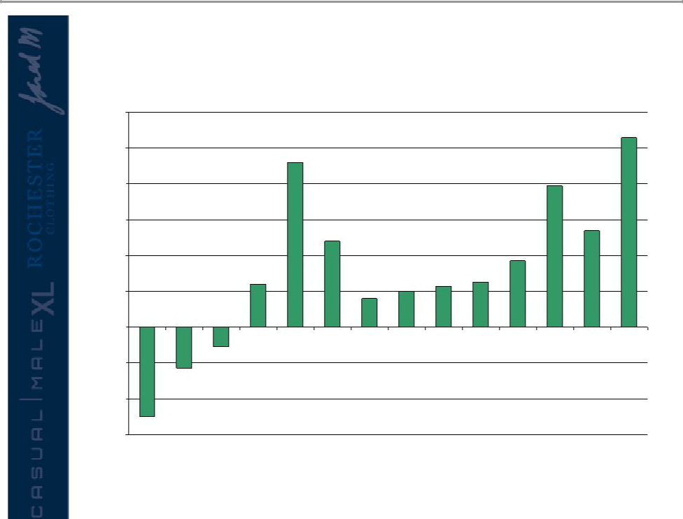
Comp Store Trend

12.0%
 |  |  |  |  | Launch of George Foreman |  |  |  |  |  |  |  | 10.60%
10.0% |  |  |  |  | collection and TV campaign
10.0% |  |  |  | 9.2%
8.0% |  |  |  |  |  |  |  |  |  |  | 7.90%
6.0% |  |  |  |  | 4.8% |  |  |  |  |  |  | 5.40%
4.0% |  |  |  |  |  |  |  |  |  | 3.70%
 |  |  | 2.4% |  |  |  | 2.0% | 2.3% | 2.5%
2.0% |  |  |  |  |  | 1.6% | 2.0%
0.0%
Q1 | Q2 | Q3 | Q4 | Q1 | Q2 | Q3 | Q4 | Q1 | Q2 | Q3 | Q4 | Q1 | Q2
-2.0% |  | -1.1% Stores change to
-2.0% |  |  | lifestyle presentation
 | -2.3%
-4.0%
-5.0%
-6.0% | 2003 |  |  |  | 2004 |  |  |  | 2005 |  |  |  | 2006

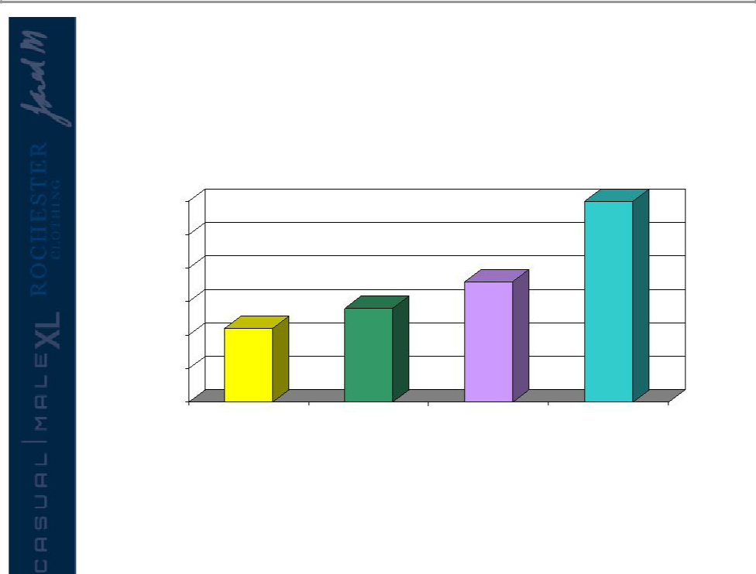
Sales Per Square Foot

200
200

195

190

185 188
184
180

181

175

170

2003 2004 2005 2006 Forecasted

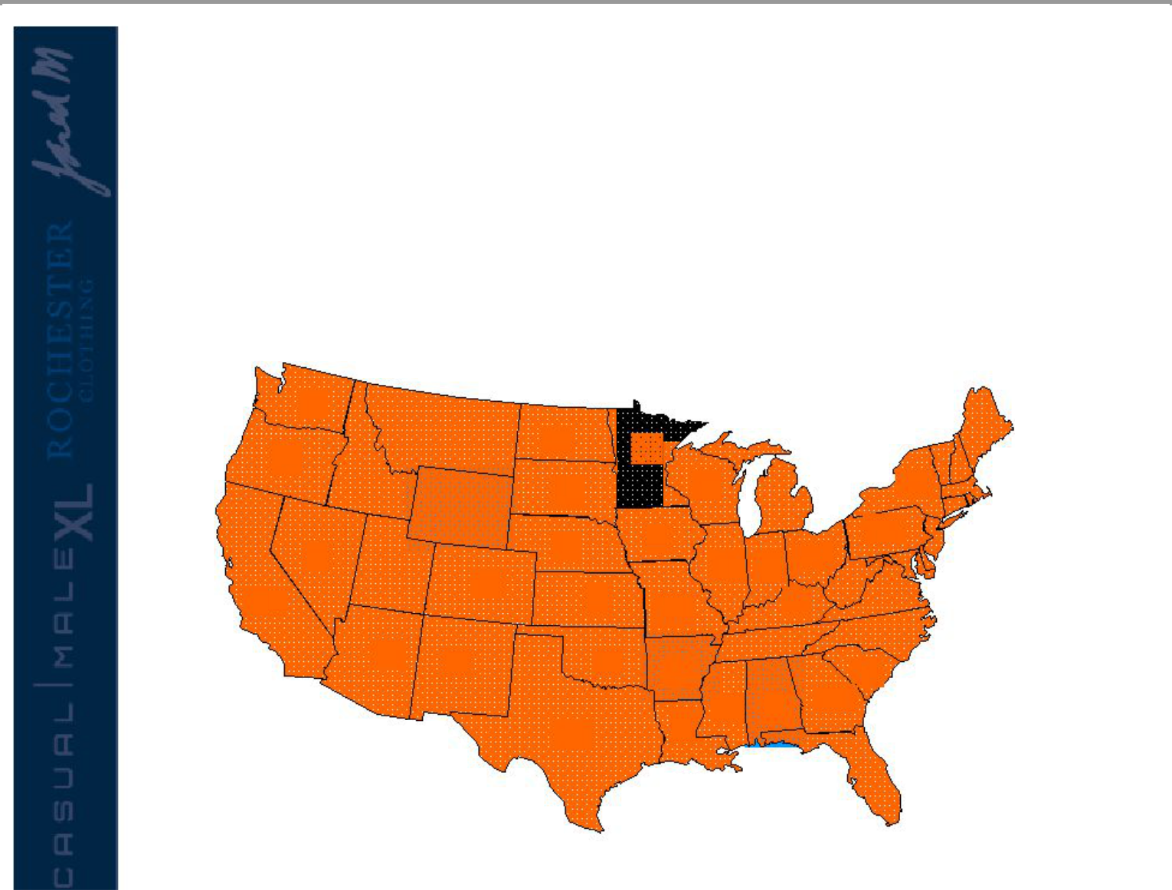
Casual Male Stores

- Casual Male XL is the nation’s largest specialty retailer of big & tall clothing with 485 stores in 44 states

7

3

5 |  | 1 |  |  |  | 9
 |  |  | 1 |  |  | 9 |  | 31
 |  |  | 1 |  |  |  | 23
 |  |  |  |  |  |  | 23 | 26
 |  |  | 4 |  |  | 4 |  | 26
5 |  |  | 4 |  |  | 4 |  | 22
5 |  |  | 4 |  |  | 28 | 12 | 22
 |  | 6 |  |  |  | 28 | 12 | 2
55 |  |  |  | 4 |  | 12 | 5 | 14
8 |  |  |  |  |  |  | 9 | 11
8 | 2 |  |  |  | 3 |  | 9
8 | 2 |  |  |  | 3 | 3 |  | 7
 |  |  |  |  |  | 2 | 5 | 11
 |  |  | 37 |  |  | 5
Long term potential – |  |  |  |  |  |  |  | 27
additional 100-130 more
stores

CT-11

DE-3

RI-1

MA-14

MD-13

NH-3

NJ-21

VT-1

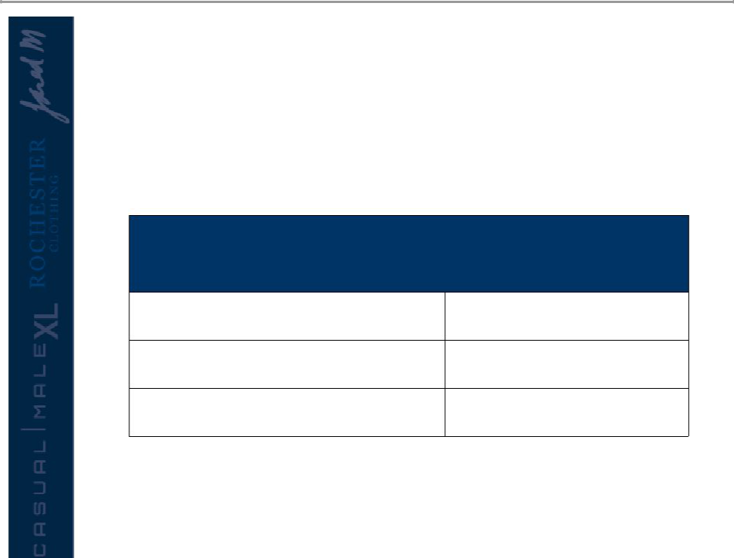
Relocation Potential

Relocation of lower performing store will improve $ per square foot

Annual Relocation Plan

Number of Stores | Calendar Year
11 | 2006
28 | 2007
26 | 2008

9064 Utica, MI to Sterling Heights, MI
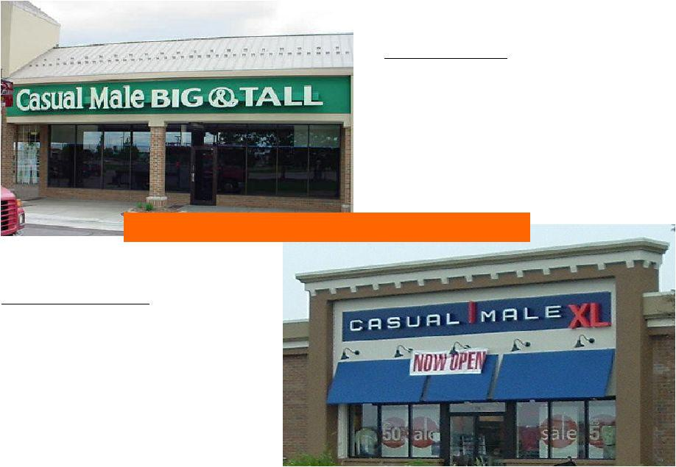

Old Location:

In-Line Strip Center

with Vacant Anchor

No Street Visibility

4000 Sq. Ft

05 sales: $817,000

05 cash flow: $194,000

- mile apart / Cost $41,975

New Location:

End-Cap

Multi-Tenant Building

Mall Pad

3500 Sq. Ft

Trend prior to relocation: -1.61%

Trend after relocation: 22.89%

9612 Katy, TX
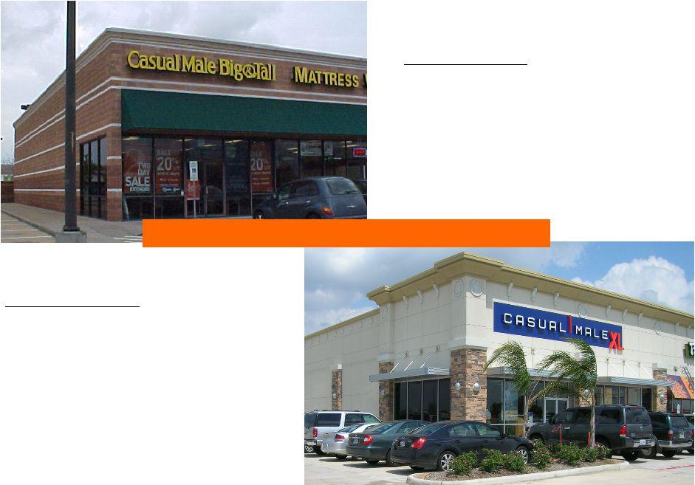

Old Location:

Power Center

Multi-Tenant Pad

2500 Sq. Ft

05 sales: $439,000

05 cash flow: $90,000

8 miles apart / Cost $126,194

New Location:

Duplex Pad

End Cap within

Regional Power Center

3700 Sq. Ft

Trend prior to relocation : 6.12%

Trend after relocation 03/30/06: 29.41%

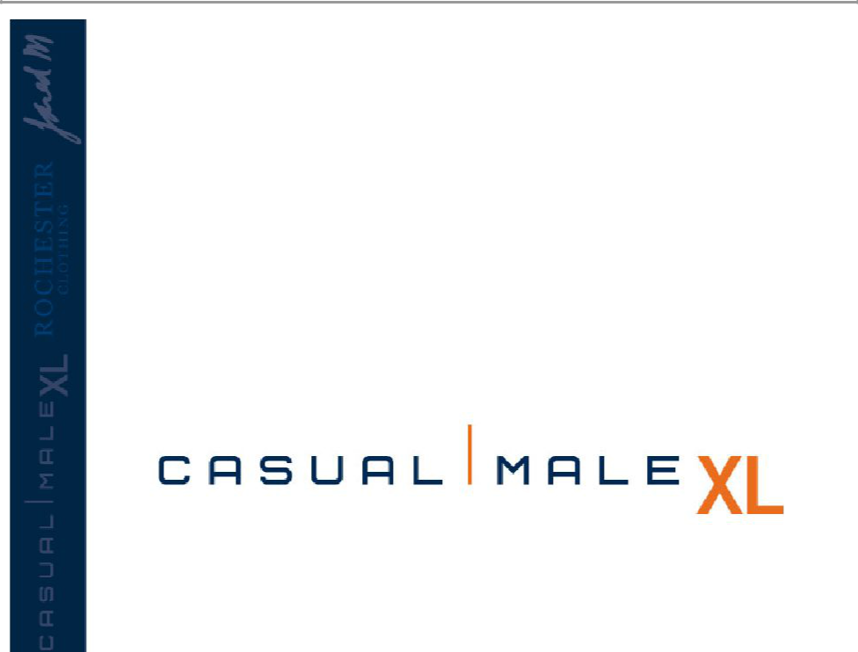

Increasing sales of smaller sizes within big & tall

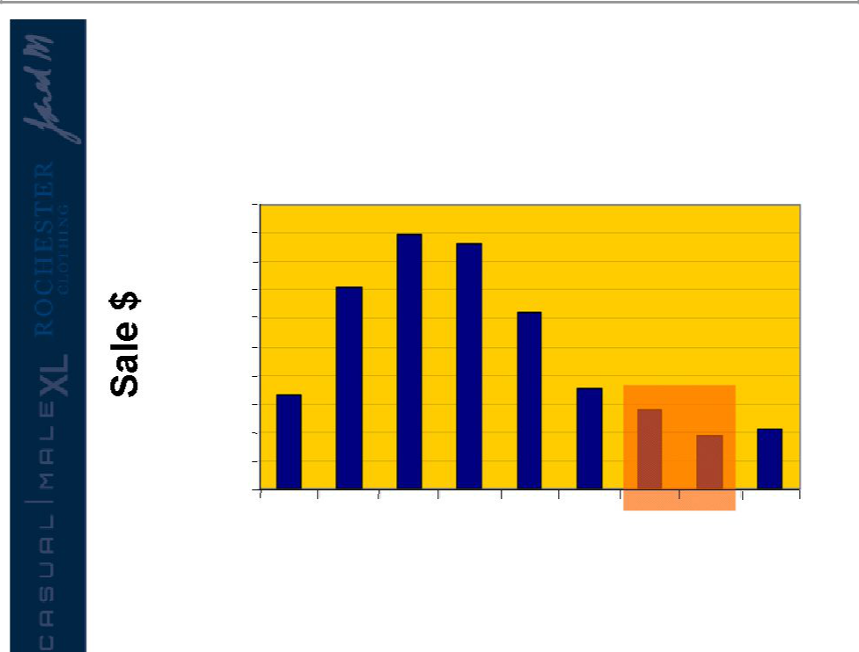
National Sales by Size

$2,000,000

$1,800,000

$1,600,000

$1,400,000

$1,200,000

$1,000,000

$800,000

$600,000

$400,000

$200,000

$0

30 32 34 36 38 40 42 44 46-60

Waist

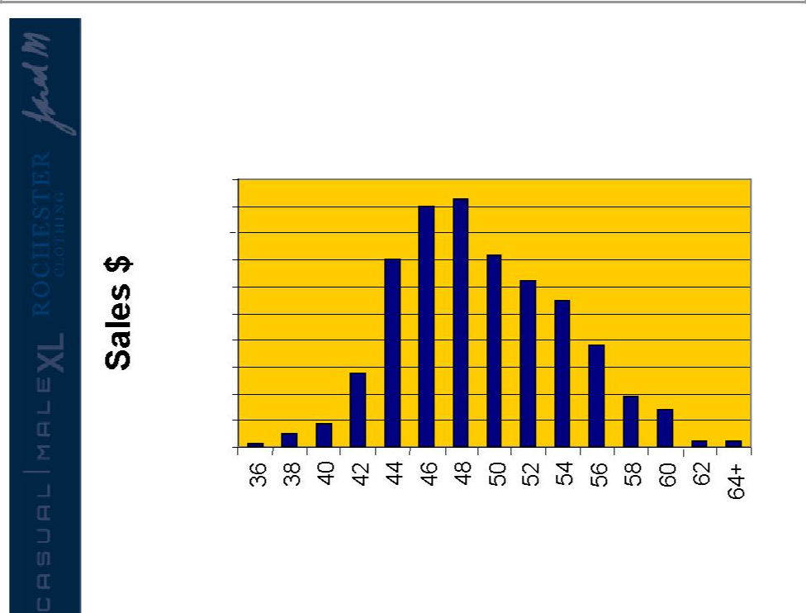
Market Share Size Opportunity

$200,000

$180,000

$160,000

$140,000

$120,000

$100,000

$80,000

$60,000

$40,000

$20,000
$0

Data based on ’04 sales of Casual Pants, Dress Pants and Jeans

Casual Male Sales by Size

Waist Size

Rebranding Casual Male


Customer Research

- Least favorite aspect of clothing shopping was “difficulty finding items in my size”

– They were shopping at “the end of the rack”

– Stigma with “big and tall” store

– “big and tall” stores were consistently referred to as
places where “fat guys” shop

- Current image associated with Casual Male

– A degree of discomfort with shopping at the store for “big and tall”

– Belief that the clothing started around a 48” waist

– Merchandise and selection lacked a sense of style

– Had unattractive, inconvenient locations

– Casual Male was a place of necessity rather than a destination of choice

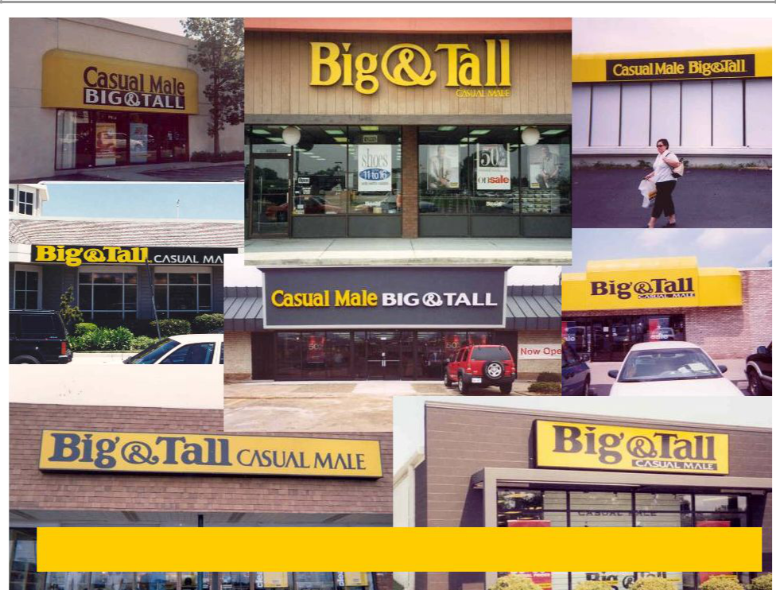

50% of customers refer to Casual Male as the “Big & Tall” store

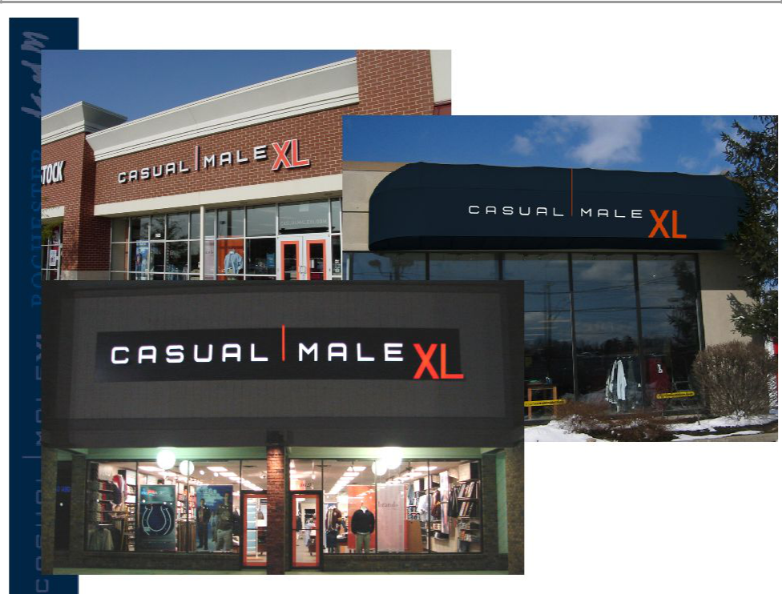

Before

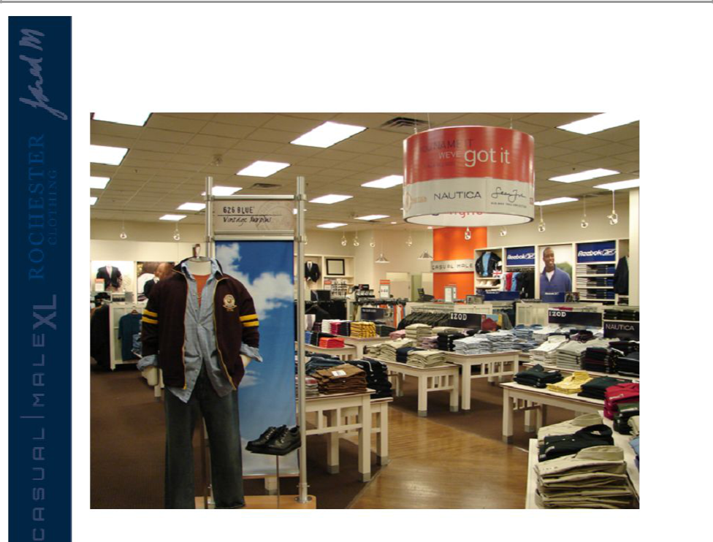
After

Attracting “Younger” Big & Tall Customers to Casual Male Brand

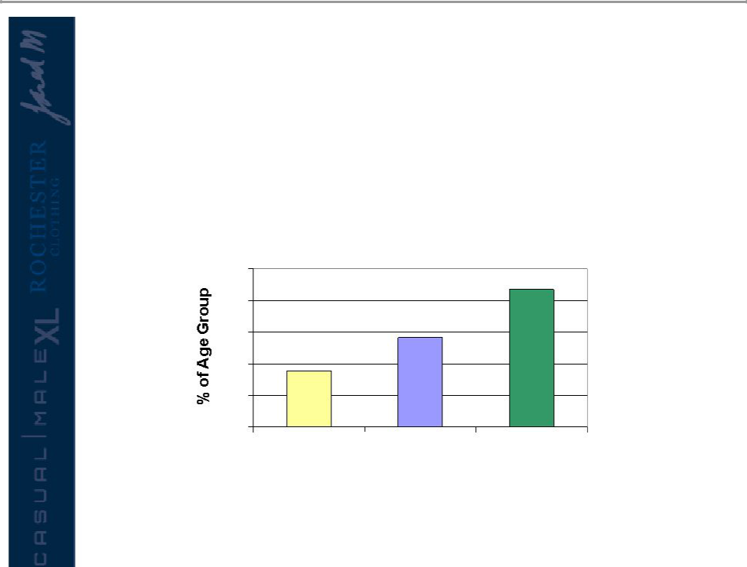
Obesity in Young Men

- Opportunity to increase penetration of under 30 demographic

– Among American men ages 20 - 34, prevalence of obesity has increased dramatically since 1976

Men Age 20 - 34

25 | 21.7
20
15 | 14.1
- 8.9

5

0

1976-1980 1988-1994 1999-2002

• CM indexes low in young men’s demo- identifies opportunity for growth


Customer Lifestyles

626 Blue | Synrgy | Harbor Bay
Age 18-35 | Age 18-35 | Age 30-50

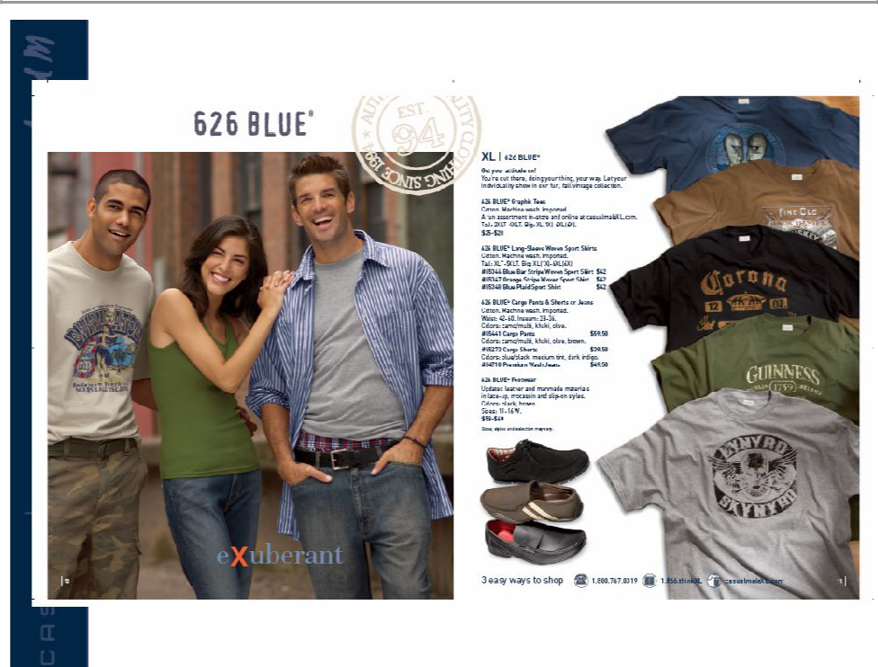

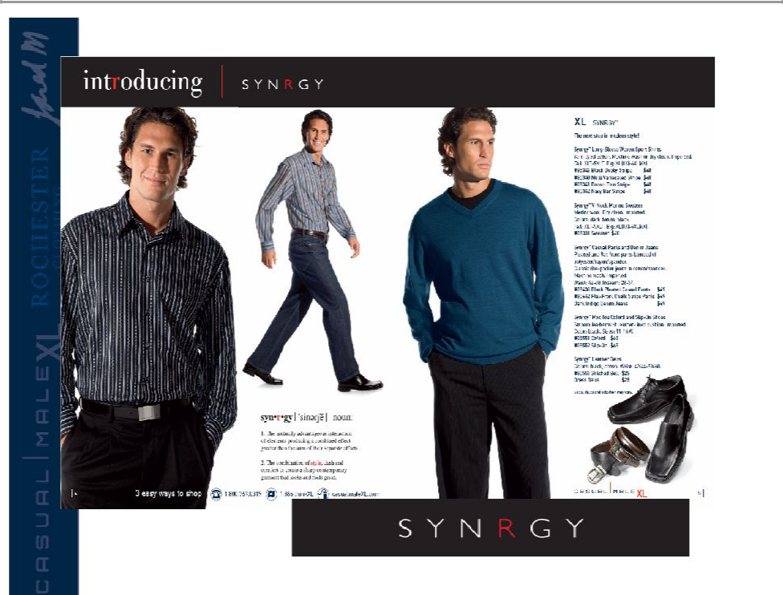

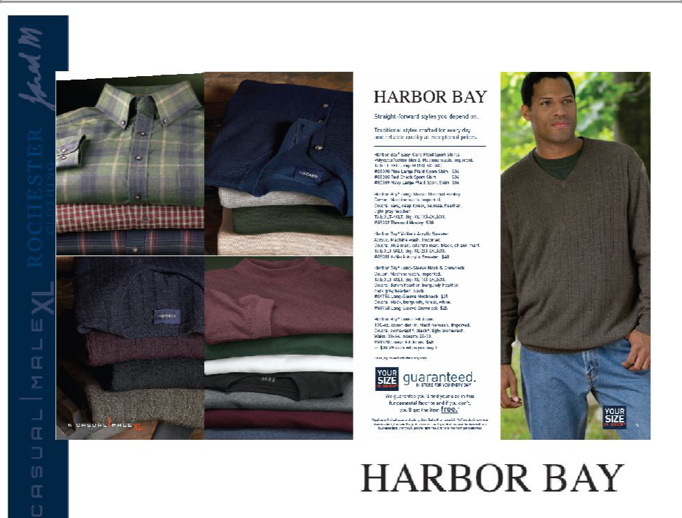

Multi Channel Shopping In-store, Catalog & Online

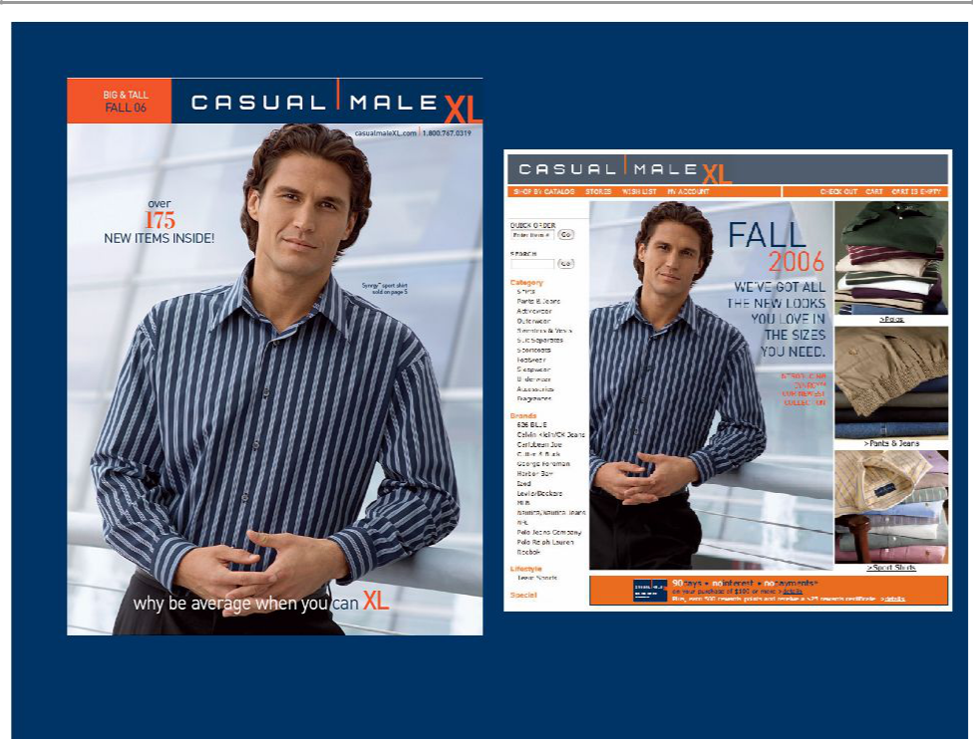

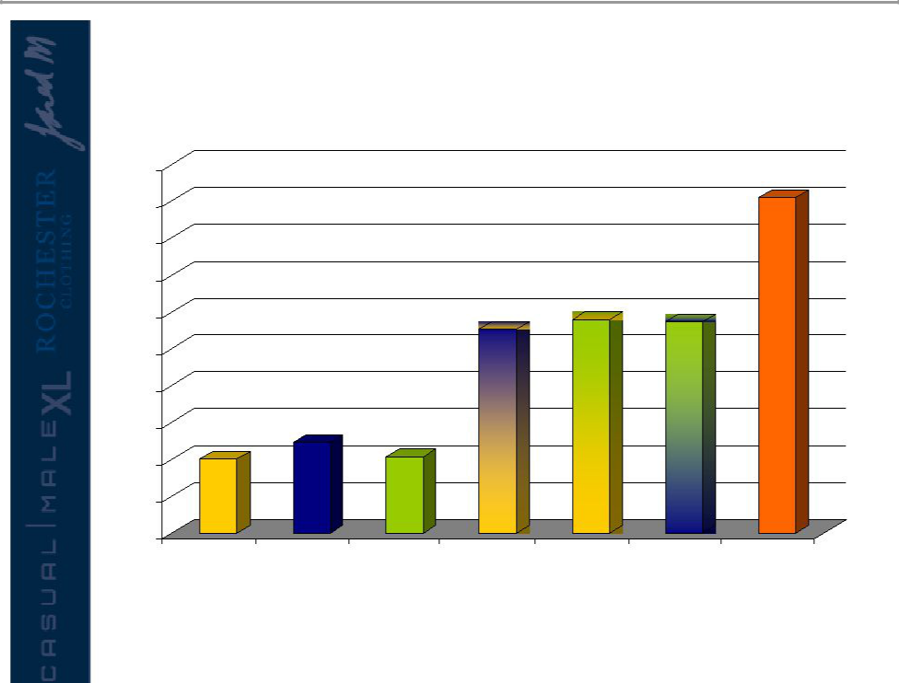
Customer Sales by Channel

500

455

450

400

350

300 |  |  | 276 | 290 | 286
250
200
150 | 123
 | 123 | 104
100 |  | 104
100
50
0
Retail only | Catalog Only | E-commerce | Retail & | Retail & E- | Catalog & E- | Retail &
 |  | Only | Catalog | commerce | commerce | Catalog & E-
 |  |  |  |  |  | commerce

* Indexed to retail only shoppers

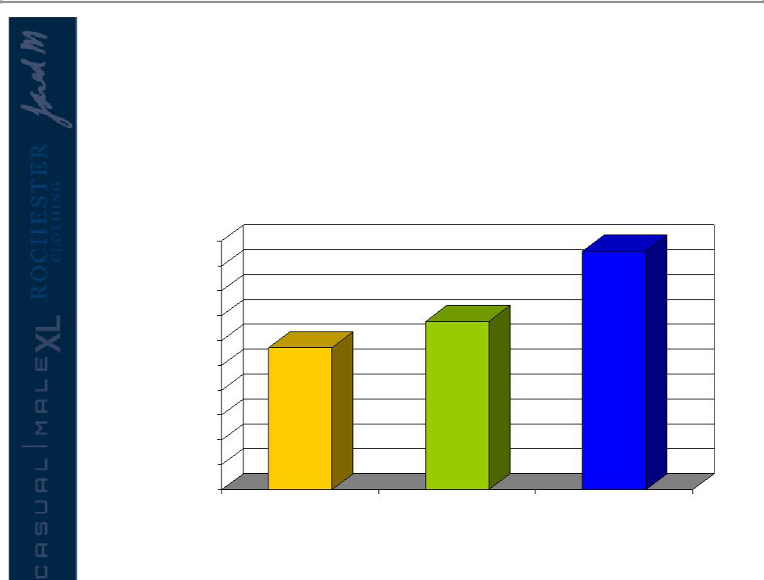
Casual Male Direct Growth

- Penetration of Casual Male’s direct business continues to grow…

$50,000,000

$45,000,000

$40,000,000

$35,000,000

$30,000,000

$25,000,000

$20,000,000

$15,000,000

$10,000,000

$5,000,000

$0

2004 2005 2006 Forecast

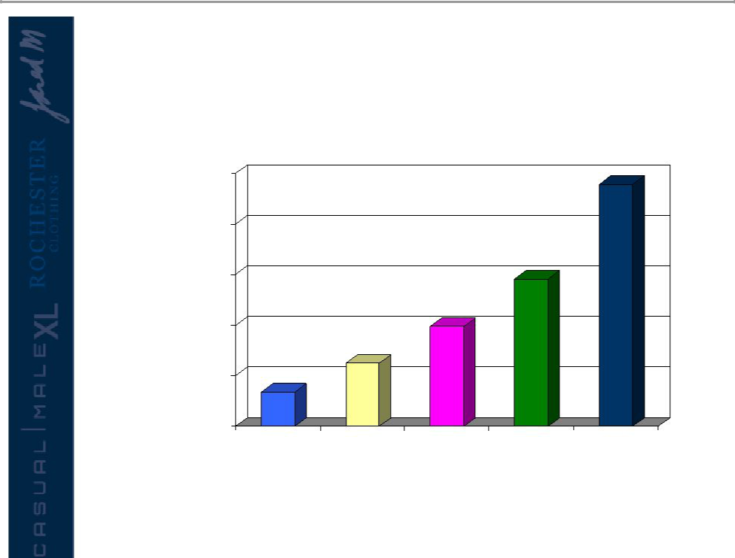
Casual Male Internet Sales by Year

$25,000,000

$20,000,000

$15,000,000

$10,000,000

$5,000,000

$0

2002 2003 2004 2005 2006 Forecast

Loyalty Program

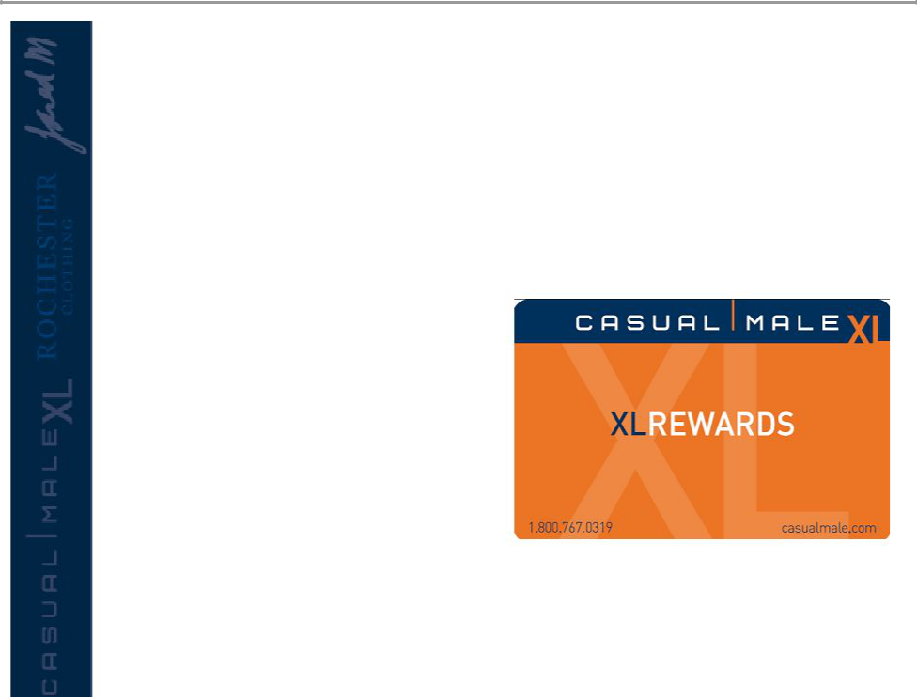
Loyalty Program Launch Mailer

• Mail date: October 15

th

/

Circulation: 1M

- Creative: 24 page mailer with wrap

- Free gift in store for top 15K customers

- Top 300K customers will be auto-enrolled and will receive loyalty card & populated application with brand mailer

- ~600K customers will receive populated customer application with brand mailer

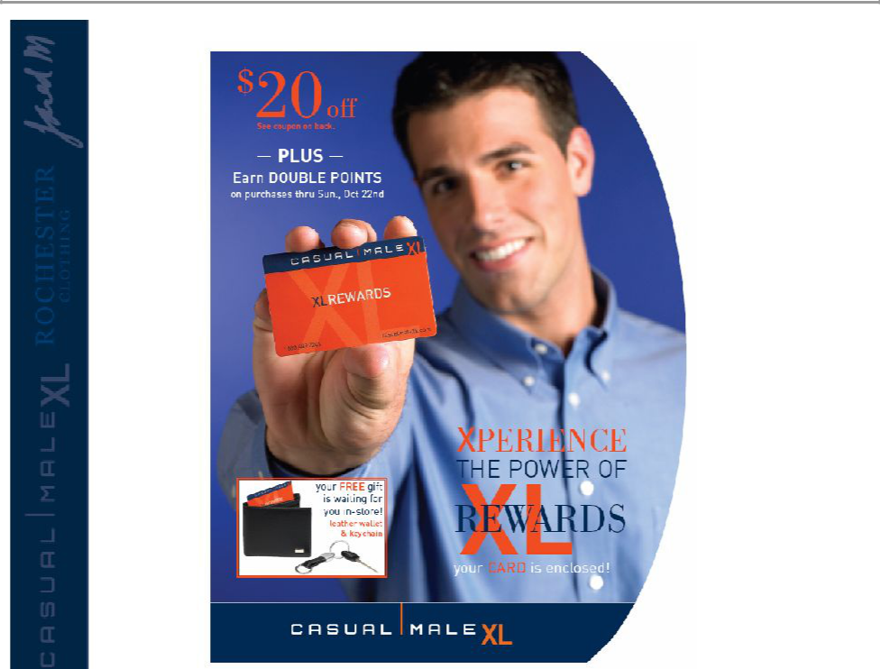

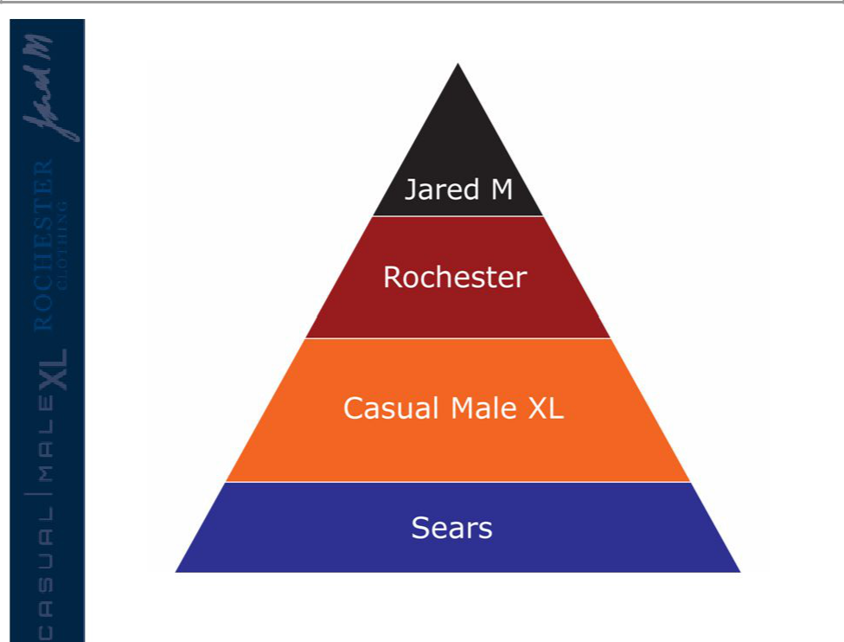

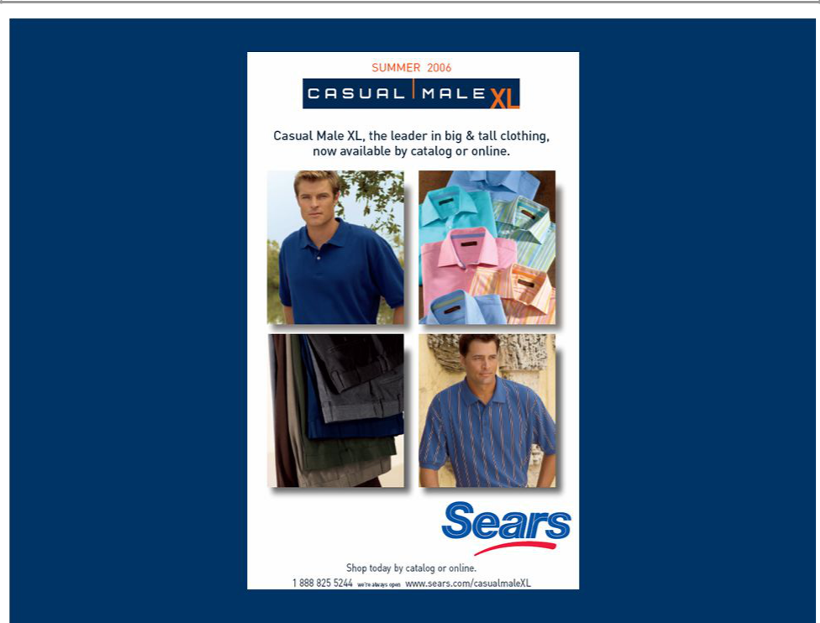

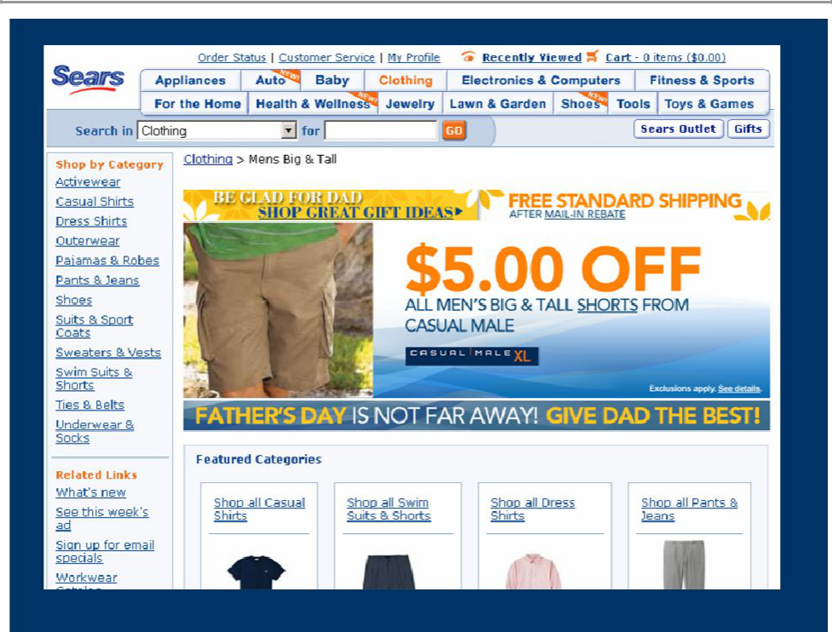

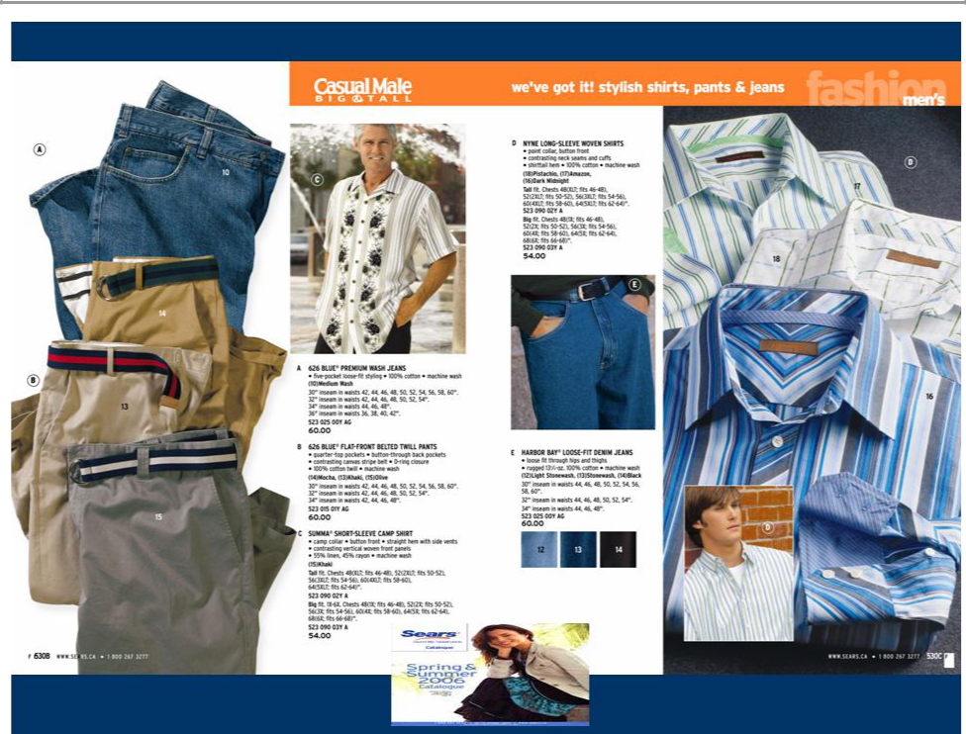

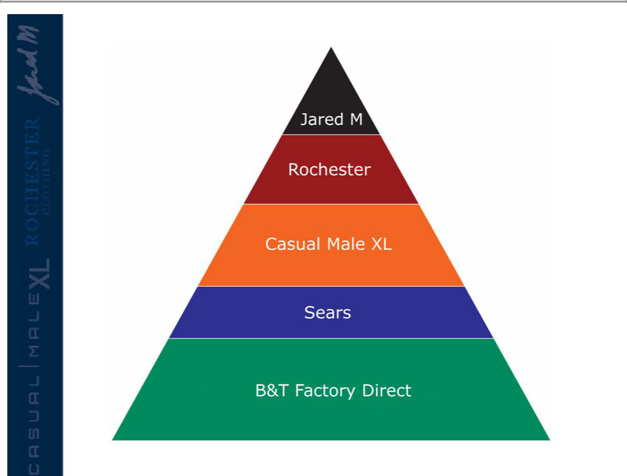

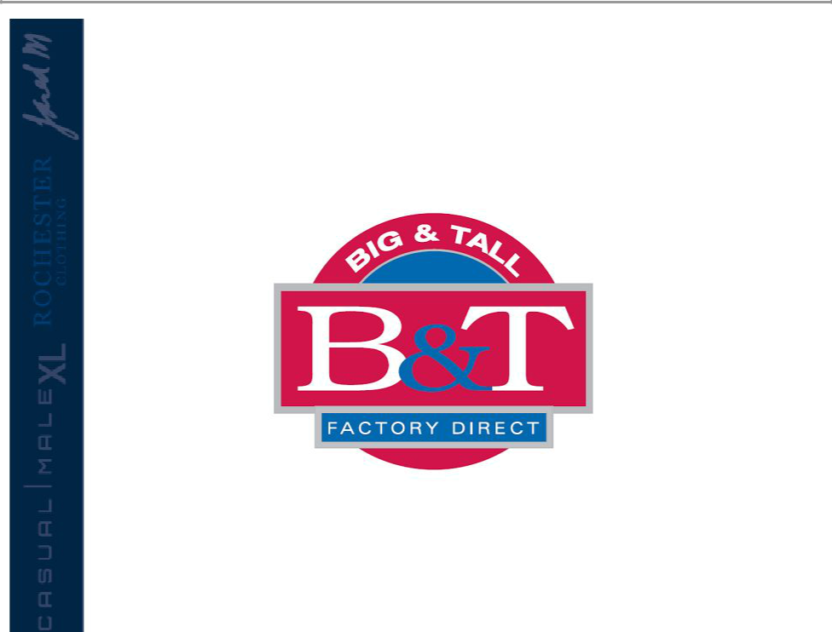


B & T Factory Direct

- Launching a new Direct venture which addresses the lower end big & tall shopper

- Strategy is to take market share from King Size, largest direct business in bit & tall

- Initial phase is web launch in mid-September with B&T Factory Direct site;www.btdirect.com

- Launch 68 page catalog in Spring ‘07

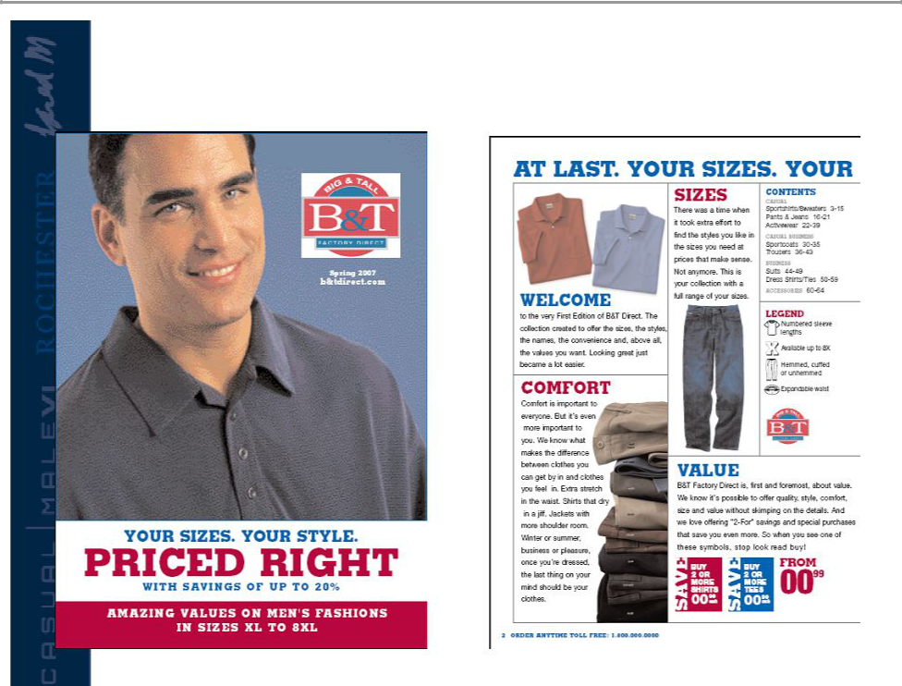
B & T Factory Direct

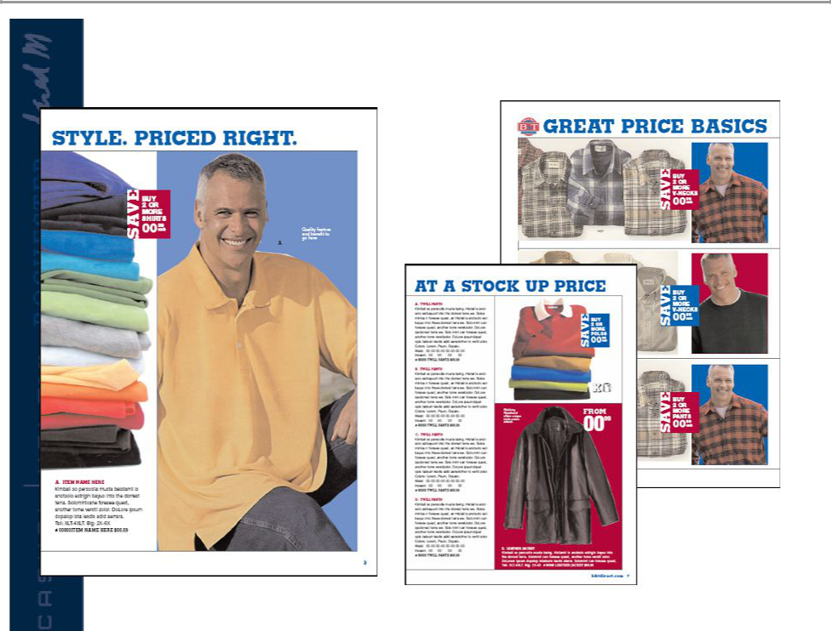
B & T Factory Direct

