UNITED STATES

SECURITIES AND EXCHANGE COMMISSION

Washington, D.C. 20549

FORM 8-K

CURRENT REPORT

PURSUANT TO SECTION 13 OR 15(d) OF THE

SECURITIES EXCHANGE ACT OF 1934

Date of Report (Date of earliest event reported): July 12, 2005

0-15898

(Commission File Number)

CASUAL MALE RETAIL GROUP, INC.

(Exact name of registrant as specified in its charter)

Delaware

04-2623104

(State of Incorporation)

(IRS Employer Identification Number)

555 Turnpike Street, Canton, Massachusetts 02021

(Address of registrant’s principal executive office)

(781) 828-9300

(Registrant’s telephone number)

Check the appropriate box below if the Form 8-K filing is intended to simultaneously satisfy the filing obligation of the registrant under any of the following provisions (see General Instruction A.2. below):

- Written communications pursuant to Rule 425 under the Securities Act (17 CFR 230.425)

- Soliciting material pursuant to Rule 14a-12 under the Exchange Act (17 CFR 240.14a-12)

- Pre-commencement communications pursuant to Rule 14d-2(b) under the Exchange Act (17 CFR 240.14d-2(b))

- Pre-commencement communications pursuant to Rule 13e-4(c) under the Exchange Act (17 CFR 240.13e-4(c))

ITEM 7.01 - Regulation FD Disclosure

On July 11, 2005, the Company issued a press release announcing that the Company is scheduled to present at the CIBC World Markets Fifth Annual Consumer Growth Conference on July 12, 2005 at 4:05 p.m., Eastern Standard Time. A copy of the press release is attached to this report as Exhibit 99.1, and is incorporated by reference herein.

Copies of the slides to be presented at the conference are attached to this report as Exhibit 99.2, and are incorporated by reference herein.

The slide presentation contained in the exhibit includes statements intended as “forward-looking statements,” which are subject to the cautionary statement about forward-looking statements set forth in the exhibit. The slide presentation is being furnished, not filed, pursuant to Regulation FD. Accordingly, the slide presentation will not be incorporated by reference into any registration statement filed by the Company under the Securities Act of 1933, as amended, unless specifically identified therein as being incorporated therein by reference. The furnishing of the slide presentation is not intended to, and does not, constitute a determination or admission by the Company that the information in the slide presentation is material or complete, or that investors should consider this information before making an investment decision with respect to the Company.

ITEM 9.01 - FINANCIAL STATEMENTS AND EXHIBITS

(c) Exhibits

Exhibit No. | Description
99.1 | Press release dated July 11, 2005
99.2 | Presentation dated July 12, 2005

SIGNATURES

Pursuant to the requirements of the Securities Exchange Act of 1934, the registrant has duly caused this report to be signed on its behalf by the undersigned, thereunto duly authorized.

CASUAL MALE RETAIL GROUP, INC.

By: | /S/ DENNIS R. HERNREICH
Name: | Dennis R. Hernreich
Title: | Executive Vice President and Chief Financial Officer

Date: July 12, 2005

Exhibit 99.1


For Information Contact:

Jeff Unger, Investor Relations

561-514-0115

Andrew Bard, Weber Shandwick

212-445-8368

Casual Male Retail Group to Present at

CIBC World Markets Fifth Annual Consumer Growth Conference

Canton, MA – July 11, 2005 – Casual Male Retail Group, Inc., (NASDAQ: CMRG) will be presenting on July 12, 2005 at the CIBC World Markets Fifth Annual Consumer Growth Conference

David Levin, President and Chief Executive Officer of Casual Male, is scheduled to present at 4:05 p.m. eastern time on Tuesday, July 12, 2005.

The presentation is expected to last approximately 30 minutes and will be broadcast live over the Internet. The live webcast links and the accompanying slide presentations will be available on the Casual Male website at www.casualmale.com/investor and will also be archived for replay.

In addition, CMRG announced today that it joined the Russell Microcap Index. The newly launched Russell Microcap Index, which debuted on July 1, 2005, is an unbiased barometer to compare performance against the genuine microcap marketplace of stocks. Russell recently posted the complete index membership list at www.russell.com/US/Indexes.

About Casual Male Retail Group, Inc.

CMRG, the largest retailer of big and tall men’s apparel with retail operations throughout the United States, London, Canada and England, operates 496 Casual Male Big & Tall stores, 13 Casual Male at Sears-Canada stores, 22 Rochester Big and Tall stores and a direct to consumer business which includes catalog and two e-commerce sites. The Company is headquartered in Canton, Massachusetts and its common stock is listed on the Nasdaq National Market under the symbol “CMRG.”

The discussion of forward-looking information requires management of Casual Male Retail Group, Inc. to make certain estimates and assumptions regarding its strategic direction and the effect of such plans on its financial results. Casual Male Retail Group, Inc.’s actual results and the implementation of its plans and operations may differ materially from forward-looking statements it made. Casual Male Retail Group, Inc. encourages readers of forward-looking information concerning the Company to refer to its prior filings with the Securities and Exchange Commission that set forth certain risks and uncertainties that may have an impact on future results and direction of Casual Male Retail Group, Inc.

# # #

Exhibit 99.2
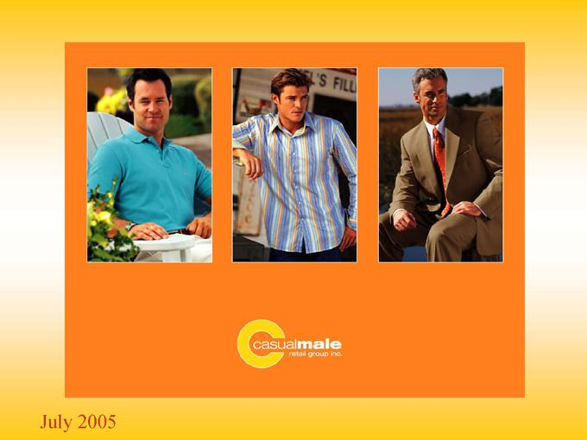

July 2005

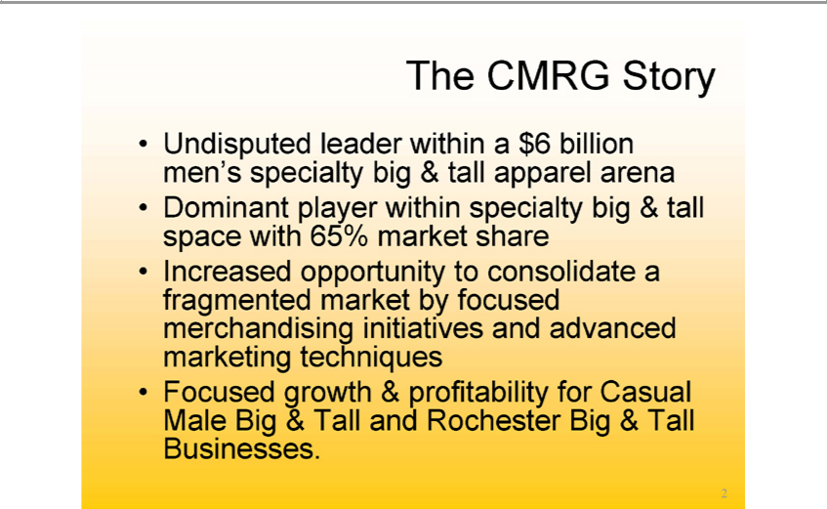

The CMRG Story
Undisputed leader within_{specialty}$6billion men’s specialty big & tall apparel arena
Dominant player within big & tall space with 65% market share
Increased opportunity to consolidate^{Casual}fragmented market by focused merchandising initiatives and advanced marketing techniques
2Focused growth & profitability for Male Big & Tall and Rochester Big & Tall Businesses.

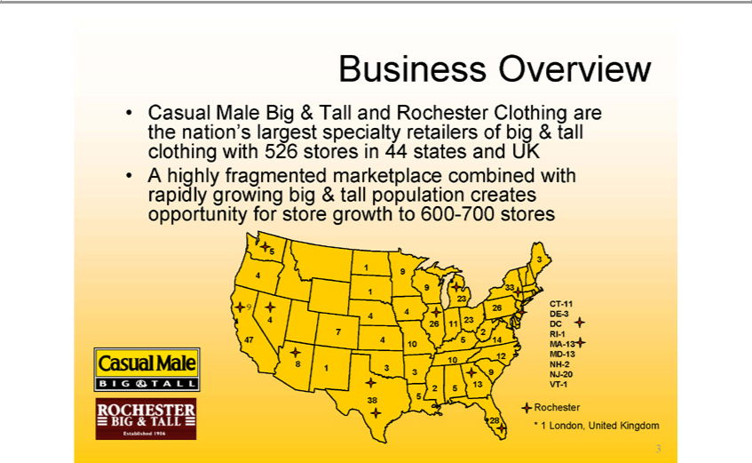

Business Overview
Casual Male Big & Tall and Rochester Clothing are the nation’s largest specialty retailers of big & tall clothing with 526 _{stores} in 44 states and UK A highly fragmented marketplace combined with rapidly growing big & tall population creates opportunity for store growth 600-700 stores

5
3 1 9 4
⁹ 33 1 23
4 23⁶ ⁴ ⁴
26 11
47²4 5 14 10 12 10 8
1 3
3 9 13
2 5 5 38
28CT-11 DE-3 DC RI-1 MA-13 MD-13 NH-2 NJ-20 VT-1
Rochester
3* 1 London, United Kingdom

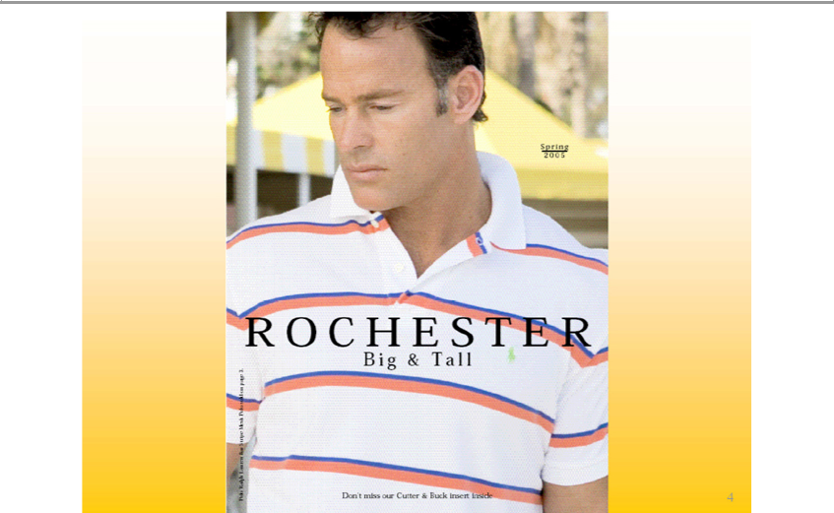

Spring
2005
BigROCHESTER&all
Don’t miss our Cutter & Buck insert inside
4Polo Ralph Lamen Pan Stripe Mesh Poloroide on Page 3.

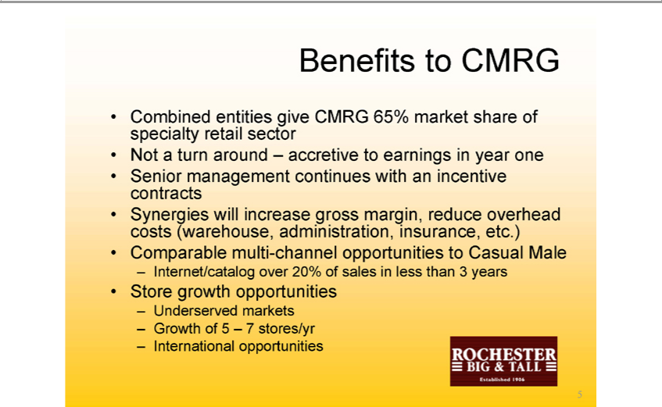

Benefits to CMRG
Combined entities give CMRG 65% market share of specialty retail sector Not a turn around – accretive to earnings in year one Senior management continues with an incentive contracts Synergies will increase gross margin, reduce overhead costs (warehouse, administration, insurance, etc.) Comparable multi-channel opportunities to Casual Male
StoreInternet/cataloggrowthopportunitiesover20%of sales in less than 3 years
5Underserved markets Growth of 5 – 7 stores/yr International opportunities

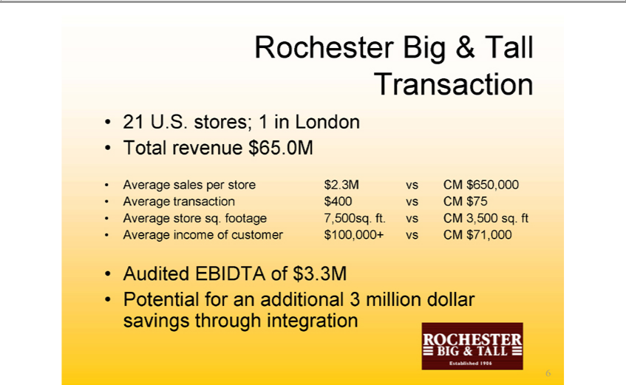

Rochester Big & Tall Transaction
21 U.S. stores;sales_{transaction}per1instoreLondon$2.3MTotalvs CMrevenue_{$650,000}.0M
$400 vs CM $75
_{Auditedverage} incomestoresq.offootagecustomer7,500sq.$100,000+ft.vs CMvsCM3,500$71,000sq.ft
EBIDTA of $3.3M
6Potential for an additional 3 million dollar savings through integration

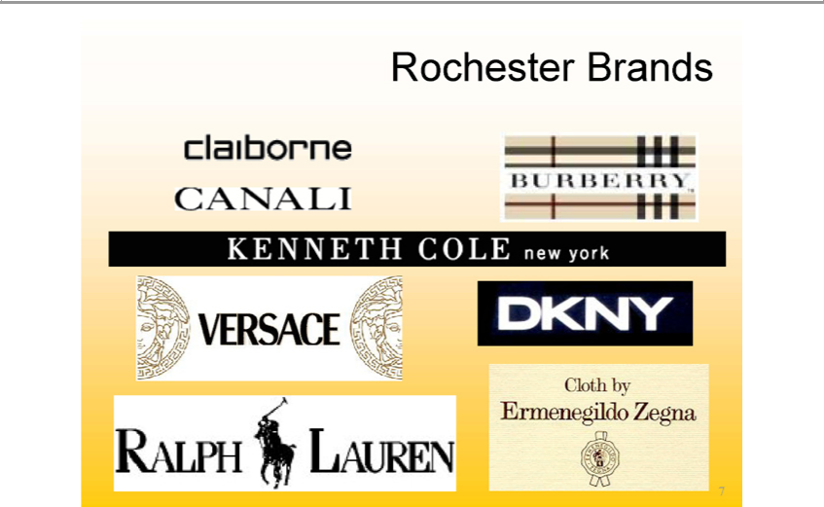

_{CANALI}Rochesterlaiborne Brands
BURBERRY
_{VERSACE}KNNETH COLE new york

DKNYRALPH LAUREN
Cloth by
7Ermenegildo Zegna

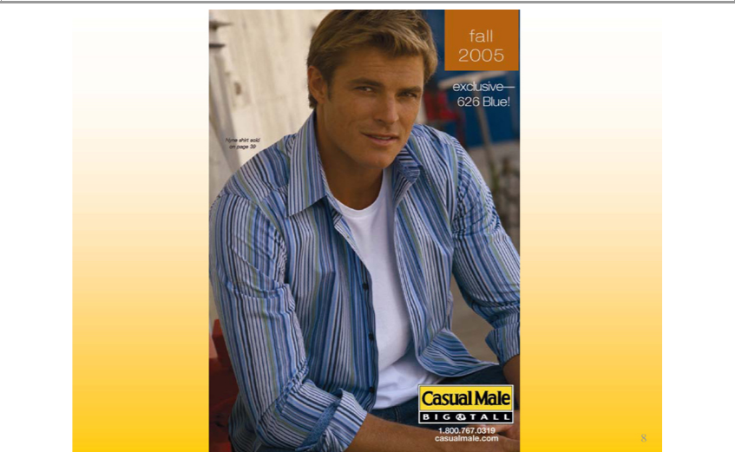

2005Fall
ExclusiveNyneshirt626onpageBlue!39
casualmale.com1.800.767.0319
8

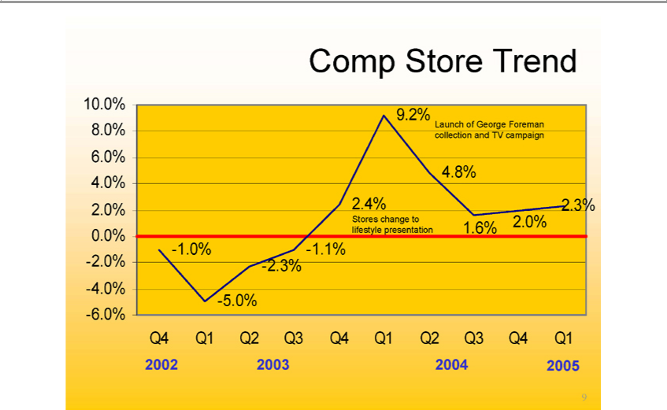

Comp Store Trend
¹⁰.0%0% 8.0% 6.0% 4.0% 2.0% 0.0% -2.0% -4.0% -6.0%
⁵
-¹².1%3%
2 4%
⁴⁹ 6%_{2%}8%
2.¹3%0%
StoresLaunchchangeofGeorgetolifestyleForemanpresentationcollection and TV campaign
Q4 Q1 Q2 Q3 Q4 Q1 Q2 Q3 Q4 Q1
²3

4
2005
9

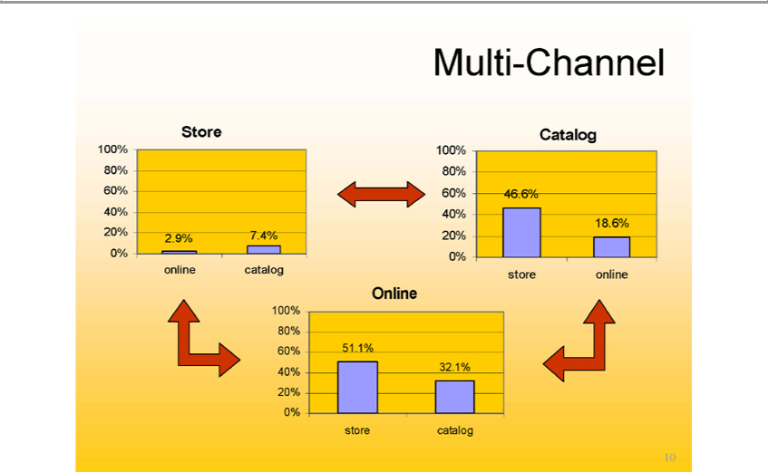

StoreMulti-Channel
100% 80% 60% 40% 20% 0%
2_{.4%}9%
Catalog7online catalog
100% 80% 60% 40% 20% 0%
⁴⁶.6%
Online18 store online
100% 80% 60% 40% 20% 0%
⁵¹.1%
32 store catalog

10

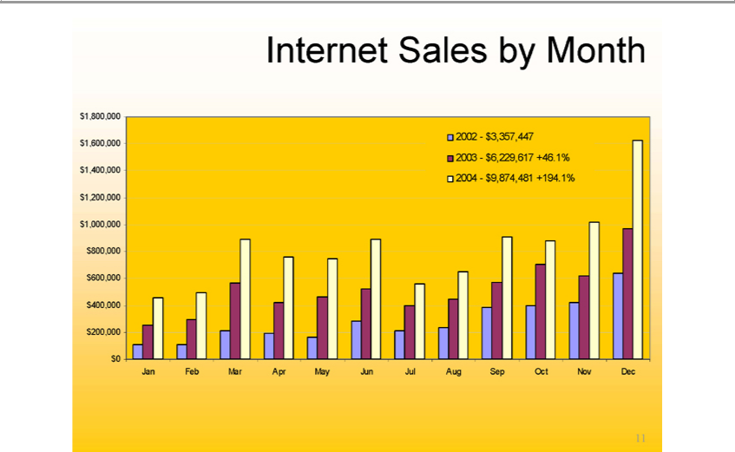

Internet Sales by Month
$1,800,000 $1,600,000 $1,400,000 $1,200,000 $1,000,000 $800,000 $600,000 $400,000 $200,000 $0 Jan Feb Mar Apr May Jun Jul Aug Sep Oct Nov Dec

112002—$3,357,447 2003—$6,229,617 +46.1% 2004—$9,874,481 +194.1%

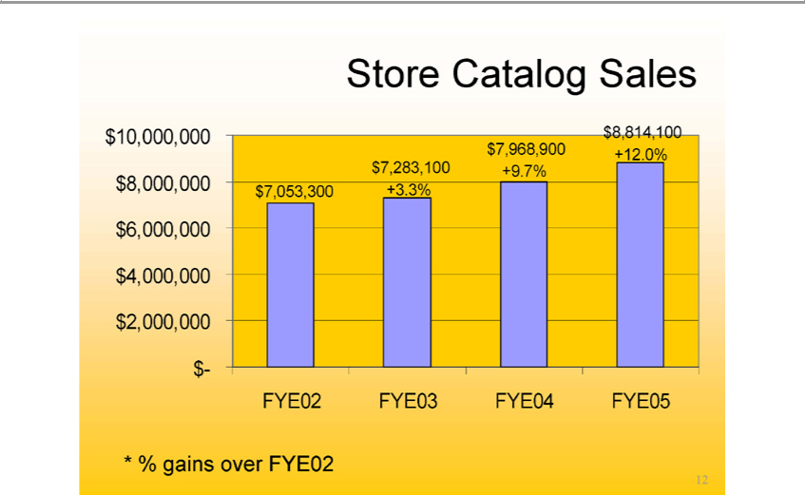

Store Catalog Sales $10,000,000 $8,000,000 $6,000,000 $4,000,000 $2,000,000 $- $7,053,300 $7,283,100 +3.3% $7,968,900 +9.7% $8,814,100 +12.0%
42₃
FYE05
12*% gains over FYE02

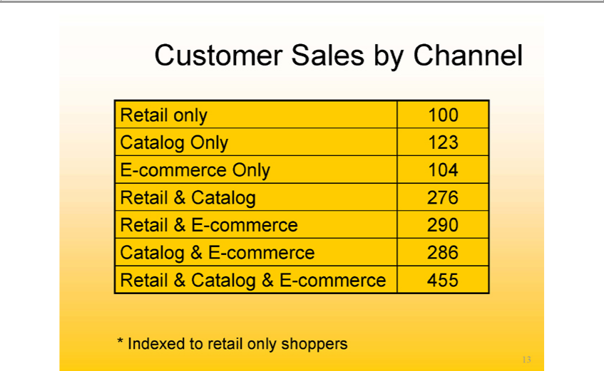

Customer Sales by Channel
Re | il only 100
Catalog Only 123
E-commerce Only 104
Re | Catalog 276 | 290
Re | il & E-
Ca | log & Ecommerce- |  | 286
Retail & Catalog & E-commerce 455

13*Indexed to retail only shoppers

summer 2005
polo ralph lauren nautioa jeans co.cutter & buck reebock izod levis dockers george foreman polo jeans co. nautica 14

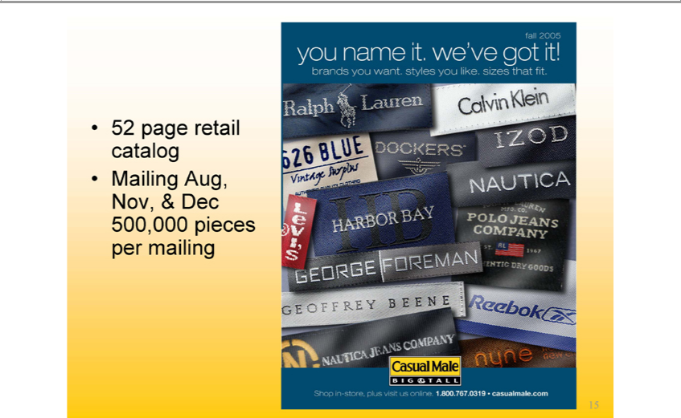

Fall 2005
You name it. we’ve got it
brands you want. styles one you like. sizes that fit
1552 page retail catalog Mailing Aug, Nov, & Dec 500,000 pieces per mailing

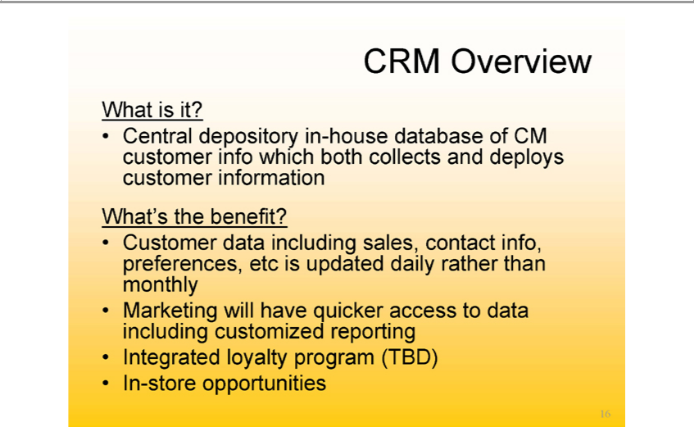

WhatCRM isOverviewit?
Central depository in-house database of CM customer info which both collects and deploys customer information _{Customer}What’the benefit?
data including sales, contact info, preferences, etc is updated daily rather than monthly Marketing will have quicker access to data including customized reporting
^{In}tegrated loyalty program (TBD)
₁₆-store opportunities

_{Customer}In-reOpportunities
lookup- will be able to view a customer’s detailed purchase history and transactional data by channel Attributes- will be able to view customer provided information: size, favorite color, brand, sports team, etc. Triggers- reminders on POS screen based on attributes. Example include:
$ threshold—$25.00 or $50.00 away from getting the 5% disc. loyalty award brand promotion reminder – customer’s favorite brand, Polo Ralph Lauren is on sale Handheld device- can perform customer lookup and view customer attribute with mobility around store
17

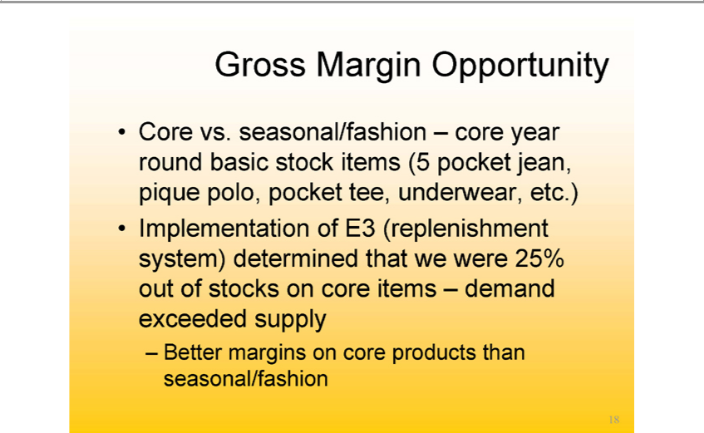

Gross Margin Opportunity
Core vs. seasonal/fashion – core year round basic stock items (5 pocket jean, pique polo, pocket tee, underwear, etc.)
BetterImplementationmarginsonofcoreE3(replenishmentproductsthan seasonal/fashionsystem)determined that we were 25% out of stocks on core items – demand exceeded supply

18

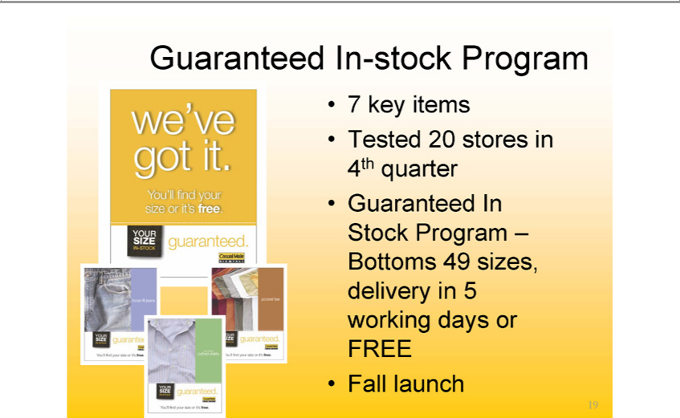

7Guaranteedkeyitems In-stock Program
Tested 20 stores in 4th quarter
FallGuaranteedlaunch In Stock Program –Bottoms 49 sizes, delivery in 5 working days or FREE
19We’ve got it. You’ll find your size or it’s free.

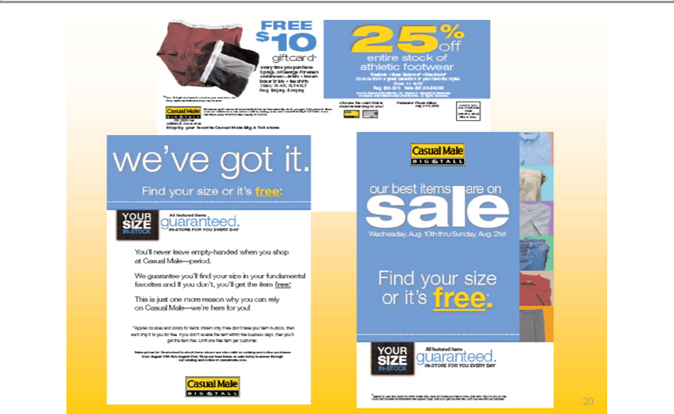

FREE$10
25%giftcardoff
athleticentirestockfo^{Now}twearof
Reebok Babree Slechers
SdelChoose11-from18Wa greet and action of your favourite styles.
we’veReg.$eogot-$joit. Sale $37 50-$52.50
Find your size or it’s free:
YOUR SIZE IN-STOCK
guaranteed.Allfeatured items
IN-STORE FOR YOU EVERY DAY
You’ll never leave empty-handed when you shop at Casual Male—period.
ThisWeguaranteeisjust_{to}oneyou’llmorefindreas_{colors}yournwhysizeyouin yourcanrelyfundamental_{only}CasualfavoritesMale—we’reandIfforyouyou!don’t you’ll get the item free:
* Applies sizes and for items shown . If we don’t have your item in stock, then we’ll shop it to you for free. If you don’t receive the item within the business days, then you’ll get the item free. Limit one free item per customer.
YOUR SIZE IN-STOCK
guaranteed.Allfeatured items
IN-STORE FOR YOU EVERY DAY
Findourbestyouritemssize areorit’son free.sale Wednesday , Aug. 10th thru Sunday, Aug. 21st

20

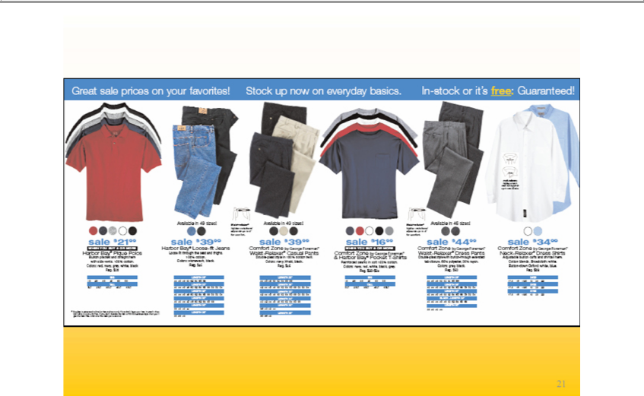

Great sale prices on your favourites!
InStock–stockup noworit’sonfree:everyday basics.
Guaranteed!
21
39
sale 16⁴⁴34
21

Customer Lifestyles
CoolJoeJockJay AgeAge 1818--5035 FunctionalUrban Active
Laid Back Kyle Age 18-35 Contemporary
Mainstream Mike Age 30-50 Traditional

ProfessorNewman AgePaul50+AgeOlder45+DressTraditional&Designer

22Gift Giver Age 25+ All Classifications

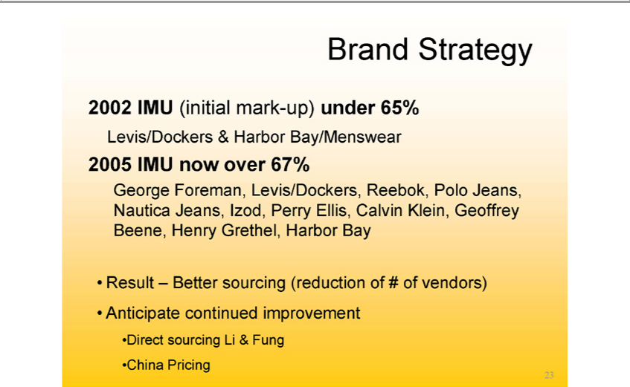

Brand Strategy
2002 IMU (initial mark-up) under 65%
2005Levis/DockersIMUnow&overHarbor67%Bay/Menswear

George Foreman, Levis/Dockers, Reebok, Polo Jeans, Nautica Jeans, Izod, Perry Ellis, Calvin Klein, Geoffrey Beene, Henry Grethel, Harbor Bay Result – Better sourcing (reduction of # of vendors) Anticipate continued improvement
ChinaDirect Pricingsourcing Li & Fung
23

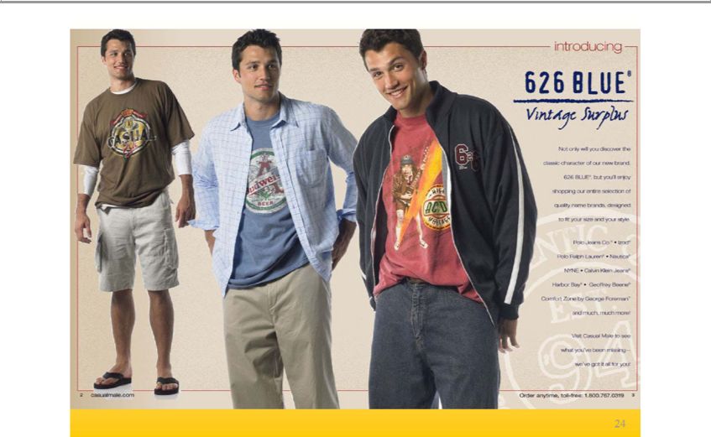

Introducing
Not only will you discover the classic character of our new brand.
_{Polo}626BLUE,JeansCo.but Izodyou’ll enjoy shopping our entire selection of quality name brands, designed to fit your size and your style.
Ralph Lauren Nautica
HarborNYNE CalvinBayGeoffreykleinJeansBeene
andComfortmuch,Zonemuchbymore!George Foreman
Visit_{Casualmale}Male to see what you’ve been missing – we’ve got it all for you!
2. .com
24Order anytime, toll-free: 1.800.767.0319

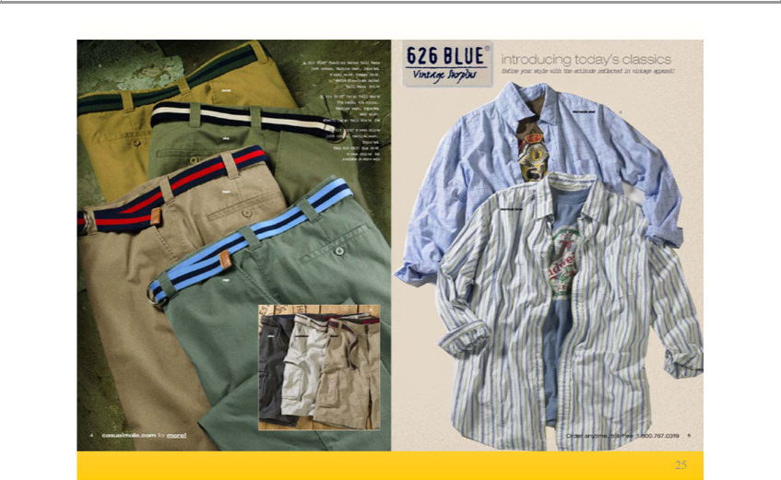

Introducing today’s classics
4.Definecasualmale.comyourstylewith the attitude reflected on vintage apparel!
25Order anytime, toll-free: 1.800.767.0319

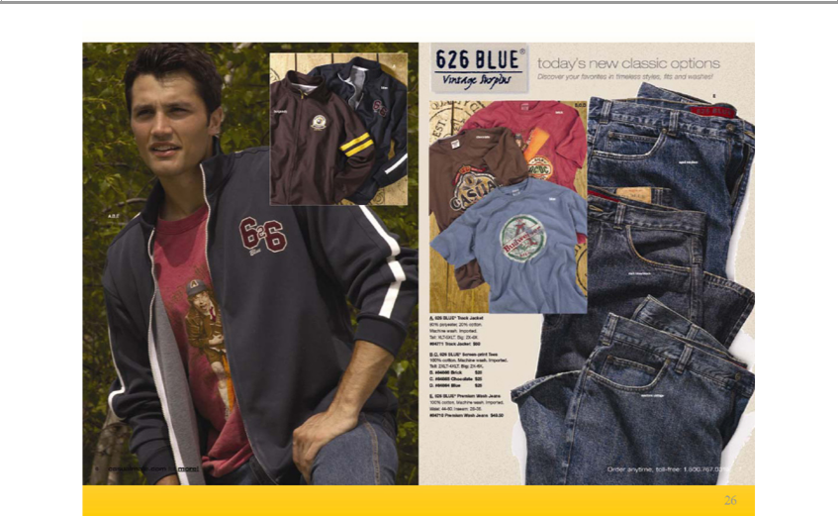

_{Discover}today’new classic options

6. casualmale.comyourfavoritestomore!intimeless styles, fits and washes!
26Order anytime, toll-free: 1.800.767.0319

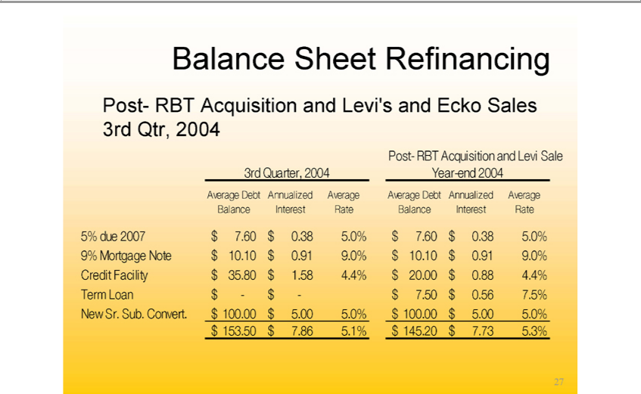

Balance Sheet Refinancing
’s and Ecko Sales 3rd Qtr, 2004
3rdPostQuarter,-RBTAcquisition2004Year-andend Levi2004^{Sale}
Average Debt Balance Annualized Interest Average Rate Average Debt Annualized Average Balance Interest Rate
^{9%}
5% Mortgagedue2007 $Note7.60 $$10.100.385.0%$0.91$7.609.0%$$0.3810.105.0%$0.91 9.0%
^{$1}
TermCreditLoanFacility$-$$-35.80$7.50 ^{$100}.58.564.4%7.5%$20.00 $0.88 4.4%
New Sr. Sub. Convert. .00 $5.00 5.0% $100.00 $5.00 5.0%
27$153.50 $7.86 5.1% $145.20 $7.73 5.3%

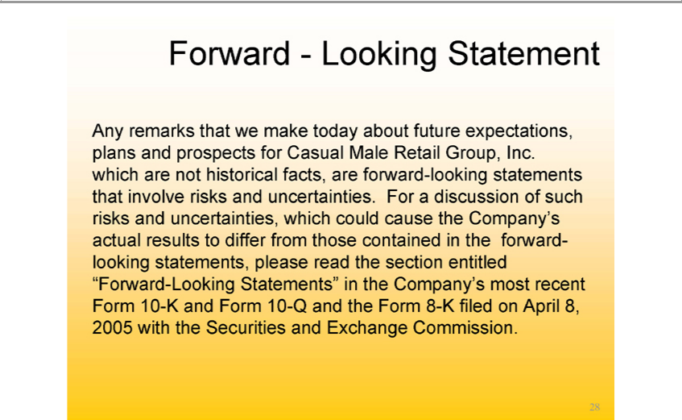

Forward - Looking Statement
Any remarks that we make today about future expectations, plans and prospects for Casual Male Retail Group, Inc. which are not historical facts, are forward-looking statements that involve risks and uncertainties. For a discussion of such risks and _{uncertainties,} which could cause the Company’s actual results to differ from those contained in the forward-looking statements, please read the section entitled “Forward-Looking Statements” in the Company’ most recent Form 10-K and Form 10-Q and the Form 8-K filed on April 8, 2005 with the Securities and Exchange Commission.
28

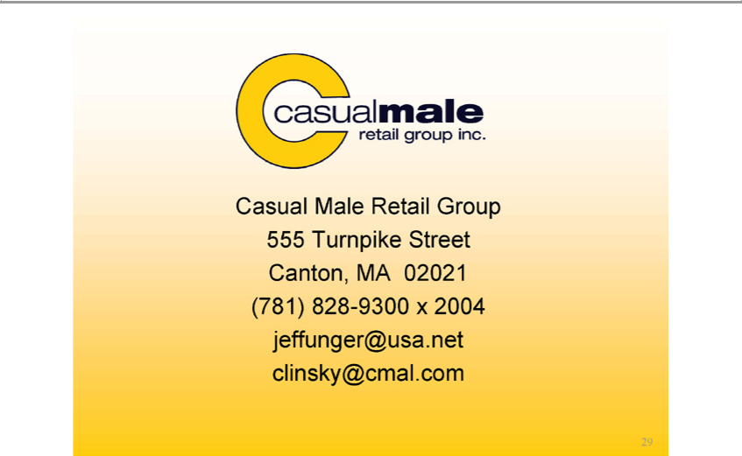

Casual Male Retail Group 555 Turnpike Street Canton, MA 02021 (781) 828-9300 x 2004 jeffunger@usa.net clinsky@cmal.com 29

