UNITED STATES

SECURITIES AND EXCHANGE COMMISSION
Washington, D.C. 20549

SCHEDULE TO

Tender Offer Statement Under Section 14(d)(1) or 13(e)(1)

of the Securities Exchange Act of 1934

Destination XL Group, Inc.

(Name of Subject Company)

Zodiac Partners II, LLC

(Name of Filing Person (Offeror))

Camac Fund, LP

(Name of Filing Person (Parent of Offeror))

Common Stock, par value $0.01 per share

(Title of Class of Securities)

25065K104

(CUSIP Number of Class of Securities)

Craig Rosmarin

Chief Financial Officer

1601-1 N Main St #3159, SMB#92283, Jacksonville, FL 32206

(917) 692-1844

(Name, Address and Telephone Number of Person Authorized to Receive Notices and Communications on

Behalf of Filing Persons)

Copies to:

Donald R. Reynolds

Wyrick Robbins Yates & Ponton LLP

4101 Lake Boone Trail, Suite 300

Raleigh, NC 27607

(919) 781-4000

☐ Check the box if the filing relates solely to preliminary communications made before the commencement of a tender offer.

Check the appropriate boxes below to designate any transactions to which the statement relates:

- third-party tender offer subject to Rule 14d-1.

- issuer tender offer subject to Rule 13e-4.

- going-private transaction subject to Rule 13e-3.

- amendment to Schedule 13D under Rule 13d-2.

Check the following box if the filing is a final amendment reporting the results of the tender offer. ☐

If applicable, check the appropriate box(es) below to designate the appropriate rule provision(s) relied upon:

- Rule 13e-4(i) (Cross-Border Issuer Tender Offer)

- Rule 14d-1(d) (Cross-Border Third-Party Tender Offer)

This Tender Offer Statement on Schedule TO (this “Schedule TO”) is filed by Camac Fund, LP, a Delaware limited partnership (“Camac Fund”), and Zodiac Partners II, LLC, a Delaware limited liability company (the “Purchaser”, “Zodiac Partners II, LLC”) and an acquisition entity of Camac Fund. This Schedule TO relates to the offer by the Purchaser to purchase all outstanding shares of common stock, par value $0.01 per share (the “Shares”), of Destination XL Group, Inc., a Delaware corporation (“DXL”), at $0.82 per Share, to the seller in cash, without interest and less any required withholding taxes, upon the terms and subject to the conditions set forth in the Offer to Purchase, dated May 12, 2026 (the “Offer to Purchase”), and in the accompanying Letter of Transmittal, copies of which are attached hereto as Exhibits (a)(1)(A) and (a)(1)(B), respectively, which, together with any amendments or supplements thereto, collectively constitute the “Offer”.

Item 1. Summary Term Sheet.

The information set forth in the Offer to Purchase under the caption SUMMARY TERM SHEET is incorporated herein by reference.

Item 2. Subject Company Information.

- The name, address, and telephone number of the subject company’s principal executive offices are as follows:

Destination XL Group, Inc.

555 Turnpike Street Canton, MA 02021

- This Schedule TO relates to the Offer by the Purchaser to purchase all of the issued and outstanding Shares. According to DXL’s Annual Report on Form 10-K filed with the Securities and Exchange Commission on March 19, 2026 (the “DXL FY2025 Form 10-K”), as of March 9, 2026 there were 54,810,511 Shares issued and outstanding, and based on the Purchaser’s review of the DXL FY2025 Form 10-K, we believe as of January 31, 2026, there were approximately 44,000 stock options to purchase Shares, and 1,259,000 restricted stock units outstanding.

- The information set forth under the caption THE OFFER - Section 6 (“Price Range of Shares; Dividends”) and Section 11 (“Background of the Offer”) of the Offer to Purchase is incorporated herein by reference.

Item 3. Identity and Background of Filing Person.

(a)-(c) The filing companies of this Schedule TO are (i) Camac Fund LP, and (ii) the Purchaser, Zodiac Partners II, LLC. The information set forth in the Offer to Purchase under the following captions is incorporated herein by reference:

SUMMARY TERM SHEET

THE OFFER - Section 9 (“Certain Information Concerning the Purchaser, Zodiac Partners II, LLC, and Camac Fund, LP”) and Schedule I attached thereto.

Item 4. Terms of the Transaction.

(a)(1)(i)-(viii), (x), (xii), (a)(2) The information set forth in the Offer to Purchase is incorporated herein by reference.

Subsections (a)(1)(ix) and (xi) are not applicable.

Item 5. Past Contacts, Transactions, Negotiations and Agreements.

(a), (b) The information set forth in the Offer to Purchase under the following captions is incorporated herein by reference:

SUMMARY TERM SHEET

INTRODUCTION

THE OFFER - Section 9 (“Certain Information Concerning the Purchaser, Zodiac Partners II, LLC, and Camac Fund, LP”) and Schedule I attached thereto THE OFFER - Section 10 (“Source and Amount of Funds”) and Schedule I attached thereto THE OFFER - Section 11 (“Background of the Offer”)

THE OFFER - Section 12 (“Purpose of the Offer and the Proposed Merger; Plans for DXL; Statutory Requirements; Approval of the Proposed Merger”)

Item 6. Purposes of the Transaction and Plans or Proposals.

- The information set forth in the Offer to Purchase under the following captions is incorporated herein by reference:

SUMMARY TERM SHEET INTRODUCTION
THE OFFER - Section 12 (“Purpose of the Offer and the Proposed Merger; Plans for DXL; Statutory Requirements; Approval of the Proposed Merger”)

- (1)-(7) The information set forth in the Offer to Purchase under the following captions is incorporated herein by reference:

SUMMARY TERM SHEET INTRODUCTION

THE OFFER - Section 7 (“Possible Effects of the Offer on the Market for the Shares; Stock Exchange Listing; Registration Under the Exchange Act; Margin Regulations”)

THE OFFER - Section 11 (“Background of the Offer”)

THE OFFER - Section 13 (“Dividends and Distributions”)

Item 7. Source and Amount of Funds or Other Consideration.

(a), (b), (d) The information set forth in the Offer to Purchase under the following captions is incorporated herein by reference:

SUMMARY TERM SHEET

THE OFFER - Section 10 (“Source and Amount of Funds”)

THE OFFER - Section 17 (“Fees and Expenses”)

Item 8. Interest in Securities of the Subject Company.

(a), (b) The information set forth in the Offer to Purchase under the following captions is incorporated herein by reference:

THE OFFER - Section 9 (“Certain Information Concerning the Purchaser, Zodiac Partners II, LLC, and Camac Fund, LP”) and Schedule I attached thereto THE OFFER - Section 11 (“Background of the Offer”)

Item 9. Persons/Assets, Retained, Employed, Compensated or Used.

- The information set forth in the Offer to Purchase under the following captions is incorporated herein by reference:

SUMMARY TERM SHEET

THE OFFER - Section 2 (“Acceptance for Payment and Payment for Shares”) THE OFFER - Section 3 (“Procedure for Tendering Shares”)
THE OFFER - Section 11 (“Background of the Offer”) THE OFFER - Section 17 (“Fees and Expenses”)

Item 10. Financial Statements.

- Not applicable.

- Not applicable.

Item 11. Additional Information.

- The information set forth in the Offer to Purchase under the following captions is incorporated herein by reference:

SUMMARY TERM SHEET

THE OFFER - Section 7 (“Possible Effects of the Offer on the Market for the Shares; Stock Exchange Listing; Registration Under the Exchange Act; Margin Regulations”)

THE OFFER - Section 11 (“Background of the Offer”)

THE OFFER - Section 12 (“Purpose of the Offer and the Proposed Merger; Plans for DXL; Statutory Requirements; Approval of the Proposed Merger”)

THE OFFER - Section 14 (“Conditions of the Offer”)

THE OFFER - Section 15 (“Certain Legal Matters; Regulatory Approvals; Appraisal Rights”)

- The information set forth in the Offer to Purchase and the Letter of Transmittal is incorporated herein by reference.

Item 12. Exhibits.

Exhibit |  |  |  |  |  | Description
 | (a)(1)(A) |  | Offer to Purchase, dated May 12, 2026.
 | (a)(1)(B) |  | Form of Letter of Transmittal.
 | (a)(5)(A) |  | Press Release Issued by Zodiac Partners II, LLC on May 12, 2026.
- Equity Commitment Letter between Zodiac Partners II, LLC and Camac Fund LP, dated May 11, 2026.

- Indicative $75 million Revolving Credit Facility Term Sheet (Pricing Redacted) issued by Eclipse Business Capital.
- Filing Fee Exhibit.

* Filed herewith.

Item 13. Information Required by Schedule 13E-3.

Not applicable.

SIGNATURE

After due inquiry and to the best of my knowledge and belief, I certify that the information set forth in this statement is true, complete and correct.

Dated: May 12, 2026

Zodiac Partners II, LLC

By: /s/ Ziggy Gokea

Name: Ziggy Gokea

Title: Managing Member

Camac Fund, LP

By: /s/ Eric Shahinian

Name: Eric Shahinian

Title: Manager of GP

Exhibit (a)(1)(A)

Offer to Purchase for Cash

All Outstanding Shares of Common Stock

of

Destination XL Group, Inc.

at

$0.82 Per Share

by

Zodiac Partners II, LLC,

An Acquisition Entity of

Camac Fund LP

THE OFFER AND WITHDRAWAL RIGHTS EXPIRE AT 5:00 PM, EASTERN TIME (ET), AT THE END OF JUNE 19th, 2026, UNLESS THE OFFER IS EXTENDED.

Zodiac Partners II, LLC, a Delaware limited liability company (the “Purchaser”) and an acquisition entity of Camac Fund, LP, a Delaware Limited Partnership (“Camac Fund”), is offering to purchase all outstanding shares of common stock, par value $0.01 per share (the “Shares”), of Destination XL Group, Inc., a Delaware corporation (“DXL”), at a price of $0.82 per share, to the seller in cash, without interest and less any required withholding taxes, upon the terms and subject to the conditions set forth in this Offer to Purchase and the accompanying letter of transmittal (the “Letter of Transmittal”), which, together with any amendments or supplements thereto, collectively constitute the “Offer”.

THE OFFER IS SUBJECT TO THE CONDITIONS SET FORTH IN THE SECTION OF THIS OFFER TO PURCHASE TITLED “THE OFFER—SECTION 14—CONDITIONS OF THE OFFER”. These include, among other things, the Minimum Tender Condition, the Board Approval Condition, the Regulatory Approvals Condition, the Material Adverse Effect Condition and the No Injunction Condition each as defined and set forth in the section of the Offer to Purchase titled “The Offer—Section 14—Conditions of the Offer” beginning on page 20.

Consummation of the Offer is subject to a financing condition.

Since late 2025, the Purchaser and its affiliates have made numerous attempts to engage constructively with DXL to reach a potential negotiated transaction that would enhance value for DXL stockholders. The Purchaser submitted a written proposal to acquire DXL for $1.25 per share in cash on January 9, 2026, which proposal represented a 36% premium over DXL’s share price as of the last trading day prior to Purchaser’s submission of the written proposal. While financial advisors for DXL spoke to a representative of the Purchaser on January 10, since Purchaser’s initial outreach in January 2026, Purchaser’s attempts at constructive engagement have been rebuffed. Despite Purchaser’s various attempts, DXL has not provided for a discussion or access to information with respect to its business, despite Purchaser’s willingness to sign a confidentiality agreement and comply with the terms of DXL’s Agreement and Plan of Merger with FBB Holdings I, Inc. (the “FBB Merger Agreement”). As a result, Purchaser felt it had no alternative to making this offer directly to the DXL stockholders without the benefit of due diligence to support a higher purchase price.

Subject to applicable law, Purchaser reserves the right to terminate the Offer, if the conditions to the Offer have not been satisfied, or amend the Offer in any respect (including amending the number of Shares to be purchased, the offer price and the consideration to be offered in a merger, including the second step merger with DXL pursuant to Section 251(h) of the General Corporation Law of the State of Delaware).

This transaction has not been approved or disapproved by the Securities and Exchange Commission (“SEC”) or any state securities commission, nor has the SEC or any state securities commission passed upon the fairness or merits of this transaction or upon the accuracy or adequacy of the information contained in this document. Any representation to the contrary is a criminal offense.

This Offer to Purchase and the related Letter of Transmittal contain important information, and you should carefully read both in their entirety before making a decision with respect to the Offer.

IMPORTANT

Any stockholder of DXL who desires to tender all or a portion of such stockholder’s Shares in the Offer should either (i) complete and manually sign the accompanying Letter of Transmittal or a facsimile thereof in accordance with the instructions in the Letter of Transmittal, and mail or deliver the Letter of Transmittal together with the certificates representing tendered Shares and all other required documents to Odyssey Transfer and Trust Company, the depositary for the Offer (the “Depositary”), or tender such Shares pursuant to the procedure for book-entry transfer set forth in “The Offer—Section 3—Procedure for Tendering Shares” or (ii) request that such stockholder’s broker, dealer, commercial bank, trust company or other nominee effect the transaction for such stockholder. Stockholders whose Shares are registered in the name of a broker, dealer, commercial bank, trust company or other nominee must contact such person if they desire to tender their Shares.

Any stockholder who desires to tender Shares and whose certificates representing such Shares are not immediately available or who cannot deliver such certificates and all other required documents to the Depositary on or prior to the expiration of the Offer, or who cannot comply with the procedures for book-entry transfer on a timely basis, may tender such Shares pursuant to the guaranteed delivery procedure set forth in “The Offer—Section 3—Procedure for Tendering Shares.”

Questions and requests for assistance may be directed to the Information Agent at the address or telephone numbers set forth on the back cover of this Offer to Purchase. Requests for copies of this Offer to Purchase, the related Letter of Transmittal, the Notice of Guaranteed Delivery and all other related materials may be directed to the Information Agent or brokers, dealers, commercial banks and trust companies, and copies will be furnished promptly at the Purchaser’s expense. Additionally, this Offer to Purchase, the related Letter of Transmittal and other materials relating to the Offer may be found at http://www.sec.gov.

This Offer to Purchase refers to a possible proxy solicitation. This Offer to Purchase is not intended to and does not constitute (i) a solicitation of a proxy, consent or authorization for or with respect to DXL’s annual meeting or any special meeting of DXL’s stockholders or (ii) a solicitation of a consent or authorization in the absence of any such meeting. Any such solicitation which Zodiac Partners II, LLC or Camac Fund may make will be made only pursuant to proxy or consent solicitation materials complying with all applicable requirements of Section 14(a) of the Securities Exchange Act of 1934, as amended, and the rules and regulations promulgated thereunder.

TABLE OF CONTENTS
 | SUMMARY TERM SHEET |  | 1
 | INTRODUCTION |  | 6
 | THE OFFER |  | 7
 | 1. | Terms of the Offer. | 7
 | 2. | Acceptance for Payment and Payment for Shares. | 8
 | 3. | Procedure for Tendering Shares. | 9
 | 4. | Withdrawal Rights. | 11
 | 5. | U.S. Federal Income Tax Considerations. | 12
 | 6. | Price Range of Shares; Dividends. | 14
- Possible Effects of the Offer on the Market for the Shares; Stock Exchange Listing; Registration Under the Exchange Act; Margin
 | Regulations. | 15
8. | Certain Information Concerning DXL. | 15
9. | Certain Information Concerning the Purchaser, Zodiac Partners II, LLC, and Camac Fund, LP. | 16
10. | Source and Amount of Funds. | 17
11. | Background of the Offer. | 18
12. | Purpose of the Offer and the Proposed Merger; Plans for DXL; Statutory Requirements; Approval of the Proposed Merger. | 18
13. | Dividends and Distributions. | 20
14. | Conditions of the Offer. | 20
15. | Certain Legal Matters; Regulatory Approvals; Appraisal Rights. | 23
16. | Legal Proceedings. | 25
17. | Fees and Expenses. | 25
18. | Miscellaneous. | 26

SUMMARY TERM SHEET

Zodiac Partners II, LLC, a Delaware limited liability company (the “Purchaser”) and an acquisition entity of Camac Fund, LP, a Delaware limited partnership (“Camac Fund”), is offering to purchase all outstanding shares of common stock, par value $0.01 per share (the “Shares”), of Destination XL Group, Inc., a Delaware corporation (“DXL”), at a price of $0.82 per Share, to the seller in cash, without interest and less any required withholding taxes (the “Offer Consideration”), upon the terms and subject to the conditions set forth in this Offer to Purchase and the accompanying letter of transmittal (the “Letter of Transmittal”), which, together with any amendments or supplements thereto, collectively constitute the “Offer”. The following are some of the questions you, as a DXL stockholder, may have and answers to those questions. You should carefully read this Offer to Purchase and the accompanying Letter of Transmittal in their entirety because the information in this summary term sheet is not complete and additional important information is contained in the remainder of this Offer to Purchase and the Letter of Transmittal. Camac Fund and the Purchaser have included cross-references in this summary term sheet to other sections of this Offer to Purchase where you will find more complete descriptions of the topics mentioned below.

The information concerning DXL contained herein and elsewhere in this Offer to Purchase has been taken from or is based upon publicly available documents or records of DXL on file with the Securities and Exchange Commission (the “SEC”) or other public sources at the time of the Offer. Camac Fund and the Purchaser have not independently verified the accuracy and completeness of such information. Camac Fund and the Purchaser have no knowledge that would indicate that any statements contained herein relating to DXL taken from or based upon such documents and records filed with the SEC are untrue or incomplete in any material respect.

In this Offer to Purchase, unless the context requires otherwise, the terms “we,” “our” and “us” refer to Zodiac Partners II, LLC, Camac Fund and their subsidiaries, collectively.

Who is offering to buy the Shares?

The Purchaser, Zodiac Partners II, LLC, is a Delaware limited liability company formed for the purpose of making this Offer to acquire all of the outstanding Shares of DXL. The Purchaser is an acquisition entity of Camac Fund LP.

What securities are you offering to purchase?

We are offering to acquire all of the outstanding Shares of DXL. We refer to one share of DXL common stock as a “share” or “Share.” See “Introduction.”

How much are you offering to pay for my Shares and what is the form of payment?

We are offering to pay $0.82 per Share to you, in cash, without interest and less any required withholding taxes. If you are the record owner of your Shares and you directly tender your Shares to us in the Offer, you will not be required to pay brokerage fees or similar expenses. If you own your Shares through a broker, dealer, commercial bank, trust company or other nominee, and your broker, dealer, commercial bank, trust company or other nominee tenders your Shares on your behalf, they may charge you a fee for doing so. You should consult your broker, dealer, commercial bank, trust company or other nominee to determine whether any charges will apply. See “Introduction.”

Why are you making the Offer?

We are making the Offer because we want to acquire control of, and ultimately the entire equity interest in, DXL. If the Offer is consummated, we intend to complete a second-step merger (the “Proposed Merger”) with DXL pursuant to Section 251(h) of the General Corporation Law of the State of Delaware (the “DGCL”), pursuant to which DXL will become a wholly owned subsidiary of Zodiac Partners II, LLC and all outstanding Shares that are not purchased in the Offer (other than Shares held by Zodiac Partners II, LLC and its subsidiaries or by stockholders who perfect their appraisal rights) will be exchanged for an amount in cash per Share equal to the highest price paid per Share pursuant to the Offer. See “The Offer—Section 12—Purpose of the Offer and the Proposed Merger; Plans for DXL; Statutory Requirements; Approval of the Proposed Merger.”

Camac Fund and the Purchaser are seeking to negotiate a definitive agreement for the acquisition of DXL by Zodiac Partners II, LLC, and have prepared a draft definitive agreement on customary terms for such purpose and are prepared to begin such negotiations immediately.

How long will it take to complete your proposed transaction?

The timing of completing the Offer and Proposed Merger will depend on, among other things, if and when DXL enters into a definitive agreement with us and the number of Shares we acquire pursuant to the Offer, and if and when any waiting period (including any extension thereof and any timing agreement entered into with any United States or foreign governmental or regulatory authority, agency, commission, body, court or other legislative, executive or judicial governmental entity (each, a “Governmental Entity”) to delay or not to consummate the transactions entered in connection therewith) applicable to the consummation of the Offer and the Proposed Merger under the Hart-Scott-Rodino Antitrust Improvements Act of 1976, as amended (the “HSR Act”).

Do you have the financial resources to pay for the Shares?

We will need approximately $46 million to purchase all outstanding Shares pursuant to the Offer and to refinance certain indebtedness in connection with the transaction. As of today, Zodiac Partners II, LLC a Delaware limited liability company and the acquisition entity has a $10 million binding Equity Commitment from Camac Fund LP, along with a conditional term sheet for a $75 million revolving credit facility (the “Debt Financing”), which together can be used, to finance the consideration for the Offer, refinance certain indebtedness in connection with the transaction and pay related fees and expenses.

1

The Debt Financing is provided by Eclipse Business Capital and is subject to the terms and conditions set forth in the related debt term sheet.

The ultimate funding for the Offer and related transactions may utilize all or only a portion of the Debt Financing in connection with the Offer and related transactions.

Camac Fund, LP and the Purchaser expect, based upon the combination of internally available cash and borrowings under the Debt Financing, to have sufficient cash on hand at the expiration of the Offer to pay the offer price for all Shares in the Offer, to refinance certain indebtedness in connection with the transaction and to pay related fees and expenses. Consummation of the Offer is subject to a financing condition. See “The Offer—Section 10—Source and Amount of Funds.”

Is your financial condition material to my decision to tender in the Offer?

We do not think that our financial condition is material to your decision whether to tender Shares and accept the Offer because:

- the Offer is being made for all outstanding Shares solely for cash;

- the Offer is subject to a financing condition;

- the purchaser has received conditional financing commitments in respect of funds, together with Camac Fund’s Equity Commitment, sufficient to purchase all Shares validly tendered in the Offer and not validly withdrawn as described in more detail in “The Offer—Section 10—Source and Amount of Funds”; and

- if we consummate the Offer, we will acquire in the Proposed Merger all remaining Shares that are not purchased in the Offer (other than Shares held by purchaser and its subsidiaries or by stockholders who perfect their appraisal rights) for an amount in cash per Share equal to the highest price paid per Share pursuant to the Offer, and we will have sufficient funds available pursuant to the financing commitments to consummate the Proposed Merger.

See “The Offer—Section 11—Background of the Offer.”

How long do I have to decide whether to tender in the Offer?

You have until the expiration time of the Offer to tender. The Offer currently is scheduled to expire at 5:00 PM, Eastern Time (ET), at the end of June 19th, 2026. We may, in our sole discretion, extend the Offer from time to time for any reason. If the Offer is extended, we will issue a press release announcing the extension at or before 9:00 a.m., Eastern Time (ET), on the next business day after the date the Offer was scheduled to expire. See “The Offer—Section 1—Terms of the Offer.”

We may elect to provide a “subsequent offering period” for the Offer. A subsequent offering period, if one is provided, will be an additional period of time beginning after we have purchased Shares tendered during the Offer, during which stockholders may tender, but not withdraw, their Shares and receive the Offer consideration. We do not currently intend to include a subsequent offering period, although we reserve the right to do so. See “The Offer—Section 1—Terms of the Offer.”

What are the conditions to the Offer?

The consummation of the Offer is subject to a number of conditions, including, among other things, the Minimum Tender Condition, the Board Approval Condition, the Regulatory Approvals Condition, the Material Adverse Effect Condition and the No Injunction Condition each as defined and set forth in the section of the Offer to Purchase titled “The Offer—Section 14—Conditions of the Offer”.

Subject to the applicable rules and regulations of the SEC and the terms and conditions of the Offer, purchaser expressly reserves the right (but will not be obligated) to waive any conditions to the Offer at any time, except for the Regulatory Approvals Condition, in each case by giving oral or written notice of such waiver to the Depositary and by making public announcement thereof. If we waive a material condition of the Offer, we will extend the Offer, if required by applicable law, for a period sufficient to allow you to consider the amended terms of the Offer.

The consummation of the Offer is subject to a financing condition.

2

How will I be notified if the Offer is extended?

If we decide to extend the Offer, we will inform the Depositary of that fact and will make a public announcement of the extension, no later than 9:00 a.m., Eastern Time (ET), on the next business day after the date the Offer was scheduled to expire. See “The Offer—Section 1—Terms of the Offer.”

How do I tender my Shares?

To tender Shares, you must deliver the certificates representing your Shares, together with a completed Letter of Transmittal and any other required documents, to the Depositary, or tender such Shares pursuant to the procedure for book-entry transfer set forth in “The Offer—Section 3—Procedure for Tendering Shares—Book-Entry Transfer,” not later than the time the Offer expires. If your Shares are held in street name by your broker, dealer, bank, trust company or other nominee, such nominee can tender your Shares through The Depository Trust Company.

If you cannot deliver everything required to make a valid tender to the Depositary before the expiration of the Offer, you may have a limited amount of additional time by having a financial institution (including most banks, savings and loan associations and brokerage houses) that is a member of Securities Transfer Agents Medallion Program or other “eligible guarantor institution,” as such term is defined in Rule 17Ad-15 under the Securities Exchange Act of 1934, as amended (the “Exchange Act”), guarantee, pursuant to a Notice of Guaranteed Delivery, that the missing items will be received by the Depositary within one NASDAQ Stock Market (“NASDAQ”) trading day. However, the Depositary must receive the missing items within that one-trading-day period. See “The Offer—Section 3— Procedure for Tendering Shares.”

Until what time can I withdraw tendered Shares?

You can withdraw tendered Shares at any time before the Offer has expired, and, thereafter, you can withdraw them at any time until we accept such Shares for payment. You may not, however, withdraw Shares tendered during a subsequent offering period, if one is provided. See “The Offer—Section 4—Withdrawal Rights.”

How do I withdraw tendered Shares?

To withdraw tendered Shares, you must deliver a written notice of withdrawal with the required information to the Depositary while you have the right to withdraw the Shares. See “The Offer—Section 4—Withdrawal Rights.”

When and how will I be paid for my tendered Shares?

Upon the terms and subject to the conditions of the Offer, we will pay for all validly tendered and not withdrawn Shares promptly after the later of the date of expiration of the Offer and the satisfaction or waiver of the conditions to the Offer set forth in “The Offer—Section 14—Conditions of the Offer.”

We will pay for your validly tendered and not withdrawn Shares by depositing the purchase price with the Depositary, which will act as your agent for the purpose of receiving payments from us and transmitting such payments to you. In all cases, payment for tendered Shares will be made only after timely receipt by the Depositary of certificates for such Shares (or of a confirmation of a book-entry transfer of such Shares) as described in “The Offer—Section 3—Procedure for Tendering Shares”, a properly completed, timely received and duly executed Letter of Transmittal (or a manually signed facsimile thereof) or Agent’s Message (as defined in “The Offer—Section 3—Procedure for Tendering Shares”) in lieu of a Letter of Transmittal and any other required documents for such Shares. See “The Offer—Section 2—Acceptance for Payment and Payment for Shares.”

3

Will the Offer be followed by a merger if all Shares are not tendered in the Offer?

If (i) the Offer is consummated, (ii) we enter into a definitive merger agreement with DXL with respect to the acquisition of DXL by purchaser, (iii) the conditions of Section 251(h) of the DGCL can be satisfied and (iv) pursuant to the Offer, we accept for payment and pay for at least that number of Shares that, when added to Shares then owned by purchaser or any of its subsidiaries, constitutes at least a majority of the outstanding Shares on a fully diluted basis, we expect to consummate the Proposed Merger with DXL in which DXL will become a wholly owned subsidiary of purchaser. In the Proposed Merger, all Shares that were not purchased in the Offer will be exchanged for an amount in cash per Share equal to the highest price paid per Share pursuant to the Offer. If the Proposed Merger takes place, stockholders who did not validly tender Shares in the Offer (other than Shares held by purchaser or its subsidiaries (including the Purchaser) and Shares owned by stockholders who properly perfect their appraisal rights under the DGCL) will receive the same amount of cash per Share that they would have received had they validly tendered their Shares in the Offer. See “The Offer—Section 12—Purpose of the Offer and the Proposed Merger; Plans for DXL; Statutory Requirements; Approval of the Proposed Merger.”

The treatment of your Shares if the Proposed Merger does take place and you properly perfect your appraisal rights is discussed in “The Offer—Section 15— Certain Legal Matters; Regulatory Approvals; Appraisal Rights.”

If at least a majority of the Shares outstanding are tendered and accepted for payment, and the other conditions to consummation of the Offer have been satisfied, will DXL continue as a public company?

As described above, we currently intend, as soon as practicable following consummation of the Offer, to seek to acquire all remaining Shares in the Proposed Merger. If the Proposed Merger takes place, DXL will no longer be publicly owned. Even if the Proposed Merger does not take place, if we purchase all the tendered Shares, it is possible that there may be so few remaining stockholders and publicly held Shares that the Shares will no longer be eligible to be traded on a securities exchange, that there may not be an active or liquid public trading market for the Shares, and/or that DXL may cease to be required to comply with the SEC rules relating to publicly held companies or otherwise cease to make filings with the SEC. See “The Offer—Section 7—Possible Effects of the Offer on the Market for the Shares; Stock Exchange Listing; Registration Under the Exchange Act; Margin Regulations.”

Do I have to vote to approve the Proposed Merger?

No. Your vote is not required to approve the Proposed Merger.

Do you intend to attempt to nominate directors to the Board at DXL’s 2026 Annual Meeting of Stockholders?

No, but we might. The Offer does not constitute a solicitation of proxies in connection with such matter. Any such solicitation will be made only pursuant to separate proxy materials complying with the requirements of the rules and regulations of the SEC.

Do I need to grant a proxy to purchaser in connection with the proxy solicitation if I wish to accept the Offer?

No. Your ability to tender your shares of DXL common stock in the offer is not conditioned on your granting of a proxy to Purchaser.

If I decide not to tender, how will the Offer affect my Shares?

As described above, if the Offer is consummated, we intend to complete a second-step merger with DXL in which DXL will become a wholly owned subsidiary of purchaser and all outstanding Shares that are not purchased in the Offer (other than Shares held by purchaser and its subsidiaries or by stockholders who perfect their appraisal rights) will be exchanged for an amount in cash per Share equal to the highest price paid per Share pursuant to the Offer. If the Proposed Merger is consummated, stockholders who did not tender their Shares in the Offer (other than those properly exercising their appraisal rights) will receive cash in an amount equal to the price per Share paid in the Offer. If, however, the Offer is consummated and the Proposed Merger does not take place for any reason, your Shares may be affected, among other ways, as described in this Offer to Purchase. See “The Offer—Section 7—Possible Effects of the Offer on the Market for the Shares; Stock Exchange Listing; Registration Under the Exchange Act; Margin Regulations.”

4

Are appraisal rights available in the Offer or the Proposed Merger?

Appraisal rights are not available in the Offer. If the Proposed Merger is consummated, holders of Shares at the effective time of the Proposed Merger who do not vote in favor of, or consent to, the Proposed Merger and who comply with Section 262 of the DGCL will have the right to demand appraisal of their Shares. Under Section 262 of the DGCL, stockholders who demand appraisal and comply with the applicable statutory procedures will be entitled to receive a judicial determination of the fair value of their Shares, exclusive of any element of value arising from the accomplishment or expectation of the Proposed Merger, and to receive payment of that fair value in cash, together with a fair rate of interest, if any. Any judicial determination of the fair value of Shares could be based upon factors other than, or in addition to, the price per share to be paid in the Proposed Merger or the market value of the Shares. The value so determined could be more or less than the price per share to be paid in the Proposed Merger. See “The Offer—Section 15—Certain Legal Matters; Regulatory Approvals; Appraisal Rights.”

What is the market value of my Shares as of a recent date?

As of May 11th, 2026, the last trading day before the public announcement by Purchaser that it had made a Tender Offer to acquire DXL, the last sales price of the Shares reported on NASDAQ was $0.6513 per Share. The Offer Consideration represents a premium of approximately 26% over that price. Please obtain a recent quotation for your Shares prior to deciding whether or not to tender. See “The Offer—Section 6—Price Range of Shares; Dividends.”

What are the material U.S. federal income tax considerations of participating in the Offer?

In general, the receipt of cash in exchange for Shares pursuant to the Offer will be a taxable transaction for U.S. federal income tax purposes. See “The Offer— Section 5—U.S. Federal Income Tax Considerations.”

We recommend that you consult your tax advisor to determine the tax consequences to you of participating in the Offer in light of your particular circumstances (including the application and effect of any state, local or non-U.S. income and other tax laws).

Who can I talk to if I have questions about the Offer?

Questions and requests for assistance may be directed to Saratoga Proxy Consulting LLC, the Information Agent for the Offer, at the telephone number and address set forth below and on the back cover page of this Offer to Purchase. Stockholders may also contact their broker, dealer, commercial bank, trust company or other nominee for assistance concerning the Offer.

The Information Agent for the Offer is:

Saratoga Proxy Consulting LLC

520 8th Avenue 14th Floor New York, NY 10018

John Ferguson / Joe Mills, 212-257-1311

info@saratogaproxy.com 7

To the Stockholders of Destination XL Group, Inc.:

5

INTRODUCTION

We, Zodiac Partners II, LLC., a Delaware limited liability company (the “Purchaser”) and an acquisition entity of Camac Fund, LP., a Delaware limited partnership (“Camac Fund”), are offering to purchase all outstanding shares of common stock (the “Shares”), par value $0.01 per share, Destination XL Group, Inc., a Delaware corporation (“DXL”) at a price of $0.82 per Share, to the seller in cash, without interest and less any required withholding taxes, upon the terms and subject to the conditions set forth in this Offer to Purchase and the accompanying letter of transmittal (the “Letter of Transmittal”), which, together with any amendments or supplements thereto, collectively constitute the “Offer”. Stockholders who have Shares registered in their own names and tender directly to Odyssey Transfer and Trust Company, the depositary for the Offer (the “Depositary”), will not have to pay brokerage fees, commissions or similar expenses. Stockholders with Shares held in street name by a broker, dealer, bank, trust company or other nominee should consult with their nominee to determine whether such nominee will charge a fee for tendering Shares on their behalf. Except as set forth in Instruction 6 of the Letter of Transmittal, stockholders will not be obligated to pay transfer taxes on the sale of Shares pursuant to the Offer. We will pay all charges and expenses of the Depositary and of Saratoga Proxy Consulting LLC as information agent for the Offer (the “Information Agent”) incurred in connection with their services in such capacities in connection with the Offer. See “The Offer—Section 17—Fees and Expenses.”

THE OFFER IS SUBJECT TO THE CONDITIONS SET FORTH IN THE SECTION OF THIS OFFER TO PURCHASE TITLED “THE OFFER—SECTION 14 —CONDITIONS OF THE OFFER”. These include, among other things, the Minimum Tender Condition, the Board Approval Condition, the Regulatory Approvals Condition, the Material Adverse Effect Condition and the No Injunction Condition set forth in the section of the Offer to Purchase titled “The Offer—Section 14— Conditions of the Offer” beginning on page 20.

Consummation of the Offer is subject to a financing condition.

As of the date of this Offer to Purchase, Zodiac Partners II, LLC and all affiliates beneficially own 100 Shares, representing less than 1% of the outstanding Shares. According to DXL’s Annual Report on Form 10-K filed with the Securities and Exchange Commission (the “SEC”) on March 19, 2026 (the “DXL FY2025 Form 10-K”), as of March 9, 2026 there were 54,810,511 Shares issued and outstanding, and based the Purchaser’s review of the DXL FY2025 Form 10-K, we believe as of March 9, 2026, there were options to purchase approximately 44,000 Shares and 1,259,000 restricted stock units (“RSUs”) outstanding.

The purpose of the Offer is to acquire control of, and ultimately the entire equity interest in, DXL. If the Offer is consummated, we intend to complete a second-step merger with DXL in which DXL will become a wholly owned subsidiary of purchaser and all outstanding Shares that are not purchased in the Offer (other than Shares held by Zodiac Partners II, LLC and its affiliates or by stockholders who perfect their appraisal rights) will be exchanged for an amount in cash per Share equal to the highest price paid per Share pursuant to the Offer. If the Offer conditions are satisfied and the Offer is consummated, the Proposed Merger may be effected as soon as practicable following consummation of the Offer pursuant to Section 251(h) of the General Corporation Law of the State of Delaware (the “DGCL”) without the affirmative vote of DXL’s stockholders, subject to satisfaction of the other conditions to Section 251(h) of the DGCL. See “The Offer—Section 12—Purpose of the Offer and the Proposed Merger; Plans for DXL; Statutory Requirements; Approval of the Proposed Merger.”

No appraisal rights are available in connection with the Offer; however, stockholders may have appraisal rights, if properly exercised under the DGCL and not withdrawn, in connection with the Proposed Merger. See “The Offer—Section 15—Certain Legal Matters; Regulatory Approvals; Appraisal Rights.”

Subject to applicable law, the Purchaser reserves the right to terminate the Offer, if the conditions to the Offer have not been satisfied, or amend the Offer in any respect (including amending the number of Shares to be purchased, the offer price and the consideration to be offered in a merger, including the Proposed Merger). In addition, in the event that the Purchaser enters into a merger agreement with DXL and such merger agreement does not provide for a tender offer, the Purchaser reserves the right to terminate the Offer, in which case the Shares would, upon consummation of such merger, be converted into the consideration negotiated by the Purchaser and DXL and specified in such merger agreement.

In the event the Offer is terminated or not consummated, or after the expiration of the Offer and pending consummation of the Proposed Merger, we may purchase additional Shares not tendered in the Offer. Such purchases may be made in the open market or through privately negotiated transactions, tender offers or otherwise. Any such purchases may be on the same terms as, or on terms more or less favorable to stockholders than, the terms of the Offer. Any possible future purchases by us will depend on many factors, including the results of the Offer, our business and financial position and general economic and market conditions.

After the expiration of the Offer, we may, in our sole discretion, but are not obligated to, provide a subsequent offering period of at least three business days to permit additional tenders of Shares (a “Subsequent Offering Period”). A Subsequent Offering Period would be an additional period of time, following the expiration of the Offer and the purchase of Shares in the Offer, during which stockholders may tender Shares not tendered in the Offer. A Subsequent Offering Period, if one is provided, is not an extension of the Offer, which already will have been completed.

This Offer to Purchase and the related Letter of Transmittal contain important information, and you should carefully read both in their entirety before you make a decision with respect to the Offer.

6

THE OFFER

- Terms of the Offer.

Upon the terms and subject to the conditions of the Offer (including, if we extend or amend the Offer, the terms and conditions of any such extension or amendment), we will accept for payment and pay for all Shares validly tendered prior to the Expiration Time (as defined below) and not previously withdrawn in

accordance with “The Offer—Section 14—Conditions of the Offer.” “Expiration Time” means 5:00 PM Eastern Time (ET), at the end of June 19th, 2026, unless extended, in which event “Expiration Time” means the time and date at which the Offer, as so extended, shall expire.

The Offer is subject to the conditions set forth in “The Offer—Section 14—Conditions of the Offer,” which include, among other things, satisfaction of the Minimum Tender Condition, the Board Approval Condition, the Regulatory Approvals Condition, the Material Adverse Effect Condition and the No Injunction Condition. If any such condition is not satisfied before the Expiration Time, we may (i) terminate the Offer and return all tendered Shares to tendering stockholders,

- extend the Offer and, subject to withdrawal rights as set forth in “The Offer—Section 4—Withdrawal Rights,” retain all such Shares until the expiration of the Offer as so extended, (iii) waive such condition and, subject to any requirement to extend the period of time during which the Offer is open, purchase all Shares validly tendered prior to the Expiration Time and not withdrawn or (iv) delay acceptance for payment or payment for Shares, subject to applicable law, until satisfaction or waiver of the conditions to the Offer.

Subject to any applicable rules and regulations of the SEC, we expressly reserve the right, but not the obligation, in our sole discretion, at any time and from time to time, to extend the period during which the Offer is open for any reason by giving oral or written notice of the extension to the Depositary and by making a public announcement of the extension. During any extension, all Shares previously tendered and not withdrawn will remain subject to the Offer and subject to the right of a tendering stockholder to withdraw Shares.

If we decrease the percentage of Shares being sought or increase or decrease the consideration to be paid for Shares pursuant to the Offer and the Offer is scheduled to expire prior to the date that is ten (10) business days from, and including, the date that notice of such increase or decrease is first published, sent or given in the manner specified below, the Offer shall be extended until the expiration of such period of ten (10) business days. If we make any other material change in the terms of or information concerning the Offer or waive a material condition of the Offer, we will extend the Offer, if required by applicable law, for a period sufficient to allow you to consider the amended terms of the Offer. In a published release, the SEC has stated that in its view an offer must remain open for a minimum period of time following a material change in the terms of such offer and that the waiver of a condition such as the Minimum Tender Condition is a material change in the terms of an offer. The SEC release states that an offer should remain open for a minimum of five (5) business days from the date the material change is first published, sent or given to stockholders, and that if material changes are made with respect to information that approaches the significance of price and number of shares tendered for, a minimum of ten (10) business days may be required to allow adequate dissemination and investor response.

“Business day” means any day other than Saturday, Sunday or a U.S. federal holiday and consists of the time period from 12:01 a.m. through 12:00 midnight., New York City time.

If we extend the Offer, are delayed in accepting for payment of or paying for Shares or are unable to accept for payment or pay for Shares pursuant to the Offer for any reason, then, without prejudice to our rights under the Offer, the Depositary may retain all Shares tendered on our behalf, and such Shares may not be withdrawn except to the extent tendering stockholders are entitled to withdrawal rights as provided in “The Offer—Section 4—Withdrawal Rights.” Our reservation of the right to delay acceptance for payment of or payment for Shares is subject to applicable law, which requires that we pay the consideration offered or return the Shares deposited by or on behalf of stockholders promptly after the termination or withdrawal of the Offer.

Any extension, delay, termination, waiver or amendment of the Offer will be followed as promptly as practicable by a public announcement thereof. In the case of an extension of the Offer, we will make a public announcement of such extension no later than 9:00 a.m., Eastern Time (ET), on the next business day after the previously scheduled Expiration Time.

7

After the expiration of the Offer, we may, in our sole discretion, but are not obligated to, provide a Subsequent Offering Period of at least three (3) business days to permit additional tenders of Shares so long as, among other things, (i) the initial offering period of at least twenty (20) business days has expired, (ii) we immediately accept and promptly pay for all securities validly tendered during the Offer, (iii) we announce the results of the Offer, including the approximate number and percentage of Shares deposited in the Offer, no later than 9:00 a.m., Eastern Time (ET), on the next business day after the Expiration Time and immediately begin the Subsequent Offering Period and (iv) we immediately accept and promptly pay for Shares as they are tendered during the Subsequent Offering Period. A Subsequent Offering Period would be an additional period of time, following the expiration of the Offer and the purchase of Shares in the Offer, during which stockholders may tender Shares not tendered in the Offer. A Subsequent Offering Period, if one is provided, is not an extension of the Offer, which already will have been completed. We do not currently intend to provide a Subsequent Offering Period, although we reserve the right to do so. If we elect, in our sole discretion, to include or extend a Subsequent Offering Period, we will make a public announcement of such inclusion or extension no later than 9:00 a.m., Eastern Time (ET), on the next business day after the Expiration Time or date of termination of any prior Subsequent Offering Period.

No withdrawal rights apply to Shares tendered in a Subsequent Offering Period, and no withdrawal rights apply during a Subsequent Offering Period with respect to Shares previously tendered in the Offer and accepted for payment. The same price paid in the Offer will be paid to stockholders tendering Shares in a Subsequent Offering Period, if one is provided.

Purchaser reserves the right, pursuant to Section 220(b) of the DGCL, to demand to inspect, among other items, DXL’s stock ledger and most recent list of stockholders and to make and/or receive copies and extracts therefrom, along with any modifications, additions or deletions thereto that become available or known to DXL or its agents or representatives. The purpose of this demand is to obtain names and addresses of DXL stockholders to enable purchaser to communicate with its fellow DXL stockholders on matters relating to their mutual interests as stockholders, including matters relating to the proposal by Purchaser to acquire DXL through a negotiated transaction.

We may separately make a request to DXL for its latest stockholder list and security position listings which will be used, if needed, for the purpose of disseminating the Offer to holders of Shares. We will send this Offer to Purchase, the related Letter of Transmittal and other related documents to record holders of Shares and to brokers, dealers, banks, trust companies and other nominees whose names appear on the stockholder list or, if applicable, who are listed as participants in a clearing agency’s security position listing for subsequent transmittal to beneficial owners of Shares.

- Acceptance for Payment and Payment for Shares.

Upon the terms and subject to the conditions of the Offer (including, if we extend or amend the Offer, the terms and conditions of any such extension or amendment), we will accept for payment and pay for all Shares validly tendered before the Expiration Time and not withdrawn promptly after the Expiration Time. We expressly reserve the right, in our sole discretion, but subject to applicable laws, to delay acceptance for and thereby delay payment for Shares in order to comply with applicable laws or if any of the conditions referred to in “The Offer—Section 14—Conditions of the Offer” have not been satisfied or if any event specified in such Section has occurred. Subject to any applicable rules and regulations of the SEC, including Rule 14e-1(c) under the Securities Exchange Act of 1934, as amended (the “Exchange Act”), we reserve the right, in our sole discretion and subject to applicable law, to delay the acceptance for payment or payment for Shares until satisfaction of all conditions to the Offer. For a description of our right to terminate the Offer and not accept for payment or pay for Shares or to delay acceptance for payment or payment for Shares, see “The Offer—Section 14—Conditions of the Offer.”

We will pay for Shares accepted for payment pursuant to the Offer by depositing the purchase price with the Depositary, which will act as your agent for the purpose of receiving payments from us and transmitting such payments to you. In all cases, payment for Shares accepted for payment pursuant to the Offer will be made only after timely receipt by the Depositary of (i) certificates for such Shares (or a confirmation of a book-entry transfer of such Shares) into the Depositary’s account at the Book-Entry Transfer Facility (as defined in “The Offer—Section 3—Procedure for Tendering Shares”), (ii) a properly completed and duly executed Letter of Transmittal (or a manually signed facsimile thereof) or Agent’s Message in lieu of a Letter of Transmittal and (iii) any other required documents. For a description of the procedure for tendering Shares pursuant to the Offer, see “The Offer—Section 3—Procedure for Tendering Shares.” Accordingly, payment may be made to tendering stockholders at different times if delivery of the Shares and other required documents occurs at different times. Under no circumstances will we pay interest on the consideration paid for tendered Shares, regardless of any extension of or amendment to the Offer or any delay in making such payment.

8

For purposes of the Offer, we shall be deemed to have accepted for payment tendered Shares when, as and if we give oral or written notice of our acceptance to the Depositary.

We will pay the same per Share consideration pursuant to the Offer to all stockholders. The per Share consideration paid to any stockholder pursuant to the Offer will be the highest per Share consideration paid to any other stockholder pursuant to the Offer.

We reserve the right to transfer or assign, in whole or in part from time to time, to one or more of our affiliates the right to purchase Shares tendered pursuant to the Offer, but any such transfer or assignment will not relieve us of our obligations under the Offer or prejudice your rights to receive payment for Shares validly tendered and accepted for payment.

If any tendered Shares are not accepted for payment pursuant to the Offer for any reason, or if certificates are submitted for more Shares than are tendered, certificates for such unpurchased or untendered Shares will be returned (or, in the case of Shares tendered by book-entry transfer, such Shares will be credited to an account maintained at the Book-Entry Transfer Facility), without expense to you, as promptly as practicable following the expiration or termination of the Offer.

- Procedure for Tendering Shares.

Valid Tender of Shares. In order for you to validly tender Shares pursuant to the Offer, either (i) the Depositary must receive at one of its addresses set forth on the back cover of this Offer to Purchase (a) a properly completed and duly executed Letter of Transmittal (or a manually signed facsimile thereof) or Agent’s Message (as defined below) in lieu of a Letter of Transmittal and any other documents required by the Letter of Transmittal and (b) certificates for the Shares to be tendered or delivery of such Shares pursuant to the procedures for book-entry transfer described below (and a confirmation of such delivery including an Agent’s Message if the tendering stockholder has not delivered a Letter of Transmittal), in each case by the Expiration Time, or (ii) the guaranteed delivery procedure described below must be complied with.

The method of delivery of Shares, the Letter of Transmittal, the Agent’s Message and all other required documents, including through the Book-Entry Transfer Facility, is at the sole option and risk of the tendering stockholder, and delivery of the Shares, the Letter of Transmittal and all other required documents will be deemed made, and risk of loss thereof will pass, only when actually received by the Depositary (including, in the case of a book-entry transfer, by book-entry confirmation). If certificates for Shares are sent by mail, we recommend registered mail with return receipt requested, properly insured, in time to be received on or prior to the Expiration Time.

The valid tender of Shares pursuant to any one of the procedures described above will constitute your acceptance of the Offer, as well as your representation and warranty that (i) you own the Shares being tendered within the meaning of Rule 14e-4 under the Exchange Act, (ii) the tender of such Shares complies with Rule 14e-4 under the Exchange Act, (iii) you have the full power and authority to tender, sell, assign and transfer the Shares tendered, as specified in the Letter of Transmittal and (iv) when the same are accepted for payment by the Purchaser, the Purchaser will acquire good and unencumbered title thereto, free and clear of all liens, restrictions, charges and encumbrances and not subject to any adverse claims.

Our acceptance for payment of Shares tendered by you pursuant to the Offer will constitute a binding agreement between us with respect to such Shares, upon the terms and subject to the conditions of the Offer.

Book-Entry Transfer. The Depositary will establish an account with respect to the Shares for purposes of the Offer at The Depository Trust Company (the “Book-Entry Transfer Facility”) after the date of this Offer to Purchase. Any financial institution that is a participant in the Book-Entry Transfer Facility’s system may make book-entry transfer of Shares by causing the Book-Entry Transfer Facility to transfer such Shares into the Depositary’s account in accordance with the Book-Entry Transfer Facility’s procedures for such transfer. However, although delivery of Shares may be effected through book-entry transfer, the Letter of Transmittal (or a manually signed facsimile thereof), properly completed and duly executed, together with any required signature guarantees or an Agent’s Message and any other required documents must, in any case, be transmitted to, and received by, the Depositary at one of its addresses set forth on the back cover of this Offer to Purchase by the Expiration Time, or the guaranteed delivery procedure described below must be complied with. Delivery of the Letter of Transmittal and any other required documents to the Book-Entry Transfer Facility does not constitute delivery to the Depositary.

9

The term “Agent’s Message” means a message, transmitted by the Book-Entry Transfer Facility to, and received by, the Depositary and forming a part of a book-entry confirmation stating that the Book-Entry Transfer Facility has received an express acknowledgment from the participant in the Book-Entry Transfer Facility tendering the Shares that such participant has received, and agrees to be bound by, the terms of the Letter of Transmittal and that we may enforce such agreement against such participant.

Signature Guarantees. All signatures on a Letter of Transmittal must be guaranteed by a financial institution (including most commercial banks, savings and loan associations and brokerage houses) that is a member in good standing of the Securities Transfer Agents Medallion Program or any other “eligible guarantor institution” (as such term is defined in Rule 17Ad-15 under the Exchange Act) (each an “Eligible Institution”), unless (i) the Letter of Transmittal is signed by the registered holder of the Shares tendered therewith and such holder has not completed the box entitled “Special Payment Instructions” on the Letter of Transmittal or (ii) such Shares are tendered for the account of an Eligible Institution. See Instructions 1, 5 and 7 of the Letter of Transmittal.

If the certificates for Shares are registered in the name of a person other than the signer of the Letter of Transmittal, or if payment is to be made or certificates for Shares not tendered or not accepted for payment are to be returned to a person other than the registered holder of the certificates surrendered, the tendered certificates must be endorsed or accompanied by appropriate stock powers, in either case signed exactly as the name or names of the registered holders or owners appear on the certificates, with the signatures on the certificates or stock powers guaranteed as aforesaid. See Instructions 1, 5 and 7 of the Letter of Transmittal.

Guaranteed Delivery. If you wish to tender Shares pursuant to the Offer and cannot deliver such Shares and all other required documents to the Depositary by the Expiration Time or cannot complete the procedure for delivery by book-entry transfer on a timely basis, you may nevertheless tender such Shares if all of the following conditions are met:

(i) such tender is made by or through an Eligible Institution;

(ii) a properly completed and duly executed Notice of Guaranteed Delivery in the form provided by us is received by the Depositary, as provided below, by the Expiration Time; and

(iii) the certificate for such Shares, together with a properly completed and duly executed Letter of Transmittal (or a manually signed facsimile thereof), with any required signature guarantees (in respect of Shares tendered by any means other than book-entry transfer through the Depository) or, in the case of a book-entry transfer through DTC, a book-entry confirmation with respect to all such Shares together with an Agent’s Message in lieu of the Letter of Transmittal, and any other required documents, are received by the Depositary within one trading day after the date of execution of such Notice of Guaranteed Delivery. A “trading day” is any day on which NASDAQ is open for business.

The Notice of Guaranteed Delivery may be delivered or transmitted by mail or email to the Depositary and must include a guarantee by an Eligible Institution in the form set forth in such Notice of Guaranteed Delivery.

Backup Withholding. Under U.S. federal income tax laws, payments in connection with the Offer and, if consummated, the Proposed Merger may be subject to backup withholding (currently at a rate of 24%) unless the applicable exempt status is established or the required information is provided. Backup withholding generally will apply to a stockholder that (1) fails to furnish its correct taxpayer identification number (“TIN”) (which, for an individual, is generally the holder’s social security number), (2) fails to certify that such holder is not subject to backup withholding, (3) fails to provide any other required information, or (4) has been notified by the Internal Revenue Service (the “IRS”) that such holder is subject to backup withholding. A stockholder that does not provide a correct TIN may be subject to IRS penalties. To avoid backup withholding on payments made pursuant to the Offer and, if applicable, the Proposed Merger, each U.S. Holder (as defined in “Section 5—Certain U.S. Federal Income Tax Considerations”) should complete and return the IRS Form W-9 included with the Letter of Transmittal. Each Non-U.S. Holder (as defined in “Section 5—Certain U.S. Federal Income Tax Considerations”) should complete and submit an IRS Form W-8BEN or W-8BEN-E (or other applicable IRS Form W-8), which can be obtained from the Depositary or at http://www.irs.gov. Backup withholding is not an additional tax and any amounts withheld may be credited against a holder’s U.S. federal income tax liability (or, if applicable, refunded) provided the required information is timely furnished to the IRS. For a more detailed discussion of backup withholding, see “Section 5—Certain U.S. Federal Income Tax Considerations.”

10

Appointment of Proxy. By executing a Letter of Transmittal or, in the case of a book-entry transfer, by delivery of an Agent’s Message in lieu of a Letter of Transmittal, you irrevocably appoint our designees as your attorneys-in-fact and proxies in the manner set forth in the Letter of Transmittal, each with full power of substitution, to the full extent of your rights with respect to the Shares tendered and accepted for payment by us (and any and all other Shares or other securities issued or issuable in respect of such Shares on or after the date of this Offer to Purchase). This power-of-attorney and proxy will be governed by and construed in accordance with the laws of the State of Delaware and applicable federal securities laws. All such powers-of-attorney and proxies are irrevocable and coupled with an interest in the tendered Shares (and such other Shares and securities). Such appointment is effective only upon our acceptance for payment of such Shares. Upon such acceptance for payment, all prior powers-of-attorney, proxies and consents granted by you with respect to such Shares (and such other Shares and securities) will, without further action, be revoked, and no subsequent powers-of-attorney, proxies or consents may be given (and, if previously given, will cease to be effective). Our designees will be empowered to exercise all your voting and other rights with respect to such Shares (and such other Shares and securities) as they, in their sole discretion, may deem proper at any annual, special or adjourned meeting of DXL’s stockholders, or with respect to any actions by written consent in lieu of any such meeting or otherwise. We reserve the right to require that, in order for Shares to be deemed validly tendered, immediately upon our acceptance for payment of such Shares, we or our designee must be able to exercise full voting, consent and other rights with respect to such Shares (and such other Shares and securities) (including voting at any meeting of stockholders).

The foregoing proxies are effective only upon acceptance for payment of Shares pursuant to the Offer. The Offer does not constitute a solicitation of proxies, absent a purchase of Shares, for any meeting of DXL’s stockholders.

Determination of Validity. All questions as to the terms and conditions of the Offer (including the Letter of Transmittal and the instructions thereto), the form of documents and the validity, form, eligibility (including time of receipt) and acceptance for payment of any tender of Shares will be determined by us, in our discretion, which determination will be final and binding on all parties, subject to the rights of holders of Shares to challenge such determination with respect to their Shares in a court of competent jurisdiction and any subsequent judgment of any such court. We reserve the absolute right to reject any and all tenders determined by us not to be in proper form or the acceptance of or payment for which may, in the opinion of our counsel, be unlawful. We also reserve the absolute right to waive any condition of the Offer to the extent permitted by applicable law or any defect or irregularity in the tender of any Shares of any particular stockholder, whether or not similar defects or irregularities are waived in the case of other stockholders. No tender of Shares will be deemed to have been validly made until all defects and irregularities have been cured or waived to our satisfaction. None of the Purchaser or any of its affiliates or assigns, the Depositary, the Information Agent or any other person will be under any duty to give any notification of any defects or irregularities in tenders or incur any liability for failure to give any such notification.

- Withdrawal Rights.

Except as otherwise provided in this Section 4, tenders of Shares are irrevocable. You may withdraw Shares that you have previously tendered pursuant to the Offer pursuant to the procedures set forth below at any time before the Expiration Time and, if such have not yet been accepted for payment as provided herein, any time after July 11, 2026, which is 60 days from the date of the commencement of the Offer.

If we extend the Offer, delay acceptance for payment or payment for Shares or are unable to accept for payment or pay for Shares pursuant to the Offer for any reason, then, without prejudice to our rights under the Offer, the Depositary may, on our behalf, retain all Shares tendered, and such Shares may not be withdrawn except as otherwise provided in this Section 4.

For your withdrawal to be effective, a written notice of withdrawal with respect to the Shares must be timely received by the Depositary at one of its addresses set forth on the back cover of this Offer to Purchase, and the notice of withdrawal must specify the name of the person who tendered the Shares to be withdrawn, the number of Shares to be withdrawn and the name of the registered holder of Shares, if different from that of the person who tendered such Shares. If the certificates evidencing Shares to be withdrawn have been delivered to the Depositary, a signed notice of withdrawal with (except in the case of Shares tendered by an Eligible Institution) signatures guaranteed by an Eligible Institution must be submitted before the release of such Shares. In addition, such notice must specify, in the case of Shares tendered by delivery of certificates, the name of the registered holder (if different from that of the tendering stockholder) and the serial numbers shown on the particular certificates evidencing the Shares to be withdrawn or, in the case of Shares tendered by book-entry transfer, the name and number of the account at the Book-Entry Transfer Facility to be credited with the withdrawn Shares.

11

Withdrawals may not be rescinded, and Shares withdrawn will thereafter be deemed not validly tendered. However, withdrawn Shares may be re-tendered by again following one of the procedures described in “The Offer—Section 3—Procedure for Tendering Shares” at any time before the Expiration Time.

If we provide a Subsequent Offering Period (as described in more detail in “The Offer—Section 1—Terms of the Offer”) following the Offer, no withdrawal rights will apply to Shares tendered in such Subsequent Offering Period and no withdrawal rights will apply during such Subsequent Offering Period with respect to Shares previously tendered in the Offer and accepted for payment.

We will determine, in our discretion, all questions as to the form and validity (including time of receipt) of any notice of withdrawal, and our determination shall be final and binding, subject to the rights of holders of Shares to challenge such determination with respect to their Shares in a court of competent jurisdiction and any subsequent judgment of any such court. We also reserve the absolute right to waive any defect or irregularity in the withdrawal of Shares by any stockholder, whether or not similar defects or irregularities are waived in the case of any other stockholder. None of the Purchaser, the Depositary, the Information Agent or any other person will be under any duty to give notification of any defect or irregularity in any notice of withdrawal or waiver of any such defect or irregularity or incur any liability for failure to give any such notification.

- U.S. Federal Income Tax Considerations.

The following is a general summary of certain material U.S. federal income tax considerations to stockholders who receive cash in exchange for Shares pursuant to the Offer or, if consummated, the Proposed Merger. This summary is based on the Internal Revenue Code of 1986, as amended (the “Code”), Treasury Regulations promulgated thereunder, published rulings and pronouncements of the IRS, administrative positions of the IRS and judicial decisions, in each case as in effect as of the date of this Offer to Purchase. All of the foregoing authorities are subject to change (possibly with retroactive effect), and any such change could affect the accuracy of the statements and conclusions set forth in this discussion. This summary does not address any tax consequences arising under state, local or non-U.S. tax laws, or U.S. federal estate or gift tax laws.

The following summary is for general information purposes only and does not purport to consider all aspects of U.S. federal income taxation that might be relevant to stockholders of DXL. We have not sought, and do not intend to seek, any ruling from the IRS or any opinion of counsel with respect to the statements made and the conclusions reached in the following summary, and no assurance can be given that the IRS will agree with the views expressed herein, or that a court will not sustain any challenge by the IRS in the event of litigation.

The following summary applies only to stockholders in whose hands Shares are capital assets within the meaning of Section 1221 of the Code. The following summary also does not address all U.S. federal income tax considerations that may be relevant to stockholders that are subject to special tax rules, including expatriates and certain former citizens of the United States, stockholders whose functional currency is not the U.S. dollar, partnerships and other pass-through entities, “controlled non-U.S. corporations,” “passive non-U.S. investment companies,” financial institutions, insurance companies, brokers, dealers or traders in securities, commodities or currencies, tax-exempt organizations, tax qualified retirement plans, persons liable for the alternative minimum tax, persons holding Shares as part of a hedge, straddle or other risk reduction strategy or as part of a conversion transaction or other integrated investment, stockholders who acquired their Shares through stock options or stock purchase plan programs or other compensatory arrangements, regulated investment companies, real estate investment trusts, a stockholder that owns, actually or constructively, 5% or more of the Shares, persons who have elected to use a mark-to-market method of tax accounting, persons subject to the personal holding company or accumulated earnings rules, taxpayers subject to the anti-inversion rules, persons subject to special tax accounting rules as a result of any item of gross income with respect to the Shares being taken into account in an “applicable financial statement” (as defined in section 451 of the Code), or stockholders deemed to sell Shares under the constructive sale provisions of the Code.

For purposes of this summary, a “U.S. Holder” means a beneficial owner of Shares that, for U.S. federal income tax purposes, is or is treated as: (i) an individual who is a citizen or resident of the United States; (ii) a corporation (or other entity taxable as a corporation for U.S. federal income tax purposes) created or organized under the laws of the United States, any state thereof or the District of Columbia; (iii) an estate, the income of which is subject to U.S. federal income taxation regardless of its source; or (iv) a trust if (1) a court within the United States is able to exercise primary supervision over its administration and one or more U.S. persons have the authority to control all of the substantial decisions of the trust, or (2) it has a valid election in effect under applicable Treasury Regulations to be treated as a U.S. person for U.S. federal income tax purposes. For purposes of this summary, a “Non-U.S. Holder” is a beneficial owner of Shares (other than an entity or arrangement treated as a partnership for U.S. federal income tax purposes) that is not a U.S. Holder.

12

If a partnership (or other entity or arrangement treated as a partnership for U.S. federal income tax purposes) holds Shares, the tax treatment of a partner will generally depend upon the status of the partner and upon the activities of the partnership. Accordingly, partnerships or other entities treated as partnerships for U.S. federal income tax purposes that hold Shares, and partners or members in those entities, are urged to consult their tax advisors regarding the specific U.S. federal income tax consequences to them of the Offer and, if applicable, the Proposed Merger.

Holders are urged to consult their tax advisors to determine the tax consequences to them of participating in the Offer or, if applicable, the Proposed Merger in light of their particular circumstances (including the application and effect of any state, local or non-U.S. income and other tax laws).

U.S. Holders

Consequences of the Offer and the Proposed Merger. The receipt of cash by U.S. Holders in exchange for Shares pursuant to the Offer or, if applicable, the Proposed Merger will be a taxable transaction for U.S. federal income tax purposes. In general, a U.S. Holder will recognize a capital gain or loss for U.S. federal income tax purposes in an amount equal to the difference, if any, between (i) the amount of cash received (determined before the deduction of any withholding tax) and (ii) the U.S. Holder’s adjusted tax basis in the Shares exchanged. Gain or loss will be determined separately for each block of Shares (that is, Shares acquired at the same price in a single transaction) exchanged. If a U.S. Holder is an individual or other non-corporate U.S. Holder whose holding period in the Shares exceeds one year, any such capital gain will generally be taxed at preferential rates. The deductibility of capital losses is subject to limitations. In addition, certain non-corporate U.S. Holders may be subject to an additional 3.8% tax on all or a portion of their “net investment income,” which may include all or a portion of the gain recognized in connection with the Offer or, if applicable, the Proposed Merger.

Information Reporting and Backup Withholding. Payments made to U.S. Holders pursuant to the Offer and, if consummated, the Proposed Merger may be subject to information reporting and backup withholding. To avoid backup withholding, each U.S. Holder should provide the Depositary with a properly executed IRS Form W-9 included with the Letter of Transmittal certifying such U.S. Holder’s correct taxpayer identification number or otherwise establishing an exemption. Backup withholding is not an additional tax. U.S. Holders may use amounts withheld as a credit against their U.S. federal income tax liability or may claim a refund of any excess amounts withheld by timely filing a claim for refund with the IRS.

Non-U.S. Holders

Consequences of the Offer and the Proposed Merger. Subject to the discussion below under “Information Reporting and Backup Withholding,” a Non-U.S. Holder who receives cash in exchange for Shares pursuant to the Offer or, if applicable, the Proposed Merger will generally not be subject to U.S. federal income tax or withholding on any gain recognized, unless:

- the gain, if any, is effectively connected with the Non-U.S. Holder’s conduct of a trade or business in the United States and, if required by an applicable income tax treaty, attributable to a permanent establishment maintained by the Non-U.S. Holder in the United States;

- the Non-U.S. Holder is a nonresident alien individual present in the United States for 183 days or more during the taxable year of the exchange of Shares pursuant to the Offer or, if applicable, the Proposed Merger, and certain other requirements are met; or

- DXL is or has been a “U.S. real property holding corporation” (a “USRPHC”) under section 897 of the Code at any time during the shorter of the five-year period ending on the date of the disposition and the Non-U.S. Holder’s holding period for the Shares, in which case, subject to the exception set forth in the second sentence of the next paragraph, such gain will be subject to U.S. federal income tax in the same manner as income effectively connected with the conduct of a trade or business within the United States.

13

In general, a corporation is a USRPHC if the fair market value of its “U.S. real property interests” equals or exceeds 50% of the sum of the fair market value of its worldwide real property interests and its other assets used or held for use in a trade or business. In the event that DXL is determined to be a USRPHC, gain will not be subject to tax as U.S. trade or business income if a Non-U.S. Holder’s holdings (direct and indirect) at all times during the applicable period constituted 5% or less of the Shares, provided that the Shares were regularly traded on an established securities market during such period. In addition, if DXL is a USRPHC, the cash paid to a Non-U.S. Holder in the Offer or, if applicable, the Proposed Merger may be subject to U.S. federal withholding tax under the Foreign Investment in Real Property Tax Act of 1980 (“FIRPTA”), unless an exception applies and/or appropriate certifications are provided.

Gain on the Shares that is effectively connected with the conduct by the Non-U.S. Holder of a trade or business within the United States (and, if required by an applicable income tax treaty, is attributable to a U.S. permanent establishment of the non-U.S. Holder) will be subject to U.S. federal income tax on a net basis at the graduated rates applicable to U.S. persons generally (and, with respect to corporate Non-U.S. Holders, may also be subject to a branch profits tax at a 30% rate or such lower rate as may be specified by an applicable income tax treaty). Gain described in the second bullet of the preceding paragraph will generally be subject to a flat 30% tax (unless reduced or eliminated by an applicable income tax treaty).

Information Reporting and Backup Withholding. Payments made to Non-U.S. Holders pursuant to the Offer and, if applicable, the Proposed Merger may be subject to information reporting and backup withholding. To avoid backup withholding, each Non-U.S. Holder should provide the Depositary with a properly executed IRS Form W-8BEN or W-8BEN-E (or other applicable IRS Form W-8) certifying such Non-U.S. Holder’s non-U.S. status or by otherwise establishing an exemption. Backup withholding is not an additional tax. Non-U.S. Holders may use amounts withheld as a credit against their U.S. federal income tax liability or may claim a refund of any excess amounts withheld by timely filing a claim for refund with the IRS. Any withholding under FIRPTA, if applicable, is separate from backup withholding.

- Price Range of Shares; Dividends.

The Shares are listed and principally traded on NASDAQ under the symbol “DXLG.” The following table sets forth, for each of the periods indicated, the high and low intraday prices per Share on NASDAQ, and dividends paid per Share, as disclosed in DXLs SEC filings or, with respect to the 2026 prices, as reported in published financial sources:

 |  |  |  |  |  |  |  |  | Dividends
 |  |  | High |  |  |  | Low |  | Paid
Fiscal Year 2024:
First Quarter (February 4-May 4, 2024) | $ |  | 4.16 |  | $ |  | 3.12 |  | —
Second Quarter (May 5-August 3, 2024) | $ |  | 3.93 |  | $ |  | 3.01 |  | —
Third Quarter (August 4-November 2, 2024) | $ |  | 3.29 |  | $ |  | 2.19 |  | —
Fourth Quarter (November 3-February 1, 2025) | $ |  | 3.10 |  | $ |  | 2.15 |  | —
Fiscal Year 2025:
First Quarter (February 2-May 3, 2025) | $ |  | 2.77 |  | $ |  | 0.90 |  | —
Second Quarter (May 4-August 2, 2025) | $ |  | 1.69 |  | $ |  | 0.93 |  | —
Third Quarter (August 3-November 1, 2025) | $ |  | 1.52 |  | $ |  | 0.97 |  | —
Fourth Quarter (November 2-January 31, 2026) | $ |  | 1.58 |  | $ |  | 0.68 |  | —
Fiscal Year 2026:
First Quarter (February 1, 2026 - April 30, 2026) | $ |  | 0.73 |  | $ |  | 0.44 |  | —
Second Quarter (May 1, 2026 - May 11, 2026) | $ |  | 0.74 |  | $ |  | 0.59 |  | —

On May 11th, 2026, the last trading day before the commencement of the Offer, the last sales price of the Shares reported on NASDAQ was $0.6513 per Share. The Offer Consideration represents a premium of approximately 26% over that price. You are urged to obtain current market quotations for the Shares prior to making any decision with respect to the Offer.

14

- Possible Effects of the Offer on the Market for the Shares; Stock Exchange Listing; Registration Under the Exchange Act; Margin Regulations.

Possible Effects of the Offer on the Market for the Shares. If the Proposed Merger is consummated, stockholders who did not tender their Shares in the Offer (other than those properly exercising their appraisal rights) will receive cash in an amount equal to the price per Share paid in the Offer. If, however, the Offer is consummated and the Proposed Merger does not take place for any reason, it is possible that there may be so few remaining stockholders and publicly held Shares that the Shares will no longer be eligible to be traded on a securities exchange and there may not be an active or liquid public trading market for the Shares. We cannot predict whether the reduction in the number of Shares that might otherwise trade publicly would have an adverse or beneficial effect on the market price for, or marketability of, the Shares or whether such reduction would cause future market prices to be greater or less than the price paid in the Offer.

Stock Exchange Listing. The Shares are listed on NASDAQ. Promptly following the consummation of the Offer, we intend to consummate the Proposed Merger. If the Proposed Merger is consummated, the Shares will no longer meet the requirements for continued listing on NASDAQ because there will only be a single holder of the Shares, which will be the Purchaser, and will cause DXL to delist the Shares from NASDAQ. However, prior to the consummation of the Proposed Merger, or in the event that the Proposed Merger is not consummated, depending on the number of Shares purchased pursuant to the Offer and the number of DXL stockholders remaining thereafter, it is possible the Shares may no longer meet the standards for continued listing on NASDAQ and may be delisted from NASDAQ following consummation of the Offer. If, as a result of the purchase of Shares pursuant to the Offer, the Shares no longer meet the criteria for continued listing on NASDAQ, the market for the Shares could be adversely affected. According to NASDAQ’s published guidelines, the Shares would not meet the criteria for continued listing on NASDAQ if, among other things, (i) the number of publicly held Shares (defined as total shares outstanding, less any shares held directly or indirectly by officers, directors or any person who is the beneficial owner of more than 10% of the total shares outstanding) were less than 750,000, (ii) the aggregate market value of the publicly held Shares was less than $5,000,000, (iii) there were fewer than 400 round-lot stockholders or (iv) there were fewer than two market makers for the Shares. According to the DXL FY2025 Form 10-K, as of March 9, 2026 there were 54,810,511 Shares issued and outstanding.

Registration Under the Exchange Act. The Shares are currently registered under the Exchange Act. Such registration may be terminated upon application of DXL to the SEC if the Shares are neither listed on a national securities exchange nor held by 300 or more holders of record. Termination of the registration of the Shares under the Exchange Act would substantially reduce the information required to be furnished by DXL to its stockholders and to the SEC and would make certain of the provisions of the Exchange Act, such as the short-swing profit recovery provisions of Section 16(b), the requirement to furnish a proxy statement pursuant to Section 14(a) in connection with a stockholders’ meeting and the related requirement to furnish an annual report to stockholders and the requirements of Rule 13e-3 under the Exchange Act with respect to “going private” transactions, no longer applicable to the Shares. Furthermore, “affiliates” of DXL and persons holding “restricted securities” of DXL may be deprived of, or delayed in, the ability to dispose of such securities pursuant to Rule 144 promulgated under the Securities Act of 1933, as amended. We intend to seek to cause DXL to terminate registration of the Shares under the Exchange Act as soon after consummation of the Offer as the requirements for termination of registration of the Shares are met.

Margin Regulations. The Shares are currently “margin securities” under the regulations of the Board of Governors of the Federal Reserve System (the “Federal Reserve Board”), which has the effect, among other things, of allowing brokers to extend credit on the collateral of such Shares. Depending upon factors similar to those described above regarding listing and market quotations, it is possible the Shares might no longer constitute “margin securities” for the purposes of the Federal Reserve Board’s margin regulations and, therefore, could no longer be used as collateral for loans made by brokers.

- Certain Information Concerning DXL.

Except as otherwise expressly set forth in this Offer to Purchase, the information concerning DXL contained in this Offer to Purchase has been taken from or based upon publicly available documents and records on file with the SEC and other public sources and is qualified in its entirety by reference thereto. None of Camac Fund or the Purchaser (or any of their respective affiliates), the Information Agent or the Depositary take responsibility for the accuracy or completeness of the information contained in such documents and records or for any failure by DXL to disclose events which may have occurred or may affect the significance or accuracy of any such information but which are unknown to Camac Fund, the Purchaser, the Information Agent or the Depositary. Camac Fund, the Purchaser, the Information Agent and the Depositary have relied upon the accuracy of the information included in such publicly available documents and records and other public sources and have not made any independent attempt to verify the accuracy of such information.

15

According to the DXL FY2025 Form 10-K, DXL was incorporated under the laws of Delaware in 1976, its principal executive offices are located at 555 Turnpike Street, Canton, MA 02021, its telephone number is (781) 828-9300 and its website address is www.dxl.com. According to the DXL FY2025 Form 10-K, Destination XL Group, Inc., together with its consolidated subsidiaries (the “Company”), is the largest specialty retailer of big + tall men’s clothing with retail and direct operations in the United States. DXL operates 58 DXL stores, 17 DXL outlet stores, 6 Casual Male XL retail stores, 15 Casual Male XL outlet stores and a digital business, including an ecommerce site at www.dxl.com.

Additional Information. DXL is subject to the informational requirements of the Exchange Act and, in accordance therewith, files periodic reports, proxy statements and other information with the SEC relating to its business, financial condition and other matters. DXL is required to disclose in such reports and proxy statements certain information, as of particular dates, concerning DXL’s directors and officers, their remuneration, stock options granted to them, the principal holders of DXL’s securities and any material interest of such persons in transactions with DXL. Such reports, proxy statements and other information may be obtained free of charge at the website maintained by the SEC at http://www.sec.gov.

- Certain Information Concerning the Purchaser, Zodiac Partners II, LLC, and Camac Fund, LP.

Purchaser. The Purchaser is a Delaware limited liability company and, to date, has engaged in no activities other than those incidental to its formation and the commencement of the Offer. The Purchaser is an acquisition entity of Camac Fund, LP, a Delaware limited partnership.

Camac Partners LLC, manager of Camac Fund, LP, provides investment management services to hedge funds making investments across industries, geographies, and asset classes. The firm manages in excess of $400 million and was founded in 2011.

Additional Information. The name, business address, citizenship, present principal occupation and employment history for the past five years of each of the members of the board of directors and the executive officers of Purchaser and the members of the board of directors and the executive officers of the Purchaser are set forth in Schedule I to this Offer to Purchase.

None of the Purchaser or affiliated entities, after reasonable inquiry, or any of the persons listed in Schedule I, has during the last five years (i) been convicted in a criminal proceeding (excluding traffic violations or similar misdemeanors) or (ii) been a party to any judicial or administrative proceeding (except for matters that were dismissed without sanction or settlement) that resulted in a judgment, decree or final order enjoining the person from future violations of, or prohibiting activities subject to, U.S. federal or state securities laws or a finding of any violation of U.S. federal or state securities laws.

As of the date of this Offer to Purchase, Purchaser beneficially owns one hundred (100) Shares, representing less than 1% of the outstanding Shares. During the past one hundred eighty (180) days, Purchaser purchased the following Shares in open market transactions:

 |  |  | Number of |  |  |  | Price per
Date of Purchase |  |  | Shares |  |  |  | Share
December 30, 2025 |  |  |  | 100 |  | $ | 0.895
 | 16

Except as set forth elsewhere in this Offer to Purchase or Schedule I to this Offer to Purchase: (i) none of the Purchaser and, to each of their respective knowledge, the persons listed in Schedule I hereto or any associate of the Purchaser or any of the persons so listed, beneficially owns or has a right to acquire any Shares or any other equity securities of DXL; (ii) none of the Purchaser and the persons or entities referred to in clause (i) above has effected any transaction in the Shares during the past sixty (60) days; (iii) during the two (2) years before the date of this Offer to Purchase, there have been no transactions between the Purchaser, and to its knowledge, any of the persons listed in Schedule I to this Offer to Purchase, on the one hand, and DXL or any of its executive officers, directors or affiliates, on the other hand, that would require reporting under SEC rules and regulations; and (iv) during the two (2) years before the date of this Offer to Purchase, there have been no contacts, negotiations or transactions between the Purchaser or any of the persons listed in Schedule I to this Offer to Purchase, on the one hand, and DXL or any of its subsidiaries or affiliates, on the other hand, concerning a merger, consolidation or acquisition, a tender offer or other acquisition of securities, an election of directors or a sale or other transfer of a material amount of assets.

Available Information. Pursuant to Rule 14d-3 under the Exchange Act, we have filed with the SEC a Tender Offer Statement on Schedule TO (the “Schedule TO”), of which this Offer to Purchase forms a part, and exhibits to the Schedule TO. The Schedule TO and the exhibits thereto, as well as other information filed by the Purchaser with the SEC, are available free of charge at the website maintained by the SEC at http://www.sec.gov. Additionally, requests for copies of this Offer to Purchase, the related Letter of Transmittal, the Notice of Guaranteed Delivery and all other related materials may be directed to the Information Agent or brokers, dealers, commercial banks and trust companies and copies will be furnished promptly at the Purchaser’s expense.

10. Source and Amount of Funds.

We will need approximately $46 million to purchase all outstanding Shares pursuant to the Offer and to refinance certain indebtedness in connection with the transaction. In connection with the proposed merger Zodiac Partners II, LLC has secured a binding Equity Commitment Letter from Camac Fund LP (the “Equity Financing”) in the amount of $10 million. Additionally, purchaser has received a conditional term sheet for up to $75 million in Debt Financing, comprised of a three-year senior secured revolving credit facility, which may be used, together with the Equity Financing, to finance the consideration for the Offer, to refinance certain indebtedness in connection with the transaction and to pay related fees and expenses.

Consummation of the Offer is subject to a financing condition.

ABL Facility.

Purchaser has obtained commitments from Eclipse Business Capital for a three-year asset-based revolving credit facility with an aggregate commitment of up to $75 million (the “ABL Debt Financing”). Purchaser has received a conditional term sheet for ABL Debt Financing as the only source of Debt Financing for this transaction.

The commitments under the ABL Debt Financing are conditioned upon customary conditions as set forth in the document.

Interest Rate and Maturity. Loans under the ABL Facility are expected to bear interest, at the Borrower’s option, at a rate equal to the adjusted Secured Overnight Financing Rate or an alternate base rate, in each case plus a spread, and mature on the three-year anniversary of the Closing Date.

Guarantors. All obligations of the Borrower under the ABL Facility will be guaranteed by Borrower and each Subsidiary Guarantor.

Security. The obligations under the ABL Facility will be secured, subject to permitted liens and other agreed upon exceptions, on a first priority basis by a perfected security interest in the ABL Priority Collateral.

Other Terms. The ABL Facility will contain customary representations and warranties and customary affirmative and negative covenants, including, among other things, restrictions on indebtedness, investments, sales of assets, mergers and acquisitions, and transactions with affiliates. The ABL Facility will also include customary events of defaults.

17

11. Background of the Offer.

Since late 2025, the Purchaser and its affiliates have made numerous attempts to engage constructively with DXL to reach a potential negotiated transaction that would enhance value for DXL stockholders. The Purchaser submitted a written proposal to acquire DXL for $1.25 per share in cash on January 9, 2026, which proposal represented a 36% premium over DXL’s share price as of the last trading day prior to Purchaser’s submission of the written proposal. While financial advisors for DXL spoke to a representative of the Purchaser on January 10, since Purchaser’s initial outreach in January 2026, Purchaser’s attempts at constructive engagement have been rebuffed. Despite Purchaser’s various attempts, DXL has not provided for a discussion or access to information with respect to its business, despite Purchaser’s willingness to sign a confidentiality agreement and comply with the terms of DXL’s Agreement and Plan of Merger with the FBB Merger Agreement. As a result, Purchaser felt it had no alternative to making this offer directly to the DXL stockholders without the benefit of due diligence to support a higher purchase price.

12. Purpose of the Offer and the Proposed Merger; Plans for DXL; Statutory Requirements; Approval of the Proposed Merger.

Purpose of the Offer and the Proposed Merger; Plans for DXL The purpose of the Offer is for the Purchaser, to acquire control of, and the entire equity interest in, DXL. The Offer, as the first step in the acquisition of DXL, is intended to facilitate the acquisition of all issued and outstanding Shares. The purpose of the Proposed Merger is to acquire all of the outstanding Shares not tendered and purchased pursuant to the Offer. If the Minimum Tender Condition, the Board Approval Condition, the Regulatory Approvals Condition, the Material Adverse Effect Condition and the No Injunction Condition and the other conditions of the Offer are satisfied and the Offer is consummated, the Proposed Merger may be effected as soon as practicable following consummation of the Offer pursuant to Section 251(h) of the DGCL without the affirmative vote of the DXL stockholders, subject to satisfaction of the other conditions to Section 251(h) of the DGCL. See “Statutory Requirements; Approval of the Proposed Merger” below.

If we acquire Shares pursuant to the Offer, depending upon the number of Shares so acquired and other factors relevant to our equity ownership in DXL, we may, subsequent to consummation of the Offer, seek to acquire additional Shares through open market purchases, privately negotiated transactions, a tender or exchange offer or other transactions or a combination of the foregoing on such terms and at such prices as we shall determine, which may be different from the price paid in the Offer. We also reserve the right to dispose of Shares that we have acquired or may acquire.

If the Shares are not delisted prior to the Proposed Merger, we intend to cause the delisting of the Shares by NASDAQ promptly following consummation of the Proposed Merger. We intend to seek to cause DXL to terminate registration of the Shares under the Exchange Act as soon after consummation of the Offer as the requirements for deregistration are met. See “The Offer—Section 7—Possible Effects of the Offer on the Market for the Shares; Stock Exchange Listing; Registration Under the Exchange Act; Margin Regulations.”

If we consummate the Offer, we do not intend to declare any dividends on the Shares prior to the consummation of the Proposed Merger or the Purchaser otherwise acquiring all of the outstanding Shares.

Purchaser is seeking to negotiate a definitive agreement for the acquisition of DXL and are prepared to begin such negotiations immediately.

Subject to applicable law, the Purchaser reserves the right to terminate the Offer, if the conditions to the Offer have not been satisfied, or amend the Offer in any respect (including amending the number of shares, the offer price and the consideration to be offered in a merger, including the Proposed Merger). In addition, in the event that the purchaser enters into a merger agreement with DXL and such merger agreement does not provide for a tender offer, Camac Fund and the Purchaser reserve the right to terminate the Offer, in which case the Shares would, upon consummation of such merger, be converted into the consideration negotiated by Camac Fund, the Purchaser and DXL and specified in such merger agreement.

The purchaser is conducting a detailed review of DXL and its assets, corporate structure, capitalization, indebtedness, operations, properties, policies, management and personnel, and will consider which changes would be desirable in light of the circumstances that exist upon completion of the Offer and the Proposed Merger. Camac Fund and the Purchaser will continue to evaluate the business and operations of DXL during the pendency of the Offer and after the consummation of the Offer and the Proposed Merger and will take such actions as they deem appropriate under the circumstances then existing. Thereafter, the purchaser intends to review such information as part of a comprehensive review of DXL’s business, operations, capitalization, indebtedness and management with a view to optimizing development of DXL’s potential in conjunction with DXL’s existing businesses. Possible changes could include changes in DXL’s business, corporate structure, certificate of incorporation, bylaws, capitalization, board of directors and management. Plans may change based on further analysis and Camac Fund, Purchaser and, after completion of the Offer and the Proposed Merger, the reconstituted DXL Board, reserve the right to change their plans and intentions at any time, as deemed appropriate by purchaser or the reconstituted Board.

18

Except as described above or elsewhere in this Offer to Purchase, the Purchaser has no present plans or proposals that would relate to or result in an extraordinary corporate transaction involving DXL or any of its subsidiaries (such as a merger, reorganization, liquidation, or sale or other transfer of a material amount of assets), any change in the DXL Board or management, any material change in DXL’s indebtedness, capitalization or dividend rate or policy or any other material change in DXL’s corporate structure or business.

Statutory Requirements; Approval of the Proposed Merger. Section 251(h) of the DGCL provides that, following the consummation of a tender offer, approval by the stockholders of the target corporation will not be required to authorize the subsequent merger if certain requirements are met, including that: (i) the merger agreement expressly permits or requires the merger to be effected pursuant to Section 251(h) and provides that such merger be effected as soon as practicable following the consummation of the tender offer; (ii) the purchaser must tender for all outstanding shares on the terms provided in such agreement of merger that, absent the provisions of Section 251(h) of the DGCL, would be entitled to vote on the adoption or rejection of the agreement of merger, provided, however, that such tender offer may be conditioned on the tender of a minimum number or percentage of shares of the stock of such constituent corporation, or any class or series thereof, and such offer may exclude any excluded stock; (iii) immediately following the consummation of the tender offer, the purchaser must own the requisite number of shares of the target corporation to adopt the merger agreement if a meeting of stockholders had to be called; (iv) the purchaser must merge with or into the target corporation pursuant to the merger agreement; and (v) the outstanding shares of stock of the target corporation that are not purchased in the tender offer must be converted in the merger into, or into the right to receive, the same amount and kind of consideration that was paid for shares of stock of the target corporation in the tender offer. The Board Approval Condition requires that any definitive merger agreement executed in respect of the Proposed Merger expressly state that the Proposed Merger is governed by Section 251(h) and provide that the Proposed Merger will be effected as soon as practicable following the consummation of the tender offer. Prior to consummating the Offer, the Purchaser will determine whether the Proposed Merger remains eligible to be effected pursuant to Section 251(h). If the Purchaser determines that the Proposed Merger can be effected pursuant to Section 251(h), after the consummation of the Offer, the Purchaser intends to effect the Proposed Merger without prior notice to, or any action by, any stockholder of DXL.

If the Board Approval Condition is not satisfied but we elect, in our sole discretion, to consummate the Offer, Section 203 could significantly delay our ability to acquire the entire equity interest in DXL. In general, Section 203 prevents an “interested stockholder” (generally, a stockholder owning fifteen percent (15%) or more of a corporation’s outstanding voting stock or an affiliate or associate thereof) from engaging in a “business combination” with a Delaware corporation, which would include the Proposed Merger, for a period of three years following the time at which such stockholder became an interested stockholder unless (i) prior to such time the corporation’s board of directors approved either the business combination or the transaction which resulted in such stockholder becoming an interested stockholder, (ii) upon consummation of the transaction which resulted in such stockholder becoming an interested stockholder, the interested stockholder owned at least eighty-five percent (85%) of the corporation’s voting stock outstanding at the time the transaction commenced (excluding shares owned by certain employee stock plans and persons who are directors and also officers of the corporation) or (iii) at or subsequent to such time the business combination is approved by the corporation’s board of directors and authorized at an annual or special meeting of stockholders, and not by written consent, by the affirmative vote of at least sixty-six and two-thirds percent (66-2⁄3%) of the outstanding voting stock not owned by the interested stockholder.

We reserve the right to waive the Board Approval Condition, although there can be no assurance that we will do so, and we have not determined whether we would be willing to do so under any circumstances. If we waive such condition and purchase Shares pursuant to the Offer or otherwise and Section 203 is applicable, we may nevertheless seek to consummate a merger or other business combination with DXL. On the other hand, if we waive the Board Approval Condition and purchase Shares pursuant to the Offer or otherwise and are prevented by Section 203 from consummating a merger or other business combination with DXL for any period of time, we may (i) determine not to seek to consummate such a merger or other business combination, (ii) seek to acquire additional Shares in the open market, pursuant to privately negotiated transactions or otherwise, at prices that may be higher, lower or the same as the price paid in the Offer or (iii) seek to effect one or more alternative transactions with or by DXL. We currently have no intention of waiving the Board Approval Condition. We have not determined whether we would take any of the other actions described above under such circumstances.

19

The exact timing and details of any merger or other similar business combination involving DXL will necessarily depend upon a variety of factors, including if and when DXL enters into a definitive merger agreement with us and the number of Shares we acquire pursuant to the Offer, and if and when any necessary approvals or waiting periods under the laws of the U.S. or any foreign jurisdiction applicable to the purchase of Shares pursuant to the Offer or the Proposed Merger expire or are terminated or obtained, as applicable, without any actions or proceedings having been threatened or commenced by any federal, state or foreign government, governmental authority or agency seeking to challenge the Offer or the Proposed Merger on antitrust grounds, as described herein.

The foregoing discussion is not a complete statement of the DGCL and is qualified in its entirety by reference to the DGCL.

13. Dividends and Distributions.

If, on or after the date of this Offer to Purchase, DXL (i) splits, combines or otherwise changes the Shares or its capitalization, (ii) acquires Shares or otherwise causes a reduction in the number of Shares, (iii) issues, distributes to stockholders or sells additional Shares, or any shares of any other class of capital stock, other voting securities or any securities convertible into or exchangeable for, or rights, warrants or options, conditional or otherwise, to acquire, any of the foregoing, or (iv) discloses that it has taken such action, then, without prejudice to our rights under “The Offer—Section 14—Conditions of the Offer,” we may make such adjustments in the offer price and other terms of the Offer and the Proposed Merger as we deem appropriate to reflect such split, distribution, combination or other change, including the number or type of securities offered to be purchased.

If, on or after the date of this Offer to Purchase, DXL declares or pays any cash dividend on the Shares or other distribution on the Shares, including without limitation any distribution of shares of any class or any other securities or warrants or rights, or issues with respect to the Shares any additional Shares, shares of any other class of capital stock, payable or distributable to stockholders of record on a date prior to the transfer of the Shares purchased pursuant to the Offer to us or our nominee or transferee on DXL’s stock transfer records, then, subject to the provisions of “The Offer—Section 14—Conditions of the Offer,” (i) the offer price may be reduced by the amount of any such cash dividends or cash distributions and (ii) the whole of any such non-cash dividend, distribution or issuance to be received by the tendering stockholders will (a) be received and held by the tendering stockholders for our account and will be required to be promptly remitted and transferred by each tendering stockholder to the Depositary for our account, accompanied by appropriate documentation of transfer, or (b) at our direction, be exercised for our benefit, in which case the proceeds of such exercise will promptly be remitted to us. Pending such remittance and subject to applicable law, we will be entitled to all rights and privileges as owner of any such non-cash dividend, distribution, issuance or proceeds and may withhold the entire offer price or deduct from the offer price the amount or value thereof, as determined by us in our sole discretion.

In the event that we make any change in the offer price or other terms of the Offer, including the number or type of securities offered to be purchased, we will inform DXL’s stockholders of this development and extend the expiration time of the Offer, in each case to the extent required by applicable law.

14. Conditions of the Offer.

Notwithstanding any other provision of the Offer, we are not required to accept for payment or, subject to any applicable rules and regulations of the SEC, including Rule 14e-1(c) under the Exchange Act (relating to the Purchaser’s obligation to pay for or return tendered Shares promptly after termination or expiration of the Offer), pay for any Shares, and may terminate or amend the Offer, if, before the Expiration Time, the following conditions shall not have been satisfied:

- Minimum Tender Condition. There being validly tendered and not validly withdrawn prior to the Expiration Time (but excluding shares tendered pursuant to guaranteed delivery procedures that have not yet been “received,” as such term is defined by Section 251(h) of the DGCL) that number of Shares that, when added to the Shares then owned by purchaser, would represent one share more than one half of all Shares then outstanding as of the Expiration Time (the “Minimum Tender Condition”).

- Board Approval Condition. The DXL Board having approved (i) the Offer and the Proposed Merger pursuant to Section 251(h) of the DGCL (and DXL having entered into a merger agreement with Purchaser that provides that the Proposed Merger can be completed in the manner permitted by Section 251(h) of the DGCL), (ii) the Offer and the Proposed Merger under Section 203 of the DGCL (the “Board Approval Condition”), and (iii) waived the restrictions of Section 4.03 of Article IV of its Certificate of Incorporation, and any other contractual, statutory or other restrictions, with respect to the Offer.

20

- Regulatory Approvals Condition. (i) The waiting period (including any extensions thereof and any timing agreement entered into with any governmental entity to delay or not consummate the Offer and the Proposed Merger) applicable to the consummation of the Offer and the Proposed Merger under the HSR Act, shall have expired or been earlier terminated or not be applicable ; and (ii) all other waiting periods (or extensions thereof or and any timing agreements entered into with any governmental entity to delay or not consummate the Offer and the Proposed Merger) any applicable antitrust or competition laws and regulations (other than the HSR Act) shall have expired or been earlier terminated and all other approvals, permits, authorizations, extensions, actions or non-actions, waivers and consents of any governmental entity required in connection the consummation of the Offer or the Proposed Merger shall have been obtained (the “Regulatory Approvals Condition”).

- Material Adverse Effect Condition. Since January 31, 2026, there has not been a Material Adverse Effect (the “Material Adverse Effect Condition”). A “Material Adverse Effect” means any change, event, violation, effect inaccuracy, circumstance or developments (a “ Change”) that, individually or in the aggregate with all other Changes that have occurred on or prior to the date of determination of the occurrence of the Material Adverse Effect, and have, or are reasonably expected to have, a material adverse effect on the business, properties, assets (including intangible assets), condition (financial or otherwise), prospects, capitalization, liabilities, financial condition or results of operations of DXL, taken as a whole; provided, however, that none of the following (by itself or when aggregated) will be deemed to be or constitute a Material Adverse Effect or will be taken into account when determining whether a Material Adverse Effect has occurred or may, would or could occur (subject to the limitations set forth below): (i) changes in general economic conditions in the United States or any other country or region in the world, or changes in conditions in the global economy generally; (ii) changes in conditions in the financial markets, credit markets or capital markets in the United States or any other country or region in the world, including (1) changes in interest rates or credit ratings in the United States or any other country; (2) changes in exchange rates for the currencies of any country; or (3) any suspension of trading in securities (whether equity, debt, derivative or hybrid securities) generally on any securities exchange or over the-counter market operating in the United States or any other country or region in the world; (iii) changes in conditions in the industries in which DXL generally conduct business; (iv) changes in regulatory, legislative or political conditions in the United States or any other country or region in the world; (v) any geopolitical conditions, outbreak of hostilities, acts of war, sabotage, terrorism (including cyberattacks or cyberterrorism) or military actions (including any escalation or general worsening of any such hostilities, acts of war, sabotage, terrorism or military actions) in the United States or any other country or region in the world; (vi) earthquakes, hurricanes, tsunamis, tornadoes, floods, mudslides, wild fires or other natural disasters, weather conditions, epidemics, pandemics or disease outbreaks and other force majeure events in the United States or any other country or region in the world; (vii) changes or proposed changes in GAAP or other accounting standards or in any applicable laws or regulations (or the enforcement or interpretation of any of the foregoing); (viii) changes in the price or trading volume of the DXL Common Stock, in and of itself (it being understood that any cause of such change may be deemed to constitute, in and of itself, a Material Adverse Effect and may be taken into consideration when determining whether a Material Adverse Effect has occurred, to the extent not otherwise excluded hereunder); and (ix) any failure, in and of itself, by DXL to meet (A) any public estimates or expectations of revenue, earnings or other financial performance or results of operations for any period; or (B) any internal budgets, plans, projections or forecasts of its revenues, earnings or other financial performance or results of operations (it being understood that any cause of any such failure may be deemed to constitute, in and of itself, a Material Adverse Effect and may be taken into consideration when determining whether a Material Adverse Effect has occurred, to the extent not otherwise excluded hereunder) except, with respect to clauses (i), (ii), (iv), (v), (vi) and (vii), to the extent that such Change has had a disproportionate adverse effect on DXL relative to other companies of a similar size operating in the industries in which DXL conducted business, in which case only the incremental disproportionate adverse impact may be taken into account in determining whether there has occurred a Material Adverse Effect. .

21

- No Injunction Condition. No court or other governmental entity of competent jurisdiction shall have proposed, enacted, issued, promulgated, enforced, entered or deemed applicable any Law (whether temporary, preliminary or permanent) that restrains, enjoins or otherwise prohibits consummation of the Offer, the acceptance for payment of or the payment for some or all of the Shares by the Purchaser or any of their respective subsidiaries or affiliates, or the consummation of the Proposed Merger or any other merger or business combination involving DXL (the “No Injunction Condition”). “Laws” mean federal, state, local or foreign law, statute or ordinance, common law, or any rule, regulation, standard, judgment, order, writ, injunction, decree, arbitration award, agency requirement, license or permit of any governmental entity.

- Other Conditions:

  - neither DXL nor any of its subsidiaries shall have (A) split, combined or otherwise changed, or authorized or proposed the split, combination or other change of, the Shares or its capitalization, (B) acquired or otherwise caused a reduction in the number of, or authorized or proposed the acquisition or other reduction in the number of, outstanding Shares or other securities, (C) issued or sold, or authorized or proposed the issuance or sale of, any additional Shares, shares of any other class or series of capital stock, other voting securities or any securities convertible into, or options, rights or warrants, conditional or otherwise, to acquire, any of the foregoing (other than the issuance of Shares, pursuant to and in accordance with the terms in effect on the date of this Offer, of employee stock options outstanding prior to such date), or any other securities or rights in respect of, in lieu of, or in substitution or exchange for any shares of its capital stock, (D) permitted the issuance or sale of any shares of any class of capital stock or other securities of any subsidiary of DXL, (E) declared, paid or proposed to declare or pay any dividend or other distribution on any shares of capital stock of DXL, including without limitation any distribution of shares of any class or any other securities or warrants or rights, (F) altered or proposed to alter any material term of any outstanding security, issued or sold, or authorized or proposed the issuance or sale of, any debt securities or otherwise incurred or authorized or proposed the incurrence of any debt other than in the ordinary course of business, (G) authorized,

recommended, proposed or announced its intent to enter into or entered into an agreement with respect to or effected any merger, consolidation, liquidation, dissolution, business combination, acquisition of assets, disposition of assets or relinquishment of any material contract or other right of DXL or any of its subsidiaries or any comparable event not in the ordinary course of business, or (H) authorized, recommended, proposed or announced its intent to enter into or entered into any agreement or arrangement with any person or group that has or may have material adverse effect with respect to either the value of DXL or any of its subsidiaries or affiliates or the value of the Shares to us or any of our subsidiaries or affiliates;

- neither DXL nor any of its subsidiaries shall have (A) adopted, entered into or amended any employment, severance, change of control, retention or other similar agreement, arrangement or plan with or for the benefit of any of its officers, directors, employees or consultants or made grants or awards thereunder, in each case other than in the ordinary course of business or adopted, entered into or amended any such agreements, arrangements or plans so as to provide for increased benefits to officers, directors, employees or consultants as a result of or in connection with the making of the Offer, the acceptance for payment of or payment for some of or all the Shares by us or our consummation of any merger or other similar business combination involving DXL (including, in each case, in combination with any other event such as termination of employment or service), (B) except as may be required by law, taken any action to terminate or amend or materially increase liability under any employee benefit plan (as defined in Section 3(2) of the Employee Retirement Income Security Act of 1974) of DXL or any of its subsidiaries, or we shall have become aware of any such action which was not previously announced, or (C) transferred into escrow (or other similar arrangement) any amounts required to fund any existing benefit, employment, severance, change of control or other similar agreement, in each case other than in the ordinary course of business;

- neither DXL nor any of its subsidiaries shall have amended, or authorized or proposed any amendment to, its certificate of incorporation or bylaws (or other similar constituent documents) or we become aware that DXL or any of its subsidiaries shall have amended, or authorized or proposed any amendment to any of their respective certificates of incorporation or bylaws (or other similar constituent documents) which has not been previously disclosed, in each case in a manner that, in the reasonable judgment of purchaser, might, directly or indirectly, (A) delay or otherwise restrain, impede or prohibit the consummation of the Offer or the Proposed Merger or (B) prohibit or limit the full rights of ownership of shares of the Shares by purchaser or any of its affiliates, including, without limitation, the right to vote any shares of Shares acquired by Purchaser pursuant to the Offer or otherwise on all matters properly presented to DXL stockholders for a vote;

22

- neither DXL nor any of its subsidiaries shall have (A) granted to any person proposing a merger or other business combination with or involving DXL or any of its subsidiaries or the purchase of securities or assets of DXL or any of its subsidiaries any type of option, warrant or right which, in our reasonable judgment, constitutes a “lock-up” device (including a right to acquire or receive any Shares or other securities, assets or business of DXL or any of its subsidiaries) or (B) paid or agreed to pay any cash or other consideration to any party in connection with or in any way related to any such business combination or purchase; and

- neither DXL nor any of its subsidiaries shall have adopted any plan or arrangement of the sort commonly referred to as a “stockholder rights plan,” “shareholder rights plan” or “poison pill” or any other similar plan, instrument or device with respect to an unsolicited takeover of DXL or acquisition of the Shares, unless such plan, instrument or device has been terminated or all of the rights issued thereunder have been redeemed.

The foregoing conditions are for the sole benefit of the Purchaser and their affiliates and may be asserted by us in our discretion or may be waived by us in our discretion in whole or in part at any time or from time to time before the Expiration Time. We expressly reserve the right to waive any of the conditions to the Offer and to make any change in the terms of or conditions to the Offer. Our failure at any time to exercise our rights under any of the foregoing conditions shall not be deemed a waiver of any such right and each such right shall be deemed an ongoing right which may be asserted at any time or from time to time before the Expiration Time. Notwithstanding the foregoing, in accordance with SEC rules and regulations, upon discovery of a condition that gives rise to termination of the Offer, we will undertake to promptly notify the DXL stockholders of a decision to either terminate the Offer, or to waive the condition and proceed with the Offer. The waiver of any such right with respect to particular facts and circumstances shall not be deemed a waiver with respect to any other facts and circumstances. If we waive a material condition of the Offer, we will extend the Offer, if required by applicable law, for a period sufficient to allow you to consider the amended terms of the Offer.

Consummation of the Offer is subject to a financing condition.

15. Certain Legal Matters; Regulatory Approvals; Appraisal Rights.

General. Based on our examination of publicly available information filed by DXL with the SEC and other publicly available information concerning DXL, we are not aware of any governmental license or regulatory permit that appears to be material to DXL’s business that might be adversely affected by our acquisition of Shares pursuant to the Offer or, except as set forth below, of any approval or other action by any government or governmental administrative or regulatory authority or agency, domestic or foreign, that would be required for our acquisition or ownership of Shares pursuant to the Offer. Should any such approval or other action be required or desirable, we currently contemplate that, except as described below under “Other State Takeover Statutes,” such approval or other action will be sought. Except as described below under “Antitrust,” there is, however, no current intent to delay the purchase of Shares tendered pursuant to the Offer pending the outcome of any such matter. There can be no assurance that any such approval or other action, if needed, would be obtained (with or without substantial conditions), or that, if such approvals were not obtained or such other actions were not taken, adverse consequences might not result to DXL’s business or certain parts of DXL’s business might not have to be disposed of, any one of which could cause us to elect to terminate the Offer without the purchase of Shares thereunder. Our obligation under the Offer to accept for payment and pay for Shares is subject to the conditions set forth in “The Offer—Section 14—Conditions of the Offer.”

Delaware Business Combination Statute. DXL is subject to the provisions of Section 203, which imposes certain restrictions on business combinations involving DXL. For a discussion of the provisions of Section 203, see “The Offer—Section 12—Purpose of the Offer and the Proposed Merger; Plans for DXL; Statutory Requirements; Approval of the Proposed Merger.”

23

Other State Takeover Statutes. A number of states have adopted laws which purport, to varying degrees, to apply to attempts to acquire corporations that are incorporated in, or which have substantial assets, stockholders, principal executive offices or principal places of business or whose business operations otherwise have substantial economic effects in, such states. DXL, directly or through subsidiaries, conducts business in a number of states throughout the United States, some of which have enacted such laws. Except as described herein, we do not know whether any of these laws will, by their terms, apply to the Offer or any merger or other business combination between us or any of our affiliates and DXL, and we have not made efforts to comply with any such laws. To the extent that certain provisions of these laws purport to apply to the Offer or any such merger or other business combination, we believe that there are reasonable bases for contesting such laws.

If any government official or third party seeks to apply any state takeover law to the Offer or any merger or other business combination between us or any of our affiliates and DXL, we will take such action as then appears desirable, which action may include challenging the applicability or validity of such statute in appropriate court proceedings. If it is asserted that one or more state takeover statutes are applicable to the Offer or any such merger or other business combination and an appropriate court does not determine that they are inapplicable or invalid as applied to the Offer or any such merger or other business combination, we might be required to file certain information with, or to receive approvals from, the relevant state authorities or holders of Shares, and we may be unable to accept for payment or pay for Shares tendered pursuant to the Offer, or be delayed in continuing or consummating the Offer or any such merger or other business combination. In such case, we may not be obligated to accept for payment or pay for any tendered Shares. See “The Offer—Section 14—Conditions of the Offer.”

Antitrust. Under the HSR Act, and the rules that have been promulgated thereunder by the Federal Trade Commission (the “FTC”), certain acquisition transactions may not be consummated unless certain information has been furnished to the Antitrust Division of the Department of Justice (the “Antitrust Division”) and the FTC and certain waiting period requirements have been satisfied. We believe that the purchase of Shares pursuant to the Offer is not subject to such requirements.

Shares will not be accepted for payment or paid for pursuant to the Offer until the expiration or earlier termination of the applicable waiting periods under the HSR Act, the Competition Act or other foreign law. See “The Offer—Section 14—Conditions of the Offer.” Subject to certain circumstances described in “The Offer —Section 14—Conditions of the Offer,” any extension of the waiting period will not give rise to any withdrawal rights not otherwise provided for by applicable law.

At any time before or after the consummation of any such transactions, the Antitrust Division, the FTC or foreign antitrust regulators could take such action under the antitrust laws as it deems necessary or desirable in the public interest, including seeking to enjoin the purchase of Shares pursuant to the Offer or seeking divestiture of the Shares so acquired or divestiture of our or DXL’s substantial assets. Private parties and individual states may also bring legal action under the antitrust laws. There can be no assurance that a challenge to the Offer on antitrust grounds will not be made, or if such a challenge is made, what the result will be. See “The Offer—Section 14—Conditions of the Offer” for certain conditions to the Offer, including conditions with respect to litigation and certain governmental actions. Shares will not be accepted for payment or paid for pursuant to the Offer if, before or after the expiration of the applicable waiting period under the HSR Act, the Antitrust Division, the FTC, a state, a private party, foreign antitrust regulators including the Competition Bureau or any other antitrust regulator has commenced or threatens to commence an action or proceeding against the Offer or Proposed Merger as a result of which any of the conditions described in “The Offer—Section 14— Conditions of the Offer” would not be satisfied.

If the Antitrust Division, the FTC, a state, a private party, foreign antitrust regulators including the Competition Bureau or any other antitrust regulator raises antitrust concerns in connection with the Offer, Camac Fund and the Purchaser, at their discretion, may engage in negotiations with the relevant governmental agency or party concerning possible means of addressing these issues and may delay consummation of the Offer or the Proposed Merger while such discussions are ongoing. Due to the fact that DXL has not provided any non-public information to Purchaser or Camac Fund, at this time, our analysis of required regulatory filings and approvals is based solely on publicly available information about DXL and, as a result, our analysis could be incomplete. Based on the information currently available to us, we are not aware of any other regulatory filings or approvals in other non-U.S. jurisdictions that will be required as a result of the Offer or the Proposed Merger. If DXL engages in a due diligence process with respect to the Offer and the Proposed Merger, we expect to receive additional non-public information that will enable us to confirm our analysis of required regulatory filings or approvals. Based on information available to date, Purchaser believes that it can make all necessary filings and obtain all necessary regulatory approvals without DXL’s cooperation with Purchaser.

24

Appraisal Rights. You do not have appraisal rights as a result of the Offer. However, if the Proposed Merger is consummated, stockholders of DXL who do not tender their Shares in the Offer, continue to hold Shares at the time of consummation of the Proposed Merger, neither vote in favor of the Proposed Merger nor consent thereto in writing and who otherwise comply with the applicable statutory procedures under Section 262 of the DGCL will be entitled to receive a judicial determination of the fair value of their Shares (exclusive of any element of value arising from the accomplishment or expectation of such merger) and to receive payment of such fair value in cash, together with a fair rate of interest, if any (all such Shares, collectively, the “Dissenting Shares”). Since appraisal rights are not available in connection with the Offer, no demand for appraisal under Section 262 of the DGCL may be made at this time. Any such judicial determination of the fair value of the Dissenting Shares could be based upon considerations other than or in addition to the price paid in the Offer and the market value of the Shares. Stockholders should recognize that the value so determined could be higher or lower than, or the same as, the price per Share paid pursuant to the Offer or the consideration paid in the Proposed Merger. Moreover, we may argue in an appraisal proceeding that, for purposes of such a proceeding, the fair value of the Dissenting Shares is less than the price paid in the Offer.

If any holder of Shares who demands appraisal under Section 262 of the DGCL fails to perfect, or effectively withdraws or loses, its, his or her rights to appraisal as provided in the DGCL, the Shares of such stockholder will be converted into the right to receive the price per Share paid in the Proposed Merger. A stockholder may withdraw his demand for appraisal by delivering to us a written withdrawal of his demand for appraisal and acceptance of the Proposed Merger.

Failure to follow the steps required by Section 262 of the DGCL for perfecting appraisal rights may result in the loss of such rights. The foregoing summary of the rights of dissenting stockholders under Delaware law does not purport to be a statement of the procedures to be followed by DXL stockholders desiring to exercise any appraisal rights under Delaware law. We recommend that any DXL stockholders wishing to pursue appraisal rights with respect to the Proposed Merger consult their legal advisors.

Any merger or other similar business combination with DXL would also have to comply with any applicable U.S. federal law. In particular, unless the Shares were deregistered under the Exchange Act prior to such transaction, if such merger or other business combination were consummated more than one year after termination of the Offer or did not provide for stockholders to receive cash for their Shares in an amount at least equal to the price paid in the Offer, we may be required to comply with Rule 13e-3 under the Exchange Act. If applicable, Rule 13e-3 would require, among other things, that certain financial information concerning DXL and certain information relating to the fairness of the proposed transaction and the consideration offered to minority stockholders in such a transaction be filed with the SEC and distributed to such stockholders prior to consummation of the transaction.

16. Legal Proceedings.

We are not aware of any legal proceedings relating to this Offer to Purchase.

17. Fees and Expenses.

We have retained Saratoga Proxy Consulting LLC to act as the Information Agent and Odyssey Transfer and Trust Company to act as the Depositary in connection with the Offer. The Information Agent may contact holders of Shares by mail, e-mail, telephone, telex, telegraph, personal interviews and other methods of communication and may request brokers, dealers, banks, trust companies and other nominees to forward materials relating to the Offer to beneficial owners. The Information Agent and the Depositary each will receive reasonable and customary compensation for their respective services, will be reimbursed for certain reasonable out-of-pocket expenses, and will be indemnified against certain liabilities in connection therewith, including certain liabilities under the U.S. federal securities laws.

We will not pay any fees or commissions to any broker or dealer or any other person (other than the Information Agent and the Depositary) for soliciting tenders of Shares pursuant to the Offer. Brokers, dealers, banks, trust companies and other nominees will, upon request, be reimbursed by us for reasonable and necessary costs and expenses incurred by them in forwarding materials to their customers.

25

18. Miscellaneous.

Neither the Purchaser, Zodiac Partners II, LLC, nor Camac Fund is aware of any jurisdiction where the making of the Offer is prohibited by any administrative or judicial action pursuant to any valid state statute. If we become aware of any valid state statute prohibiting the making of the Offer or the acceptance of the Shares pursuant thereto, we will make a good faith effort to comply with that state statute or seek to have such statute declared inapplicable to the Offer. If, after a good faith effort, we cannot cause the Offer to comply with the state statute, we will not make the Offer to the holders of Shares in that state. In those jurisdictions where applicable laws require the Offer to be made by a licensed broker or dealer, the Offer will be deemed to be made on behalf of Purchaser by one or more registered brokers or dealers licensed under the laws of such jurisdiction to be designated by Purchaser.

No person has been authorized to give any information or make any representation on behalf of the Purchaser not contained in this Offer to Purchase or in the Letter of Transmittal and, if given or made, such information or representation must not be relied upon as having been authorized.

We have filed with the SEC a Tender Offer Statement on Schedule TO, together with exhibits, pursuant to Rule 14d-3 under the Exchange Act, furnishing certain additional information with respect to the Offer. The Schedule TO and any amendments thereto, including exhibits, are available free of charge at the website maintained by the SEC at http://www.sec.gov in the manner described in “The Offer - Section 9 - Certain Information Concerning the Purchaser, Zodiac Partners II, LLC, and Camac Fund, LP” of this Offer to Purchase.

Zodiac Partners II, LLC.

May 12th, 2026

The Depositary for the Offer is:

By Mail:

Odyssey Transfer and Trust Company

Attn: Corporate Actions, DXLG

860 Blue Gentian Road, Suite 320

Eagan, MN 55121

By Express Mail; or Courier:

Odyssey Transfer and Trust Company

Attn: Corporate Actions, DXLG

860 Blue Gentian Road, Suite 320

Eagan, MN 55121

Questions or requests for assistance may be directed to the Information Agent at the address or telephone numbers set forth below. Requests for copies of this Offer to Purchase, the related Letter of Transmittal, the Notice of Guaranteed Delivery and all other related materials may be directed to the Information Agent or brokers, dealers, commercial banks and trust companies, and copies will be furnished promptly at the Purchaser’s expense. Stockholders may also contact their broker, dealer, commercial bank, trust company or other nominee for assistance concerning the Offer.

The Information Agent for the Offer is:

Saratoga Proxy Consulting LLC

520 8th Avenue 14th Floor New York, NY 10018

John Ferguson / Joe Mills, 212-257-1311

info@saratogaproxy.com

26

Exhibit (a)(1)(B)

Corporate Actions Voluntary COY: DXLG

LETTER OF TRANSMITTAL

To Tender Shares of Common Stock

of

Destination XL Group, Inc.

Pursuant to the Offer to Purchase
dated May 12th, 2026

by

Zodiac Partners II, LLC,

An Acquisition Entity of

Camac Fund, LP

THE OFFER AND WITHDRAWAL RIGHTS EXPIRE AT 5:00 PM EASTERN TIME (ET), AT THE END OF JUNE 19th, 2026, UNLESS THE OFFER IS EXTENDED.

The undersigned represents that I (we) have full authority to surrender without restriction the certificate(s) for exchange. You are hereby authorized and instructed to prepare in the name of and deliver to the address indicated below (unless otherwise instructed in the boxes on the following page) a check representing a cash payment for shares tendered pursuant to this Letter of Transmittal. Such cash payment shall equal $0.82 per share of common stock tendered.

Method and delivery of the certificate(s) is at the option and risk of the owner. Mail or deliver this Letter of Transmittal, together with the certificate(s) representing

your shares, to the Depositary for this Offer:

By Mail:

By Express Mail; or Courier:

Odyssey Transfer and Trust Company

Odyssey Transfer and Trust Company

Attn: Corporate Actions, DXLG

Attn: Corporate Actions, DXLG

860 Blue Gentian Road, Suite 320

860 Blue Gentian Road, Suite 320

Eagan, MN 55121

Eagan, MN 55121

uscorporateactions@odysseytrust.com

uscorporateactions@odysseytrust.com

ALL QUESTIONS REGARDING THE OFFER SHOULD BE DIRECTED TO THE INFORMATION AGENT, SARATOGA PROXY CONSULTING LLC, AT THE ADDRESS OR TELEPHONE NUMBERS AS SET FORTH ON THE BACK COVER PAGE OF THE OFFER TO PURCHASE.

IF YOU WOULD LIKE ADDITIONAL COPIES OF THIS LETTER OF TRANSMITTAL OR ANY OF THE OTHER MATERIALS RELATED TO THE OFFER, YOU SHOULD CONTACT THE INFORMATION AGENT AT THE ADDRESS OR TELEPHONE NUMBERS AS SET FORTH ON THE BACK COVER PAGE OF THE OFFER TO PURCHASE.

DELIVERY OF THIS LETTER OF TRANSMITTAL TO AN ADDRESS OTHER THAN AS SET FORTH ABOVE FOR THE DEPOSITARY WILL NOT CONSTITUTE A VALID DELIVERY. YOU MUST SIGN THIS LETTER OF TRANSMITTAL IN THE APPROPRIATE SPACE PROVIDED BELOW, WITH A SIGNATURE GUARANTEE, IF REQUIRED, AND COMPLETE THE IRS FORM W-9 SET FORTH BELOW, IF REQUIRED. PLEASE READ THE INSTRUCTIONS ACCOMPANYING THIS LETTER OF TRANSMITTAL CAREFULLY BEFORE COMPLETING THIS LETTER OF TRANSMITTAL.

NEITHER THE PURCHASER NOR CAMAC FUND IS AWARE OF ANY JURISDICTION WHERE THE MAKING OF THE OFFER IS PROHIBITED BY ANY ADMINISTRATIVE OR JUDICIAL ACTION PURSUANT TO ANY VALID STATE STATUTE. IF WE BECOME AWARE OF ANY VALID STATE STATUTE PROHIBITING THE MAKING OF THE OFFER OR THE ACCEPTANCE OF THE SHARES PURSUANT THERETO, WE WILL MAKE A GOOD FAITH EFFORT TO COMPLY WITH THAT STATE STATUTE OR SEEK TO HAVE SUCH STATUTE DECLARED INAPPLICABLE TO THE OFFER. IF, AFTER A GOOD FAITH EFFORT, WE CANNOT CAUSE THE OFFER TO COMPLY WITH THE STATE STATUTE, WE WILL NOT MAKE THE OFFER TO THE HOLDERS OF SHARES IN THAT STATE. IN THOSE JURISDICTIONS WHERE APPLICABLE LAWS REQUIRE THE OFFER TO BE MADE BY A LICENSED BROKER OR DEALER, THE OFFER WILL BE DEEMED TO BE MADE ON BEHALF OF PURCHASER BY ONE OR MORE REGISTERED BROKERS OR DEALERS LICENSED UNDER THE LAWS OF SUCH JURISDICTION TO BE DESIGNATED BY PURCHASER.

Corporate Actions Voluntary COY: DXLG

THIS LETTER OF TRANSMITTAL AND THE INSTRUCTIONS ACCOMPANYING THIS LETTER OF TRANSMITTAL SHOULD BE READ CAREFULLY BEFORE THIS LETTER OF TRANSMITTAL IS COMPLETED.

THE UNDERSIGNED TENDERS ALL UNCERTIFICATED SHARES THAT MAY BE HELD IN THE NAME OF THE REGISTERED HOLDER(S) BY THE TRANSFER AGENT.

☐ YES

☐ NO

DESCRIPTION OF SHARES TENDERED (INCLUDING UNCERTIFICATED SHARES)
 | Name(s) and Address(es) of Registered Holder(s)
 | (Name(s) should be exactly as name(s) appear(s) on stock
 | certificate(s) or on a security position listing. |  |  |  |  |  | Shares Tendered
 | Please correct any errors below or fill in, if blank.) |  |  |  | (Attach additional list if necessary)
 |  |  |  |  |  |  | Total Number
 |  |  |  |  |  |  | of Shares |  |  | Number of Shares
 |  |  |  | Certificate |  |  | Represented by |  |  | Tendered (including
 |  |  |  | Number(s)* |  |  | Certificate(s)* |  |  | uncertificated shares)
 |  |  | Total Shares

NOTE: IF YOU DO NOT CHECK EITHER OF THE BOXES ABOVE, UNCERTIFICATED SHARES, IF ANY, HELD IN THE NAME OF THE REGISTERED HOLDER(S) BY THE TRANSFER AGENT WILL NOT BE TENDERED.

The Offer (as defined below) expires at the Expiration Time (as defined below), unless extended as described in the Offer to Purchase, in which case the term “Expiration Time” means such subsequent time on such subsequent date.

This Letter of Transmittal is to be used if certificates are to be forwarded herewith or, unless an Agent’s Message (as defined in the Offer to Purchase) is utilized, if delivery of Shares (as defined below) is to be made by book-entry transfer to the Depositary’s account at The Depository Trust Company (the “Book-Entry Transfer Facility” or “DTC”), pursuant to the procedures set forth in Section 3 of the Offer to Purchase or through DTC’s Automated Tender Offer Program (“ATOP”).
Delivery of documents to the DTC does not constitute delivery to the Depositary.

Holders of outstanding shares of common stock, par value $0.01 per share (the “Shares”), of Destination XL Group, Inc. (“DXL”), whose certificates for such Shares are not immediately available or who cannot deliver such certificates and all other required documents to the Depositary on or prior to the expiration of the offer, or who cannot complete the procedure for book-entry transfer on a timely basis, must tender their Shares according to the guaranteed delivery procedure set forth in Section 3 of the Offer to Purchase. See Instruction 2. Delivery of documents to DTC does not constitute delivery to the Depositary.

Corporate Actions Voluntary COY: DXLG

If the certificate(s) representing Shares to be tendered have been mutilated, lost, stolen or destroyed, stockholders should (i) complete this Letter of Transmittal and (ii) contact DXL’s transfer agent, Equiniti Trust Company, LLC, immediately by calling 1-800-937-5449. DXL’s transfer agent will provide such holder with all necessary forms and instructions to replace any such mutilated, lost, stolen or destroyed certificates. The stockholder may be required to post a bond as indemnity against any claim that may be made against it with respect to the certificate(s) alleged to have been mutilated, lost, stolen or destroyed. See Instruction 9.

NOTE: SIGNATURES MUST BE PROVIDED BELOW

PLEASE READ ACCOMPANYING INSTRUCTIONS CAREFULLY

☐ | CHECK HERE IF TENDERED SHARES ARE BEING DELIVERED BY BOOK-ENTRY TRANSFER TO THE DEPOSITARY’S ACCOUNT AT THE
 | BOOK-ENTRY TRANSFER FACILITY AND COMPLETE THE FOLLOWING:
 | Name of Tendering Institution
 | Account Number
 | Transaction Code Number
☐
☐ | CHECK HERE IF TENDERED SHARES ARE BEING DELIVERED PURSUANT TO A NOTICE OF GUARANTEED DELIVERY PREVIOUSLY
 | SENT TO THE DEPOSITARY AND COMPLETE THE FOLLOWING:
 | Name(s) of Tendering Stockholder(s)
 | Date of Execution of Notice of Guaranteed Delivery
 | Name of Institution that Guaranteed Delivery
 | If delivery is by book-entry transfer:
 | Name of Tendering Institution
 | Account Number
 | Transaction Code Number

Ladies and Gentlemen:

The undersigned hereby tenders to Zodiac Partners II, LLC, a Delaware limited liability company (the “Purchaser”) and an acquisition entity of Camac Fund, LP, a Delaware limited partnership (“Camac Fund”), the above-described shares of common stock, par value $0.01 per share (the “Shares”), of Destination XL Group, Inc., a Delaware corporation (“DXL”), pursuant to the Purchaser’s offer to purchase all outstanding Shares at a price of $0.82 per Share, to the seller in cash, without
interest and less any required withholding taxes, upon the terms and subject to the conditions set forth in the Offer to Purchase, dated May 12th, 2026, receipt of which is hereby acknowledged, and in this Letter of Transmittal (which, together with any amendments or supplements thereto, collectively constitute the “Offer”). The Offer
expires at 5:00 PM Eastern Time (ET), at the end of June 19th, 2026, unless extended as described in the Offer to Purchase (as extended, the “Expiration Time”). The Purchaser reserves the right to transfer or assign, in whole or from time to time in part, to one or more of its affiliates the right to purchase Shares tendered pursuant to the Offer, but any such transfer or assignment will not relieve the Purchaser of its obligations under the Offer or prejudice your rights to receive payment for Shares validly tendered and accepted for payment.

Corporate Actions Voluntary COY: DXLG

Upon the terms and subject to the conditions of the Offer (including, if the Offer is extended or amended, the terms and conditions of such extension or amendment) and subject to, and effective upon, acceptance for payment of and payment for the Shares tendered herewith and not validly withdrawn prior to the Expiration Time in accordance with the terms of the Offer, the undersigned hereby sells, assigns and transfers to, or upon the order of, the Purchaser all right, title and interest in and to all the Shares that are being tendered hereby (and any and all other Shares or other securities issued or issuable in respect thereof (collectively, “Distributions”)) on or after the commencement of the Offer and appoints the Purchaser the true and lawful agent and attorney-in-fact of the undersigned with respect to such Shares (and all such other Shares or securities), with full power of substitution (such power of attorney being deemed to be an irrevocable power coupled with an interest in the Shares tendered by this Letter of Transmittal), to (i) deliver certificates for such Shares (and all such other Shares or securities), or transfer ownership of such Shares (and all such other Shares or securities) on the account books maintained by The Depository Trust Company (the “Book-Entry Transfer Facility” or “DTC”), together, in any such case, with all accompanying evidences of transfer and authenticity, to or upon the order of the Purchaser, (ii) present such Shares (and all such other Shares or securities) for transfer on the books of DXL, and (iii) receive all benefits and otherwise exercise all rights of beneficial ownership of such Shares (and all such other Shares, securities or Distributions), all in accordance with the terms and conditions of the Offer.

By executing this Letter of Transmittal (or, in the case of a book-entry transfer, by delivery of an Agent’s Message (as defined in the Offer to Purchase) in lieu of this Letter of Transmittal), the undersigned hereby irrevocably appoints the Purchaser and its officers, and each of them, and any other designees of the Purchaser, the attorneys and proxies of the undersigned, each with full power of substitution, (i) to exercise all voting and other rights of the undersigned in such manner as each such attorney and proxy or its, his or her substitute shall in its, his or her sole discretion deem proper, with respect to all of the Shares tendered hereby which have been accepted for payment by the Purchaser prior to the time of any vote or other action (and any and all other Shares or other securities or Distributions issued or issuable in respect thereof) on or after the commencement of the Offer, at any meeting of stockholders of DXL (whether annual or special and whether or not an adjourned or postponed meeting) or by written consent in lieu of any such meeting and (ii) to otherwise act as each such attorney-in-fact and proxy or its, his or her substitute shall in its, his or her sole discretion deem proper with respect to, all the Shares tendered hereby and accepted for payment by the Purchaser. This proxy is irrevocable and is granted in consideration of, and is effective upon, the acceptance for payment of such Shares by the Purchaser in accordance with the terms of the Offer. Such acceptance for payment shall, without further action, revoke any other proxy granted by the undersigned at any time with respect to such Shares (and all such other Shares or securities), and no subsequent proxies will be given by the undersigned (and if given, will not be deemed to be effective). This proxy will be governed by and construed in accordance with the laws of the State of Delaware and applicable federal securities laws.

Purchaser reserves the right to require that, in order for Shares to be deemed validly tendered immediately upon Purchaser’s acceptance for payment of such Shares, Purchaser must be able to exercise full voting, consent and other rights with respect to such Shares and other related securities or rights, including voting at any meeting of stockholders of DXL.

The undersigned hereby represents and warrants that the undersigned has full power and authority to tender, sell, assign and transfer the Shares tendered herein (and any and all other Shares or other securities or Distributions issued or issuable in respect thereof) on or after the commencement of the Offer and that when the same are accepted for payment by the Purchaser, the Purchaser will acquire good, marketable and unencumbered title thereto, free and clear of all liens, restrictions, charges and encumbrances and not subject to any adverse claims. The undersigned hereby represents and warrants that (a) the undersigned is the holder of record of the Shares, (b) the Share Certificate(s) have been endorsed to the undersigned in blank, or (c) the undersigned is a participant in DTC whose name appears on a security position listing as owner of the Shares. The undersigned will, upon request, execute and deliver any additional documents deemed by Odyssey Transfer and Trust Company (the “Depositary”), the depositary and paying agent, for the Offer, or Purchaser to be necessary or desirable to complete the sale, assignment and transfer of any and all of the Shares tendered hereby and any and all Distributions in respect of any and all of the Shares tendered hereby, accompanied by appropriate documentation of transfer and, pending such remittance and transfer or appropriate assurance thereof, Purchaser shall be entitled to all rights and privileges as owner of any such Distributions and may withhold the entire offer price or deduct from such offer price the amount or value thereof, as determined by Purchaser in its sole discretion.

It is understood that the undersigned will not receive payment for the Shares unless and until the Shares are accepted for payment and until the Share Certificate(s) owned by the undersigned (if any) are timely received by the Depositary at the address set forth above, together with such additional documents as the Depositary may require, or in the case of Shares held in book-entry form, ownership of Shares is validly and timely transferred on the account books maintained by DTC, and until the same are processed for payment by the Depositary.

Corporate Actions Voluntary COY: DXLG

The undersigned will, upon request, execute and deliver any additional documents deemed by the Depositary or the Purchaser to be necessary or desirable to complete the sale, assignment and transfer of the Shares tendered hereby (and all such other Shares or securities).

THE METHOD OF DELIVERY OF SHARES, THIS LETTER OF TRANSMITTAL, THE AGENT’S MESSAGE AND ALL OTHER REQUIRED DOCUMENTS, INCLUDING THROUGH THE BOOK-ENTRY TRANSFER FACILITY, IS AT THE SOLE OPTION AND RISK OF THE TENDERING STOCKHOLDER, AND DELIVERY OF THE SHARES, THIS LETTER OF TRANSMITTAL AND ALL OTHER REQUIRED DOCUMENTS WILL BE DEEMED MADE, AND RISK OF LOSS THEREOF WILL PASS, ONLY WHEN ACTUALLY RECEIVED BY THE DEPOSITARY (INCLUDING, IN THE CASE OF A BOOK-ENTRY TRANSFER, BY BOOK-ENTRY CONFIRMATION). IF CERTIFICATES FOR SHARES ARE SENT BY MAIL, WE RECOMMEND REGISTERED MAIL WITH RETURN RECEIPT REQUESTED, PROPERLY INSURED, IN TIME TO BE RECEIVED ON OR PRIOR TO THE EXPIRATION TIME.

All authority herein conferred or agreed to be conferred shall survive the death or incapacity of the undersigned, and any obligation of the undersigned hereunder shall be binding upon the heirs, personal representatives, successors and assigns of the undersigned. Except as stated in the Offer, this tender is irrevocable.

The undersigned understands that tenders of Shares pursuant to any one of the procedures described in Section 3 of the Offer to Purchase and in the instructions hereto will constitute an agreement between the undersigned and the Purchaser upon the terms and subject to the conditions of the Offer. The Purchaser’s acceptance of such Shares for payment will constitute a binding agreement between the undersigned and the Purchaser upon the terms and subject to the conditions of the Offer. The undersigned recognizes that under certain circumstances set forth in the Offer, the Purchaser will not be required to accept any Shares tendered hereby.

Unless otherwise indicated under “Special Payment Instructions,” please issue the check for the purchase price of any Shares purchased, and return any Shares not tendered or not purchased, in the name(s) of the undersigned (and, in the case of Shares tendered by book-entry transfer, by credit to the account at the Book-Entry Transfer Facility). Similarly, unless otherwise indicated under “Special Delivery Instructions,” please mail the check for the purchase price of any Shares purchased and, if appropriate, return any certificates for Shares not tendered or not purchased (and accompanying documents, as appropriate) to the undersigned at the address shown below the undersigned’s signature(s). In the event that both “Special Payment Instructions” and “Special Delivery Instructions” are completed, please issue the check for the purchase price of any Shares purchased and return any Shares not tendered or not purchased in the name(s) of, and mail said check and any certificates to, the person(s) so indicated. Unless otherwise indicated herein in the box entitled “Special Payment Instructions,” please credit any Shares tendered herewith by book-entry transfer that are not accepted for payment by crediting the account at the Book-Entry Transfer Facility. The undersigned recognizes that the Purchaser has no obligation, pursuant to the “Special Payment Instructions,” to transfer any Shares from the name of the registered holder(s) thereof if the Purchaser does not accept for payment any of the Shares so tendered.

 | SPECIAL PAYMENT INSTRUCTIONS
 | (See Instructions 1, 6, 7 and 8)
 | To be completed ONLY if the check for the purchase price of Shares purchased
 | (less any required withholding taxes) or certificates for Shares not tendered or
 | not purchased are to be issued in the name of someone other than the
 | undersigned.
 |  |  | ☐ check
 | Issue |  | ☐ check
 |  |  | ☐ certificates to:
Name
 |  |  | (Please Print)
Address
 |  |  | (Zip Code)
 | Taxpayer Identification Number
 | SPECIAL DELIVERY INSTRUCTIONS
 | (See Instructions 1, 6, 7 and 8)
 | To be completed ONLY if the check for the purchase price of Shares purchased
 | (less any required withholding taxes) or certificates for Shares not tendered or

not purchased are to be mailed to someone other than the undersigned or to the
undersigned at an address other than that shown below the undersigned’s
signature(s).
 |  | ☐ check
Issue |  | ☐ check
 |  | ☐ certificates to:
Name
 |  | (Please Print)
Address
 |  | (Zip Code)

Corporate Actions Voluntary COY: DXLG
Important
SIGN HERE
(PLEASE COMPLETE ENCLOSED FORM W-9)
(Signature(s) of Stockholder(s))
Dated , 2026
Name(s)
(Please Print)
Capacity (Full Title)
Address
(Zip Code)
Area Code and Telephone Number
Tax Identification or Social Security No.:

(Must be signed by registered holder(s) exactly as name(s) appear(s) on stock certificate(s) or on a security position listing or by person(s) authorized to become registered holder(s) by certificates and documents transmitted herewith. If signature is by a trustee, executor, administrator, guardian, attorney-in-fact, agent, officer of a corporation or other person acting in a fiduciary or representative capacity, please set forth full title and see Instruction 5.)

Guarantee of Signature(s)

(If required; see Instructions 1 and 5)

(For use by Eligible Institutions only.

Place medallion guarantee in space below)

Name of Firm
Address
 |  |  | (Zip Code)
Authorized Signature
Name
 |  |  | (Please Print)
Area Code and Telephone Number
Dated |  |  | , 2026

INSTRUCTIONS

Forming Part of the Terms and Conditions of the Offer

- Guarantee of Signatures. Except as otherwise provided below, all signatures on this Letter of Transmittal must be guaranteed by a financial institution (including most commercial banks, savings and loan associations and brokerage houses) that is a member in good standing of the Securities Transfer Agents Medallion Program or any other “eligible guarantor institution” (as such term is defined in Rule 17Ad-15 under the Securities Exchange Act of 1934, as amended (the “Exchange Act”)) (each an “Eligible Institution”). Signatures on this Letter of Transmittal need not be guaranteed (i) if this Letter of Transmittal is signed by the registered holder(s) of the Shares (which term, for purposes of this document, shall include any participant in the Book-Entry Transfer Facility whose name appears on a security position listing as the owner of Shares) tendered herewith and such holder(s) has not completed the box entitled “Special Payment Instructions” or “Special Delivery Instructions” on this Letter of Transmittal or (ii) if such Shares are tendered for the account of an Eligible Institution. See Instruction 5.

Corporate Actions Voluntary COY: DXLG

- Delivery of Letter of Transmittal and Shares. This Letter of Transmittal is to be used either if certificates are to be forwarded herewith or, unless an Agent’s Message is utilized, if delivery of Shares is to be made by book-entry transfer pursuant to the procedures set forth in Section 3 of the Offer to Purchase. Certificates for all physically delivered Shares, or a confirmation of a book-entry transfer into the Depositary’s account at the Book-Entry Transfer Facility of all Shares delivered electronically, as well as a properly completed and duly executed Letter of Transmittal (or a manually signed facsimile thereof or, in the case of a book-entry transfer, an Agent’s Message) and any other documents required by this Letter of Transmittal, must be received by the Depositary at one of its addresses set forth on the front page of this Letter of Transmittal by the Expiration Time, in order for payment for Shares accepted for payment pursuant to the Offer to be made. Stockholders who cannot deliver their Shares and all other required documents to the Depositary by the Expiration Time must tender their Shares pursuant to the guaranteed delivery procedure set forth in Section 3 of the Offer to Purchase. Pursuant to such procedure: (i) such tender must be made by or through an Eligible Institution, (ii) a properly completed and duly executed Notice of Guaranteed Delivery substantially in the form provided by the Purchaser must be received by the Depositary by the Expiration Time, and (iii) the certificates for all physically delivered Shares, or a confirmation of a book-entry transfer into the Depositary’s account at the Book-Entry Transfer Facility of all Shares delivered electronically, as well as a properly completed and duly executed Letter of Transmittal (or a manually signed facsimile thereof) together with any required signature guarantee or, in the case of a book-entry delivery, an Agent’s Message and any other documents required by this Letter of Transmittal, must be received by the Depositary within one NASDAQ trading day after the date of execution of such Notice of Guaranteed Delivery, all as provided in Section 3 of the Offer to Purchase.

The term “Agent’s Message” means a message transmitted through electronic means by DTC in accordance with the normal procedures of DTC to, and received by, the Depositary and forming part of a Book-Entry Confirmation, that states that DTC has received an express acknowledgment from the participant in DTC tendering the Shares that are the subject of such Book-Entry Confirmation that such participant has received and agrees to be bound by the terms of, this Letter of Transmittal, and that Purchaser may enforce such agreement against such participant. The term “Agent’s Message” also includes any hard copy printout evidencing such message generated by a computer terminal maintained at the Depositary’s office.

THE METHOD OF DELIVERY OF SHARES, THIS LETTER OF TRANSMITTAL, THE AGENT’S MESSAGE AND ALL OTHER REQUIRED DOCUMENTS, INCLUDING THROUGH THE BOOK-ENTRY TRANSFER FACILITY, IS AT THE SOLE OPTION AND RISK OF THE TENDERING STOCKHOLDER, AND DELIVERY OF THE SHARES, THIS LETTER OF TRANSMITTAL AND ALL OTHER REQUIRED DOCUMENTS WILL BE DEEMED MADE, AND RISK OF LOSS THEREOF WILL PASS, ONLY WHEN ACTUALLY RECEIVED BY THE DEPOSITARY (INCLUDING, IN THE CASE OF A BOOK-ENTRY TRANSFER, BY BOOK-ENTRY CONFIRMATION). IF CERTIFICATES FOR SHARES ARE SENT BY MAIL, WE RECOMMEND REGISTERED MAIL WITH RETURN RECEIPT REQUESTED, PROPERLY INSURED, IN TIME TO BE RECEIVED ON OR PRIOR TO THE EXPIRATION TIME.

No alternative, conditional or contingent tenders will be accepted, and no fractional Shares will be purchased. By executing this Letter of Transmittal (or a manually signed facsimile thereof), the tendering stockholder waives any right to receive any notice of the acceptance for payment of the Shares.

- Inadequate Space. If the space provided herein is inadequate, the certificate numbers and/or the number of Shares should be listed on a separate schedule attached hereto and separately signed on each page thereof in the same manner as this Letter of Transmittal is signed.

- Partial Tenders (Applicable to Certificate Stockholders Only). If fewer than all the Shares represented by any certificate delivered to the Depositary are to be tendered, fill in the number of Shares that are to be tendered in the box entitled “Total Number of Shares Tendered.” Stockholders should contact DXL’s transfer agent by phone at 1-800-937-5449 (toll free in the United States) to arrange to have such certificate divided into separate certificates representing the number of shares to be tendered and the number of shares to not be tendered. In such case, a new certificate for the remainder of Shares represented by the old certificate will be sent to the person(s) signing this Letter of Transmittal, unless otherwise provided in the appropriate box on this Letter of Transmittal, as promptly as practicable following the expiration or termination of the Offer. All Shares represented by certificates delivered to the Depositary will be deemed to have been tendered unless otherwise indicated.

- Signatures on Letter of Transmittal; Stock Powers and Endorsements. If this Letter of Transmittal is signed by the registered holder(s) of the Shares tendered hereby, the signature(s) must correspond with the name(s) as written on the face of the certificates without alteration, enlargement or any change whatsoever.

Corporate Actions Voluntary COY: DXLG

If any of the Shares tendered hereby is held of record by two or more persons, all such persons must sign this Letter of Transmittal.

If any of the Shares tendered hereby are registered in different names on different certificates, it will be necessary to complete, sign and submit as many separate Letters of Transmittal as there are different registrations of certificates.

If this Letter of Transmittal is signed by the registered holder(s) of the Shares tendered hereby, no endorsements of certificates or separate stock powers are required unless payment of the purchase price is to be made, or Shares not tendered or not purchased are to be returned, in the name of any person other than the registered holder(s), in which case the certificates representing the Shares tendered by this Letter of Transmittal must be endorsed or accompanied by appropriate stock powers, in either case, signed exactly as the name(s) of the holder(s) of record appear(s) on the certificates. Signatures on any such certificates or stock powers must be guaranteed by an Eligible Institution.

If this Letter of Transmittal is signed by a person other than the registered holder(s) of the Shares tendered hereby, certificates must be endorsed or accompanied by appropriate stock powers, in either case, signed exactly as the name(s) of the registered holder(s) appear(s) on the certificates for such Shares. Signature(s) on any such certificates or stock powers must be guaranteed by an Eligible Institution.

If this Letter of Transmittal or any certificate or stock power is signed by a trustee, executor, administrator, guardian, attorney-in-fact, officer of a corporation or other person acting in a fiduciary or representative capacity, such person should so indicate when signing, and proper evidence satisfactory to the Purchaser of the authority of such person so to act must be submitted with this Letter of Transmittal.

- Stock Transfer Taxes. The Purchaser will pay any stock transfer taxes with respect to the sale and transfer of any Shares to it or its order pursuant to the Offer. If, however, payment of the purchase price is to be made to, or Shares not tendered or not purchased are to be returned in the name of, any person other than the registered holder(s), or if a transfer tax is imposed for any reason other than the sale or transfer of Shares to the Purchaser pursuant to the Offer, then the amount of any stock transfer taxes (whether imposed on the registered holder(s), such other person or otherwise) will be deducted from the purchase price unless satisfactory evidence of the payment of such taxes, or exemption therefrom, is submitted herewith.

- Special Payment and Delivery Instructions. If the check for the purchase price of any Shares purchased is to be issued, or any Shares not tendered or not purchased are to be issued or returned, in the name of a person other than the person(s) signing this Letter of Transmittal or if the check or any certificates for Shares not tendered or not purchased are to be mailed to someone other than the person(s) signing this Letter of Transmittal or to the person(s) signing this Letter of Transmittal at an address other than that shown above, the appropriate boxes on this Letter of Transmittal should be completed. Stockholders tendering Shares by book-entry transfer may request that Shares not purchased be credited to such account at the Book-Entry Transfer Facility as such stockholder may designate under “Special Payment Instructions.” If no such instructions are given, any such Shares not purchased will be returned by crediting the account at the Book-Entry Transfer Facility designated above.

- Tax Information. Payments made to certain stockholders pursuant to the Offer may be subject to backup withholding. To avoid backup withholding, each U.S. Holder (as defined in the Offer to Purchase), and, if applicable, each other payee, must provide the Depositary with such stockholder’s or payee’s correct taxpayer identification number and certify that such stockholder or payee is not subject to such backup withholding by completing the enclosed Form W-9. In general, if a stockholder or payee is an individual, the taxpayer identification number is the social security number of such individual. If the Depositary is not provided with the correct taxpayer identification number, the stockholder or payee may be subject to a penalty imposed by the Internal Revenue Service. Certain stockholders or payees (including, among others, all corporations and certain Non-U.S. Holders (as defined in the Offer to Purchase)) are not subject to these backup withholding and reporting requirements. To avoid backup withholding, a Non-U.S. Holder (as defined in the Offer to Purchase) should submit a properly completed Form W-8BEN or W-8BEN-E (or other applicable IRS Form W-8), including certification of such holder’s foreign status, and signed under penalty of perjury. Such certificates can be obtained from the Depositary or at http://www.irs.gov.

Failure to complete the enclosed Form W-9 or any other applicable form will not, by itself, cause Shares to be deemed invalidly tendered, but may require the Depositary to withhold from amount otherwise payable pursuant to the Offer. Backup withholding is not an additional tax. Rather, the U.S. federal income tax liability of a person subject to backup withholding will generally be reduced by the amount of tax withheld. If withholding results in an overpayment of taxes, a refund may be obtained provided that the required information is furnished to the Internal Revenue Service. We recommend that you consult your tax advisor or the Depositary for further guidance regarding the completion of the enclosed Form W-9 or Form W-8BEN or W-8BEN-E (or other applicable IRS Form W-8) to claim exemption from backup withholding.

Corporate Actions Voluntary COY: DXLG

NOTE: FAILURE TO COMPLETE AND RETURN THE IRS FORM W-9 (OR APPROPRIATE IRS FORM W-8, AS APPLICABLE) MAY RESULT IN BACKUP WITHHOLDING OF A PORTION OF ANY PAYMENTS MADE TO YOU PURSUANT TO THE OFFER. PLEASE REVIEW THE SECTION “U.S. FEDERAL INCOME TAX CONSIDERATIONS IN THE OFFER TO PURCHASE.

- Mutilated, Lost, Stolen or Destroyed Certificates. If the certificate(s) representing Shares to be tendered have been mutilated, lost, stolen or destroyed, stockholders should (i) complete this Letter of Transmittal and (ii) contact DXL’s transfer agent, Equiniti Trust Company, LLC, immediately by calling 1-800-937-5449. DXL’s transfer agent will provide such holder with all necessary forms and instructions to replace any such mutilated, lost, stolen or destroyed certificates. The stockholder may be required to post a bond as indemnity against any claim that may be made against it with respect to the certificate(s) alleged to have been mutilated, lost, stolen or destroyed. You are urged to contact the transfer agent immediately in order to receive further instructions and for a determination of whether you will need to post a bond and to permit timely processing of this documentation. The Depositary will not accept any Letter of Transmittal without the accompanying Shares. DXL stockholders wishing to tender their certificates must first obtain replacement certificates from Equiniti Trust Company, LLC. and present such replacement certificates to the Depositary with this Letter of Transmittal.

- Waiver of Conditions. Purchaser expressly reserves the right (but is not obligated) at any time and from time to time in its sole discretion to (i) waive, in whole or in part, any Offer Condition (as defined in the Offer to Purchase), (ii) increase the offer price or (iii) modify or amend the terms of the Offer.

- Determination of Validity. All questions as to the validity, form, eligibility (including time of receipt) and acceptance for payment of any tender of Shares will be determined by Purchaser, in Purchaser’s sole discretion, which determination will be final and binding on all parties, subject to the rights of holders of Shares to challenge such determination with respect to their Shares in a court of competent jurisdiction and any subsequent judgment of any such court. Purchaser reserves the absolute right to reject any and all tenders determined by Purchaser not to be in proper form or the acceptance for payment of which may, in Purchaser’s opinion, be unlawful. Purchaser also reserves the absolute right to waive any defect or irregularity in the tender of any Shares of any particular stockholder, whether or not similar defects or irregularities are waived in the case of other stockholders. No tender of Shares will be deemed to have been validly made until all defects and irregularities have been cured or waived to Purchaser’s satisfaction. None of Purchaser, Camac Fund LP or any of their respective affiliates or assigns, the Depositary, the Information Agent or any other person will be under any duty to give any notification of any defects or irregularities in tenders or incur any liability for failure to give any such notification. Subject to the rights of holders of Shares to challenge any interpretation with respect to their Shares in a court of competent jurisdiction and any subsequent judgment of any such court, Purchaser’s interpretation of the terms and conditions of the Offer (including this Letter of Transmittal and the instructions hereto) will be final and binding.

IMPORTANT: THIS LETTER OF TRANSMITTAL OR AN AGENT’S MESSAGE, TOGETHER WITH SHARE CERTIFICATE(S) OR BOOK-ENTRY CONFIRMATION AND ALL OTHER REQUIRED DOCUMENTS, MUST BE RECEIVED BY THE DEPOSITARY PRIOR TO THE EXPIRATION TIME.

- Requests for Assistance or Additional Copies. Requests for assistance or additional copies of the Offer to Purchase, this Letter of Transmittal and other materials related to the Offer may be obtained at no cost from the Information Agent at the address or telephone numbers set forth below. Additionally, copies of the Offer to Purchase, this Letter of Transmittal and any other materials related to the Offer are available free of charge at www.sec.gov. Stockholders may also contact their brokers, dealers, commercial banks, trust companies or other nominees for assistance.

The Information Agent for the Offer is:

Saratoga Proxy Consulting LLC

520 8th Avenue 14th Floor New York, NY 10018

John Ferguson / Joe Mills

212-257-1311

info@saratogaproxy.com

Exhibit (a)(5)(A)

Zodiac Partners II, LLC Launches a $46 million Tender Offer

to Acquire Destination XL Group, Inc. for $0.82 Per Share in Cash

Urges DXL Shareholders to Secure Significant and Immediate Cash Value by Tendering

into Zodiac’s Offer

West Palm Beach FL, May 12th, 2026 – Zodiac Partners II, LLC an acquisition entity of Camac Fund, today announced that it is commencing an all-cash tender offer to acquire all outstanding shares of Destination XL Group, Inc. (NASDAQ: DXLG) for $0.82 per share. This price implies an approximately 26% premium above DXL’s closing share price of $0.6513 per share as of May 11th, 2026. The total transaction value is approximately $46 million.

Compelling All-Cash Alternative

Zodiac’s proposal provides shareholders with the opportunity to realize immediate all-cash value, in contrast to the inherent uncertainty and risk associated with DXL’s proposed all-stock Full Beauty Brands merger. Full Beauty Brands is a formerly bankrupt company, and we believe this proposed merger with DXL would add harmful complexity, a new management team and a large debt burden in a very uncertain macro environment. Zodiac’s offer represents certainty of value and does not rely on future projections of synergy.

Go-Forward Timeline after Private Board approach

To date, DXL has refused to provide Zodiac access to a data room or the customary information required to complete confirmatory diligence. Zodiac Partners has previously approached the board privately with a detailed take-private proposal, however, after brief conversations, multiple requests for diligence access have been rebuffed and the current offer is therefore based solely on publicly available information. Notwithstanding this lack of access, Zodiac Partners remains fully prepared to proceed immediately and is confident it can execute a Definitive Agreement within 45 days of being granted appropriate access.

Financing

Zodiac Partners II, LLC has secured a conditional financing commitment from Eclipse Business Capital. The proceeds from the conditional financing commitment, together with Zodiac’s equity commitment, will be sufficient to pay 100% of the purchase consideration, any required refinancing of DXL’s debt, and associated transaction fees and expenses. Zodiac’s equity commitment is fully committed and not subject to conditions. The conditional financing commitment from Eclipse Business Capital includes customary diligence-related conditionality, reflecting the practical reality that full binding commitments cannot be obtained without access to non-public information. Zodiac is confident that with appropriate diligence access, these conditions can be satisfied within the 45-day timeline.

“After surveying the landscape and speaking with other DXL stockholders, we’ve come to appreciate the fantastic work the DXL team has done to weather a difficult macro environment. We continue to be open to constructive engagement with everyone involved and believe that DXL is more resilient and better suited as a private stand-alone company. We believe our offer to be superior to the proposed transaction with Full Beauty Brands and are pleased to offer shareholders an all-cash alternative at a large premium to the share price,” said Ziggy Gokea of Zodiac Partners II LLC.

Terms

The offer and withdrawal rights are scheduled to expire at 5:00 PM, Eastern Time (ET), at the end of June 19th, 2026, unless the offer is extended. The full terms, conditions and other details of the tender offer are set forth in the offering documents that the Purchaser is filing today with the Securities and Exchange Commission (the “SEC”). Wyrick Robbins Yates & Ponton LLP is acting as legal counsel to Zodiac Partners II, LLC.

Zodiac Partners II, LLC, which is sometimes also referred to as the “Purchaser,” intends to complete a back-end short-form merger at the same price quickly after the tender offer expires, subject to the terms of the offer, but it might also acquire control and not merge out stockholders who do not tender. The proposed transaction is subject to a financing contingency.

In addition, the Purchaser reiterates that it intends to pursue all options to complete a transaction, including potentially nominating directors for election at DXL’s Annual Meeting.

Forward-Looking Statements

This communication contains forward-looking statements. Statements that are not historical facts, including statements about beliefs, expectations, targets, goals, regulatory approval timing and nominating directors are forward-looking statements. These statements are based on plans, estimates, expectations and/or goals at the time the statements are made, and readers should not place undue reliance on them. In some cases, readers can identify forward-looking statements by the use of forward-looking terms such as “may,” “will,” “should,” “expect,” “opportunity,” “intend,” “plan,” “anticipate,” “believe,” “estimate,” “predict,” “potential,” “target,” “goal,” or “continue,” or the negative of these terms or other comparable terms. Forward-looking statements involve inherent risks and uncertainties and readers are cautioned that a number of important factors could cause actual results to differ materially from those contained in any such forward-looking statements. Such factors include but are not limited to: the ultimate outcome of any possible transaction between the Purchaser and DXL, including the possibility that the parties will not agree to pursue a business combination transaction or that the terms of any definitive agreement will be materially different from those proposed; uncertainties as to whether DXL will cooperate with the Purchaser regarding the proposed transaction; the Purchaser’s ability to consummate the proposed transaction with DXL; the conditions to the completion of the proposed transaction, including the receipt of any required stockholder approvals and any required regulatory approvals; and the Purchaser’s ability to finance the proposed transaction. In addition, if the Purchaser consummates the tender offer but does not acquire 100% of the outstanding DXL stock through a merger or otherwise, the remaining DXL stockholders will face risks, including: the substantial indebtedness the Purchaser expects to incur in connection with the proposed transaction and the need to generate sufficient cash flows to service and repay such debt; the possibility that operating costs, customer loss and business disruption (including, without limitation, difficulties in maintaining relationships with employees, customers or suppliers) may be greater than expected following the proposed transaction or the public announcement of the proposed transaction; the Purchaser’s ability to retain certain key employees; and general economic conditions that are less favorable than expected. The Purchaser cautions that forward-looking statements should not be relied on as predictions of future events, and these statements are not guarantees of performance or results. Forward-looking statements herein speak only as of the date each statement is made. The Purchaser does not assume any obligation to update any of these statements in light of new information or future events, except to the extent required by applicable law.

Important Additional Information and Where to Find It

This communication is for informational purposes only and does not constitute a recommendation, an offer to purchase or a solicitation of an offer to sell DXL securities. Zodiac Partners II, LLC (the “Purchaser”) filed a Tender Offer Statement on Schedule TO with the SEC on the date hereof, and DXL will file a Solicitation/Recommendation Statement on Schedule 14D-9 with respect to the tender offer with the SEC. Investors and security holders are urged to carefully read the Tender Offer Statement (including the Offer to Purchase, the related Letter of Transmittal and certain other tender offer documents, as each may be amended or supplemented from time to time), and the Solicitation/Recommendation Statement when available, as these materials contain important information that investors and security holders should consider before making any decision regarding tendering their common stock, including the terms and conditions of the tender offer. The Tender Offer Statement, Offer to Purchase, Solicitation/Recommendation Statement and related materials are filed with the SEC, and investors and security holders may obtain a free copy of these materials and other documents filed by the Purchaser and DXL with the SEC at the website maintained by the SEC at www.sec.gov. In addition, the Tender Offer Statement and other documents that the Purchaser file with the SEC will be made available to all investors and security holders of DXL free of charge from the information agent for the tender offer:

Investor Contacts

Saratoga Proxy Consulting LLC

520 8th Avenue 14th Floor

New York, NY 10018

toll-free telephone: +1 (212) 257-1311

info@saratogaproxy.com

Exhibit (b)
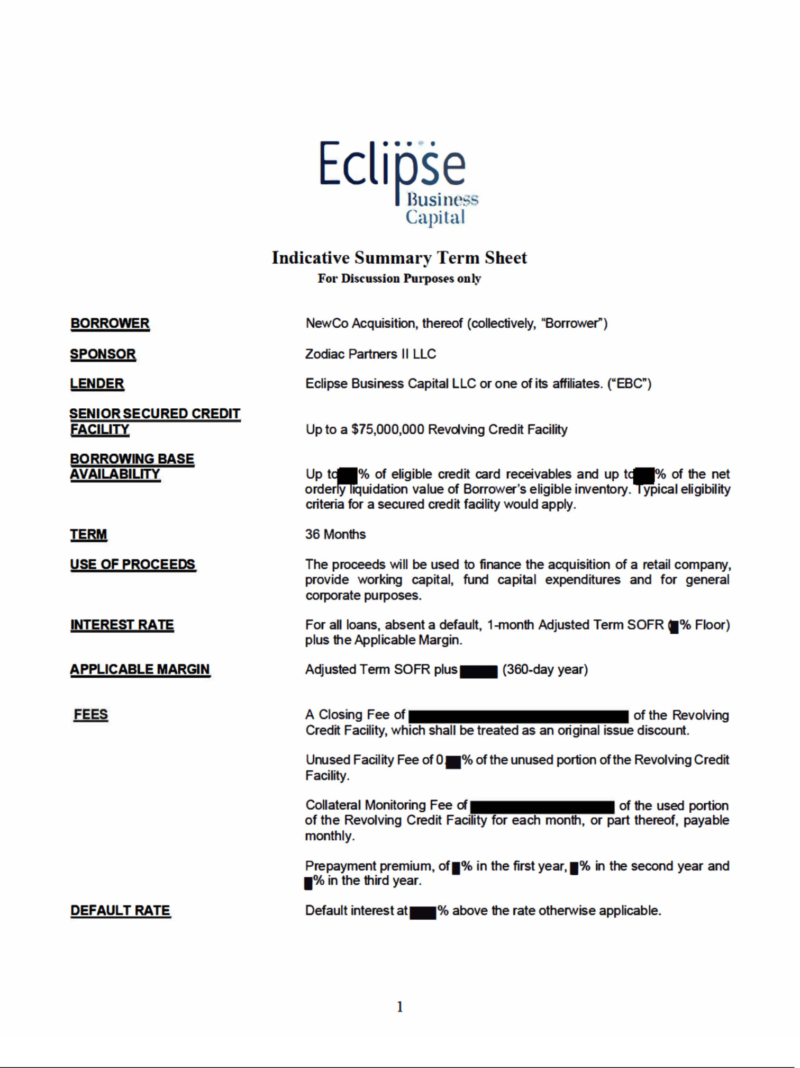



Exhibit (d)
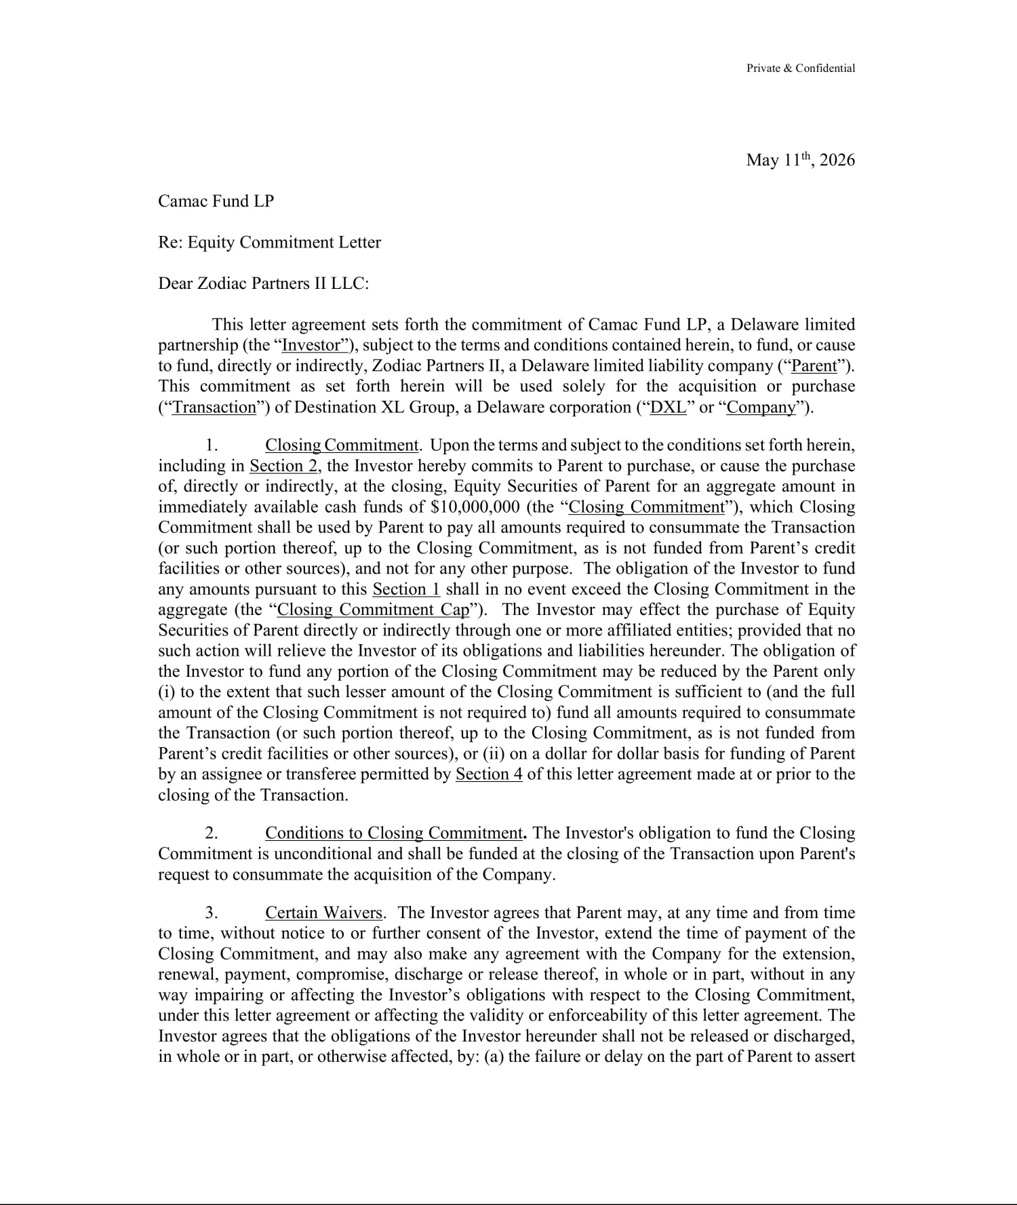

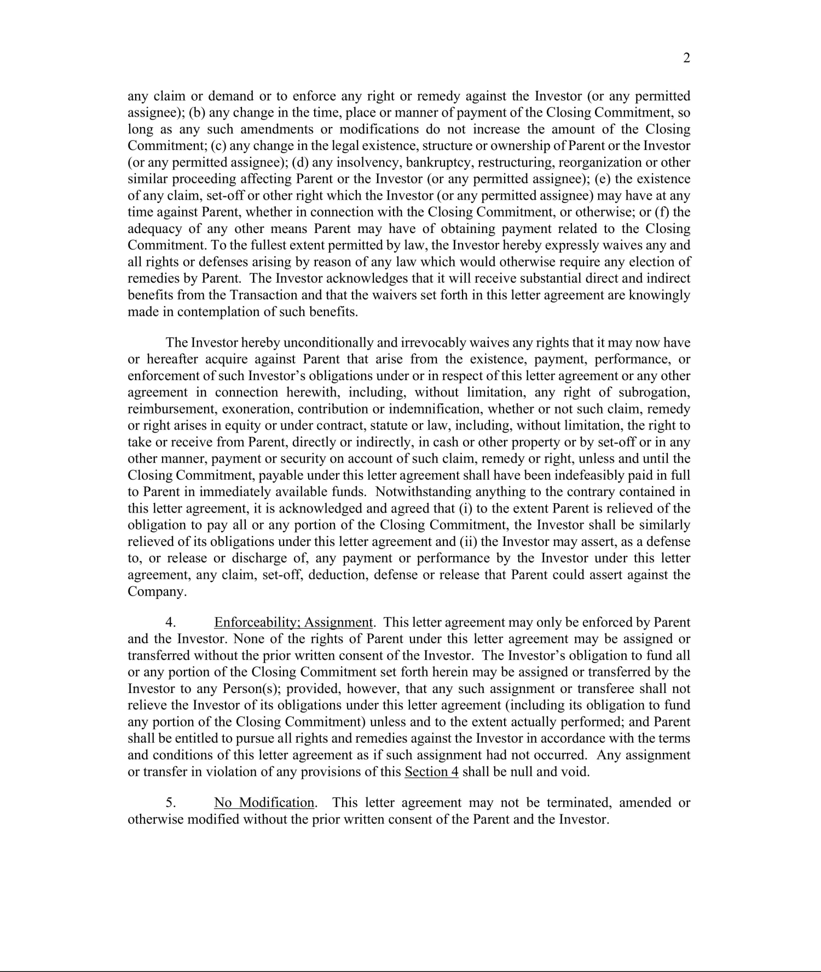

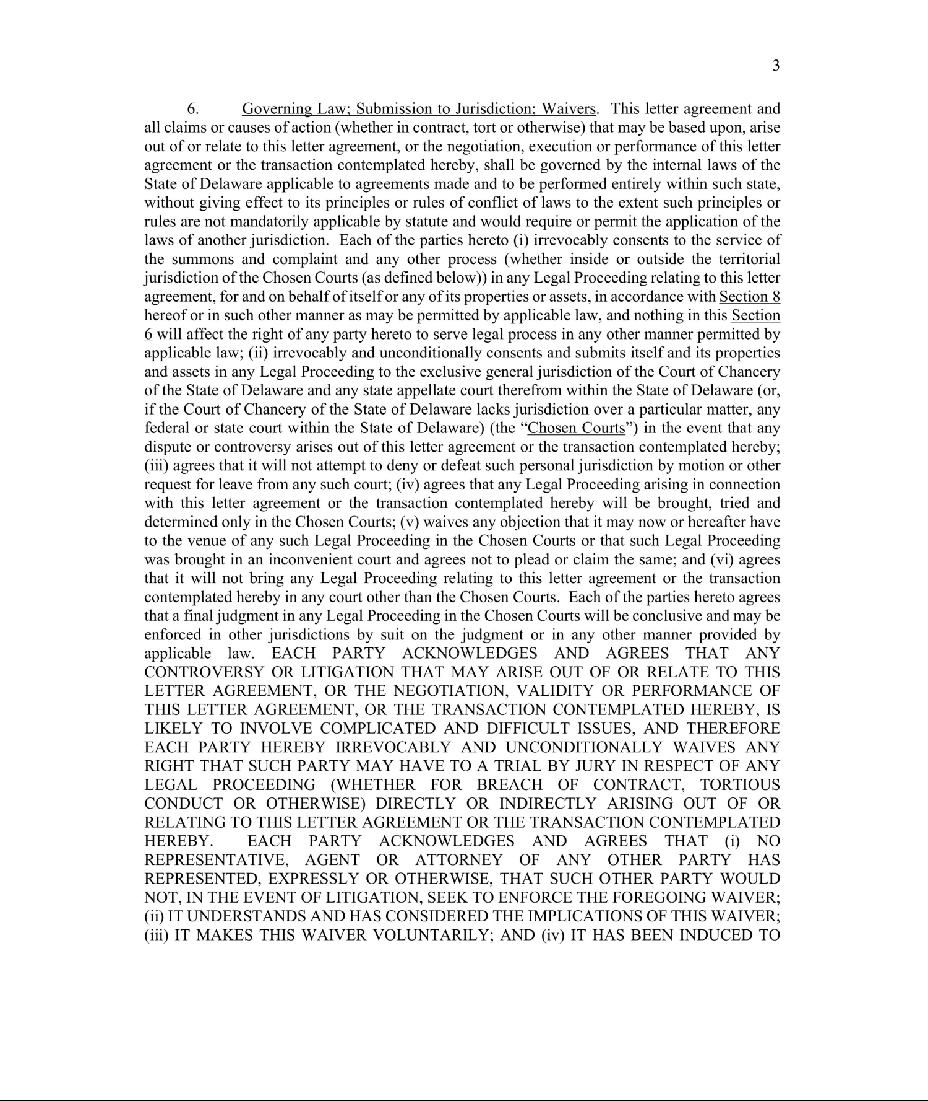

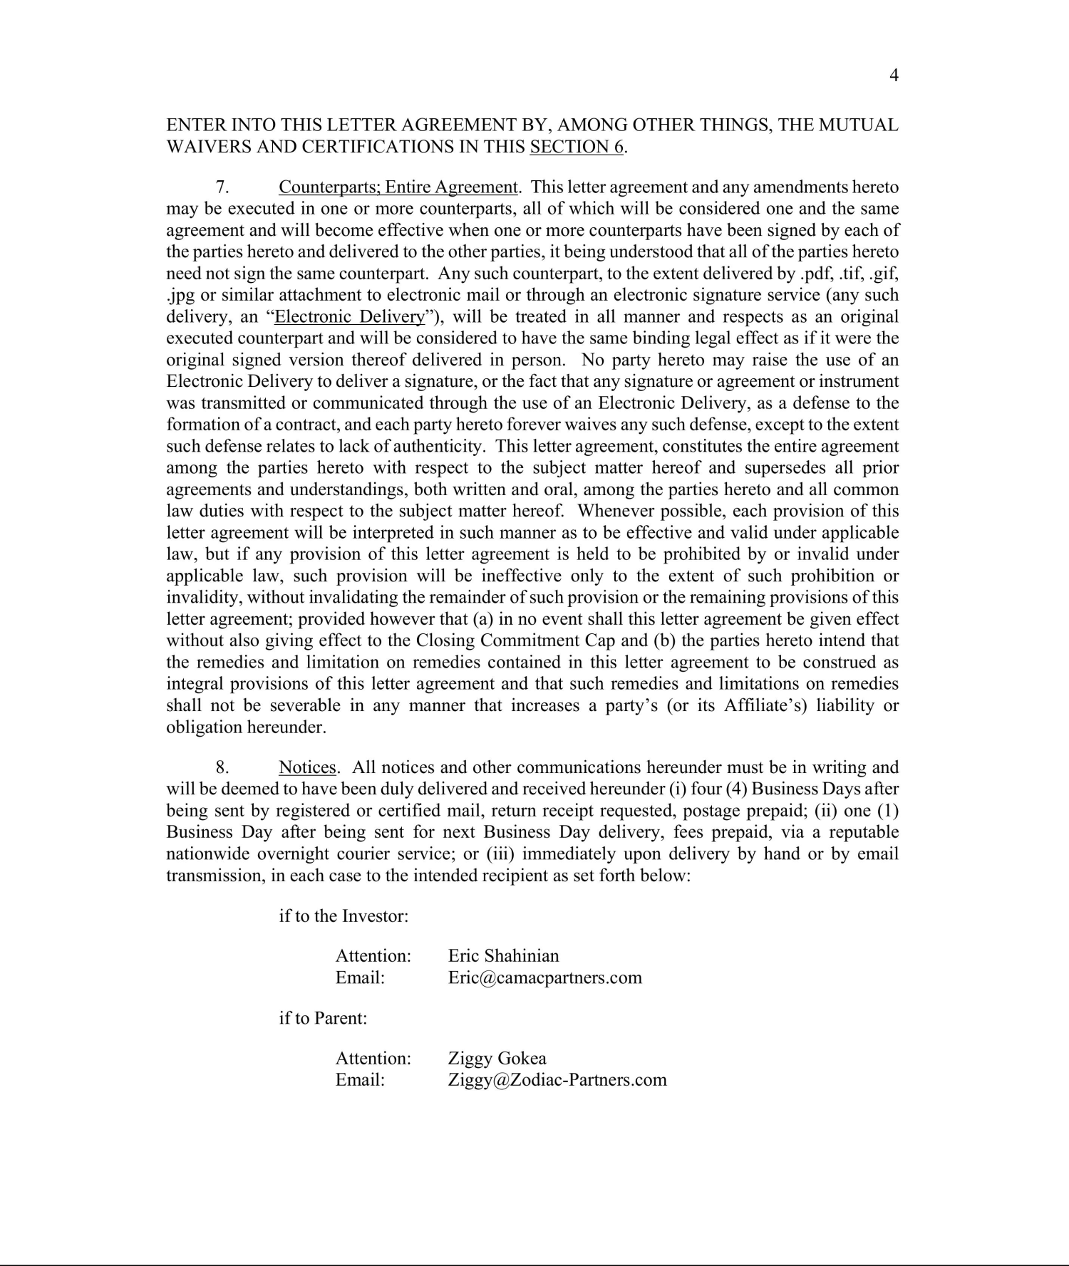

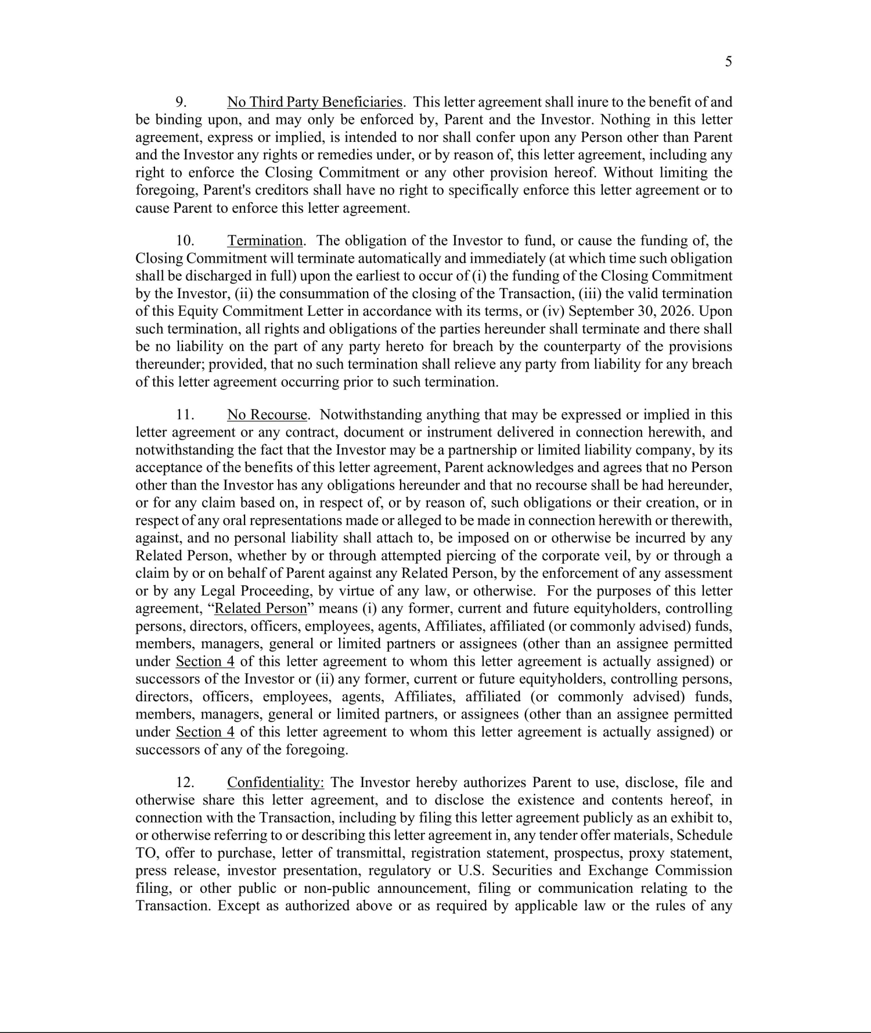

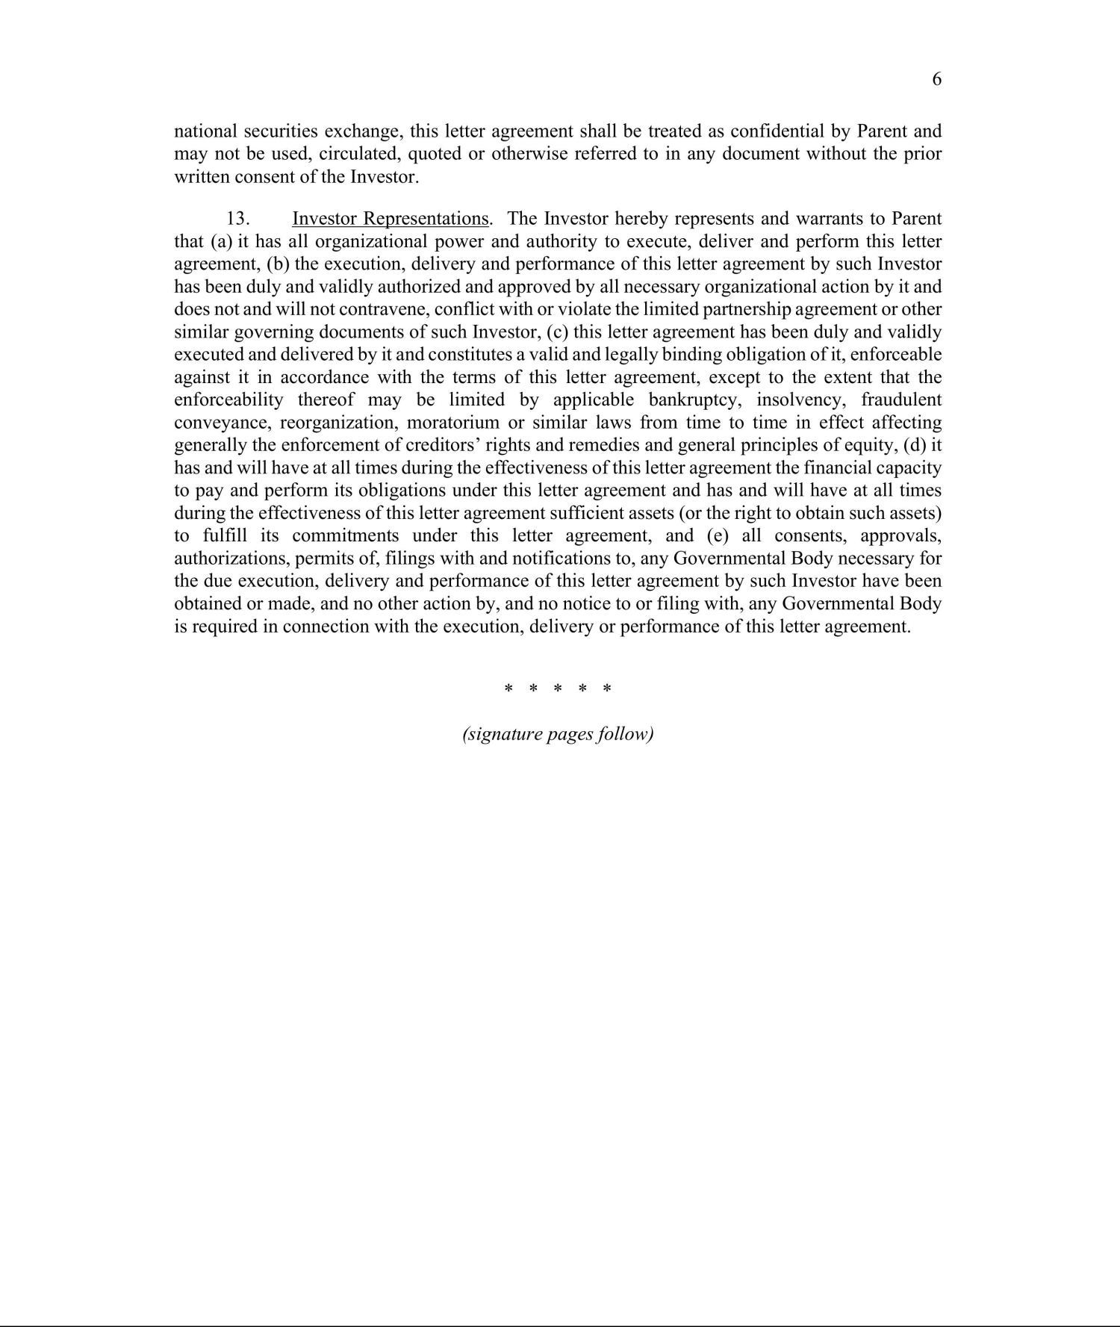

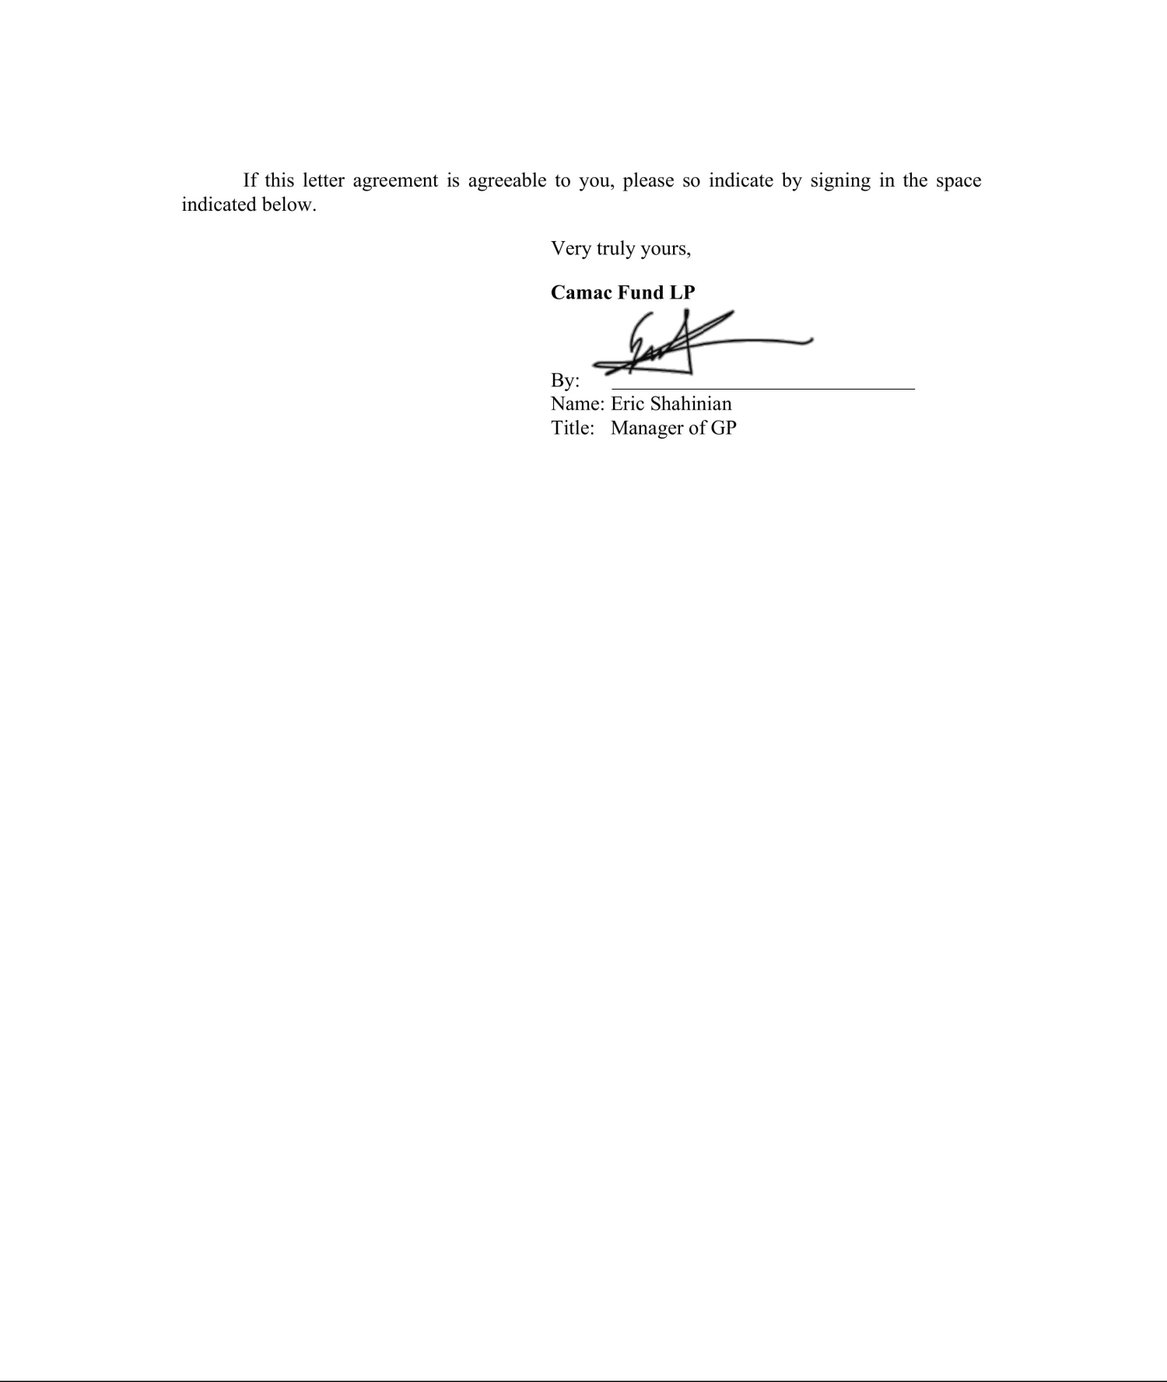

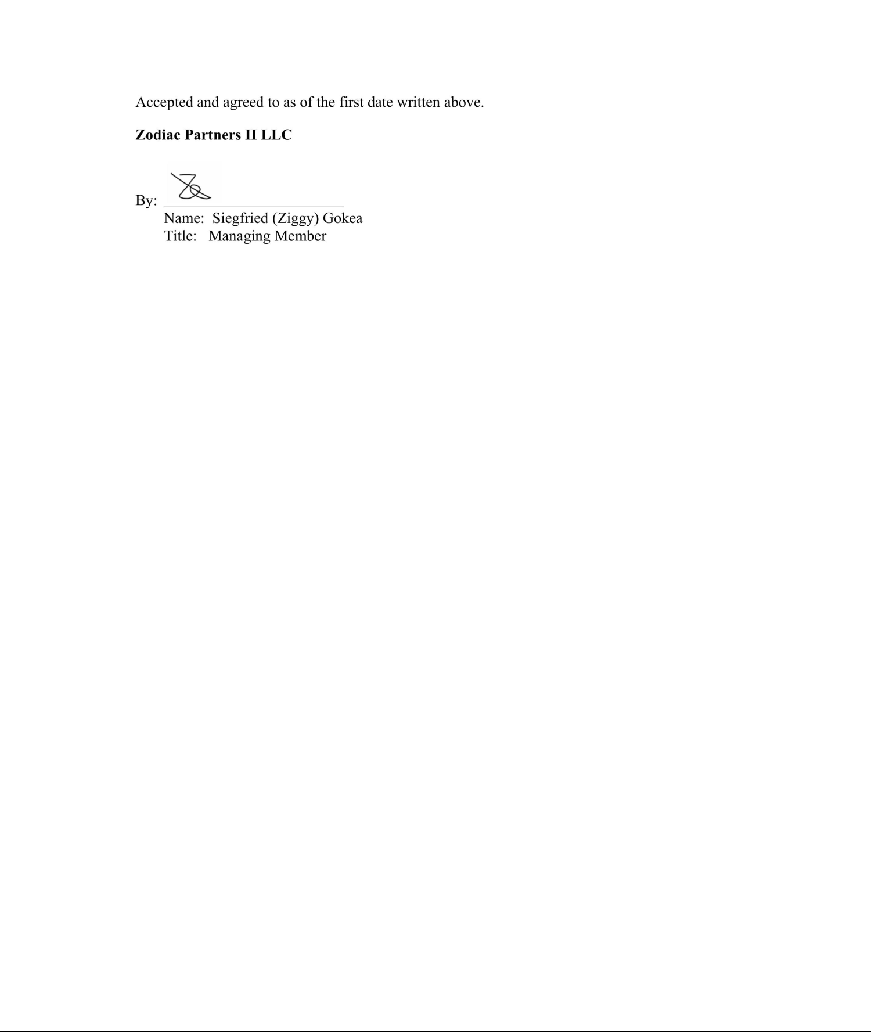

Calculation of Filing Fee Tables

Table 1: Transaction Valuation

 |  |  |  |  | Transaction |  |  |  | Amount
 |  |  |  |  | Transaction |  | Fee Rate |  | of Filing
 |  |  |  |  | Valuation |  | Fee Rate |  | of Filing
 |  |  |  |  | Valuation |  |  |  | Fee
 | Fees to be Paid |  | 1 |  | $ |  | 0.0001381 |  | $
 | Fees to be Paid |  | 1 |  | 46,012,639.02 |  | 0.0001381 |  | 6,354.35
 | Fees Previously Paid
 |  |  | Total Transaction | $
 |  |  | Valuation: | 46,012,639.02
 |  |  | Total Fees Due for |  |  |  |  | $
 |  |  | Filing: |  |  |  |  | 6,354.35
 |  |  | Total Fees |  |  |  |  | $ 0.00
 |  |  | Previously Paid:
 |  |  | Total Fee Offsets: |  |  |  |  | $ 0.00
 |  |  | Net Fee Due: |  |  |  |  | $
 |  |  |  |  |  |  |  | 6,354.35
Offering Note
1

The "transaction valuation" was estimated solely for purposes of calculating the filing fee as the sum of (i) 54,810,511 issued and outstanding shares of common stock, par value $0.01 per share (the "Shares") of Destination XL Group, Inc. (the "Company"), multiplied by $0.82 per share (the "Offer Price"); (ii) 44,000 Shares issuable pursuant to outstanding in-the-money stock options, multiplied by $0.81, which is the difference between the Offer Price and $0.01, the weighted average exercise price of such options; (iii) 1,259,000 Shares issuable upon settlement of outstanding restricted stock units, multiplied by the Offer Price. The calculation of the transaction value is based on information contained in the Company's Annual Report on Form 10-K for the fiscal year ended January 31, 2026.

The "amount of filing fee" was calculated in accordance with Rule 0-11 under the Securities Exchange Act of 1934, as amended, and Section 6(b) Filing Fee Rate Advisory for Fiscal Year 2026 beginning on October 1, 2025, issued August 25, 2025, by multiplying the transaction valuation by 0.00013810.

Table 2: Fee Offset Claims and Sources |  |  |  |  |  |  |  |  |  |  |  |  |  |  |  |  | ☑Not Applicable
 |  |  |  |  |  |  |  |  | Form or |  |  |  | Initial |  |  |  |  |  | Fee Paid
 |  |  |  |  |  |  |  |  | Form or |  | File |  | Initial |  | Filing |  | Fee Offset |  | with Fee
 |  |  |  |  |  | Registrant or Filer Name |  |  | Filing |  | File |  | Filing |  | Filing |  | Fee Offset |  | with Fee
 |  |  |  |  |  |  |  |  | Filing |  | Number |  | Filing |  | Date |  | Claimed |  | Offset
 |  |  |  |  |  |  |  |  | Type |  | Number |  | Date |  | Date |  | Claimed |  | Offset
 |  |  |  |  |  |  |  |  | Type |  |  |  | Date |  |  |  |  |  | Source
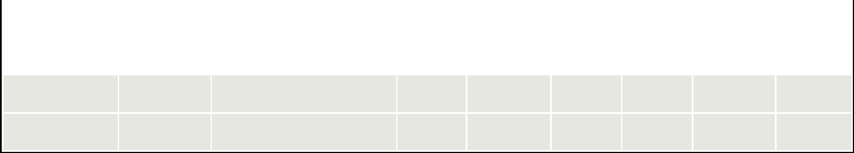
Fee Offset

Claims

Fee Offset

Sources

