UNITED STATES

SECURITIES AND EXCHANGE COMMISSION
Washington, D.C. 20549

FORM 8-K

CURRENT REPORT

PURSUANT TO SECTION 13 OR 15(d) OF THE

SECURITIES EXCHANGE ACT OF 1934

Date of Report (Date of earliest event reported): April 22, 2009

0-15898

(Commission File Number)

CASUAL MALE RETAIL GROUP, INC.

 | (Exact name of registrant as specified in its charter)
Delaware | 04-2623104
(State of Incorporation) |  |  | (IRS Employer Identification Number)
 | 555 Turnpike Street, Canton, Massachusetts 02021
 | (Address of registrant’s principal executive office)
 | (781) 828-9300
 |  | (Registrant’s telephone number)

Check the appropriate box below if the Form 8-K filing is intended to simultaneously satisfy the filing obligation of the registrant under any of the following provisions (see General Instruction A.2. below):

- Written communications pursuant to Rule 425 under the Securities Act (17 CFR 230.425)

- Soliciting material pursuant to Rule 14a-12 under the Exchange Act (17 CFR 240.14a-12)

- Pre-commencement communications pursuant to Rule 14d-2(b) under the Exchange Act (17 CFR 240.14d-2(b))

- Pre-commencement communications pursuant to Rule 13e-4(c) under the Exchange Act (17 CFR 240.13e-4(c))

ITEM 7.01 -Regulation FD Disclosure

The Company will be presenting a slide presentation to various investment groups at upcoming investors conferences beginning on April 22, 2009. A copy of the slides to be presented at those conferences is attached to this report as Exhibit 99.1, which slide presentation is incorporated by reference herein.

The slide presentation contained in the exhibit includes statements intended as “forward-looking statements,” which are subject to the cautionary statement about forward-looking statements set forth in the exhibit. The slide presentation is being furnished, not filed, pursuant to Regulation FD. Accordingly, the slide presentation will not be incorporated by reference into any registration statement filed by the Company under the Securities Act of 1933, as amended, unless specifically identified therein as being incorporated therein by reference. The furnishing of the slide presentation is not intended to, and does not, constitute a determination or admission by the Company that the information in the slide presentation is material or complete, or that investors should consider this information before making an investment decision with respect to the Company.

Presentation of Non-GAAP Measures

The slide presentation includes the discussion of non-GAAP free cash flow on slide 4 and slide 7. Free cash flow is not a measure determined by generally accepted accounting principles (“GAAP”) and should not be considered superior to or as a substitute for net income (loss) or cash flows from operating activities or any other measure of performance derived in accordance with GAAP.

In addition, all companies do not calculate non-GAAP financial measures in the same manner and, accordingly, “free cash flows” as presented in this slide presentation may not be comparable to similar measures used by other companies. We calculate projected free cash flows for fiscal 2009 of $15.0 million by subtracting estimated capital expenditures for fiscal 2009 of approximately $5.0 million from estimated cash flow from operations for fiscal 2009 of $20.0 million.

We believe that inclusion of this non-GAAP measure helps investors gain a better understanding of our performance, especially when comparing such results to previous periods.

ITEM 9.01 - FINANCIAL STATEMENTS AND EXHIBITS

(d) Exhibits

Exhibit No. |  | Description
99.1 |  | Presentation dated April 22, 2009

SIGNATURES

Pursuant to the requirements of the Securities Exchange Act of 1934, the registrant has duly caused this report to be signed on its behalf by the undersigned, thereunto duly authorized.

CASUAL MALE RETAIL GROUP, INC.

By: | /S/ DENNIS R. HERNREICH
Name: | Dennis R. Hernreich
Title: | Executive Vice President and Chief Financial Officer

Date: April 22, 2009

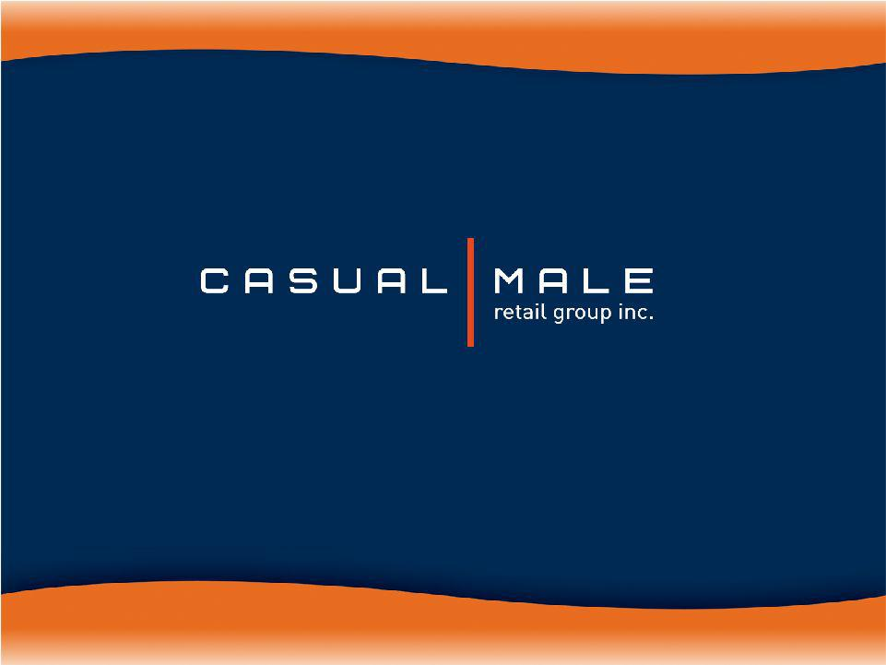
Exhibit 99.1

April 2009


Big & Tall Market

- Market defined as:

– big = waist size between 40” and 70”

– tall = height over 6’2”

- Big and tall men account for approximately 11% of the male population.

- Big and tall market size is approximately $6 billion and growing at almost twice the rate of the regular size men’s apparel market.

– Big & tall apparel market is highly fragmented; characterized by many small, local operators.

2

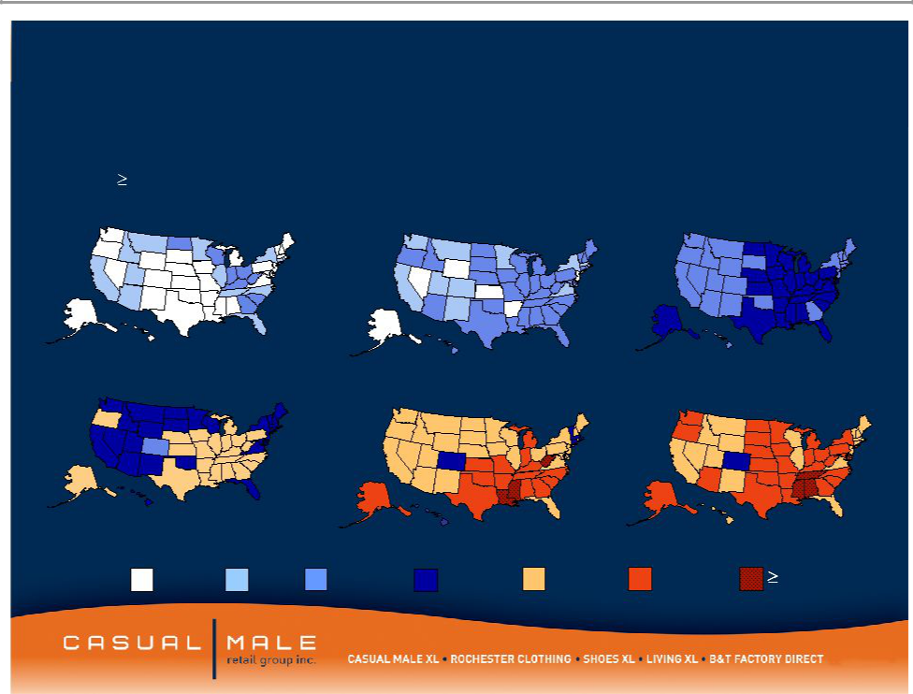
Market is growing as a percent to total menswear sales
Obesity Trends* Among U.S. Adults

(*BMI 30, or about 30 lbs overweight)
1985 | 1990 | 1995

2000 2005 2007

No Data <10% 10%–14%15%–19% 20%–24% 25%–29%30%

Source: CDC

3


2009 Goals

- Optimize Free Cash Flow projected $15 million

- Maximize liquidity of our Revolver and paying down balance to $25- $30 million at year end

- Managing inventory levels and reducing by 10% or $10 million

- Reducing SGA by 9% to $162.5 million

- Cutting Capital Expenditures to $5 million

- Improving Merchandise Margins by 225 to 275 basis points

- Implement a store customer service improvement program

4

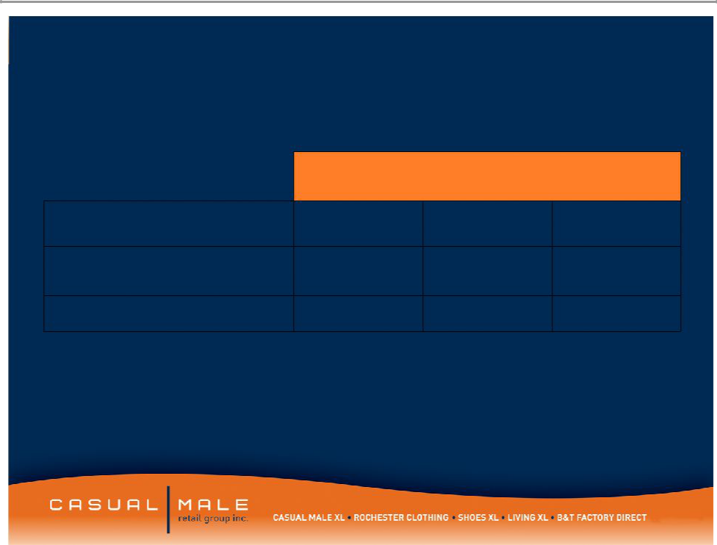
Selected Balance Sheet Information

 | 2009
 | Projected | 2008 | 2007
Inventory | 88.6 | 98.6 | 117.8
Borrowing Under
Revolver | 25-30 | 38.7 | 41.0
Fixed Term Loan | 7.6 | 12.5 | 17.3

5

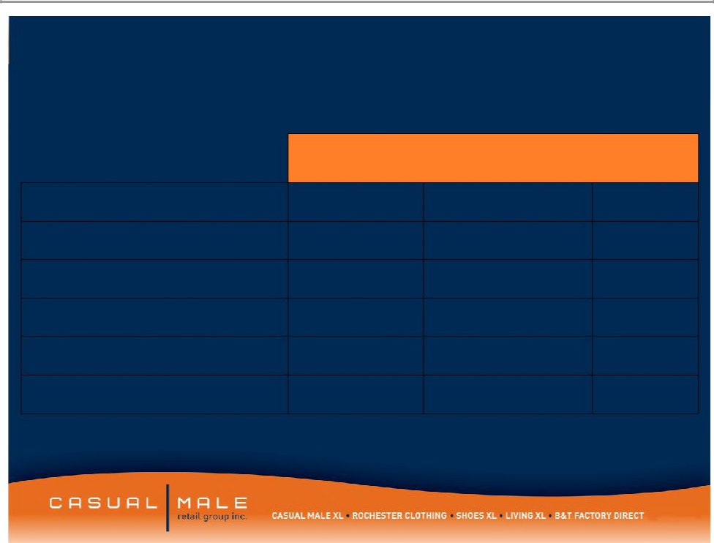
Selected Income Statement Information

Sales

SGA

Gross Margin

Capital Expenditure

Marketing Expense

Interest Expense

2009
Projected | 2008 | 2007
400.0 | 444.2 | 464.1
162.5 | 178.1 | 178.1
45.2% | 42.7% | 44.4%
5.0 | 12.6 | 21.4
26.6 | 34.1 | 33.9
1.5 | 3.0 | 4.3

6

Cash Flow Analysis

- Generate Free Cash Flow in the amount of $15 million with total sales down 10%

- Cash Flow is Neutral with total sales decline in the mid to high double digits

7

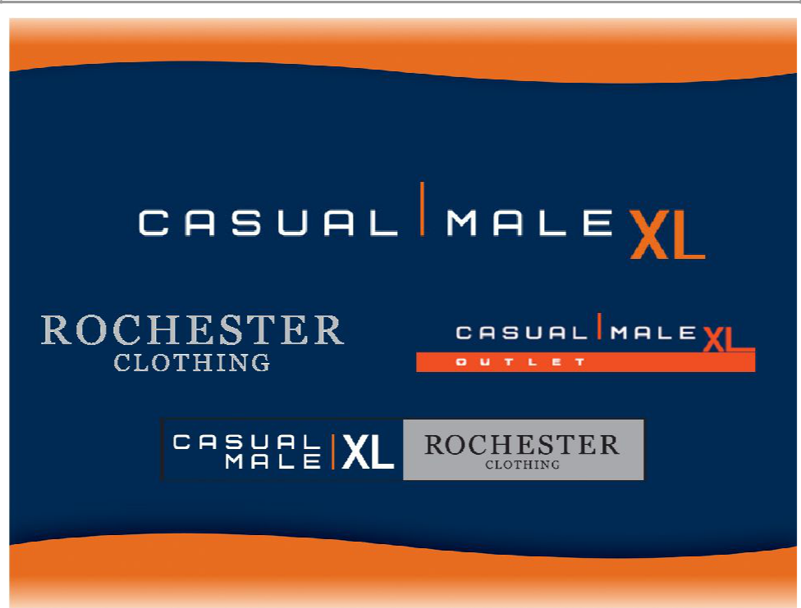
Our Store Concepts

8

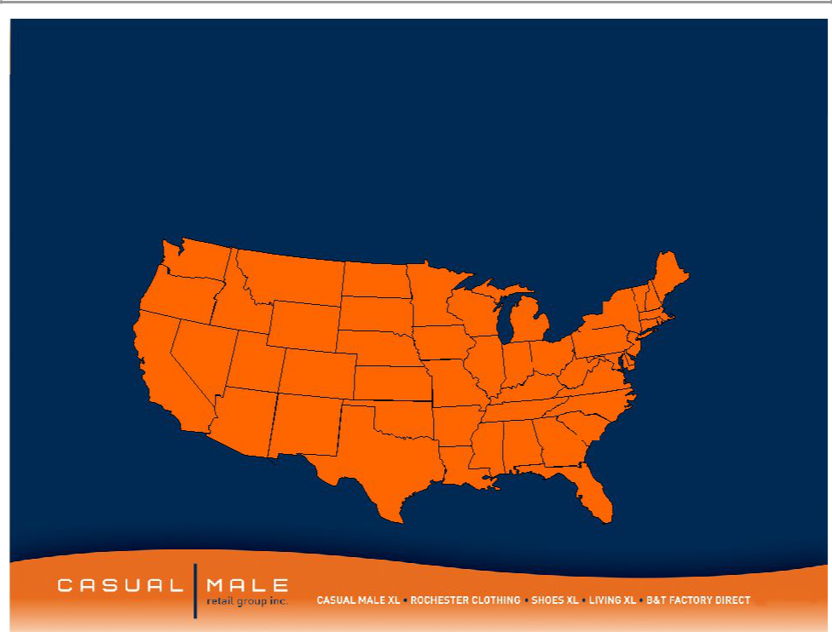
Casual Male Stores

- Casual Male XL is the nation’s largest specialty retailer of big & tall clothing with 401 full price stores and 66 outlet stores in 47 states
 |  |  |  |  |  |  |  |  |  |  |  | CT-10
 |  |  |  |  |  |  |  |  |  |  |  | DE-3
7 |  | 1 |  |  |  |  |  |  |  |  | 2 | RI-1
 |  | 1 | 1 |  |  |  |  |  |  |  | 2 | MA-13
 |  |  | 1 |  |  | 8 |  |  |  |  |  | MA-13
5 |  |  |  |  |  | 8 |  |  |  |  |  | MD-13
5 | 1 |  |  |  |  |  |  |  |  |  |  | MD-13
 | 1 |  | 1 |  |  |  | 8 |  |  | 33 |  | NH-3
 |  |  | 1 |  |  |  | 8 |  | 20 | 33 |  | NH-3
 |  |  |  |  |  |  |  |  | 20 | 25 |  | NJ-20
 |  |  | 4 |  |  | 4 |  |  |  | 25 |  | VT-1
6 | 3 |  | 4 |  |  | 4 | 23 | 12 | 19 |  |  | VT-1
 | 3 |  | 5 |  |  |  | 23 | 12 |  | 1
55 |  |  | 5 | 3 |  |  |  |  |  | 1
55 |  |  |  | 3 |  | 10 |  |  | 5 | 13
 | 10 |  |  |  |  |  |  | 8 |  | 11
 | 10 | 2 |  |  | 3 |  |  | 8
 | 10 | 2 |  |  | 3 | 2 |  |  |  | 5
Long term potential – |  |  | 39 |  |  |  | 2 | 4 |  | 10
 |  |  |  |  |  |  | 5

additional 100-130 more stores | 29

9

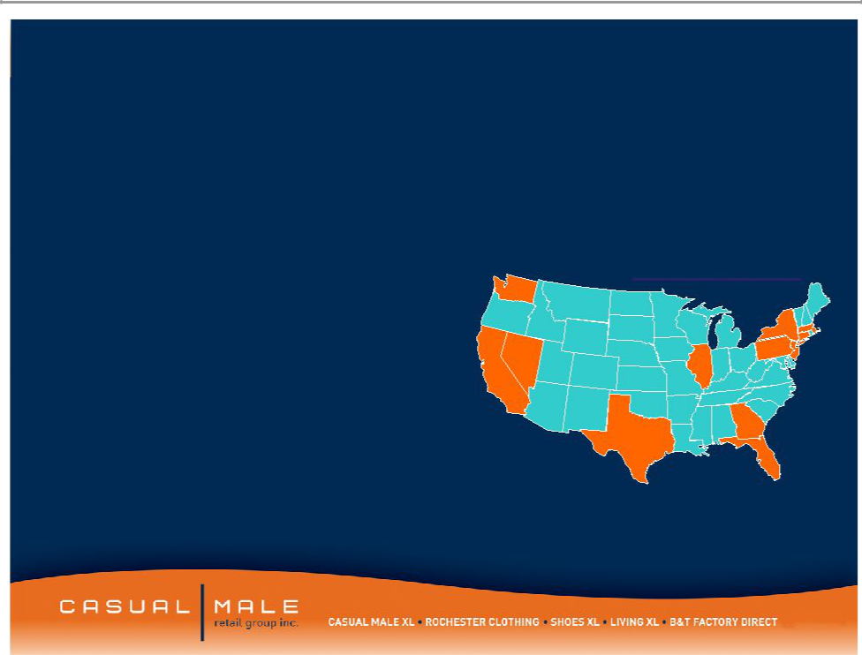

- Targets the higher income consumer within the big and tall market

– $100,000 per year average salary

- 21 store locations in downtown major metropolitan areas and upscale suburbs

- Average store size: 8,192 square ft

- Average sales / square foot: $256

– Stores carry higher-end designer product

– Average transaction size: $300

Rochester

 |  | Locations
 | 1
 |  |  | 3
 |  | 1
 | 1 | 1 | Ma-1
5 |  | 1 | Ma-1

CT-1

 |  | 1 | DC-1
 | 2 |  | DC-1
Rochester |  |  | 2
* 1 London, United Kingdom

10



Hybrid Stores

11

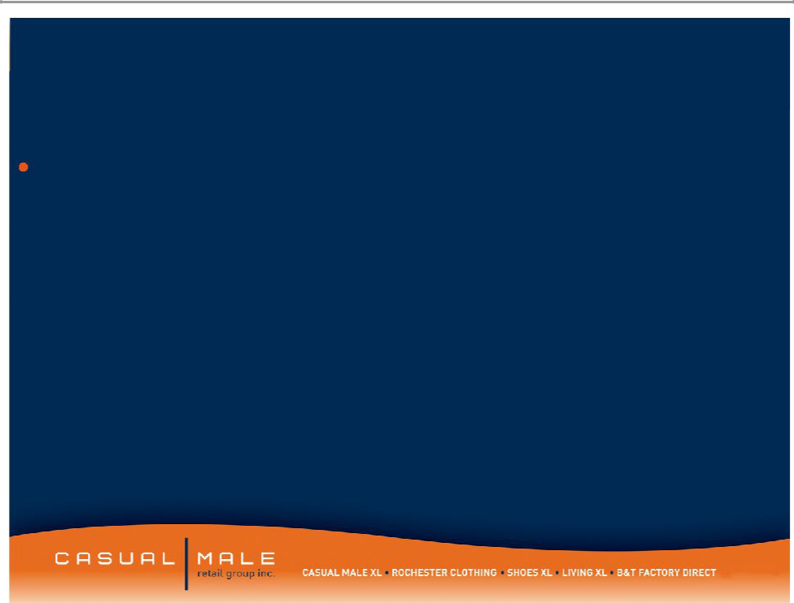
Concept

The Hybrid store, as conceived, is a 6,000 square ft. combination Casual Male, Rochester store featuring the lifestyle sportswear apparel wardrobe needs offered by Casual Male, but with an added lifestyle of higher end fashion apparel offered by Rochester and an enhanced Clothing section featuring the quality and fashion of Rochester Clothing and the price points of Casual Male clothing

12

Hybrids

- Eliminated duplicative accessories/furnishings between combined Rochester and Casual Male.

- Good, better, best tiered offering with most of best coming from Rochester’s good and better assortment.

- Edited assortment for brands carried in both companies i.e. Polo, CK Jeans. Assortment will be merged presenting a broader range of price points and looks without duplication

- Store will be merchandised separately by brand except:

– Denim will be presented as a combined shop

– Sportswear will be presented by Brand

– Clothing/Furnishings will be merchandised as a combined shop

– Shoes will be set up as a service environment.

13

Square Footage

Pricing

Average Unit

Retail

Service

Tailoring

OPERATIONAL MODELS
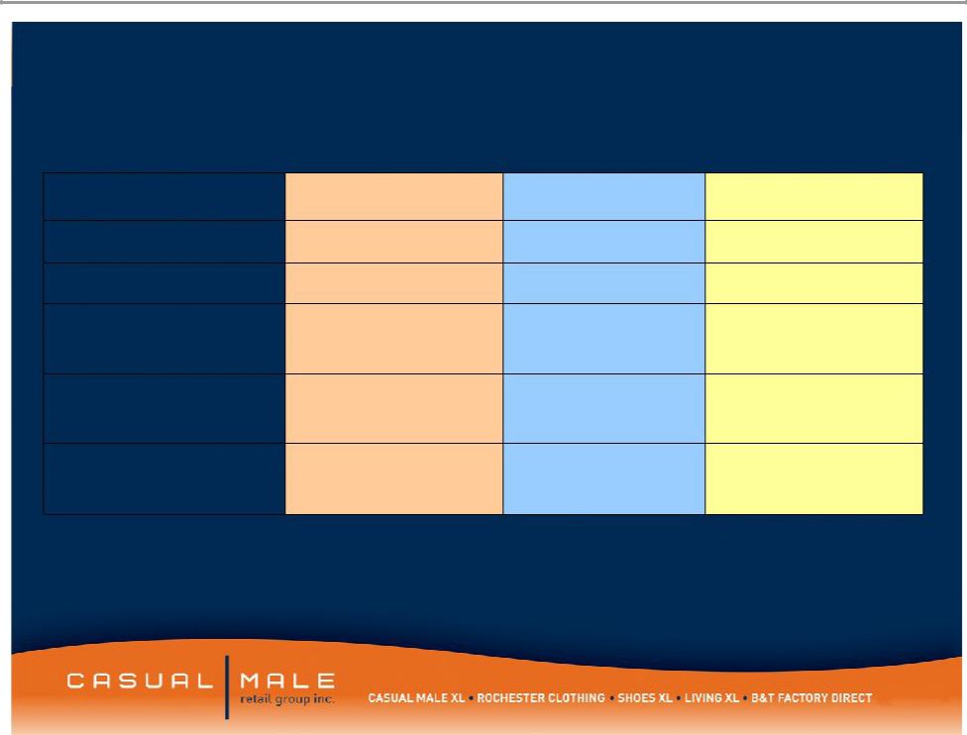

Casual Male | Rochester | Hybrid Store
3,534 | 8,069 | 9,045
Moderate | High End | Mid-High Moderate
$32.10 | $74.90 | $45.00
Semi Self Service | Full Service | Leaning Towards Full
 |  | Service
No Tailoring Service | Full Service | Full Service Tailoring
Offered | Tailoring

14

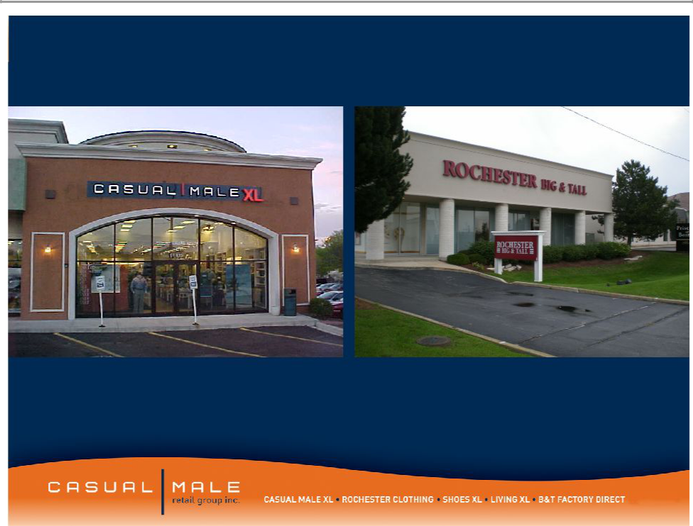

OAKBROOK, IL •Existing Locations

15

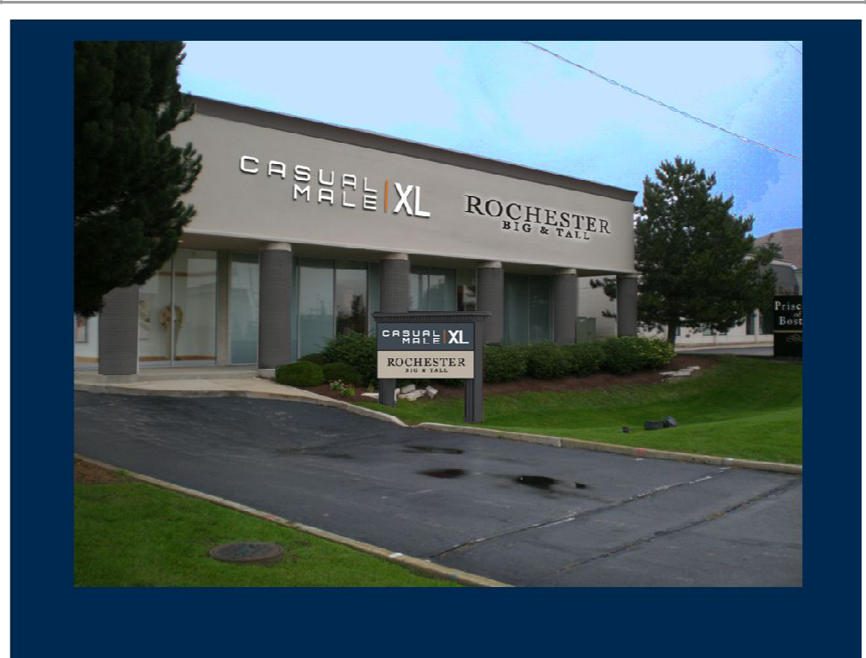

OAKBROOK, IL •Hybrid Store Front

16

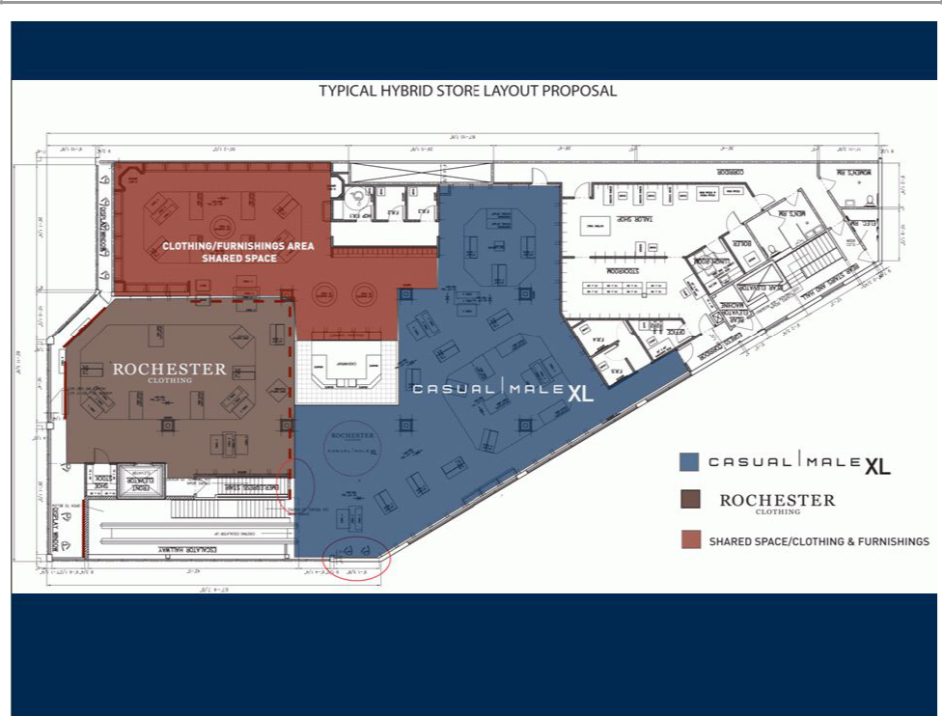

TYPICAL HYBRID STORE LAYOUT PROPOSAL

17

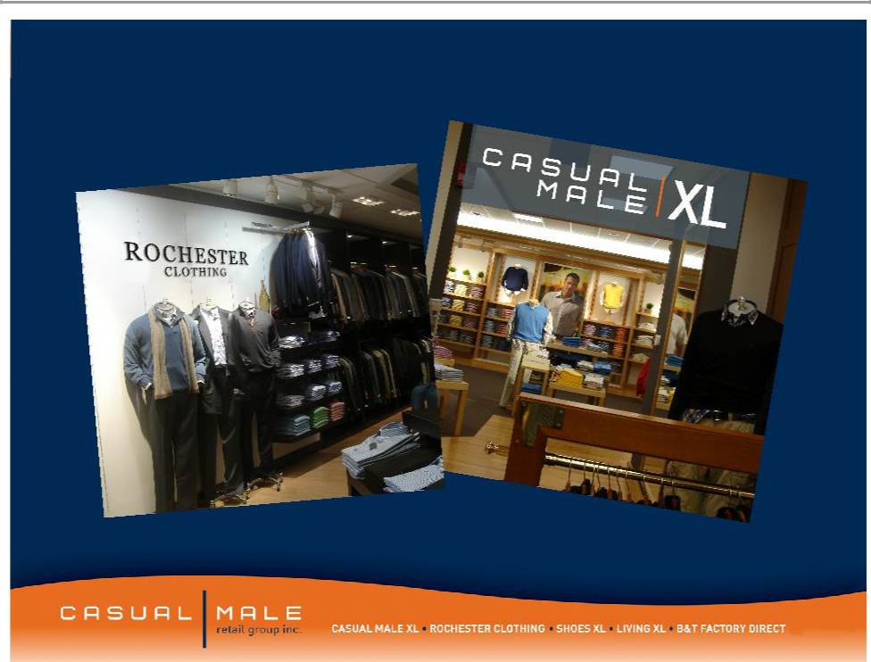

TYPICAL HYBRID STORE SHOP IDENTITY

LIGHT WOOD vs. DARK WOOD

18

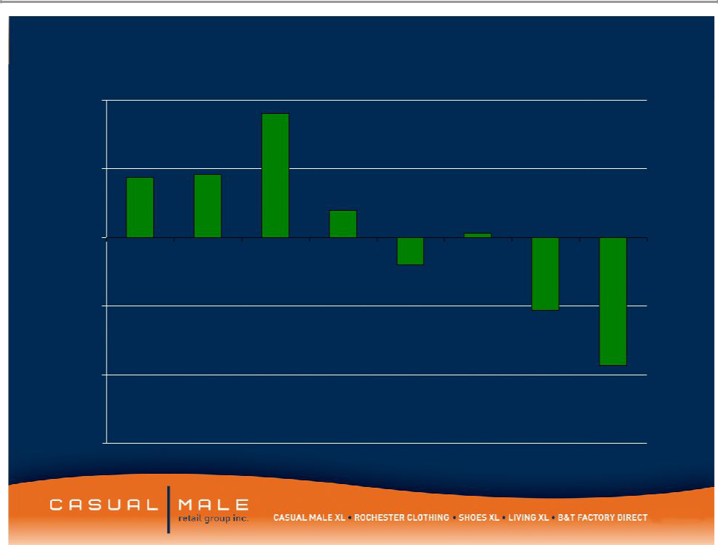
Comp Trend

10.0% _{9.0%}

_{5.0%} 4.4% ^{4.6%}

2.0%

0.3%

0.0%

2004 2005 2006 2007 Q1 Q2 Q3 Q4

-2.0%

-5.0%

-5.3%

2008

-10.0% _{-9.3%}

-15.0%

19

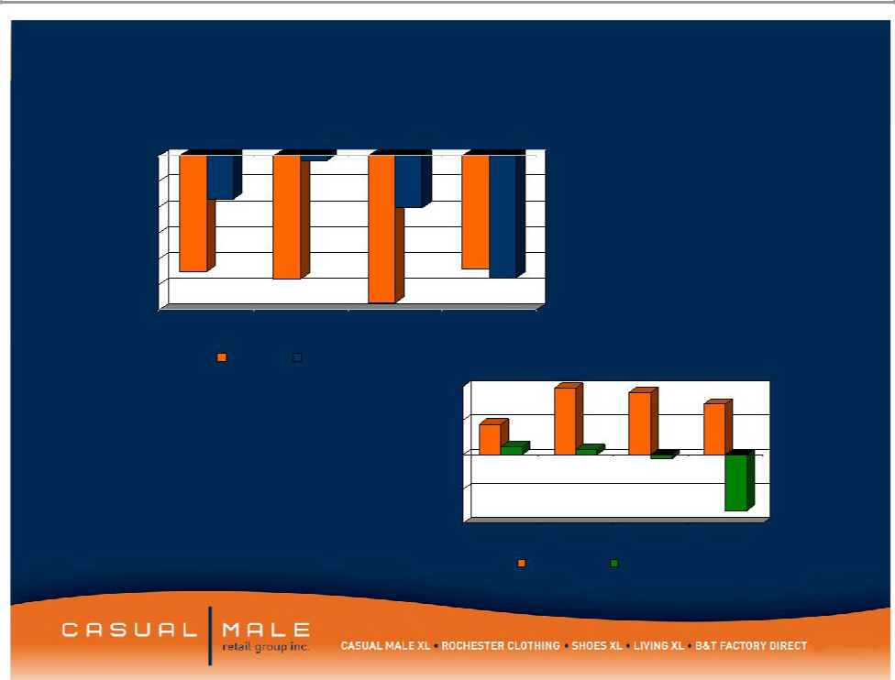
CM Sales Metrics By Quarter

0.00%

-2.00%

-4.00%

-6.00%

-8.00%

-10.00%

-12.00%
1st Qtr | 2nd Qtr |  | 3rd Qtr | 4th Qtr
 | Traffic | Comp Sales
 |  |  | 10.00%
 |  |  | 5.00%
 |  |  | 0.00%
 |  |  | -5.00%
 |  |  | -10.00% | 1st Qtr | 2nd Qtr | 3rd Qtr | 4th Qtr

Conversion DPT

20

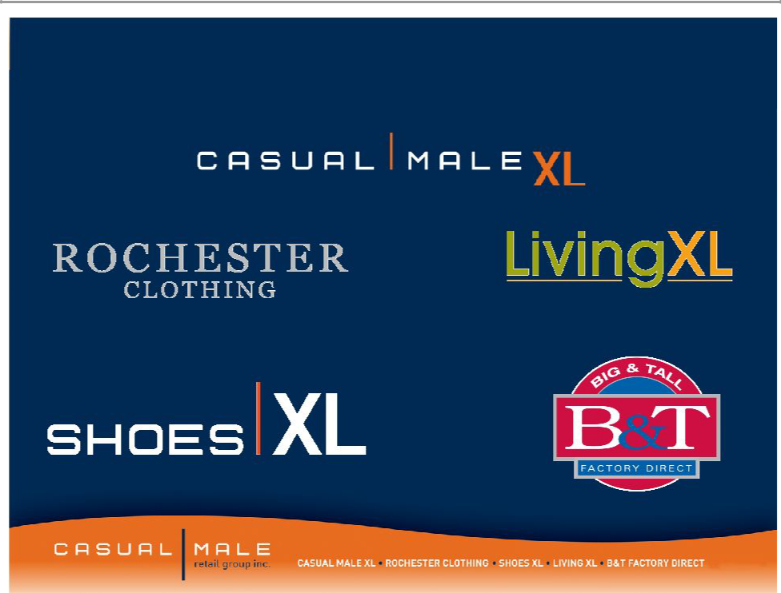
Our Direct to Consumer Brands

CasualmaleXL.com

Rochesterclothing.com ^{Livingxl.com}

ShoesXL.com

BTDirect.com

21

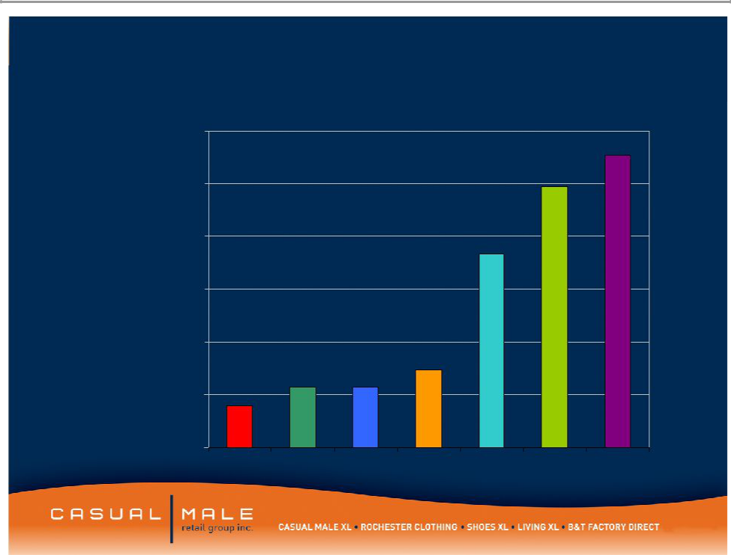
CMRG Internet Sales by Year

$60,000,000

$50,000,000

$40,000,000

$30,000,000

$20,000,000

$10,000,000

$0

2002 2003 2004 2005 2006 2007 2008

22

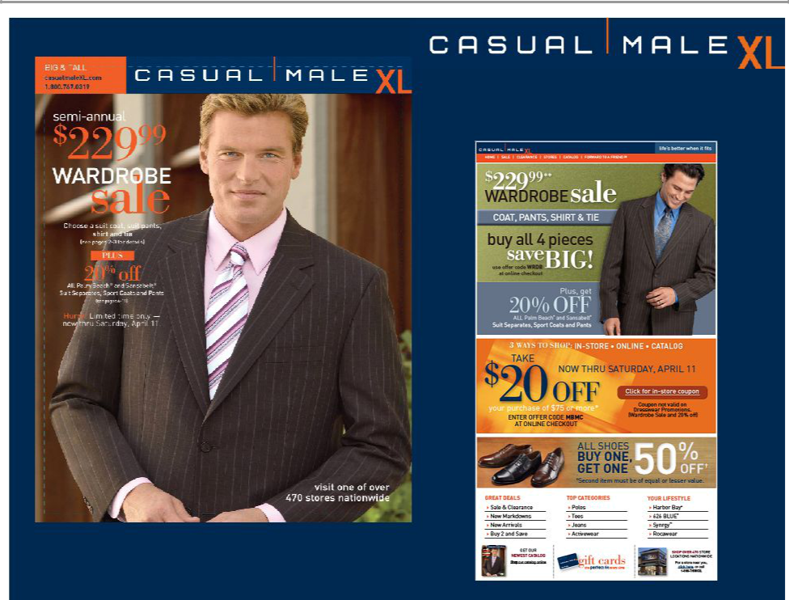

23

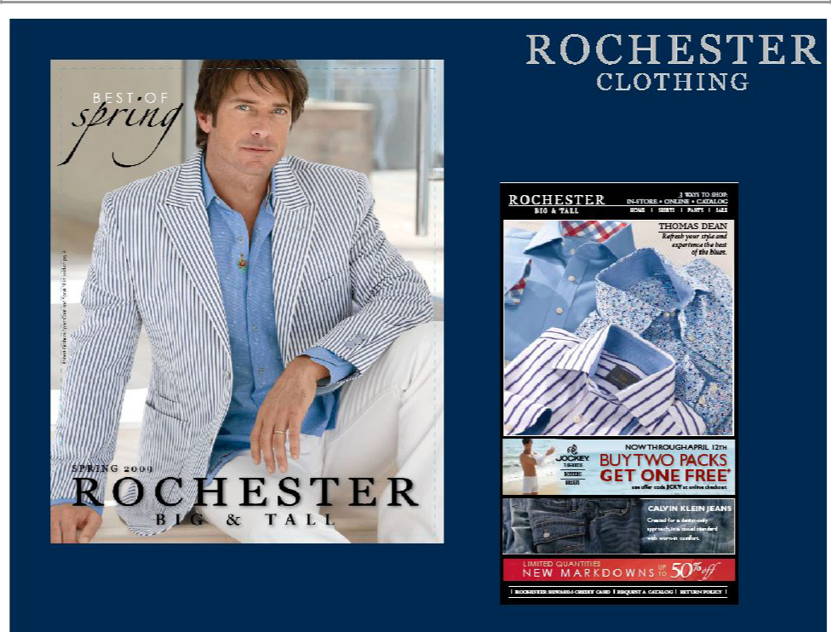

24

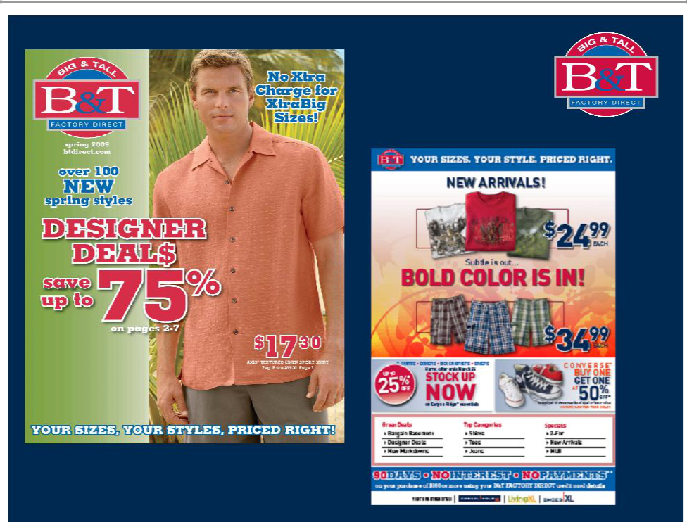

25

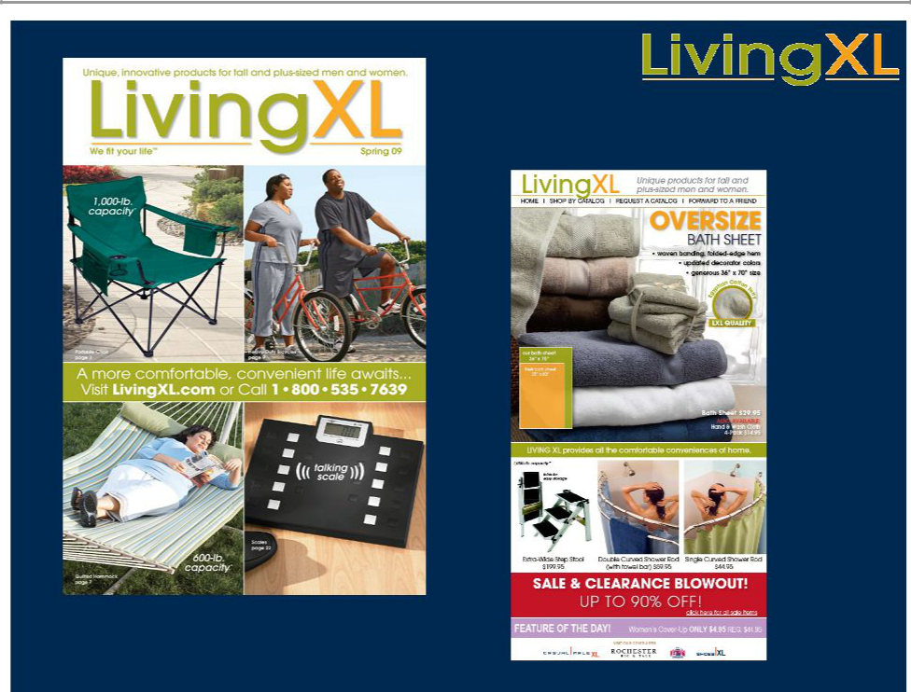

26

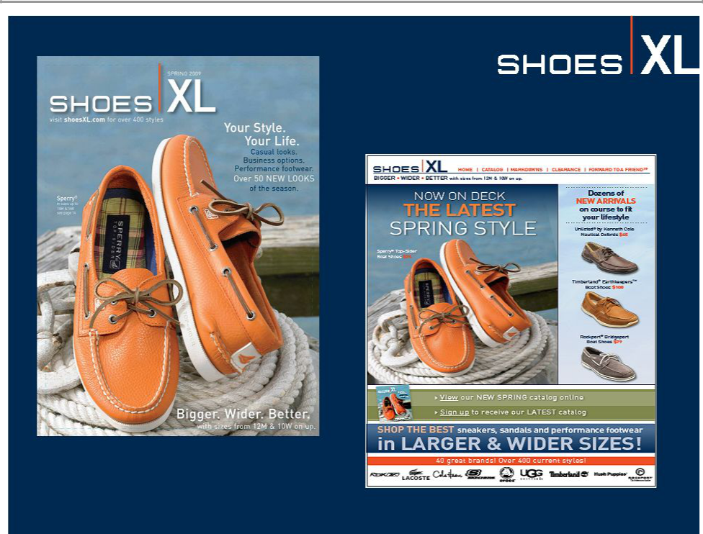

27

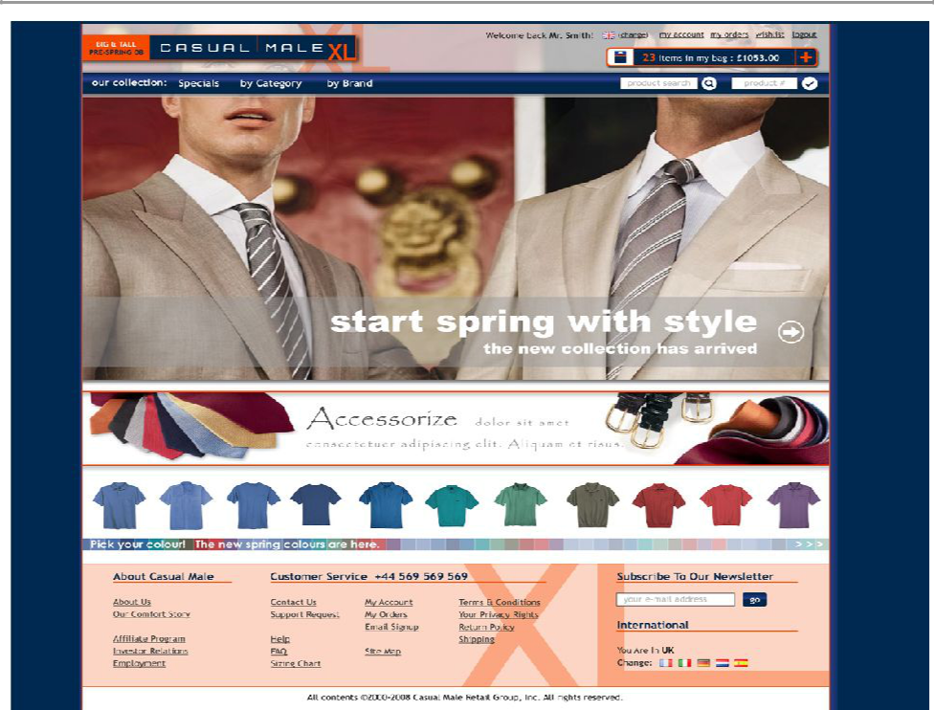

28

Obesity in Europe

- 135 million adults are affected by obesity

- Many countries more than half the adult population is overweight and 30% defined as clinically obese

- In most European countries 1 in 4 children are obese which is over 80 million children

29

Casual Male XL Loyalty Program Rewards

Current Program Performance:

- 2.2MM customers have been enrolled to date

- Of the 1.43MM retail customers, 1.18 or 83% are enrolled

- 83% of new customers captured in POS are being enrolled

- 88% of transactions involved an XL Rewards member

- Loyalty members average spend per transaction is 17% or $15 higher than non-members

- March 2009 Launched Prestige XL rewards for highest spending customers, spend over $1,000 per year

30


Forward Looking Statements:

This presentation contains certain forward-looking statements concerning the
Company's operations, performance, and financial condition. Such forward-looking statements are subject to various risks and uncertainties that could cause actual results

to differ materially from those indicated. Such risks and uncertainties may include, but are not limited to: the failure to implement the Company's business plan for increased profitability and growth in the Company's retail stores sales and direct-to-consumer segments, the failure of management to develop the Company’s new direct to consumer businesses, the failure of changes in management to achieve improvement in the Company's competitive position, adverse changes in costs vital to catalog operations,

such as postage, paper and acquisition of prospects, declining response rates to catalog offerings, failure to maintain efficient and uninterrupted order-taking and fulfillment in our direct-to-consumer business, changes in or miscalculation of fashion trends, extreme or unseasonable weather conditions, economic downturns, escalation of energy costs, a weakness in overall consumer demand, increases in wage rates, the ability to hire and train associates, trade and security restrictions and political or financial

instability in countries where goods are manufactured, increases in raw material costs from inflation and other factors, the interruption of merchandise flow from the

Company's centralized distribution facilities, competitive pressures, and the adverse effects of natural disasters, war, acts of terrorism or threats of either, or other armed conflict, on the United States and international economies. These, and other risks and uncertainties, are detailed in the Company's filings with the Securities and Exchange
Commission, including the Company's Annual Report on Form 10-K for the fiscal year

ended January 31, 2009 filed on March 23, 2009 and other Company filings with the Securities and Exchange Commission. Casual Male assumes no duty to update or revise

its forward-looking statements even if experience or future changes make it clear that any projected results expressed or implied therein will not be realized.

31

