UNITED STATES

SECURITIES AND EXCHANGE COMMISSION
Washington, D.C. 20549

FORM 8-K

CURRENT REPORT

PURSUANT TO SECTION 13 OR 15(d) OF THE

SECURITIES EXCHANGE ACT OF 1934

Date of Report (Date of earliest event reported): January 7, 2010

01-34219

(Commission File Number)

CASUAL MALE RETAIL GROUP, INC.

 | (Exact name of registrant as specified in its charter)
Delaware | 04-2623104
(State of Incorporation) |  |  | (IRS Employer Identification Number)
 | 555 Turnpike Street, Canton, Massachusetts 02021
 | (Address of registrant’s principal executive office)
 | (781) 828-9300
 |  | (Registrant’s telephone number)

Check the appropriate box below if the Form 8-K filing is intended to simultaneously satisfy the filing obligation of the registrant under any of the following provisions (see General Instruction A.2. below):

- Written communications pursuant to Rule 425 under the Securities Act (17 CFR 230.425)

- Soliciting material pursuant to Rule 14a-12 under the Exchange Act (17 CFR 240.14a-12)

- Pre-commencement communications pursuant to Rule 14d-2(b) under the Exchange Act (17 CFR 240.14d-2(b))

- Pre-commencement communications pursuant to Rule 13e-4(c) under the Exchange Act (17 CFR 240.13e-4(c))

ITEM 5.02 Departure of Directors or Certain Officers; Election of Directors; Appointment of Certain Officers; Compensatory Arrangements of Certain Officers.

Compensatory Arrangements of Certain Officers

On January 7, 2010, Casual Male Retail Group, Inc. (the “Company”) entered into new Employment Agreements (collectively, the “Employment Agreements”) which supersede the prior agreements, with each of Henry J. Metscher, Senior Vice President, General Merchandise Manager, Direct Businesses and President of Footwear/LivingXL and Robert S. Molloy, Vice President, General Counsel. Messrs. Metscher and Molloy were “named executive officers” in the Company’s 2009 Proxy Statement.

The term of the Employment Agreements begin January 7, 2010 and continue until terminated by either party. The Employment Agreements provide that Messrs. Metscher and Molloy will be paid base salaries of $300,000 and $325,000 per year, respectively, with an annual automobile allowance of $8,400 for Mr. Metscher and $7,200 for Mr. Molloy. Each executive will also be eligible to participate in the Company’s Annual Incentive Plan at a target rate of 35% of each executive’s actual annual base salary, as defined in that plan, and in its Long Term Incentive Plan (“LTIP”) at a target incentive rate of 70% of each executive’s combined actual annual base earnings for the incentive period.

The Employment Agreements provide that in the event the executive officer’s employment is terminated by the Company at any time for any reason other than “justifiable cause” (as defined in the Employment Agreements), disability or death, the Company is required to pay the executive his then current base salary for five months after the effectiveness of such termination. This severance benefit is conditioned upon the executive officer’s execution of a general release.

The above-listed payments are not made if the executive officer is terminated with “justifiable cause”, the executive officer resigns, or the executive officer dies or becomes disabled.

In the event the executive officer’s employment is terminated at any time within one (1) year following a Change of Control (as defined in the Employment Agreement) other than for “justifiable cause,” or if the executive resigns for “good reason” (as defined in the Employee Agreement), the Company shall pay the executive an amount equal to twelve months of executive’s highest Base Salary in effect at any time during the six (6) month period ending on the date of the Change of Control. This payment also is conditioned upon the executive officer’s execution of a general release. Payments made under this provision are to be reduced if and to the extent necessary to avoid any payments or benefits to executive being treated as “excess parachute payments” within the meaning of Internal Revenue Code Section 280G(b)(i).

The Employment Agreements contain confidentiality provisions pursuant to which each executive officer agrees not to disclose confidential information regarding the Company. The Employment Agreements also contain covenants pursuant to which each executive officer agrees, during the term of his employment and for a one-year period following the termination of his employment, not to have any connection with any business which is a specialty retailer that primarily distributes, sells or markets so-called “big and tall” apparel of any kind for men or which utilizes

the “big and tall” retail or wholesale marketing concept as part of its business. The Employment Agreements also contain a “clawback” provision which provides for remedies in the event the Company learns after the executive officer’s termination by the Company other than for “justifiable cause” that the executive officer could have been terminated for “justifiable cause”.

ITEM 7.01 - Regulation FD Disclosure

The Company will be presenting a slide presentation to various investment groups at upcoming investor conferences beginning on January 12, 2010. A copy of the slides to be presented at those conferences is attached to this report as Exhibit 99.1, which slide presentation is incorporated by reference herein.

The slide presentation contained in the exhibit includes statements intended as “forward-looking statements,” which are subject to the cautionary statement about forward-looking statements set forth in the exhibit. The slide presentation is being furnished, not filed, pursuant to Regulation FD. Accordingly, the slide presentation will not be incorporated by reference into any registration statement filed by the Company under the Securities Act of 1933, as amended, unless specifically identified therein as being incorporated therein by reference. The furnishing of the slide presentation is not intended to, and does not, constitute a determination or admission by the Company that the information in the slide presentation is material or complete, or that investors should consider this information before making an investment decision with respect to the Company.

Presentation of Non-GAAP Measures

The slide presentation includes the discussion of non-GAAP free cash flow on slide 4. Free cash flow is not a measure determined by generally accepted accounting principles (“GAAP”) and should not be considered superior to or as a substitute for net income (loss) or cash flows from operating activities or any other measure of performance derived in accordance with GAAP.

In addition, all companies do not calculate non-GAAP financial measures in the same manner and, accordingly, “free cash flows” as presented in this slide presentation may not be comparable to similar measures used by other companies. The Company calculates free cash flows as cash flow from operating activities less capital expenditures and discretionary store asset acquisitions, if any. We calculate projected free cash flows for fiscal 2009 of $15.0-$20.0 million as estimated cash flow from operating activities of $20.0-$25.0 million, less estimated capital expenditures of $5.0 million (no discretionary store asset acquisitions are anticipated in fiscal 2009). Free cash flow for fiscal 2008 of $7.6 million was calculated as cash flow from operating activities of $23.2 million less capital expenditures of $12.6 million and less $3.0 million for discretionary store asset acquisitions. Free cash flow for fiscal 2007 of $(9.6) million was calculated as cash flow from operating activities of $11.7 million less capital expenditures of $21.3 million. There were no discretionary store asset acquisitions in fiscal 2007. During the second quarter of fiscal 2009, we changed our method of calculating free cash flow to include, as a deduction, the use of cash for discretionary store asset acquisitions, if any. Accordingly, free cash flow for fiscal 2008, which was previously defined as cash flow from operating activities less capital expenditures, was restated to include, as a deduction, the cash used for discretionary store asset acquisitions of $3.0 million, for the Company’s acquisition of Dahle Big & Tall stores.

We believe that inclusion of this non-GAAP measure helps investors gain a better understanding of our performance, especially when comparing such results to previous periods

ITEM 9.01 - FINANCIAL STATEMENTS AND EXHIBITS

(d) Exhibits

Exhibit
No. |  | Description
10.1 |  | Employment Agreement dated January 7, 2010 between the Company and Henry J. Metscher.
10.2 |  | Employment Agreement dated January 7, 2010 between the Company and Robert S. Molloy.
99.1 |  | Investor Presentation dated January 2010.

SIGNATURES

Pursuant to the requirements of the Securities Exchange Act of 1934, the registrant has duly caused this report to be signed on its behalf by the undersigned, thereunto duly authorized.

CASUAL MALE RETAIL GROUP, INC.

By: | /s/ DENNIS R. HERNREICH
Name: | Dennis R. Hernreich
Title: | Executive Vice President and Chief Financial Officer

Date: January 11, 2010

Exhibit 10.1

EMPLOYMENT AGREEMENT

This Employment Agreement (“Agreement”) is made as of January 7, 2010 between CASUAL MALE RETAIL GROUP, INC., a Delaware corporation with an office at 555 Turnpike Street, Canton, Massachusetts, 02021 (the “Company” which term includes any affiliates and subsidiaries), and Henry J. Metscher (the “Executive”) having an address at 29 Brewster Street, Plymouth, MA 02360.

WITNESSETH:

WHEREAS, the Company desires that Executive serve as Senior Vice President, General Merchandise Manager, Direct Businesses and President of Footwear/LivingXL and Executive desires to be so employed by the Company.

WHEREAS, Executive and the Company desire to set forth in writing the terms and conditions of the Executive’s employment with the Company from the date hereof.

NOW, THEREFORE, in consideration of the promises and the mutual promises, representations and covenants herein contained, the parties hereto agree as follows:

- EMPLOYMENT

The Company hereby employs Executive and Executive hereby accepts such employment, subject to the terms and conditions herein set forth. Executive shall hold the office of Senior Vice President, General Merchandise Manager, Direct Businesses and President of Footwear/LivingXL.

- TERM

The term of employment under this Agreement (the “Term of Employment”) shall begin on the date set forth above (the “Effective Date”) and shall continue until terminated by either party as hereinafter set forth.

- COMPENSATION

- During the Term of Employment, as compensation for the employment services to be rendered by Executive hereunder, the Company agrees to pay to Executive, and Executive agrees to accept, payable in equal bi-weekly installments in accordance with Company practice, an annual base salary of Three Hundred Thousand Dollars and 00/100 Cents ($300,000.00) (the “Base Salary”). The Base Salary shall be reviewed at least annually to ascertain whether, in the judgment of the Company, such Base Salary should be adjusted. If so, the adjusted Base Salary shall be adjusted for all purposes of this Agreement.

- In addition to the Base Salary, during the Term of Employment, Executive is eligible to participate in the Company’s Annual Incentive Plan. Such incentive shall be determined and payable in accordance with the Company’s incentive program in effect at the

time, subject to change from year to year in the Company’s sole discretion. Executive will participate in the Company’s incentive program and Executive’s target bonus under such plan (if all individual and Company performance conditions are met) shall be 35% of Executive’s actual annual base earnings (which shall be the total Base Salary as may be paid during the fiscal year (“Base Earnings”)). The actual award under the incentive program, if any, may be more or less than the target and will be based on Executive’s performance and the performance of the Company and payment will be made in accordance with and subject to the terms and conditions of the incentive program then in effect.

- In addition, during the Term of Employment, Executive is eligible to participate in the Company’s Long Term Incentive Plan (“LTIP”). Such incentive shall be determined and distributable in accordance with and subject to the terms and conditions as described in the LTIP documents in effect at the time of the award, subject to change from year to year in the Compensation Committee’s sole discretion. Executive will participate in the Company’s LTIP at a target incentive rate of 70%, of Executive’s combined actual annual Base Earnings, for the incentive period, based upon the Company’s targeted performance as defined in the LTIP documents in effect at the time of the award.

- EXPENSES

The Company shall pay or reimburse Executive, in accordance with the Company’s policies and procedures and upon presentment of suitable vouchers, for all reasonable business and travel expenses, which may be incurred or paid by Executive during the Term of Employment in connection with his employment hereunder. Executive shall comply with such restrictions and shall keep such records as the Company may reasonably deem necessary to meet the requirements of the Internal Revenue Code of 1986, as amended from time to time, and regulations promulgated thereunder.

- OTHER BENEFITS

- During the Term of Employment, Executive shall be entitled to such vacations and to participate in and receive any other benefits customarily provided by the Company to its management (including any profit sharing, pension, 401(k), short and long-term disability insurance, medical and dental insurance and group life insurance plans in accordance with and subject to the terms of such plans, including, without limitation, any eligibility requirements contained therein), all as determined from time to time by the Compensation Committee of the Board of Directors in its discretion.

- The Company will, during the Term of Employment, provide Executive with an automobile allowance in the total amount of Eight Thousand Four Hundred Dollars and 00/100 ($8,400.00) annually, in equal bi-weekly payments in accordance with the Company’s normal payroll practices. Executive shall pay and be responsible for all insurance, repairs and maintenance costs associated with operating the automobile. Executive is responsible for his gasoline, unless the gasoline expense is reimbursable under the Company’s policies and procedures.

2

(b) Executive will be eligible to participate in the Company’s annual performance appraisal process.

- DUTIES

- Executive shall perform such duties and functions consistent with the position of Senior Vice President, General Merchandise Manager, Direct Businesses and President of Footwear/LivingXL and/or as the Company shall from time to time determine and Executive shall comply in the performance of his duties with the policies of, and be subject to the direction of the Company.

- During the Term of Employment, Executive shall devote substantially all of his time and attention, vacation time and absences for sickness excepted, to the business of the Company, as necessary to fulfill his duties. Executive shall perform the duties assigned to him with fidelity and to the best of his ability. Notwithstanding anything herein to the contrary, and subject to the foregoing, Executive shall not be prevented from accepting positions in outside organizations so long as such activities do not interfere with Executive’s performance of his duties hereunder and do not violate paragraph 10 hereof.

- The principal location at which the Executive shall perform his duties hereunder shall be at the Company’s offices in Canton, Massachusetts or at such other location as may be temporarily designated from time to time by the Company. Notwithstanding the foregoing, Executive shall perform such services at such other locations as may be required for the proper performance of his duties hereunder, and Executive recognizes that such duties may involve travel.

- TERMINATION OF EMPLOYMENT; EFFECT OF TERMINATION

  - The Term of Employment may be terminated by the Company at any time:

    - upon the determination by the Company that Executive’s performance of his duties has not been fully satisfactory for any reason which would not constitute justifiable cause (as hereinafter defined) or for other business reasons necessitating termination which do not constitute justifiable cause, in either case upon thirty (30) days’ prior written notice to Executive; or

    - upon the determination of the Company that there is justifiable cause (as hereinafter defined) for such termination.

  - The Term of Employment shall terminate upon:

    - the death of Executive;

    - the date on which the Company elects to terminate the Term of Employment by reason of the “disability” of Executive (as hereinafter defined in subsection

- herein) pursuant to subsection (g) hereof; or

3

  - Executive’s resignation of employment.

- For the purposes of this Agreement, the term “disability” shall mean Executive is physically or mentally incapacitated so as to render Executive incapable of performing the essentials of Executive’s job, even with reasonable accommodation, as reasonably determined by the Company, which determination shall be final and binding.

- For the purposes hereof, the term “justifiable cause” shall mean: any failure or refusal to perform any of the duties pursuant to this Agreement or any breach of this Agreement by the Executive; Executive’s breach of any material written policies, rules or regulations which have been adopted by the Company; Executive’s repeated failure to perform his duties in a satisfactory manner; Executive’s performance of any act or his failure to act, as to which if Executive were prosecuted and convicted, a crime or offense involving money or property of the Company or its subsidiaries or affiliates, or a crime or offense constituting a felony in the jurisdiction involved, would have occurred; any unauthorized disclosure by Executive to any person, firm or corporation of any confidential information or trade secret of the Company or any of its subsidiaries or affiliates; any attempt by Executive to secure any personal profit in connection with the business of the Company or any of its subsidiaries and affiliates; or the engaging by Executive in any business other than the business of the Company and its subsidiaries and affiliates which interferes with the performance of his duties hereunder. Upon termination of Executive’s employment for justifiable cause, Executive shall not be entitled to any amounts or benefits hereunder other than such portion of Executive’s Base Salary and reimbursement of expenses pursuant to paragraph 5 hereof as have been accrued through the date of his termination of employment.

- If the Company terminates this Agreement without “justifiable cause” as provided in subsection 7(a)(i), the Company shall pay Executive his then current base salary for five months after the effectiveness of such termination, payable in equal payments in accordance with the Company’s customary payroll practices commencing with the first payroll period that begins at least 30 days after the termination of the Executive’s Term of Employment conditioned upon the Executive having provided the Company with an executed general release in the form attached hereto as Exhibit A (the “General Release”) and the time for Executive’s revocation of the General Release having expired. Such payments shall be made in accordance with the Company’s customary payroll practices until paid in full. Any payment pursuant to this paragraph 7(e) is contingent upon Executive’s execution of the General Release within 21 days after termination of the Term of Employment (and the Executive’s not revoking that General Release) and will be in lieu of payments to which Executive might have been entitled under any other severance plan of the Company.

- If Executive shall die during the term of his employment hereunder, this Agreement shall terminate immediately. In such event, the estate of Executive shall thereupon be entitled to receive such portion of Executive’s base annual salary and reimbursement of expenses pursuant to paragraph 4 as have been accrued through the date of his death.

4

- Upon Executive’s “disability”, the Company shall have the right to terminate Executive’s employment. Any termination pursuant to this subsection (g) shall be effective on the earlier of (i) the date 30 days after which Executive shall have received written notice of the Company’s election to terminate or (ii) the date he begins to receive long-term disability insurance benefits under the policy provided by the Company pursuant to paragraph 5 hereof.

- Upon the resignation of Executive in any capacity, that resignation will be deemed to be a resignation from all offices and positions that Executive holds with respect to the Company and any of its subsidiaries and affiliates. In the event of Executive’s resignation, he shall be entitled only to receive such portion of his annual Base Salary and reimbursement of expenses pursuant to paragraph 4 as have been accrued through the date of his resignation.

- Change of Control. In the event the Term of Employment is terminated by the Company without justifiable cause (as defined herein) or Executive resigns with Good Reason (as defined herein) within one (1) year following a Change of Control of the Company has occurred, then, in such event, the Company shall pay Executive an amount equal to twelve (12) months of Executive’s highest Base Salary in effect at any time during the six (6) month period ending on the date of the Change of Control. For the purposes of the foregoing, Change of Control shall have the meaning set forth in the Company’s 2006 Incentive Compensation Plan (without regard to any subsequent amendments thereto). For purposes of the foregoing, “Good Reason” means the occurrence of any of the following: (i) a material diminution in the Executive’s base compensation; (ii) a material diminution in the Executive’s authority, duties, or responsibilities; (iii) a material change in the geographic location at which the Employee must perform the services under this Agreement; or (iv) any other action or inaction that constitutes a material breach by the Company of this Agreement. For purposes of this provision, Good Reason shall not be deemed to exist unless the Employee’s termination of employment for Good Reason occurs within 2 years following the initial existence of one of the conditions specified in clauses (i) through (iv) above, the Employee provides the Company with written notice of the existence of such condition within 90 days after the initial existence of the condition, and the Company fails to remedy the condition within 30 days after its receipt of such notice. The Company shall pay the amount required under this paragraph 7(i) in a single payment thirty (30) days after termination of the Term of Employment, subject to and conditioned upon the Executive’s execution of the General Release required pursuant to paragraph 7(k) hereof and such release becoming irrevocable. Any payments made pursuant to this paragraph 7(j) will be in lieu of payments to which Executive might have been entitled under paragraph 7(e) of this Agreement or under any other severance plan of the Company. The payments under this Agreement shall be reduced if and to the extent necessary to avoid any payments or benefits to Executive being treated as “excess parachute payments” within the meaning of Internal Revenue Code Section 280G(b)(i).

- Clawback of Certain Compensation and Benefits. If, after the termination of the Term of Employment for any reason other than by the Company for “justifiable cause”:

  - it is determined in good faith by the Company within twelve (12) months after the termination of the Term of Employment (the “Termination Date”) that the Executive’s employment could have been terminated by the Company for justifiable cause under paragraph 7(d) hereof (unless the Company knew or should have known that as of the Termination Date, the Executive’s employment could have been terminated for justifiable cause in accordance with paragraph 7(d) hereof); or

5

  - the Executive breaches any of the provisions of paragraph 10, then, in addition to any other remedy that may be available to the Company in law or equity and/or pursuant to any other provisions of this Agreement, the Executive’s employment shall be deemed to have been terminated for justifiable cause retroactively to the Termination Date and the Executive also shall be subject to the following provisions:

    - the Executive shall be required to pay to the Company, immediately upon written demand by the Company, all amounts paid to Executive by the Company, whether or not pursuant to this Agreement (other than such portion of Executive’s Base Salary and reimbursement of expenses pursuant to paragraph 4 hereof as have been accrued through the date of the termination of the Term of Employment), on or after the Termination Date (including the pre-tax cost to the Company of any benefits that are in excess of the total amount that the Company would have been required to pay to the Executive if the Executive’s employment with the Company had been terminated by the Company for justifiable cause in accordance with paragraph 7(d) above);

    - all vested and unvested Awards (as that term is defined in the 2006 Incentive Compensation Plan) then held by the Executive shall immediately expire;

and

    - the Executive shall be required to pay to the Company, immediately upon written demand by the Company, an amount equal to any Gains resulting from the exercise or payment of any Awards (as that term is defined in the 2006 Incentive Compensation Plan) at any time on or after, or during the one year period prior to, the Termination Date. For these purposes, the term “Gain” shall mean (i) in the case of each stock option or stock appreciation right (“SAR”), the difference between the fair market value per share of the Company’s common stock underlying such option or SAR as of the date on which the Executive exercised the option or SAR, less the exercise price or grant price of the option or SAR; and (ii) in the case of any Award other than a stock option or SAR that is satisfied by the issuance of Common Stock of the Company, the value of such stock on the Termination Date, and (iii) in the case of any Award other than a stock option or SAR, that is satisfied in cash or any property other than Common Stock of the Company, the amount of cash and the value of the property on the payment date paid to satisfy the Award.

- Any payment pursuant to paragraph 7(e) or 7(j) shall be contingent upon Executive’s execution of the General Release within 21 days after termination of the Term of Employment, and the Executive’s not revoking that release.

6

- COMPLIANCE WITH SECTION 409A

- General. It is the intention of both the Company and the Executive that the benefits and rights to which the Executive could be entitled pursuant to this Agreement comply with Section 409A of the Code and the Treasury Regulations and other guidance promulgated or issued thereunder (“Section 409A”), to the extent that the requirements of Section 409A are applicable thereto, and the provisions of this Agreement shall be construed in a manner consistent with that intention. If the Executive or the Company believes, at any time, that any such benefit or right that is subject to Section 409A does not so comply, it shall promptly advise the other and shall negotiate reasonably and in good faith to amend the timing of such benefits and rights such that they comply with Section 409A (with the most limited possible economic effect on the Executive).

- Distributions on Account of Separation from Service. If and to the extent required to comply with Section 409A, no payment or benefit required to be paid under this Agreement on account of termination of the Executive’s employment shall be made unless and until the Executive incurs a “separation from service” within the meaning of Section 409A.

- 6 Month Delay for “Specified Employees”.

  - If the Executive is a “specified employee”, then no payment or benefit that is payable on account of the Executive’s “separation from service”, as that term is defined for purposes of Section 409A, shall be made before the date that is six months after the Executive’s “separation from service” (or, if earlier, the date of the Executive’s death) if and to the extent that such payment or benefit constitutes deferred compensation (or may be nonqualified deferred compensation) under Section 409A and such deferral is required to comply with the requirements of Section 409A. Any payment or benefit delayed by reason of the prior sentence shall be paid out or provided in a single lump sum at the end of such required delay period in order to catch up to the original payment schedule. There shall be added to any payments that are delayed pursuant to this provision interest at the prime rate as reported in the Wall Street Journal for the date of the Executive’s separation from service. Such interest shall be calculated from the date on which the payment otherwise would have been made until the date on which the payment is made.

  - For purposes of this provision, the Executive shall be considered to be a “specified employee” if, at the time of his or her separation from service, the Executive is a “key employee”, within the meaning of Section 416(i) of the Code, of the Company (or any person or entity with whom the Company would be considered a single employer under Section 414(b) or Section 414(c) of the Code) any stock in which is publicly traded on an established securities market or otherwise.

- No Acceleration of Payments. Neither the Company nor the Executive, individually or in combination, may accelerate any payment or benefit that is subject to

Section 409A, except in compliance with Section 409A and the provisions of this Agreement, and no amount that is subject to Section 409A shall be paid prior to the earliest date on which it may be paid without violating Section 409A.

- Treatment of Each Installment as a Separate Payment. For purposes of applying the provisions of Section 409A to this Agreement, each separately identified amount to which the Executive is entitled under this Agreement shall be treated as a separate payment. In addition, to the extent permissible under Section 409A, any series of installment payments under this Agreement shall be treated as a right to a series of separate payments.

7

- Taxable Reimbursements.

  - Any reimbursements by the Company to the Executive of any eligible expenses under this Agreement that are not excludable from the Executive’s income for Federal income tax purposes (the “Taxable Reimbursements”) shall be made by no later than the earlier of the date on which they would be paid under the Company’s normal policies and the last day of the taxable year of the Executive following the year in which the expense was incurred.

  - The amount of any Taxable Reimbursements to be provided to the Executive during any taxable year of the Executive shall not affect the expenses eligible for reimbursement to be provided in any other taxable year of the Executive.

  - The right to Taxable Reimbursements shall not be subject to liquidation or exchange for another benefit.

- REPRESENTATION AND AGREEMENTS OF EXECUTIVE

  - Executive represents and warrants that he is free to enter into this Agreement and to perform the duties required hereunder, and that there are no employment contracts or understandings, restrictive covenants or other restrictions, whether written or oral, preventing the performance of his duties hereunder.

  - Executive agrees to submit to a medical examination and to cooperate and supply such other information and documents as may be required by any insurance company in connection with the Company’s obtaining life insurance on the life of Executive, and any other type of insurance or fringe benefit as the Company shall determine from time to time to obtain.

  - Executive represents and warrants that he has never been convicted of a felony and he has not been convicted or incarcerated for a misdemeanor within the past five years, other than a first conviction for drunkenness, simple assault, speeding, minor traffic violations, affray, or disturbance of the peace.

  - Executive represents and warrants that he has never been a party to any judicial or administrative proceeding that resulted in a judgement, decree, or final order

- enjoining him from future violations of, or prohibiting any violations of any federal or state securities law, or (ii) finding any violations of any federal or state securities law.

  - Executive represents and warrants that he has never been accused of any impropriety in connection with any employment;

Any breach of any of the above representations and warranties is “justifiable cause” for termination under paragraph 7(d) of this Agreement.

8

- NON-COMPETITION

- Executive agrees that during the Term of Employment and during the one (1) year period immediately following the Termination Date (the “Non-Competitive Period”), Executive shall not, directly or indirectly, as owner, partner, joint venturer, stockholder, employee, broker, agent, principal, trustee, corporate officer, director, licensor, or in any capacity whatsoever, engage in, become financially interested in, be employed by, render any consultation or business advice with respect to, accept any competitive business on behalf of, or have any connection with any business which is competitive with products or services of the Company or any subsidiaries and affiliates, in any geographic area in which the Company or any of its subsidiaries or affiliates are then conducting or proposing to conduct business, including, without limitation, the United States of America and its possessions, Canada and Europe; provided, however, that Executive may own any securities of any corporation which is engaged in such business and is publicly owned and traded but in an amount not to exceed at any one time one percent (1%) of any class of stock or securities of such corporation. In addition, Executive shall not, during the Non-Competitive Period, directly or indirectly, request or cause any suppliers or customers with whom the Company or any of its subsidiaries or affiliates has a business relationship to cancel or terminate any such business relationship with the Company or any of its subsidiaries or affiliates or otherwise compromise the Company’s good will or solicit, hire, interfere with or entice from the Company or any of its subsidiaries or affiliates any employee (or former employee who has been separated from service for less than 12 months) of the Company or any of its subsidiaries or affiliates.

- If any portion of the restrictions set forth in this paragraph 10 should, for any reason whatsoever, be declared invalid by a court of competent jurisdiction, the validity or enforceability of the remainder of such restrictions shall not thereby be adversely affected. For the purposes of this paragraph 10, a business competitive with the products and services of the Company (or such subsidiaries and affiliates) is limited to a specialty retailer which primarily distributes, sells or markets so-called “big and tall” apparel of any kind for men or which utilizes the “big and tall” retail or wholesale marketing concept as part of its business.

- Executive acknowledges that the Company conducts business throughout the world, that Executive’s duties and responsibilities on behalf of the Company are of a worldwide nature, that its sales and marketing prospects are for continued expansion throughout the world and therefore, the territorial and time limitations set forth in this paragraph 10 are reasonable and properly required for the adequate protection of the business of the Company and its subsidiaries and affiliates. In the event any such territorial or time limitation is deemed to be unreasonable by a court of competent jurisdiction, Executive agrees to the reduction of the territorial or time limitation to the area or period which such court shall deem reasonable.

- The existence of any claim or cause of action (a claim or cause of action is defined as a claim or cause of action which results from a breach of the terms and provisions of this Agreement by the Company, regardless of whether the breach is material) by Executive against the Company or any subsidiary or affiliate shall not constitute a defense to the enforcement by the Company or any subsidiary or affiliate of the foregoing restrictive covenants, but such claim or cause of action shall be litigated separately.

9

- INVENTIONS AND DISCOVERIES

- Upon execution of this Agreement and thereafter, Executive shall promptly and fully disclose to the Company, and with all necessary detail for a complete understanding of the same, all existing and future developments, know-how, discoveries, inventions, improvements, concepts, ideas, writings, formulae, processes and methods (whether copyrightable, patentable or otherwise) made, received, conceived, acquired or written during working hours, or otherwise, by Executive (whether or not at the request or upon the suggestion of the Company) during the period of his employment with, or rendering of advisory or consulting services to, the Company or any of its subsidiaries and affiliates, solely or jointly with others, in or relating to any activities of the Company or its subsidiaries and affiliates known to him as a consequence of his employment or the rendering of advisory and consulting services hereunder (collectively the “Subject Matter”).

- Executive hereby assigns and transfers, and agrees to assign and transfer, to the Company, all his rights, title and interest in and to the Subject Matter, and Executive further agrees to deliver to the Company any and all drawings, notes, specifications and data relating to the Subject Matter, and to execute, acknowledge and deliver all such further papers, including applications for copyrights or patents, as may be necessary to obtain copyrights and patents for any thereof in any and all countries and to vest title thereto to the Company. Executive shall assist the Company in obtaining such copyrights or patents during the term of this Agreement, and at any time thereafter on reasonable notice and at mutually convenient times, and Executive agrees to testify in any prosecution or litigation involving any of the Subject Matter; provided, however, after the Term of Employment that Executive shall be compensated in a timely manner at the rate of $250 per day (or portion thereof), plus out-of-pocket expenses incurred in rendering such assistance or giving or preparing to give such testimony if it is required after the termination of this Agreement.

- NON-DISCLOSURE OF CONFIDENTIAL INFORMATION

- Executive acknowledges that the Company possesses certain confidential and propriety information that has been or may be revealed to him or learned by Executive during the course of Executive’s employment with the Company and that it would be unfair to use that information or knowledge to compete with or to otherwise disadvantage the Company. Executive shall not, during the Term of Employment or at any time following the Term of Employment, directly or indirectly, disclose or permit to be known (other than as is required in the regular course of his duties (including without limitation disclosures to the Company’s advisors and consultants), as required by law (in which case Executive shall give the Company prior written notice of such required disclosure) or with the prior written consent of the Board of Directors, to any person, firm, corporation, or other entity, any confidential information acquired by him during the course of, or as an incident to, his employment or the rendering of his advisory or consulting services hereunder, relating to the Company or any of its subsidiaries or affiliates, the directors of the Company or its subsidiaries or affiliates, any supplier or customer of the

10

Company or any of their subsidiaries or affiliates, or any corporation, partnership or other entity owned or controlled, directly or indirectly, by any of the foregoing, or in which any of the foregoing has a beneficial interest, including, but not limited to, the business affairs of each of the foregoing. Such confidential information shall include, but shall not be limited to, proprietary technology, trade secrets, patented processes, research and development data, know-how, market studies and forecasts, financial data, competitive analyses, pricing policies, employee lists, personnel policies, the substance of agreements with customers, suppliers and others, marketing or dealership arrangements, servicing and training programs and arrangements, supplier lists, customer lists and any other documents embodying such confidential information. This confidentiality obligation shall not apply to any confidential information, which is or becomes publicly available other than pursuant to a breach of this paragraph 12(a) by Executive.

- All information and documents relating to the Company and its subsidiaries or affiliates as herein above described (or other business affairs) shall be the exclusive property of the Company, and Executive shall use commercially reasonable best efforts to prevent any publication or disclosure thereof. Upon termination of Executive’s employment with the Company, all documents, records, reports, writings and other similar documents containing confidential information, including copies thereof then in Executive’s possession or control shall be returned and left with the Company.

- SPECIFIC PERFORMANCE

Executive agrees that if he breaches, or threatens to commit a breach of, any enforceable provision of paragraphs 10, 11 or 12 (the “Restrictive Covenants”), the Company shall have, in addition to, and not in lieu of, any other rights and remedies available to the Company under law and in equity, the right to have the Restrictive Covenants specifically enforced by a court of competent jurisdiction, it being agreed that any such breach or threatened breach of the Restrictive Covenants would cause irreparable injury to the Company and that money damages would not provide an adequate remedy to the Company. Notwithstanding the foregoing, nothing herein shall constitute a waiver by Executive of his right to contest whether such a breach or threatened breach of any Restrictive Covenant has occurred. In the event of litigation between the parties to this Agreement regarding their respective rights and obligations under paragraphs 10, 11, or 12 hereof, the prevailing party shall be entitled to recover from the other all attorneys’ fees and expenses reasonably incurred in obtaining a ruling in the prevailing party’s favor. Any such damages, attorneys’ fees and costs shall be in addition to and not in lieu of any injunctive relief that may be available to the Company.

- AMENDMENT OR ALTERATION

No amendment or alteration of the terms of this Agreement shall be valid unless made in writing and signed by both of the parties hereto.

- GOVERNING LAW

This Agreement shall be governed by, and construed and enforced in accordance with the substantive laws of the Commonwealth of Massachusetts, without regard to its principles of conflicts of laws.

11

- SEVERABILITY

The holding of any provision of this Agreement to be invalid or unenforceable by a court of competent jurisdiction shall not affect any other provision of this Agreement, which shall remain in full force and effect.

- NOTICES

Any notices required or permitted to be given hereunder shall be sufficient if in writing, and if delivered by hand or courier, or sent by certified mail, return receipt requested, to the addresses set forth above or such other address as either party may from time to time designate in writing to the other, and shall be deemed given as of the date of the delivery or of the placement of the notice in the mail.

- WAIVER OR BREACH

It is agreed that a waiver by either party of a breach of any provision of this Agreement shall not operate, or be construed as a waiver of any subsequent breach by that same

party.

- ENTIRE AGREEMENT AND BINDING EFFECT

This Agreement contains the entire agreement of the parties with respect to the subject matter hereof and shall be binding upon and inure to the benefit of the parties hereto and their respective legal representatives, heirs, distributors, successors and assigns and supersedes any and all prior agreements between the parties whether oral or written. This Agreement may not be modified except upon further written agreement executed by both parties. Executive agrees that the Company may in its sole discretion, during the term of Executive’s employment with the Company and thereafter, provide copies of this Agreement (or excerpts of the Agreement) to others, including businesses or entities that may employ, do business with, or consider employing Executive in the future. Executive further agrees that any subsequent change or changes in his duties, compensation or areas of responsibility shall in no way affect the validity of this Agreement or otherwise render inapplicable any of the provisions of paragraphs 10 through 13 of this Agreement, which shall remain in full force and effect except as may be modified by a subsequent written agreement.

- SURVIVAL

Except as otherwise expressly provided herein, the termination of Executive’s employment hereunder or the expiration of this Agreement shall not affect the enforceability of paragraphs 7 through 26 hereof, which shall survive the termination or expiration.

12

- RESOLUTION OF DISPUTES

Any and all disputes arising under or in connection with this Agreement shall be resolved in accordance with this paragraph 21 and paragraph 15.

The parties shall attempt to resolve any dispute, controversy or difference that may arise between them through good faith negotiations. In the event the parties fail to reach resolution of any such dispute within thirty (30) days after entering into negotiations, either party may proceed to institute action in any state or federal court located within the Commonwealth of Massachusetts, which courts shall have exclusive jurisdiction, and each party consents to the personal jurisdiction of any such state or federal court. Both parties waive their right to a trial by jury.

- NON-DISPARAGEMENT

Executive agrees not to make disparaging, critical or otherwise detrimental comments to any person or entity concerning the Company, its officers, directors, trustees, and employees or the services or programs provided or to be provided by the Company and the Company agrees not to make any disparaging, critical or otherwise detrimental comments to any person or entity concerning Executive.

- FURTHER ASSURANCES

The parties agree to execute and deliver all such further documents, agreements and instruments and take such other and further action as may be necessary or appropriate to carry out the purposes and intent of this Agreement.

- SUBSIDIARIES AND AFFILIATES For purposes of this Agreement:
  - “affiliate” means any entity that controls, is controlled by, or is under common control with, the Company, and “control” means the power to exercise a controlling influence over the management or policies of an entity, unless such power is solely the result of an official position with such entity; and

  - “subsidiary” means any corporation or other entity in which the Company has a direct or indirect ownership interest of 50% or more of the total combined voting power of the then outstanding securities or interests of such corporation or other entity entitled to vote generally in the election of directors (or similar governing body of a non-corporate entity) or in which the Company has the right to receive 50% or more of the distribution of profits or 50% or more of the assets on liquidation or dissolution.

13

- HEADINGS

The paragraph headings appearing in this Agreement are for the purposes of easy reference and shall not be considered a part of this Agreement or in any way modify, amend or affect its provisions.

- COUNTERPARTS

This Agreement may be executed in one or more counterparts, each of which shall be deemed an original and all of which together shall constitute one and the same

agreement.

IN WITNESS WHEREOF, the parties hereto have executed this Agreement, under seal, as of the date and year first above written.

CASUAL MALE RETAIL GROUP, INC.

By: | /s/ | David A. Levin
Name: | David A. Levin
Its: | President, Chief Executive Officer
By: | /s/ | Dennis R. Hernreich
Name: | Dennis R. Hernreich
Its: | Executive VP, COO, CFO

Date: January 7, 2010

Date: January 7, 2010

/s/ Henry J. Metscher | Date: January 7, 2010
Henry J. Metscher
 | 14

EXHIBIT A

FORM OF RELEASE

GENERAL RELEASE OF CLAIMS

  - Henry J. Metscher (“Executive”), for himself and his family, heirs, executors, administrators, legal representatives and their respective successors and assigns, in exchange for good and valuable consideration to be paid after the date of his termination as set forth in the Employment Agreement to which this release is attached as Exhibit A (the “Employment Agreement”), does hereby release and forever discharge Casual Male Retail Group, Inc. (the “Company”), its subsidiaries, affiliated companies, successors and assigns, and their respective current or former directors, officers, employees, shareholders or agents in such capacities (collectively with the Company, the “Released Parties”) from any and all actions, causes of action, suits, controversies, claims and demands whatsoever, for or by reason of any matter, cause or thing whatsoever, whether known or unknown including, but not limited to, all claims under any applicable laws arising under or in connection with Executive’s employment or termination thereof, whether for tort, breach of express or implied employment contract, wrongful discharge, intentional infliction of emotional distress, or defamation or injuries incurred on the job or incurred as a result of loss of employment. Executive acknowledges that the Company encouraged him to consult with an attorney of his choosing, and through this General Release of Claims encourages him to consult with his attorney with respect to possible claims under the Age Discrimination in Employment Act (“ADEA”) and that he understands that the ADEA is a Federal statute that, among other things, prohibits discrimination on the basis of age in employment and employee benefits and benefit plans. Without limiting the generality of the release provided above, Executive expressly waives any and all claims under ADEA that he may have as of the date hereof. Executive further understands that by signing this General Release of Claims he is in fact waiving, releasing and forever giving up any claim under the ADEA as well as all other laws within the scope of this paragraph 1 that may have existed on or prior to the date hereof. Notwithstanding anything in this paragraph 1 to the contrary, this General Release of Claims shall not apply to (i) any rights to receive any payments pursuant to paragraph 7 of the Employment Agreement, or any accrued but unpaid benefits under any employee benefit plan maintained by the Company (ii) any rights or claims that may arise as a result of events occurring after the date this General Release of Claims is executed, (iii) any indemnification rights Executive may have as a former officer or director of the Company or its subsidiaries or affiliated companies, (iv) any claims for benefits under any directors’ and officers’ liability policy maintained by the Company or its subsidiaries or affiliated companies in accordance with the terms of such policy,

- any rights as a holder of equity securities of the Company, and (vi) any rights or claims that, by law, may not be waived, including claims for unemployment compensation and workers’ compensation. Nothing contained in this Agreement prevents you from filing a charge, cooperating with or participating in any investigation or proceeding before any federal or state Fair Employment Practices Agency, including, without limitation, the Equal Employment Opportunity Commission, except that you acknowledge that you will not be able to recover any monetary benefits in connection with any such claim, charge or proceeding.

15

- Executive represents that he has not filed against the Released Parties any complaints, charges, or lawsuits arising out of his employment, or any other matter arising on or prior to the date of this General Release of Claims, and covenants and agrees that he will never individually or with any person file, or commence the filing of, any charges, lawsuits, complaints or proceedings with any governmental agency, or against the Released Parties with respect to any of the matters released by Executive pursuant to paragraph 1 hereof (a “Proceeding”); provided, however, Executive shall not have relinquished his right to commence a Proceeding to challenge whether Executive knowingly and voluntarily waived his rights under ADEA.

- Executive hereby acknowledges that the Company has informed him that he has up to twenty-one (21) days to sign this General Release of Claims and he may knowingly and voluntarily waive that twenty-one (21) day period by signing this General Release of Claims earlier. Executive also understands that he shall have seven (7) days following the date on which he signs this General Release of Claims within which to revoke it by providing a written notice of his revocation to the Company.

- Executive acknowledges that this General Release of Claims will be governed by and construed and enforced in accordance with the internal laws of the Commonwealth of Massachusetts applicable to contracts made and to be performed entirely within such State.

- Executive acknowledges that he has read this General Release of Claims, that he has been advised that he should consult with an attorney before he executes this general release of claims, and that he understands all of its terms and executes it voluntarily and with full knowledge of its significance and the consequences thereof.

- This General Release of Claims shall take effect on the eighth day following Executive’s execution of this General Release of Claims unless Executive’s written revocation is delivered to the Company within seven (7) days after such execution.

Henry J. Metscher

16

Exhibit 10.2

EMPLOYMENT AGREEMENT

This Employment Agreement (“Agreement”) is made as of January 7, 2010 between CASUAL MALE RETAIL GROUP, INC., a Delaware corporation with an office at 555 Turnpike Street, Canton, Massachusetts, 02021 (the “Company” which term includes any affiliates and subsidiaries), and Robert S. Molloy (the “Executive”) having an address at 103 Oakland Avenue, Arlington, MA 02476.

WITNESSETH:

WHEREAS, the Company desires that Executive serve as Vice President, General Counsel and Executive desires to be so employed by the Company.

WHEREAS, Executive and the Company desire to set forth in writing the terms and conditions of the Executive’s employment with the Company from the date hereof.

NOW, THEREFORE, in consideration of the promises and the mutual promises, representations and covenants herein contained, the parties hereto agree as follows:

- EMPLOYMENT

The Company hereby employs Executive and Executive hereby accepts such employment, subject to the terms and conditions herein set forth. Executive shall hold the office of Vice President, General Counsel.

- TERM

The term of employment under this Agreement (the “Term of Employment”) shall begin on the date set forth above (the “Effective Date”) and shall continue until terminated by either party as hereinafter set forth.

- COMPENSATION

- During the Term of Employment, as compensation for the employment services to be rendered by Executive hereunder, the Company agrees to pay to Executive, and Executive agrees to accept, payable in equal bi-weekly installments in accordance with Company practice, an annual base salary of Three Hundred Twenty-Five Thousand Dollars and 00/100 Cents ($325,000.00) (the “Base Salary”). The Base Salary shall be reviewed at least annually to ascertain whether, in the judgment of the Company, such Base Salary should be adjusted. If so, the adjusted Base Salary shall be adjusted for all purposes of this Agreement.

- In addition to the Base Salary, during the Term of Employment, Executive is eligible to participate in the Company’s Annual Incentive Plan. Such incentive shall be determined and payable in accordance with the Company’s incentive program in effect at the time, subject to change from year to year in the Company’s sole discretion. Executive will participate in the Company’s incentive program and Executive’s target bonus under such plan (if

all individual and Company performance conditions are met) shall be 35% of Executive’s actual annual base earnings (which shall be the total Base Salary as may be paid during the fiscal year (“Base Earnings”)). The actual award under the incentive program, if any, may be more or less than the target and will be based on Executive’s performance and the performance of the Company and payment will be made in accordance with and subject to the terms and conditions of the incentive program then in effect.

- In addition, during the Term of Employment, Executive is eligible to participate in the Company’s Long Term Incentive Plan (“LTIP”). Such incentive shall be determined and distributable in accordance with and subject to the terms and conditions as described in the LTIP documents in effect at the time of the award, subject to change from year to year in the Compensation Committee’s sole discretion. Executive will participate in the Company’s LTIP at a target incentive rate of 70%, of Executive’s combined actual annual Base Earnings, for the incentive period, based upon the Company’s targeted performance as defined in the LTIP documents in effect at the time of the award.

- EXPENSES

The Company shall pay or reimburse Executive, in accordance with the Company’s policies and procedures and upon presentment of suitable vouchers, for all reasonable business and travel expenses, which may be incurred or paid by Executive during the Term of Employment in connection with his employment hereunder. Executive shall comply with such restrictions and shall keep such records as the Company may reasonably deem necessary to meet the requirements of the Internal Revenue Code of 1986, as amended from time to time, and regulations promulgated thereunder.

- OTHER BENEFITS

- During the Term of Employment, Executive shall be entitled to such vacations and to participate in and receive any other benefits customarily provided by the Company to its management (including any profit sharing, pension, 401(k), short and long-term disability insurance, medical and dental insurance and group life insurance plans in accordance with and subject to the terms of such plans, including, without limitation, any eligibility requirements contained therein), all as determined from time to time by the Compensation Committee of the Board of Directors in its discretion.

- The Company will, during the Term of Employment, provide Executive with an automobile allowance in the total amount of Seven Thousand Two Hundred Dollars and 00/100 ($7,200.00) annually, in equal bi-weekly payments in accordance with the Company’s normal payroll practices. Executive shall pay and be responsible for all insurance, repairs and maintenance costs associated with operating the automobile. Executive is responsible for his gasoline, unless the gasoline expense is reimbursable under the Company’s policies and procedures.

- Executive will be eligible to participate in the Company’s annual performance appraisal process. 2

- DUTIES

- Executive shall perform such duties and functions consistent with the position of Vice President, General Counsel and/or as the Company shall from time to time determine and Executive shall comply in the performance of his duties with the policies of, and be subject to the direction of the Company.

- During the Term of Employment, Executive shall devote substantially all of his time and attention, vacation time and absences for sickness excepted, to the business of the Company, as necessary to fulfill his duties. Executive shall perform the duties assigned to him with fidelity and to the best of his ability. Notwithstanding anything herein to the contrary, and subject to the foregoing, Executive shall not be prevented from accepting positions in outside organizations so long as such activities do not interfere with Executive’s performance of his duties hereunder and do not violate paragraph 10 hereof.

- The principal location at which the Executive shall perform his duties hereunder shall be at the Company’s offices in Canton, Massachusetts or at such other location as may be temporarily designated from time to time by the Company. Notwithstanding the foregoing, Executive shall perform such services at such other locations as may be required for the proper performance of his duties hereunder, and Executive recognizes that such duties may involve travel.

- TERMINATION OF EMPLOYMENT; EFFECT OF TERMINATION

  - The Term of Employment may be terminated by the Company at any time:

    - upon the determination by the Company that Executive’s performance of his duties has not been fully satisfactory for any reason which would not constitute justifiable cause (as hereinafter defined) or for other business reasons necessitating termination which do not constitute justifiable cause, in either case upon thirty (30) days’ prior written notice to Executive; or

    - upon the determination of the Company that there is justifiable cause (as hereinafter defined) for such termination.

  - The Term of Employment shall terminate upon:

    - the death of Executive;

    - the date on which the Company elects to terminate the Term of Employment by reason of the “disability” of Executive (as hereinafter defined in subsection

- herein) pursuant to subsection (g) hereof; or

    - Executive’s resignation of employment.

3

- For the purposes of this Agreement, the term “disability” shall mean Executive is physically or mentally incapacitated so as to render Executive incapable of performing the essentials of Executive’s job, even with reasonable accommodation, as reasonably determined by the Company, which determination shall be final and binding.

- For the purposes hereof, the term “justifiable cause” shall mean: any failure or refusal to perform any of the duties pursuant to this Agreement or any breach of this Agreement by the Executive; Executive’s breach of any material written policies, rules or regulations which have been adopted by the Company; Executive’s repeated failure to perform his duties in a satisfactory manner; Executive’s performance of any act or his failure to act, as to which if Executive were prosecuted and convicted, a crime or offense involving money or property of the Company or its subsidiaries or affiliates, or a crime or offense constituting a felony in the jurisdiction involved, would have occurred; any unauthorized disclosure by Executive to any person, firm or corporation of any confidential information or trade secret of the Company or any of its subsidiaries or affiliates; any attempt by Executive to secure any personal profit in connection with the business of the Company or any of its subsidiaries and affiliates; or the engaging by Executive in any business other than the business of the Company and its subsidiaries and affiliates which interferes with the performance of his duties hereunder. Upon termination of Executive’s employment for justifiable cause, Executive shall not be entitled to any amounts or benefits hereunder other than such portion of Executive’s Base Salary and reimbursement of expenses pursuant to paragraph 5 hereof as have been accrued through the date of his termination of employment.

- If the Company terminates this Agreement without “justifiable cause” as provided in subsection 7(a)(i), the Company shall pay Executive his then current base salary for five months after the effectiveness of such termination, payable in equal payments in accordance with the Company’s customary payroll practices commencing with the first payroll period that begins at least 30 days after the termination of the Executive’s Term of Employment conditioned upon the Executive having provided the Company with an executed general release in the form attached hereto as Exhibit A (the “General Release”) and the time for Executive’s revocation of the General Release having expired. Such payments shall be made in accordance with the Company’s customary payroll practices until paid in full. Any payment pursuant to this paragraph 7(e) is contingent upon Executive’s execution of the General Release within 21 days after termination of the Term of Employment (and the Executive’s not revoking that General Release) and will be in lieu of payments to which Executive might have been entitled under any other severance plan of the Company.

- If Executive shall die during the term of his employment hereunder, this Agreement shall terminate immediately. In such event, the estate of Executive shall thereupon be entitled to receive such portion of Executive’s base annual salary and reimbursement of expenses pursuant to paragraph 4 as have been accrued through the date of his death.

- Upon Executive’s “disability”, the Company shall have the right to terminate Executive’s employment. Any termination pursuant to this subsection (g) shall be effective on the earlier of (i) the date 30 days after which Executive shall have received written notice of the Company’s election to terminate or (ii) the date he begins to receive long-term disability insurance benefits under the policy provided by the Company pursuant to paragraph 5 hereof.

4

- Upon the resignation of Executive in any capacity, that resignation will be deemed to be a resignation from all offices and positions that Executive holds with respect to the Company and any of its subsidiaries and affiliates. In the event of Executive’s resignation, he shall be entitled only to receive such portion of his annual Base Salary and reimbursement of expenses pursuant to paragraph 4 as have been accrued through the date of his resignation.

- Change of Control. In the event the Term of Employment is terminated by the Company without justifiable cause (as defined herein) or Executive resigns with Good Reason (as defined herein) within one (1) year following a Change of Control of the Company has occurred, then, in such event, the Company shall pay Executive an amount equal to twelve (12) months of Executive’s highest Base Salary in effect at any time during the six (6) month period ending on the date of the Change of Control. For the purposes of the foregoing, Change of Control shall have the meaning set forth in the Company’s 2006 Incentive Compensation Plan (without regard to any subsequent amendments thereto). For purposes of the foregoing, “Good Reason” means the occurrence of any of the following: (i) a material diminution in the Executive’s base compensation; (ii) a material diminution in the Executive’s authority, duties, or responsibilities; (iii) a material change in the geographic location at which the Employee must perform the services under this Agreement; or (iv) any other action or inaction that constitutes a material breach by the Company of this Agreement. For purposes of this provision, Good Reason shall not be deemed to exist unless the Employee’s termination of employment for Good Reason occurs within 2 years following the initial existence of one of the conditions specified in clauses (i) through (iv) above, the Employee provides the Company with written notice of the existence of such condition within 90 days after the initial existence of the condition, and the Company fails to remedy the condition within 30 days after its receipt of such notice. The Company shall pay the amount required under this paragraph 7(i) in a single payment thirty (30) days after termination of the Term of Employment, subject to and conditioned upon the Executive’s execution of the General Release required pursuant to paragraph 7(k) hereof and such release becoming irrevocable. Any payments made pursuant to this paragraph 7(j) will be in lieu of payments to which Executive might have been entitled under paragraph 7(e) of this Agreement or under any other severance plan of the Company. The payments under this Agreement shall be reduced if and to the extent necessary to avoid any payments or benefits to Executive being treated as “excess parachute payments” within the meaning of Internal Revenue Code Section 280G(b)(i).

- Clawback of Certain Compensation and Benefits. If, after the termination of the Term of Employment for any reason other than by the Company for “justifiable cause”:

  - it is determined in good faith by the Company within twelve (12) months after the termination of the Term of Employment (the “Termination Date”) that the Executive’s employment could have been terminated by the Company for justifiable cause under paragraph 7(d) hereof (unless the Company knew or should have known that as of the Termination Date, the Executive’s employment could have been terminated for justifiable cause in accordance with paragraph 7(d) hereof); or

5

  - the Executive breaches any of the provisions of paragraph 10, then, in addition to any other remedy that may be available to the Company in law or equity and/or pursuant to any other provisions of this Agreement, the Executive’s employment shall be deemed to have been terminated for justifiable cause retroactively to the Termination Date and the Executive also shall be subject to the following provisions:

    - the Executive shall be required to pay to the Company, immediately upon written demand by the Company, all amounts paid to Executive by the Company, whether or not pursuant to this Agreement (other than such portion of Executive’s Base Salary and reimbursement of expenses pursuant to paragraph 4 hereof as have been accrued through the date of the termination of the Term of Employment), on or after the Termination Date (including the pre-tax cost to the Company of any benefits that are in excess of the total amount that the Company would have been required to pay to the Executive if the Executive’s employment with the Company had been terminated by the Company for justifiable cause in accordance with paragraph 7(d) above);

    - all vested and unvested Awards (as that term is defined in the 2006 Incentive Compensation Plan) then held by the Executive shall immediately expire;

and

    - the Executive shall be required to pay to the Company, immediately upon written demand by the Company, an amount equal to any Gains resulting from the exercise or payment of any Awards (as that term is defined in the 2006 Incentive Compensation Plan) at any time on or after, or during the one year period prior to, the Termination Date. For these purposes, the term “Gain” shall mean (i) in the case of each stock option or stock appreciation right (“SAR”), the difference between the fair market value per share of the Company’s common stock underlying such option or SAR as of the date on which the Executive exercised the option or SAR, less the exercise price or grant price of the option or SAR; and (ii) in the case of any Award other than a stock option or SAR that is satisfied by the issuance of Common Stock of the Company, the value of such stock on the Termination Date, and (iii) in the case of any Award other than a stock option or SAR, that is satisfied in cash or any property other than Common Stock of the Company, the amount of cash and the value of the property on the payment date paid to satisfy the Award.

- Any payment pursuant to paragraph 7(e) or 7(j) shall be contingent upon Executive’s execution of the General Release within 21 days after termination of the Term of Employment, and the Executive’s not revoking that release.

- COMPLIANCE WITH SECTION 409A

- General. It is the intention of both the Company and the Executive that the benefits and rights to which the Executive could be entitled pursuant to this Agreement comply with Section 409A of the Code and the Treasury Regulations and other guidance promulgated or

6

issued thereunder (“Section 409A”), to the extent that the requirements of Section 409A are applicable thereto, and the provisions of this Agreement shall be construed in a manner consistent with that intention. If the Executive or the Company believes, at any time, that any such benefit or right that is subject to Section 409A does not so comply, it shall promptly advise the other and shall negotiate reasonably and in good faith to amend the timing of such benefits and rights such that they comply with Section 409A (with the most limited possible economic effect on the Executive).

- Distributions on Account of Separation from Service. If and to the extent required to comply with Section 409A, no payment or benefit required to be paid under this Agreement on account of termination of the Executive’s employment shall be made unless and until the Executive incurs a “separation from service” within the meaning of Section 409A.

- 6 Month Delay for “Specified Employees”.

  - If the Executive is a “specified employee”, then no payment or benefit that is payable on account of the Executive’s “separation from service”, as that term is defined for purposes of Section 409A, shall be made before the date that is six months after the Executive’s “separation from service” (or, if earlier, the date of the Executive’s death) if and to the extent that such payment or benefit constitutes deferred compensation (or may be nonqualified deferred compensation) under Section 409A and such deferral is required to comply with the requirements of Section 409A. Any payment or benefit delayed by reason of the prior sentence shall be paid out or provided in a single lump sum at the end of such required delay period in order to catch up to the original payment schedule. There shall be added to any payments that are delayed pursuant to this provision interest at the prime rate as reported in the Wall Street Journal for the date of the Executive’s separation from service. Such interest shall be calculated from the date on which the payment otherwise would have been made until the date on which the payment is made.

  - For purposes of this provision, the Executive shall be considered to be a “specified employee” if, at the time of his or her separation from service, the Executive is a “key employee”, within the meaning of Section 416(i) of the Code, of the Company (or any person or entity with whom the Company would be considered a single employer under Section 414(b) or Section 414(c) of the Code) any stock in which is publicly traded on an established securities market or otherwise.

- No Acceleration of Payments. Neither the Company nor the Executive, individually or in combination, may accelerate any payment or benefit that is subject to

Section 409A, except in compliance with Section 409A and the provisions of this Agreement, and no amount that is subject to Section 409A shall be paid prior to the earliest date on which it may be paid without violating Section 409A.

- Treatment of Each Installment as a Separate Payment. For purposes of applying the provisions of Section 409A to this Agreement, each separately identified amount to which the Executive is entitled under this Agreement shall be treated as a separate payment. In addition, to the extent permissible under Section 409A, any series of installment payments under this Agreement shall be treated as a right to a series of separate payments.

7

- Taxable Reimbursements.

  - Any reimbursements by the Company to the Executive of any eligible expenses under this Agreement that are not excludable from the Executive’s income for Federal income tax purposes (the “Taxable Reimbursements”) shall be made by no later than the earlier of the date on which they would be paid under the Company’s normal policies and the last day of the taxable year of the Executive following the year in which the expense was incurred.

  - The amount of any Taxable Reimbursements to be provided to the Executive during any taxable year of the Executive shall not affect the expenses eligible for reimbursement to be provided in any other taxable year of the Executive.

  - The right to Taxable Reimbursements shall not be subject to liquidation or exchange for another benefit.

- REPRESENTATION AND AGREEMENTS OF EXECUTIVE

  - Executive represents and warrants that he is free to enter into this Agreement and to perform the duties required hereunder, and that there are no employment contracts or understandings, restrictive covenants or other restrictions, whether written or oral, preventing the performance of his duties hereunder.

  - Executive agrees to submit to a medical examination and to cooperate and supply such other information and documents as may be required by any insurance company in connection with the Company’s obtaining life insurance on the life of Executive, and any other type of insurance or fringe benefit as the Company shall determine from time to time to obtain.

  - Executive represents and warrants that he has never been convicted of a felony and he has not been convicted or incarcerated for a misdemeanor within the past five years, other than a first conviction for drunkenness, simple assault, speeding, minor traffic violations, affray, or disturbance of the peace.

  - Executive represents and warrants that he has never been a party to any judicial or administrative proceeding that resulted in a judgement, decree, or final order

- enjoining him from future violations of, or prohibiting any violations of any federal or state securities law, or (ii) finding any violations of any federal or state securities law.

  - Executive represents and warrants that he has never been accused of any impropriety in connection with any employment;

Any breach of any of the above representations and warranties is “justifiable cause” for termination under paragraph 7(d) of this Agreement.

8

- NON-COMPETITION

- Executive agrees that during the Term of Employment and during the one (1) year period immediately following the Termination Date (the “Non-Competitive Period”), Executive shall not, directly or indirectly, as owner, partner, joint venturer, stockholder, employee, broker, agent, principal, trustee, corporate officer, director, licensor, or in any capacity whatsoever, engage in, become financially interested in, be employed by, render any consultation or business advice with respect to, accept any competitive business on behalf of, or have any connection with any business which is competitive with products or services of the Company or any subsidiaries and affiliates, in any geographic area in which the Company or any of its subsidiaries or affiliates are then conducting or proposing to conduct business, including, without limitation, the United States of America and its possessions, Canada and Europe; provided, however, that Executive may own any securities of any corporation which is engaged in such business and is publicly owned and traded but in an amount not to exceed at any one time one percent (1%) of any class of stock or securities of such corporation. In addition, Executive shall not, during the Non-Competitive Period, directly or indirectly, request or cause any suppliers or customers with whom the Company or any of its subsidiaries or affiliates has a business relationship to cancel or terminate any such business relationship with the Company or any of its subsidiaries or affiliates or otherwise compromise the Company’s good will or solicit, hire, interfere with or entice from the Company or any of its subsidiaries or affiliates any employee (or former employee who has been separated from service for less than 12 months) of the Company or any of its subsidiaries or affiliates.

- If any portion of the restrictions set forth in this paragraph 10 should, for any reason whatsoever, be declared invalid by a court of competent jurisdiction, the validity or enforceability of the remainder of such restrictions shall not thereby be adversely affected. For the purposes of this paragraph 10, a business competitive with the products and services of the Company (or such subsidiaries and affiliates) is limited to a specialty retailer which primarily distributes, sells or markets so-called “big and tall” apparel of any kind for men or which utilizes the “big and tall” retail or wholesale marketing concept as part of its business.

- Executive acknowledges that the Company conducts business throughout the world, that Executive’s duties and responsibilities on behalf of the Company are of a worldwide nature, that its sales and marketing prospects are for continued expansion throughout the world and therefore, the territorial and time limitations set forth in this paragraph 10 are reasonable and properly required for the adequate protection of the business of the Company and its subsidiaries and affiliates. In the event any such territorial or time limitation is deemed to be unreasonable by a court of competent jurisdiction, Executive agrees to the reduction of the territorial or time limitation to the area or period which such court shall deem reasonable.

- The existence of any claim or cause of action (a claim or cause of action is defined as a claim or cause of action which results from a breach of the terms and provisions of this Agreement by the Company, regardless of whether the breach is material) by Executive against the Company or any subsidiary or affiliate shall not constitute a defense to the enforcement by the Company or any subsidiary or affiliate of the foregoing restrictive covenants, but such claim or cause of action shall be litigated separately.

9

- INVENTIONS AND DISCOVERIES

- Upon execution of this Agreement and thereafter, Executive shall promptly and fully disclose to the Company, and with all necessary detail for a complete understanding of the same, all existing and future developments, know-how, discoveries, inventions, improvements, concepts, ideas, writings, formulae, processes and methods (whether copyrightable, patentable or otherwise) made, received, conceived, acquired or written during working hours, or otherwise, by Executive (whether or not at the request or upon the suggestion of the Company) during the period of his employment with, or rendering of advisory or consulting services to, the Company or any of its subsidiaries and affiliates, solely or jointly with others, in or relating to any activities of the Company or its subsidiaries and affiliates known to him as a consequence of his employment or the rendering of advisory and consulting services hereunder (collectively the “Subject Matter”).

- Executive hereby assigns and transfers, and agrees to assign and transfer, to the Company, all his rights, title and interest in and to the Subject Matter, and Executive further agrees to deliver to the Company any and all drawings, notes, specifications and data relating to the Subject Matter, and to execute, acknowledge and deliver all such further papers, including applications for copyrights or patents, as may be necessary to obtain copyrights and patents for any thereof in any and all countries and to vest title thereto to the Company. Executive shall assist the Company in obtaining such copyrights or patents during the term of this Agreement, and at any time thereafter on reasonable notice and at mutually convenient times, and Executive agrees to testify in any prosecution or litigation involving any of the Subject Matter; provided, however, after the Term of Employment that Executive shall be compensated in a timely manner at the rate of $250 per day (or portion thereof), plus out-of-pocket expenses incurred in rendering such assistance or giving or preparing to give such testimony if it is required after the termination of this Agreement.

- NON-DISCLOSURE OF CONFIDENTIAL INFORMATION

- Executive acknowledges that the Company possesses certain confidential and propriety information that has been or may be revealed to him or learned by Executive during the course of Executive’s employment with the Company and that it would be unfair to use that information or knowledge to compete with or to otherwise disadvantage the Company. Executive shall not, during the Term of Employment or at any time following the Term of Employment, directly or indirectly, disclose or permit to be known (other than as is required in the regular course of his duties (including without limitation disclosures to the Company’s advisors and consultants), as required by law (in which case Executive shall give the Company prior written notice of such required disclosure) or with the prior written consent of the Board of Directors, to any person, firm, corporation, or other entity, any confidential information acquired by him during the course of, or as an incident to, his employment or the rendering of his advisory or consulting services hereunder, relating to the Company or any of its subsidiaries or affiliates, the directors of the Company or its subsidiaries or affiliates, any supplier or customer of the

10

Company or any of their subsidiaries or affiliates, or any corporation, partnership or other entity owned or controlled, directly or indirectly, by any of the foregoing, or in which any of the foregoing has a beneficial interest, including, but not limited to, the business affairs of each of the foregoing. Such confidential information shall include, but shall not be limited to, proprietary technology, trade secrets, patented processes, research and development data, know-how, market studies and forecasts, financial data, competitive analyses, pricing policies, employee lists, personnel policies, the substance of agreements with customers, suppliers and others, marketing or dealership arrangements, servicing and training programs and arrangements, supplier lists, customer lists and any other documents embodying such confidential information. This confidentiality obligation shall not apply to any confidential information, which is or becomes publicly available other than pursuant to a breach of this paragraph 12(a) by Executive.

- All information and documents relating to the Company and its subsidiaries or affiliates as herein above described (or other business affairs) shall be the exclusive property of the Company, and Executive shall use commercially reasonable best efforts to prevent any publication or disclosure thereof. Upon termination of Executive’s employment with the Company, all documents, records, reports, writings and other similar documents containing confidential information, including copies thereof then in Executive’s possession or control shall be returned and left with the Company.

- SPECIFIC PERFORMANCE

Executive agrees that if he breaches, or threatens to commit a breach of, any enforceable provision of paragraphs 10, 11 or 12 (the “Restrictive Covenants”), the Company shall have, in addition to, and not in lieu of, any other rights and remedies available to the Company under law and in equity, the right to have the Restrictive Covenants specifically enforced by a court of competent jurisdiction, it being agreed that any such breach or threatened breach of the Restrictive Covenants would cause irreparable injury to the Company and that money damages would not provide an adequate remedy to the Company. Notwithstanding the foregoing, nothing herein shall constitute a waiver by Executive of his right to contest whether such a breach or threatened breach of any Restrictive Covenant has occurred. In the event of litigation between the parties to this Agreement regarding their respective rights and obligations under paragraphs 10, 11, or 12 hereof, the prevailing party shall be entitled to recover from the other all attorneys’ fees and expenses reasonably incurred in obtaining a ruling in the prevailing party’s favor. Any such damages, attorneys’ fees and costs shall be in addition to and not in lieu of any injunctive relief that may be available to the Company.

- AMENDMENT OR ALTERATION

No amendment or alteration of the terms of this Agreement shall be valid unless made in writing and signed by both of the parties hereto.

- GOVERNING LAW

This Agreement shall be governed by, and construed and enforced in accordance with the substantive laws of the Commonwealth of Massachusetts, without regard to its principles of conflicts of laws.

11

- SEVERABILITY

The holding of any provision of this Agreement to be invalid or unenforceable by a court of competent jurisdiction shall not affect any other provision of this Agreement, which shall remain in full force and effect.

- NOTICES

Any notices required or permitted to be given hereunder shall be sufficient if in writing, and if delivered by hand or courier, or sent by certified mail, return receipt requested, to the addresses set forth above or such other address as either party may from time to time designate in writing to the other, and shall be deemed given as of the date of the delivery or of the placement of the notice in the mail.

- WAIVER OR BREACH

It is agreed that a waiver by either party of a breach of any provision of this Agreement shall not operate, or be construed as a waiver of any subsequent breach by that same

party.

- ENTIRE AGREEMENT AND BINDING EFFECT

This Agreement contains the entire agreement of the parties with respect to the subject matter hereof and shall be binding upon and inure to the benefit of the parties hereto and their respective legal representatives, heirs, distributors, successors and assigns and supersedes any and all prior agreements between the parties whether oral or written. This Agreement may not be modified except upon further written agreement executed by both parties. Executive agrees that the Company may in its sole discretion, during the term of Executive’s employment with the Company and thereafter, provide copies of this Agreement (or excerpts of the Agreement) to others, including businesses or entities that may employ, do business with, or consider employing Executive in the future. Executive further agrees that any subsequent change or changes in his duties, compensation or areas of responsibility shall in no way affect the validity of this Agreement or otherwise render inapplicable any of the provisions of paragraphs 10 through 13 of this Agreement, which shall remain in full force and effect except as may be modified by a subsequent written agreement.

- SURVIVAL

Except as otherwise expressly provided herein, the termination of Executive’s employment hereunder or the expiration of this Agreement shall not affect the enforceability of paragraphs 7 through 26 hereof, which shall survive the termination or expiration.

12

- RESOLUTION OF DISPUTES

Any and all disputes arising under or in connection with this Agreement shall be resolved in accordance with this paragraph 21 and paragraph 15.

The parties shall attempt to resolve any dispute, controversy or difference that may arise between them through good faith negotiations. In the event the parties fail to reach resolution of any such dispute within thirty (30) days after entering into negotiations, either party may proceed to institute action in any state or federal court located within the Commonwealth of Massachusetts, which courts shall have exclusive jurisdiction, and each party consents to the personal jurisdiction of any such state or federal court. Both parties waive their right to a trial by jury.

- NON-DISPARAGEMENT

Executive agrees not to make disparaging, critical or otherwise detrimental comments to any person or entity concerning the Company, its officers, directors, trustees, and employees or the services or programs provided or to be provided by the Company and the Company agrees not to make any disparaging, critical or otherwise detrimental comments to any person or entity concerning Executive.

- FURTHER ASSURANCES

The parties agree to execute and deliver all such further documents, agreements and instruments and take such other and further action as may be necessary or appropriate to carry out the purposes and intent of this Agreement.

- SUBSIDIARIES AND AFFILIATES For purposes of this Agreement:

  - “affiliate” means any entity that controls, is controlled by, or is under common control with, the Company, and “control” means the power to exercise a controlling influence over the management or policies of an entity, unless such power is solely the result of an official position with such entity; and

  - “subsidiary” means any corporation or other entity in which the Company has a direct or indirect ownership interest of 50% or more of the total combined voting power of the then outstanding securities or interests of such corporation or other entity entitled to vote generally in the election of directors (or similar governing body of a non-corporate entity) or in which the Company has the right to receive 50% or more of the distribution of profits or 50% or more of the assets on liquidation or dissolution.

13

- HEADINGS

The paragraph headings appearing in this Agreement are for the purposes of easy reference and shall not be considered a part of this Agreement or in any way modify, amend or affect its provisions.

- COUNTERPARTS

This Agreement may be executed in one or more counterparts, each of which shall be deemed an original and all of which together shall constitute one and the same

agreement.

IN WITNESS WHEREOF, the parties hereto have executed this Agreement, under seal, as of the date and year first above written.

CASUAL MALE RETAIL GROUP, INC.

By: | /s/ | David A. Levin
Name: | David A. Levin
Its: | President, Chief Executive Officer
By: | /s/ | Dennis R. Hernreich
Name: | Dennis R. Hernreich
Its: | Executive VP, COO, CFO

Date: January 7, 2010

Date: January 7, 2010

/s/ Robert S. Molloy | Date: January 7, 2010
Robert S. Molloy
 | 14

EXHIBIT A

FORM OF RELEASE

GENERAL RELEASE OF CLAIMS

  - Robert S. Molloy (“Executive”), for himself and his family, heirs, executors, administrators, legal representatives and their respective successors and assigns, in exchange for good and valuable consideration to be paid after the date of his termination as set forth in the Employment Agreement to which this release is attached as Exhibit A (the “Employment Agreement”), does hereby release and forever discharge Casual Male Retail Group, Inc. (the “Company”), its subsidiaries, affiliated companies, successors and assigns, and their respective current or former directors, officers, employees, shareholders or agents in such capacities (collectively with the Company, the “Released Parties”) from any and all actions, causes of action, suits, controversies, claims and demands whatsoever, for or by reason of any matter, cause or thing whatsoever, whether known or unknown including, but not limited to, all claims under any applicable laws arising under or in connection with Executive’s employment or termination thereof, whether for tort, breach of express or implied employment contract, wrongful discharge, intentional infliction of emotional distress, or defamation or injuries incurred on the job or incurred as a result of loss of employment. Executive acknowledges that the Company encouraged him to consult with an attorney of his choosing, and through this General Release of Claims encourages him to consult with his attorney with respect to possible claims under the Age Discrimination in Employment Act (“ADEA”) and that he understands that the ADEA is a Federal statute that, among other things, prohibits discrimination on the basis of age in employment and employee benefits and benefit plans. Without limiting the generality of the release provided above, Executive expressly waives any and all claims under ADEA that he may have as of the date hereof. Executive further understands that by signing this General Release of Claims he is in fact waiving, releasing and forever giving up any claim under the ADEA as well as all other laws within the scope of this paragraph 1 that may have existed on or prior to the date hereof. Notwithstanding anything in this paragraph 1 to the contrary, this General Release of Claims shall not apply to (i) any rights to receive any payments pursuant to paragraph 7 of the Employment Agreement, or any accrued but unpaid benefits under any employee benefit plan maintained by the Company (ii) any rights or claims that may arise as a result of events occurring after the date this General Release of Claims is executed, (iii) any indemnification rights Executive may have as a former officer or director of the Company or its subsidiaries or affiliated companies, (iv) any claims for benefits under any directors’ and officers’ liability policy maintained by the Company or its subsidiaries or affiliated companies in accordance with the terms of such policy,

- any rights as a holder of equity securities of the Company, and (vi) any rights or claims that, by law, may not be waived, including claims for unemployment compensation and workers’ compensation. Nothing contained in this Agreement prevents you from filing a charge, cooperating with or participating in any investigation or proceeding before any federal or state Fair Employment Practices Agency, including, without limitation, the Equal Employment Opportunity Commission, except that you acknowledge that you will not be able to recover any monetary benefits in connection with any such claim, charge or proceeding.

15

- Executive represents that he has not filed against the Released Parties any complaints, charges, or lawsuits arising out of his employment, or any other matter arising on or prior to the date of this General Release of Claims, and covenants and agrees that he will never individually or with any person file, or commence the filing of, any charges, lawsuits, complaints or proceedings with any governmental agency, or against the Released Parties with respect to any of the matters released by Executive pursuant to paragraph 1 hereof (a “Proceeding”); provided, however, Executive shall not have relinquished his right to commence a Proceeding to challenge whether Executive knowingly and voluntarily waived his rights under ADEA.

- Executive hereby acknowledges that the Company has informed him that he has up to twenty-one (21) days to sign this General Release of Claims and he may knowingly and voluntarily waive that twenty-one (21) day period by signing this General Release of Claims earlier. Executive also understands that he shall have seven (7) days following the date on which he signs this General Release of Claims within which to revoke it by providing a written notice of his revocation to the Company.

- Executive acknowledges that this General Release of Claims will be governed by and construed and enforced in accordance with the internal laws of the Commonwealth of Massachusetts applicable to contracts made and to be performed entirely within such State.

- Executive acknowledges that he has read this General Release of Claims, that he has been advised that he should consult with an attorney before he executes this general release of claims, and that he understands all of its terms and executes it voluntarily and with full knowledge of its significance and the consequences thereof.

- This General Release of Claims shall take effect on the eighth day following Executive’s execution of this General Release of Claims unless Executive’s written revocation is delivered to the Company within seven (7) days after such execution.

Robert S. Molloy

16


Exhibit 99.1


Big & Tall Market

- Market defined as:

– big = waist size between 40” and 70”

– tall = height over 6’2”

- Big and tall men account for approximately 11% of the male population.

- Big and tall market size is approximately $6 billion and growing at almost twice the rate of the regular size men’s apparel market.

– Big & tall apparel market is highly fragmented; characterized by many small, local operators.

2

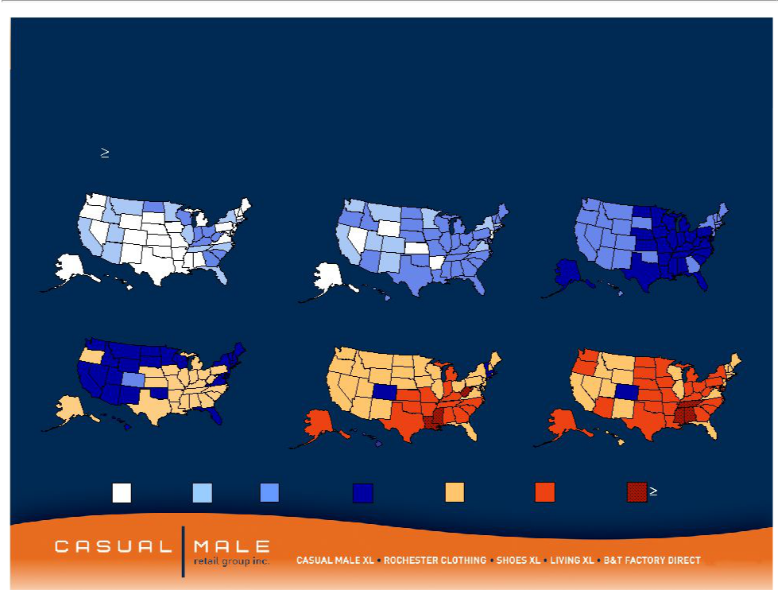
Market is growing as a percent to total menswear sales

Obesity Trends* Among U.S. Adults

(*BMI 30, or about 30 lbs overweight)
1985 | 1990 | 1995

2000 2005 2007

No Data <10% 10%–14%15%–19% 20%–24% 25%–29%30%

Source: CDC

3

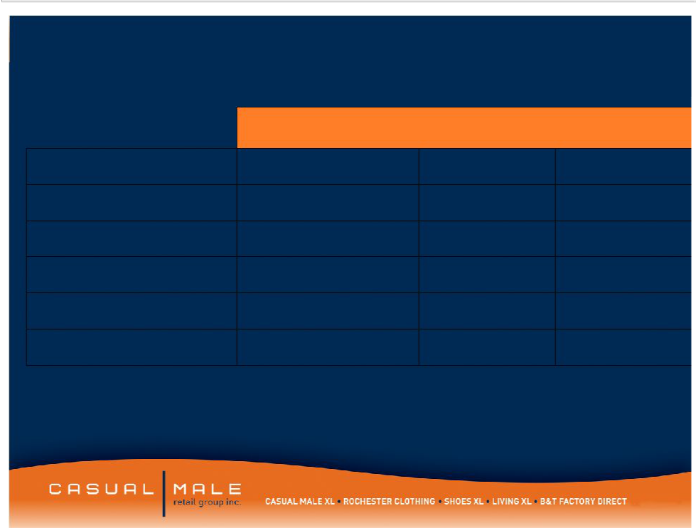
Selected Income Statement Information

 | 2009 Projected |  | 2008 | 2007
Sales | -11.0% to -12.0% |  | $444.2m | $464.1m
SG&A | $152.0m |  | $178.1m | $178.1m
Gross Margin | 43.7% - | 44.2% | 42.7% | 44.4%
Marketing Expense | $20.0m |  | $34.1m | $33.9m
Interest Expense | $1.0m |  | $3.0m | $4.3m
Free Cash Flow | $15.0m - | $20.0m | $7.6m | $-9.6m

- Free Cash Flow is defined as cash flow from operating activities, less capital expenditures and discretionary store asset acquisitions.

4

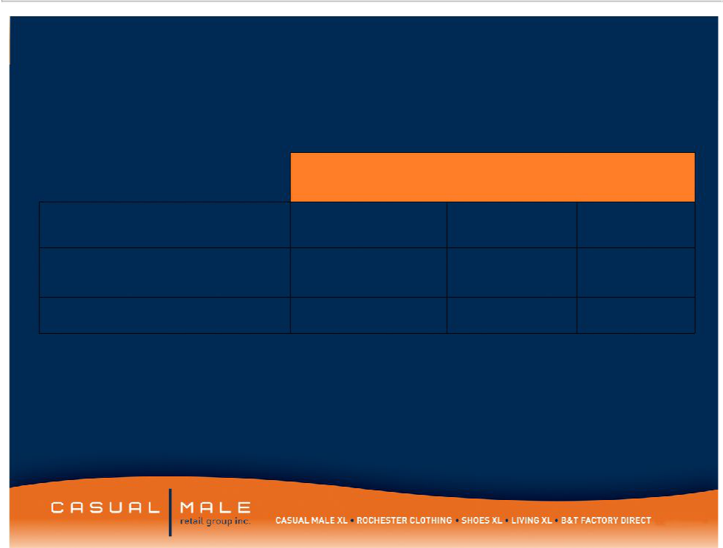
Selected Balance Sheet Information

 | 2009
 | Projected | 2008 | 2007
Inventory | $88.6m | $98.6m | $117.8m
Borrowing Under
Revolver | $7.5m -$10.0m | $38.7m | $41.0m
Fixed Term Loan | $7.0 - $8.0m | $12.5m | $17.3m

- Projected Borrowing Under Revolver includes the impact from the September 2009 sale of stock from a shelf registration.

5


Our Store Concepts

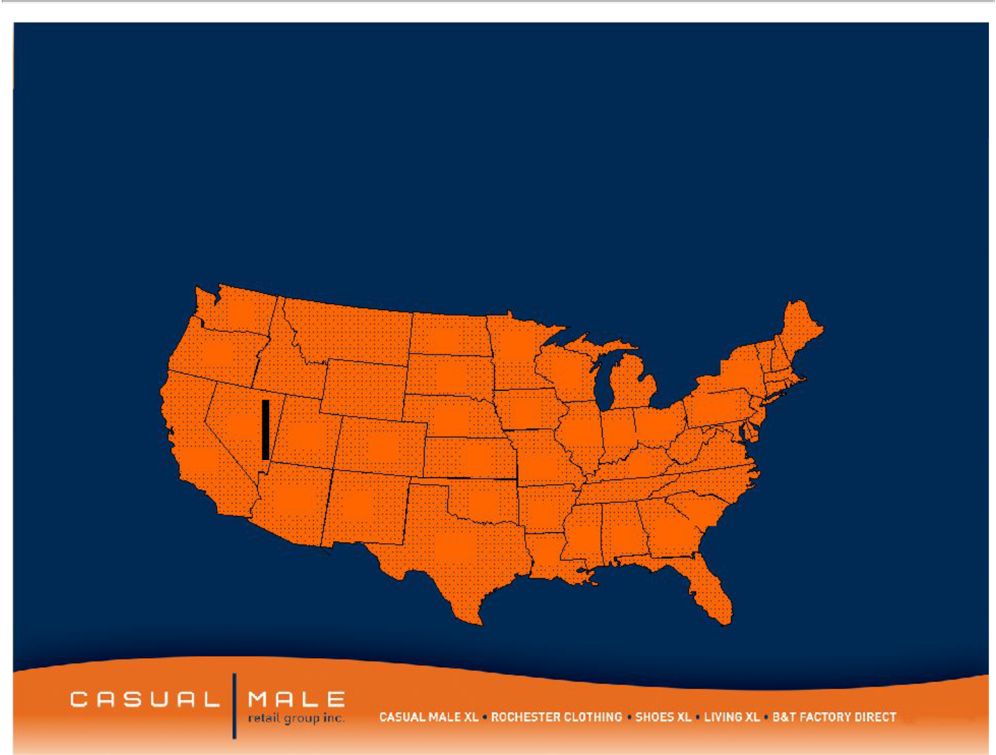
Casual Male Stores

- Casual Male XL is the nation’s largest specialty retailer of big & tall clothing with 396 full price stores and 65 outlet stores in 47 states
 |  |  |  |  |  |  |  |  |  | CT-10
 |  |  |  |  |  |  |  |  |  | DE-3
7 |  | 1 |  |  |  |  |  |  | 2 | RI-1
 |  | 1 |  |  |  |  |  |  | 2 | MA-13
 |  | 1 |  |  | 8 |  |  |  |  | MA-13
5 |  |  |  |  | 8 |  |  |  |  | MD-13
5 | 1 |  |  |  |  |  |  |  |  | MD-13
 | 1 | 1 |  |  | 8 |  |  | 32 |  | NH-3
 |  | 1 |  |  | 8 |  | 18 | 32 |  | NH-3
 |  |  |  |  |  |  | 18 | 26 |  | NJ-20
 |  | 4 |  |  | 4 |  |  | 26 |  | VT-1
6 |  | 4 |  |  | 4 |  | 17 |  |  | VT-1
6 | 3 |  |  |  | 23 | 12 | 17
 | 3 | 5 |  |  | 23 | 12 |  | 1
55 |  | 5 | 3 |  |  |  |  | 1
55 |  |  | 3 |  | 10 |  | 5 | 13
 | 10 |  |  |  |  | 8 |  | 11
 | 10 | 2 |  | 3 |  | 8
 | 10 | 2 |  | 3 | 2 |  |  | 5
 |  | 38 |  |  | 2 | 4 |  | 10
 |  | 38 |  |  | 5
 |  |  |  |  |  |  |  | 26

7

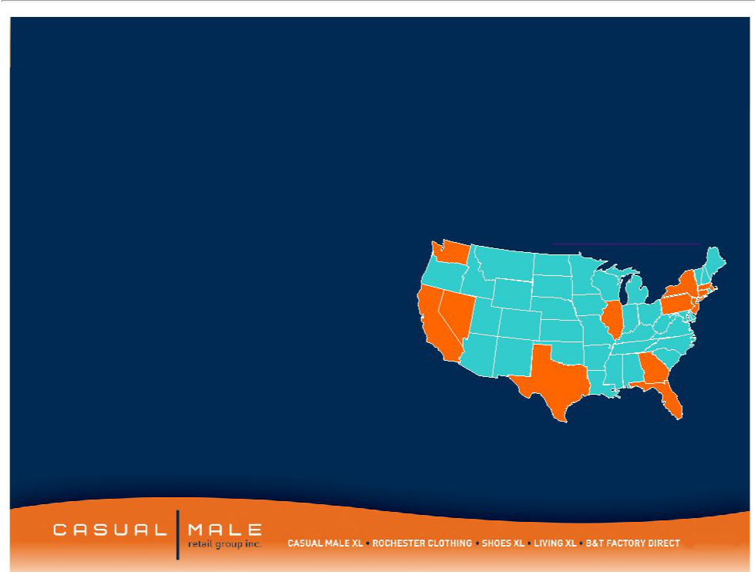

- Targets the higher income consumer within the big and tall market

– $100,000 per year average salary

- 20 store locations in downtown major metropolitan areas and upscale suburbs

- Average store size: 8,156 square ft

- Average sales / square foot: $256

– Stores carry higher-end designer product

– Average transaction size: $300

Rochester

 |  | Locations
 | 1
 |  |  | 3
 |  | 1
 | 1 | 1 | Ma-1
5 |  | 1 | Ma-1

DC-1

1

2

Rochester | 2
* 1 London, United Kingdom

8



Hybrid Stores


Concept

The Hybrid store, as conceived, is a combination Casual Male, Rochester store featuring the lifestyle sportswear apparel wardrobe needs offered by Casual Male, but with an added lifestyle of higher-end fashion apparel offered by Rochester and an enhanced Clothing section featuring the quality and fashion of Rochester Clothing and the price points of Casual Male clothing

10



OAKBROOK, IL •Hybrid Store Front

11


Hybrid Store Customers

- Prior Casual Male XL only customers are now spending 16% of their purchases on Rochester merchandise.

- Customers who previously shopped both Casual Male XL and Rochester Clothing are shopping more frequently.

- Prior Rochester only customers that are now shopping at a Hybrid store are spending 4% more than Rochester non-hybrid customers.

12



Destination XLTM _{TM}

DXLTM – Superstore concept

DXLTM Superstore – Customer Research

- Through customer research conducted in 2009, customers expressed the need for more apparel choices within one store concept supporting the concept of Destination XL.

– The Destination XL store concept received positive feedback from focus groups due to its comprehensive selection

– Customers willing to travel between 45 minutes to 1 hour on average to shop the store

14


DXLTM Store Concept

- DXL Store will range from 10,000 SF – 12,000 SF as compared to the average Casual Male Store of 3,500 SF

- DXL Store will combine all products at CMRG including Casual Male XL, Rochester Clothing, B&T Factory Direct, Living XL, and Shoes XL Expanding the assortment will offer consumers more than 3 times the current selection at Casual Male XL, allowing customers to select from a broad selection of price points and brands within each lifestyle.

- In addition to the expansive merchandise, DXL Store will house new services such as on-site tailors and online ordering presented in a new and exciting way.

15

DXLTM Store Concept

- With the re-branding of Casual Male Big and Tall to Casual Male XL, we experienced increased traffic and new customers. We anticipate the same results with the new DXL logo and store front,
attracting the smaller big and tall customer (42” – 44” waists)

- CMRG has a plan to open 5 to 10 DXL stores in major markets each year over the next several years.

- With the expansion of DXL stores, we will reduce the number of

Casual Male XL stores with a market which we anticipate will result in lower operating costs and higher profits per store.

16


DXLTM Schaumburg, IL

- Moving our current 5,000-square foot Casual Male XL store less than a mile down the road to a 12,000-square foot DXL store.

- We will roll in the two stores closest to Schaumburg, Bloomingdale and Niles 11.2 and 11.4 miles away respectively, with combined sales of close to one million dollars in 2008.

- We expect 4-Wall Store Cash Flow to increase from 21% in our existing 3 Casual Male XL stores to 30%-35% with the new DXL store.

17

9451 Schaumburg, IL

9512 Bloomingdale, IL

11.2 miles

DXL
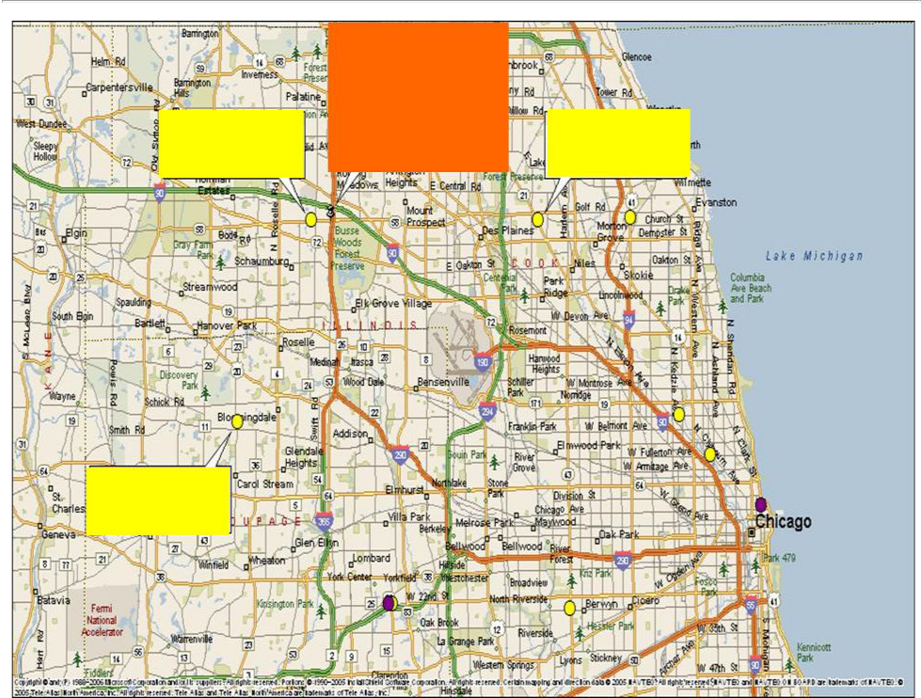

Schaumburg, IL

0.9 miles

9183 Niles, IL

11.4 miles


Invitation: Identity Application

SAMPLE ONLY – NOT FINAL

19

20

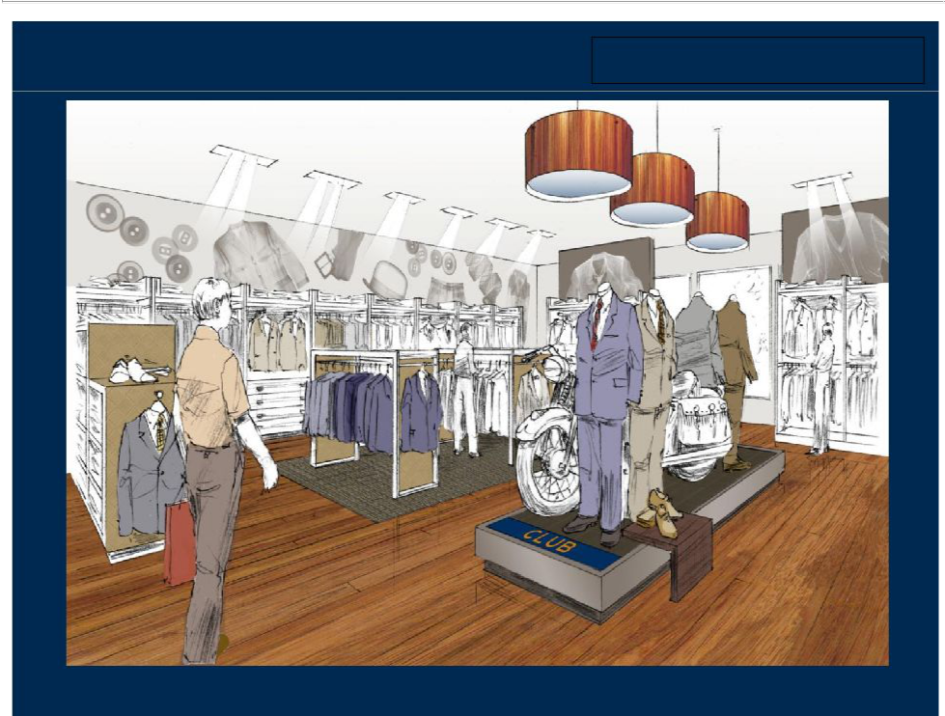
Club: Suits SAMPLE ONLY – NOT FINAL

21


Prototype

Only

22


Our Direct to Consumer Brands

CasualmaleXL.com

Rochesterclothing.com ^{Livingxl.com}

ShoesXL.com

BTDirect.com

23

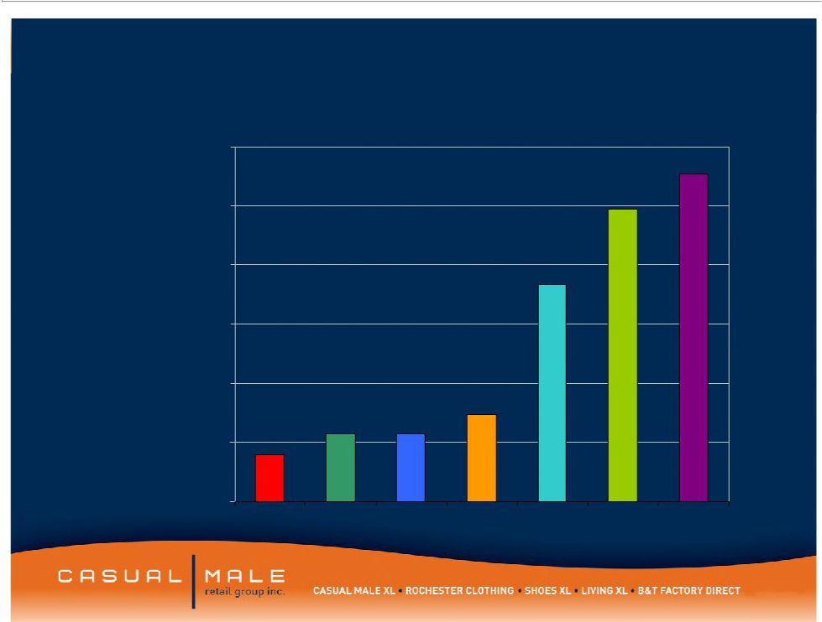
CMRG Internet Sales by Year

$60,000,000

$50,000,000

$40,000,000

$30,000,000

$20,000,000

$10,000,000

$0

2002 2003 2004 2005 2006 2007 2008

24



25



26



27



28



29


Europe

United Kingdom

France

Italy

Netherlands

Spain

Germany

30


Casual Male XL Program Rewards

- 2.6MM customers enrolled to date

- 85% of all Casual Male XL customers are enrolled

- Loyalty member’s average spend per transaction is 26% or $18 higher than non-members

- 90% of all transactions involve a loyalty member

31


Prestige XL Program 2009

- Launched a new level of the XL loyalty program in 2009 to 43,000 of Casual Male XL’s top customers.

- Benefits included double point promotions, presale opportunities as well as special recognition on all marketing collateral.

- Prestige customers spent almost $600 on clothing purchases in 2009.

32

Forward Looking Statements:

This presentation contains certain forward-looking statements concerning the
Company's operations, performance, and financial condition. Such forward-looking statements are subject to various risks and uncertainties that could cause actual results

to differ materially from those indicated. Such risks and uncertainties may include, but are not limited to: the failure to implement the Company's business plan for increased profitability and growth in the Company's retail stores sales and direct-to-consumer segments, the failure of management to develop the Company’s new direct to consumer businesses, the failure of changes in management to achieve improvement in the Company's competitive position, adverse changes in costs vital to catalog operations,

such as postage, paper and acquisition of prospects, declining response rates to catalog offerings, failure to maintain efficient and uninterrupted order-taking and fulfillment in our direct-to-consumer business, changes in or miscalculation of fashion trends, extreme or unseasonable weather conditions, economic downturns, escalation of energy costs, a weakness in overall consumer demand, increases in wage rates, the ability to hire and train associates, trade and security restrictions and political or financial

instability in countries where goods are manufactured, increases in raw material costs from inflation and other factors, the interruption of merchandise flow from the

Company's centralized distribution facilities, competitive pressures, and the adverse effects of natural disasters, war, acts of terrorism or threats of either, or other armed conflict, on the United States and international economies. These, and other risks and uncertainties, are detailed in the Company's filings with the Securities and Exchange
Commission, including the Company's Annual Report on Form 10-K for the fiscal year
ended January 31, 2009 filed on March 23, 2009 and other Company filings with the Securities and Exchange Commission. Casual Male assumes no duty to update or revise

its forward-looking statements even if experience or future changes make it clear that any projected results expressed or implied therein will not be realized.

33

