UNITED STATES

SECURITIES AND EXCHANGE COMMISSION
Washington, D.C. 20549

FORM 8-K

CURRENT REPORT

PURSUANT TO SECTION 13 OR 15(d) OF THE

SECURITIES EXCHANGE ACT OF 1934

Date of Report (Date of earliest event reported): September 15, 2009

0-15898

(Commission File Number)

CASUAL MALE RETAIL GROUP, INC.

 | (Exact name of registrant as specified in its charter)
Delaware | 04-2623104
(State of Incorporation) |  |  | (IRS Employer Identification Number)
 | 555 Turnpike Street, Canton, Massachusetts 02021
 | (Address of registrant’s principal executive office)
 | (781) 828-9300
 |  | (Registrant’s telephone number)

Check the appropriate box below if the Form 8-K filing is intended to simultaneously satisfy the filing obligation of the registrant under any of the following provisions (see General Instruction A.2. below):

- Written communications pursuant to Rule 425 under the Securities Act (17 CFR 230.425)

- Soliciting material pursuant to Rule 14a-12 under the Exchange Act (17 CFR 240.14a-12)

- Pre-commencement communications pursuant to Rule 14d-2(b) under the Exchange Act (17 CFR 240.14d-2(b))

- Pre-commencement communications pursuant to Rule 13e-4(c) under the Exchange Act (17 CFR 240.13e-4(c))

ITEM 7.01 - Regulation FD Disclosure

The Company will be presenting a slide presentation to various investment groups at upcoming investor conferences beginning on September 16, 2009. A copy of the slides to be presented at those conferences is attached to this report as Exhibit 99.1, which slide presentation is incorporated by reference herein.

The slide presentation contained in the exhibit includes statements intended as “forward-looking statements,” which are subject to the cautionary statement about forward-looking statements set forth in the exhibit. The slide presentation is being furnished, not filed, pursuant to Regulation FD. Accordingly, the slide presentation will not be incorporated by reference into any registration statement filed by the Company under the Securities Act of 1933, as amended, unless specifically identified therein as being incorporated therein by reference. The furnishing of the slide presentation is not intended to, and does not, constitute a determination or admission by the Company that the information in the slide presentation is material or complete, or that investors should consider this information before making an investment decision with respect to the Company.

Presentation of Non-GAAP Measures

The slide presentation includes the discussion of non-GAAP free cash flow on slides 4 and 7. Free cash flow is not a measure determined by generally accepted accounting principles (“GAAP”) and should not be considered superior to or as a substitute for net income (loss) or cash flows from operating activities or any other measure of performance derived in accordance with GAAP.

In addition, all companies do not calculate non-GAAP financial measures in the same manner and, accordingly, “free cash flows” as presented in this slide presentation may not be comparable to similar measures used by other companies. The Company calculates free cash flows as cash flow from operating activities less capital expenditures and discretionary store asset acquisitions, if any. We calculate projected free cash flows for fiscal 2009 of $20.0-$25.0 million as estimated cash flow from operating activities of $25.0-$30.0 million, less estimated capital expenditures of $5.0 million (no discretionary store asset acquisitions are anticipated in fiscal 2009). Free cash flow for fiscal 2008 of $7.6 million was calculated as cash flow from operating activities of $23.2 million less capital expenditures of $12.6 million and less $3.0 million for discretionary store asset acquisitions. Free cash flow for fiscal 2007 of $(9.6) million was calculated as cash flow from operating activities of $11.7 million less capital expenditures of $21.3 million. There were no discretionary store asset acquisitions in fiscal 2007. During the second quarter of fiscal 2009, we changed our method of calculating free cash flow to include, as a deduction, the use of cash for discretionary store asset acquisitions, if any. Accordingly, free cash flow for fiscal 2008, which was previously defined as cash flow from operating activities less capital expenditures, was restated to include, as a deduction, the cash used for discretionary store asset acquisitions of $3.0 million, for the Company’s acquisition of Dahle’s Big & Tall stores.

We believe that inclusion of this non-GAAP measure helps investors gain a better understanding of our performance, especially when comparing such results to previous periods

ITEM 9.01 - FINANCIAL STATEMENTS AND EXHIBITS

(d) Exhibits

Exhibit No. |  | Description
99.1 |  | Presentation | dated September 15, 2009

SIGNATURES

Pursuant to the requirements of the Securities Exchange Act of 1934, the registrant has duly caused this report to be signed on its behalf by the undersigned, thereunto duly authorized.

CASUAL MALE RETAIL GROUP, INC.

By: | /S/ DENNIS R. HERNREICH
Name: | Dennis R. Hernreich
Title: | Executive Vice President and Chief Financial Officer

Date: September 15, 2009

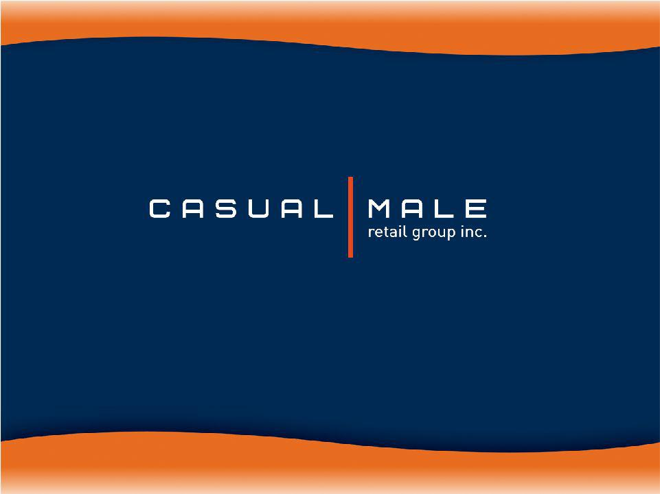
Exhibit 99.1

September 2009


Big & Tall Market

- Market defined as:

– big = waist size between 40” and 70”

– tall = height over 6’2”

- Big and tall men account for approximately 11% of the male population.

- Big and tall market size is approximately $6 billion and growing at almost twice the rate of the regular size men’s apparel market.

– Big & tall apparel market is highly fragmented; characterized by many small, local operators.

2

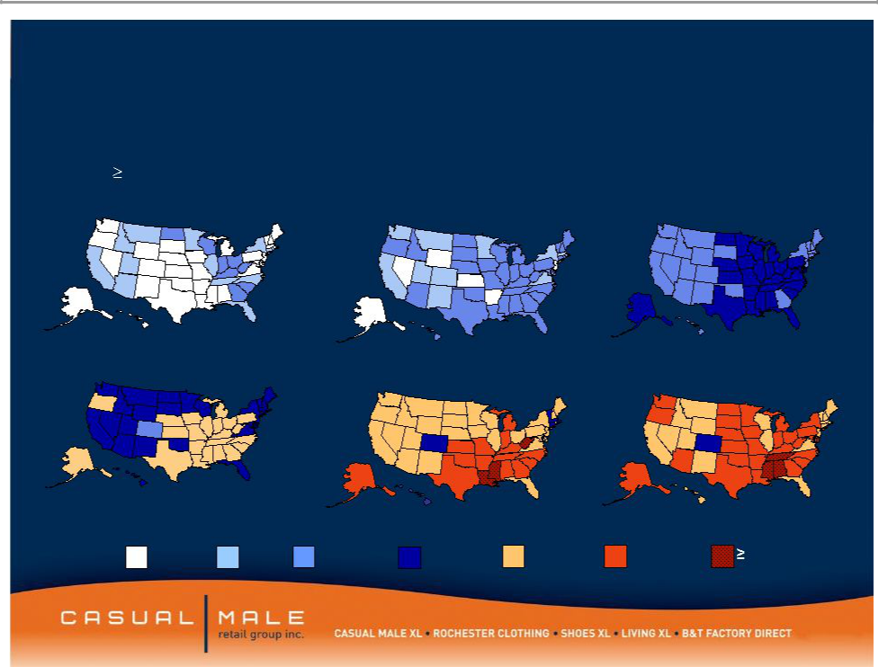
Market is growing as a percent to total menswear sales
Obesity Trends* Among U.S. Adults

(*BMI 30, or about 30 lbs overweight)
1985 | 1990 | 1995

2000 2005 2007

No Data | <10% | 10%–14%15%–19% | 20%–24% | 25%–29% | 30%
 |  |  |  |  | Source: CDC

3


2009

Goals

• Sales Decrease of 10% -

12%

• Generate Free Cash Flow between $20.0m -

$25.0m

- Maximize Availability under the Credit Facility and

pay down bank debt to $14.5m - | $18.0m

- Reduce Inventory Levels by 10.0% or $10.0m

- Reduce SG&A Expense by 15% to $151.0m

- Limit Capital Expenditures to $5.0m

- Improve Merchandise Margins between 275 to 325 basis points

• Improve our Customers’ Shopping Experience through enhanced sales training programs and the use of business productivity tools.

4

Sale of Common Stock

- On September 2, we sold 4,950,000 shares of common stock to institutional investors.

- Sale price of $2.75/share raised $13.6m of capital.

- Transaction costs of approximately $1.0m results in Net Proceeds of approximately $12.6m.

- Funds will be used to pay down revolving debt and used for working capital purposes.

5

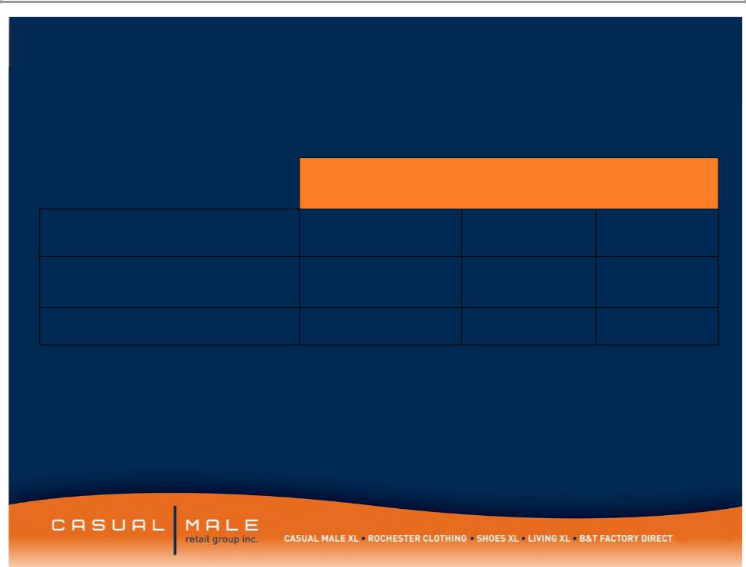
Selected Balance Sheet Information

 | 2009
 | Projected | 2008 | 2007
Inventory | $88.6m | $98.6m | $117.8m
Borrowing Under
Revolver | $7.5m – $10.0m | $38.7m | $41.0m
Fixed Term Loan | $7.0 - $8.0m | $12.5m | $17.3m

- Projected Borrowing Under Revolver includes the impact from the September 2009 sale of stock from a shelf registration.

6

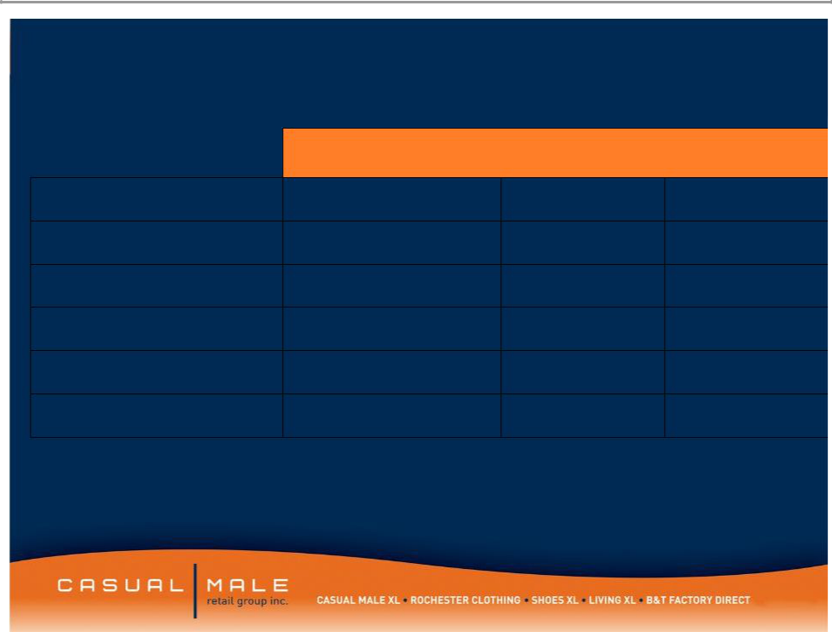
Selected Income Statement Information

 | 2009 Projected |  | 2008 | 2007
Sales | -10.0% to -12.0% |  | $444.2m | $464.1m
SG&A | $151.0m |  | $178.1m | $178.1m
Gross Margin | 43.7% – | 44.2% | 42.7% | 44.4%
Marketing Expense | $20.0m |  | $34.1m | $33.9m
Interest Expense | $1.0m |  | $3.0m | $4.3m
Free Cash Flow | $20.0m - | $25.0m | $7.6m | $-9.6m

- Free Cash Flow is defined as cash flow from operating activities, less capital expenditures and discretionary store asset acquisitions.

7

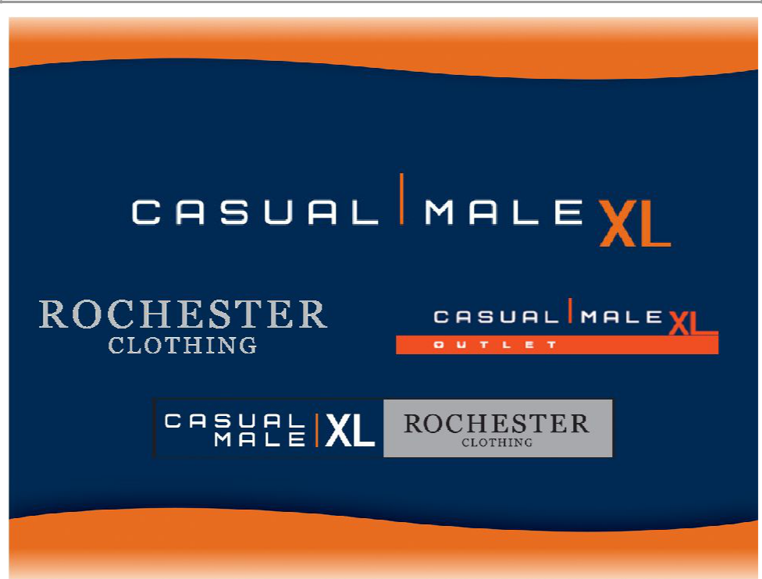
Our Store Concepts

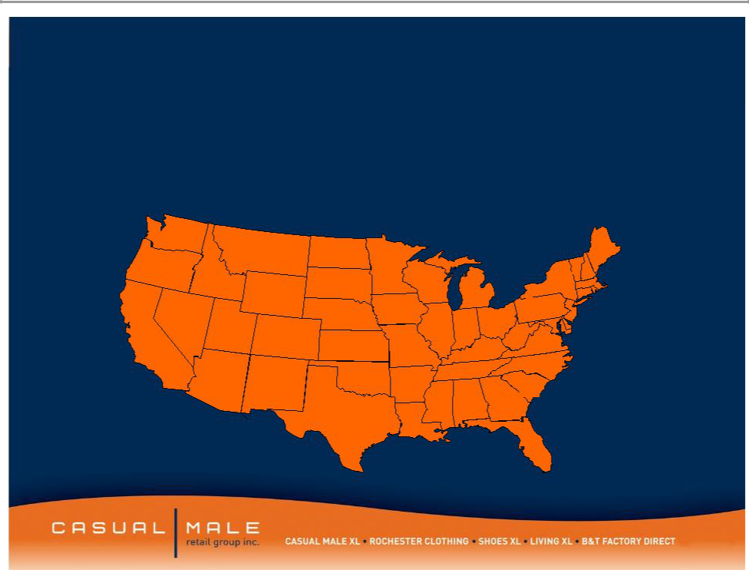
Casual Male Stores

- Casual Male XL is the nation’s largest specialty retailer of big & tall clothing with 401 full price stores and 65 outlet stores in 47 states
 |  |  |  |  |  |  |  |  |  |  |  | CT-10
 |  |  |  |  |  |  |  |  |  |  |  | DE-3
7 |  | 1 |  |  |  |  |  |  |  |  | 2 | RI-1
 |  | 1 | 1 |  |  |  |  |  |  |  | 2 | MA-13
 |  |  | 1 |  |  | 8 |  |  |  |  |  | MA-13
5 |  |  |  |  |  | 8 |  |  |  |  |  | MD-13
5 | 1 |  |  |  |  |  |  |  |  |  |  | MD-13
 | 1 |  | 1 |  |  |  | 8 |  |  | 33 |  | NH-3
 |  |  | 1 |  |  |  | 8 |  | 20 | 33 |  | NH-3
 |  |  |  |  |  |  |  |  | 20 | 25 |  | NJ-20
 |  |  | 4 |  |  | 4 |  |  |  | 25 |  | VT-1
6 | 3 |  | 4 |  |  | 4 | 23 | 12 | 19 |  |  | VT-1
 | 3 |  | 5 |  |  |  | 23 | 12 |  | 1
55 |  |  | 5 | 3 |  |  |  |  |  | 1
55 |  |  |  | 3 |  | 10 |  |  | 5 | 13
 | 10 |  |  |  |  |  |  | 8 |  | 11
 | 10 | 2 |  |  | 3 |  |  | 8
 | 10 | 2 |  |  | 3 | 2 |  |  |  | 5
Long term potential – |  |  | 39 |  |  |  | 2 | 4 |  | 10
 |  |  |  |  |  |  | 5

additional 100-130 more stores | 29

9

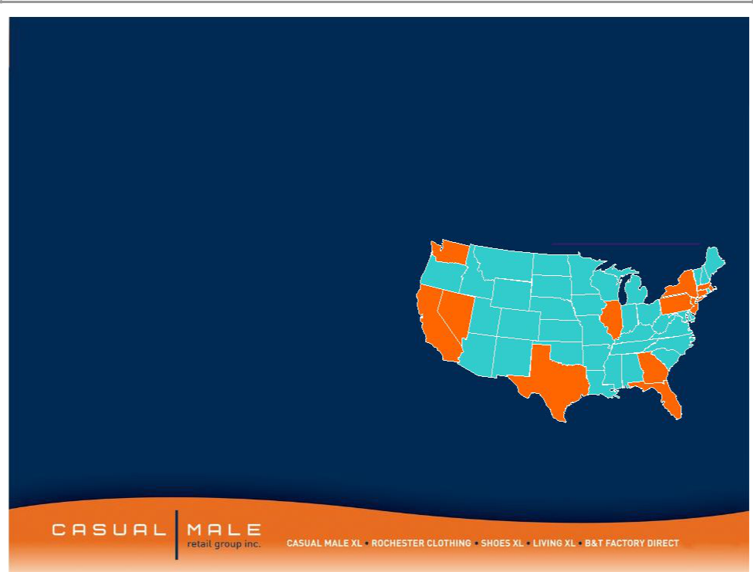

- Targets the higher income consumer within the big and tall market

– $100,000 per year average salary

- 22 store locations in downtown major metropolitan areas and upscale suburbs

- Average store size: 8,156 square ft

- Average sales / square foot: $256

– Stores carry higher-end designer product

– Average transaction size: $300

Rochester

 |  | Locations
 | 1
 |  |  | 3
 |  | 1
 | 1 | 1 | Ma-1
5 |  | 1 | Ma-1

CT-1

 |  | 1 | DC-1
 | 2 |  | DC-1
Rochester |  |  | 2
* 1 London, United Kingdom

10

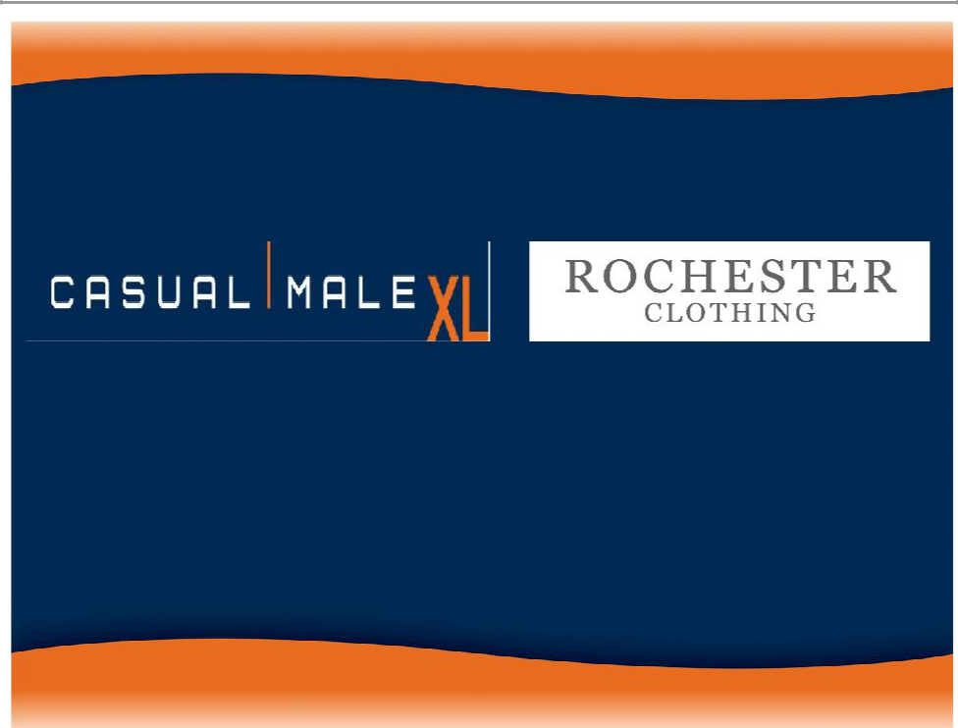

Hybrid Stores

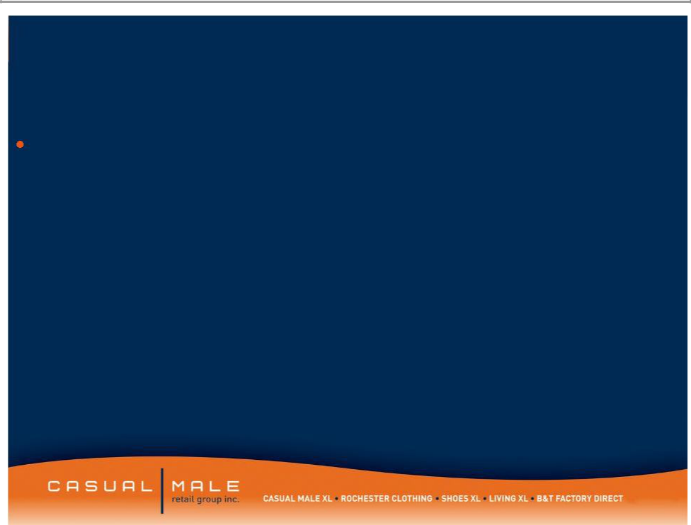
Concept

The Hybrid store, as conceived, is a combination Casual Male, Rochester store featuring the lifestyle sportswear apparel wardrobe needs offered by Casual Male, but with an added lifestyle of higher end fashion apparel offered by Rochester and an enhanced Clothing section featuring the quality and fashion of Rochester Clothing and the price points of Casual Male clothing

12

Hybrids

- Eliminated duplicative accessories/furnishings between combined Rochester and Casual Male.

- Good, better, best tiered offering with most of best coming from Rochester’s good and better assortment.

- Edited assortment for brands carried in both companies i.e. Polo, CK Jeans. Assortment will be merged presenting a broader range of price points and looks without duplication

- Store will be merchandised separately by brand except:

– Denim will be presented as a combined shop

– Sportswear will be presented by Brand

– Clothing/Furnishings will be merchandised as a combined shop

– Shoes will be set up as a service environment.

13

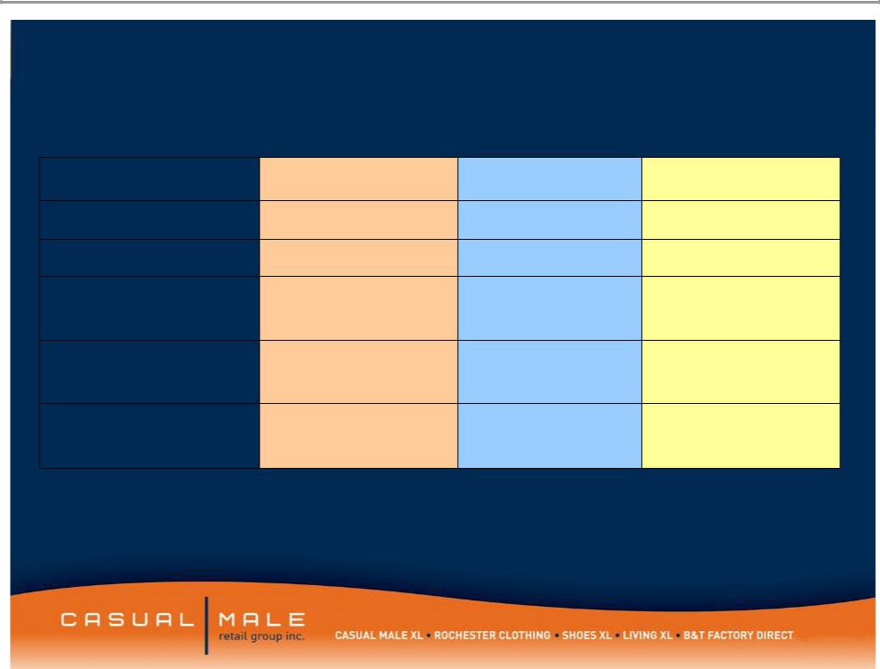
OPERATIONAL MODELS

 | Casual Male | Rochester | Hybrid Store
Square Footage | 3,515 | 8,156 | 9,045
Pricing | Moderate | High End | Mid-High Moderate
Average Unit | $32.10 | $74.90 | $45.00
Retail
Service | Semi Self Service | Full Service | Leaning Towards Full
 |  |  | Service
Tailoring | No Tailoring Service | Full Service | Full Service Tailoring
 | Offered | Tailoring

14

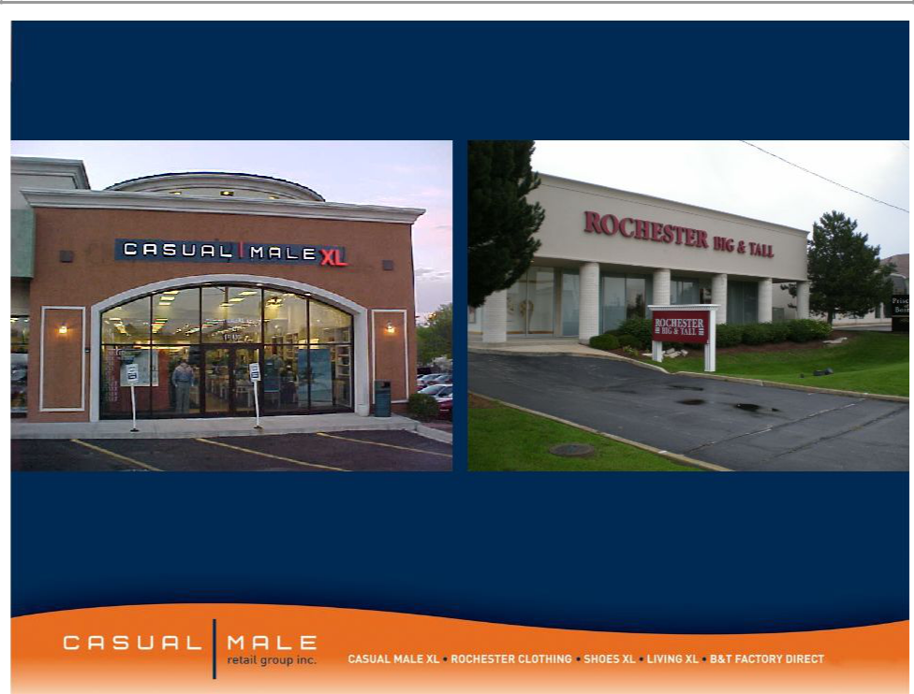

OAKBROOK, IL •Existing Locations

15

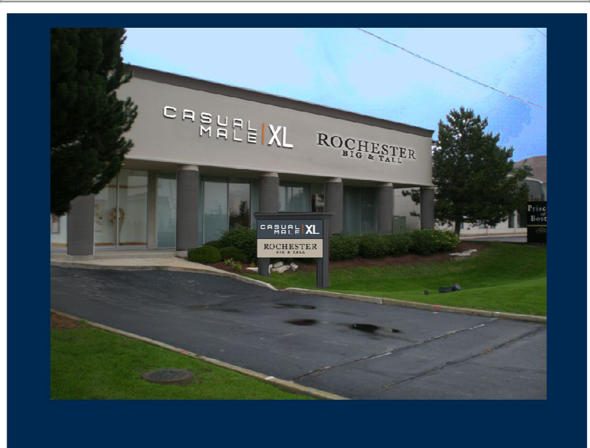

OAKBROOK, IL •Hybrid Store Front

16

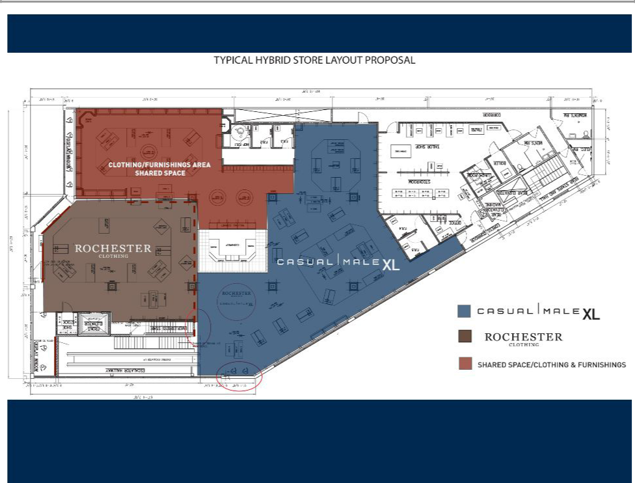

TYPICAL HYBRID STORE LAYOUT PROPOSAL

17

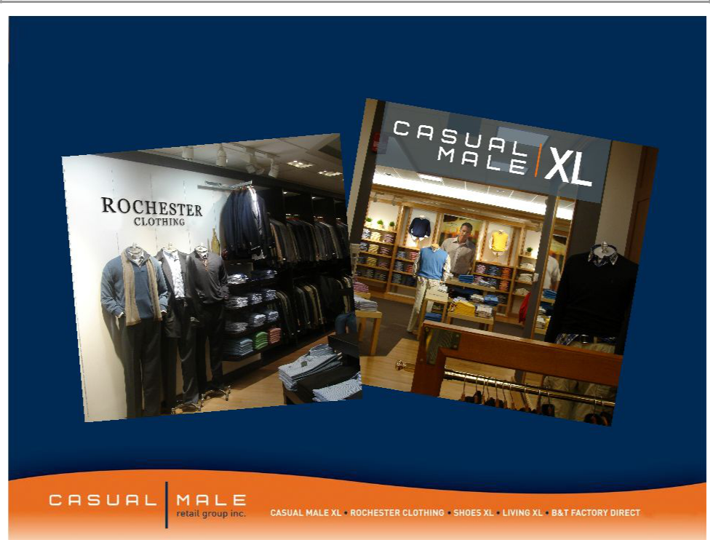

TYPICAL HYBRID STORE SHOP IDENTITY

LIGHT WOOD vs. DARK WOOD

18

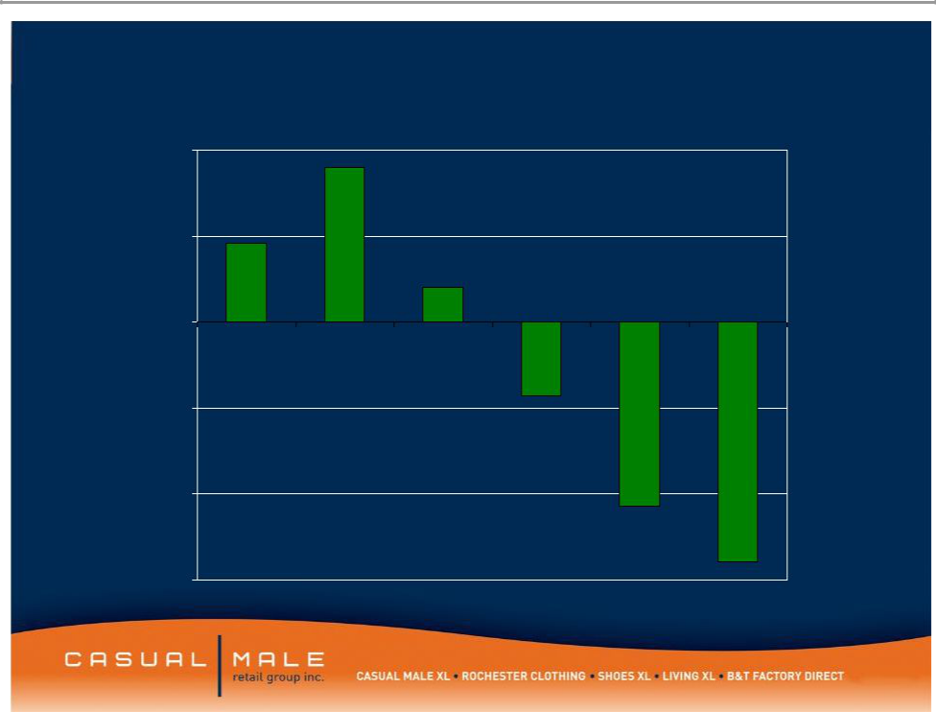
CMRG Comparable Sales Trend

0.1

0.05

2009

0

2005 2006 2007 2008 Q1 Q2

-0.05

-0.1

-0.15

19

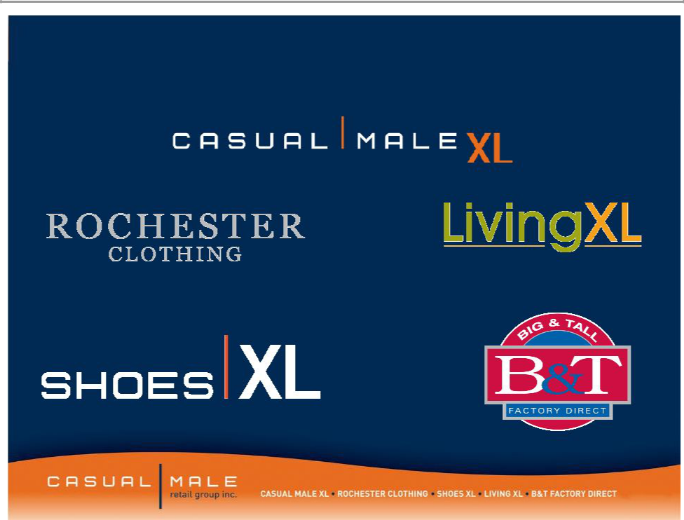
Our Direct to Consumer Brands

CasualmaleXL.com

Rochesterclothing.com ^{Livingxl.com}

ShoesXL.com

BTDirect.com

20

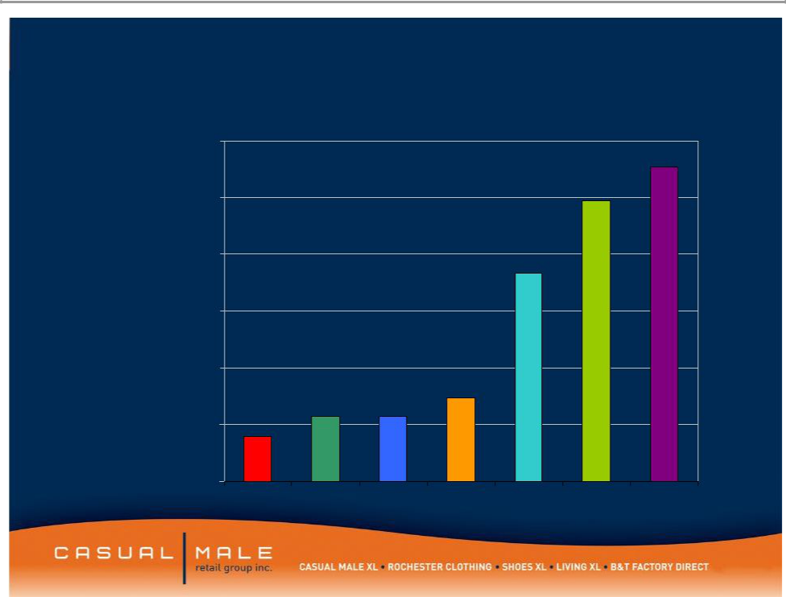
CMRG Internet Sales by Year

$60,000,000

$50,000,000

$40,000,000

$30,000,000

$20,000,000

$10,000,000

$0

2002 2003 2004 2005 2006 2007 2008

21

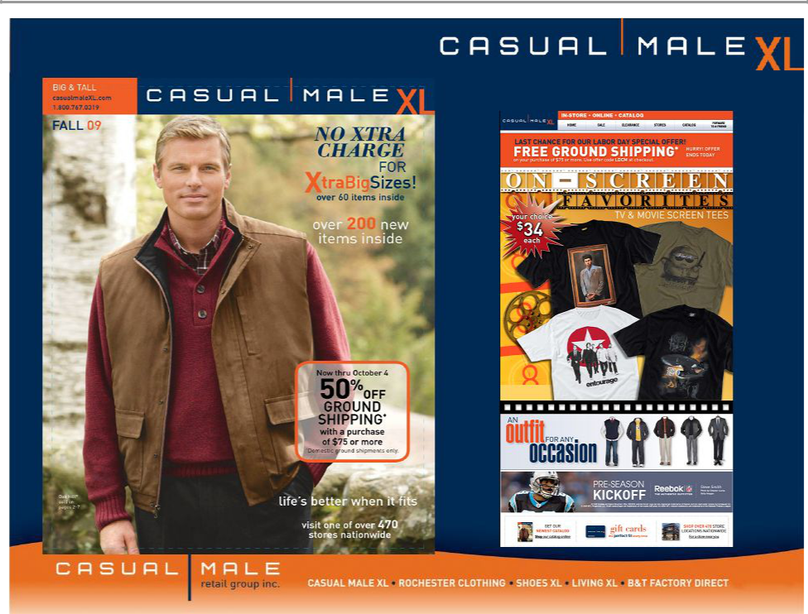

22

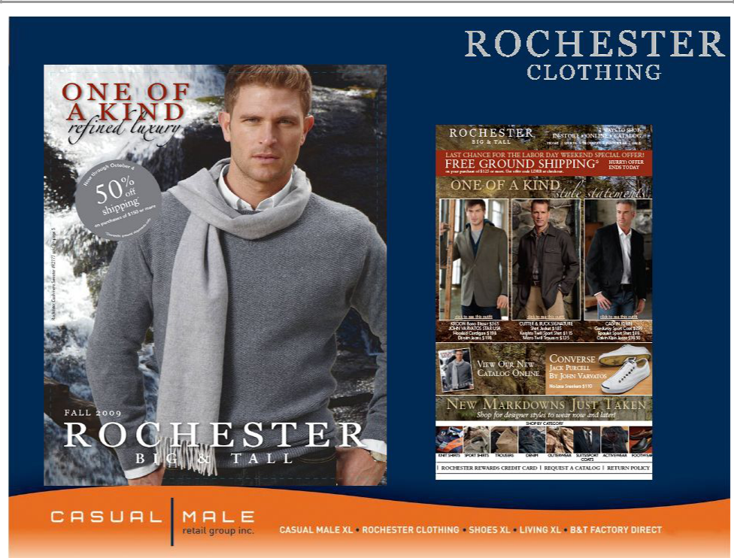

23

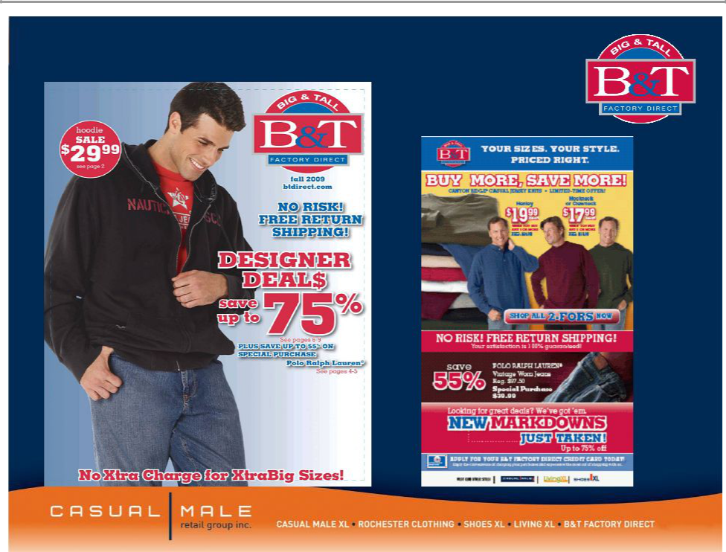

24

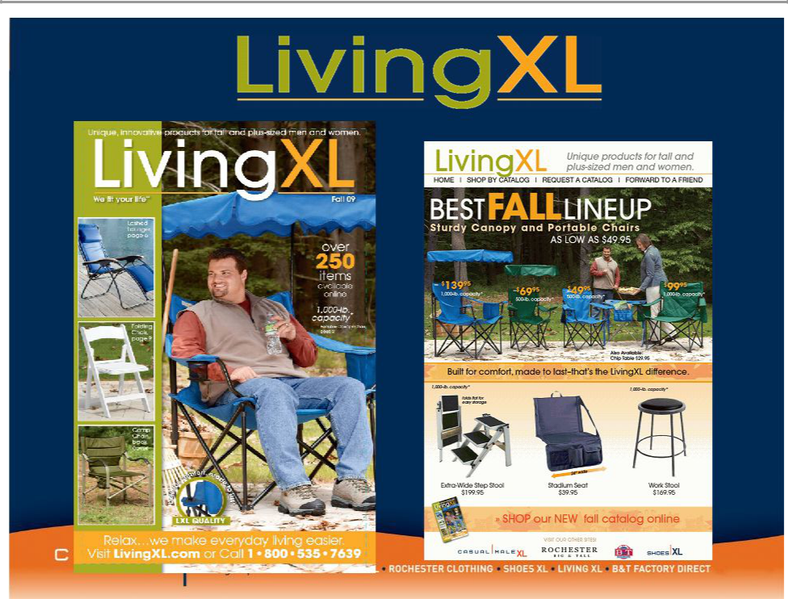

25

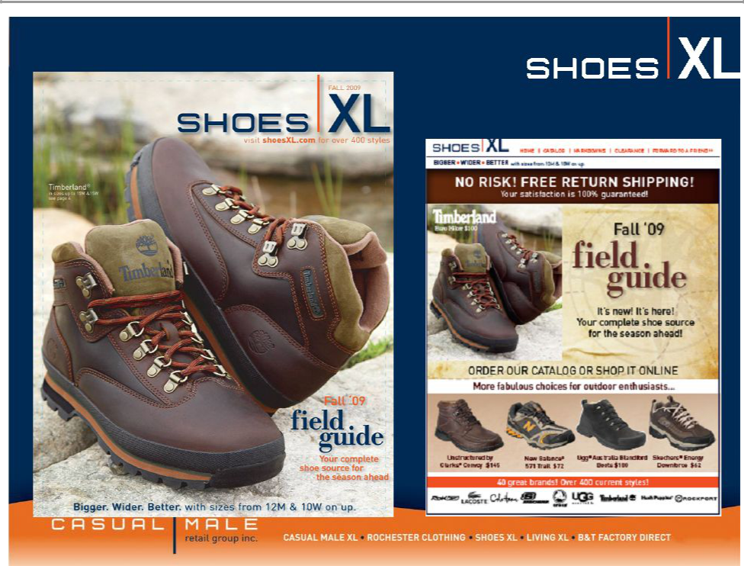

26

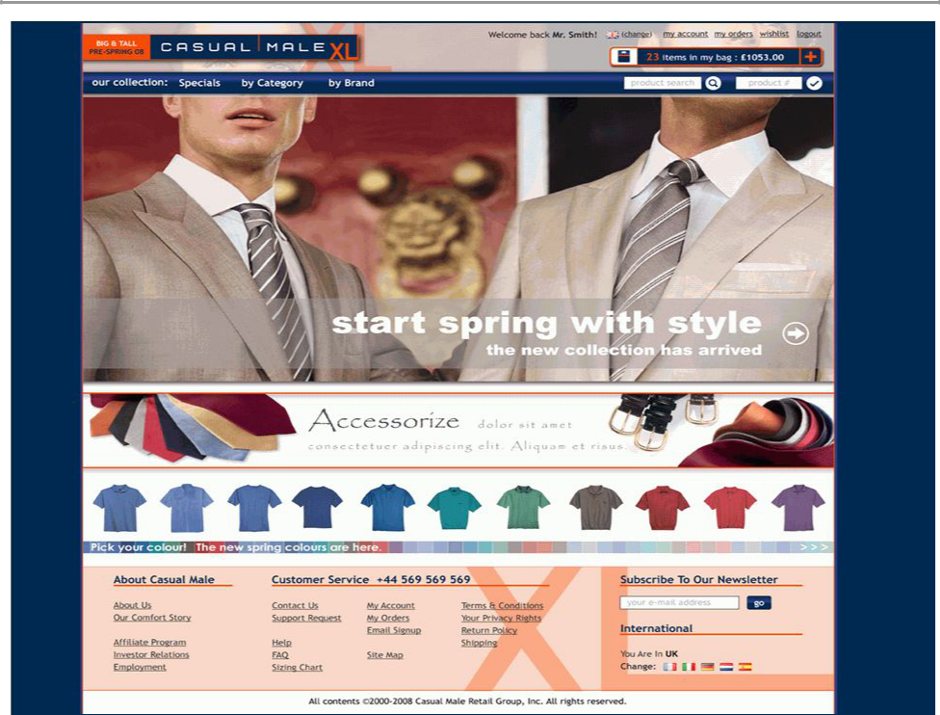

27


Obesity in Europe

- 135 million adults are affected by obesity

- Many countries more than half the adult population is overweight and 30% defined as clinically obese

- In most European countries 1 in 4 children are obese which is over 80 million children

28

Casual Male XL Loyalty Program Rewards

Current Program Performance:

- 2.2MM customers have been enrolled to date

- Of the 1.43MM retail customers, 1.18 or 83% are enrolled

- 83% of new customers captured in POS are being enrolled

- 88% of transactions involved an XL Rewards member

- Loyalty members average spend per transaction is 17% or $15 higher than non-members

- March 2009 Launched Prestige XL rewards for highest spending customers, spend over $1,000 per year

29

Forward Looking Statements:

This presentation contains certain forward-looking statements concerning the
Company's operations, performance, and financial condition. Such forward-looking statements are subject to various risks and uncertainties that could cause actual results

to differ materially from those indicated. Such risks and uncertainties may include, but are not limited to: the failure to implement the Company's business plan for increased profitability and growth in the Company's retail stores sales and direct-to-consumer segments, the failure of management to develop the Company’s new direct to consumer businesses, the failure of changes in management to achieve improvement in the Company's competitive position, adverse changes in costs vital to catalog operations,

such as postage, paper and acquisition of prospects, declining response rates to catalog offerings, failure to maintain efficient and uninterrupted order-taking and fulfillment in our direct-to-consumer business, changes in or miscalculation of fashion trends, extreme or unseasonable weather conditions, economic downturns, escalation of energy costs, a weakness in overall consumer demand, increases in wage rates, the ability to hire and train associates, trade and security restrictions and political or financial

instability in countries where goods are manufactured, increases in raw material costs from inflation and other factors, the interruption of merchandise flow from the

Company's centralized distribution facilities, competitive pressures, and the adverse effects of natural disasters, war, acts of terrorism or threats of either, or other armed conflict, on the United States and international economies. These, and other risks and uncertainties, are detailed in the Company's filings with the Securities and Exchange
Commission, including the Company's Annual Report on Form 10-K for the fiscal year

ended January 31, 2009 filed on March 23, 2009 and other Company filings with the Securities and Exchange Commission. Casual Male assumes no duty to update or revise

its forward-looking statements even if experience or future changes make it clear that any projected results expressed or implied therein will not be realized.

30

