UNITED STATES

SECURITIES AND EXCHANGE COMMISSION
Washington, D.C. 20549

FORM 8-K

CURRENT REPORT

PURSUANT TO SECTION 13 OR 15(d) OF THE

SECURITIES EXCHANGE ACT OF 1934

Date of Report (Date of earliest event reported): April 7, 2005

0-15898

(Commission File Number)

CASUAL MALE RETAIL GROUP, INC.

(Exact name of registrant as specified in its charter)

Delaware

04-2623104

(State of Incorporation)

(IRS Employer
Identification Number)

555 Turnpike Street, Canton, Massachusetts 02021

(Address of registrant’s principal executive office)

(781) 828-9300

(Registrant’s telephone number)

Check the appropriate box below if the Form 8-K filing is intended to simultaneously satisfy the filing obligation of the registrant under any of the following provisions (see General Instruction A.2. below):

- Written communications pursuant to Rule 425 under the Securities Act (17 CFR 230.425)

- Soliciting material pursuant to Rule 14a-12 under the Exchange Act (17 CFR 240.14a-12)

- Pre-commencement communications pursuant to Rule 14d-2(b) under the Exchange Act (17 CFR 240.14d-2(b))

- Pre-commencement communications pursuant to Rule 13e-4(c) under the Exchange Act (17 CFR 240.13e-4(c))

ITEM 7.01 - Regulation FD Disclosure

Casual Male Retail Group, Inc. (the “Company”) is scheduled to present at the Sidoti & Company, LLC, Ninth Annual New York Emerging Growth Institutional Investor Forum on April 7, 2005. A copy of the slides to be presented are attached to this report as Exhibit 99.1, which slide presentation is incorporated by reference herein.

The slide presentation contained in the exhibit includes statements intended as “forward-looking statements,” which are subject to the cautionary statement about forward-looking statements set forth in the exhibit. The slide presentation is being furnished, not filed, pursuant to Regulation FD. Accordingly, the slide presentation will not be incorporated by reference into any registration statement filed by the Company under the Securities Act of 1933, as amended, unless specifically identified therein as being incorporated therein by reference. The furnishing of the slide presentation is not intended to, and does not, constitute a determination or admission by the Company that the information in the slide presentation is material or complete, or that investors should consider this information before making an investment decision with respect to the Company.

ITEM 9.01 - FINANCIAL STATEMENTS AND EXHIBITS

(c) Exhibits

Exhibit No. |  | Description
99.1 |  | Presentation dated April 4, 2005

Page 2

SIGNATURES

Pursuant to the requirements of the Securities Exchange Act of 1934, the registrant has duly caused this report to be signed on its behalf by the undersigned, thereunto duly authorized.

CASUAL MALE RETAIL GROUP, INC.

By: /S/ DENNIS R. HERNREICH

Name: Dennis R. Hernreich

Title: Executive Vice President

and Chief Financial Officer

Date: April 7, 2005

Page 3

EXHIBIT 99.1
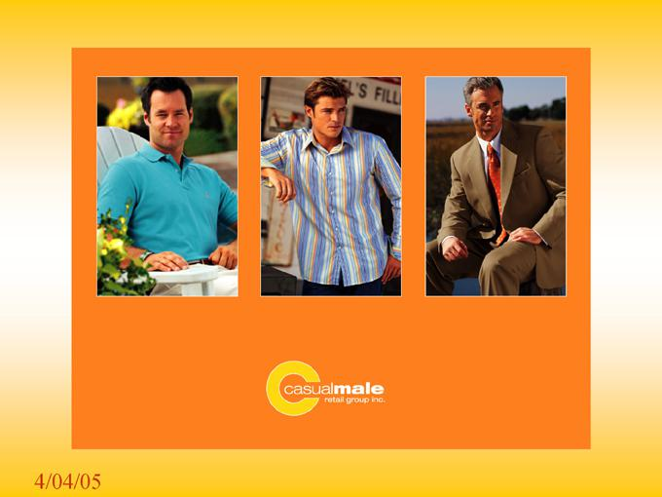

4/04/05

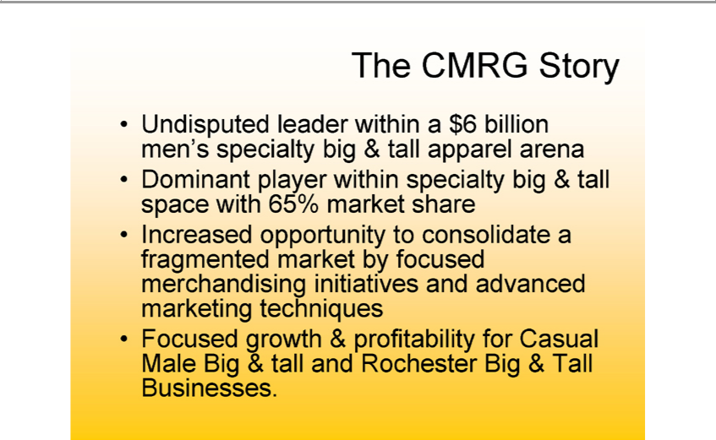

The CMRG Story
Undisputed leader within_{specialty}$6billion men’s specialty big & tall apparel arena
Dominant player within big & tall space with 65% market share
Increased opportunity to consolidate^{Casual}fragmented market by focused merchandising initiatives and advanced marketing techniques
Focused growth & profitability for Male Big & tall and Rochester Big & Tall Businesses.

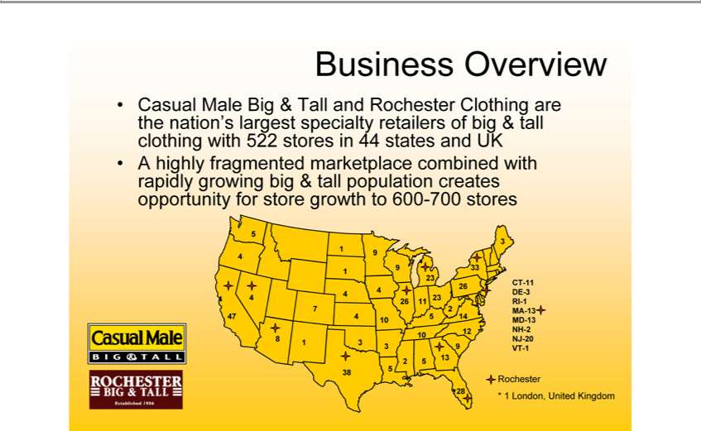

Business Overview | in 44 states and UK
Casual Male Big & Tall and Rochester Clothing are the nation’s largest specialty retailers of big & tall clothing with 522 | in 44 states and UK
A highly fragmented marketplace combined with rapidly growing big & tall population creates opportunity for store growthstores 600-700 stores CT-11
DE-3
RIMD^{A}-1-13
NJ^{H-}20⁻
RochesterVT-1

1 London, United Kingdom

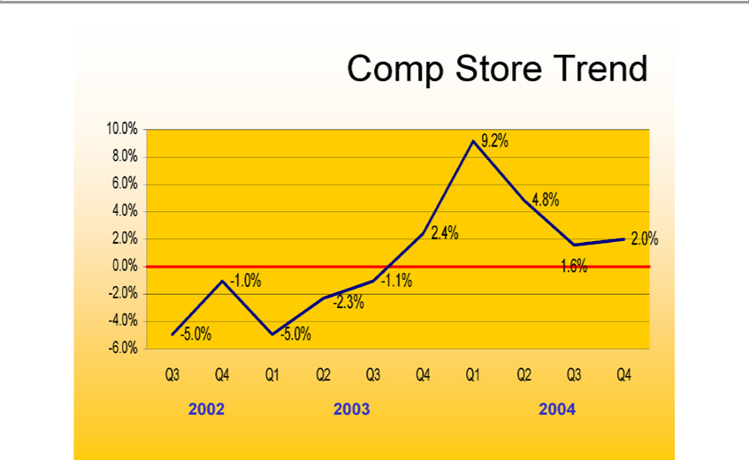

Comp Store Trend
810.0%
46
².0%
0₂
4
6
5
¹ 0%
⁵
-¹².1%3%
2 4%
⁴⁹ 6%_{2%}8%
2¹.0%
Q3 Q4 Q1 Q2 Q3 Q4 Q1 Q2 Q3 Q4

2002 2003 2004

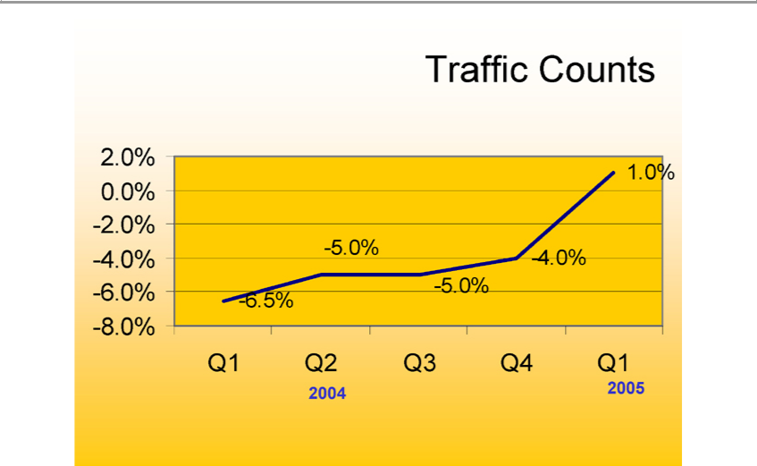

Traffic Counts
0².0%
4₂
⁶ 0%
⁸ 5%
6
⁵
-4.0%
_{Q1}.0%
Q2 Q3 Q4 Q1

2004 2005

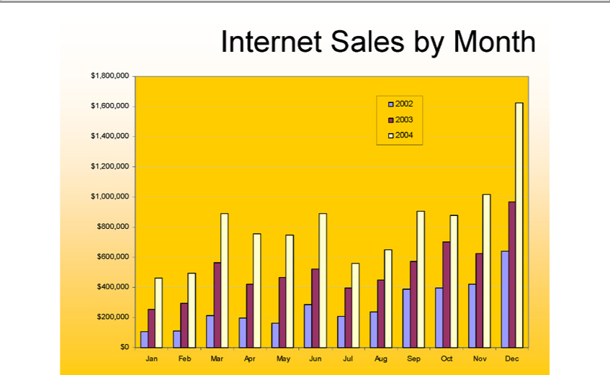

Internet⁸6 Sales by Month

24

1,00 ,000

8

6
4

$0200,000
2002 2003 2004
Jan Feb Mar Apr May Jun Jul Aug Sep Oct Nov Dec

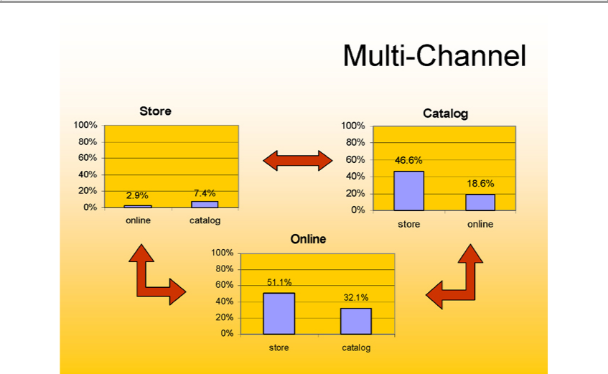

StoreMulti-Channel
100% 80% 60% 40% 20% 0%
2_{.4%}9%
Catalog7online catalog
100% 80% 60% 40% 20% 0%
⁴⁶.6%
Online18 store online
100% 80% 60% 40% 20% 0% store catalog
⁵¹.1%
32

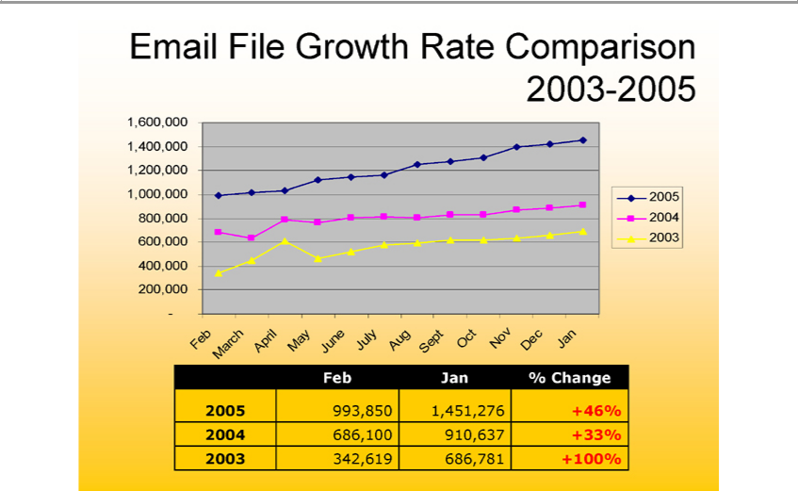

Email File Growth Rate Comparison 2003-2005
²⁰⁰³
20051,600,00020041,4 0,000 1,200,000 1,000,000 800,000 600,000 400,000 200,000 -
Feb
March
April
May
July^{ne}
Aug
Sept
Oct
Nov
Dec
Jan
Feb Jan % Change
⁴5 ⁶⁸⁶993 ¹⁰⁰850 1,451,276 +46%
2003 342,619 686,781⁹¹⁰⁶³⁷ +100%^{33%}

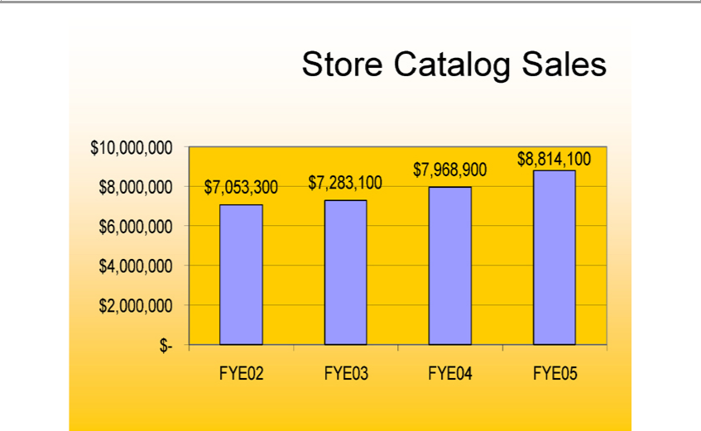

Store Catalog Sales
10, | 0, | 0
8
6
4
2,000,000
-$₂₈₃7,053,300₁
$8,814,10079689
FYE02 FYE03 FYE04 FYE05

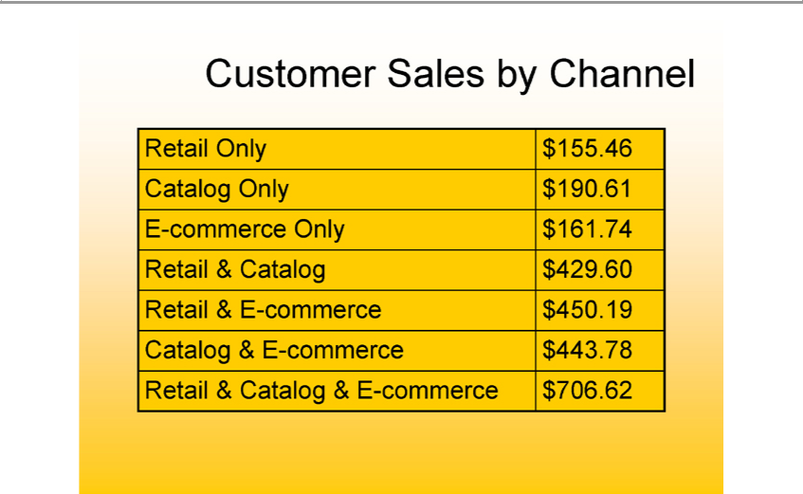

Customer Sales by Channel
Re | il Only $155.46
Catalog Only $190.
E-commerce Only |  | $161.74
Re | Catalog $429.60
Re | il & E- | $450.19
Ca | log & Ecommerce- |  | $443.78
Retail & Catalog & E-commerce $706.62

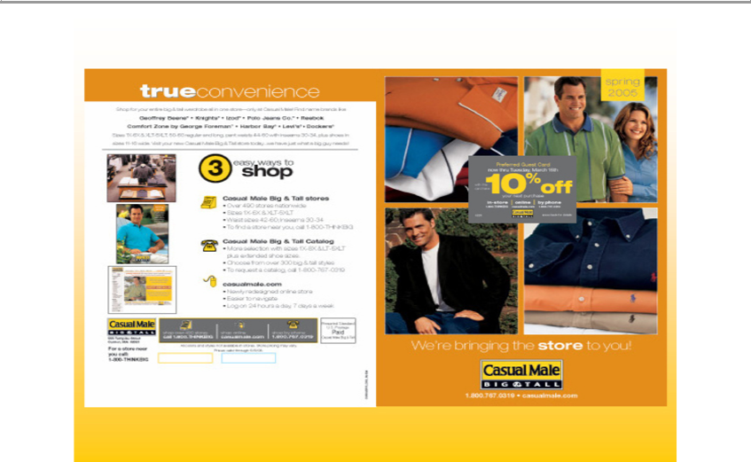

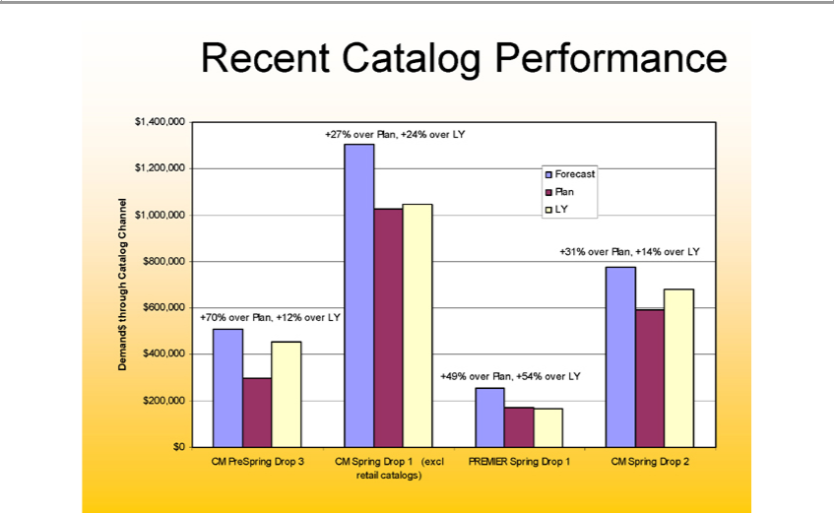

Recent Ca alog Performance |  | $1,200,000 | $1,000,000 | $800,000 | $600,000 | $400,000 | $200,000 | $0
Demand$ through Catalog Channel $1,400,000
_{27%}70% | 12%
49% | 5
+31% over Plan, +14% over LY
Forecast Plan LY
CM PreSpring Drop 3
Drop 1 (excl retail catalogs)



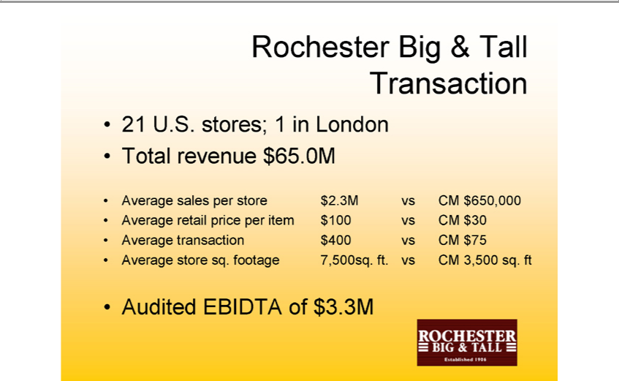

Rochester Big & Tall Transaction
Total21U.S.revenuestores;$165.0MinLondon
retailsales perpricestoreper $item2.3M$100vsCMvsCM$650,000$30
_{verage} transaction $400 vs CM $75
_{Audited} EBIDTAstoresq. footageof$3.3M7,500sq. ft. vs CM 3,500 sq. ft

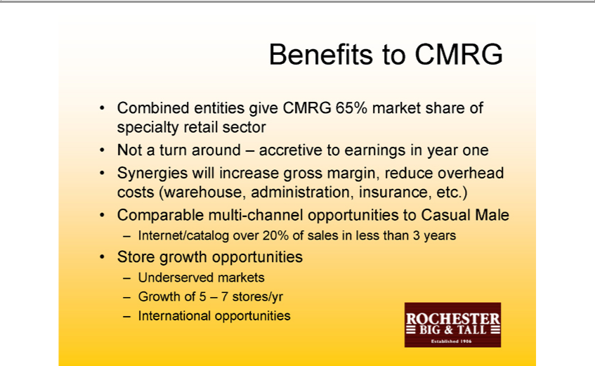

Benefits to CMRG
NotCombinedaturn aroundentities –giveaccretiveCMRGto 65%earningsmarketin yearshareoneof specialty retail sector
ComparableSynergieswillmultiincrease-channelgrossopportunitiesmargin,reducetoCasualoverheadMalecosts (warehouse, administration, insurance, etc.)
StoreInternet/cataloggrowthopportunitiesover20%of sales in less than 3 years
Underserved markets
InternationalGrowthof5 –opportunities7stores/yr

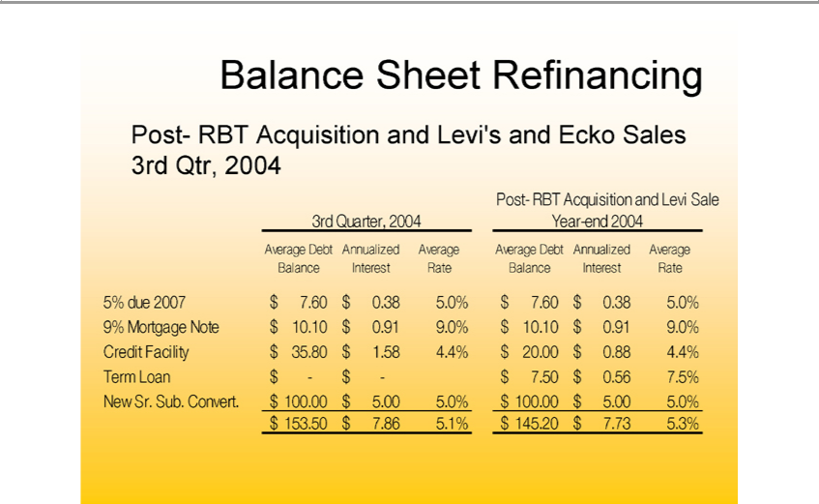

Balance Sheet Refinancing
Post- RBT Acquisition and Levi’s and Ecko Sales 3rd Qtr, 2004 Sale

BalanceAverage InterestDebtAnnualizedRateBalanceAverageInterestAverageRate Debt Annualized Average
^{9%} ^{0%}
5% Mortgagedue2007 $Note7.60 $$0.3810.¹⁰5.$ .91$7.609.0%$0.38$10.5.0%¹⁰$ 0.91 9.0%
TermCreditLoanFacility$- $$ -35.80$7.50$ ₁₀₀$.58.564.4%7._{5%}$ 20.00 $ .88 4.4%
$New153.50Sr.Sub.$7.86Convert.5.1%$$145.20.00$$7.73.005.3%5.0% $ 100.00 $ 5.00 5.0%

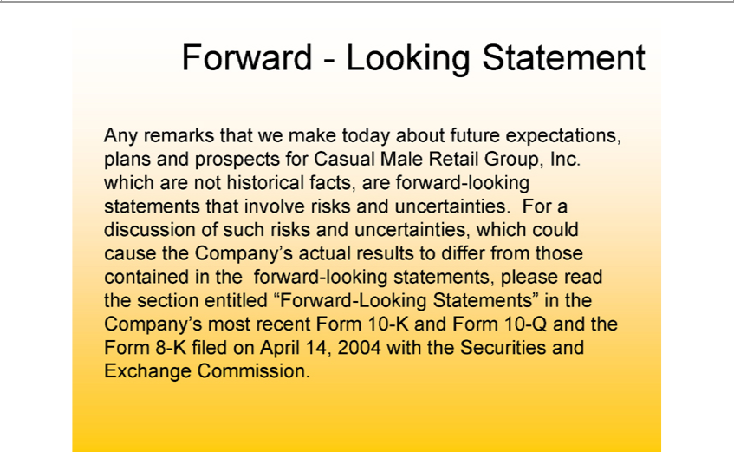

Forward - Looking Statement
Any remarks that we make today about future expectations, plans and prospects for Casual Male Retail Group, Inc. which are not historical facts, are forward-looking statements that involve risks and uncertainties. For a discussion of such risks and _{uncertainties,} which could cause the Company’s actual results to differ from those contained in the forward-looking statements, please read the section entitled “Forward-Looking Statements” in the Company’ most recent Form 10-K and Form 10-Q and the Form 8-K filed on April 14, 2004 with the Securities and Exchange Commission.

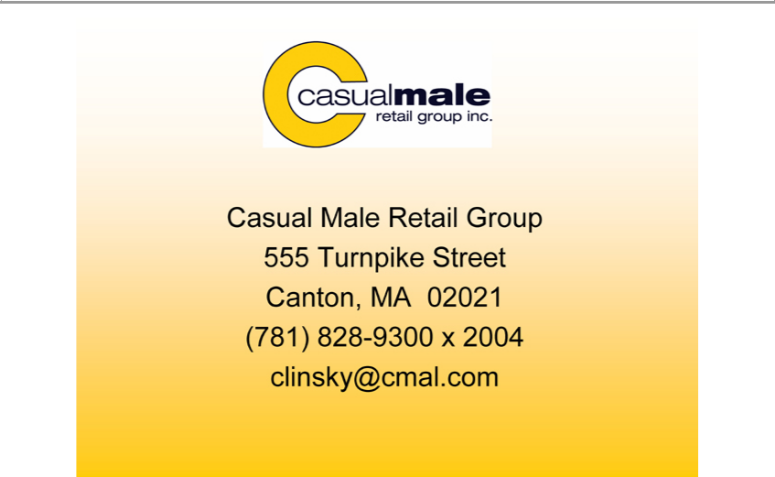

Casual Male Retail Group 555 Turnpike Street Canton, MA 02021 (781) 828-9300 x 2004 clinsky@cmal.com

