UNITED STATES

SECURITIES AND EXCHANGE COMMISSION

Washington, D.C. 20549

FORM 8-K

CURRENT REPORT

PURSUANT TO SECTION 13 OR 15(d) OF THE

SECURITIES EXCHANGE ACT OF 1934

Date of Report (Date of earliest event reported): June 2, 2008

0-15898

(Commission File Number)

CASUAL MALE RETAIL GROUP, INC.

(Exact name of registrant as specified in its charter)

Delaware

04-2623104

(State of Incorporation)

(IRS Employer Identification Number)

555 Turnpike Street, Canton, Massachusetts 02021

(Address of registrant’s principal executive office)

(781) 828-9300

(Registrant’s telephone number)

Check the appropriate box below if the Form 8-K filing is intended to simultaneously satisfy the filing obligation of the registrant under any of the following provisions (see General Instruction A.2. below):

- Written communications pursuant to Rule 425 under the Securities Act (17 CFR 230.425)

- Soliciting material pursuant to Rule 14a-12 under the Exchange Act (17 CFR 240.14a-12)

- Pre-commencement communications pursuant to Rule 14d-2(b) under the Exchange Act (17 CFR 240.14d-2(b))

- Pre-commencement communications pursuant to Rule 13e-4(c) under the Exchange Act (17 CFR 240.13e-4(c))

ITEM 7.01—Regulation FD Disclosure

The Company has updated its slide presentation as filed via Form 8-K on April 25, 2008 to include three additional slides. A copy of the additional slides is attached to this report as Exhibit 99.1 and is incorporated by reference herein. The updated slide presentation will be presented at upcoming meetings with various investment groups.

The slides contained in the exhibit include statements intended as “forward-looking statements,” which are subject to the cautionary statement about forward-looking statements set forth in the exhibit. The slides are being furnished, not filed, pursuant to Regulation FD. Accordingly, the slides will not be incorporated by reference into any registration statement filed by the Company under the Securities Act of 1933, as amended, unless specifically identified therein as being incorporated therein by reference. The furnishing of the slides is not intended to, and does not, constitute a determination or admission by the Company that the information in the slides is material or complete, or that investors should consider this information before making an investment decision with respect to the Company.

ITEM 9.01—FINANCIAL STATEMENTS AND EXHIBITS

- Exhibits

Exhibit No. |  | Description
99.1 | Additional Slides to Slide Presentation dated April 24, 2008

SIGNATURES

Pursuant to the requirements of the Securities Exchange Act of 1934, the registrant has duly caused this report to be signed on its behalf by the undersigned, thereunto duly authorized.

CASUAL MALE RETAIL GROUP, INC.

By: /S/ DENNIS R. HERNREICH

Name: Dennis R. Hernreich

Title: Executive Vice President

and Chief Financial Officer

Date: June 2, 2008

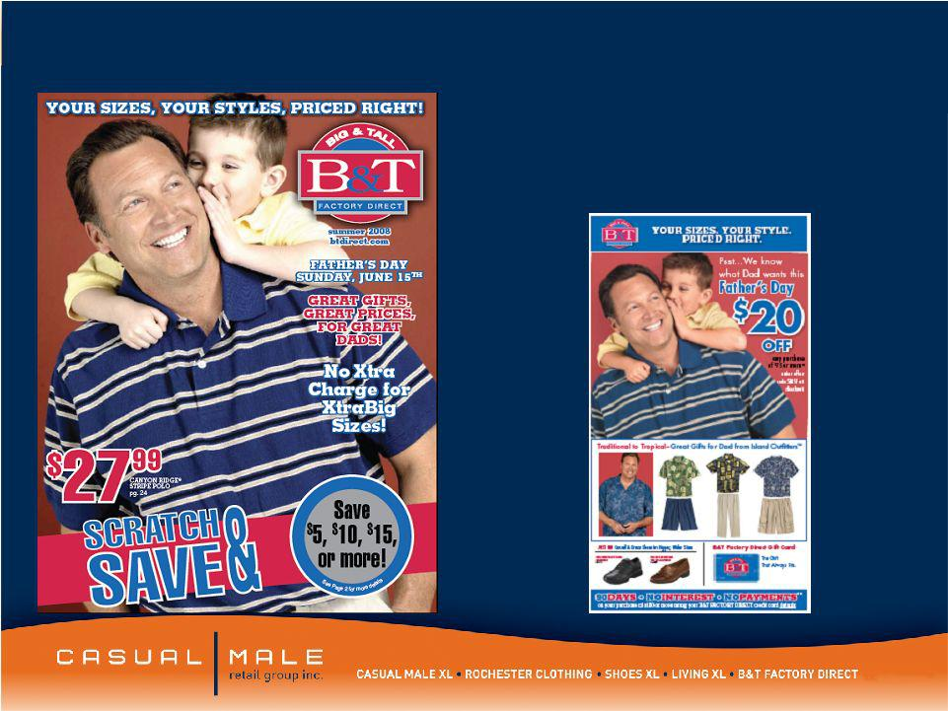
Exhibit 99.1

B & T Factory Direct

1

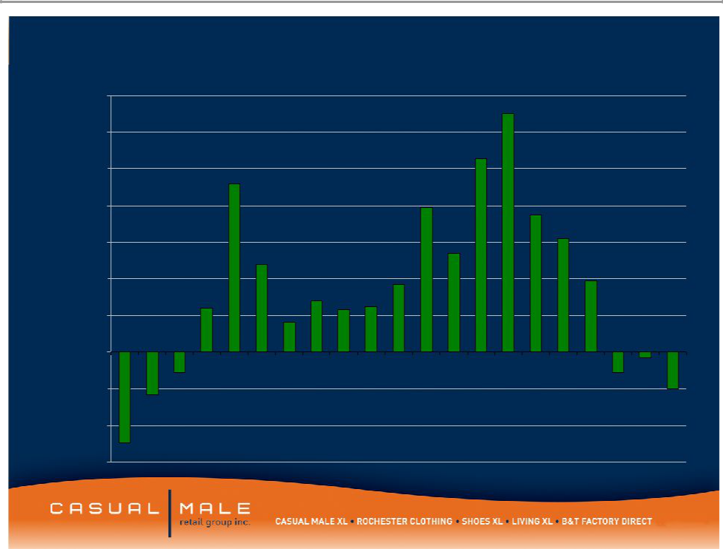
Comp Store Trend

14.0%
13.0%

12.0%

 |  |  |  |  |  |  |  |  |  |  |  |  | 10.6%
10.0% |  |  |  | 9.2%
8.0% |  |  |  |  |  |  |  |  |  |  | 7.9% |  |  |  | 7.5%
 |  |  |  |  |  |  |  |  |  |  |  |  |  |  |  | 6.2%
6.0% |  |  |  |  | 4.8% |  |  |  |  |  |  | 5.4%
4.0% |  |  |  |  |  |  |  |  |  | 3.7% |  |  |  |  |  |  | 3.90%
 |  |  | 2.4% |  |  |  | 2.8% | 2.3% | 2.5%
2.0% |  |  |  |  |  | 1.6%
0.0%
Q1 | Q2 | Q3 | Q4 | Q1 | Q2 | Q3 | Q4 | Q1 | Q2 | Q3 | Q4 | Q1 | Q2 | Q3 | Q4 | Q1 | Q2 | Q3 | Q4 | Q1
-2.0% |  | -1.1% |  | Stores change to |  |  |  |  |  |  |  |  |  |  |  |  |  | -1.1% ^{-0.3%}
-2.0% |  |  |  |  |  |  |  |  |  |  |  |  |  |  |  |  |  |  |  | -2%
 | -2.3% |  |  | lifestyle presentation |  |  |  |  |  |  |  |  |  |  |  |  |  |  |  | -2%
-4.0%
-5.0% |  |  |  |  | 2004 |  |  |  | 2005 |  |  |  |  |  |  |  |  |  |  | 2008
-6.0% |  | 2003 |  |  |  |  |  |  |  |  |  |  | 2006 |  |  | 2007 |  |  |  | 2008

2

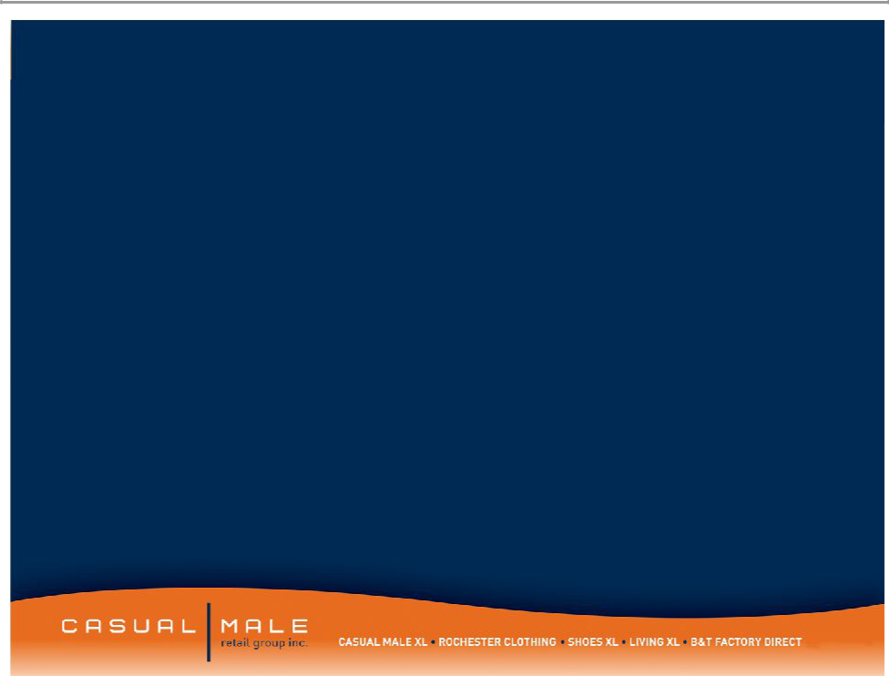
Forward Looking Statements:

This presentation contains certain forward-looking statements concerning the
Company's operations, performance, and financial condition. Such forward-looking statements are subject to various risks and uncertainties that could cause actual results

to differ materially from those indicated. Such risks and uncertainties may include, but are not limited to: the failure to implement the Company's business plan for increased profitability and growth in the Company's retail stores sales and direct-to-consumer segments, the failure of management to develop the Company’s new direct to consumer businesses, the failure of changes in management to achieve improvement in the Company's competitive position, adverse changes in costs vital to catalog operations,

such as postage, paper and acquisition of prospects, declining response rates to catalog offerings, failure to maintain efficient and uninterrupted order-taking and fulfillment in our direct-to-consumer business, changes in or miscalculation of fashion trends, extreme or unseasonable weather conditions, economic downturns, escalation of energy costs, a weakness in overall consumer demand, increases in wage rates, the ability to hire and train associates, trade and security restrictions and political or financial

instability in countries where goods are manufactured, increases in raw material costs from inflation and other factors, the interruption of merchandise flow from the

Company's centralized distribution facilities, competitive pressures, and the adverse effects of natural disasters, war, acts of terrorism or threats of either, or other armed conflict, on the United States and international economies. These, and other risks and uncertainties, are detailed in the Company's filings with the Securities and Exchange
Commission, including the Company's Annual Report on Form 10-K for the fiscal year

ended February 2, 2008 filed on March 26, 2008 and other Company filings with the Securities and Exchange Commission. Casual Male assumes no duty to update or revise

its forward-looking statements even if experience or future changes make it clear that any projected results expressed or implied therein will not be realized.

3

