UNITED STATES

SECURITIES AND EXCHANGE COMMISSION
WASHINGTON, D.C. 20549

FORM 8-K

CURRENT REPORT

Pursuant to Section 13 or 15(d)
of The Securities Exchange Act of 1934

Date of Report (Date of earliest event reported): December 3, 2013

DESTINATION XL GROUP, INC.

(Exact Name of Registrant as Specified in its Charter)

Delaware | 01-34219 | 04-2623104
(State or Other Jurisdiction | (Commission | (I.R.S. Employer
of Incorporation) | File Number) | Identification No.)
555 Turnpike Street, Canton, Massachusetts |  | 02021
 | (Address of Principal Executive Offices) | (Zip Code)
 | (781) 828-9300
 | (Registrant’s telephone number, including area code)

Check the appropriate box below if the Form 8-K filing is intended to simultaneously satisfy the filing obligation of the registrant under any of the following provisions (see General Instruction A.2. below):

- Written communications pursuant to Rule 425 under the Securities Act (17 CFR 230.425)

- Soliciting material pursuant to Rule 14a-12 under the Exchange Act (17 CFR 240.14a-12)

- Pre-commencement communications pursuant to Rule 14d-2(b) under the Exchange Act (17 CFR 240.14d-2(b))

- Pre-commencement communications pursuant to Rule 13e-4(c) under the Exchange Act (17 CFR 240.13e-4(c))

Item 7.01 -Regulation FD Disclosure

The Company will be presenting a slide presentation to various investment groups at upcoming investor conferences beginning today. A copy of the slides to be presented at those conferences is attached to this report as Exhibit 99.1 and is incorporated by reference herein.

The slide presentation contained in the exhibit includes statements intended as “forward-looking statements,” which are subject to the cautionary statement about forward-looking statements set forth in the exhibit. The slide presentation is being furnished, not filed, pursuant to Regulation FD. Accordingly, the slide presentation will not be incorporated by reference into any registration statement filed by the Company under the Securities Act of 1933, as amended, unless specifically identified therein as being incorporated therein by reference. The furnishing of the slide presentation is not intended to, and does not, constitute a determination or admission by the Company that the information in the slide presentation is material or complete, or that investors should consider this information before making an investment decision with respect to the Company.

Item 9.01 Financial Statements and Exhibits.

- Exhibits

Exhibit
No. Description

99.1 Investor Slide Presentation dated December 2013.

SIGNATURE

Pursuant to the requirements of the Securities Exchange Act of 1934, the Registrant has duly caused this report to be signed on its behalf by the undersigned hereunto duly authorized.

 | DESTINATION XL GROUP, INC.
Date: December 3, 2013 | By: | /s/ Dennis R. Hernreich
 | Name: | Dennis R. Hernreich
 | Title: | Executive Vice President and Chief
 |  | Financial Officer


Exhibit 99.1

Investor Presentation

December 2013

Destination XL Group, Inc.

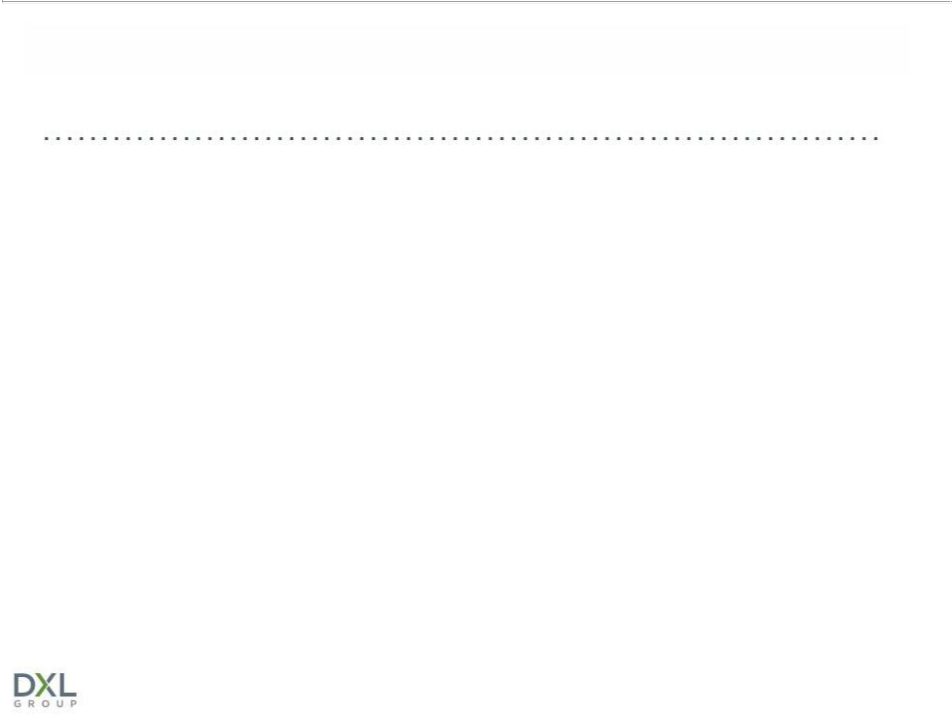
SAFE HARBOR

Certain information contained in this presentation, including, but not limited to, sales, cash flows, operating margins and store counts for fiscal 2013 and estimates through fiscal 2016, constitute forward-looking statements under the federal securities laws. The discussion of forward-looking information requires management of the Company to make certain estimates and assumptions regarding the Company's strategic direction and the effect of such plans on the Company's financial results. Such forward-looking statements are subject to various risks and uncertainties that could cause actual results to differ materially from those indicated. Such risks and uncertainties may include, but are not limited to: the failure to implement the Company's business plan for increased profitability and growth in the Company's retail stores sales and direct-to-consumer business, the failure to achieve improvement in the Company's competitive position, changes in or miscalculation of fashion trends, extreme or unseasonable weather conditions, economic downturns, a weakness in overall consumer demand, trade and security restrictions and political or financial instability in countries where goods are manufactured, increases in raw material costs from inflation and other factors, the interruption of merchandise flow from the Company's distribution facility, competitive pressures, and the adverse effects of natural disasters, war, acts of terrorism or threats of either, or other armed conflict, on the United States and international economies. These, and other risks and uncertainties, are detailed in the Company's Annual Report on Form 10-K filed with the Securities and Exchange Commission for the fiscal year ended February 2, 2013 filed on March 15, 2013 and other Company filings with the Securities and Exchange Commission. Casual Male assumes no duty to update or revise its forward-looking statements even if experience or future changes make it clear that any projected results expressed or implied therein will not be realized.

Destination XL Group, Inc. | 2

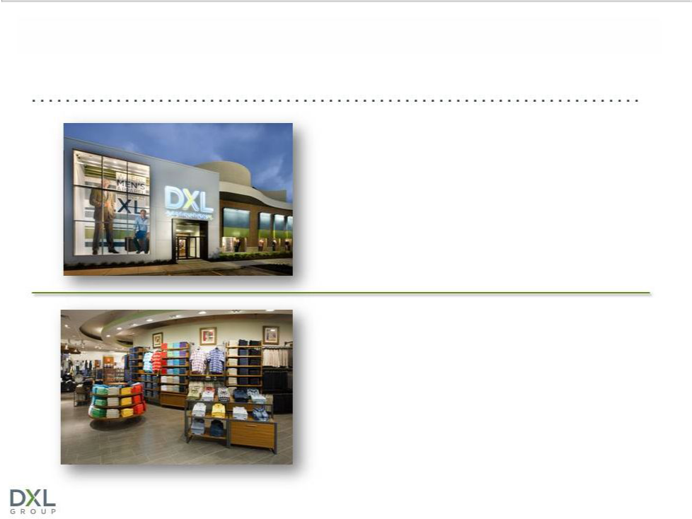
WHO IS DESTINATION XL GROUP?

Largest multi-channel specialty

retailer in niche men’s big and tall

(B&T) market

Offers unique blend of wardrobe

solutions – Private label & leading

apparel name brands

Destination XL Group, Inc. | 3



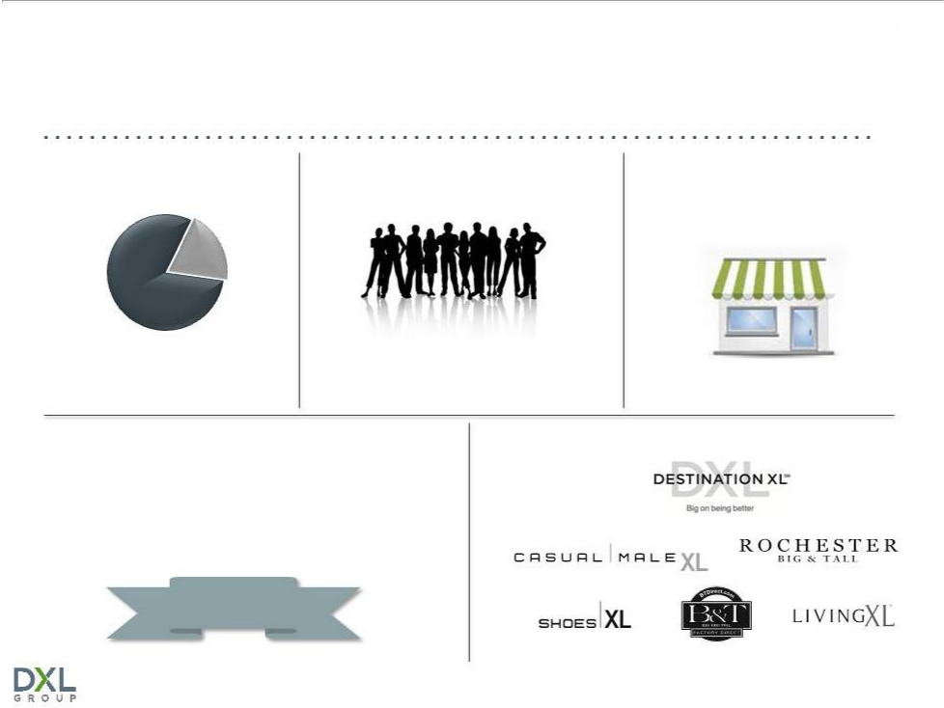
DXLG BY THE NUMBERS

80% RETAIL | 1.4M ACTIVE CUSTOMERS
 | 375 RETAIL STORES

SALES

20% DIRECT 90%ENROLLEDENROLLEDININLOYALTYLOYALTYPROGRAMPROGRAM

85%
#1Customer

Satisfaction

Destination XL Group, Inc. | 5


WHO IS OUR CUSTOMER?

Males with

a waist size
40” and
greater

(40M men)

Determined

by physical
characteristic,

not demographic

Seeking | Not dependent
Seeking | on age,
greater | on age,
greater | income, race
selection | income, race
selection | or nationality
in size | or nationality

Values convenience, selection and fit over price

6

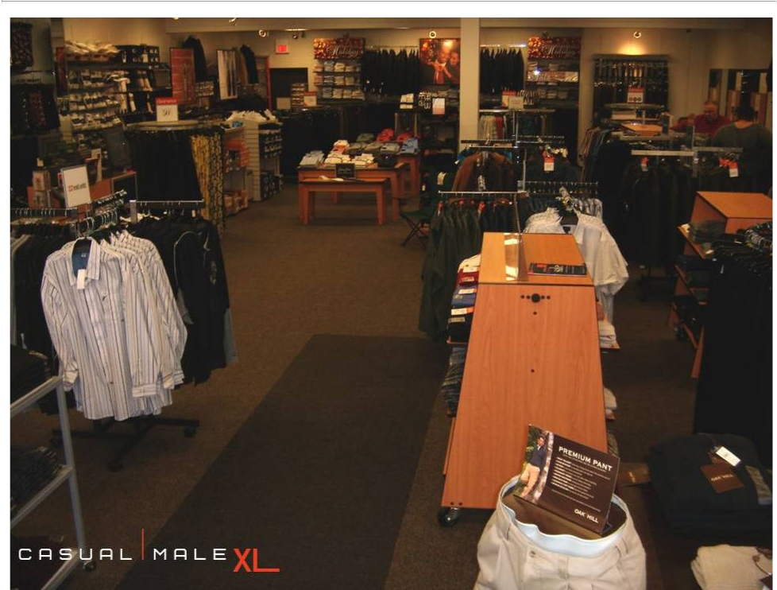
CURRENT CASUAL MALE XL STORES

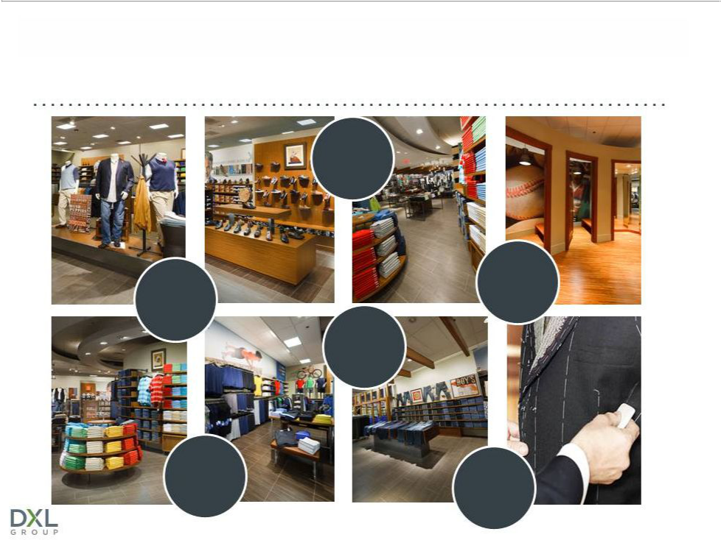
WHAT OUR CUSTOMERS WANT

Wide

aisles

Large
changing

One-stop rooms shopping

More

brands

Bright
Atmosphere Onsite

tailoring

Destination XL Group, Inc. | 8

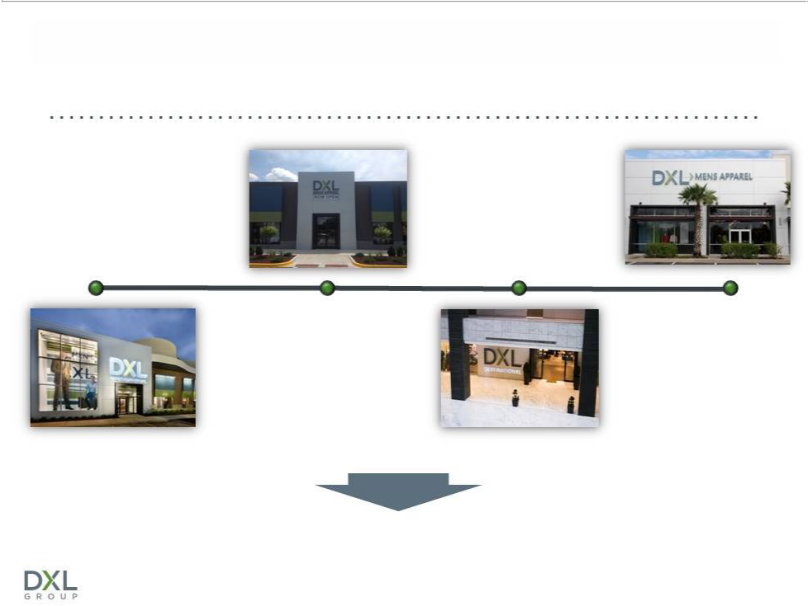
RESPONDING WITH DESTINATION XL

2010 | 2012
Opened 4 DXL concept stores | Opened 32 DXL stores
2011 | 2013
Opened 12 DXL stores | Expect to open 53 stores

Opportunity for accelerated growth and profitability

Destination XL Group, Inc. | 9

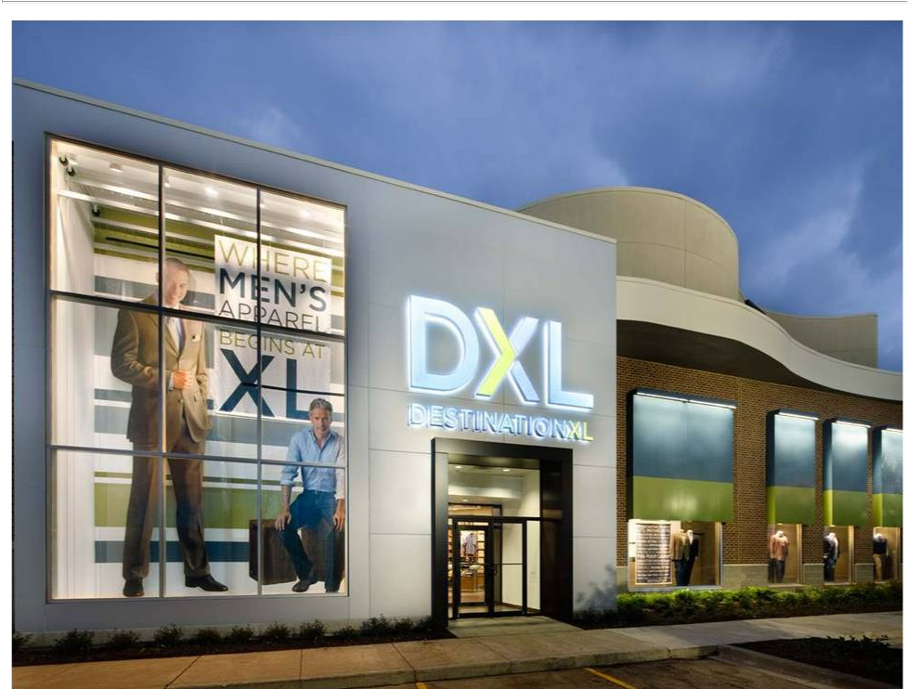

Schaumburg, IL

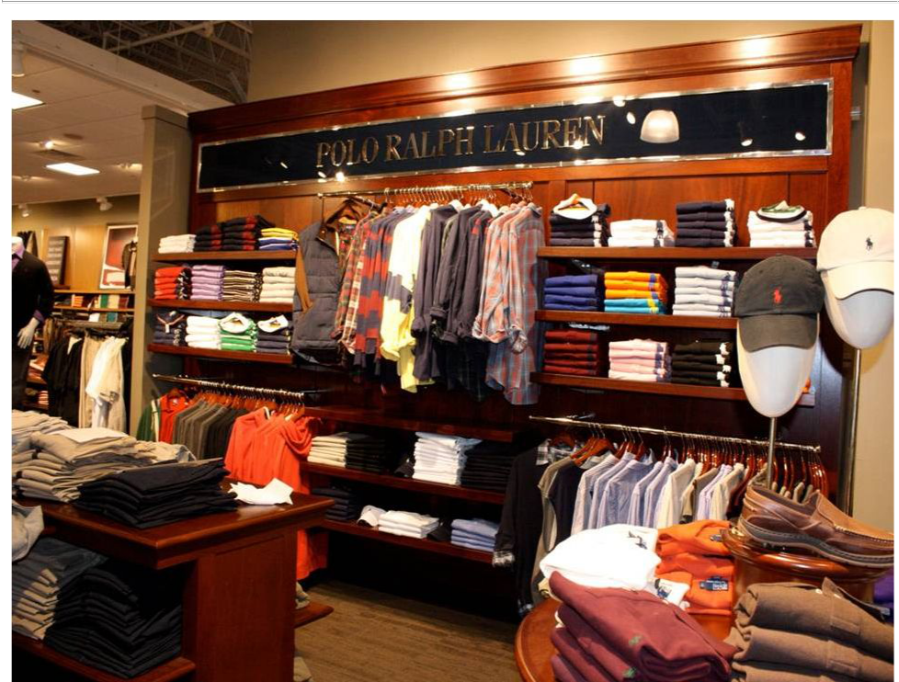

Traditional Section, POLO

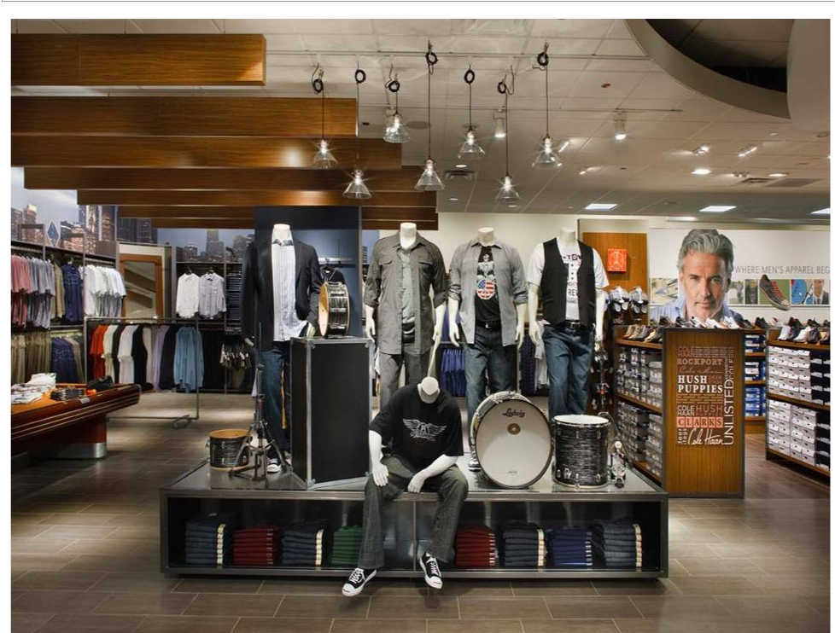

Studio Section, Runway

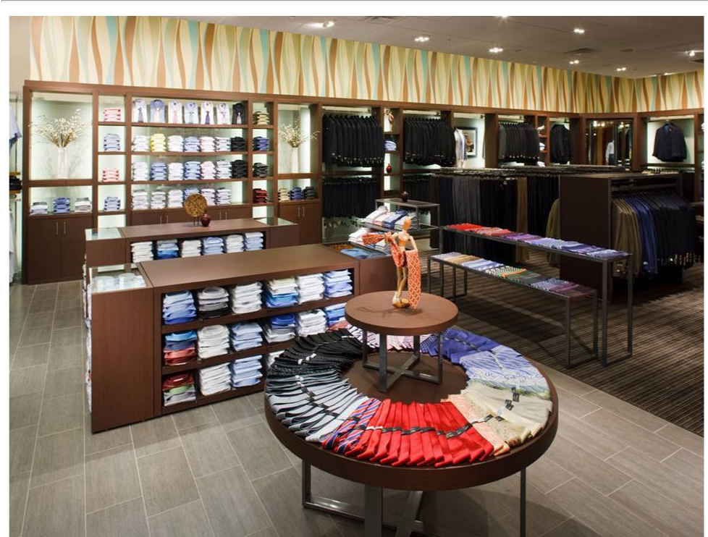

Club Department

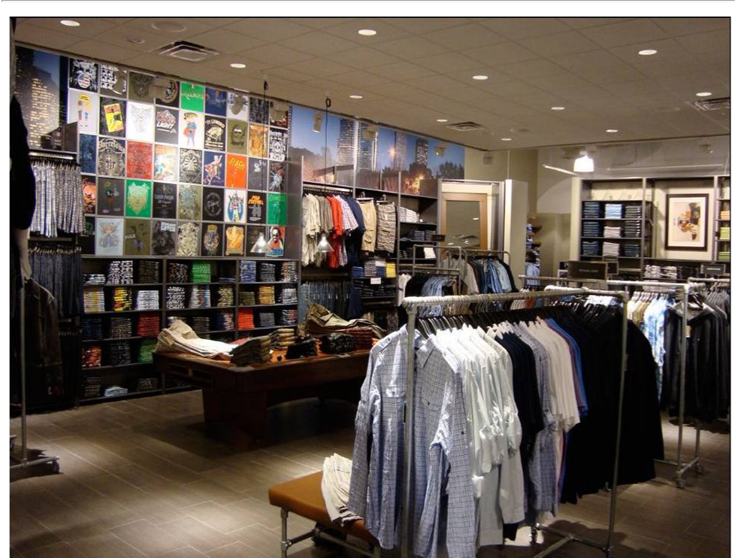

Studio Department

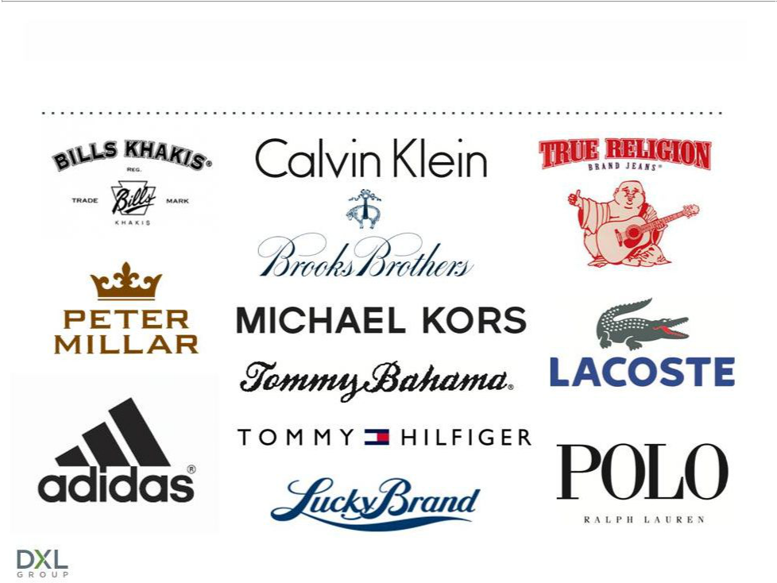
LARGE SELECTION OF NAME BRANDS

Destination XL Group, Inc. | 15

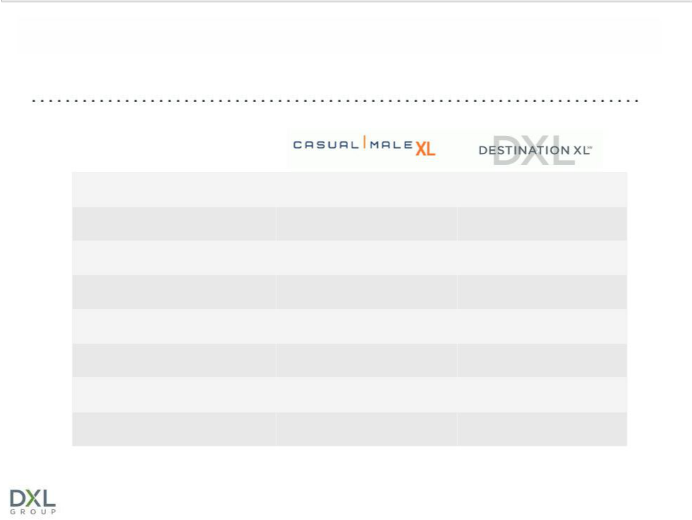
CASUAL MALE XL vs. DESTINATION XL

Store size | 3,600 sq. ft. | 8,400 sq. ft.
Sales per sq. ft. | $172 | $147 (maturing to $230)
Build out costs | $50 | $70
Occupancy costs | $30 | $30
Dollars per transaction | $102 | $150
Style choices | 600 | 2,000
Private label brands | 10 | 15
Name brands | 8 | 30
 |  | *Average store
 | Destination XL Group, Inc. | 16

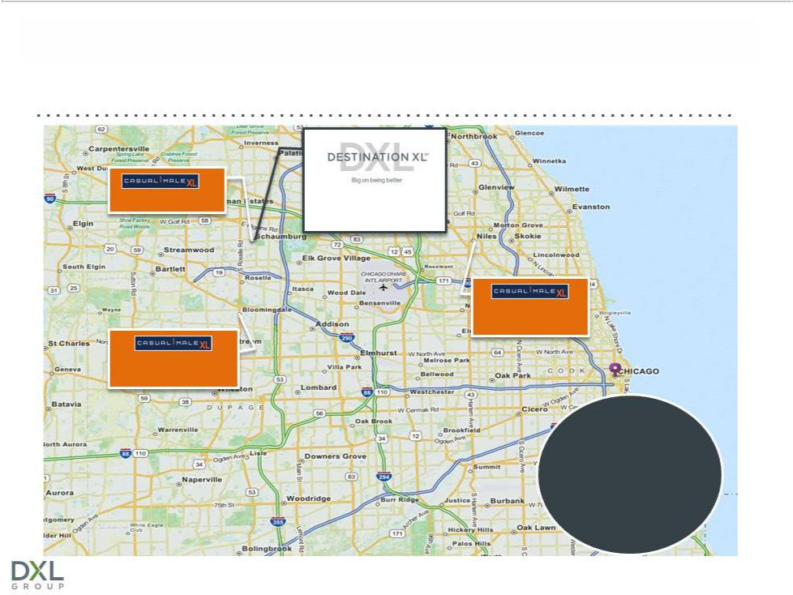
MARKET CONSOLIDATION TO DXL

9451 Schaumburg, IL Schaumburg, IL

0.9 miles

9183 Niles, IL

11.4 Miles

9512 Bloomingdale, IL

11.2 miles

Chicago

Metro

Customers are
willing to drive
up to 20 miles

*Customers are willing to drive up to 20 miles

Destination XL Group, Inc. | 17

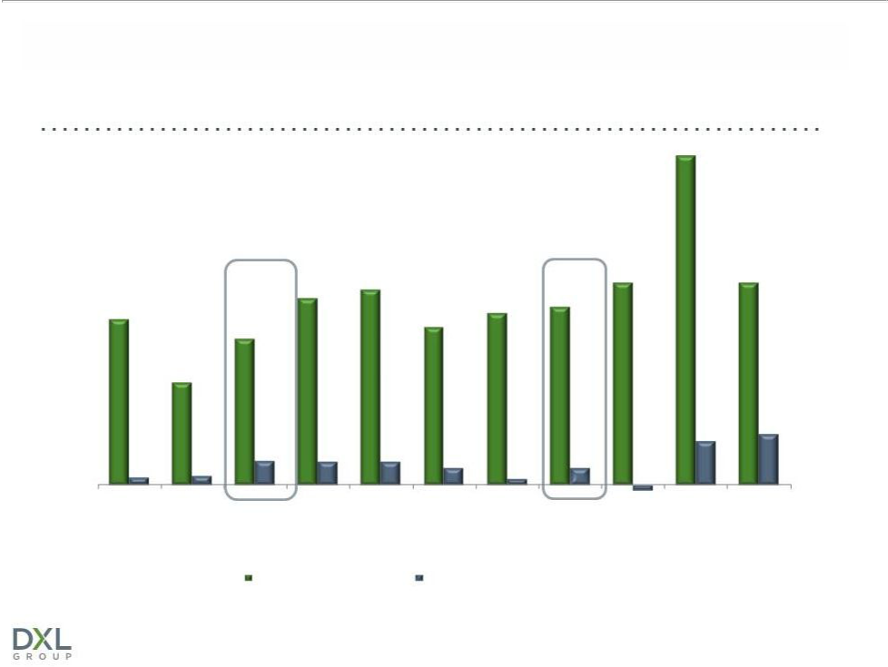
DXL COMPS REFLECT GROWTH OPPORTUNITY

28.8%

 |  | 16 .3% | 17.1% |  | 17.7% |  | 17.7%
 |  | 16 .3% | 17.1% |  | 15.6%
 |  | 16 .3% |  | 15 .0% | 15.6%
14.5% |  |  |  | 15 .0% | 15.6%
14.5% |  |  |  | 13 .8%
 | 12.8% |  |  | 13 .8%
 | 9.0%
 |  |  |  |  |  | 3.8% | 4.4%
0.7% | 2.1% | 2.0% | 2.0% | 1.5% | 1.5%
0.7% | 0.8% |  |  | 0.5%
 |  |  |  |  | -0.5%
Q3 2011 | Q4 2011 FY 2011 | Q1 2012 | Q2 2012 | Q3 2012 Q4 2012 | FY 2012 Q1 2013 | Q2 2013 Q3 2013
 | DXL Comparables |  |  | Total DXLG Comparables*
*Total DXLG Comparables consist of all stores, including DXL stores and direct channel
 |  |  | Destination XL Group, Inc. |  |  |  | 18

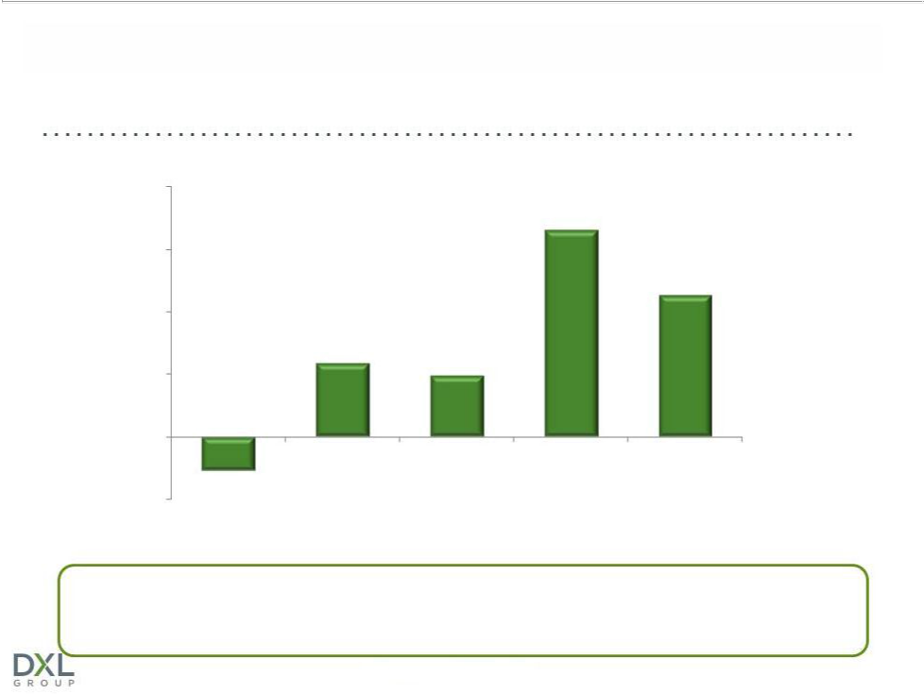
COMPARABLE SALES FOR DXL OPEN > 1 YEAR

20%

 |  |  | 16.5%
15%
 |  |  |  | 11.3%
10%
 | 5.9% | 4.7%
5% |  | 4.7%
0%
(2.7)%
-5% |  |  | 1 | 2
Q3 2012 | Q4 2012 | Q1 2013 | 1 | 2
Q3 2012 | Q4 2012 | Q1 2013 | Q2 2013 | Q3 2013
(11 stores) | (16 stores) | (23 stores) | (29 stores) | (36 stores)

¹Spring market campaign ran from 5/5/13 to 6/14/13
²Fall marketing campaign ran from 9/28/13 to 11/23/13 Reported 25.3% increase at DXLs open >1 year in October 2013

Destination XL Group, Inc. | 19

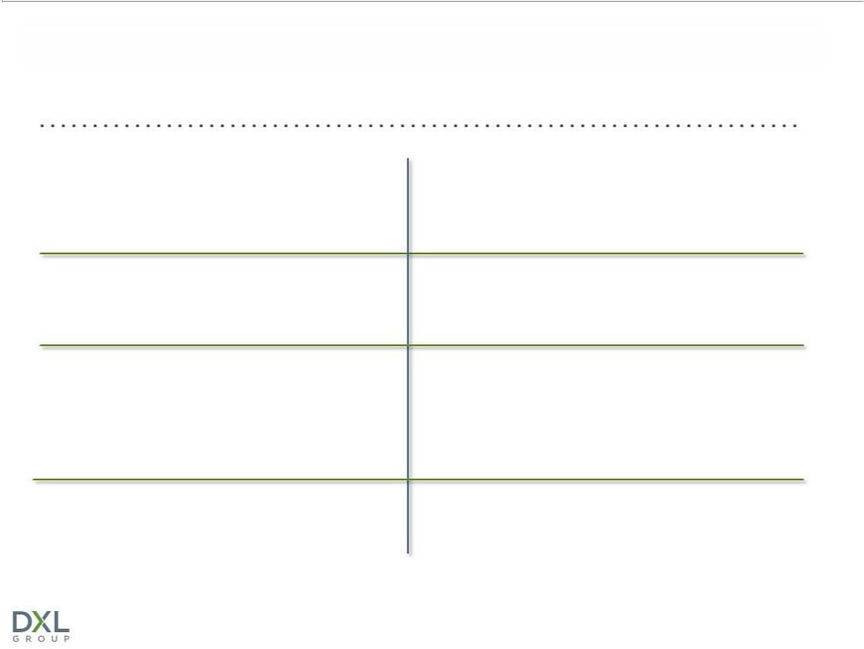
COMPELLING DXL RETURNS

Expect greater store productivity and profitability

Projecting higher 4-wall profits than combined profits of individual stores

Potential to capture additional market share

Opportunity to improve

operating margins

Better leveraging of expenses -- occupancy, labor productivity and local/district management

Targeting between 25%-30% store operating margin

Attract new customers

Better cross-selling environment to capture greater share of apparel wallet from existing customers

Expect to increase margins significantly after the transition to DXL is complete

Destination XL Group, Inc. | 20

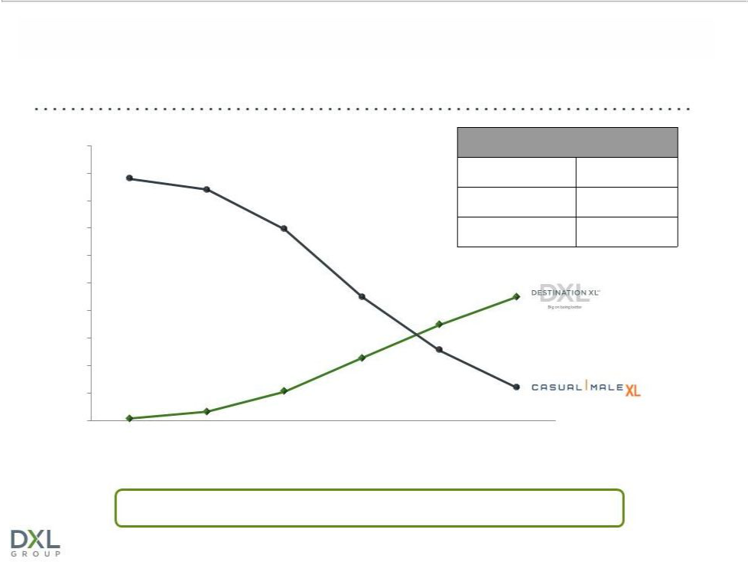
ACCELERATED DXL OPENINGS

500

450

400

350

300

250

200

150

100

50

0

2015 Store Count Target

Destination XL | 215-230
Casual Male XL Outlet | 55-60
Rochester Clothing | 5

2010 2011 2012 2013 2014 2015

Total Stores: | (460) | (450) | (412) | (~363) | (315-330) | (275-295)

Accelerated rollout based on success of DXL stores in 2011

Destination XL Group, Inc. | 21

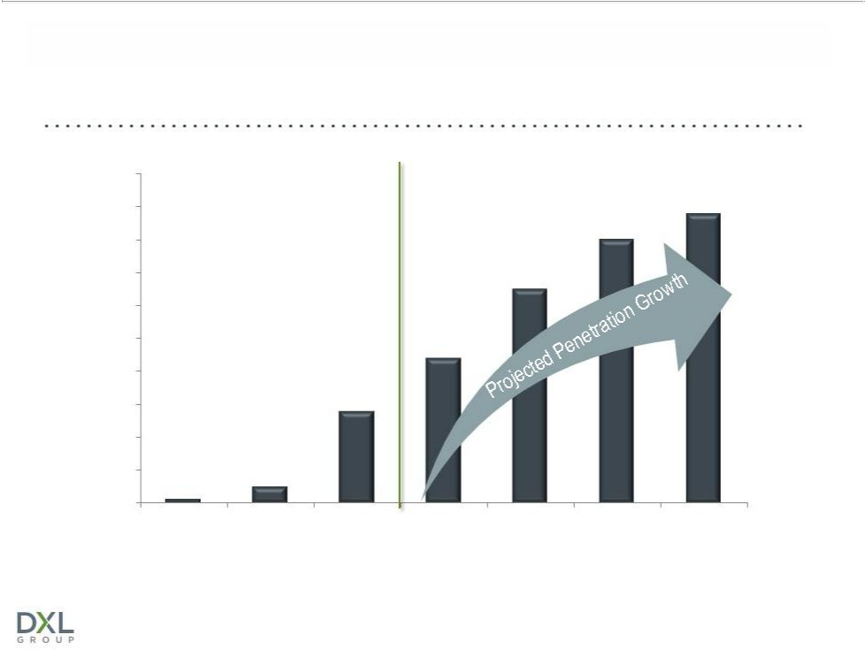
DXL SALES INCREASE AS % OF TOTAL REVENUE

100%
90% |  |  |  |  |  | 88%
90% |  |  |  |  | 80%
80% |  |  |  |  | 80%
70% |  |  |  | 65%
60%
50% |  |  | 44%
40%
30% |  | 28%
20%
10% | 5%
1%
0%
2010 | 2011 | 2012 | 2013 | 2014 | 2015 | 2016

* DXL sales include direct sales via the DestinationXL.com website.

Destination XL Group, Inc. | 22

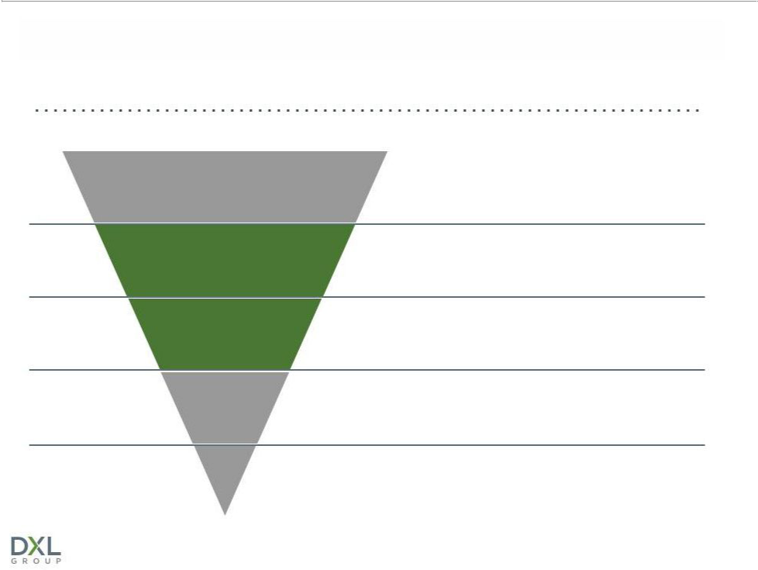
INCREASED AWARENESS = OPPORTUNITY

DXL Customer Purchase Funnel*

17%

8%

Addressable Population

Aware of DXL

Visiting DXL

DXL’s addressable market is primarily men with over 40” waist

Awareness of DXL is low across its markets, directly impacting ability to attract new customers

Of those aware of DXL, only 8% are visiting the store

73%

89%

Purchasing | 73% of those that visit the store make a purchase
from DXL | 73% of those that visit the store make a purchase

Repeat

89% of those that make a purchase intend to return

Source: L.E.K analysis prior to launch of marketing campaign (November 2012)

*Based on consumers’ stated responses per L.E.K’s survey within DXL markets

Destination XL Group, Inc. | 23

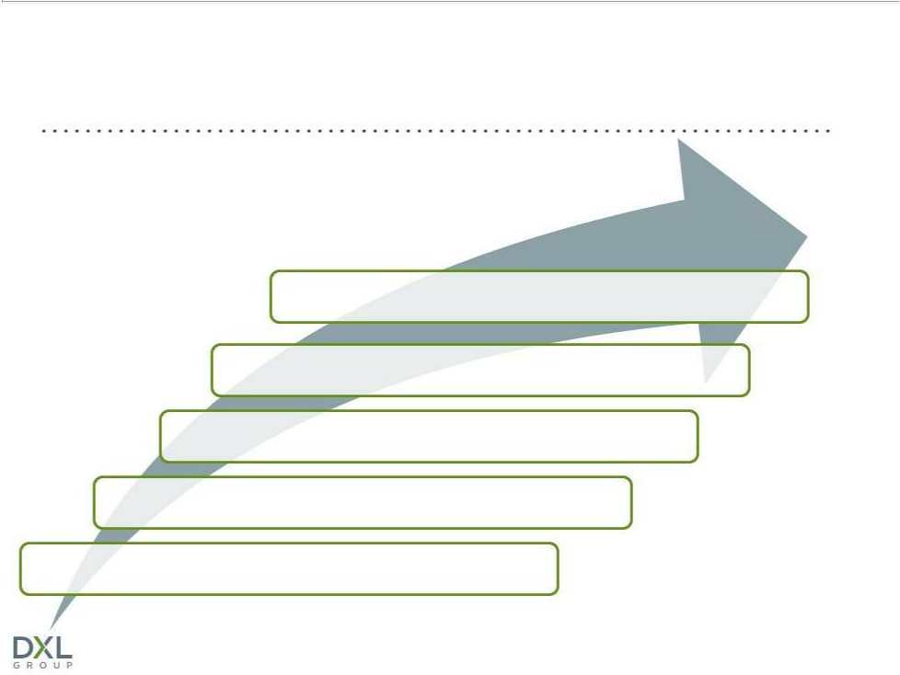
OPPORTUNITY TO GROW MARKET SHARE

Addressable Market = 40M Customers

1.4M Currently Active Customers

Capture greater wallet share with DXL concept

Attract broader customer audience with one-stop-shop

Target “end-of-rack” customers

Paradigm shift in marketing improves awareness

Grow direct business with new website

Destination XL Group, Inc. | 24


DXL ADVERTISING CAMPAIGN

- Combination of TV, radio & digital support

- Built stronger brand to attract and serve customers

- Results demonstrate ability to grow market share

Spring Flight (May 5 to June 14)

- Increased market awareness from 13% to 18%

- Transaction size increased 23%

- New customers grew by 26.1%

- Traffic increased 7.5%

- “End-of-rack” customer base grew to 40.5%

- Web traffic increased 80%

Fall Flight (Sept 28 – Nov 23)

  - Broadening to include network television ad-buy to supplement national cable presence

- Eliminating catalog distribution; introducing smaller 16-page brand mailers to announce seasonal offerings

- Reallocating $2 million of marketing dollars to fall advertising campaign

  - Added additional week to duration of campaign

25

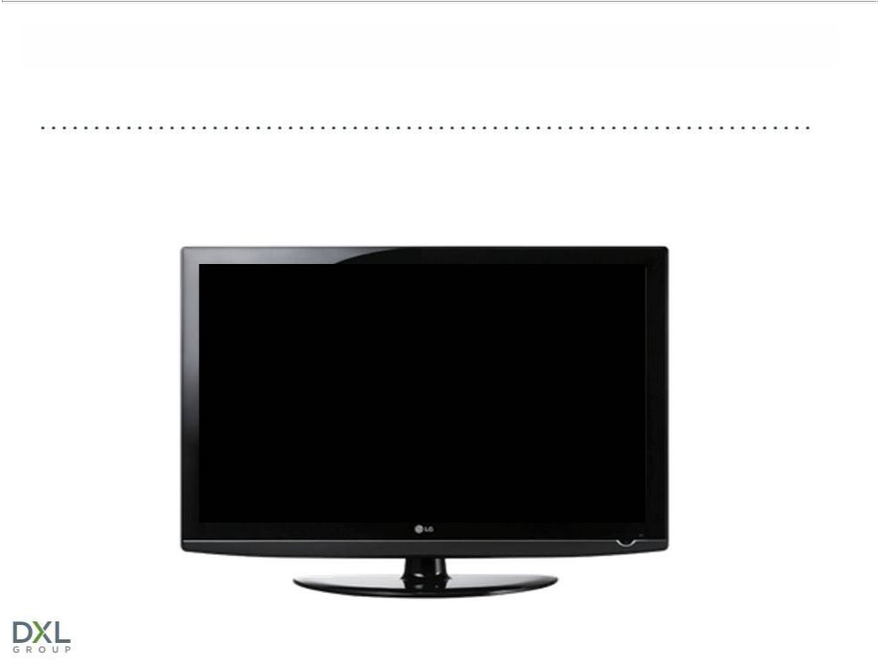
DXL ADVERTISING CAMPAIGN

Marketing to Customers in “No Man’s Land”

Destination XL Group, Inc. | 26

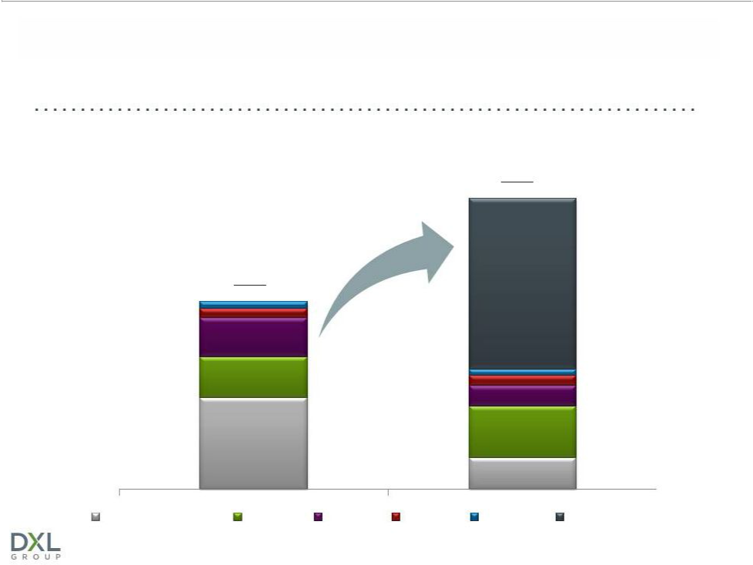
2013 MARKETING SPEND

• Strategically increase marketing spend as percent of sales from 4.5% to 7.0%

• | Rebalance spend to focus on prospecting and reduce direct marketing | 2013
• | Increase budget by $10M to support DXL media and digital acquisition | $27.1M (7.0%)

+$10M

2012

$18.5M (4.6%)

Direct Marketing

Digital

Other

Visual

Loyalty

Media

Destination XL Group, Inc.

27



FINANCIAL PERFORMANCE

Destination XL Group, Inc.

28

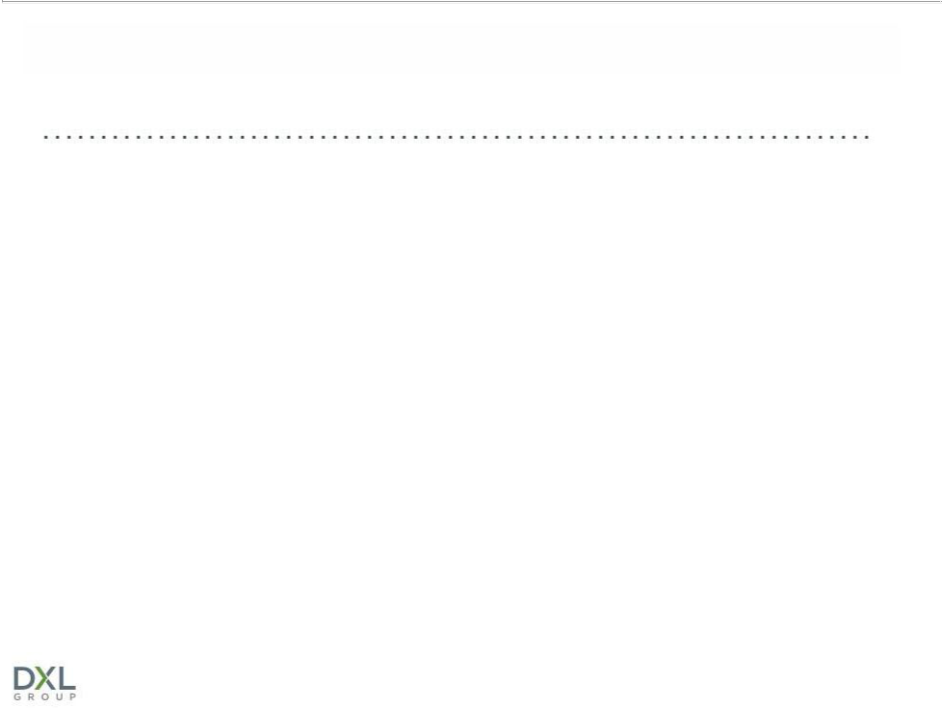
YTD 2013 RESULTS THROUGH Q3

- DXL stores comparable sales increased 21.4% and represented 26.5% of total comparable retail sales

- 36 DXL stores opened 1 year comparable sales increased 11.5%

- Dollars per transaction have increased 17.5% over the prior year

- Comp sales for Casual Male XL and Rochester Clothing stores decreased (0.3)%

- Overall comparable retail sales increased 2.5% and total sales were $279.4M

- U.S. direct e-commerce sales increased 3.3%

- Loss from continuing operations was ($4.6) million, or ($0.10) per diluted share, which included $9.1 million (after tax), or $0.19 per share, of Transition Costs and incremental marketing expenses
to support the DXL rollout

Destination XL Group, Inc. | 29

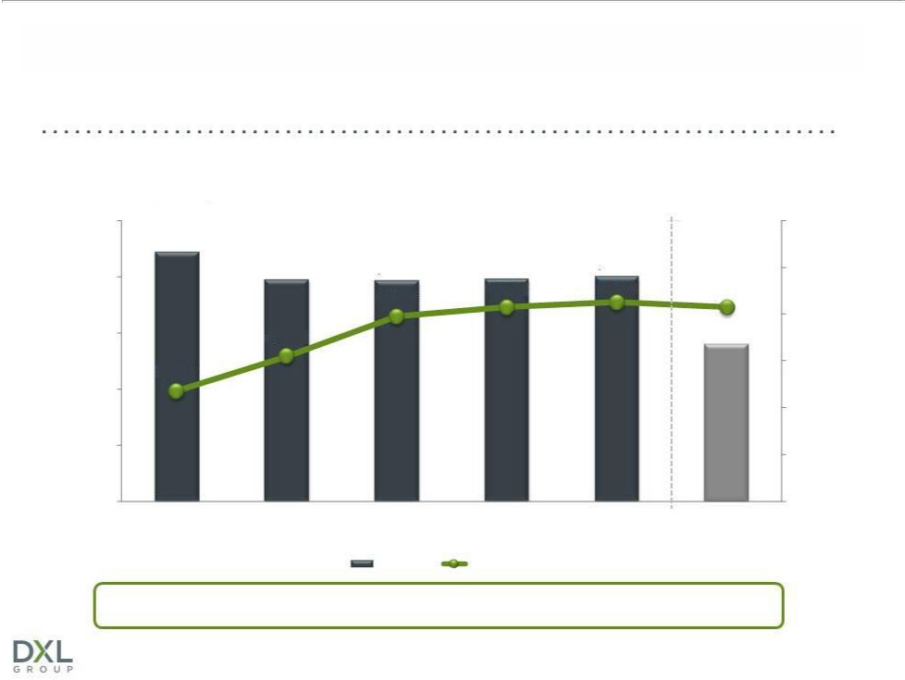
SALES & GROSS MARGIN

Revenue ($MM)

$500

 | $443.9
$400 | $393.9 | $392.0 | $395.9 | $399.6 | 46.3%
$400 |  |  | 46.3% | 46.5% | 46.3%
 |  | 45.9% | 46.3% | 46.5% | 46.3%
$300 | 44.2% |  |  |  | $279.4

42.7%

$200

$100

$0

2008 | 2009 | 2010 | 2011 | 2012 | YTD 2013
 |  | Revenue | Gross Margin

Strong gross margins provide opportunity for significant sales leverage

Destination XL Group, Inc.

50%

48%

46%

44%

42%

40%

38%

30

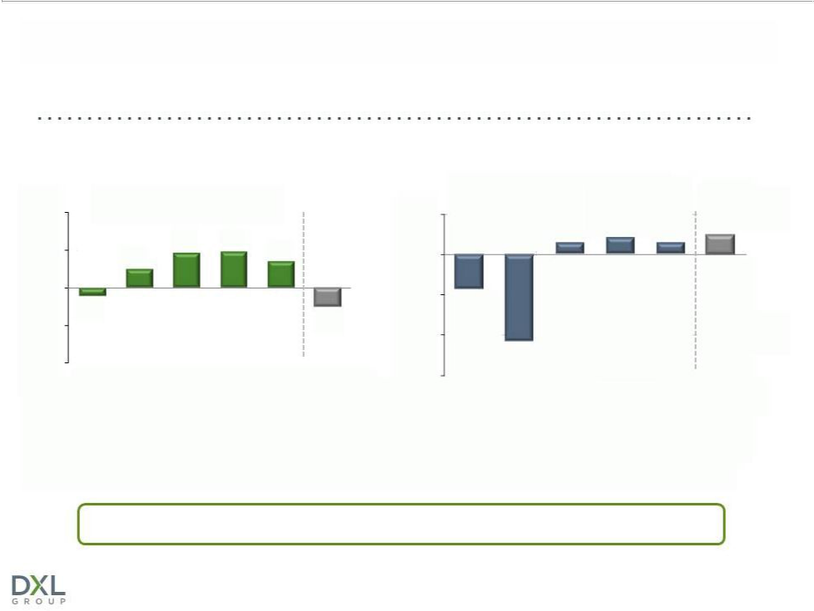
OPERATING MARGIN & COMPARABLE SALES

(continuing operations)

DXLG Operating Margin |  |  |  | DXLG Comp Sales
10% |  |  | 5%
 |  |  | 5% | 1.5% | 2.1% | 2.5%
 | 4.6% | 4.7% |  | 1.5% | 2.1% | 1.5%
5% | 4.6% | 4.7% |  |  |  | 1.5%
5% | 2.4% | 3.5% | 0%
0% |  |  | (5%) | (4.3)%
(1.1)% |  |  | (5%) | (4.3)%
(1.1)% |  | (2.5)%
(5%) |  | (2.5)%
(5%) |  |  | (10%)
(10%) |  |  |  | (10.8)%
2008 | 20092010 | 2011*2012 YTD 2013 | (15%) | 2008 2009 2010 | 2011 2012 YTD 2013

* Before impairment charge of $23.1M

Focus on improving operating margins through greater DXL sales

Destination XL Group, Inc. | 31

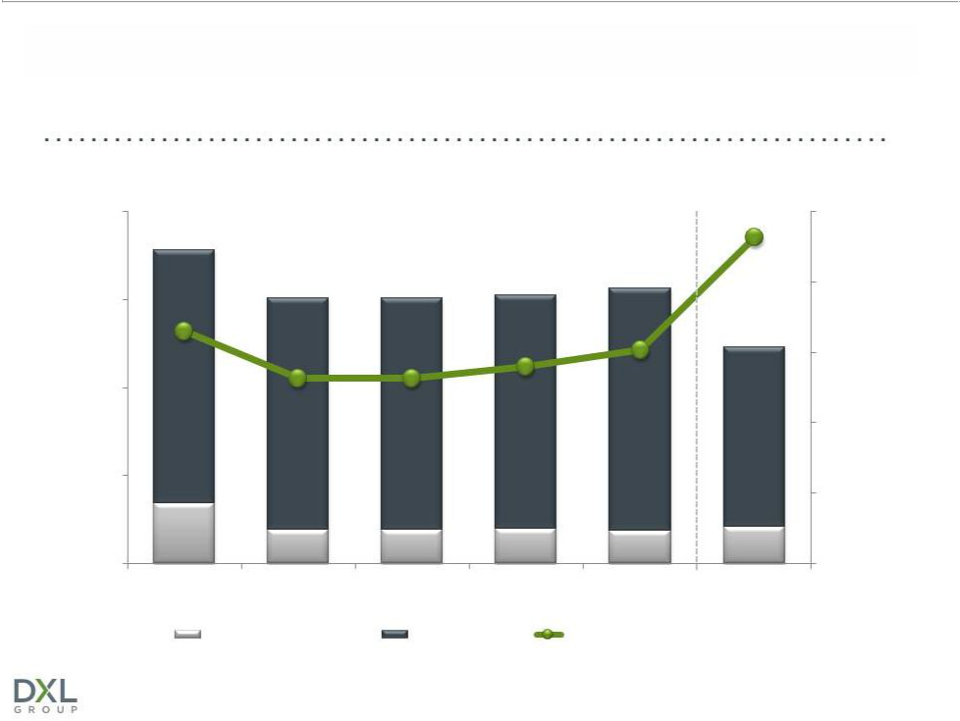
STRICT EXPENSE MANAGEMENT

($ mm)

$200

$177.3
 | $149.2 | $148.4 | $152.0 | $156.4 | 43.9%
$150 | $149.2 | $148.4 | $152.0
 |  |  |  |  | $122.8
39.9% |  |  |  | 39.1%
$100 |  |  |  | 39.1%
$100 | 37.9% | 37.9% | 38.4%
$50
$34.1 | $19.1 | $19.0 | $19.6 | $18.5 | $21.0
$0
2008 | 2009 | 2010 | 2011 | 2012 | YTD 2013
 | Marketing Expense | Total SG&A |  | SG&A as a Percentage of Sales

Destination XL Group, Inc.

45%

42%

39%

36%

33%

30%

32

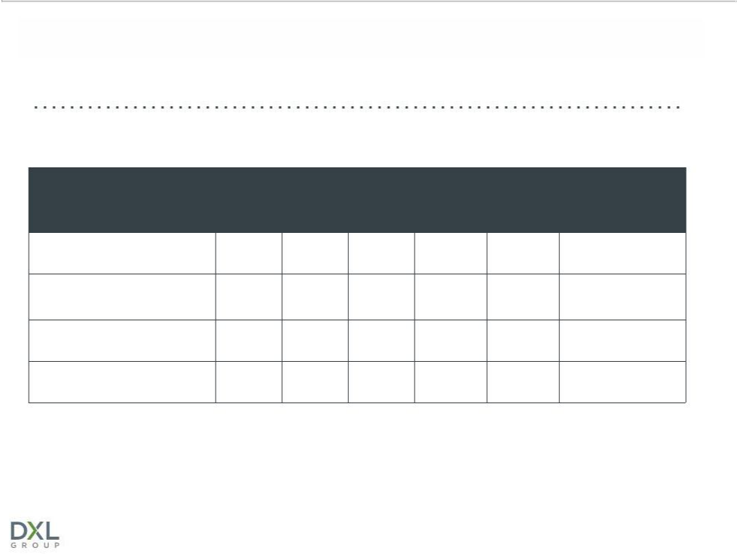
STRONG BALANCE SHEET

 | 2008 | 2009 | 2010 | 2011 | 2012 | FY 2013
 |  |  |  |  |  | Forecast
Inventory $98.6M $90.0M |  |  | $92.9M | $104.2M | $104.2M | $102M
Net borrowings under |  |  |  |  |  | $0¹
revolver | $38.7M | $3.5M | $0 | $0 | $0 | $0¹
Cash on hand | $5.0 | $4.3 | $4.1M | $10.4M | $8.2M | $0
Fixed term loan | $12.5M | $7.6M | $0 | $0 | $0 | $18M

1FY 2013 Net borrowings estimate includes $5.0 million in debt and $5.0 million in cash

Destination XL Group, Inc. | 33

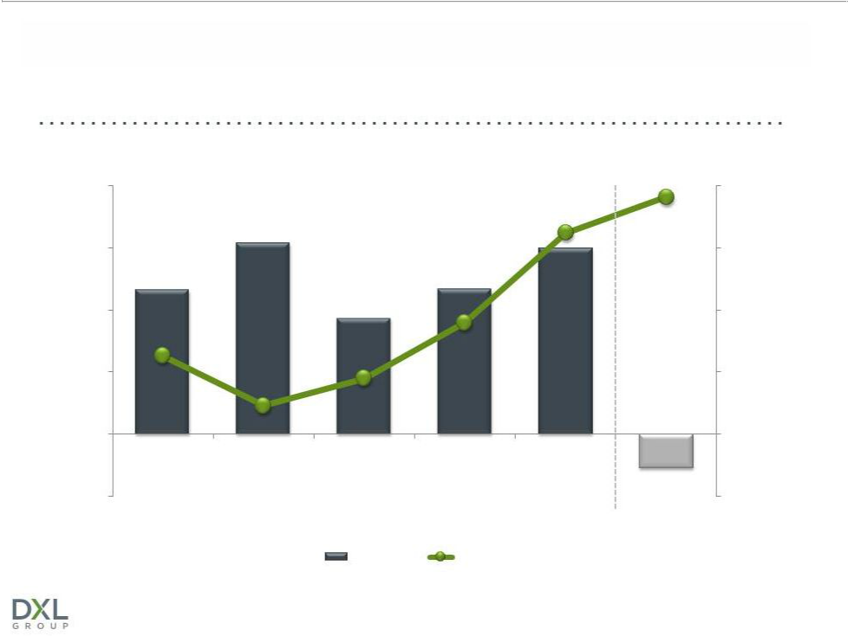
CASH FLOW & CAPITAL EXPENDITURES

$40 |  | ($ mm) |  |  | $38.2
$40 |  |  |  |  | $40
 | $30.8 |  |  | $32.4
$30 | $30.8 |  |  |  | $30
$30 |  |  | $29.9 |  | $30
$23.2 |  |  | $23.4
$20 |  | $18.7 |  |  | $20
$12.6 |  |  | $18.0
$10 |  |  |  |  | $10
 |  | $9.0
$0 | $4.6 |  |  |  | $0
-$10 |  |  |  |  | $(5.5)
-$10 |  |  |  |  | -$10
2008 | 2009 | 2010 | 2011 | 2012 | YTD 2013
 |  | Cash Flow | CAPEX
 |  | Destination XL Group, Inc. |  |  | 34

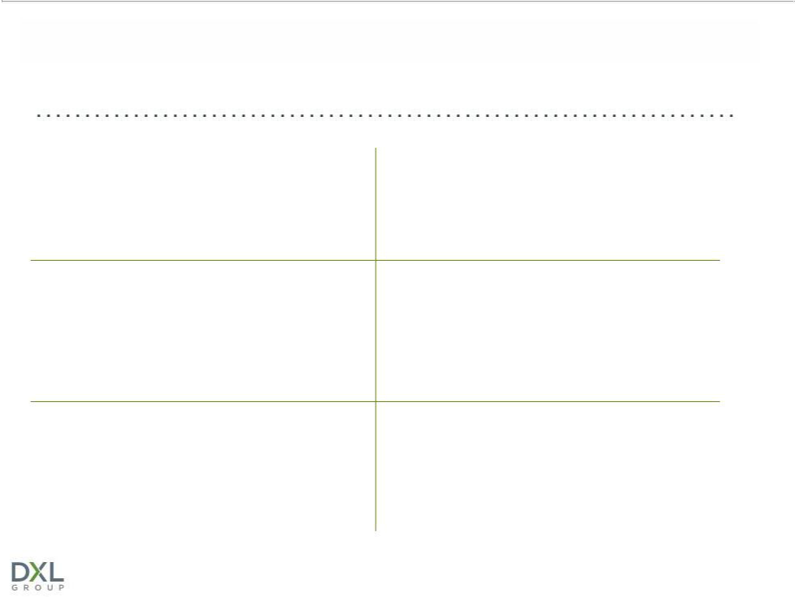
WHY INVEST IN DXLG?

Accelerated conversion to DXL

concept creates compelling

investment opportunity

Strong gross margins; Ability to greatly improve operating margins

Significant market share/sales growth opportunity

Leader in large and growing B&T market

Three-year $150M investment in DXL rollout to be funded primarily by free cash flow and deferred tax benefits

Strong balance sheet

with borrowing capacity

Destination XL Group, Inc. | 35

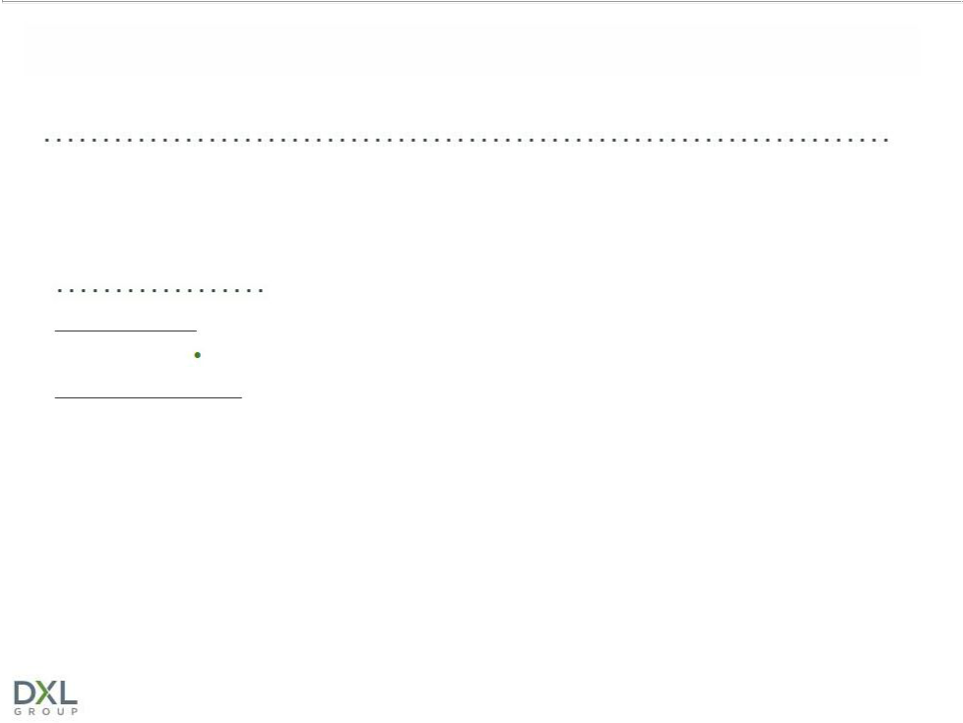
FOR ADDITIONAL INFORMATION:

Jeffrey Unger

V. P. Investor Relations

Destination XL Group, Inc.

jeffunger@usa.net

561-482-9715 (o)561-543-9806 (c)

www.DestinationXL.com

Destination XL Group, Inc. | 36

