UNITED STATES

SECURITIES AND EXCHANGE COMMISSION

Washington, D.C. 20549

FORM 8-K

CURRENT REPORT

PURSUANT TO SECTION 13 OR 15(d) OF THE

SECURITIES EXCHANGE ACT OF 1934

Date of Report (Date of earliest event reported): September 15, 2005

0-15898

(Commission File Number)

CASUAL MALE RETAIL GROUP, INC.

(Exact name of registrant as specified in its charter)

Delaware

04-2623104

(State of Incorporation)

(IRS Employer
Identification Number)

555 Turnpike Street, Canton, Massachusetts 02021

(Address of registrant’s principal executive office)

(781) 828-9300

(Registrant’s telephone number)

Check the appropriate box below if the Form 8-K filing is intended to simultaneously satisfy the filing obligation of the registrant under any of the following provisions (see General Instruction A.2. below):

- Written communications pursuant to Rule 425 under the Securities Act (17 CFR 230.425)

- Soliciting material pursuant to Rule 14a-12 under the Exchange Act (17 CFR 240.14a-12)

- Pre-commencement communications pursuant to Rule 14d-2(b) under the Exchange Act(17 CFR 240.14d-2(b))

- Pre-commencement communications pursuant to Rule 13e-4(c) under the Exchange Act(17 CFR 240.13e-4(c))

ITEM 7.01 – REGULATION FD DISCLOSURE

The Company is scheduled to present at the Susquehanna International Group, LLP Retail Focus Forum on September 15, 2005. A copy of the slides to be presented are attached to this report as Exhibit 99.1, which slide presentation is incorporated by reference herein.

The slide presentation contained in the exhibit includes statements intended as “forward-looking statements,” which are subject to the cautionary statement about forward-looking statements set forth in the exhibit. The slide presentation is being furnished, not filed, pursuant to Regulation FD. Accordingly, the slide presentation will not be incorporated by reference into any registration statement filed by the Company under the Securities Act of 1933, as amended, unless specifically identified therein as being incorporated therein by reference. The furnishing of the slide presentation is not intended to, and does not, constitute a determination or admission by the Company that the information in the slide presentation is material or complete, or that investors should consider this information before making an investment decision with respect to the Company.

ITEM 9.01 – FINANCIAL STATEMENTS AND EXHIBITS

(c) Exhibits

Exhibit No. | Description
99.1 | Presentation dated September 15, 2005

SIGNATURES

Pursuant to the requirements of the Securities Exchange Act of 1934, the registrant has duly caused this report to be signed on its behalf by the undersigned, thereunto duly authorized.

CASUAL MALE RETAIL GROUP, INC.

By: /S/ DENNIS R. HERNREICH
Name: Dennis R. Hernreich
Title: Executive Vice President
and Chief Financial Officer

Date: September 15, 2005

Exhibit A
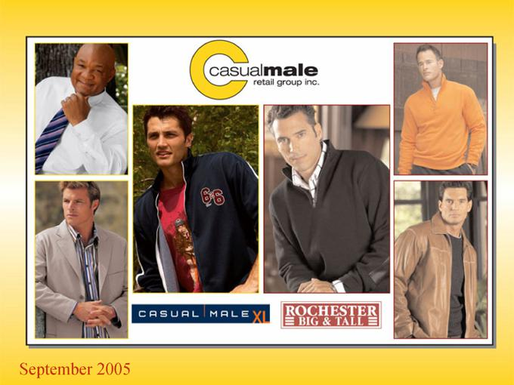

September 2005

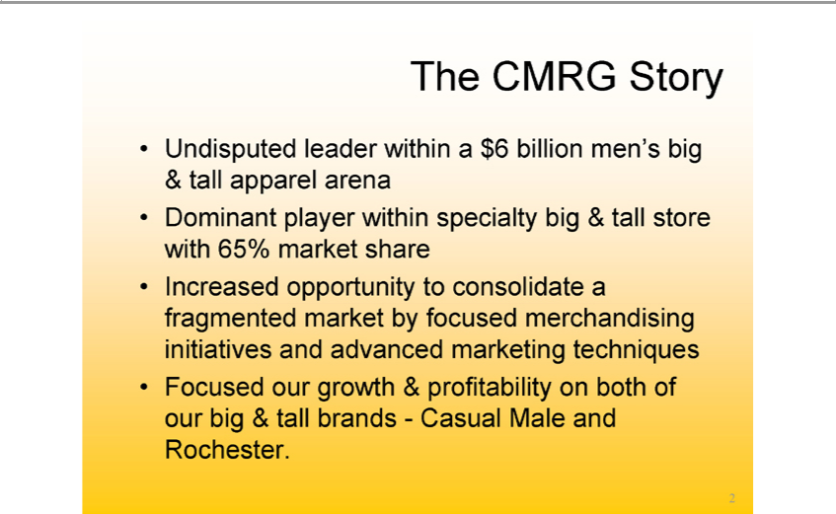

The CMRG Story
Undisputed leader within_{specialty}$6billion men’s big & tall apparel arena
Dominant player within big & tall store with 65% market share

Increased opportunity to consolidate a fragmented market by focused merchandising initiatives and advanced marketing techniques Focused our growth & profitability on both of our big & tall brands—Casual Male and Rochester.
2

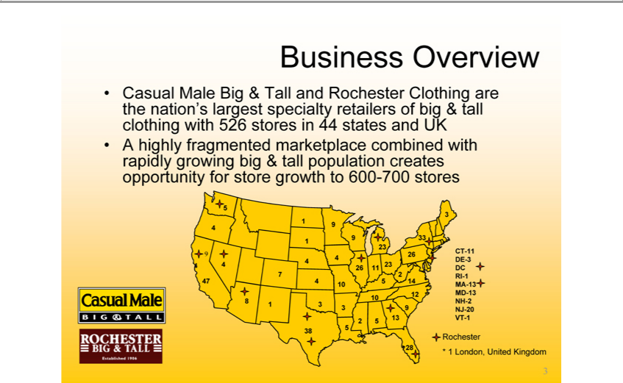

Business Overview | in 44 states and UK
Casual Male Big & Tall and Rochester Clothing are the nation’s largest specialty retailers of big & tall clothing with 526 | in 44 states and UK
A5 highly fragmented marketplace combined with rapidly growing big & tall population creates opportunity for store growthstores 600-700 stores
94
₄7
8
7
1
4
38
9
4
10
3
5
9₆
23
10
5
23
5
13
9
26
₃3
12⁴
28 CT-11 _{DC}E-3 RI-1 MD^{A}-13 NJ^{H-}20 -
RochesterVT-1
3* 1 London, United Kingdom

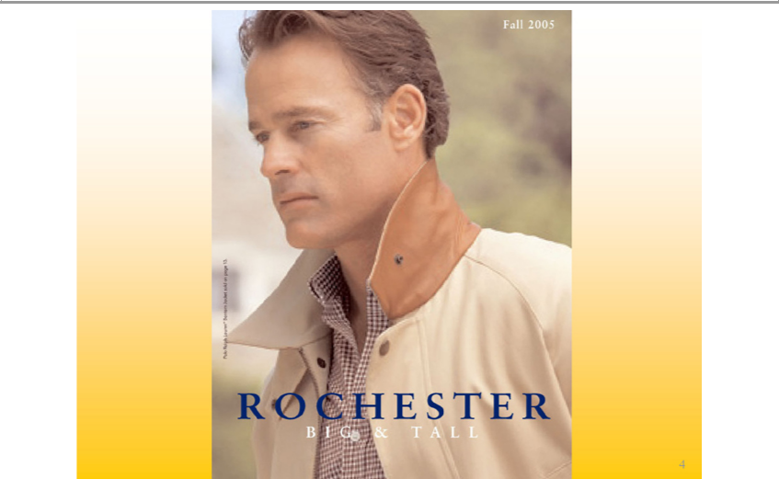

Fall 2005
ROCHESTER
4BIG & ALL



5Rochester Brands

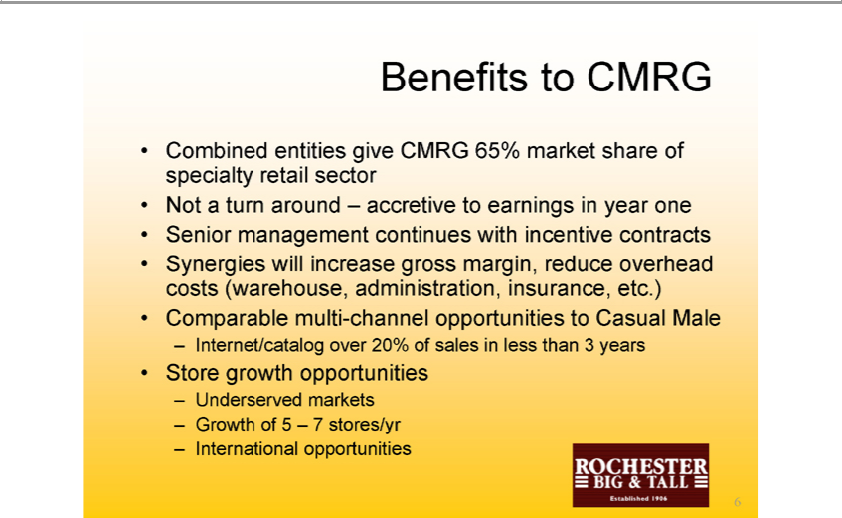

Benefits to CMRG
NotCombinedaturn aroundentities –giveaccretiveCMRGto 65%earnings_{incentive}marketyearshareoneof specialty retail sector
^{Syner}enior management continues with contracts
Comparablegieswillmultiincrease-channelgrossopportunitiesmargin,reducetoCasualoverheadMalecosts (warehouse, administration, insurance, etc.)
StoreInternet/cataloggrowthopportunitiesover20%of sales in less than 3 years
UnderservedGrowthof5 –markets7stores/yr
6International opportunities

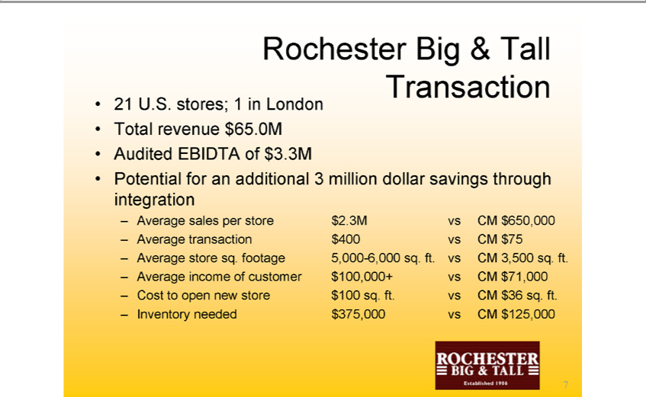

Rochester21U.S.stores;Big &1 inTallLondonTransaction
AuditedTotalrevenueEBIDTA$65.0Mof$3.3M
Potential sales_{transaction}forperadditionalstore$2.3M3millionvsCMdollar$650,000savings through integration
$400 vs CM $75
_{Average} incomestoresq.offootagecustomer5,000$100,000+-6,000sq.vsft.CMvs CM$71,0003,500 sq. ft.
_{Inventory}Costopen new store $100 sq. ft. vs CM $36 sq. ft.
₇ needed $375,000 vs CM $125,000

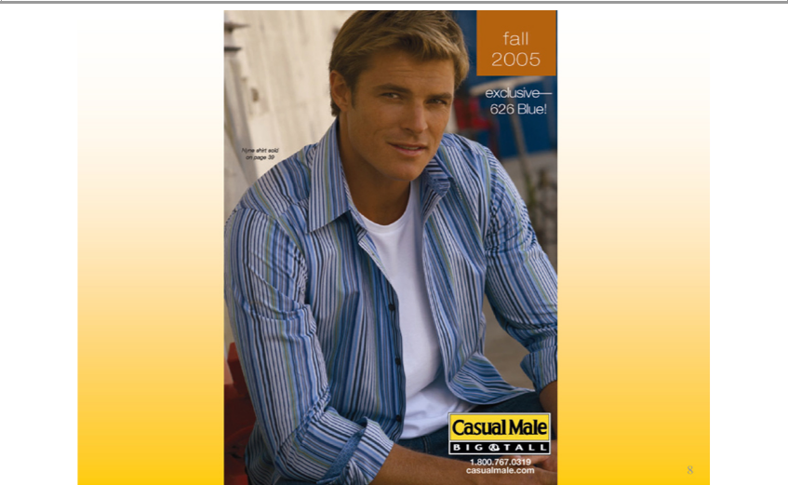

fall 2005 exclusive — 626 Blue!
CasualNyneshirtMalesold on page 39
BIG & TALL
1.800.767.0319
8casualmale.com

Comp Store Trend
810.0%
46
².0%
0₂
-⁴⁶.0%
1
4₂3

1
423
Q21 4
2005₃
9.2%
Launch of George Foreman collection and TV campaign
24_{.4%}8%
1Stores_{0%}6% change to lifestyle presentation

3%
2.5%
1 _{3%}1%
²
9-⁵.0%

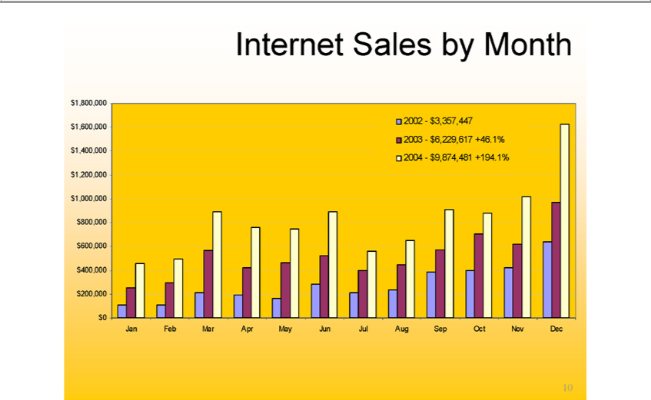

Internet Sales by Month
 | 3 | 6³ | 229³⁵⁷ | 617⁴⁴⁷ | 46.1%
2004 |  | - $9,874,481 +194.1%
 | 8
 | 6
 | 4
 | 2 | ,000
1,00
8
6
4
200,000
$0
Jan
FebMar
Apr
JulMay^{n}
Aug
Sep
NovOct
10Dec

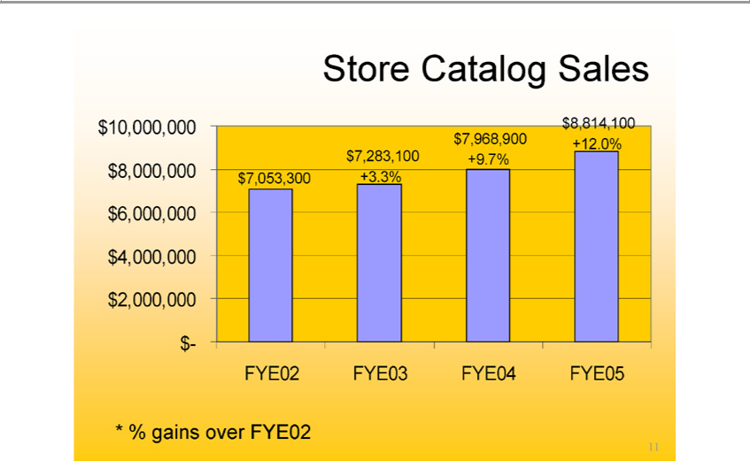

Store Catalog Sales $10,000,000 $8,000,000 $6,000,000 $4,000,000 $2,000,000 $- $7,053,300 $7,283,100 +3.3% $7,968,900 +9.7% $8,814,100 +12.0% FYE02 FYE03 FYE04 FYE05

11*% gains over FYE02

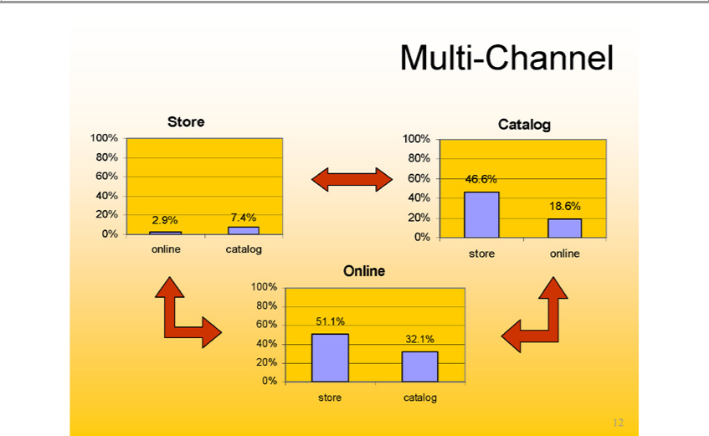

Multi-Channel
Store
1 | 0%
8
6
4
20%9%
7.4%
online
catalog
Catalog
1 | 0%
8
6
4
20%
46
18.6%
store online
Online
1 | 0%
8

6

4
20%
⁵¹.1%
₁₂32 store catalog

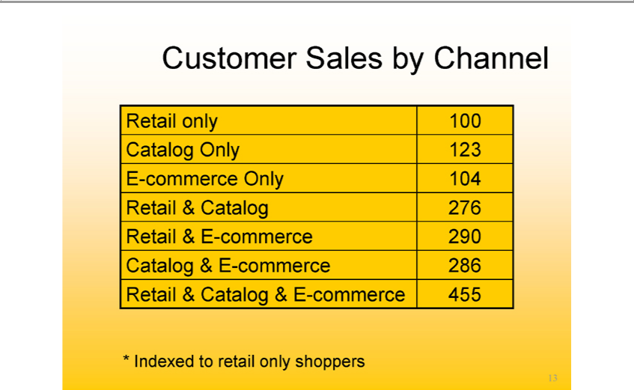

Customer Sales by Channel
Re | il only 100
Catalog Only 123
E-commerce Only 104
Re | Catalog 276 | 290
Re | il & E-
Ca | log & Ecommerce- |  | 286
Retail & Catalog & E-commerce 455

13*Indexed to retail only shoppers

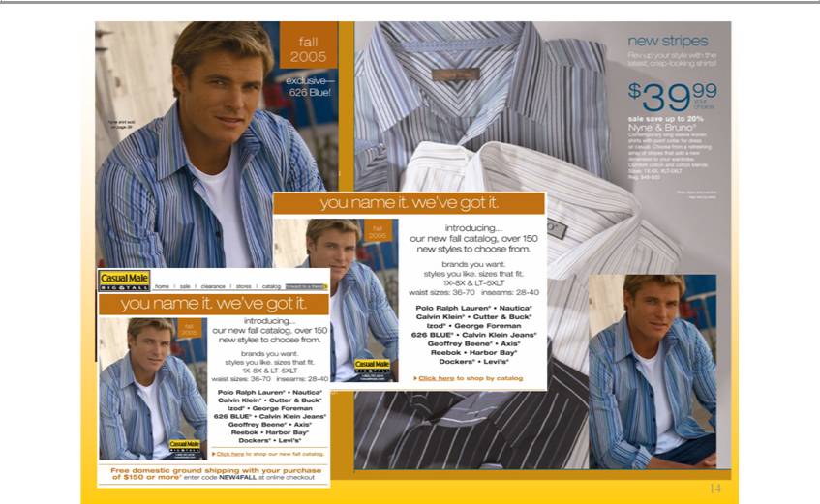

14Introducing our new Fall 2005 collection

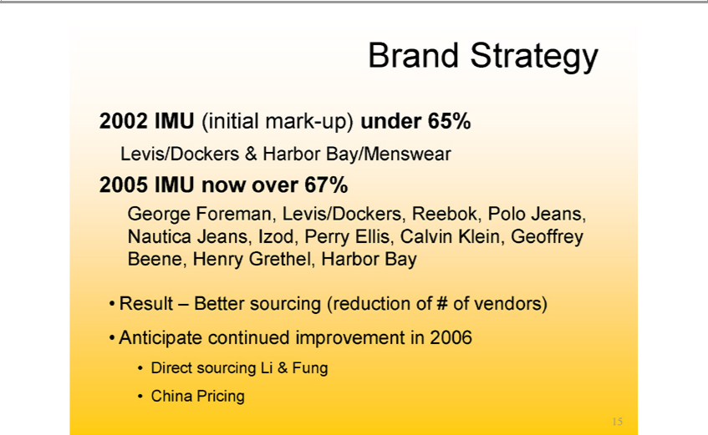

Brand Strategy
2002 IMU (initial mark-up) under 65%
2005Levis/DockersIMUnow&overHarbor67%Bay/Menswear

George Foreman, Levis/Dockers, Reebok, Polo Jeans, Nautica Jeans, Izod, Perry Ellis, Calvin Klein, Geoffrey Beene, Henry Grethel, Harbor Bay Result – Better sourcing (reduction of # of vendors)
Anti_{Direct}ipatesourcingcontinuedLi& Fungimprovement in 2006
15China Pricing

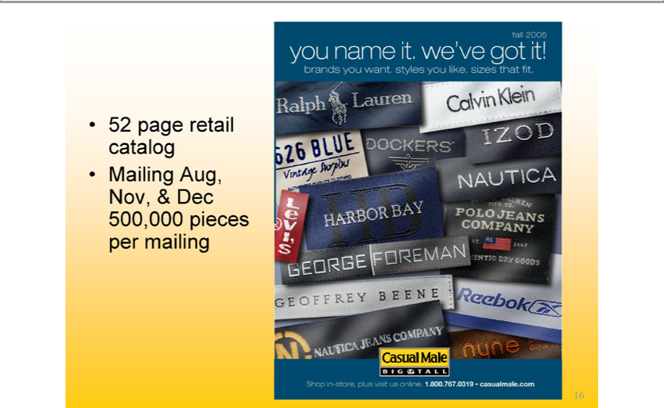

1652 page retail catalog Mailing Aug, Nov, & Dec 500,000 pieces per mailing

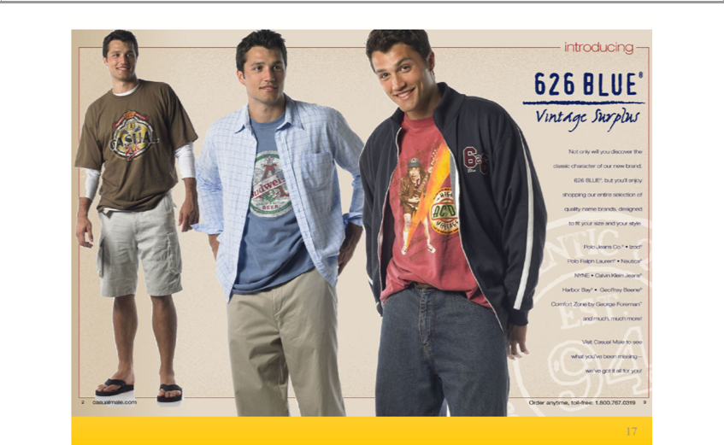

17Introducing 626 Blue® Vintage Surplus

626 Blue® today’s classics
18

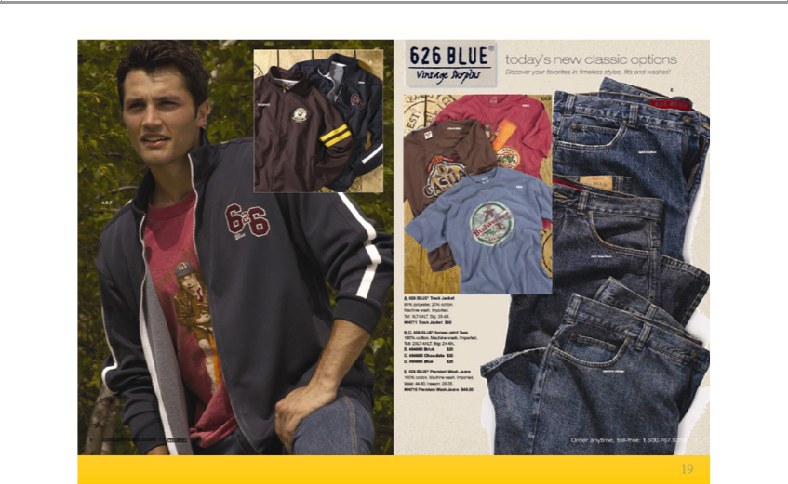

626 Blue® new classic options
19

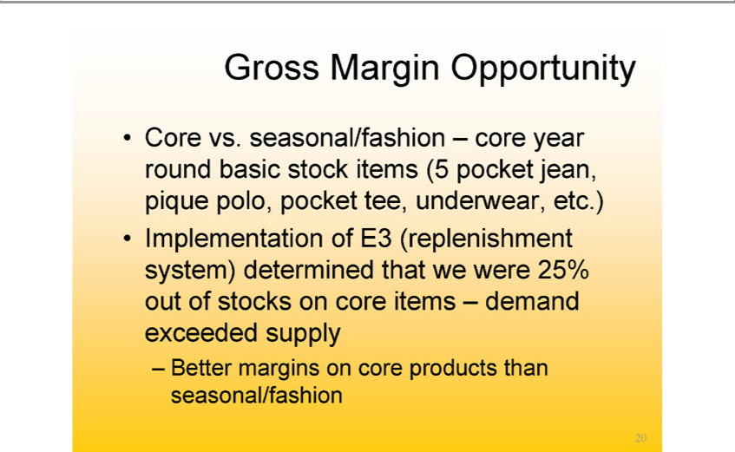

Gross Margin Opportunity
Core vs. seasonal/fashion – core year round basic stock items (5 pocket jean, pique polo, pocket tee, underwear, etc.)
BetterImplementationmarginsonofcoreE3(replenishmentproductsthan seasonal/fashionsystem)determined that we were 25% out of stocks on core items – demand exceeded supply

20

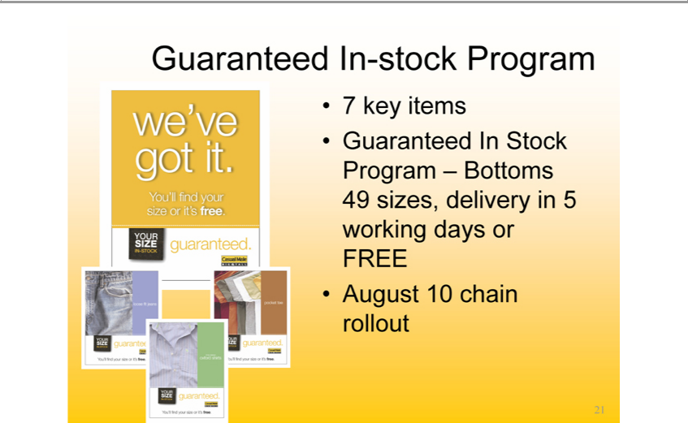

7Guaranteedkeyitems In-stock Program
_{August}Garanteed In Stock Program – Bottoms 49 sizes, delivery in 5 working days or FREE
₂₁ 10 chain rollout

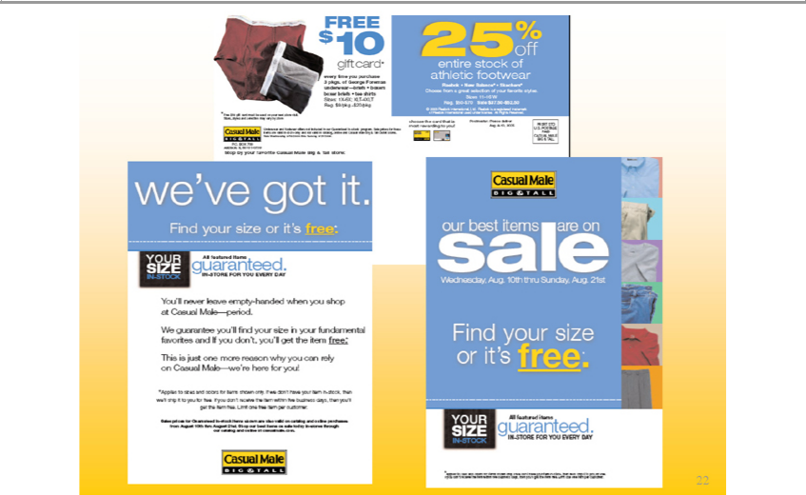

22“Your Size In-Stock-Guaranteed” Program

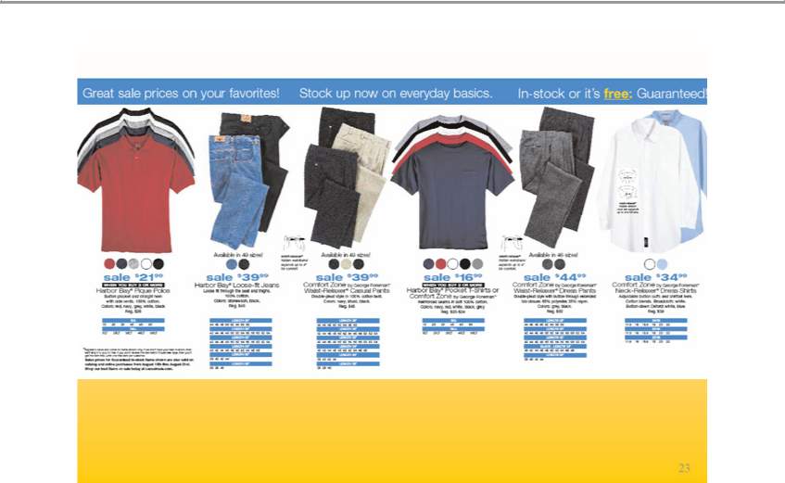

23Merchandise included in the “Your Size In-Stock-Guaranteed” Program



New Design
CASUAL MALE XL

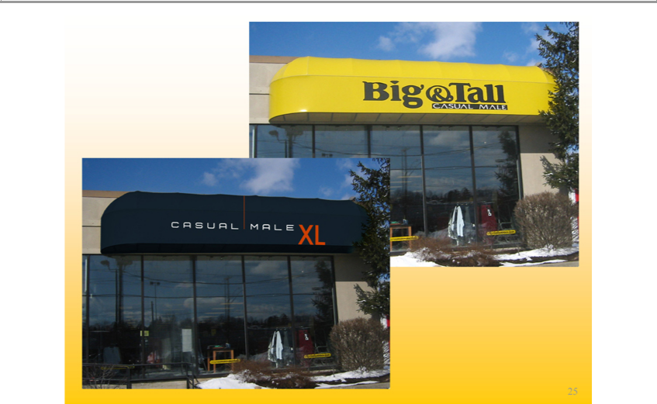

Big & Tall
CASUAL MALE
25 XL

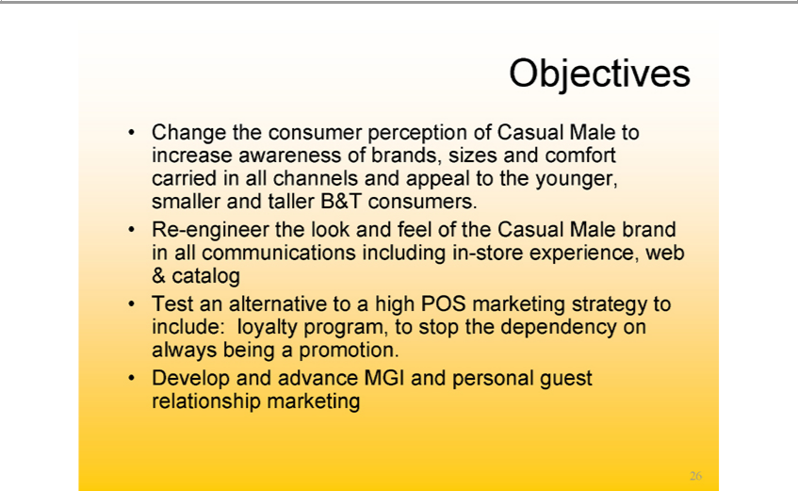

Objectives | awareness of brands, sizes and comfort carried in all channels and appeal to the younger, smaller and taller B&T consumers.
Change the consumer perception of Casual Male to
Re-engineer the look and feel of the Casual Male brandincreaseall communications including in-store experience, web & catalog
Test an alternative to a high POS marketing strategy to include: loyalty program, to stop the dependency on always being promotion.
26

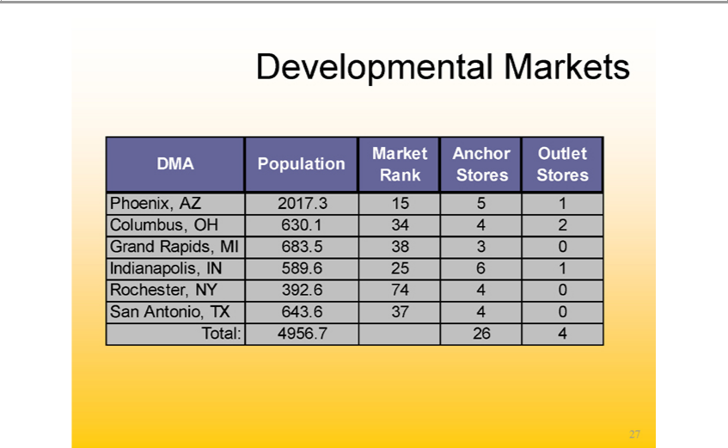

evelopmental Markets
Phoenix,DMAPopulationAZ2017.3Market155 Rank1 Anchor Stores Outlet Stores
Columbus, OH 630.1 34 4 2

Grand Rapids,INMI589. .25386 13 0
Indianapolis, 683
SanRochesterAntonio,NYTX392.643.674374 04 0
27

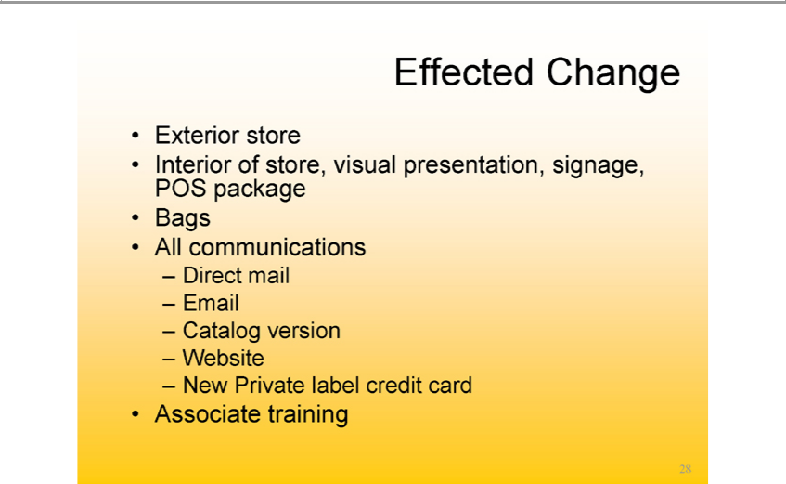

_{Exterior}ffected storeChange
BagsInterior of store, visual presentation, signage, POS package
All communications
^{Em}CatalogDirect^{il}mail
Website version
AssociateNewPrivatetraininglabel credit card

28

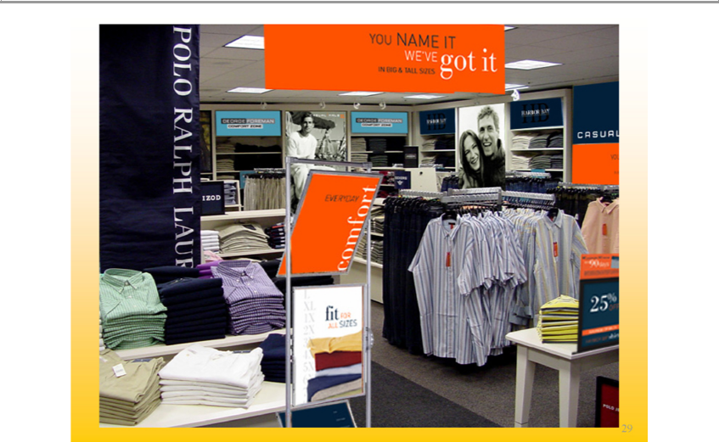

WE’VEYOUNAMEgotit IT
29IN BIG & TALL SIZES

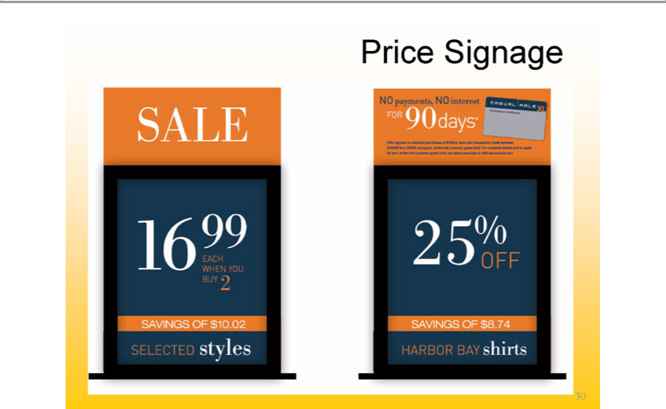

30New in-store price signage

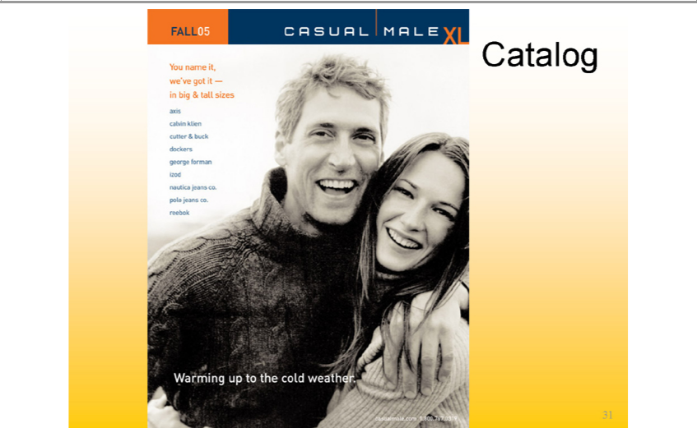

FALL05
inYoubigname&tallit, sizeswe’ve got it —
axis
_{cutter}alvin &kleinbuck
dockers
izodgeorge forman
nauticapolojeansjeansco.co.
Catalogreebok
Warming up to the cold weather.
31casualmale.com 1.800.767.0319

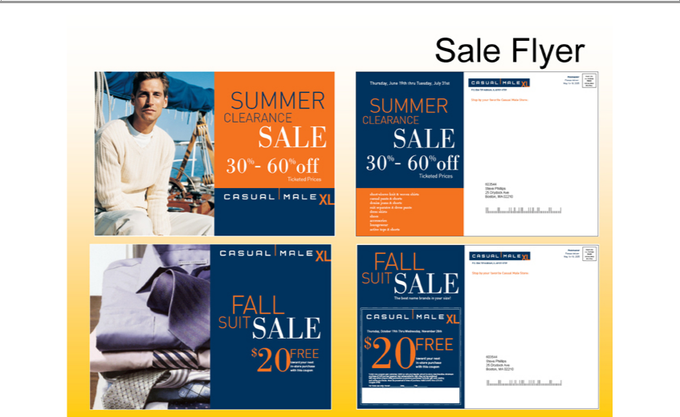

Sale flyer with new logo

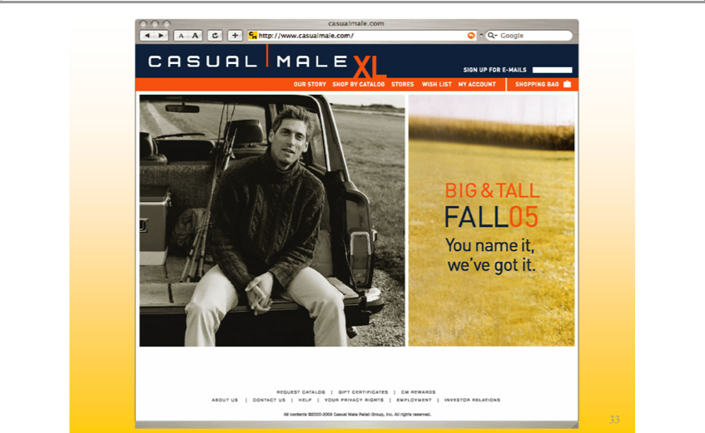

casualmale.com
Googlehttp://www.casualmale.com/
CASUAL MALE XL
^{ST}OURHOPSTORYBYCATALOG
ORES
WISH LIST
SHOPPINGMYACCOUNTBAG
FALL05BIG&TALL
we’veYounamegot it.it,
REQUEST_{TIFICA}TALOG
GIFT CER TES
ABOUTCMREWARDSUS
HELPCONTACT US
YOUR PRIVACY RIGHTS
INVESTOREMPLOYMENTRELATIONS
33All Contents ©2000-2005 Casual Male Retail Group, inc. All rights reserved.

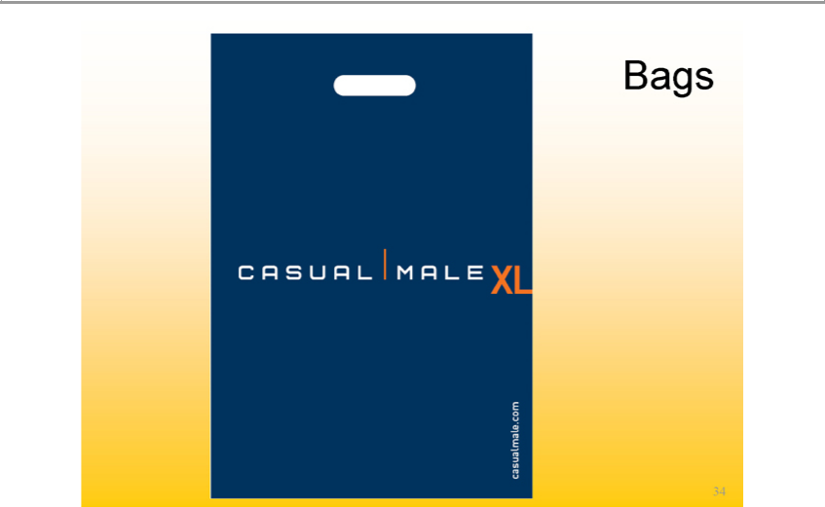

Bags
casualmale.comCASUALMALE XL

34

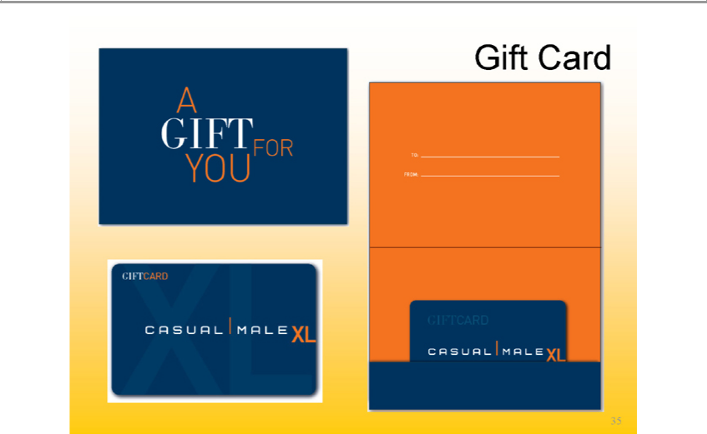

Gift Card
TO:AGIFT FOR YOU
FROM:
GIFTCARD
GIFTCARDCASUALMALE XL
35CASUAL MALE XL

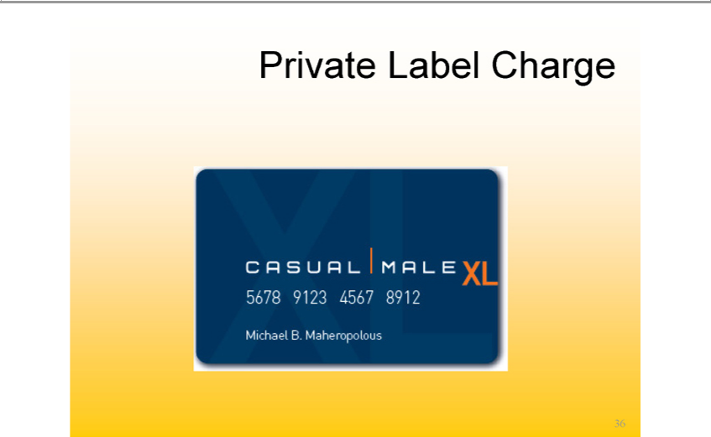

Private Label Charge
CASUAL56789123MALE45678912XL

36Michael B. Maheropolous

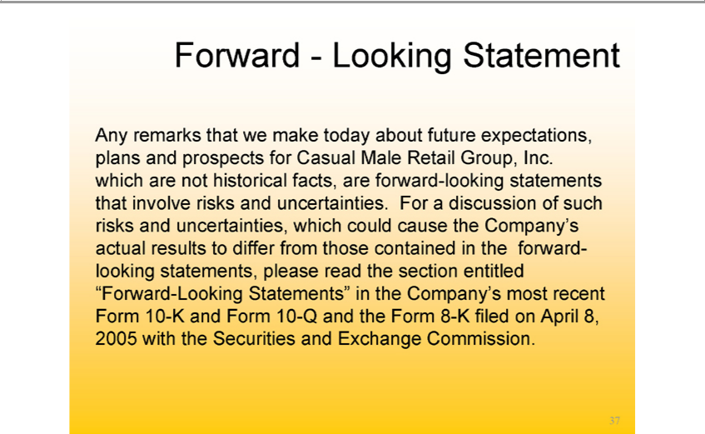

Forward—Looking Statement
Any remarks that we make today about future expectations, plans and prospects for Casual Male Retail Group, Inc. which are not historical facts, are forward-looking statements that involve risks and uncertainties. For a discussion of such risks and _{uncertainties,} which could cause the Company’s actual results to differ from those contained in the forward-looking statements, please read the section entitled “Forward-Looking Statements” in the Company’ most recent Form 10-K and Form 10-Q and the Form 8-K filed on April 8, 2005 with the Securities and Exchange Commission.
37

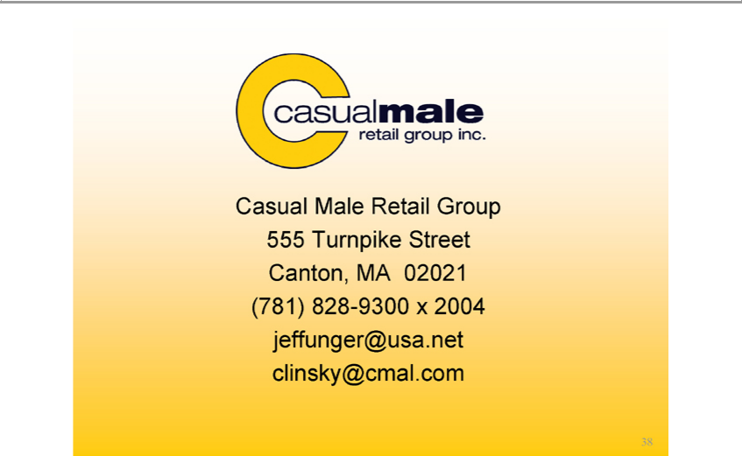

Casual Male Retail Group
Canton,555TurnpikeMA⁹³⁰⁰Street2021
(781)jeffunger@usa.net828-x2004

38clinsky@cmal.com

