UNITED STATES

SECURITIES AND EXCHANGE COMMISSION
Washington, D.C. 20549

FORM 8-K

CURRENT REPORT

PURSUANT TO SECTION 13 OR 15(d) OF THE

SECURITIES EXCHANGE ACT OF 1934

Date of Report (Date of earliest event reported): December 18, 2012

01-34219

(Commission File Number)

CASUAL MALE RETAIL GROUP, INC.

 | (Exact name of registrant as specified in its charter)
Delaware | 04-2623104
(State of Incorporation) |  |  | (IRS Employer
 |  |  | Identification Number)
 | 555 Turnpike Street, Canton, Massachusetts 02021
 | (Address of registrant’s principal executive office)
 | (781) 828-9300
 |  | (Registrant’s telephone number)

Check the appropriate box below if the Form 8-K filing is intended to simultaneously satisfy the filing obligation of the registrant under any of the following provisions (see General Instruction A.2. below):

- Written communications pursuant to Rule 425 under the Securities Act (17 CFR 230.425)

- Soliciting material pursuant to Rule 14a-12 under the Exchange Act (17 CFR 240.14a-12)

- Pre-commencement communications pursuant to Rule 14d-2(b) under the Exchange Act (17 CFR 240.14d-2(b))

- Pre-commencement communications pursuant to Rule 13e-4(c) under the Exchange Act (17 CFR 240.13e-4(c))

ITEM 7.01 - Regulation FD Disclosure

The Company will be presenting an investor slide presentation at upcoming meetings with various investment groups. A copy of the slide presentation is attached to this report as Exhibit 99.1, and is incorporated by reference herein.

The slide presentation contained in the exhibit includes statements intended as “forward-looking statements,” which are subject to the cautionary statement about forward-looking statements set forth in the exhibit. The slide presentation is being furnished, not filed, pursuant to Regulation FD. Accordingly, the slide presentation will not be incorporated by reference into any registration statement filed by the Company under the Securities Act of 1933, as amended, unless specifically identified therein as being incorporated therein by reference. The furnishing of the slide presentation is not intended to, and does not, constitute a determination or admission by the Company that the information in the slide presentation is material or complete, or that investors should consider this information before making an investment decision with respect to the Company.

Presentation of Non-GAAP Measures

The slide presentation includes the discussion of non-GAAP free cash flow on slide 36. Free cash flow is not a measure determined by generally accepted accounting principles (“GAAP”) and should not be considered superior to or as a substitute for net income (loss) or cash flows from operating activities or any other measure of performance derived in accordance with GAAP.

In addition, all companies do not calculate non-GAAP financial measures in the same manner and, accordingly, “free cash flows” as presented in this slide presentation may not be comparable to similar measures used by other companies. The Company calculates free cash flows as cash flow from operating activities less capital expenditures and discretionary store asset acquisitions, if any. We believe that inclusion of this non-GAAP measure helps investors gain a better understanding of our performance, especially when comparing such results to previous periods.

Free cash flow is calculated as follows for each of the respective fiscal years, as disclosed on slide 36 of the slide presentation:

 |  |  | Fiscal |  | Fiscal |  |  | Fiscal |  |  | Fiscal |  | Fiscal |  |  | Fiscal |  | Fiscal
(in millions) |  | 2012 YTD |  |  | 2011 |  | 2010 |  |  | 2009 |  |  | 2008 |  | 2007 |  |  | 2006
Cash flow provided by operations |  | $ | 8.4 |  | $ | 23.4 |  | $19.0 |  |  | $30.8 |  | $ | 23.2 |  | $11.7 |  | $ 12.1
Less: capital expenditures |  |  | 21.3 |  |  | 18.0 | 9.0 |  |  | 4.6 |  |  |  | 12.6 | 21.4 |  |  | 22.7
Less acquisitions |  |  | — |  |  | — |  | — |  |  | — |  |  | 3.0 |  | — |  | 3.0
Free cash flow | $ |  | (12.9) |  | $ | 5.4 | $10.0 |  |  | $26.2 |  |  | $ | 7.6 | $ (9.7) |  |  | $ (13.6)

- Free cash flow for fiscal 2008 and fiscal 2006 include the cash used for the Dahle acquisition of $3.0 million and the Jared M. acquisition of $3.0 million, respectively.

Item 9.01 Financial Statements and Exhibits.

- Exhibits

Exhibit

No. Description

99.1 Investor Slide Presentation

SIGNATURES

Pursuant to the requirements of the Securities Exchange Act of 1934, the registrant has duly caused this report to be signed on its behalf by the undersigned, thereunto duly authorized.

CASUAL MALE RETAIL GROUP, INC.

By: | /s/ DENNIS R. HERNREICH
Name: | Dennis R. Hernreich
Title: | Executive Vice President and Chief Financial Officer

Date: December 18, 2012

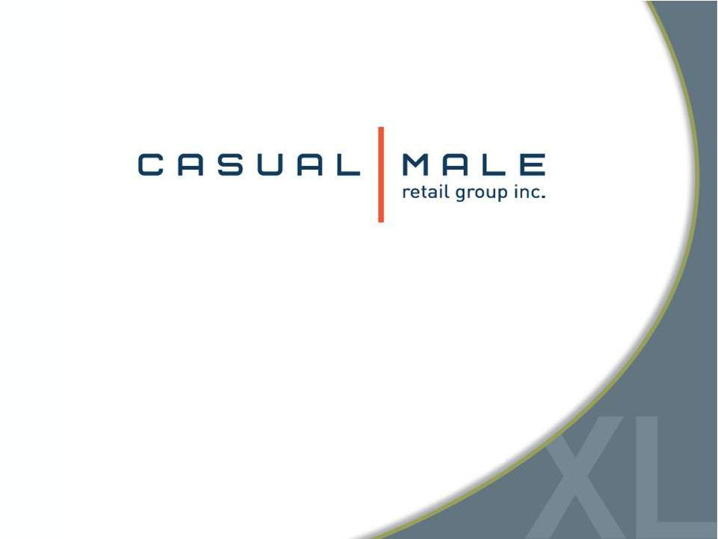
Exhibit 99.1

Generating Value on the Road to Destination XL®

Investor Presentation
December 2012

1


Safe Harbor

Certain information contained in this presentation, including, but not limited to, cash flows, operating margins, store counts, earnings expectations for fiscal 2012 and estimates through fiscal 2016, constitute forward-looking statements under the federal securities laws. The discussion of forward-looking information requires management of the Company to make certain estimates and assumptions regarding the Company's strategic direction and the effect of such plans on the Company's financial results. Such forward-looking statements are subject to various risks and uncertainties that could cause actual results to differ materially from those indicated. Such risks and uncertainties may include, but are not limited to: the failure to implement the Company's business plan for increased profitability and growth in the Company's retail stores sales and direct-to-consumer business, the failure to achieve improvement in the Company's competitive position, changes in or miscalculation of fashion trends, extreme or unseasonable weather conditions, economic downturns, a weakness in overall consumer demand, trade and security restrictions and political or financial instability in countries where goods are manufactured, increases in raw material costs from inflation and other factors, the interruption of merchandise flow from the Company's distribution facility, competitive pressures, and the adverse effects of natural disasters, war, acts of terrorism or threats of either, or other armed conflict, on the United States and international economies. These, and other risks and uncertainties, are detailed in the Company's Annual Report on Form 10-K filed with the Securities and Exchange Commission for the fiscal year ended January 28, 2012 filed on March 16, 2012 and other Company filings with the Securities and Exchange Commission. Casual Male assumes no duty to update or revise its forward-looking statements even if experience or future changes make it clear that any projected results expressed or implied therein will not be realized.

2

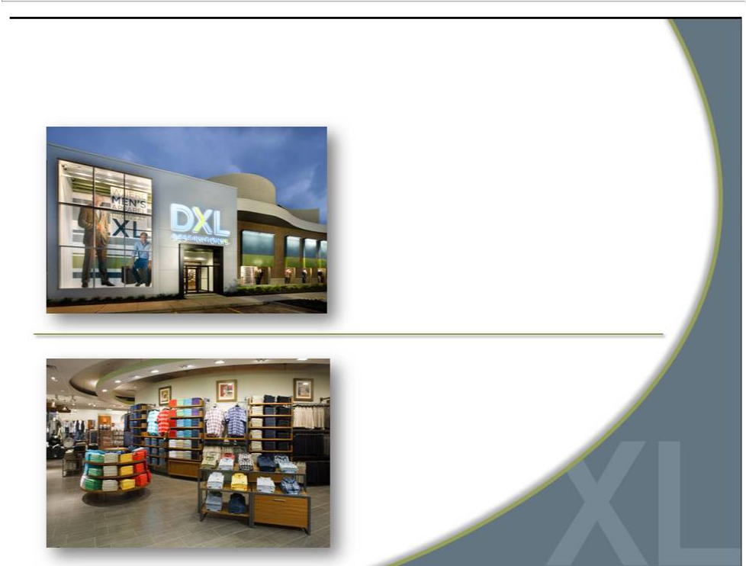
Who is Casual Male Retail Group?

Largest multi-channel specialty

retailer in niche men’s big and

tall (B&T) market

Offering unique blend

of wardrobe solutions

Private label & leading

apparel name brands

3

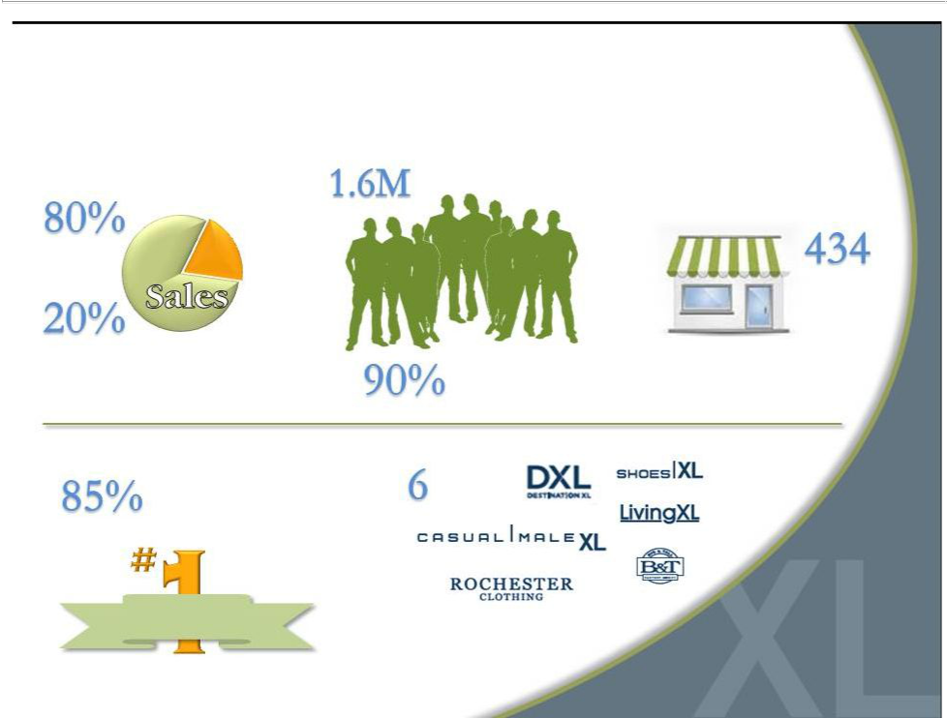
CMRG by the Numbers

Active customers

Retail

Retail Stores

Direct

Enrolled in loyalty program

Highest rated retailer
in 2011 CSI ^{Brands}

Customer Survey

Customer

Satisfaction

4

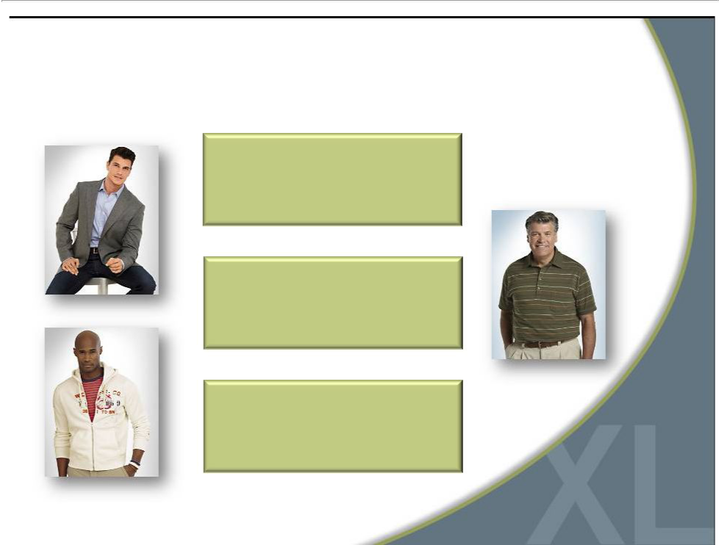
Who is Our Customer?

Males with a waist size 42”and

greater (35M men in US).

Determined by physical

characteristic, not demographic.

Not dependent on age, income,

race or nationality

Seeking greater selection in size.

Values convenience, selection

and fit over price.

5

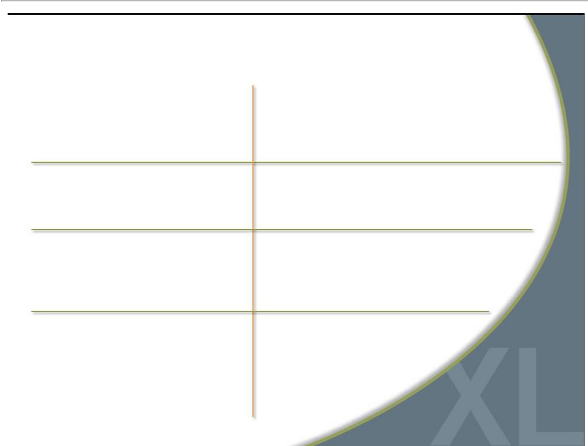
Attractive Big & Tall Segment

Men’s B&T market annual sales approximately $3.5 - $4B

B&T men account for approximately 11% in U.S.

B&T consumers shop 50% more for apparel on the Internet than regular size consumers

Highly fragmented market

Current CMRG market share of ~ 11%

Growing at nearly twice the rate of the regular size men’s apparel market

New CMRG marketing strategy focuses on direct sales through digital platforms

Opportunity to take share by offering one-stop shop solution

6


Why Invest in CMRG?

Accelerated conversion to DXL concept creates compelling investment opportunity

Strong gross margins; Ability to greatly improve operating margins

Significant market share/sales growth opportunity

Leader in large and growing

B&T market

Three-year $150M investment in DXL rollout to be

funded by free cash flow, including use of $47 million in tax benefits

Strong, debt-free balance

sheet

7

Our Current Casual Male XL Stores
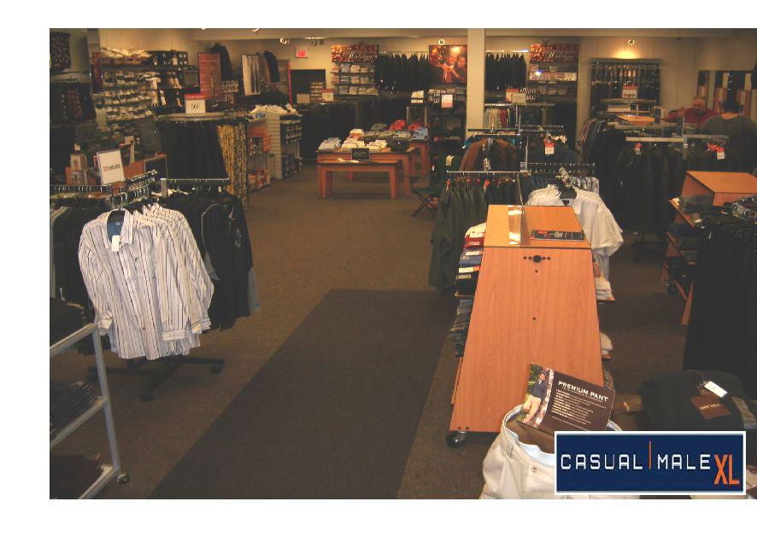

8

What Our Customer Wants

Large | More brand | On-site | Bright
changing | More brand | On-site | Bright
changing | selections | tailoring | atmosphere
rooms | selections | tailoring | atmosphere

Suggested | Wide aisles | One-stop
wardrobe | Wide aisles | shopping
solutions

9

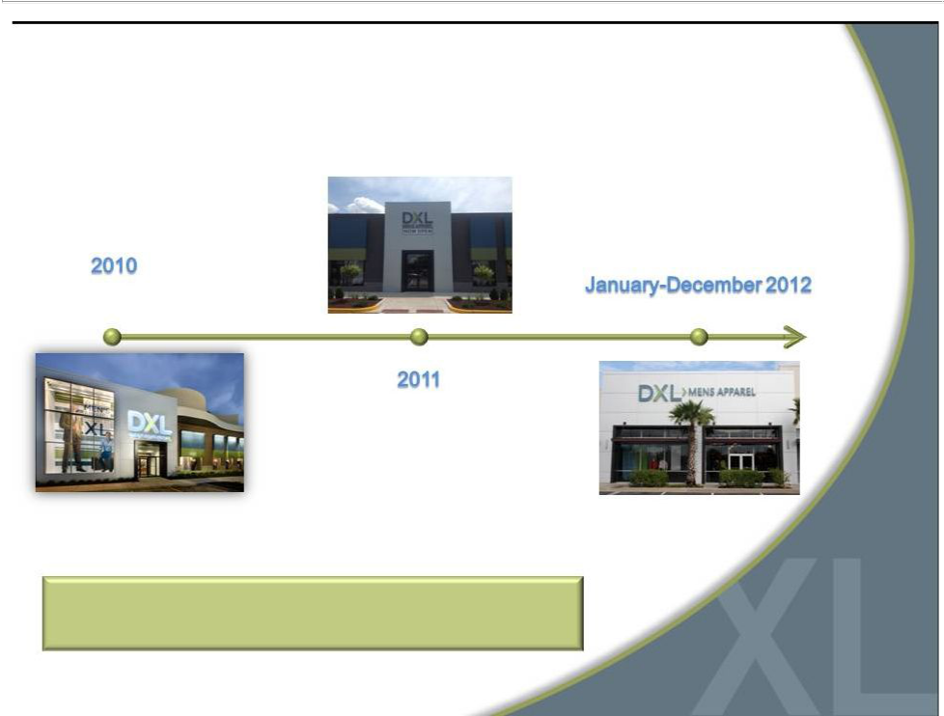
Responding with DestinationXL ®

Opened 4 DXL

concept stores Opened 31 DXL stores

Opened 12

DXL stores

Opportunity for accelerated growth and profitability

10

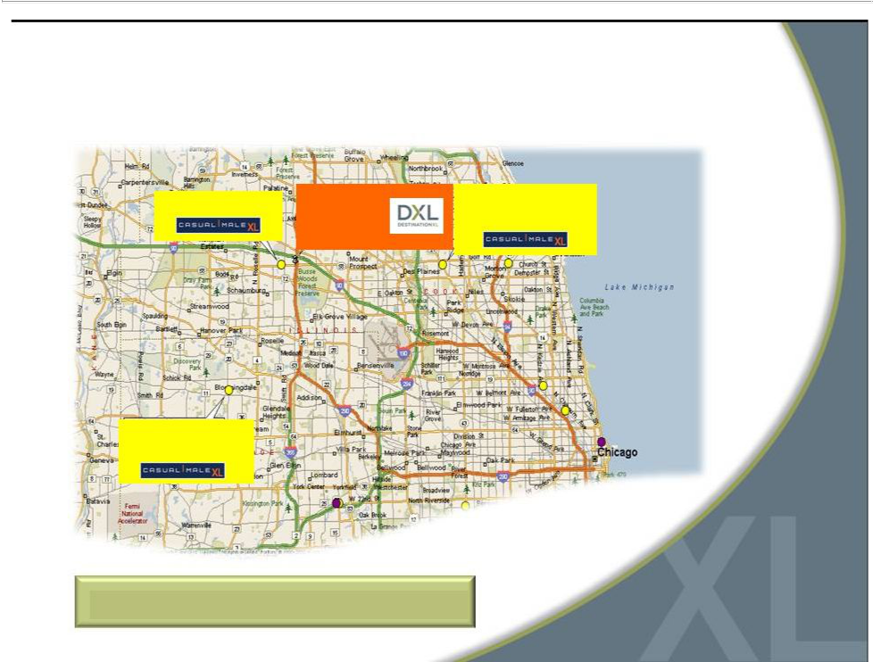
Market Consolidation to DXL

9451 Schaumburg, IL | DXL | 9183 Niles, IL
9451 Schaumburg, IL | Schaumburg, IL | 9183 Niles, IL
 | Schaumburg, IL | 11.4 miles

0.9 miles

Chicago Metro

9512 Bloomingdale, IL

11.2 miles

Customers are willing to drive up to 20 miles

11

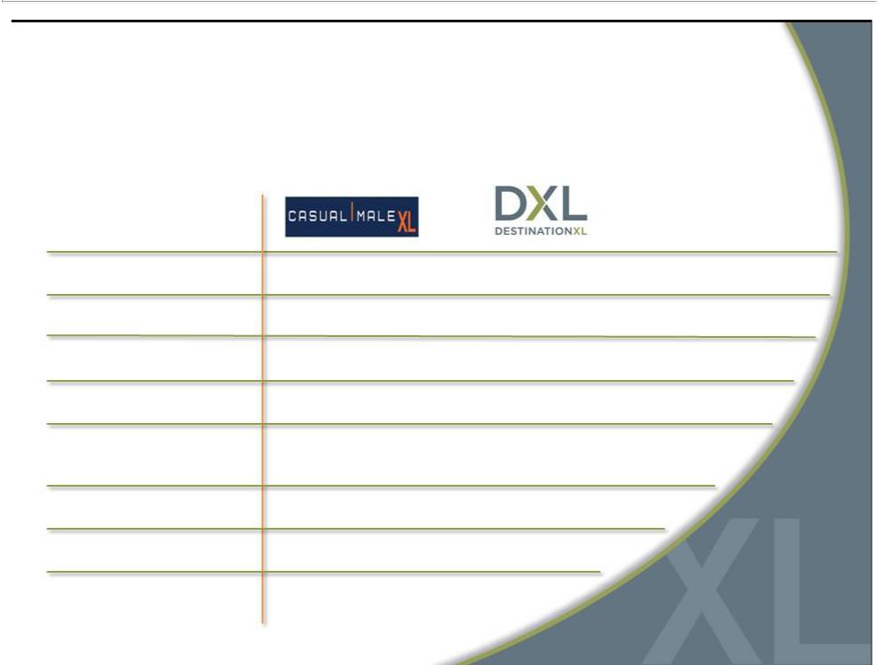
Casual Male XL vs. DestinationXL ®

Average

Store size

Sales per sq. ft.

Build out costs

Occupancy costs

Dollars per

transaction

Style choices

Private label brands

Name brands

3,400 sq. ft. | 8,000 sq. ft.
$166 | $175 ($229 by 2016)
$50 | $70
$30 | $30
$101 | $142
600 | 2,000
10 | 15
8 | 30

12

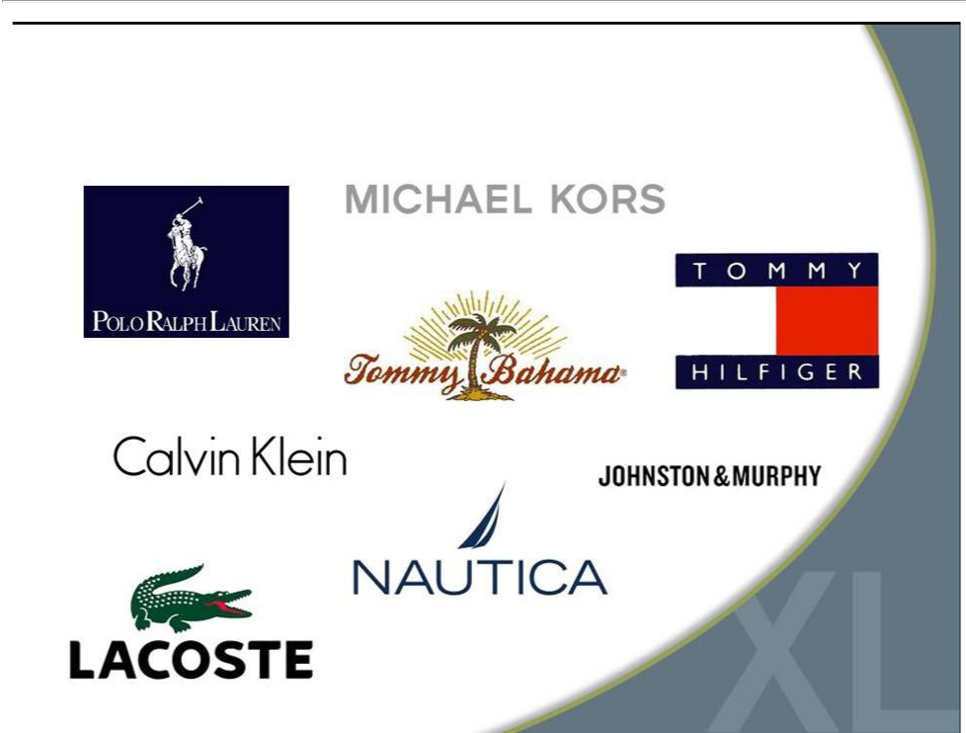
Large Selection of Name Brands

13

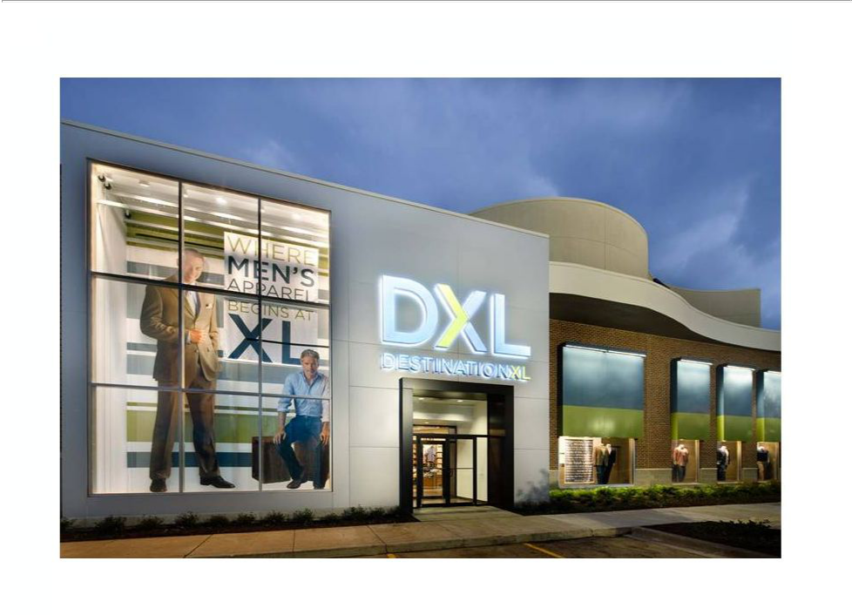

14

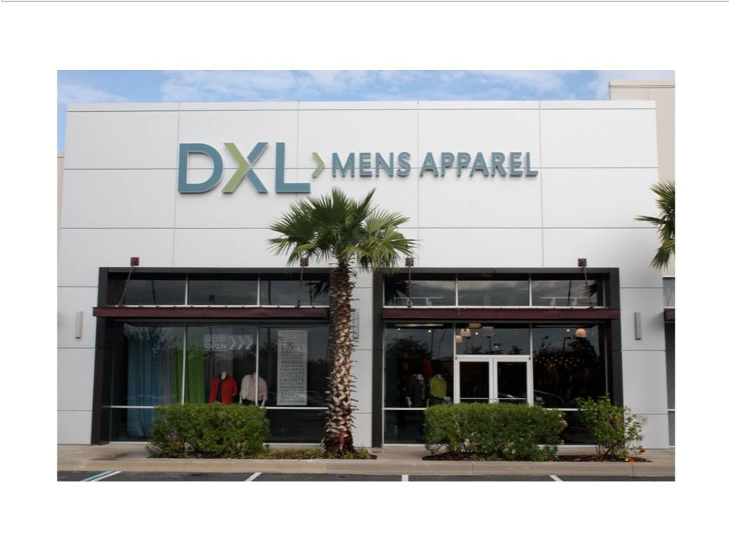

15

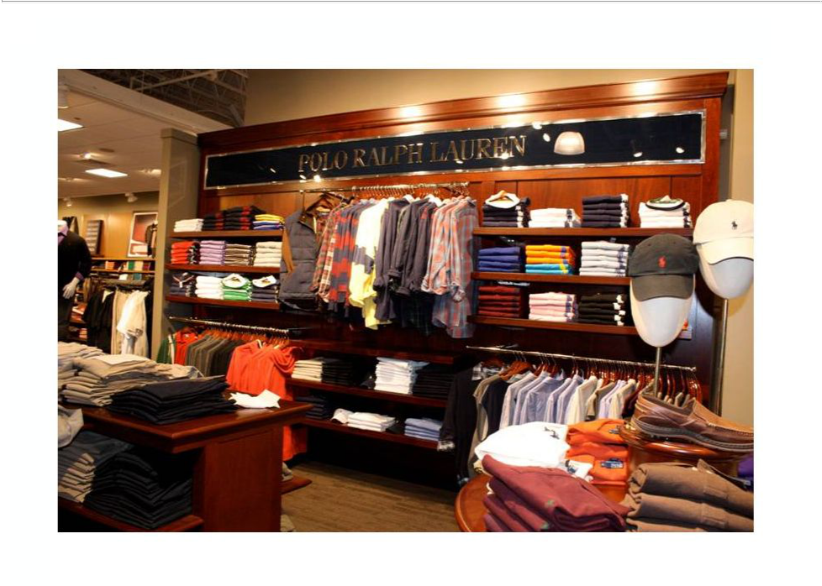

16

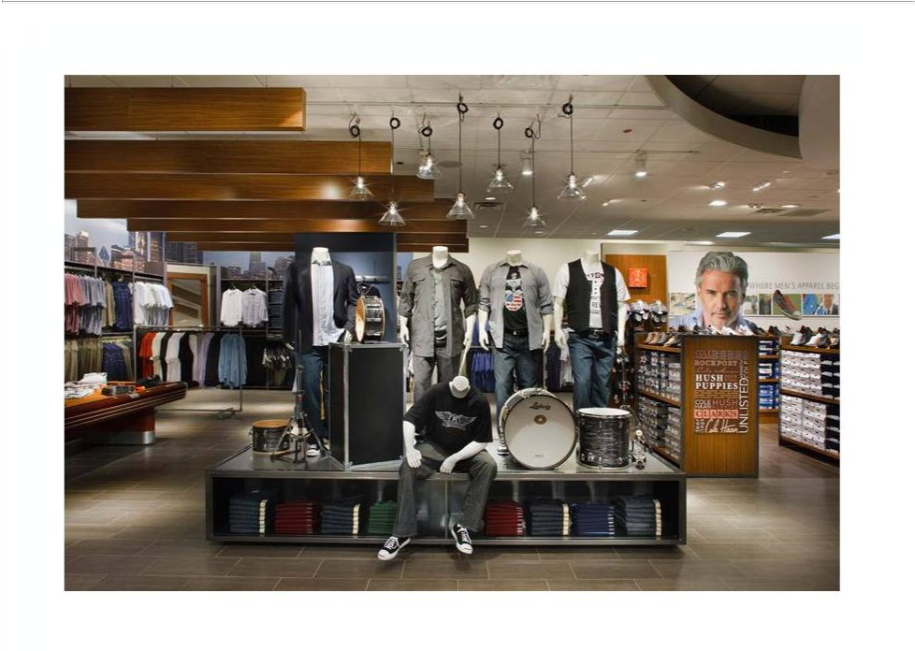

17

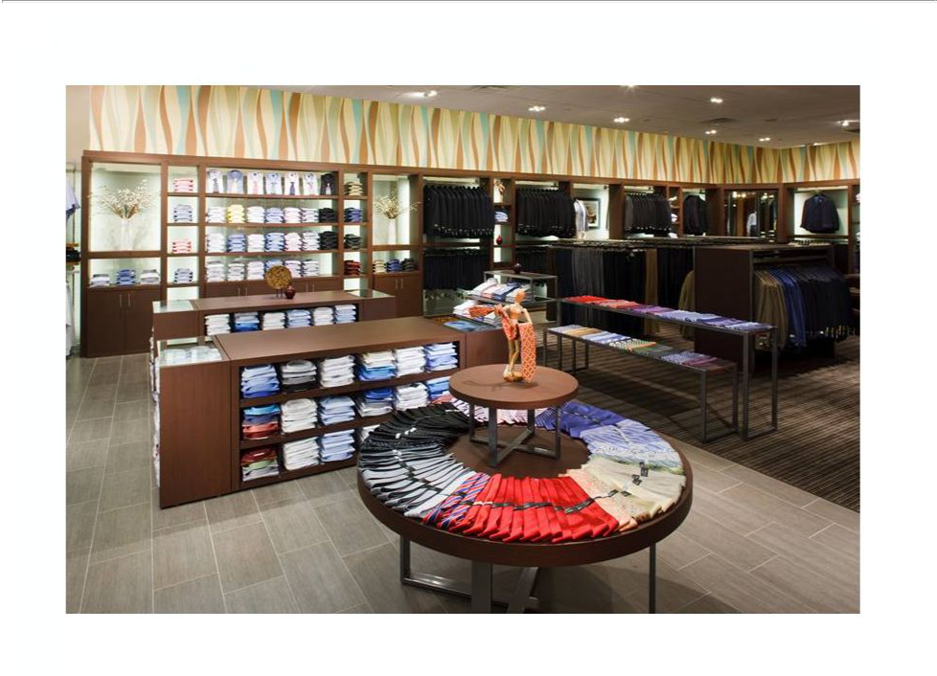

18

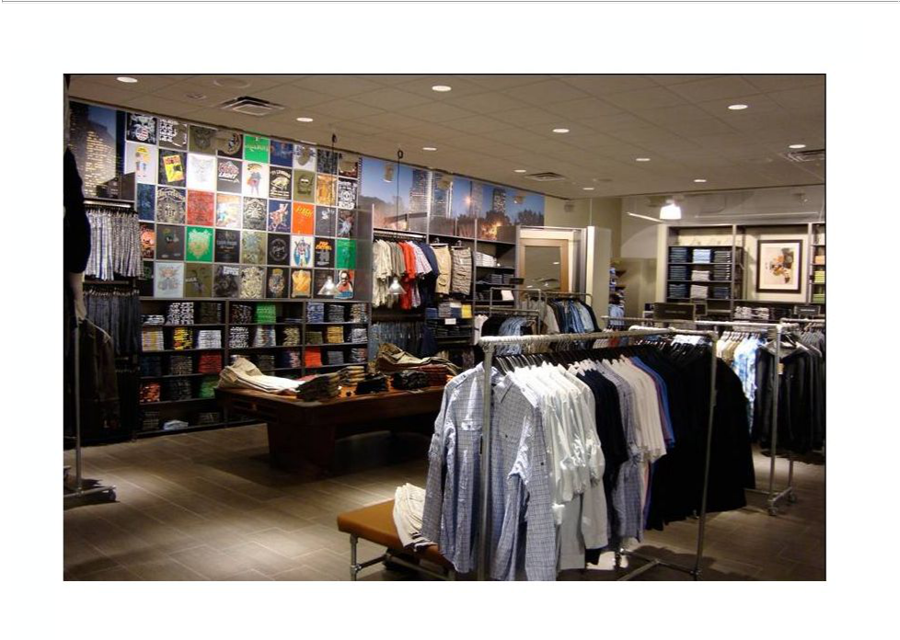

19

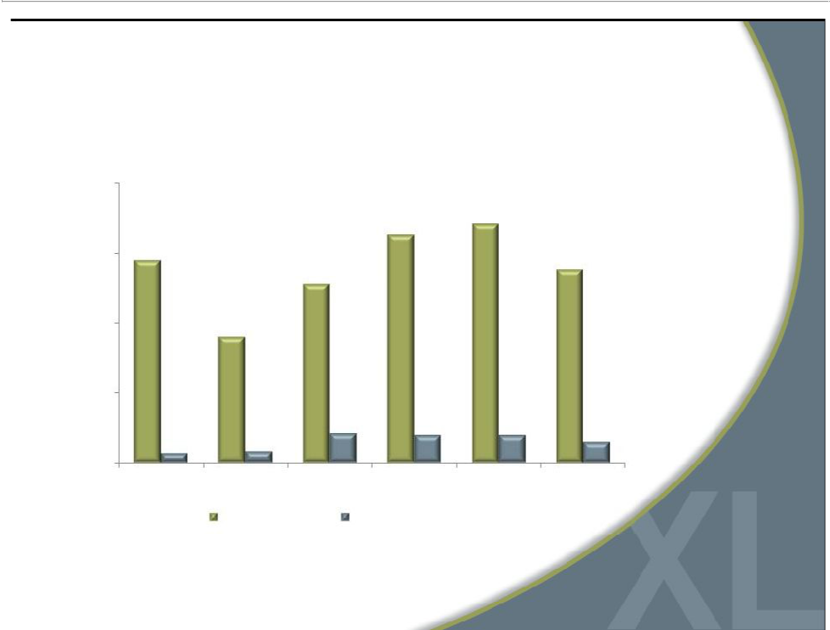
DXL Comps Reflect Growth Opportunity

20.0%

- stores

15.0% ^{14.5%}

10.0%

5.0%

0.7%

0.0%

Q3 2011

29 stores
20 stores _{17.1%}
16.3%

- stores

12.8%

- stores

9.0%

0.8% | 2.1% | 2.0% | 2.0%
Q4 2011 | FY 2011 | Q1 2012 | Q2 2012

DXL Comparables Total CMRG Comparables*

- stores 13.8%

1.5%

Q3 2012

*Total CMRG Comparables include all stores and direct channel | 20


Comparable Sales Definition

- Comparablesalesfor allperiods includeretailstores that have been open for at least one full fiscal year.

- Stores that have been remodeled, expanded or re-located during the period also are included in determination of comparable sales.

- Most DXL stores are considered relocations and comparable to all closed stores in each respective market area.

- Direct businesses are included in the calculation since CMRG is a multi-channel retailer.

21

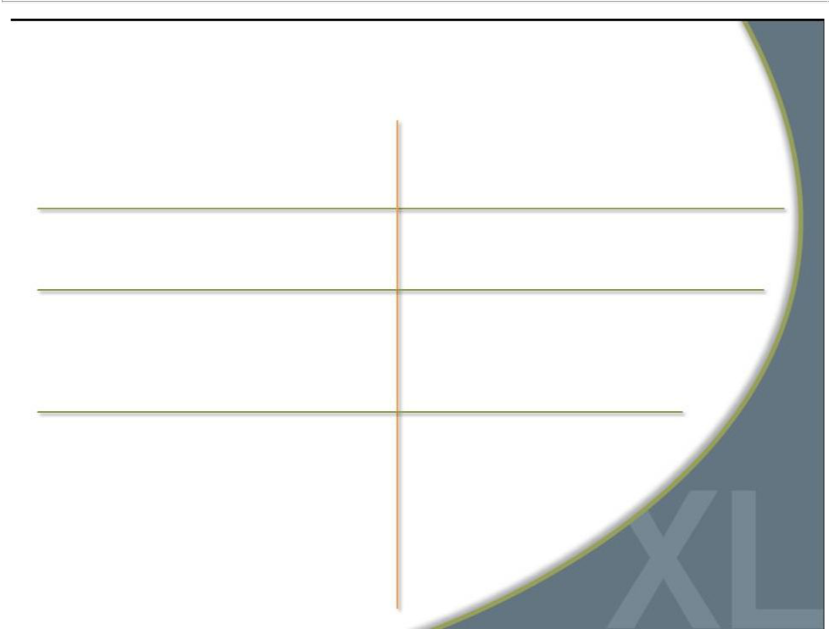
Compelling DXL Returns

Expect greater store productivity and profitability

Projecting higher 4-wall profits than combined profits of individual stores

Potential to capture additional market share

Opportunity to improve operating margins

Better leveraging of expenses -- occupancy, labor productivity and local/district management

Targeting between 25%-30% store operating margin

Attract new customers

Better cross-selling environment to capture greater share of apparel wallet from existing customers

Expect to significantly increase margins after the transition to DXL is complete

22

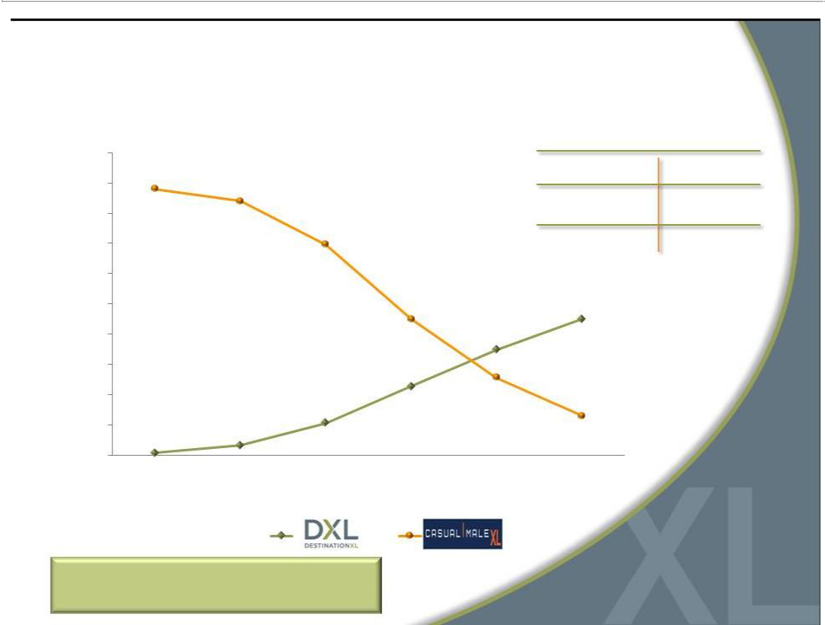
Accelerated DXL Openings

500

450

400

350

300

250

200

150

100

50

0

Total Stores:

2010 2011 2012 2013

(460) (450) (413) (350)

2015 Store Count Target

DestinationXL® 225-250

Casual Male XL
Outlet ^{~50}

Rochester Clothing | 5

2014 2015

- (280-305)

Accelerated rollout based on

success of DXL stores in 2011

23

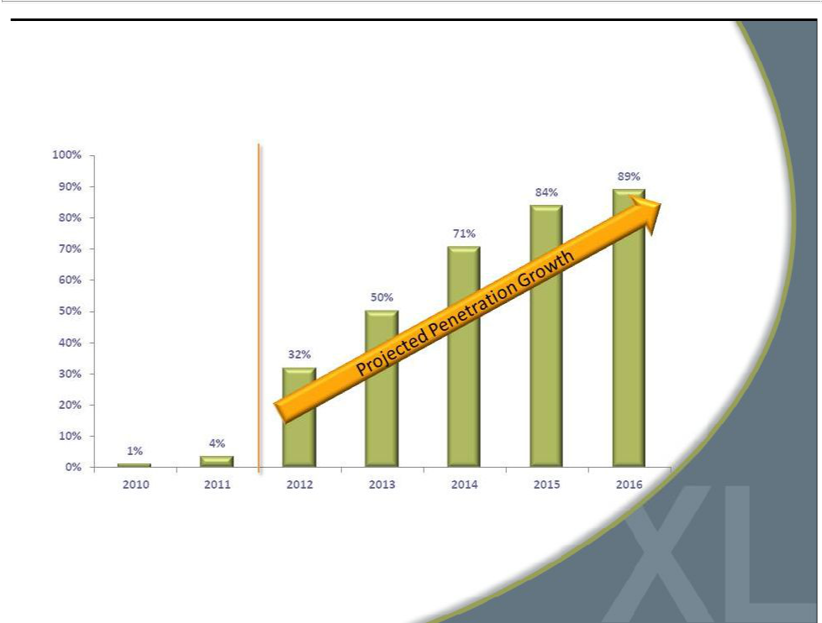
DXL Sales Increase as % of Total Revenue

* DXL sales include direct sales via the DXL website. | 24


Accelerated Rollout of DXL

2012

Commence new marketing strategy

Open 32 DXL stores/ Close69 CMXLstores

Operating marginsin the range of 4% - 5%

CapEx expected to be $35M

2013

 | Open 60 DXL stores / Close120 CMXLstores
 | Operating marginsin the rangeof 4%-5%
 | Lease exit and asset impairment charges in the the
 | range of $8-$12M *
 | CapEx expectedto peak at $45M
2012 - 2014 | 2014
 | Open 60 DXL stores / Close100 CMXLstores
 | Operatingmarginsin the rangeof 5% - 6%
 | Lease exit and asset impairment
 | chargesin the range of $5-$7M *
 | CapEx expected to
* Net of subleases | be $40M
* Net of subleases | 25


Accelerated Rollout of DXL

2015

2015

Completerolloutwith 225 - 250 opened DXL stores and Closureof remaining 60 Casual Male XL anchor stores

Operatingmarginsgaintraction and increaseto 8% - 9% (from 4.2% in ‘11)

CapEx expected to be approximately $35M

Lease exit and asset impairment charges in the range of $2-$4M*

2012 - 2014

* Net of subleases | 26


Accelerated Rollout of DXL

2016

2015

2012 -2014

2016

Full benefit of DXL concept drives revenue >$600M

Open average of 10 DXL stores per year

Approximately50 CMXLoutlet stores and 5 Rochester Clothing stores remain open

Operating margins >10%

Generating freecash flowin the rangeof $55 -$65M

27

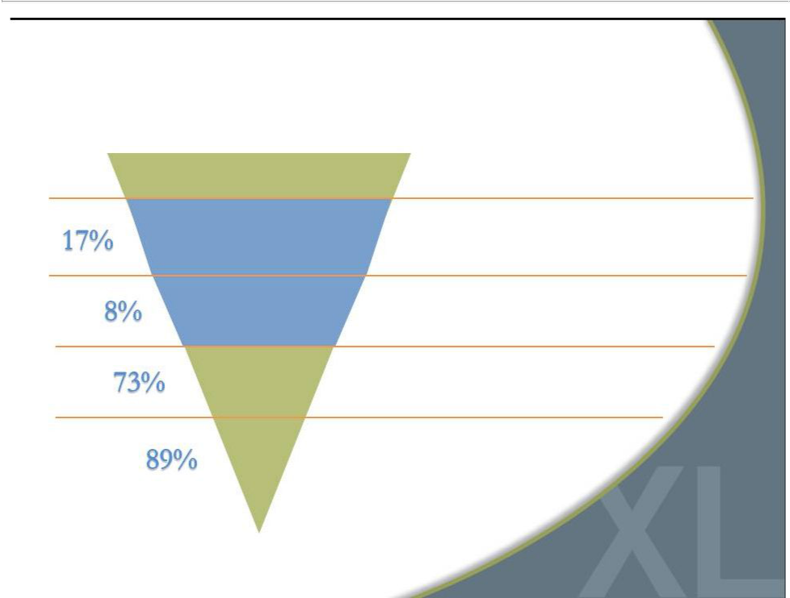
Increased Awareness = Opportunity

DXL Customer Purchase Funnel*

Addressable Population

Aware of DXL

Visiting DXL

Purchasing

from DXL

Repeat

DXL’s addressable market is primarily men with over 40”waist

Awareness of DXL is low across its markets, directly impacting ability to attract new customers

Of those aware of DXL, only 8% are visiting the store

73% of those that visit the store make a purchase

89% of those that make a purchase

intend to return

*Based on consumers’stated responses per L.E.K’s survey within DXL markets | 28
Source: L.E.K analysis | 28

Raising DestinationXL ® Awareness

Launched DestinationXL rebranding initiative

Hired Chief Marketing Officer in June 2012

Began developing

marketing strategy

Engaged

advertising firm

Identified

target customers

Developed balanced

marketing budget

29


Opportunity to Grow Market Share

- Capture greater wallet share with DXL concept

– Expansive selection blending private label/name brand apparel

– Appealing shopping environment

– Opportunity to grow clothing business with more complete solution

- Attract a broader customer audience with one-stop-shop

- Target “end-of-rack”customers

– 42”-46”waist size

– Younger than traditional Casual Male customer

– 65% of B&T market / 20% of current sales

– Adding regular XL/XLT size in 2013

- Paradigm shift in marketing improves awareness

- Improve direct business with new website

30



Financial Performance

31

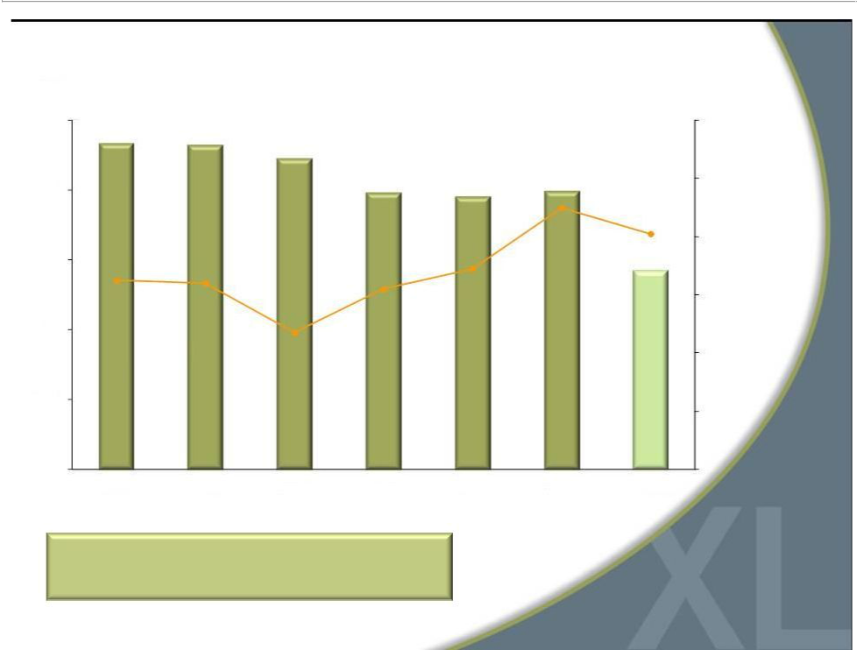
Revenue ($ mm)
_{$500} Sales and Gross Margin

$465.4 $464.1
 |  |  | $444.2
$400 |  |  | $395.2 | $390.0 | $397.7
 |  |  |  |  | 47.0%
$300 | 44.5% | 44.4% | 44.2% | 44.9%

42.7%
$200

$100

$0

2006 2007 2008 2009 2010 2011

50%

48%

46.1%

46%

$284.8

44%

42%

40%

38%

2012 YTD

Strong gross margins provide opportunity for

significant sales leverage

32

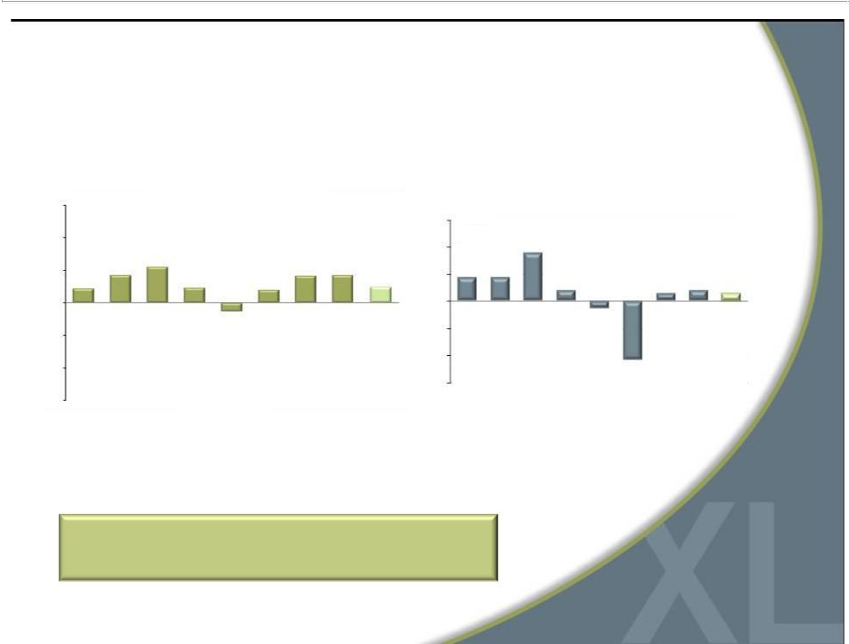
Operating Margin & Comparable Sales

CMRG Annual Historic Operating Margin

15%

10%

5.5%

5% | 4.2% |  | 4.1% | 4.2%
 | 2.2% | 2.3% |  | 2.4%
 | 2.2% | 2.3% | 2.0%
0%

(1.3)%

(5%)

(10%)

(15%)

2004 2005 2006 2007 2008 2009 2010 2011* 2012 YTD

* Before impairment charge of $23.1m

CMRG Historical Annual Comp Sales

15%

10% |  | 9.0%
5% | 4.4% | 4.5% | 1.5% | 2.1% 1.5%
 |  | 2.0% | 1.5% | 2.1% 1.5%

0%

(5%) | (1.3)%
(10%)
(15%) | (10.8)%
2004 2005 2006 2007 2008 2009 2010 2011 2012 YTD

Focus on improving operating margins

through greater DXL sales

33

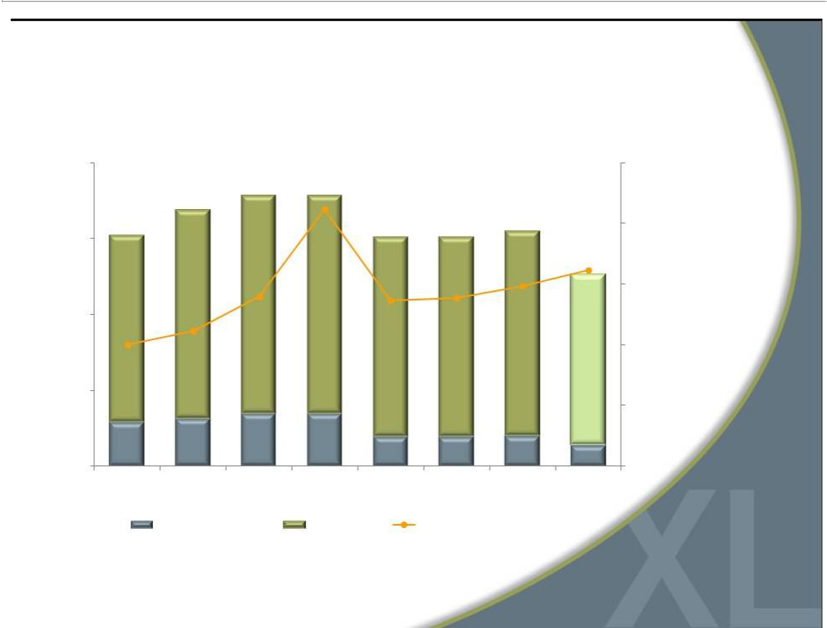
Strict Expense Management

($ mm)
$200 |  |  |  |  |  |  | 45.0%
 | $168.8 | $178.1 | $178.1
$151.9 |  |  |  | $151.0 | $150.9 | $154.8 | 42.0%
$151.9 |  |  | 42.7% | $151.0 | $150.9 |  | 42.0%
$150 |  |  | 42.7% |  |  |  | $113.1
 |  |  |  |  |  |  | 39.0%
$100 |  | 38.4% |  | 38.2% | 38.3% | 38.9% | 39.7%
36.0% | 36.7% |  |  |  |  |  | 36.0%
$50 |  |  |  |  |  |  | 33.0%
$28.6 | $30.9 | $34.4 | $34.1 |  |  |  | $13.6
$28.6 | $30.9 |  |  | $19.1 | $19.0 | $19.6
$0 |  |  |  | $19.1 | $19.0 | $19.6 | 30.0%
2005 | 2006 | 2007 | 2008 | 2009 | 2010 | 2011 | 2012 YTD
 | Marketing Expense |  | Total SG&A |  | SG&A as a Percentage of Sales

34

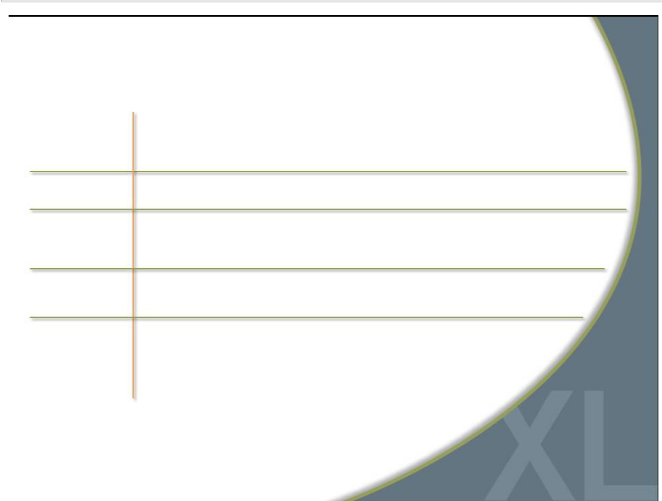
Strong Debt-Free Balance Sheet

 |  |  |  |  |  | Q3
 | 2007 | 2008 | 2009 | 2010 | 2011 | 2012
Inventory | $117.8M | $98.6M | $90.0M | $92.9M | $104.2M | $116.1M
Borrowing under | $41.0M | $38.7M | $3.5M | - | - | $7.6M
revolver
Cash on hand | - | - | - | $4.1M | $10.4M | $5.2M
Fixed term loan | $17.3M | $12.5M | $7.6M | - | - | -

35

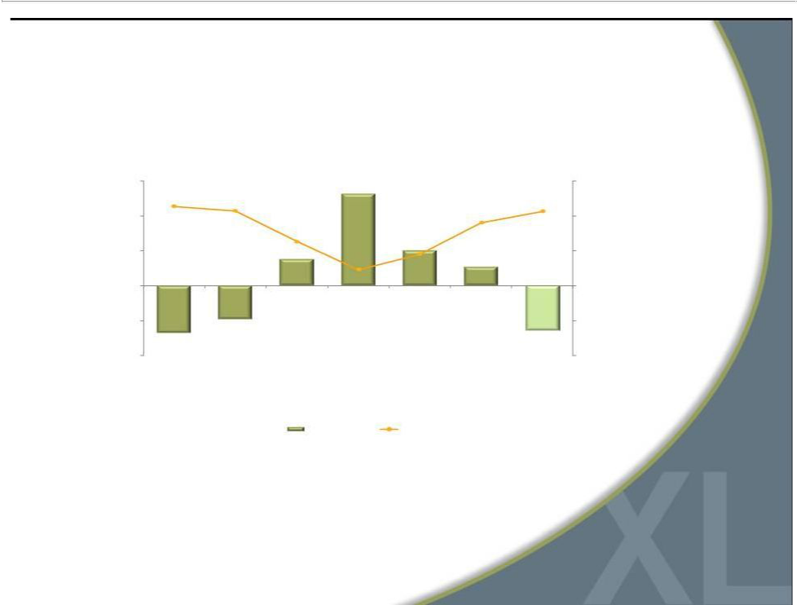
Free Cash Flow * and CapEx

($ mm)

$30 |  |  |  |  |  | $30
$22.7 |  |  | $26.2
$22.7 | $21.4 |  |  |  |  | $21.3
$20 |  |  |  |  | $18.0 | $20
 |  | $12.6
$10 |  |  |  | $10.0 |  | $10
$10 |  | $7.6 | $4.6 |  |  | $10
 |  | $7.6 | $4.6 | $9.0 | $5.4
$0 |  |  |  |  |  | $0
($10) | $(9.7) |  |  |  |  | ($10)
$(13.6) |  |  |  |  |  | $(12.9)
($20) |  |  |  |  |  | ($20)
2006 | 2007 | 2008 | 2009 | 2010 | 2011 | 2012 YTD

Free Cash Flow CAPEX

*Free cash flow is defined as cash flow from operating activities, less capital expenditures and discretionary store asset acquisitions.

36


Why Invest in CMRG?

- Accelerated conversion to DXL concept creates compelling investment opportunity

– Investment to be funded by operating cash flow

- Leader in large and growing B&T market

- Strong gross margins

- Ability to greatly improve operating margins

- Three-year $150M investment in DXL rollout to be funded by free cash flow, including use of $47 million in tax benefits

- Significant market share/sales growth opportunity

– Goal of increasing share from 11% to 17.5%-20% by 2015

– Increasing DXL brand awareness

– Expanding customers to include “end-of-rack”

– Improving direct sales business
• Strong, debt-free balance sheet | 37



For additional information:

Jeffrey Unger

Casual Male Retail Group, Inc.

V. P. Investor Relations

561-482-9715 Office

561-543-9806 Cell

jeffunger@usa.net

www.destinationxl.com

38

