UNITED STATES

SECURITIES AND EXCHANGE COMMISSION
Washington, D.C. 20549

FORM 8-K

CURRENT REPORT

PURSUANT TO SECTION 13 OR 15(d) OF THE

SECURITIES EXCHANGE ACT OF 1934

Date of Report (Date of earliest event reported): April 24, 2008

0-15898

(Commission File Number)

CASUAL MALE RETAIL GROUP, INC.

 | (Exact name of registrant as specified in its charter)
Delaware | 04-2623104
(State of Incorporation) |  |  | (IRS Employer Identification Number)
 | 555 Turnpike Street, Canton, Massachusetts 02021
 | (Address of registrant's principal executive office)
 | (781) 828-9300
 |  | (Registrant's telephone number)

Check the appropriate box below if the Form 8-K filing is intended to simultaneously satisfy the filing obligation of the registrant under any of the following provisions (see General Instruction A.2. below):

- Written communications pursuant to Rule 425 under the Securities Act (17 CFR 230.425)

- Soliciting material pursuant to Rule 14a-12 under the Exchange Act (17 CFR 240.14a-12)

- Pre-commencement communications pursuant to Rule 14d-2(b) under the Exchange Act(17 CFR 240.14d-2(b))

- Pre-commencement communications pursuant to Rule 13e-4(c) under the Exchange Act(17 CFR 240.13e-4(c))

ITEM 7.01 – Regulation FD Disclosure

The Company will be presenting a slide presentation at meetings with various investment groups. A copy of the slides to be presented at those meetings is attached to this report as Exhibit 99.1, which slide presentation is incorporated by reference herein.

The slide presentation contained in the exhibit includes statements intended as "forward-looking statements," which are subject to the cautionary statement about forward-looking statements set forth in the exhibit. The slide presentation is being furnished, not filed, pursuant to Regulation FD. Accordingly, the slide presentation will not be incorporated by reference into any registration statement filed by the Company under the Securities Act of 1933, as amended, unless specifically identified therein as being incorporated therein by reference. The furnishing of the slide presentation is not intended to, and does not, constitute a determination or admission by the Company that the information in the slide presentation is material or complete, or that investors should consider this information before making an investment decision with respect to the Company.

ITEM 9.01 – FINANCIAL STATEMENTS AND EXHIBITS

(c) Exhibits

Exhibit No. |  | Description
99.1 |  | Presentation dated April 24, 2008

SIGNATURES

Pursuant to the requirements of the Securities Exchange Act of 1934, the registrant has duly caused this report to be signed on its behalf by the undersigned, thereunto duly authorized.

CASUAL MALE RETAIL GROUP, INC.

By: | /S/ DENNIS R. HERNREICH
Name: | Dennis R. Hernreich
Title: | Executive Vice President and Chief Financial Officer

Date: April 24, 2008


EXHIBIT 99.1

April 2008

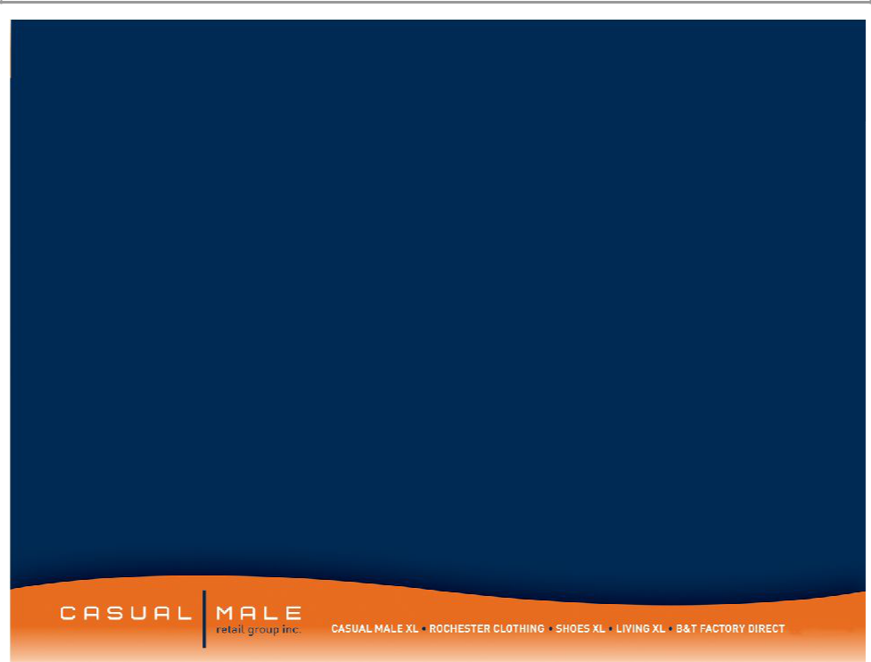
Big & Tall Market

- Market defined as:

– big = waist size between 40” and 70”

– tall = height over 6’2”

- Big and tall men account for approximately 11% of the male population.

- Big and tall market size is approximately $6 billion and growing at almost twice the rate of the regular size men’s apparel market.

– Big & tall apparel market is highly fragmented; characterized by many small, local operators.

2

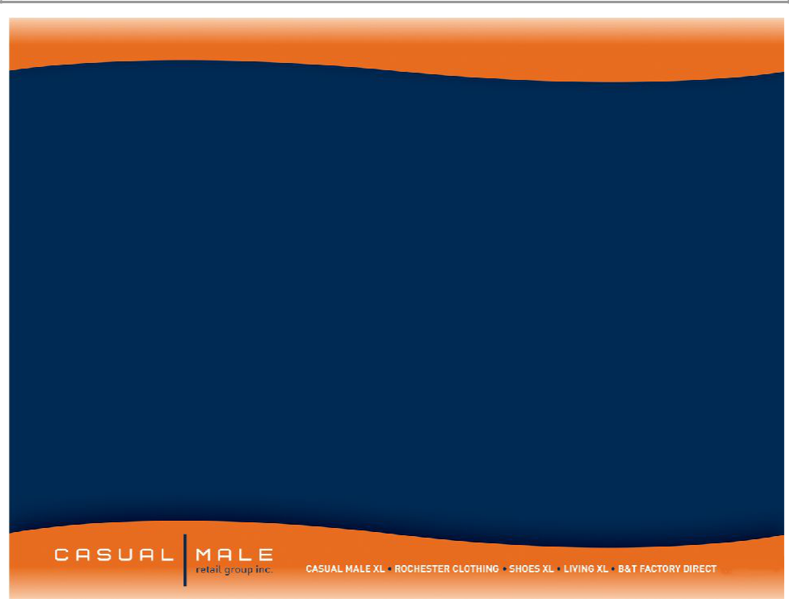

Casual Male Retail Group properly positioned to increase market share to 12% of the big & tall market

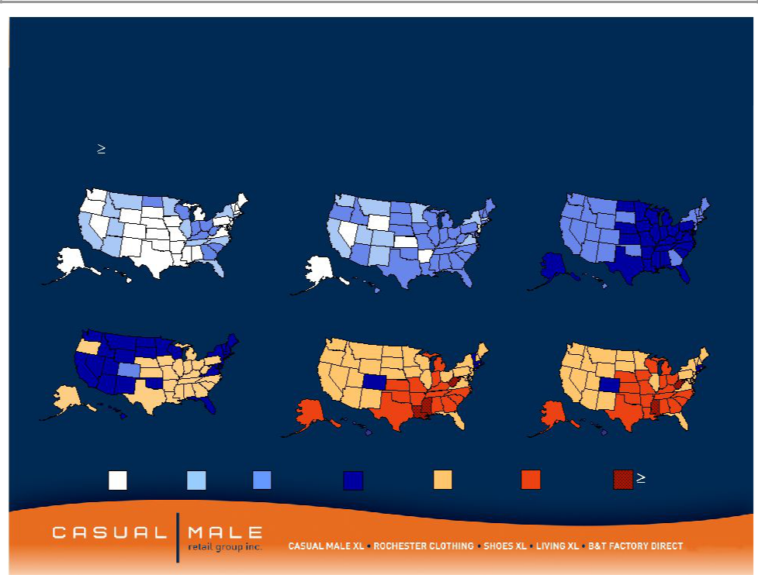
Market is growing as a percent to total menswear sales

Obesity Trends* Among U.S. Adults

(*BMI 30, or about 30 lbs overweight)

1985 1990 1995

2000 2005 2006

No Data <10% 10%–14%15%–19% 20%–24% 25%–29%30%

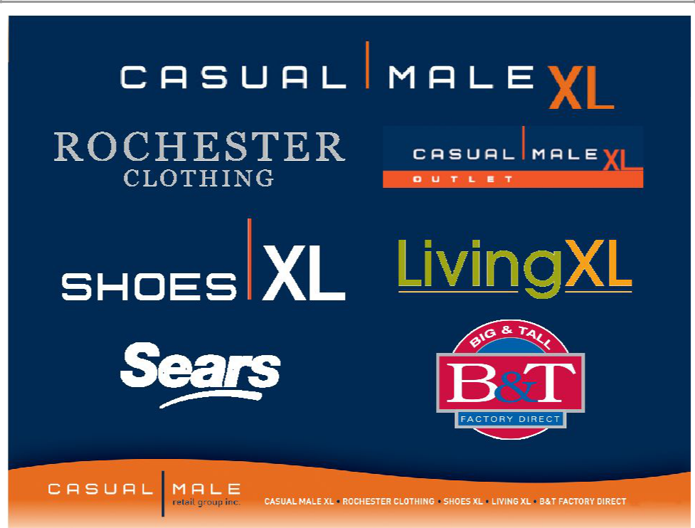

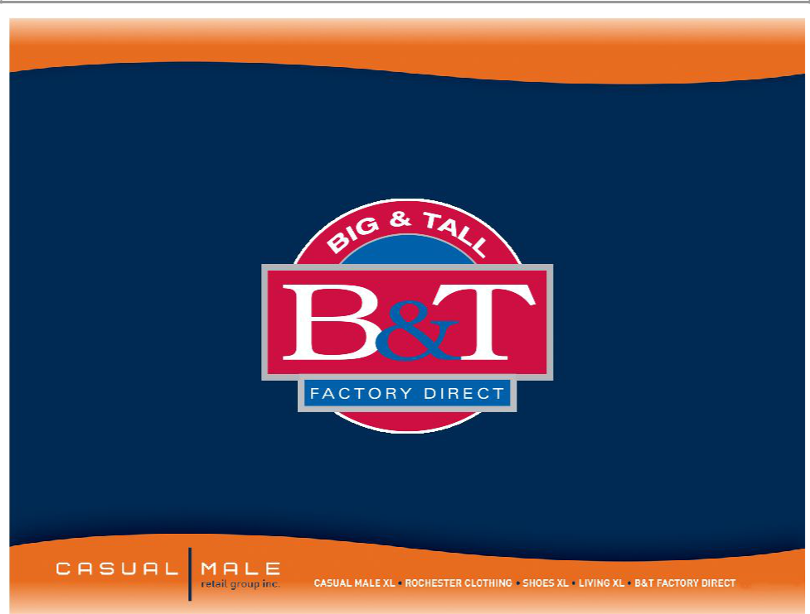

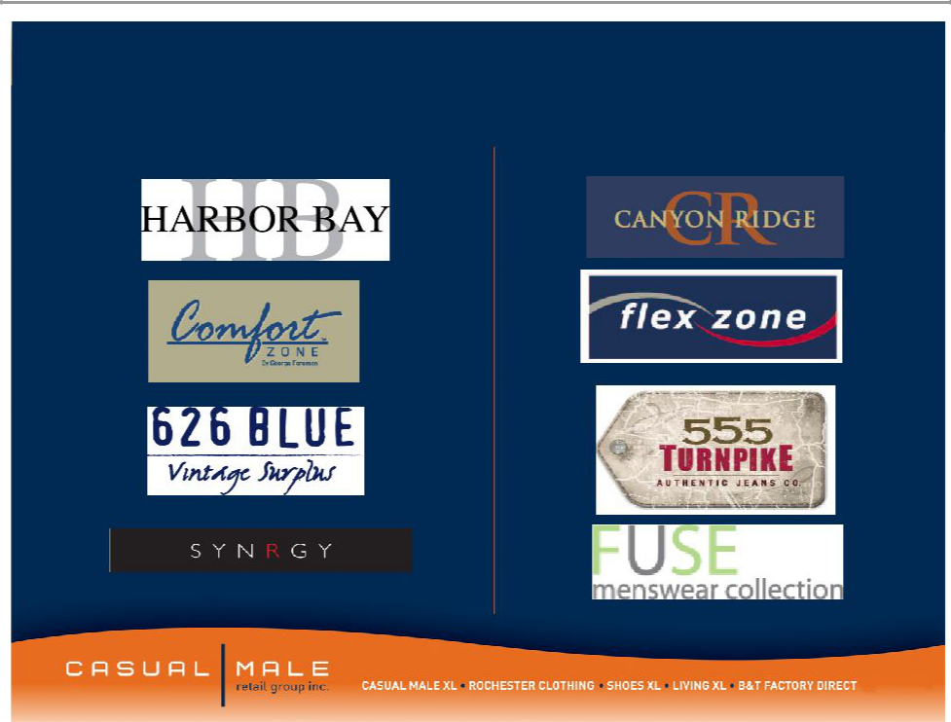
B & T Factory Direct

Full Price Brands Outlet Brands

B & T Factory Direct

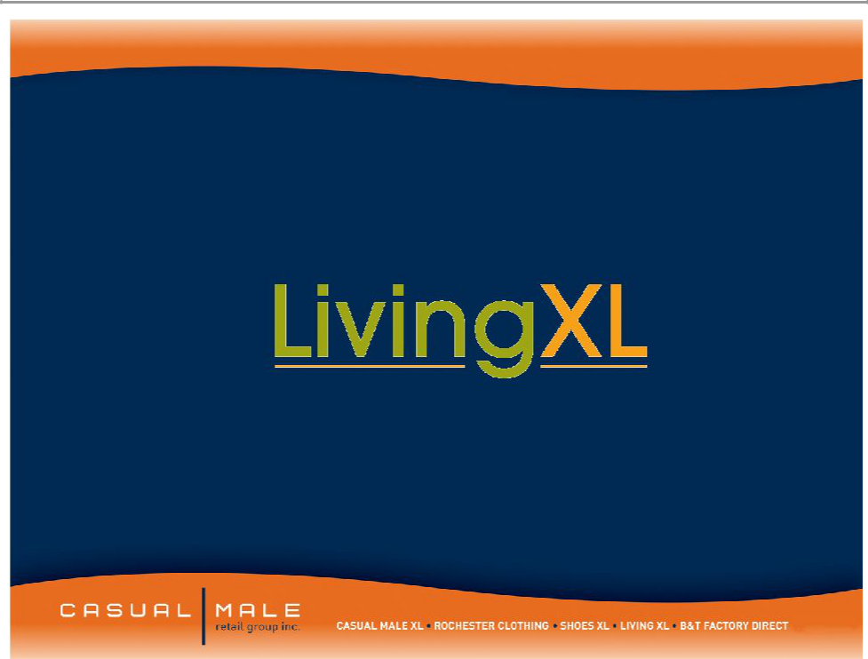

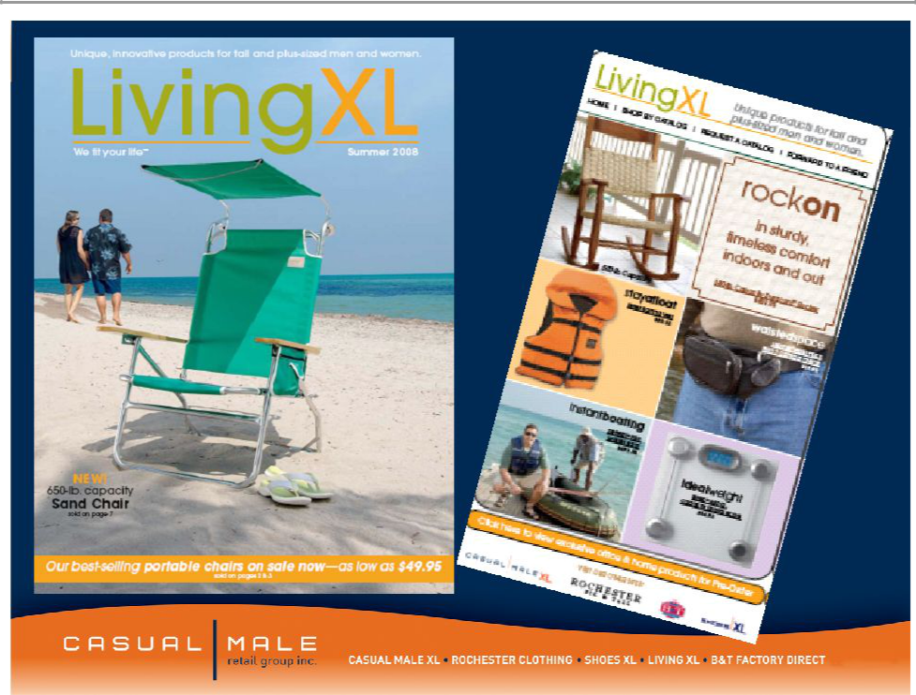

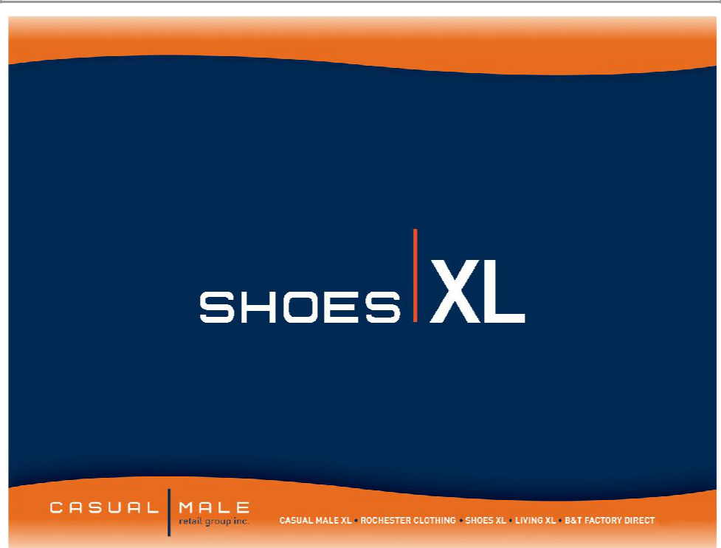

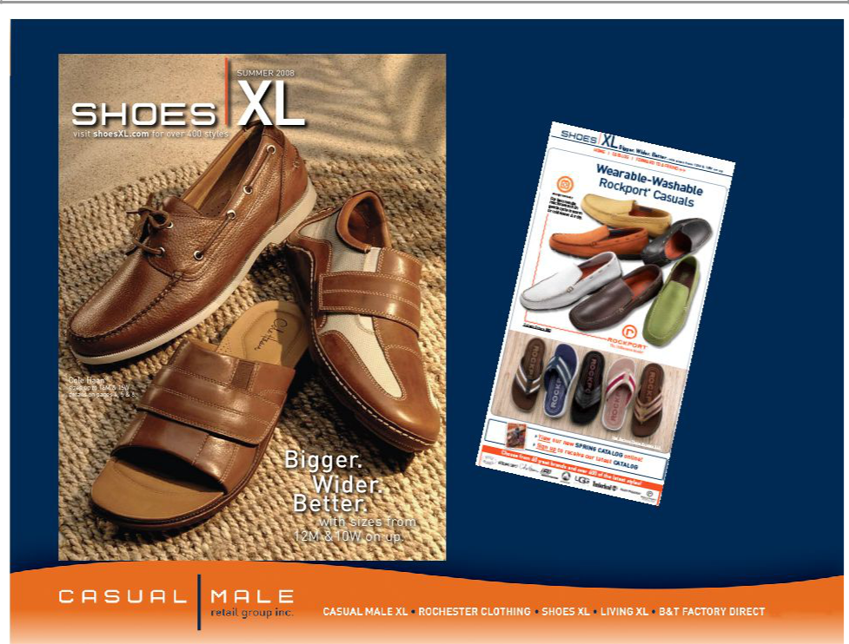

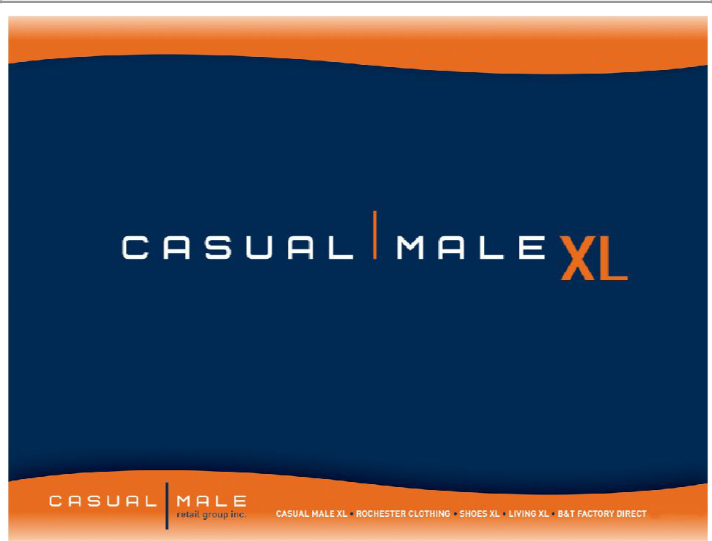

Casual Male Stores

- Casual Male XL is the nation’s largest specialty retailer of big & tall clothing with 461 stores in 44 states
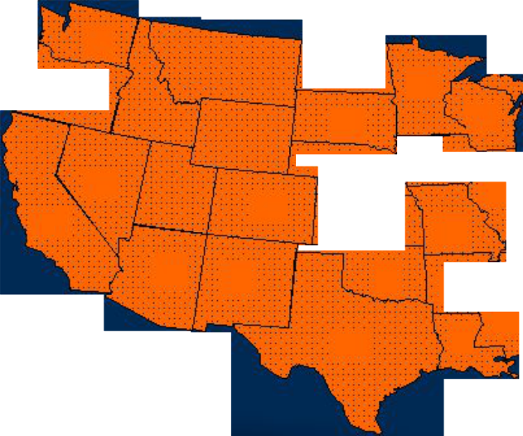

7

5 |  | 1 |  |  | 9
 |  |  | 1
5 |  |  | 4 |  | 4
55 |  | 6 |  | 4 | 12
8 | 2 |  |  | 3 | 3
Long term potential – |  |  | 37 |  | 5

additional 100-130 more stores

3


9 31

23

26
28 12 ²²
2
- 14
- 11

7
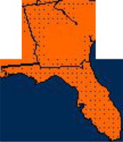

2 5 ¹¹

27

CT-11

DE-3

RI-1

MA-14

MD-13

NH-3

NJ-21

VT-1

14.0%

12.0%

10.0%

8.0%

6.0%

4.0%

2.0%

0.0%

-2.0%

Comp Store Trend
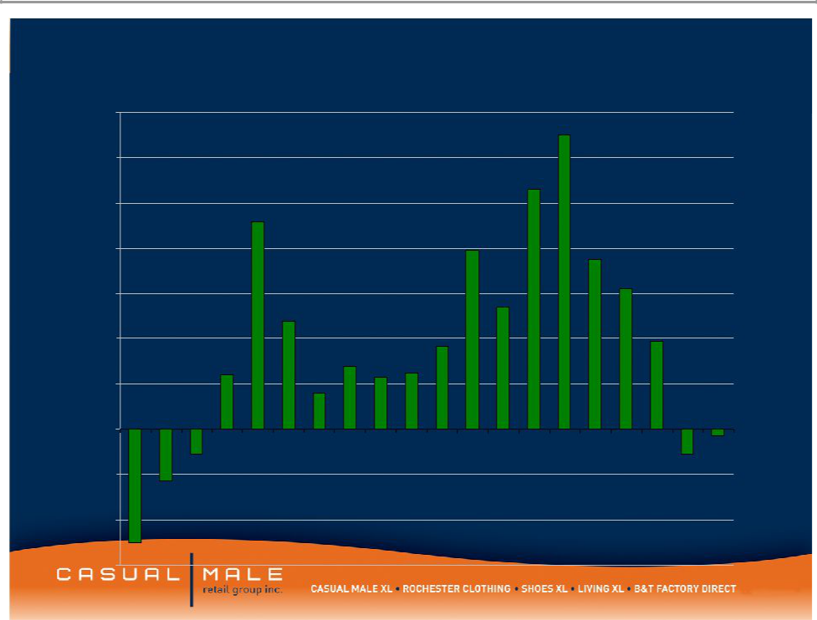

13.0%

10.6%

9.2%

7.9%
7.5%

6.2%

5.4%
4.8%

 |  |  |  |  |  |  |  |  | 3.7% |  |  |  |  |  |  |  | 3.90%
 |  |  | 2.4% |  |  | ^{2.8%}_{2.3%}2.5%
 |  |  |  |  |  | 1.6%
 |  |  |  | Stores change to
Q1 | Q2 | Q3 | Q4 | Q1 | Q2 | Q3 | Q4 | Q1 | Q2 | Q3 | Q4 | Q1 | Q2 | Q3 | Q4 | Q1 | Q2 | Q3 | Q4
 |  | -1.1% |  | lifestyle presentation |  |  |  |  |  |  |  |  |  |  |  |  |  | -1.1%^{-0.3%}
-2.3%

-4.0% | 2003 | 2004 | 2005 | 2006 | 2007
-6.0% ^{-5.0%}

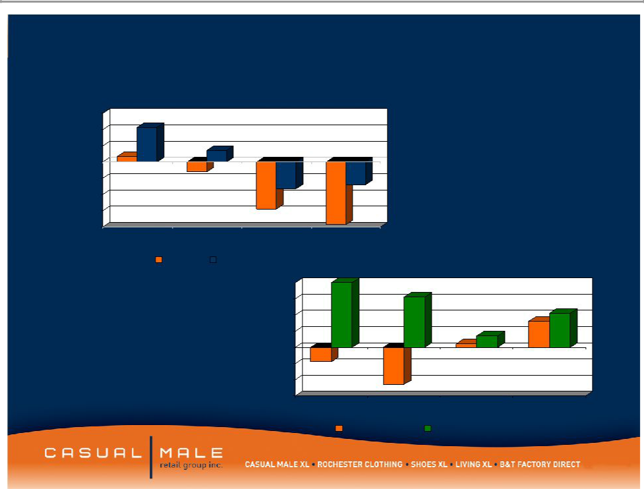
CM Sales Metrics By Quarter

6.0%
4.0%
2.0%
0.0%
-2.0%
-4.0%
-6.0%
-8.0% | 4th Qtr
1st Qtr2nd Qtr3rd Qtr | 4th Qtr
Traffic Comp Sales
4.0%
3.0%
2.0%
1.0%
0.0%
-1.0%
-2.0%
-3.0% | 1st Qtr | 2nd Qtr | 3rd Qtr | 4th Qtr
 | Conversion |  | $Per Guest

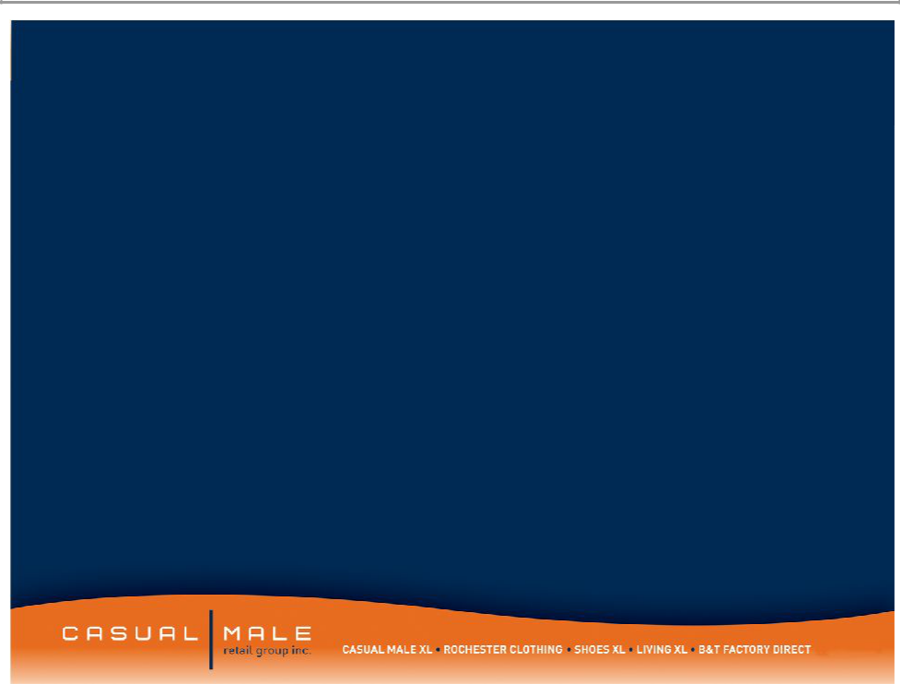
Surveys

- Inactive (13-24M) Customers

- Most customers were satisfied with their last purchase

- 88% of customers stated that they were likely to return to Casual Male

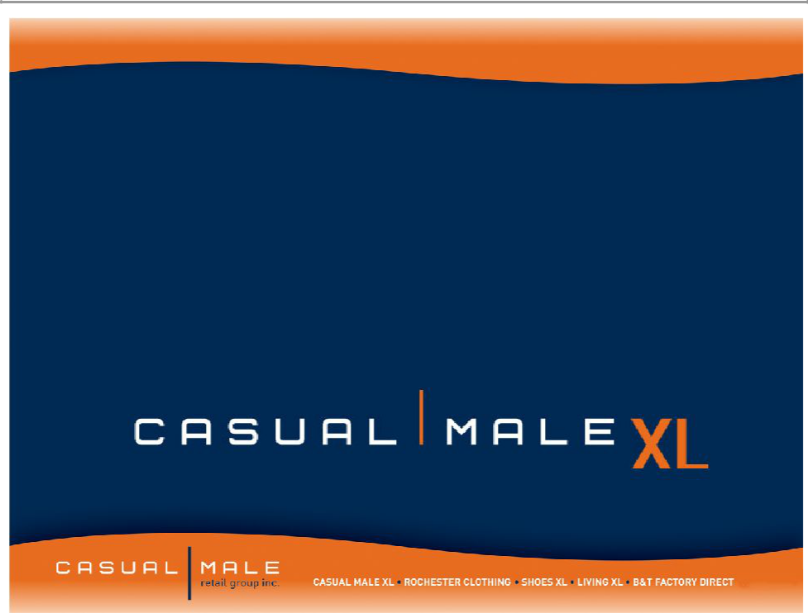

Private Label Lifestyle Brands

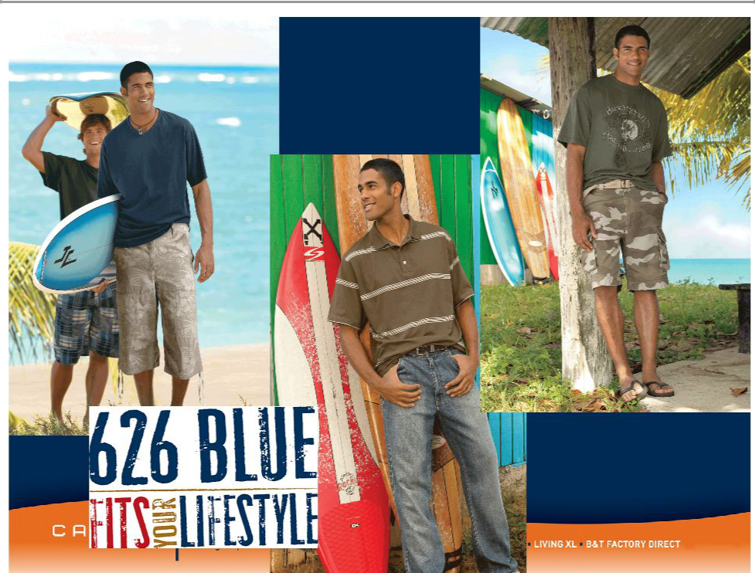

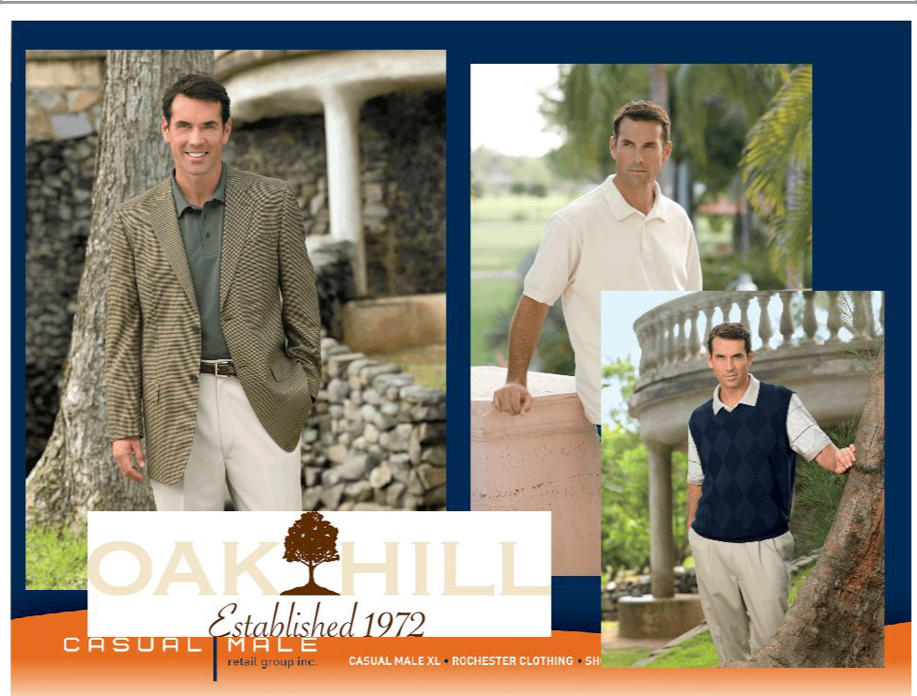

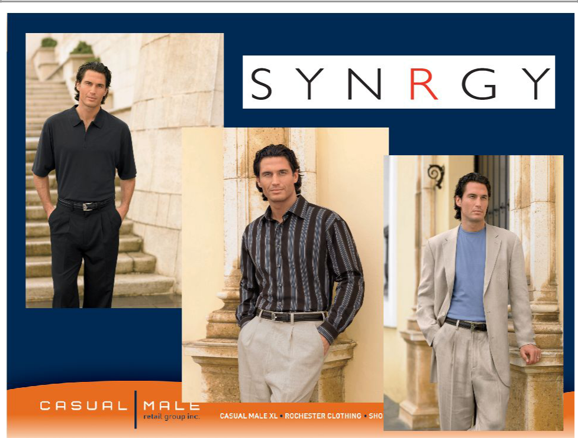

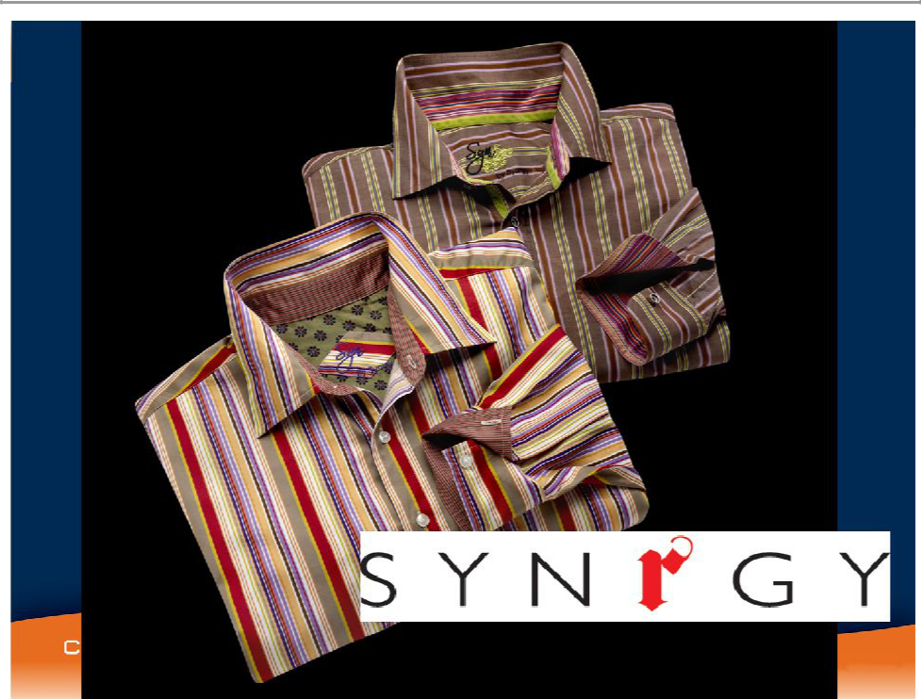

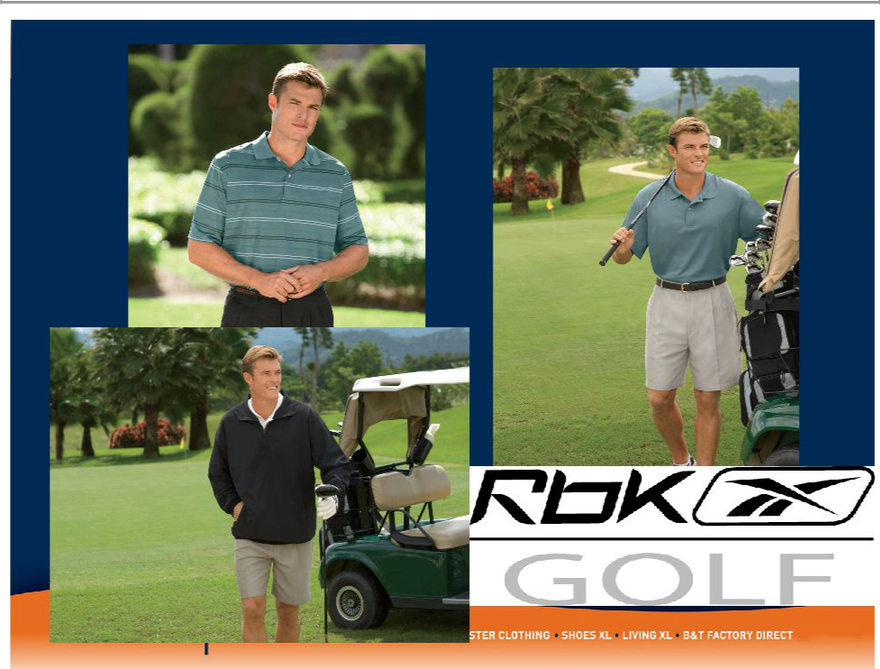

Casual Male XL Loyalty Program Rewards

Current Program Performance:

- 1.5MM customers have been enrolled to date

- 80% of new customers captured in POS are being enrolled

- 88% of transactions involved an XL Rewards member

- Loyalty members average spend per transaction is 17% or $15 higher than non-members

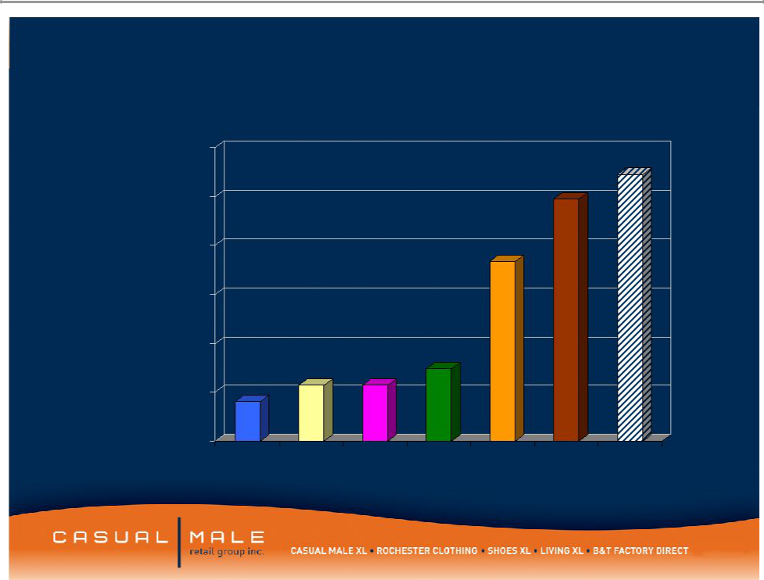
CMRG Internet Sales by Year

$60,000,000

$50,000,000

$40,000,000

$30,000,000

$20,000,000

$10,000,000

$0
2002 | 2003 | 2004 | 2005 | 2006 | 2007 | 2008
 |  |  |  |  |  | Plan

Obesity in Europe

- 135 million adults are affected by obesity

- Many countries more than half the adult population is overweight and 30% defined as clinically obese

- In most European countries 1 in 4 children are obese which is over 80 million children

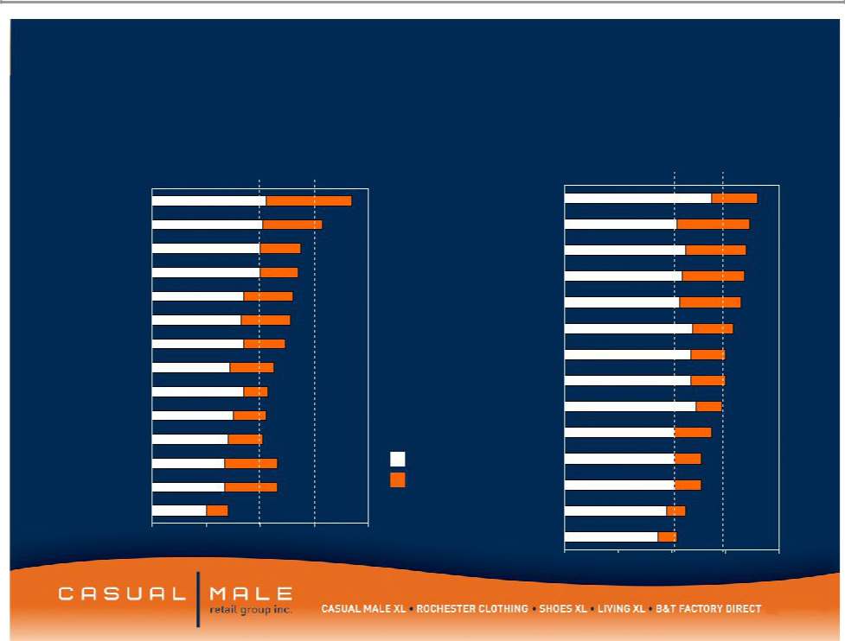
Estimated EU country prevalence of overweight and obesity

Greece* UK (England)
Spain

Portugal

Finland

Germany** Ireland

Austria

Denmark

Sweden

Belgium

Italy

Netherlands

Women

Legend

BMI 25 - 29.9

BMI

Men

Germany**

Greece*

Finland

Ireland

UK (England)

Belgium

Austria

Spain

Denmark

Portugal

Sweden

Italy

France

- Netherlands

0 | 20 | 40 | 60 | 80 | France

0 20 40 60 80

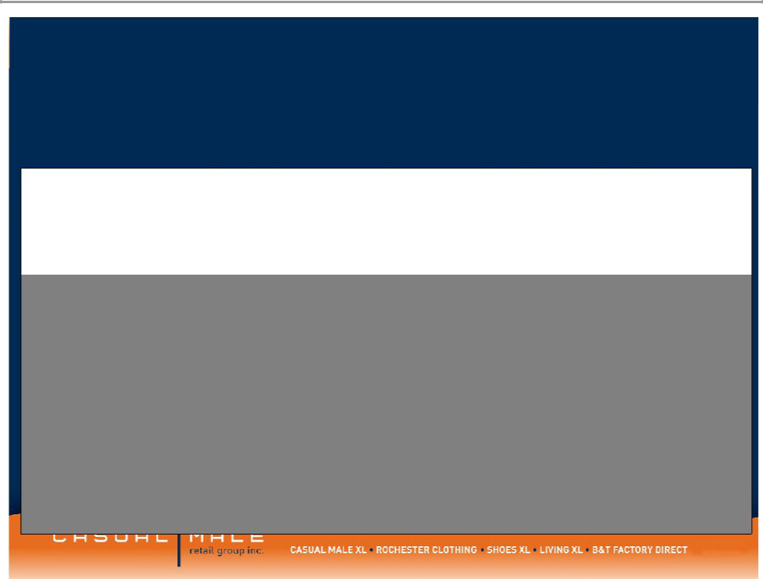
Internet Usage in Europe

 |  |  |  |  | User
 |  |  | Penetration | Usage | Growth
 |  | Internet | (% of | % in | (2000-
 | Population | Users | population) | EU | 2007)
France | 61,350,009 | 32,925,953 | 53.7% | 12.9% | 287.4%
Germany | 82,509,367 | 50,426,117 | 61.1% | 19.7% | 110.1%
Italy | 59,546,696 | 31,481,928 | 52.9% | 12.3% | 138.5%
Netherlands | 16,447,682 | 12,060,000 | 73.3% | 4.7% | 209.2%
Spain | 45,003,663 | 19,765,033 | 43.9% | 7.7% | 266.8%
UK | 60,363,602 | 37,600,000 | 62.3% | 14.7% | 144.2%
Total | 325,221,019 | 184,259,031 | 56.66%
US | 301,967,681 | 212,080,000 | 70.2% | N/A | 171.0%

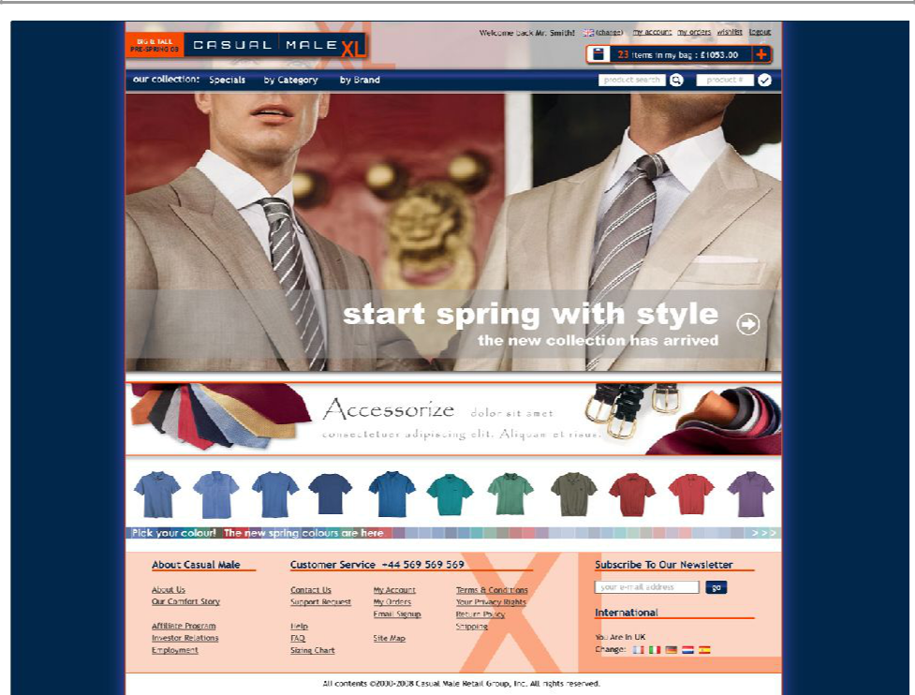

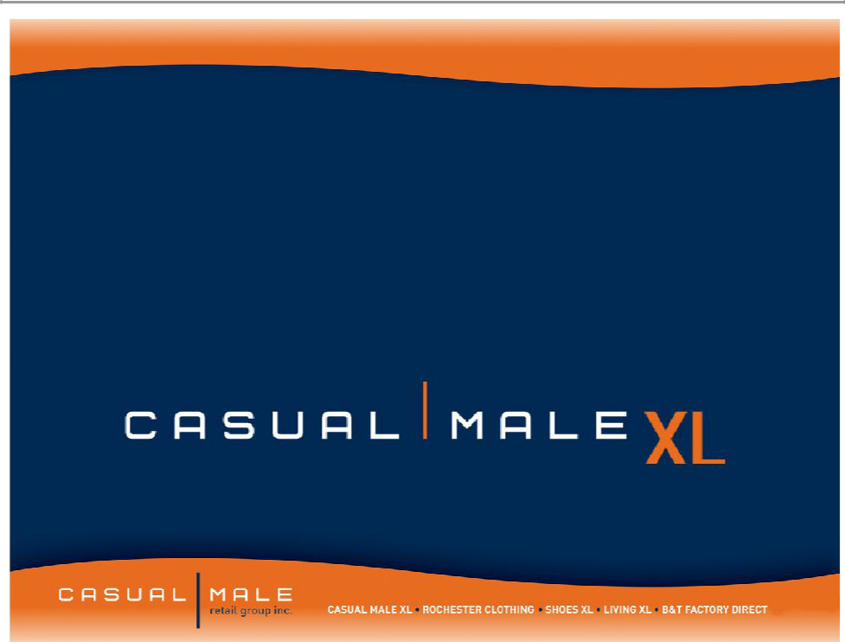

Marketing Strategy for 2008

National Sales by Size

$2,000,000

$1,800,000

$1,600,000

$1,400,000

$1,200,000

$1,000,000

$800,000

$600,000

$400,000

$200,000

$0

30 32 34 36 38 40 42 44 46-60

Waist

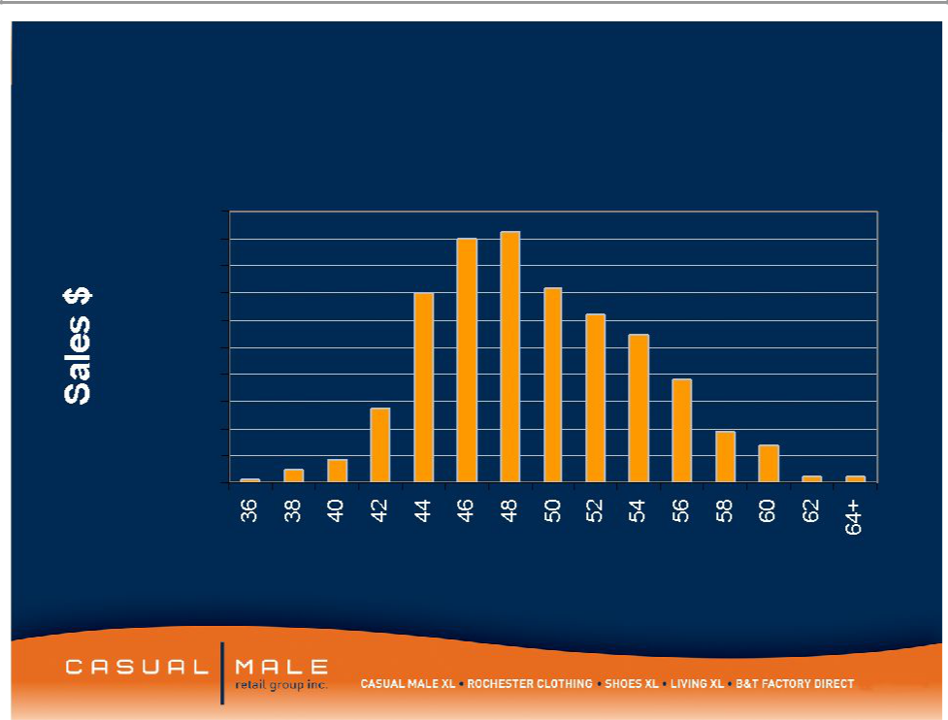
Market Share Size Opportunity

Casual Male Sales by Size

$200,000

$180,000

$160,000

$140,000

$120,000

$100,000

$80,000

$60,000

$40,000

$20,000

$0

Data based on ’04 sales of Casual Pants, Dress Pants and Jeans

Waist Size

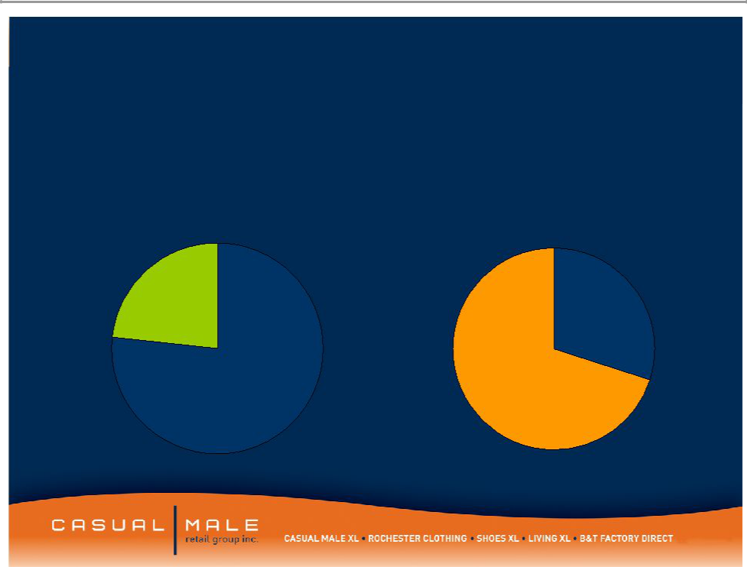
National Waist Size Market vs. Casual Male XL

• Sizes 42-46 • Sizes 48+

4.5 billion

1.4 billion

National Size Market

Casual Male Size Market

48"-52+" _{42"-46"}

^{42"-46"} 48"-52+"

*data interpreted by NPD *CM size selling history

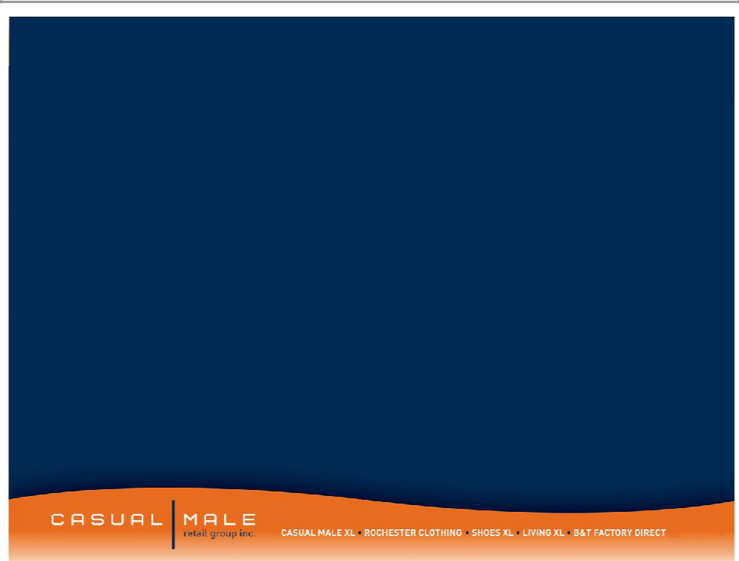
Creative objective

- Target men 25-54 size 42-46 waist size

- Take away stigma that Big & tall stores are only for fat guys

- Address that regular department stores have very little selection for guys that are 42-46

- CMXL has lots of cool clothes

Media campaign

- National campaign targeted to men

- Dates: May 1 – June 15th

- Spend is 3 times more than Spring ’07

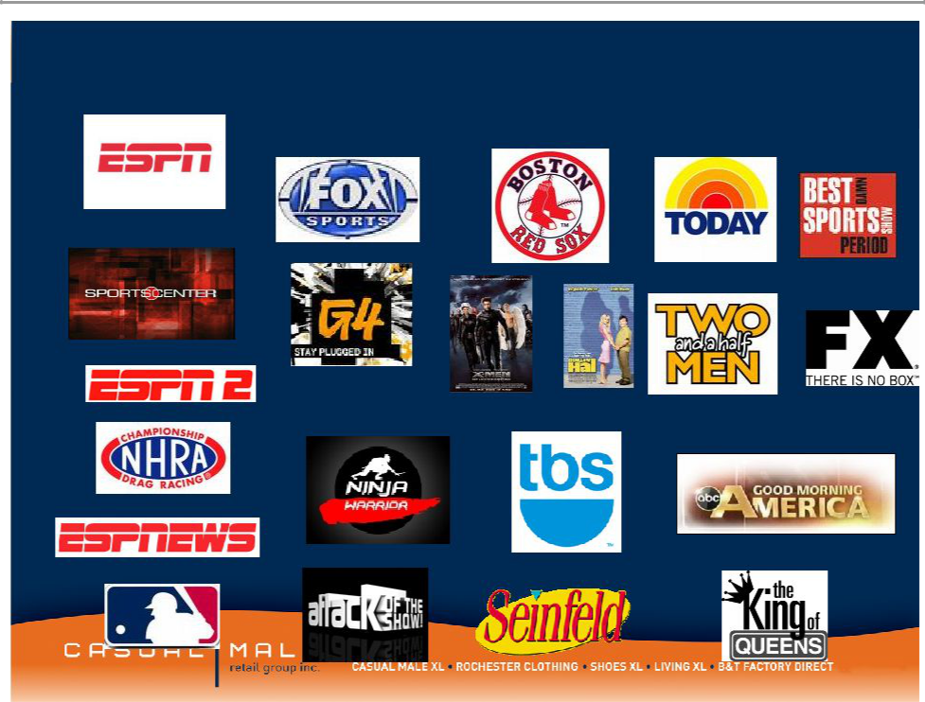
Network Highlights

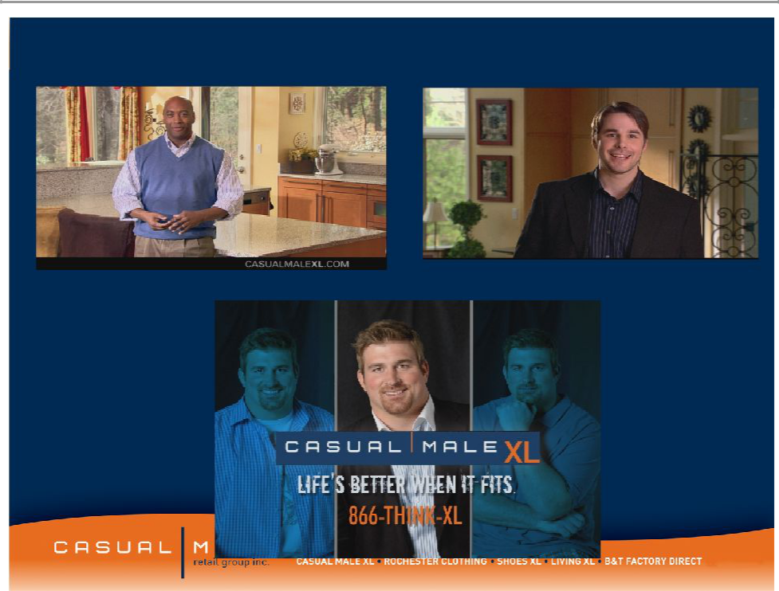
Creative 1 Creative 2

Creative 3

– Targets the higher income |  | Rochester
consumer within the big
and tall market
• $100,000 per year
average salary
– 26 store locations in |  | Locations
downtown major
metropolitan areas and
upscale suburbs |  | ³ 32
• Average store size: |  | ³ 32
8,200 square feet | 7 | 2
• Average sales / square | 7
foot: $304
– Stores carry higher-end
designer product |  | 2
– Average transaction size:
$300 |  | Rochester
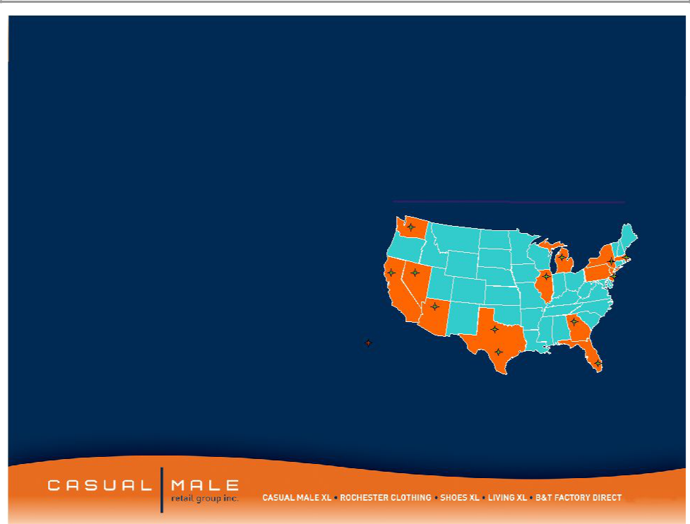
* 1 London, United Kingdom

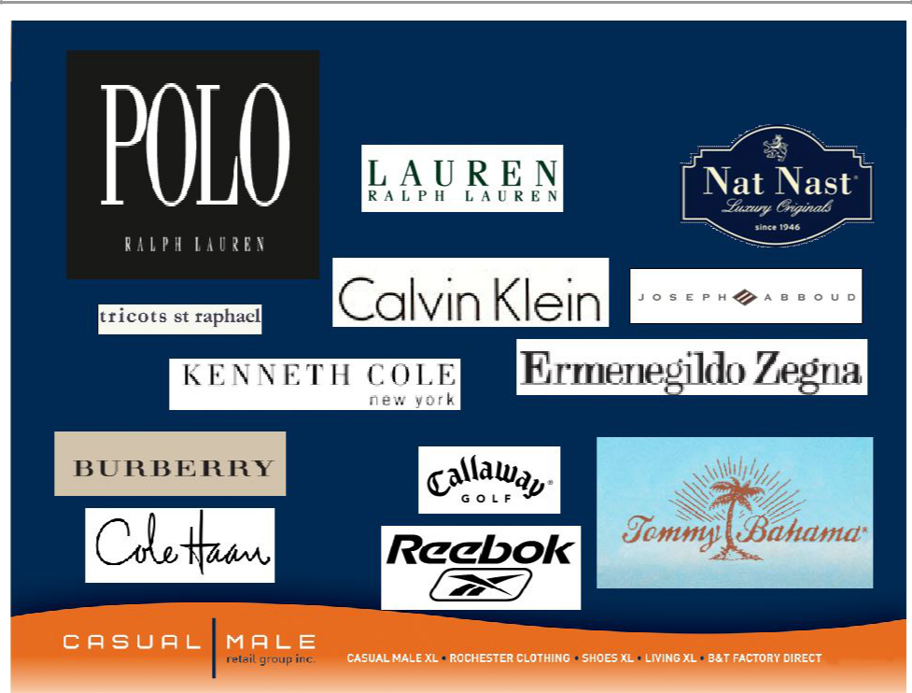
Rochester Brands



