UNITED STATES

SECURITIES AND EXCHANGE COMMISSION
WASHINGTON, D.C. 20549

FORM 8-K

CURRENT REPORT

Pursuant to Section 13 or 15(d) of

The Securities Exchange Act of 1934

Date of Report (Date of earliest event reported): February 27, 2013

DESTINATION XL GROUP, INC.

(Exact Name of Registrant as Specified in its Charter)

Delaware

01-34219

04-2623104

(State or Other Jurisdiction

of Incorporation)

(Commission

File Number)

(I.R.S. Employer

Identification No.)

555 Turnpike Street, Canton, Massachusetts

02021

(Address of Principal Executive Offices)

(Zip Code)

(781) 828-9300

(Registrant’s telephone number, including area code)

Check the appropriate box below if the Form 8-K filing is intended to simultaneously satisfy the filing obligation of the registrant under any of the following provisions (see General Instruction A.2. below):

- Written communications pursuant to Rule 425 under the Securities Act (17 CFR 230.425)

- Soliciting material pursuant to Rule 14a-12 under the Exchange Act (17 CFR 240.14a-12)

- Pre-commencement communications pursuant to Rule 14d-2(b) under the Exchange Act (17 CFR 240.14d-2(b))

- Pre-commencement communications pursuant to Rule 13e-4(c) under the Exchange Act (17 CFR 240.13e-4(c))

Item 2.02 Results of Operations and Financial Condition.

On February 27, 2013, Destination XL Group, Inc. (the “Company”) issued a press release announcing preliminary results for the fourth quarter and fiscal year ending February 2, 2013 (“fiscal 2012”). A copy of this press release is attached hereto as Exhibit 99.1.

Item 7.01 Regulation FD Disclosure.

The Company will be presenting a slide presentation to various investment groups at upcoming investor conferences beginning on February 28, 2013. A copy of the slides to be presented at those conferences is attached to this report as Exhibit 99.2 and is incorporated by reference herein.

The slide presentation contained in the exhibit includes statements intended as “forward-looking statements,” which are subject to the cautionary statement about forward-looking statements set forth in the exhibit. The slide presentation is being furnished, not filed, pursuant to Regulation FD. Accordingly, the slide presentation will not be incorporated by reference into any registration statement filed by the Company under the Securities Act of 1933, as amended, unless specifically identified therein as being incorporated therein by reference. The furnishing of the slide presentation is not intended to, and does not, constitute a determination or admission by the Company that the information in the slide presentation is material or complete, or that investors should consider this information before making an investment decision with respect to the Company.

Presentation of Non-GAAP Measures

The slide presentation includes the discussion of non-GAAP free cash flow on slide 24. Free cash flow is not a measure determined by generally accepted accounting principles (“GAAP”) and should not be considered superior to or as a substitute for net income (loss) or cash flows from operating activities or any other measure of performance derived in accordance with GAAP.

In addition, all companies do not calculate non-GAAP financial measures in the same manner and, accordingly, “free cash flows” as presented in this slide presentation may not be comparable to similar measures used by other companies. The Company calculates free cash flows as cash flow from operating activities less capital expenditures and discretionary store asset acquisitions, if any. We calculate projected free cash flows for fiscal 2016 of $60.0-$70.0 million as estimated cash flow from operating activities of $77.0-$87.0 million, less estimated capital expenditures of $17.0 million (no discretionary store asset acquisitions are anticipated in fiscal 2016). We believe that inclusion of this non-GAAP measure helps investors gain a better understanding of projected performance, especially when comparing such results to previous periods.

Item 9.01 Financial Statements and Exhibits.

- Exhibits

Exhibit No. |  | Description
99.1 | Press Release dated February 27, 2013
99.2 | Investor Slide Presentation dated February 28, 2013

SIGNATURE

Pursuant to the requirements of the Securities Exchange Act of 1934, the Registrant has duly caused this report to be signed on its behalf by the undersigned hereunto duly authorized.

DESTINATION XL GROUP, INC.

Date: February 27, 2013 By: /s/ Dennis R. Hernreich

Name: Dennis R. Hernreich

Title: Executive Vice President and Chief Financial Officer

Exhibit 99.1


CONTACT:

Jeff Unger

Vice President Investor Relations

(561) 482-9715

Destination XL Group, Inc. Announces Preliminary

Fourth-Quarter 2012 Results in Advance of KeyBanc Consumer Conference

Destination XL Retail Store and E-commerce Platform Deliver Increased Sales Comps;

Company to Launch DXL Marketing Campaign in Spring 2013

Following Successful Test Marketing;

Expects 2013 to be Year of Accelerated Progress in DXL Transformation;

Full Fourth-Quarter and Full-Year Results to be Announced Friday, March 15

Canton, Mass., February 27, 2013 –Destination XL Group, Inc. (NASDAQ: DXLG), the largest retailer of big & tall men’s apparel and accessories, announced today preliminary operating results for the fourth quarter of 2012.

Highlights

- Comparable fourth-quarter sales increased approximately 0.5% – the Company’s 11th consecutive quarter of positive comparable sales – and total sales increased to approximately $114.9 million compared with $111.1 million in the fourth quarter of fiscal 2011. Full year comparable sales increased approximately 1.5%, and 2012 total sales were approximately $399.6 million compared with $395.9 million in 2011.

- Comparable fourth quarter sales for Destination XL® (DXL®) stores were up approximately 15.0%, while comparable fourth quarter sales for Casual Male XL retail and outlet stores decreased approximately 2.3%. In the quarter, the DXL stores represented approximately 18% of the Company’s comparable retail business. Comparable fourth quarter sales from the e-commerce platform increased approximately 13%.

- Income from continuing operations, on a diluted basis, for the fourth quarter is expected to be approximately $0.08 per share, flat with adjusted income from continuing operations for the fourth quarter of 2011. Without adjusting for the reversal of the Company’s valuation allowance and trademark impairment, income from continuing operations was $0.71 per share for the fourth quarter of fiscal 2011. (See below for non-GAAP reconciliation).

- For the full year, income from continuing operations, on a diluted basis, is expected to be approximately $0.16 per share compared with adjusted income from continuing operations of $0.22 per share in 2011. Without adjusting for the reversal of the Company’s valuation allowance and trademark impairment, income from continuing operations was $0.93 per share for fiscal 2011. (See below for non-GAAP reconciliation).

DXLG/2

- For the full year, loss from discontinued operations, associated with the Company’s exiting of its International direct business in the second quarter of fiscal 2012, is expected to be $0.04 per share for both fiscal 2012 and fiscal 2011.

- The Company opened 14 DXL stores and closed 34 Casual Male XL stores during the fourth quarter of 2012. For the year, the Company opened 32 DXL stores, and closed 68 Casual Male XL retail and outlet stores and 2 Rochester Clothing stores.

“Our financial results for the quarter were essentially in line with our expectations,” said President and CEO David Levin. “Sales and net income growth would have been stronger but for mild winter weather that affected sales of seasonal apparel and some delays in DXL store openings. We continue to be encouraged by the success of our new DXL stores, for which we expect to report very positive comparable sales of approximately 15.6% for the full year. In addition, while our direct business decreased year-over-year due to lower catalog sales, our web sales are growing at an accelerated rate as we shift marketing dollars from catalog to digital.”

“We expect 2013 to be a critical year of accelerated progress in our transformation to the DXL concept. With the acceleration of DXL store openings and Casual Male XL closings, the implementation of our new marketing campaign, and enhancements to certain aspects of our infrastructure to support the DXL rollout, we expect our SG&A costs to increase approximately $17 million in 2013, which will have a negative short-term effect on 2013 earnings. At the same time, our substantial investments this year will yield vastly improved profitability and cash flow beginning in 2014. Because we will have a significantly greater number of DXL stores in operation, our new marketing campaign should have a much greater impact on our performance in 2014 and beyond,” said Levin.

“During 2013 we plan to more than double the number of DXL stores in operation to between 105 to 112 by opening between 57 and 64 stores,” said Levin. “At the same time, we have an aggressive schedule to close between 110 and 119 Casual Male XL and Rochester stores. Our expected 2013 financial results include an approximate 10% increase in expenses to fund the marketing campaign as well as other necessary SG&A, real estate and capital expenditure support for the accelerated DXL transformation this year.”

For 2013, the Company now expects revenue to increase to a range of $415 to $420 million, with an operating margin in the range of breakeven to 0.5%, EBITDA (non-GAAP) in the range of $20 to $23 million, and EPS of approximately breakeven with a negative free cash flow such that revolver borrowing is expected to be, at the end of the year, between $10-$15 million. Following the execution of its DXL strategy in 2013, the Company expects to leverage an increasing proportion of sales from its new DXL stores, which will result in operating margins rapidly expanding to approximately 4% in 2014 and approximately 8% in 2015, on annual sales growth of approximately 10-15%. The Company’s free cash flow at the end of 2014 is anticipated to be breakeven, with $10-$15 million revolver debt while, at the end of 2015, the Company anticipates positive free cash flow such that the revolver debt will be extinguished with cash-on-hand estimated to be between $5-$10 million. Longer-term, the Company expects to grow revenues beyond $600 million and

DXLG/3

operating margins to more than 10%, while generating free cash flow in the range of $60 to $70 million in fiscal 2016. Projection of free cash flow (non-GAAP) for fiscal 2016 is based on expected cash flow from operating activities of $77.0-$87.0 million, less expected capital expenditures of $17.0 million. See Non-GAAP measures below.

“To accomplish our long-term financial goals, we are combining an aggressive DXL store opening schedule with a comprehensive national marketing campaign designed to define the DXL brand more clearly, expand market awareness and grow our active customer base,” said Levin. “The marketing campaign we are launching this spring is the result of the highly successful test marketing that we conducted in the fall of 2012 around the DXL brand in five geographic markets. The test marketing included TV, radio and digital advertisements which generated very positive results around brand awareness, store and web sales, traffic and new customers to the brand. Consequently, we are enthusiastic about the prospects for our marketing campaign and for the long-term profit potential generated by the DXL transformation.”

KeyBanc Capital Markets Consumer Conference

Management will be meeting with investors and presenting tomorrow at 10:00 a.m. ET at the 2013 KeyBanc Capital Markets Consumer Conference at the InterContinental New York Barclay in New York City. A PDF version of the updated investor presentation is available for download on the “Investor Relations” section of Company’s website.

Fourth-Quarter 2012 Financial Results Conference Call

The Company will release its fourth-quarter and year-end 2012 financial results before the market opens on Friday, March 15, 2013. President and Chief Executive Officer David Levin and Executive Vice President, Chief Operating Officer and Chief Financial Officer Dennis Hernreich will host a conference call to discuss the financial results and provide an outlook for 2013 the same morning at 9:00 a.m. ET. During the conference call, the Company may discuss and answer questions concerning business and financial developments and trends. The Company’s responses to questions, as well as other matters discussed during the conference call, may contain or constitute information that has not been disclosed previously.

Those who wish to listen to the live webcast should visit the “Investor Relations” section of the Company’s website. The live call also can be accessed by dialing: (888) 503-8169. For interested parties unable to participate live, an archived version of the webcast may be accessed by visiting the “Events & Presentations” section of the Company’s website for up to one year.

This preliminary financial information is subject to change and is based on management’s estimates derived from the information available at this time. In addition, the financial information provided has not yet been reviewed by the Company’s independent registered public accounting firm and is subject to that review and may change before filing on Form 10-K, which the Company expects to file in March 2013.

DXLG/4

About Destination XL Group, Inc.

Destination XL Group, Inc. is the largest multi-channel specialty retailer of big & tall men’s apparel with operations throughout the United States, Canada and Europe. The retailer operates under six brands: Destination XL®, Casual Male XL, Rochester Clothing, B&T Factory Direct, ShoesXL and LivingXL. Several catalogs and e-commerce sites, including www.destinationxl.com, make up the Company’s direct-to-consumer business. With more than 2,000 private label and name brand styles to choose from, customers are provided with a unique blend of wardrobe solutions not available at traditional retailers. The Company is headquartered in Canton, Massachusetts. For more information, please visit the Company’s investor relations website: http://investor.destinationxl.com.

Non-GAAP Measures

In addition to financial measures prepared in accordance with generally accepted accounting principles (GAAP), the above discussion refers to non-GAAP adjusted income from continuing operations and adjusted income from continuing operations, per diluted share (“non-GAAP” or “adjusted”). These measures should not be considered superior to or as a substitute for income from continuing operations per diluted share and diluted earnings per share derived in accordance with GAAP. The Company believes that these non-GAAP measures are useful as an additional means for investors to evaluate the Company’s operating results, when reviewed in conjunction with the Company’s GAAP financial statements. The Company believes the inclusion of these non-GAAP measures enhances an investor’s understanding of the underlying trends in the Company’s business and provide for better comparability between different periods in different years.

Below is a table showing the reconciliation to adjusted income from continuing operations for the fourth quarter and fiscal year 2011.

The above discussion refers to free cash flow and EBITDA (Earnings before income taxes and depreciation and amortization), both of which are non-GAAP measures. The presentation of these non-GAAP measures are not measures determined by GAAP and should not be considered superior to or as a substitute for operating income or cash flows from operating activities or any other measure of performance derived in accordance with GAAP. In addition, all companies do not calculate non-GAAP financial measures in the same manner and, accordingly, the measures, “free cash flows” and “EBITDA”, presented in this release may not be comparable to similar measures used by other companies.

The Company calculates free cash flows as cash flow from operating activities less capital expenditures and less discretionary store asset acquisitions, if applicable. For fiscal 2016, free cash flow of $60.0 to $70.0 million was calculated by subtracting forecasted capital expenditures of $17.0 million from forecasted cash flow from operating activities of $77.0-$87.0 million.

The Company calculates forecasted EBITDA for fiscal 2013 of $20.0-$23.0 million as forecasted operating income of breakeven to $3.0 million plus the add-back of depreciation and amortization of $20.0 million.

DXLG/5

Forward-Looking Statements

Certain information contained in this press release including cash flows, operating margins, store counts, revenue and earnings expectations for the fourth quarter and full-year of fiscal 2012, full-year fiscal 2013 and longer-term, including through fiscal 2016, constitute forward-looking statements under the federal securities laws. The discussion of forward-looking information requires management of the Company to make certain estimates and assumptions regarding the Company’s strategic direction and the effect of such plans on the Company’s financial results. The Company’s actual results and the implementation of its plans and operations may differ materially from forward-looking statements made by the Company. These factors include, without limitation, the following: the risk that additional information may arise during the Company’s close process or as a result of subsequent events that would require the Company to make adjustments to the financial information; the risk that adjustments to the Company’s financial statements may be identified through the course of the Company’s independent registered public accounting firm completing its integrated audit of the Company’s financial statements and financial controls; the risk that the Company will be unsuccessful in implementing its strategic plans with respect to store openings and closings in fiscal 2013; and the risk that such strategic plans and related marketing campaign will not have the expected impact on profitability, cash flow and performance. The Company encourages readers of forward-looking information concerning the Company to refer to its prior filings with the Securities and Exchange Commission, including without limitation, its Annual Report on Form 10-K filed on March 16, 2012, that set forth certain risks and uncertainties that may have an impact on future results and direction of the Company. Forward-looking statements contained in this press release speak only as of the date of this release. Subsequent events or circumstances occurring after such date may render these statements incomplete or out of date. The Company undertakes no obligation and expressly disclaims any duty to update such statements.

# # #

DXLG/6

DESTINATION XL GROUP, INC.

GAAP TO NON-GAAP RECONCILIATION

OF INCOME FROM CONTINUING OPERATIONS

 |  | Fourth quarter ended |  |  |  | Fiscal year ended
 |  |  | January 28, 2012 |  |  | January 28, 2012
 | Income from continuing operations, GAAP basis, before income taxes | $ | (17,034) |  |  | $ | (5,274)
Add back: Provision for trademark impairment |  | $ | 23,110 |  | $ |  | 23,110
 | Adjusted income from continuing operations, non-GAAP, before income taxes | $ | 6,076 |  | $ |  | 17,836
 | Assumed income tax provision at 40% (1) | $ | (2,430) |  | $ |  | (7,134)
 | Adjusted income from continuing operations, non-GAAP | $ | 3,646 |  | $ |  | 10,702
Adjusted income from continuing operations per diluted share, non-GAAP |  | $ | 0.08 |  | $ |  | 0.22
 | Weighted average number of common shares outstanding on a diluted basis |  | 48,131 |  |  |  | 48,044

- In the fourth quarter of fiscal 2011, the Company reversed substantially all of its valuation allowance against its deferred tax assets, which resulted in an income tax benefit of

$50.1 million for fiscal 2011. Accordingly, for comparative purposes, the non-GAAP income from continuing operations has been adjusted to assume no income tax benefit from such allowance and an assumed tax rate of 40% was used.

DESTINATION XL GROUP, INC.

GAAP TO NON-GAAP EPS RECONCILIATION

 |  |  |  | Fiscal 2012 |  |  |  |  |  | Fiscal 2011
 |  |  |  | Fourth |  |  | Fiscal |  |  | Fourth |  |  | Fiscal
 |  |  | Quarter |  |  |  | Year |  | Quarter |  |  |  | Year
 | Income from continuing operations, GAAP basis |  | $ | 0.08 |  | $ | 0.16 |  | $ | 0.71 |  | $ | 0.93
Add back: Provision for trademark impairment, tax-effected |  |  | $ | — |  | $ | — |  | $ | 0.29 |  | $ | 0.29
 | Adjusted income from continuing operations, non-GAAP, before income taxes |  | $ | 0.08 |  | $ | 0.16 |  | $ | 1.00 |  | $ | 1.22
 | Deduct: Valuation allowance reversal |  |  |  |  |  |  |  | $ | (0.88) |  | $ | (0.88)
 | Add: additional income tax provision to 40% |  | $ | — |  | $ | — |  | $ | (0.04) |  | $ | (0.12)
Adjusted income from continuing operations, non-GAAP
 |  |  | $ | 0.08 |  | $ | 0.16 |  | $ | 0.08 |  | $ | 0.22
 | Weighted average number of common shares outstanding on a diluted basis |  |  | 48,504 |  |  | 48,385 |  |  | 48,131 |  |  | 48,044


Exhibit 99.2

Generating Value on the Road to Destination XL®

Keybanc Consumer Conference

February 28, 2013

1


Safe Harbor

Certain information contained in this presentation, including, but not limited to, cash flows, operating margins, store counts, earnings expectations for fiscal 2012 and estimates through fiscal 2016, constitute forward-looking statements under the federal securities laws. The discussion of forward-looking information requires management of the Company to make certain estimates and assumptions regarding the Company's strategic direction and the effect of such plans on the Company's financial results. Such forward-looking statements are subject to various risks and uncertainties that could cause actual results to differ materially from those indicated.Suchrisksanduncertaintiesmayinclude,but arenot limitedto: the failureto

implement the Company's business plan for increased profitability and growth in the Company's retail stores sales and direct-to-consumer business, the failure to achieve improvementin the Company'scompetitiveposition,changesin or miscalculationof fashion trends, extreme or unseasonable weather conditions, economic downturns, a weakness in overall consumer demand, trade and security restrictions and political or financial instability in countries where goods are manufactured, increases in raw material costs from inflation and other factors, the interruption of merchandise flow from the Company's distribution facility, competitive pressures, and the adverse effects of natural disasters, war, acts of terrorism or threatsof either,or other armedconflict,on the UnitedStatesandinternationaleconomies.

These, and other risks and uncertainties, are detailed in the Company's Annual Report on Form 10-K filed with the Securities and Exchange Commission for the fiscal year ended January 28, 2012 filed on March 16, 2012 and other Company filings with the Securities and Exchange
CommissionDestinationXLGroup,Inc..assumesno dutyto updateor reviseits forward-looking statements even if experience or future changes make it clear that any projected results expressed or implied therein will not be realized.

2

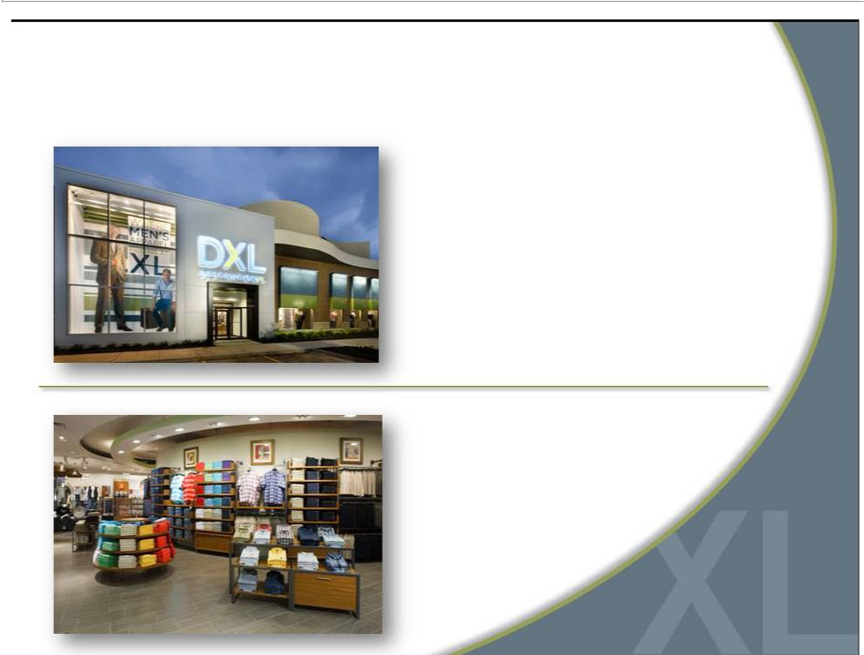
Who is Destination XL Group, Inc.?

Largest multi-channel specialty

retailer in niche men’s big and

tall (B&T) market

Offering unique blend

of wardrobe solutions

Private label & leading

apparel name brands

3

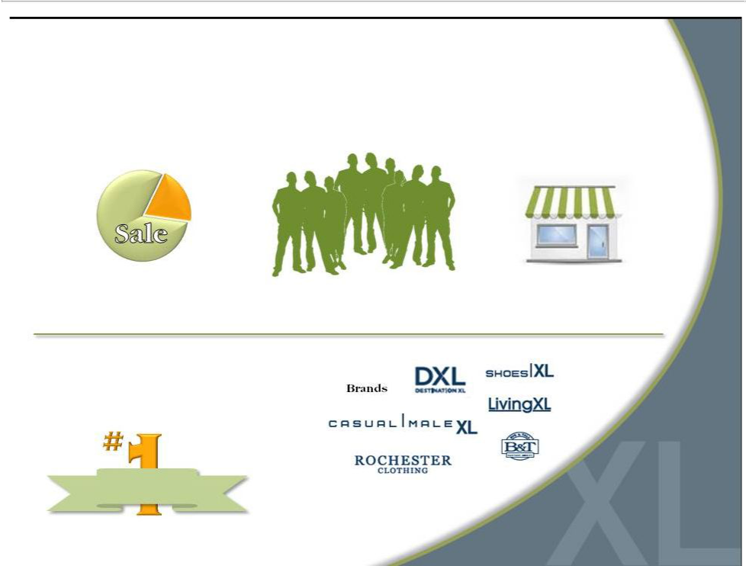
DXLG by the Numbers

1.5MActive customers
80%
Retail

20%
Direct

90% Enrolled in loyalty program

85% | Highest rated retailer | 6
85% | in 2011 CSI | 6
85% | Customer Survey | 6

Customer

Satisfaction

412

Retail Stores

4


Who is Our Customer?

Males with a waist size 42”and

greater (35M men in US).

Determined by physical

characteristic, not demographic.

Not dependent on age, income,

race or nationality

Seeking greater selection in size.

Values convenience, selection

and fit over price.

5

Our Current Casual Male XL Stores

6


What Our Customer Wants

Large | More brand | On-site | Bright
changing | More brand | On-site | Bright
changing | selections | tailoring | atmosphere
rooms | selections | tailoring | atmosphere

Suggested | Wide aisles | One-stop
wardrobe | Wide aisles | shopping
solutions

7

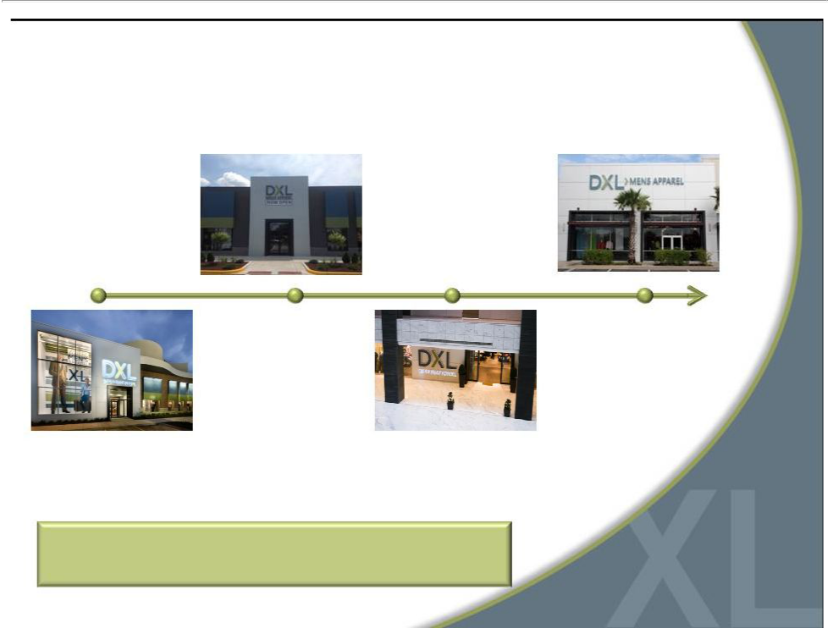
Responding with Destination XL®

2010 | 2012
Opened 4 DXL | Opened 32
concept stores | DXL stores
2011 | 2013
Opened 12 | Expect to Open
DXL stores | ~60 DXL stores

Opportunity for accelerated growth and profitability

8

9

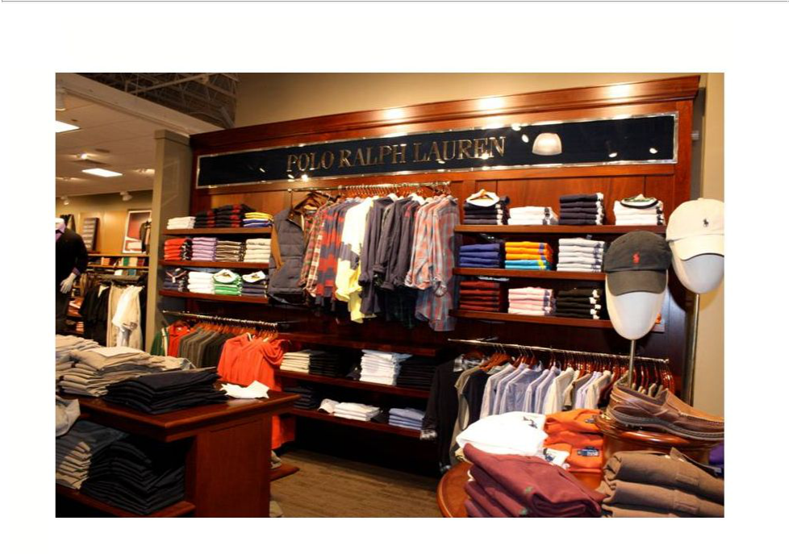

10

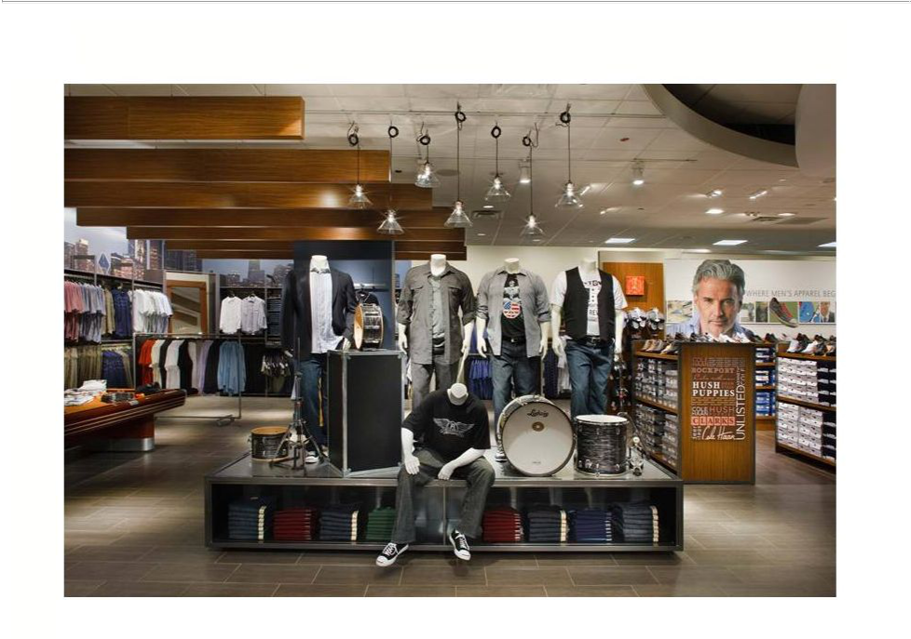

11

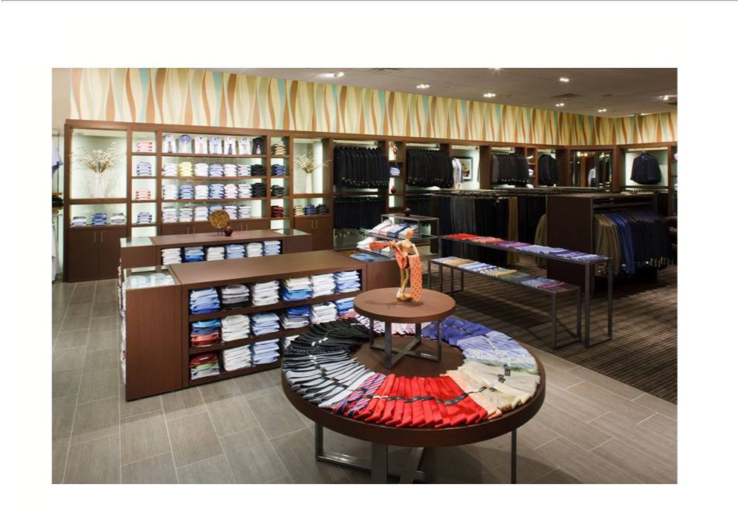

12

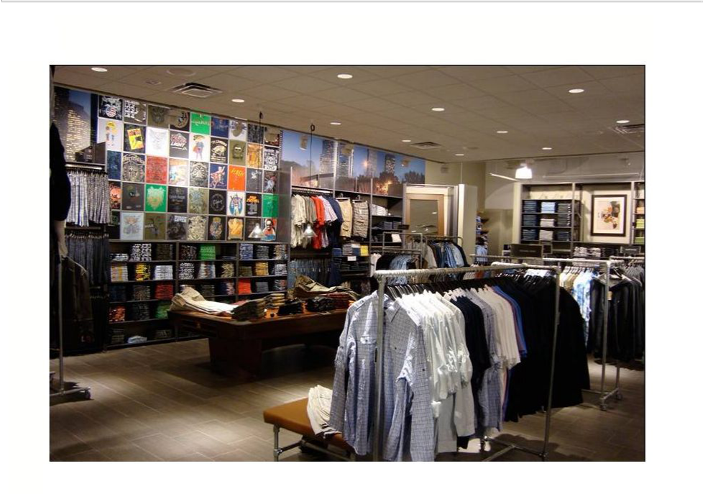

13

Large Selection of Name Brands

14

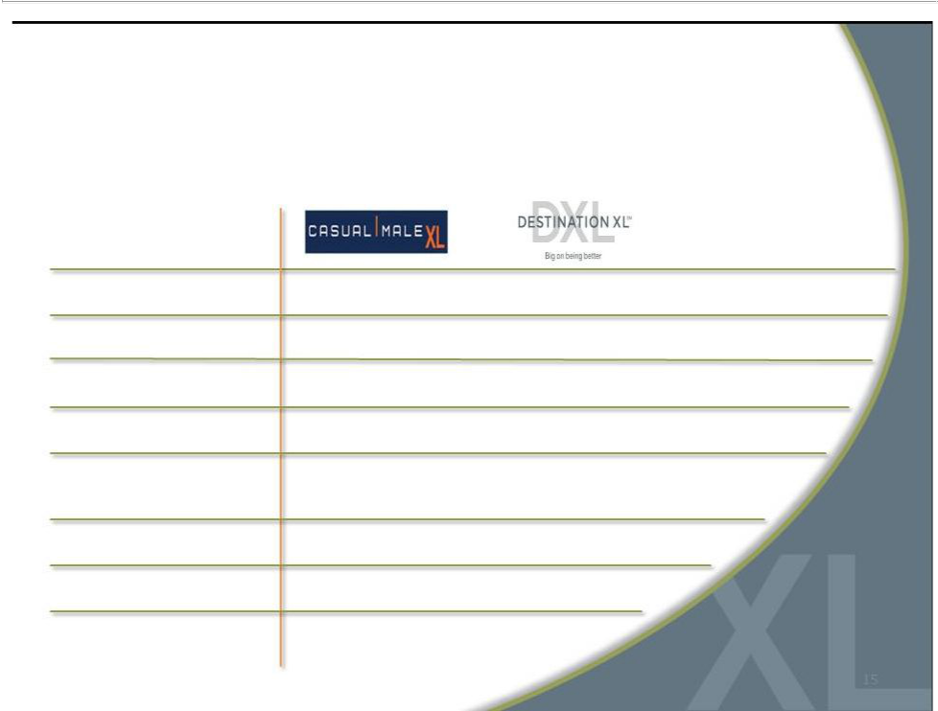
Casual Male XL vs. Destination XL®

Average

Store size

Sales per sq. ft.

Build out costs

Occupancy costs

Dollars per

transaction

Style choices

Private label brands

Name brands

3,400 sq. ft. | 8,400 sq. ft.
$166 | $147 ($230 by 2016)
$50 | $70
$30 | $30
$97 | $137
600 | 2,000
10 | 15
8 | 30

15

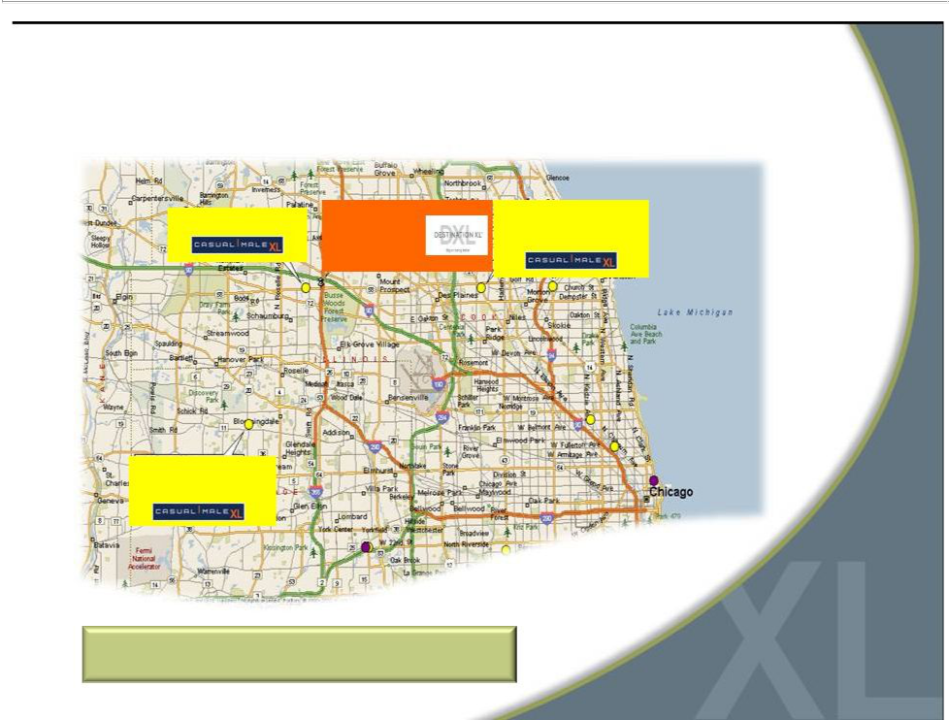
Market Consolidation to DXL

9451 Schaumburg, IL | DXL | 9183 Niles, IL
9451 Schaumburg, IL | Schaumburg, IL | 9183 Niles, IL
 | Schaumburg, IL | 11.4 miles
 | 0.9 miles

Chicago Metro

9512 Bloomingdale, IL

11.2 miles

Customers are willing to drive up to 20 miles

16

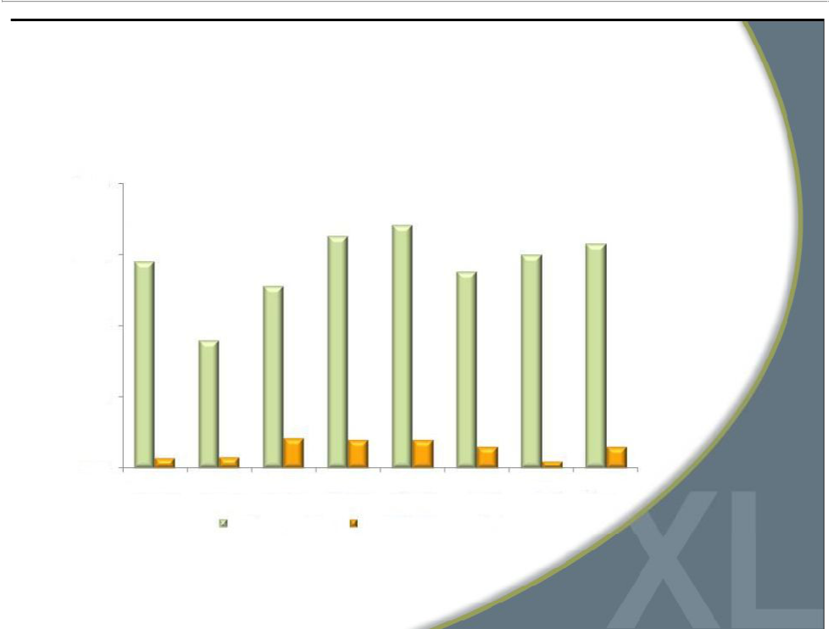
DXL Comps Reflect Growth Opportunity

20.0%
 |  | 16.3% | 17.1% | 15.8%
 | 14.5% |  | 15.0% | 15.8%
15.0% | 14.5% |  | 15.0%
15.0% | 14.5% | 12.8% | 13.8%
10.0% |  | 9.0%
5.0%

 | 2.1% | 2.0% | 2.0% | 1.5% | 1.5%
0.7% | 0.8% |  |  | 1.5% | 1.5%
0.7% | 0.8% |  |  | 0.5%
0.0%
Q3 2011 | Q4 2011 FY 2011 Q1 2012 |  | Q2 2012 Q3 2012 Q4 2012 |  | FY 2012
 | DXL Comparables | Total DXLG Comparables*

*Total DXLG Comparables consist of all stores, | 17
including DXL stores and direct channel | 17


Compelling DXL Returns

Expect greater store productivity and profitability

Projecting higher 4-wall profits than combined profits of individual stores

Potential to capture additional market share

Opportunity to improve

operating margins

Better leveraging of expenses --

occupancy, labor productivity and

local/district management

Targeting between 25%-30% store

operating margin

Attract new customers

Better cross-selling environment to capture greater share of apparel wallet from existing customers

Expect to increase margins

significantly after the transition to

DXL is complete

18

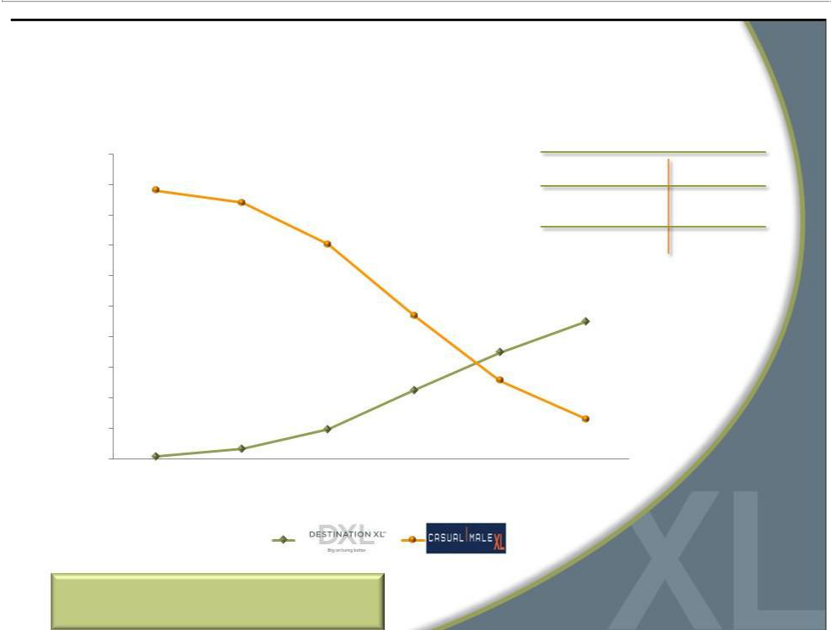
Accelerated DXL Openings

500

450

400

350

300

250

200

150

100

50

0

2015 Store Count Target

Destination XL® | 215-230
Casual Male XL | ~65
Outlet | ~65
Rochester Clothing | 3

2010 2011 2012 2013 2014 2015

Total Stores: | (460) | (450) | (412) | (348-358) | (308-318) | (283-298)

Accelerated rollout based on
19
success of DXL stores in 2011

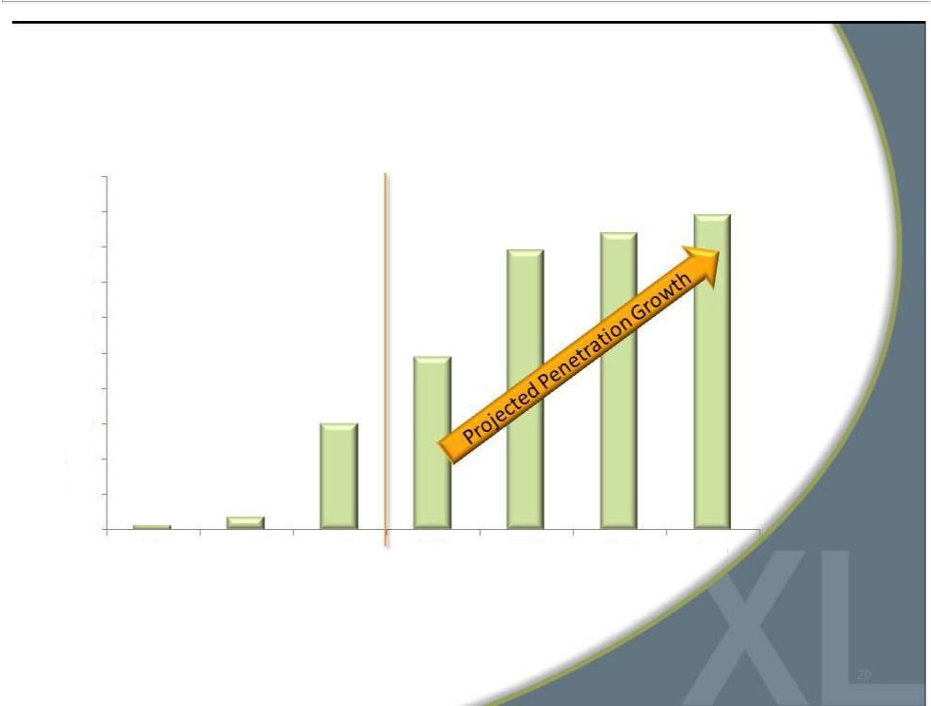
DXL Sales Increase as % of Total Revenue

100%
90% | 89%
90% | 84%
80% | 79%

70%

60%

49%
50%

40%

30%
30%
20%
10% | 4%
1% | 4%
0%
2010 | 2011 | 2012 | 2013 | 2014 | 2015 | 2016

* DXL sales include direct sales via the DestinationXL.com website. | 20

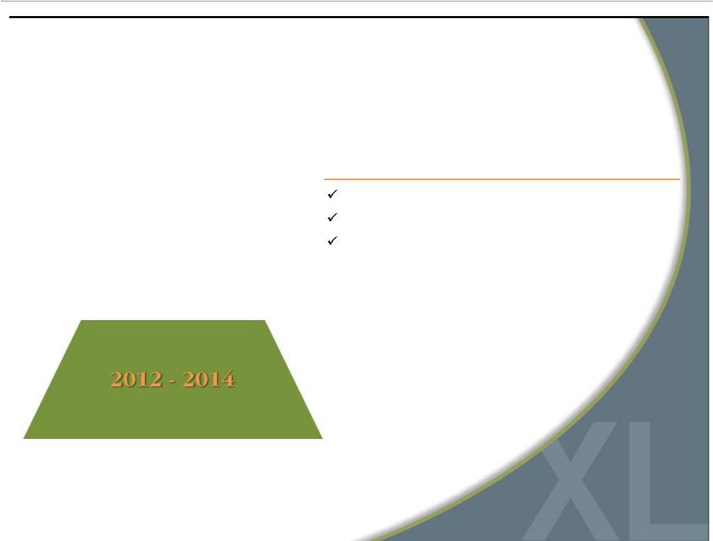
Accelerated Rollout of DXL

2012

Opened 32 DXL stores / Closed 70 stores

Operating margins were approximately 4.2%

CapEx was $36M

21

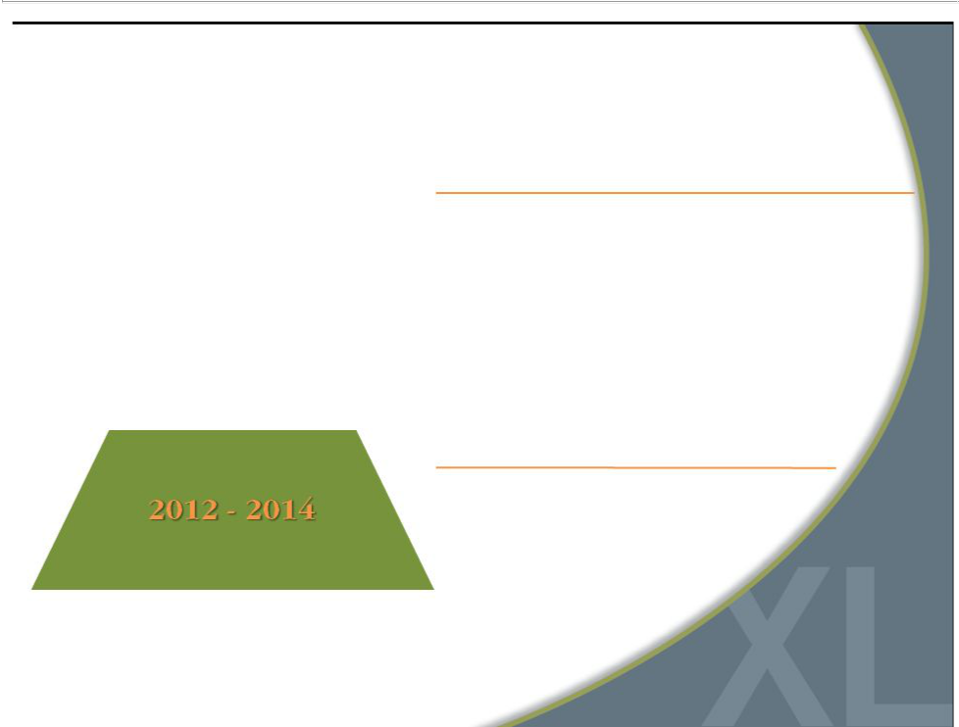
Accelerated Rollout of DXL

2013

Open 57-64 DXL stores / Close 110-119 stores

Sales of $415 - $420M

Expected borrowing level of $10 - $15M at year end

Commence new marketing strategy with incremental $10M spend

Lease exit and asset impairment charges in the range
of $3-$4M *

Operating margins of ~ breakeven to 0.5%

CapEx expected to peak at $45M

2014

 | Open 60 DXL stores / Close 99 | stores
 | Annual sales growth of ~ 10% - 15%
 | Expected borrowing level of $10 - $15M
 | at year end
 | Lease exit and asset impairment | *
 | charges in the range of $3-$4M | *
 | Operating margins of ~4%
* Net of subleases | CapEx expected to
* Net of subleases | be $40M | 22

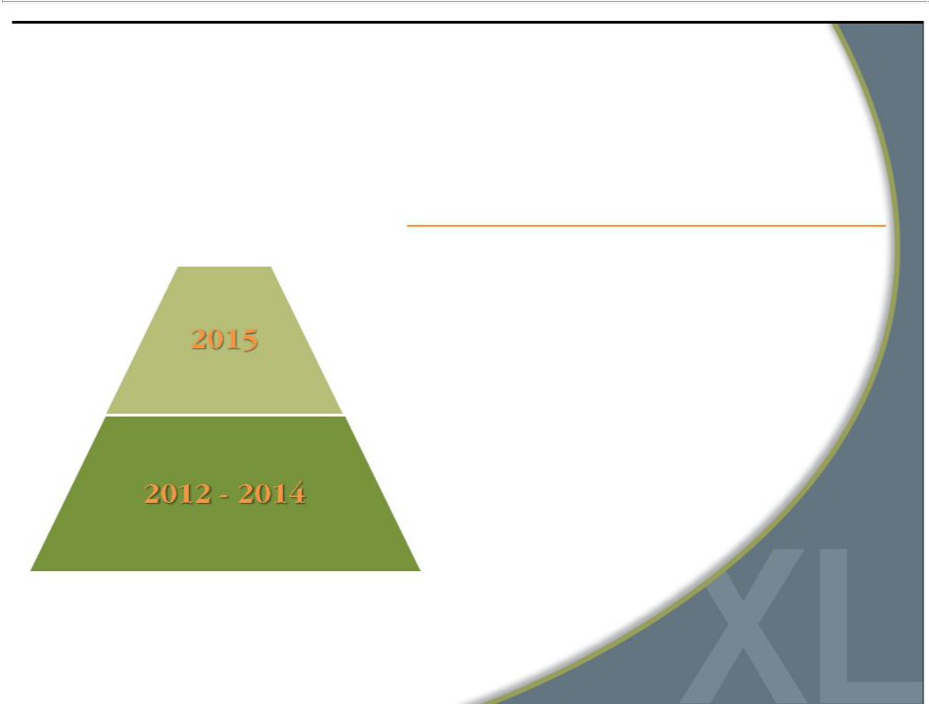
Accelerated Rollout of DXL

2015

Complete rollout with 215 - 230 opened DXL stores and

Closure of remaining 63 Casual Male XL anchor stores

Annual sales growth of ~10% – 15%

Operating margins gain traction and increase to ~8%

(from 4.2% in ‘11)

Expected ending cash balance of $5 - $10M

CapEx expected to be approximately $38M

Lease exit and asset impairment charges in the range

of $2-$3M*

* Net of subleases | 23

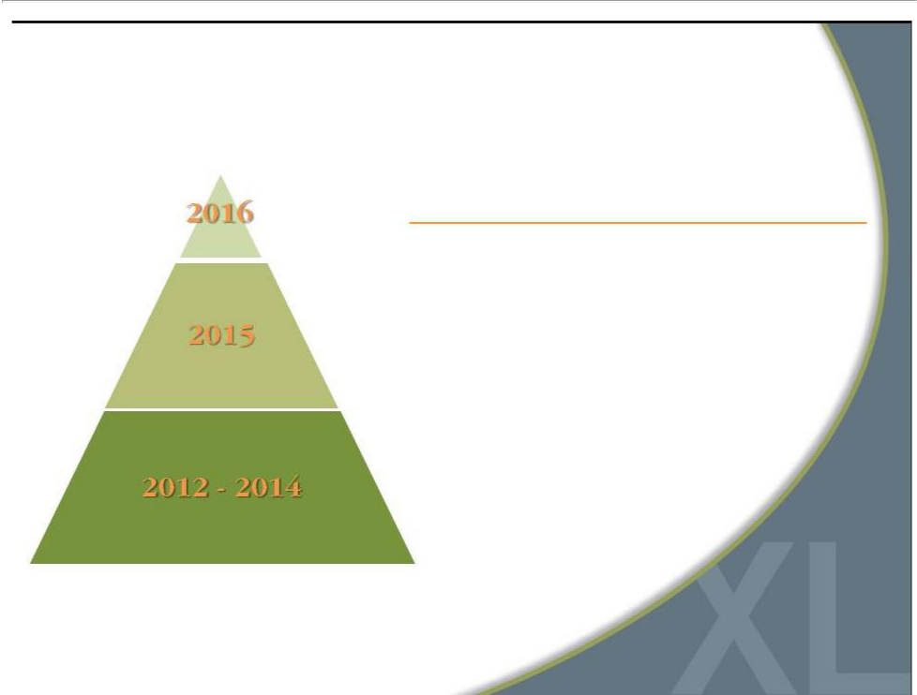
Accelerated Rollout of DXL

2016

Full benefit of DXL concept drives revenue >$600M

Open average of 10 DXL stores per year

Operating margins >10%

Generating freecash flowin the rangeof $60 - $70M

24


Increased Awareness = Opportunity

DXL Customer Purchase Funnel*

Addressable Population

17% | Aware of DXL
8% | Visiting DXL
73% | Purchasing
73% | from DXL

DXL’s addressable market is primarily men with over 40”waist

Awareness of DXL is low across its markets, directly impacting ability to attract new customers

Of those aware of DXL, only 8% are visiting the store

73% of those that visit the store make a purchase

89%

Repeat

89% of those that make a purchase

intend to return

*Based on consumers’stated responses per L.E.K’s survey within DXL markets | 25
Source: L.E.K analysis | 25

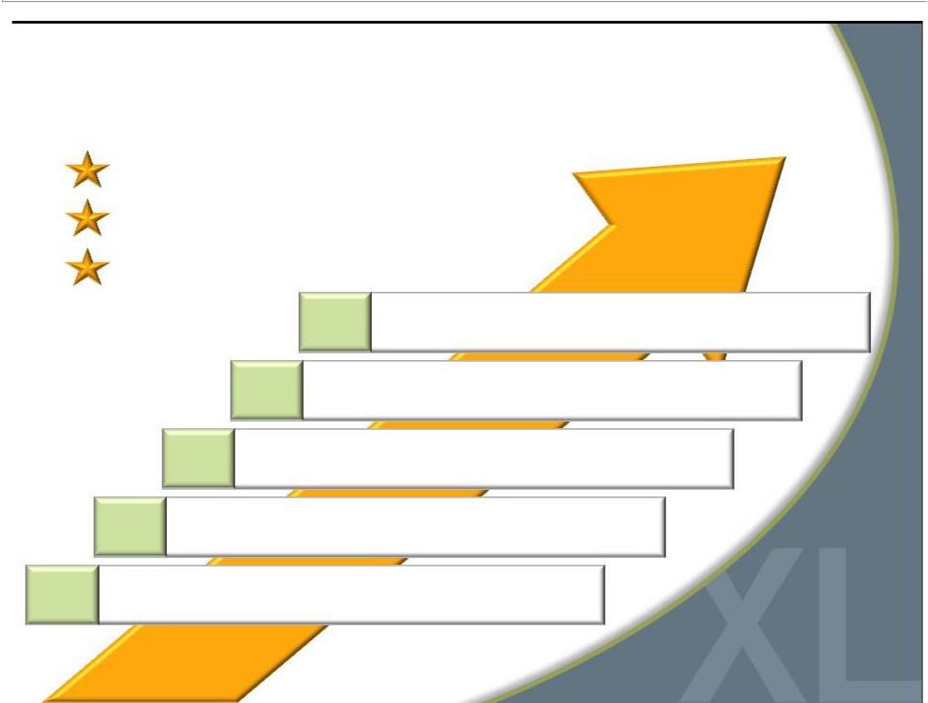
Opportunity to Grow Market Share

Addressable Market = 40M Customers

1.5M Currently Active Customers

Goal = Grow Customers by 40% Over 3 Years

Capture greater wallet share with DXL concept

Attract a broader customer audience with one-stop-shop

Target “end-of-rack” customers

Paradigm shift in marketing improves awareness

Grow direct business with new website

26


Destination XL® Marketing Campaign

Launched test campaign in 5 markets:

Memphis, Minneapolis, Denver, Atlanta and Oklahoma City

Increased awareness by 100%

in new markets & 38% in established markets

Built Stronger Brand

to Attract and Serve

Customers

“End-of-rack” customer

base grew by 38%

Results Demonstrate

Ability to Grow

Market Share

27

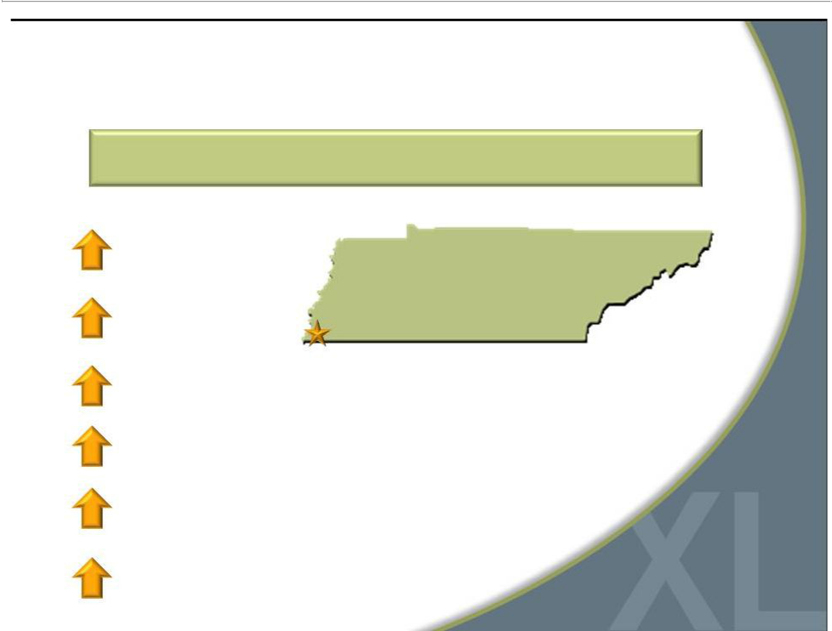
Established Effective Marketing Mix

6-Week Test Demonstrated TV, Radio and Digital is Most Effective Marketing Combination

15% sales | Established Market
 | Memphis DXL Opened in 2010
24% traffic

64% new customer purchases

38% market awareness

84% web traffic

7% web sales
28


DXL Test TV Commercial

Marketing to Customers in “No Man’s Land”

29

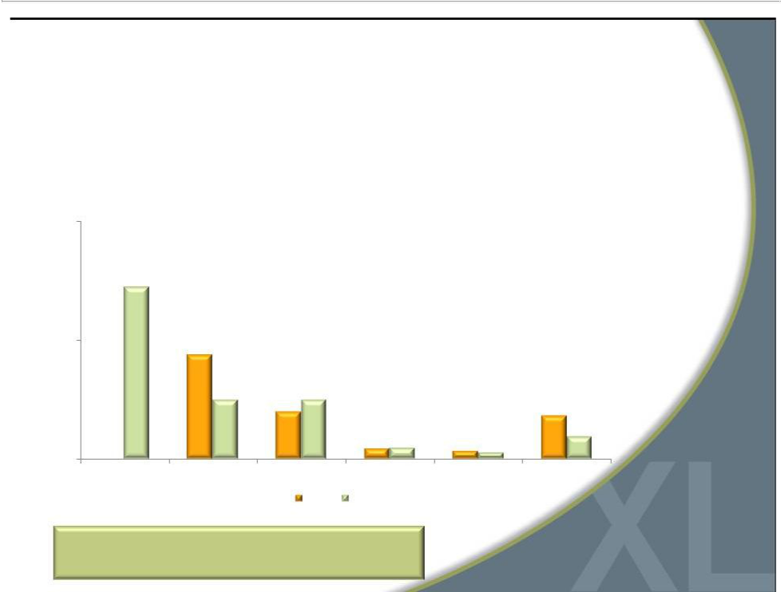
Proposed 2013 Marketing Spend

- Increase marketing spend as percent of sales from 4.5% to 6.5%

- Launch strong national marketing campaign in spring 2013

$M

20

10

0

DXL Media

Direct

Digital

Visual

Loyalty

Other

2012

2013

Total 50% Increase YOY

to Drive DXL Awareness

30


Q4 2012 Preliminary Results

- Comparable sales increased ~0.5% and total sales were ~$114.9M

- Full year comparable sales increased ~1.5% and total sales were ~$399.6M

- Q4 comparable sales for DXLwere up ~15%, while comparable sales for Casual Male XL stores decreased ~2.3%

- DXL stores represented ~18% of retail sales

- Direct e-commerce sales increased ~13.0%

- Income from continuing operations expected to be ~$0.08 per diluted share

31


Why Invest in DXLG?

Accelerated conversion to DXL concept creates compelling investment opportunity

Strong gross margins; Ability to greatly improve operating margins

Significant market share/sales growth opportunity

Leader in large and growing

B&T market

Three-year $150M investment

in DXL rollout to be

funded primarily by free cash flow, including use of $47 million in tax benefits

Strong balance sheet

with borrowing capacity

32



For additional information:

Jeffrey Unger

Destination XL Group, Inc.

V. P. Investor Relations

561-482-9715 Office

561-543-9806 Cell

jeffunger@usa.net

www.destinationxl.com

33

