UNITED STATES

SECURITIES AND EXCHANGE COMMISSION

Washington, D.C. 20549

FORM 8-K

CURRENT REPORT

PURSUANT TO SECTION 13 OR 15(d) OF THE
SECURITIES EXCHANGE ACT OF 1934

Date of Report (Date of earliest event reported): June 7, 2006

0-15898

(Commission File Number)

CASUAL MALE RETAIL GROUP, INC.

(Exact name of registrant as specified in its charter)

Delaware

04-2623104

(State of Incorporation)

(IRS Employer
Identification Number)

555 Turnpike Street, Canton, Massachusetts 02021

(Address of registrant’s principal executive office)

(781) 828-9300

(Registrant’s telephone number)

Check the appropriate box below if the Form 8-K filing is intended to simultaneously satisfy the filing obligation of the registrant under any of the following provisions (see

General Instruction A.2. below):

- Written communications pursuant to Rule 425 under the Securities Act (17 CFR 230.425)

- Soliciting material pursuant to Rule 14a-12 under the Exchange Act (17 CFR 240.14a-12)

- Pre-commencement communications pursuant to Rule 14d-2(b) under the Exchange Act (17 CFR 240.14d-2(b))

- Pre-commencement communications pursuant to Rule 13e-4(c) under the Exchange Act (17 CFR 240.13e-4(c))

ITEM 7.01 – Regulation FD Disclosure

The Company will be presenting a slide presentation to various investment groups as part of its upcoming road show. A copy of the slides to be presented at those meetings are attached to this report as Exhibit 99.1, which slide presentation is incorporated by reference herein.

The slide presentation contained in the exhibit includes statements intended as “forward-looking statements,” which are subject to the cautionary statement about forward-looking statements set forth in the exhibit. The slide presentation is being furnished, not filed, pursuant to Regulation FD. Accordingly, the slide presentation will not be incorporated by reference into any registration statement filed by the Company under the Securities Act of 1933, as amended, unless specifically identified therein as being incorporated therein by reference. The furnishing of the slide presentation is not intended to, and does not, constitute a determination or admission by the Company that the information in the slide presentation is material or complete, or that investors should consider this information before making an investment decision with respect to the Company.

ITEM 9.01 – FINANCIAL STATEMENTS AND EXHIBITS

(d) Exhibits

Exhibit No. |  | Description
99.1 |  | Presentation dated June 7, 2006

SIGNATURES

Pursuant to the requirements of the Securities Exchange Act of 1934, the registrant has duly caused this report to be signed on its behalf by the undersigned, thereunto duly authorized.

CASUAL MALE RETAIL GROUP, INC.

By: /s/ DENNIS R. HERNREICH

Name: Dennis R. Hernreich

Title: Executive Vice President

and Chief Financial Officer

Date: June 7, 2006

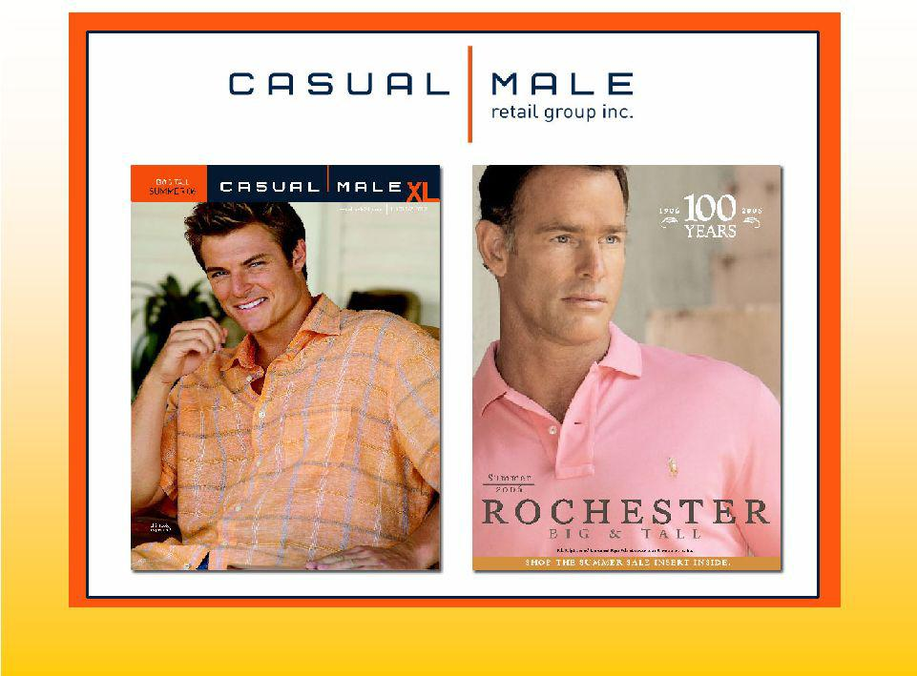

June 2006

Exhibit 99.1

1


’06 & ’07 Initiatives

- Redefine Casual Male image to increase market share

- Store growth – expansion of Rochester Clothing

- Jared M. Acquisition

- Continued accelerated growth of internet and catalog

- Gross margin improvement

2



Redefine Casual Male Image

3

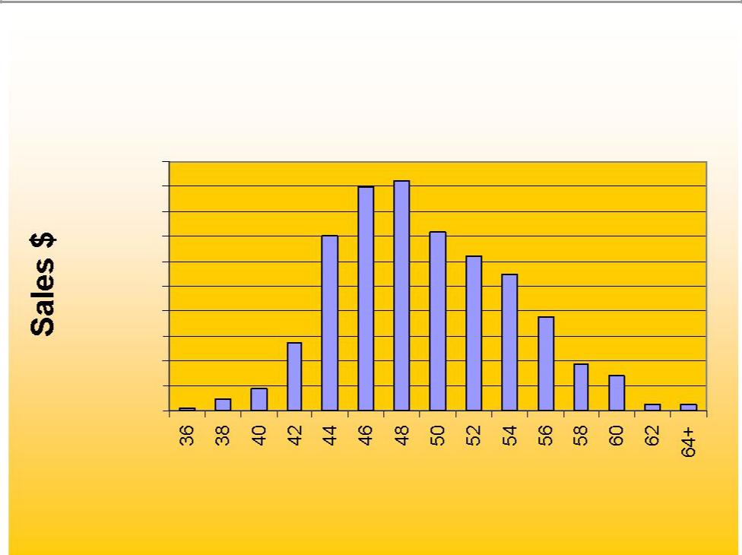
Market Share Size Opportunity

Casual Male Sales by Size

$200,000

$180,000

$160,000

$140,000

$120,000

$100,000

$80,000

$60,000

$40,000

$20,000

$0

Data based on ’04 sales of Casual Pants, Dress Pants and Jeans

Waist Size

4

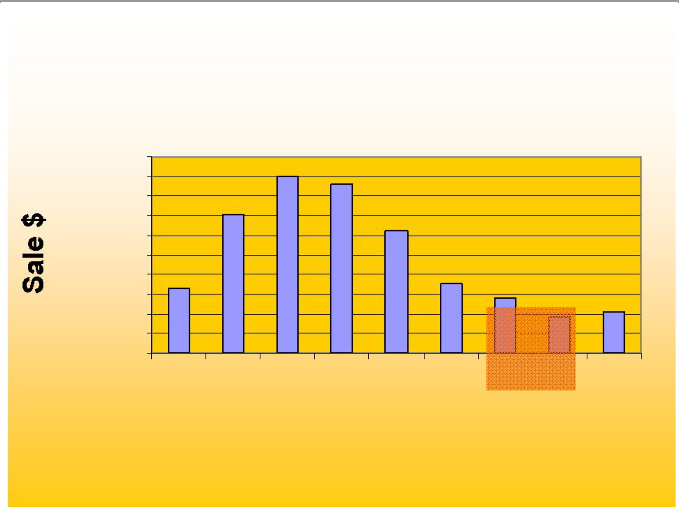
National Sales by Size

$2,000,000

$1,800,000

$1,600,000

$1,400,000

$1,200,000

$1,000,000

$800,000

$600,000

$400,000

$200,000

$0

30 32 34 36 38 40 42 44 46+

Waist

5

Customer Research

Least favorite aspect of clothing shopping was “difficulty finding items in my size”

– They were shopping at “the end of the rack”

– Stigma with “big and tall”store

– “big and tall” stores were consistently referred to as places where “fat guys” shop

Current image associated with Casual Male
– A degree of discomfort with shopping at the store for “big and tall”

– Belief that the clothing started around a 48” waist

– Merchandise and selection lacked a sense of style

– Had unattractive, inconvenient locations

– Casual Male was a place of necessity rather than a destination of choice

6

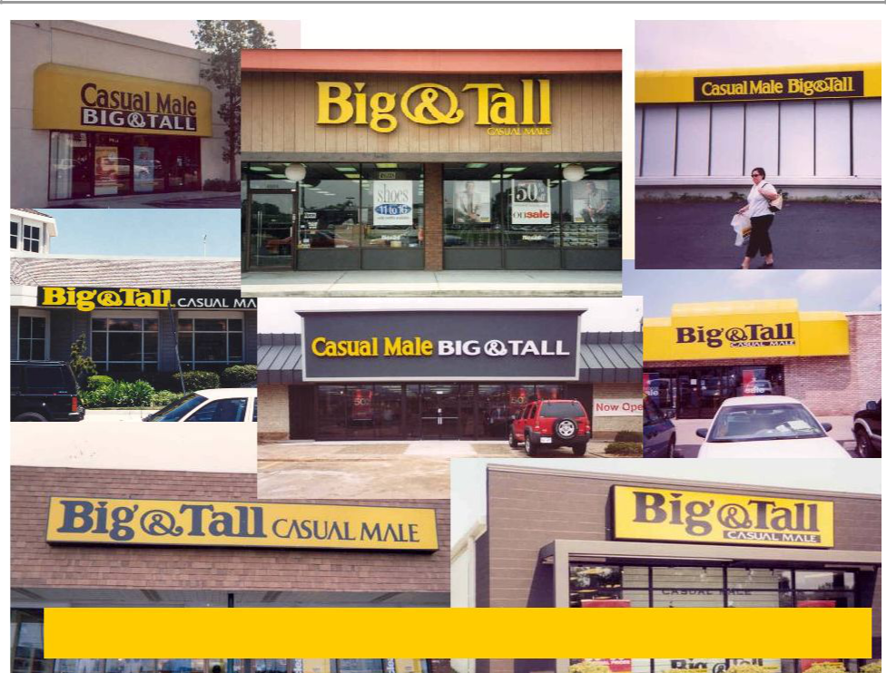

50% of customers refer to Casual Male as the “Big & Tall” store7

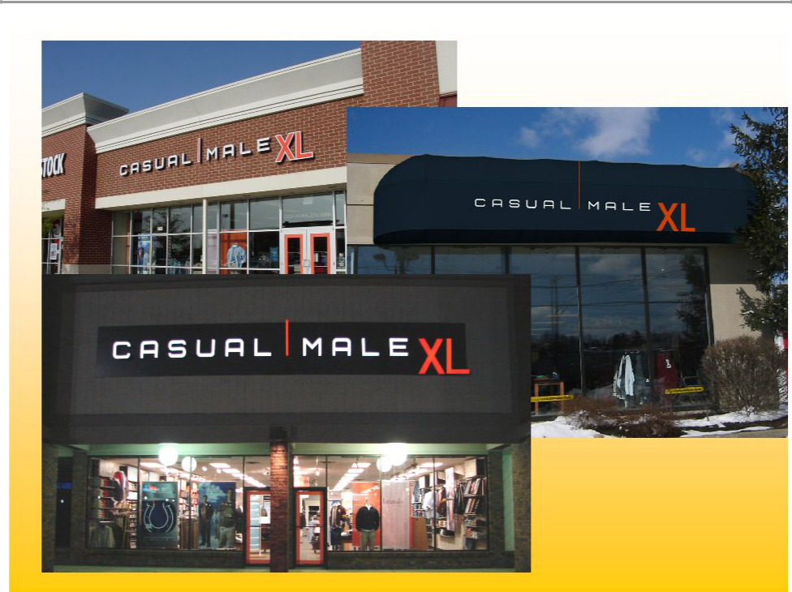

8

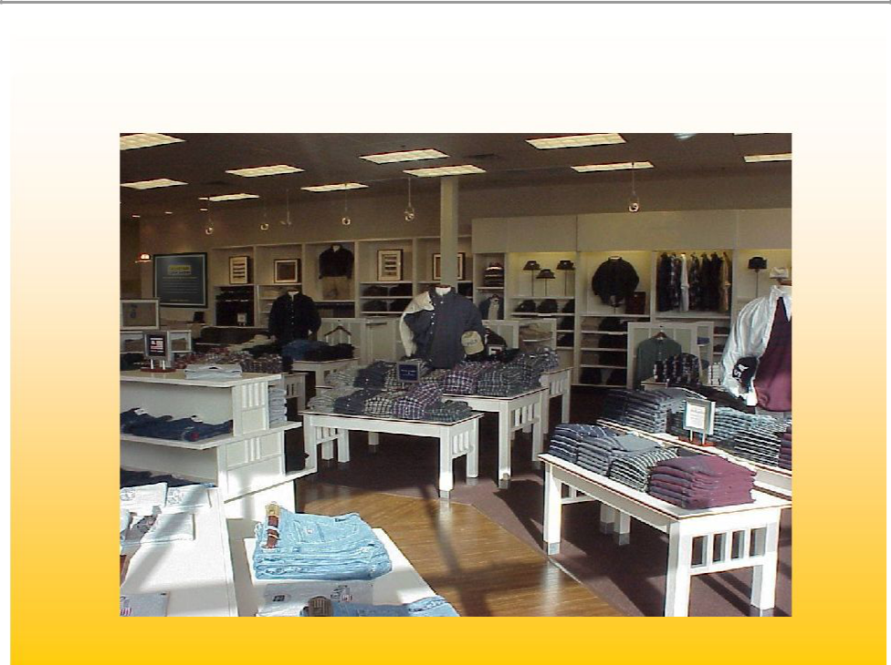
Before

9

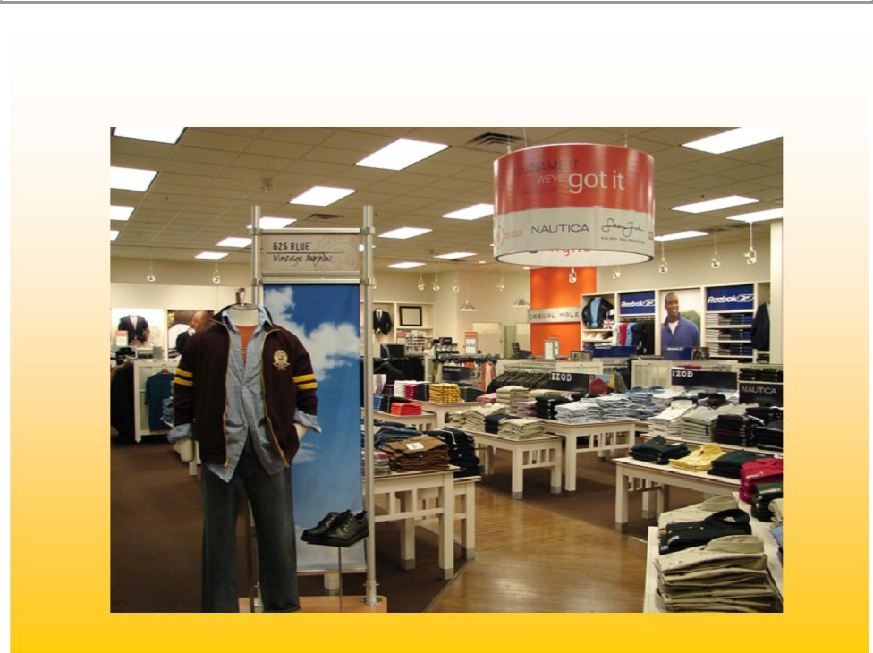
After

10

11

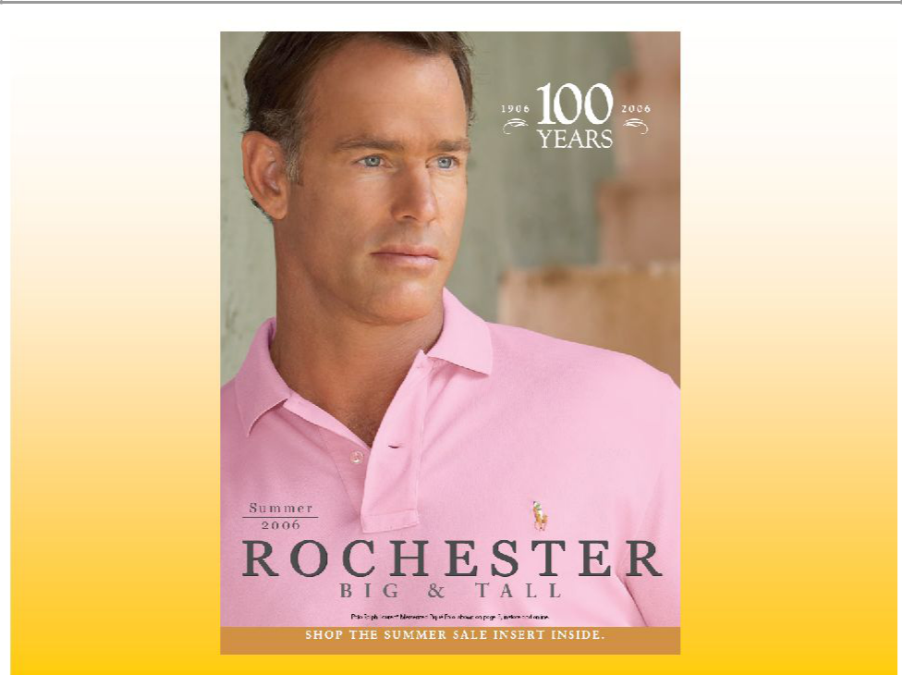

12

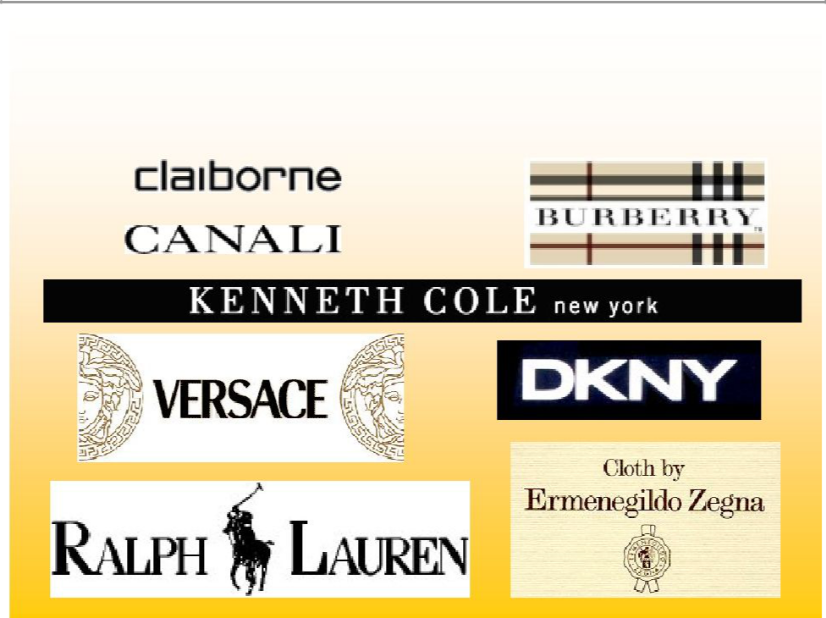
Rochester Brands

13


Rochester vs. Casual Male Metrics

Average sales per store | $2.3M | vs | CM $650,000
Average transaction | $400 | vs | CM $75
Average store sq. footage | 5,000-6,000 sq. ft. | vs | CM 3,500 sq. ft.
Average income of customer $100,000+ |  | vs | CM $71,000
Cost to open new store | $100 sq. ft. | vs | CM $36 sq. ft.
Inventory needed | $375,000 | vs | CM $125,000

14

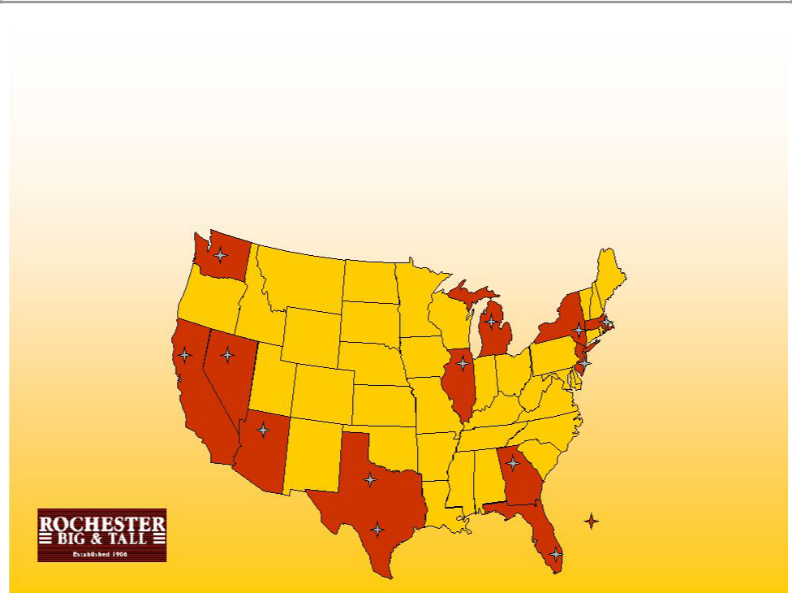
Rochester Overview

- Major growth for next 5 years. We will be in expanding Rochester from 24 stores to 40 more stores

2

9

Rochester
2 | * 1 London, United Kingdom
 | 15

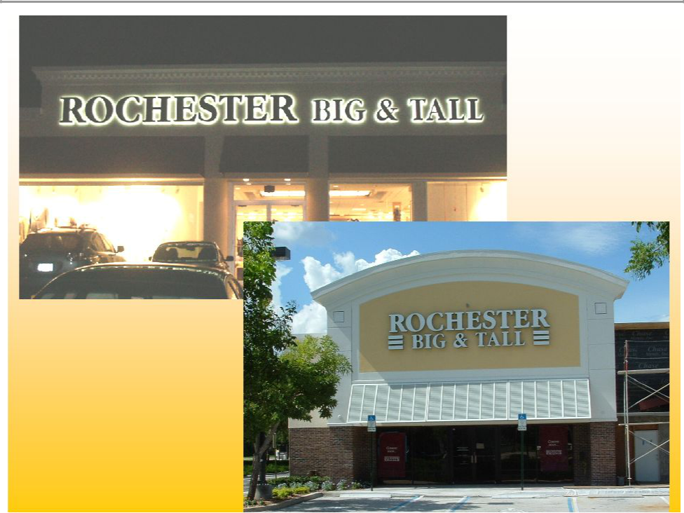

16

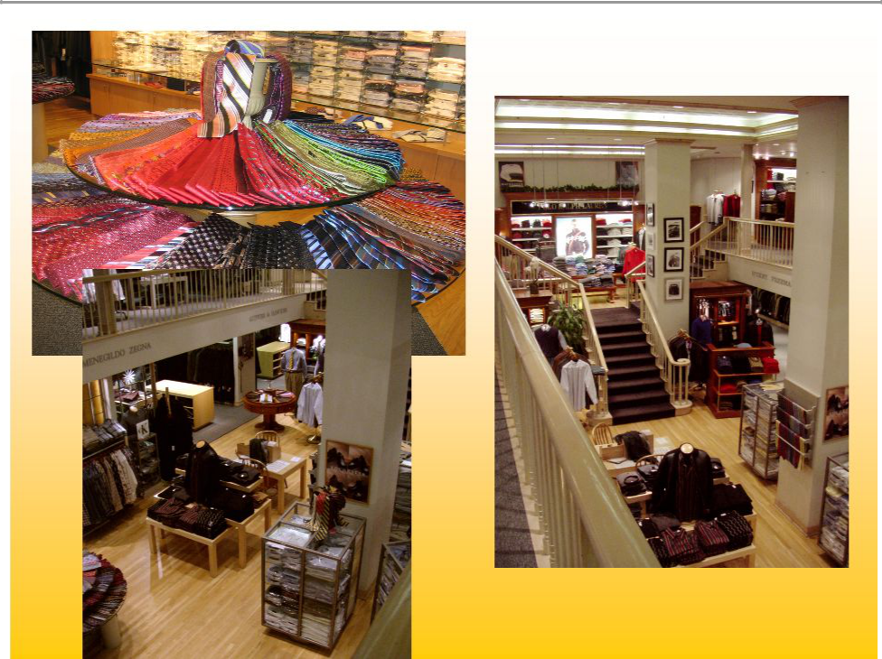

17


Jared M. Acquisition

18


Jared M. Acquisition

- Custom clothing continues to be growing in the higher end men’s business

- Rochester is underdeveloped in custom clothing (3.5% of sales)

- Jared M. $3.0M company catering to professional athletes

- Utilized CMRG infrastructure for multi-channeled opportunities

- Spring ’07 launch

– Jared M. shops in several high profile Rochester markets

– Jared M. catalog

– Jared M. website

19

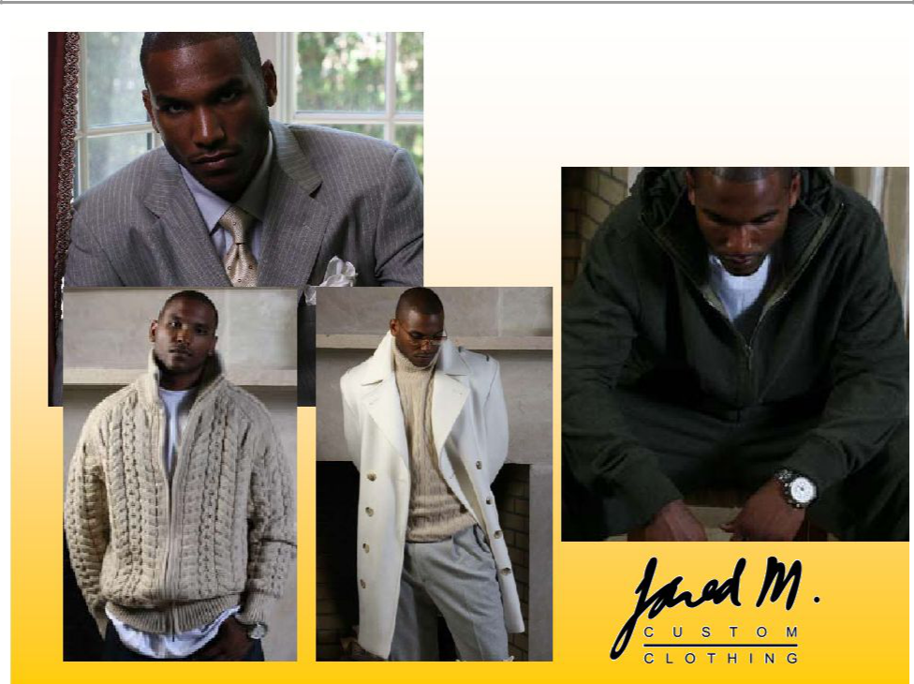
Jared M.

20

Continued accelerated growth of internet and catalog

21

 |  |  |  |  | Comp Store Trend
10.0% |  |  |  | 9.2%
 |  |  |  | 9.2% | Launch of George Foreman
 |  |  |  |  | collection and TV campaign |  |  |  |  |  | 7.90%
8.0% |  |  |  |  |  |  |  |  |  |  | 7.90%
6.0% |  |  |  |  |  |  |  |  |  |  |  | 5.40%
 |  |  |  |  | 4.8%
4.0% |  |  |  |  |  |  |  |  |  | 3.70%
 |  |  | 2.4% |  |  |  | 2.0% | 2.3% | 2.5%
2.0% |  |  |  |  |  | 1.6% | 2.0%
0.0%
Q1 | Q2 | Q3 | Q4 | Q1 | Q2 | Q3 | Q4 | Q1 | Q2 | Q3 | Q4 | Q1
-2.0% |  | -1.1%
-2.0% |  | Stores change to
 | -2.3%
 | -2.3% | lifestyle presentation
-4.0%
-5.0%
-6.0% | 2003 |  |  |  | 2004 |  |  |  | 2005 |  |  | 2006
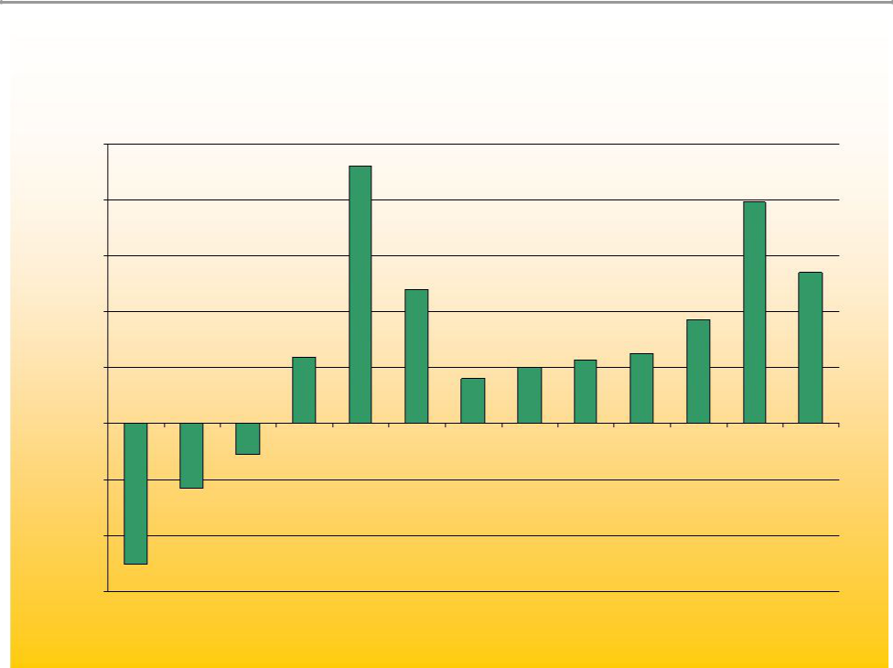
22

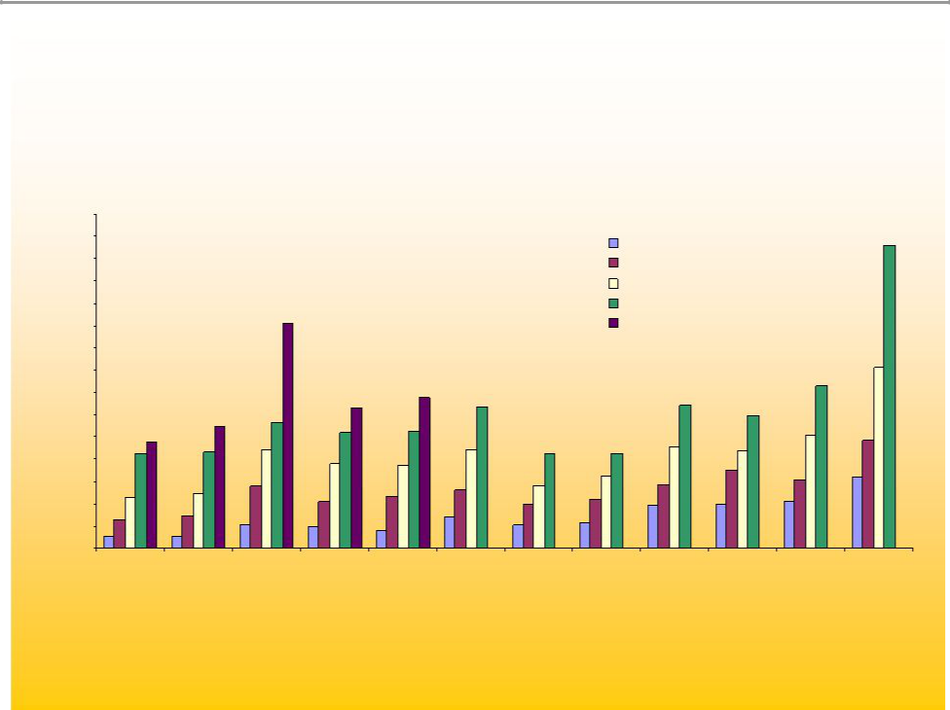
CM 2005 Internet Sales by Month

$3,000,000 $2,800,000 $2,600,000 $2,400,000 $2,200,000 $2,000,000 $1,800,000 $1,600,000 $1,400,000 $1,200,000 $1,000,000 $800,000

$600,000

$400,000

$200,000

$0

2002 - $3,357,447

2003 - $6,229,617

2004 - $9,874,481

2005 - 14,559,045

2006

Jan Feb Mar Apr May Jun Jul Aug Sep Oct Nov Dec

23

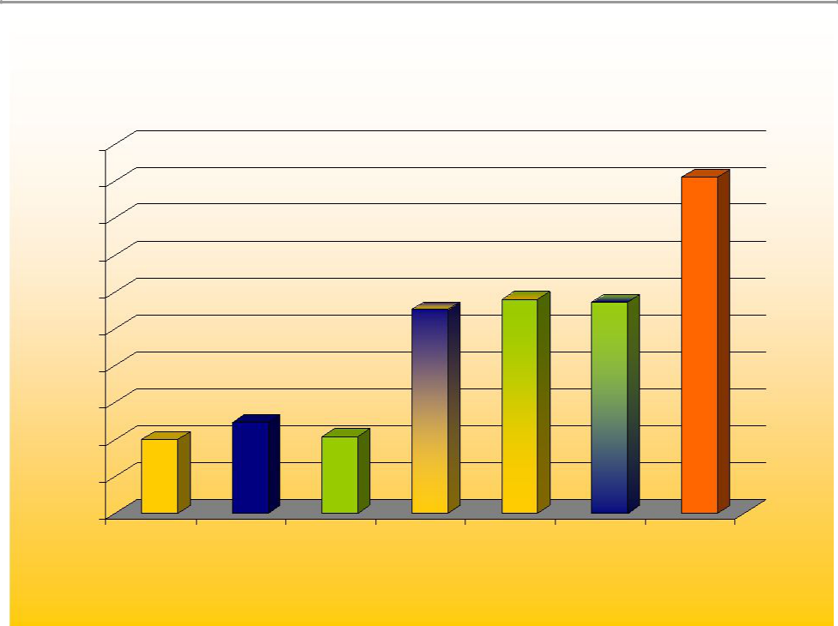
Customer Sales by Channel

500

455

450
400
350
300 |  | 276 | 290 | 286
250
200
150 | 123
100 | 104
100
50
0
Retail only | Catalog OnlyE-commerce | Retail & | Retail & E- | Catalog & E- | Retail &
 | Only | Catalog | commerce | commerce | Catalog & E-
* Indexed to retail only shoppers |  |  |  |  | commerce
24

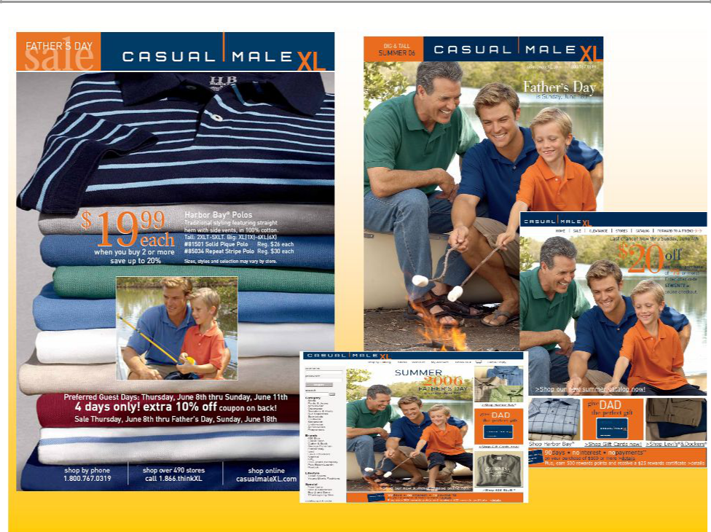

25

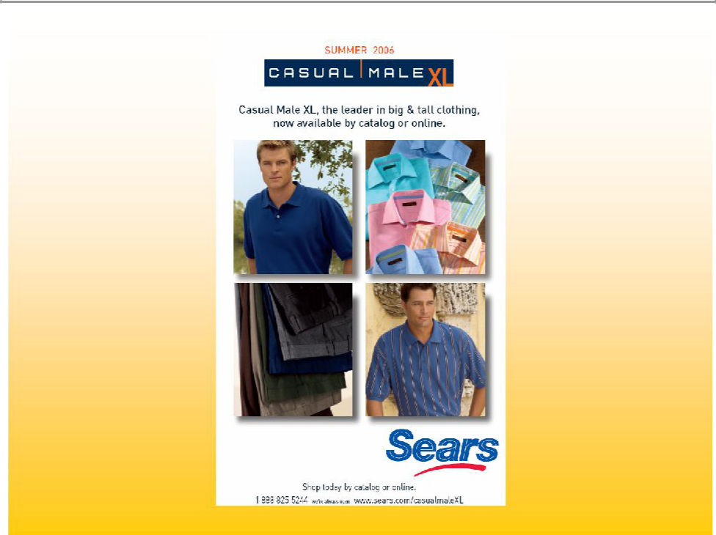

26

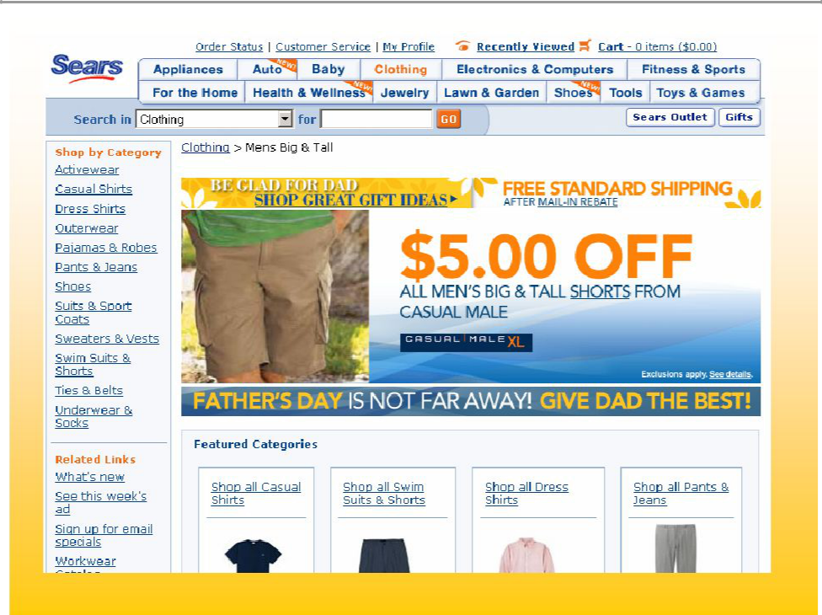

27

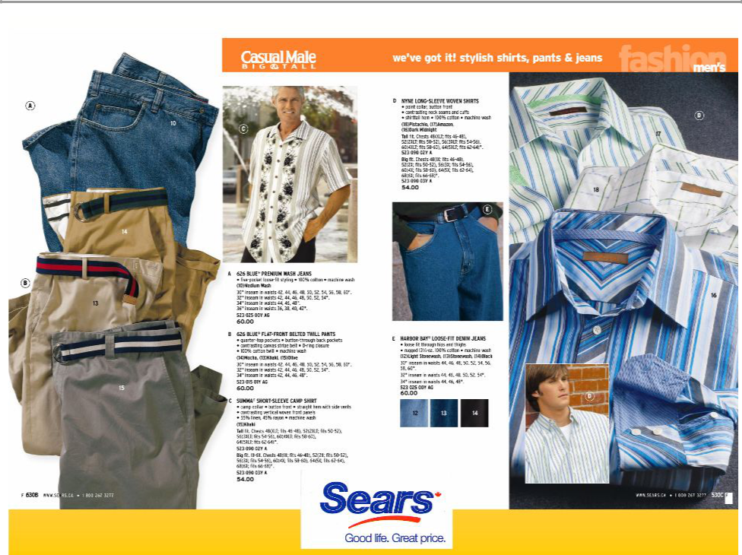

28

Gross Margin Improvements

- Inventory management

- Direct sourcing

- Building proprietary brands

29

Gross Margin Opportunity

- Core vs. seasonal/fashion – core year round basic stock items (5 pocket jean, pique polo, pocket tee, underwear, etc.)

- Implementation of E3 (replenishment system) determined that we were 25% out of stocks on core items – demand exceeded supply

– Better margins on core products than seasonal/fashion

30


Guaranteed In-stock Program

- 7 key items

- GIS Program – Bottoms 49 sizes, delivery in 5 working days or FREE

- 8/21 launch

- Sold 449,405 units

- Units 26% increase

- 4,623 units fulfilled through catalog

- 13 pieces of free items given away

31

Direct Sourcing

- Direct Sourcing of goods through Li & Fung, as agent beginning in 2006

- New Department created, hiring of industry veteran

- Potential for 40% of Casual Male Inventory to go Direct

- Cost saving of up to 15%

- Better sourcing (reduction of # of Vendors)

- Rochester has very little private label, potential for 20%

- Cost savings of up to 20% for Rochester

32

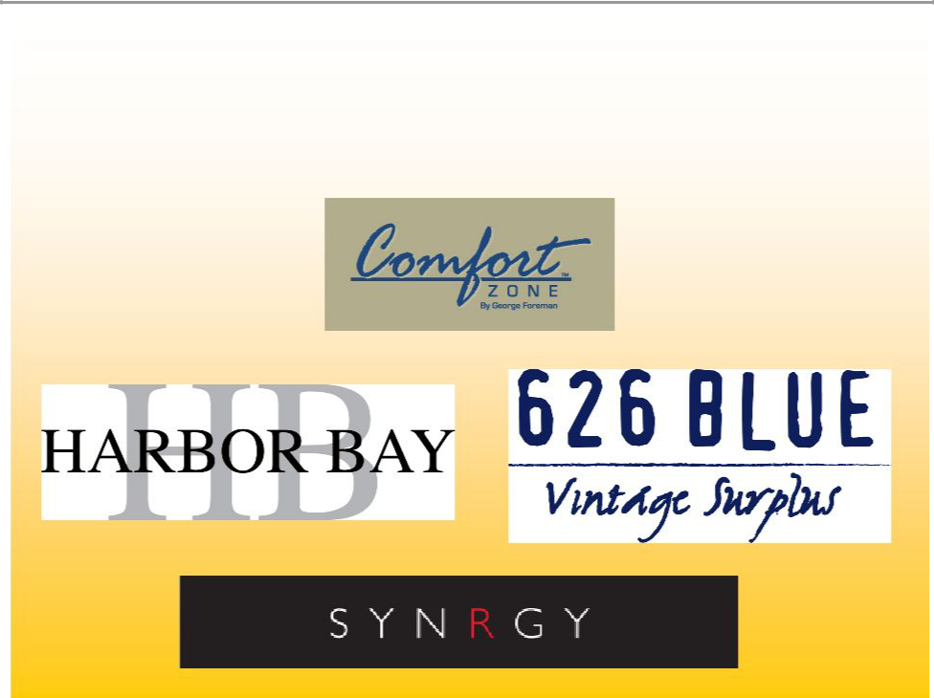
Proprietary Brands

33

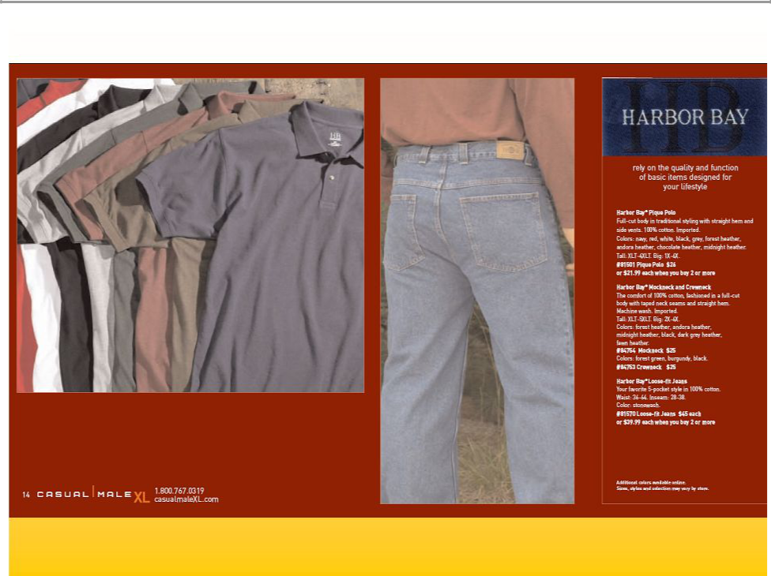

34

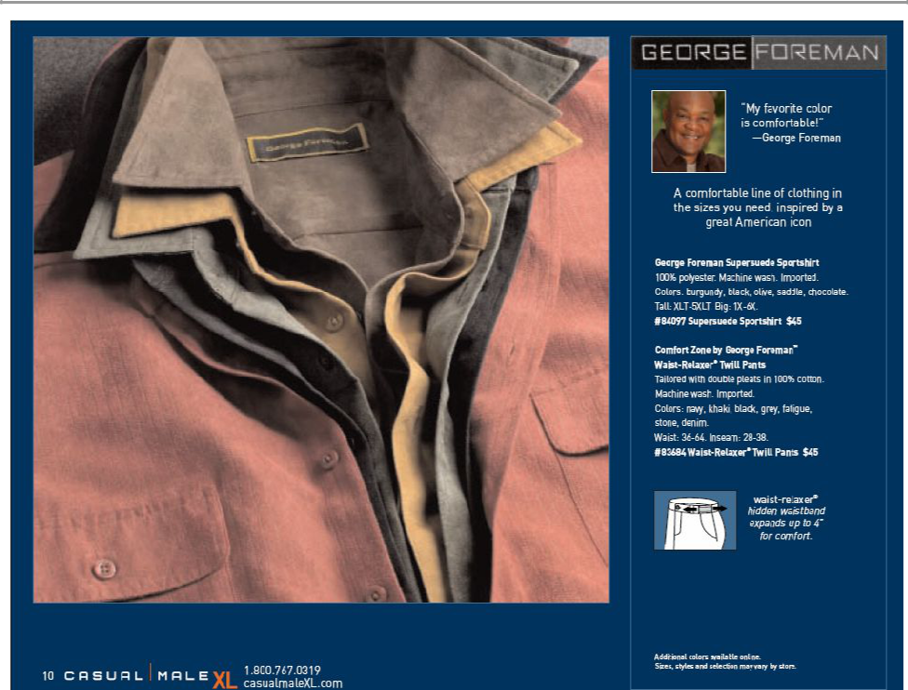

35

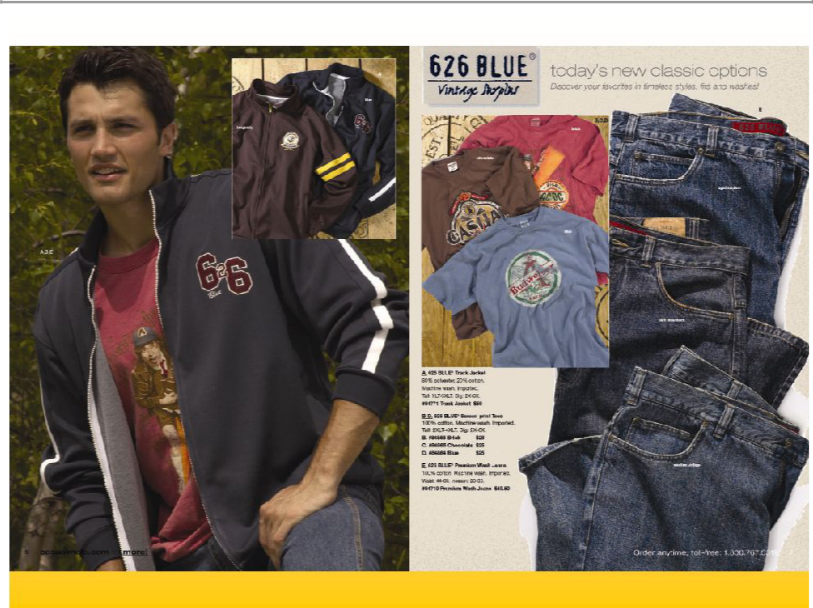

36

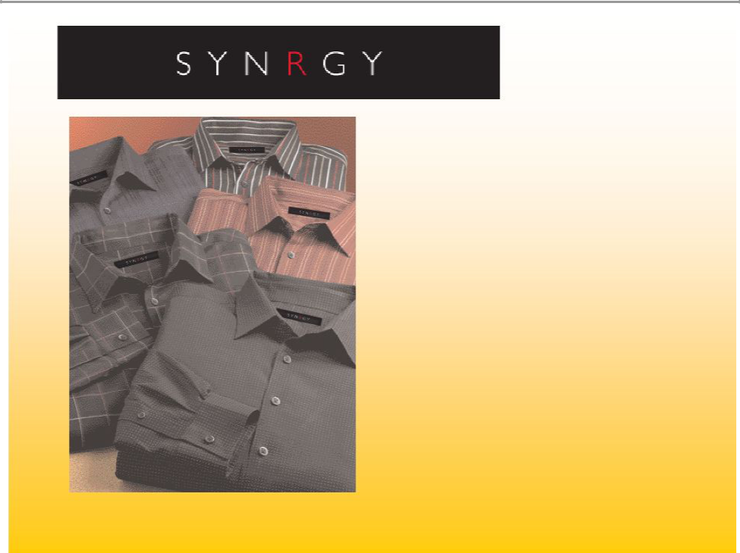

Collection will consist of Wovens, Casual Pant, and Knits

Assortment will reflect items/attitude and overall look of successful contemporary brands such as George Foreman Signature, Perry Ellis, I.N.C., etc.

37

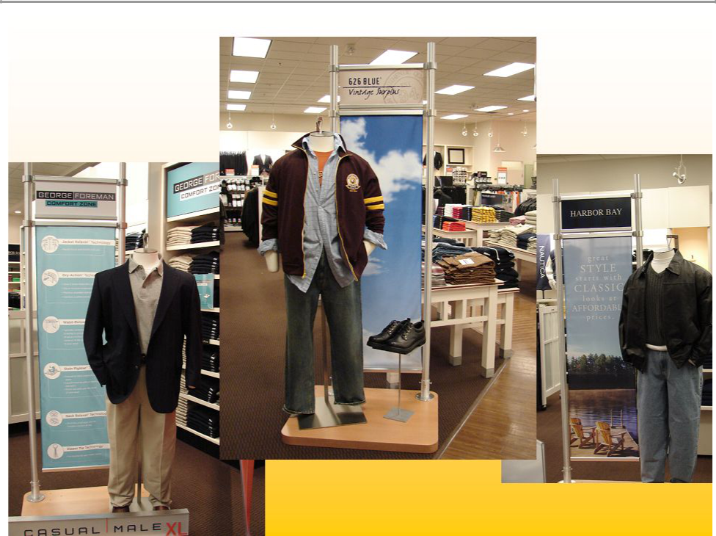

38

Forward - Looking Statement

Any remarks that we make today about future expectations, plans and prospects for Casual Male Retail Group, Inc. which are not historical facts, are forward-looking statements that involve risks and uncertainties. For a discussion of such risks and uncertainties, which could cause the Company’s actual results to differ from those contained in the forward-looking statements, please read the section entitled “Forward-Looking Statements” in the Company’s most recent Form 10-K and Form 10-Q and the Form 8-K filed on April 8, 2005 with the Securities and Exchange Commission.

39

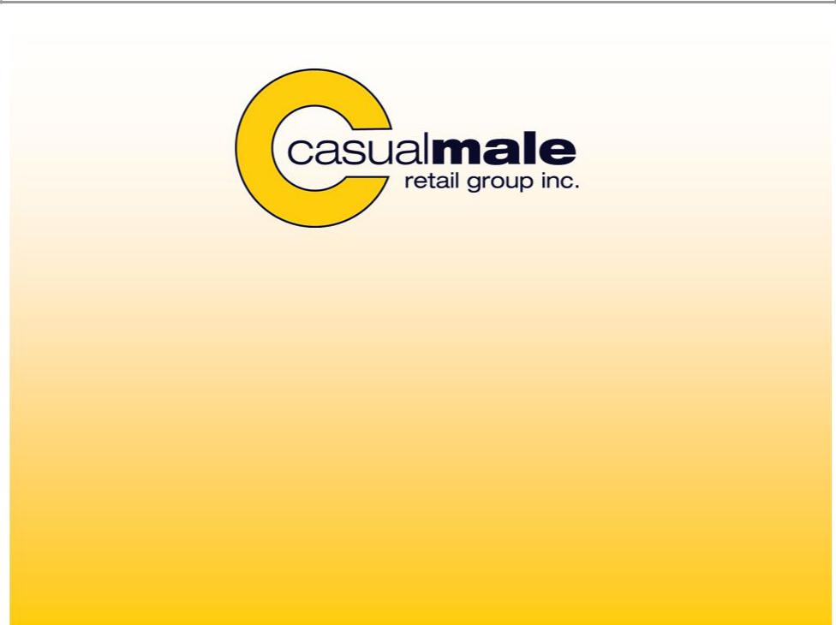

Casual Male Retail Group 555 Turnpike Street Canton, MA 02021

- 828-9300 x 2004 jeffunger@usa.net clinsky@cmal.com

40

