UNITED STATES

SECURITIES AND EXCHANGE COMMISSION
Washington, D.C. 20549

FORM 8-K

CURRENT REPORT

PURSUANT TO SECTION 13 OR 15(d) OF THE

SECURITIES EXCHANGE ACT OF 1934

Date of Report (Date of earliest event reported): June 29, 2010

01-34219

(Commission File Number)

CASUAL MALE RETAIL GROUP, INC.

 | (Exact name of registrant as specified in its charter)
Delaware | 04-2623104
(State of Incorporation) |  |  | (IRS Employer Identification Number)
 | 555 Turnpike Street, Canton, Massachusetts 02021
 | (Address of registrant’s principal executive office)
 | (781) 828-9300
 |  | (Registrant’s telephone number)

Check the appropriate box below if the Form 8-K filing is intended to simultaneously satisfy the filing obligation of the registrant under any of the following provisions (see

General Instruction A.2. below):

- Written communications pursuant to Rule 425 under the Securities Act (17 CFR 230.425)

- Soliciting material pursuant to Rule 14a-12 under the Exchange Act (17 CFR 240.14a-12)

- Pre-commencement communications pursuant to Rule 14d-2(b) under the Exchange Act (17 CFR 240.14d-2(b))

- Pre-commencement communications pursuant to Rule 13e-4(c) under the Exchange Act (17 CFR 240.13e-4(c))

ITEM 7.01 - Regulation FD Disclosure

The Company will be presenting an investor slide presentation at upcoming meetings with various investment groups. A copy of the slide presentation is attached to this report as Exhibit 99.1, and is incorporated by reference herein.

The slide presentation contained in the exhibit includes statements intended as “forward-looking statements,” which are subject to the cautionary statement about forward-looking statements set forth in the exhibit. The slide presentation is being furnished, not filed, pursuant to Regulation FD. Accordingly, the slide presentation will not be incorporated by reference into any registration statement filed by the Company under the Securities Act of 1933, as amended, unless specifically identified therein as being incorporated therein by reference. The furnishing of the slide presentation is not intended to, and does not, constitute a determination or admission by the Company that the information in the slide presentation is material or complete, or that investors should consider this information before making an investment decision with respect to the Company.

Presentation of Non-GAAP Measures

The slide presentation includes the discussion of non-GAAP free cash flow on slides 3, 7, 26 and 28. Free cash flow is not a measure determined by generally accepted accounting principles (“GAAP”) and should not be considered superior to or as a substitute for net income (loss) or cash flows from operating activities or any other measure of performance derived in accordance with GAAP.

In addition, all companies do not calculate non-GAAP financial measures in the same manner and, accordingly, “free cash flows” as presented in this slide presentation may not be comparable to similar measures used by other companies. The Company calculates free cash flows as cash flow from operating activities less capital expenditures and discretionary store asset acquisitions, if any. We believe that inclusion of this non-GAAP measure helps investors gain a better understanding of our performance, especially when comparing such results to previous periods

Free cash flow is calculated as follows for each of the respective fiscal years, as disclosed on slide 26 of the slide presentation:

 |  |  |  | Projected
 |  |  |  |  | Fiscal |  |  | Fiscal |  | Fiscal |  |  | Fiscal |  | Fiscal
(in millions) |  |  |  |  | 2010 |  | 2009 |  | 2008 |  |  | 2007 |  |  | 2006
 | Cash flow provided by operations |  | $ |  | 30.0 |  | $30.8 |  | $ |  | 23.2 | $11.7 |  |  | $ 12.1
 | Less: capital expenditures |  |  |  | 10.0 |  | 4.6 |  |  |  | 12.6 | 21.4 |  |  | 22.7
 | Less acquisitions |  |  |  | — |  |  | — |  |  | 3.0 |  | — |  | 3.0
Free cash flow |  |  | $ |  | 20.0 |  | $26.2 |  | $ |  | 7.6 | $ (9.7) |  |  | $ (13.6)

- Free cash flow for fiscal 2008 and fiscal 2006 include the cash used for the Dahle acquisition of $3.0 million and the Jared M. acquisition of $3.0 million, respectively.

ITEM 9.01 - FINANCIAL STATEMENTS AND EXHIBITS

(d) Exhibits

Exhibit No. |  | Description
99.1 | Investor Slide Presentation.

SIGNATURES

Pursuant to the requirements of the Securities Exchange Act of 1934, the registrant has duly caused this report to be signed on its behalf by the undersigned, thereunto duly authorized.

CASUAL MALE RETAIL GROUP, INC.

By: | /s/ DENNIS R. HERNREICH
Name: | Dennis R. Hernreich
Title: | Executive Vice President
 | and Chief Financial Officer

Date: June 29, 2010

Exhibit 99.1

********************Investor Presentation


Forward Looking Statements

Thispresentationcontainscertainforward-lookingstatementsconcerningthe Company'soperations, performance,andfinancialcondition.Suchforward-lookingstatementsare subjectto variousrisksand uncertaintiesthat could causeactualresults to differ materiallyfrom those indicated.Suchrisksand uncertaintiesmayinclude,but are not limitedto: the failureto implementthe Company'sbusinessplan for increasedprofitability and growth in the Company'sretail stores sales and direct-to-consumer segments,the failureof managemento developthe Company’snewdirectto consumerbusinesses,the failure of changesin managementto achieveimprovementin the Company'scompetitiveposition, adversechangesin costsvitalto catalogoperations,suchaspostage,paperandacquisitionof prospects, decliningresponseratesto catalogofferings,failureto maintainefficientanduninterruptedorder-taking and fulfillment in our direct-to-consumerbusiness,changesin or miscalculationof fashion trends, extreme or unseasonableweather conditions, economicdownturns, escalationof energy costs, a weaknessin overallconsumerdemand,increasesin wagerates,the abilityto hire andtrain associates, trade and security restrictions and political or financial instability in countries where goods are manufactured,increasesin raw material costs from inflation and other factors, the interruption of merchandiseflow from the Company'scentralizeddistributionfacilities,competitivepressures,andthe adverseeffectsof naturaldisasters,war, actsof terrorismor threatsof either, or other armedconflict, on the UnitedStatesandinternationaleconomies.These,andother risksanduncertainties,aredetailed in the Company'sfilingswith the SecuritiesandExchangeCommission,includingthe Company'sAnnual Reporton Form 10-Kfor the fiscal year endedJanuary30, 2010 filed on March 19, 2010 and other Companyfilingswith the SecuritiesandExchangeCommissionCasualMaleassumesno. duty to update or reviseits forward-lookingstatementseven if experienceor future changesmake it clear that any projectedresultsexpressedor impliedthereinwill not berealized.

2


Company Overview

- Largest multi-channel specialty retailer of men’s big and tall (B&T) market

- Vertically integrated multi-channel model of 476 stores (47 states), direct to consumer presence in U.S., Canada and EU

- Geographically and demographically diverse customer base

– 2.5 million active customers

– 90% enrollment in Loyalty program

- 2009 sales of $395 million. EBITDA of $23 million (5.8%)

– 80% retail sales

– 20% direct to consumer

- 2009 free cash flow of $26 million

– $11 million in debt at end of FY 2009

3

Attractive Big and Tall Segment

- Annual sales of men’s B&T market is approximately $6B

- B&T men account for approximately 11% of the U.S. population

- Growing at almost twice the rate of the regular size men’s apparel market

- B&T consumers shop 50% more for apparel on the web than regular sized consumers

- B&T market is highly fragmented

4

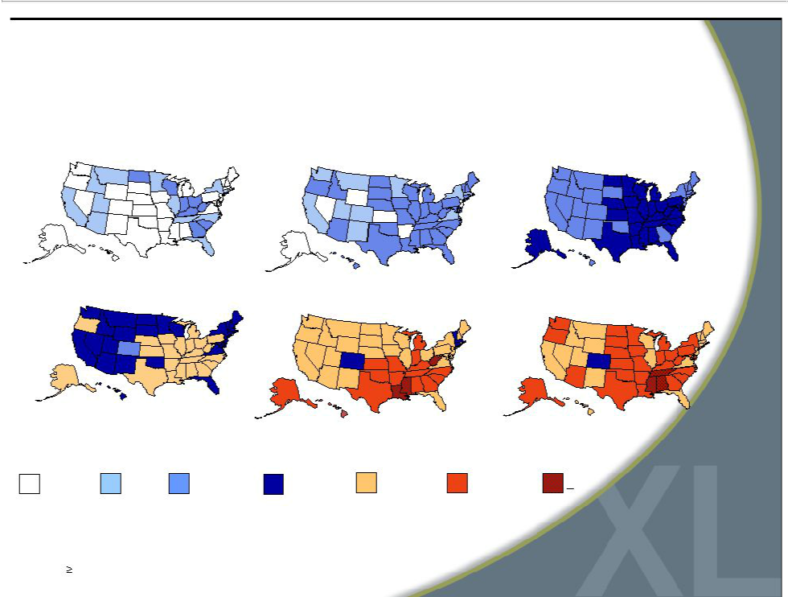
Growing Obesity Trends Among U.S. Adults
1985 1990 1995

2000 2005 2007

No Data <10% 10%–14%15%–19% 20%–24% 25%–29% >30%

(*BMI 30, or about 30 lbs overweight) | 5

Company Strategic Repositioning: 2003-2009

- Merchandise:built comprehensive demographic and socio-economically accessible range of product assortments and brands

- VerticalModel:fully integratedstoresanddirectto consumer businessesinto amulti-channelplatform

- Systems:built elaborate store planning and size management applications

- Marketing:reformulated marketing program to focus on customer base

- Expense Structure:ationalized expense structure and lowered inventory levels

- Culture:implemented advanced in-store sales culture

6


Rebound to Financial Health: 2009 vs. 2007

- Maintained operating margin after a sales decline of 15% over two years

– Increased gross margin 150 bps in 2009 (from 2008)

– Lowered the expense ratio 190 bps in 2009 (from 2008)

– Eliminated in 2009 unproductive marketing spend and reduced marketing spend to 5% of sales

- Substantial financial improvements over the two years:

– Decreased inventory by 24%

– Increased free cash flow by $36 million

– Reduced total debt by $47 million, or 80% to $11 million

7

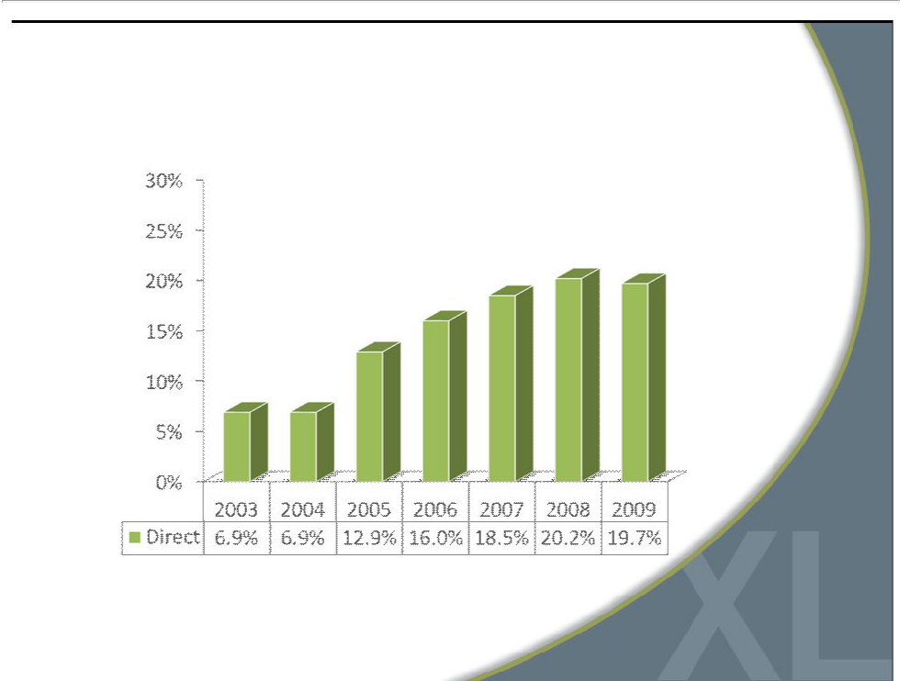
Growth of Direct to Consumer Business

8

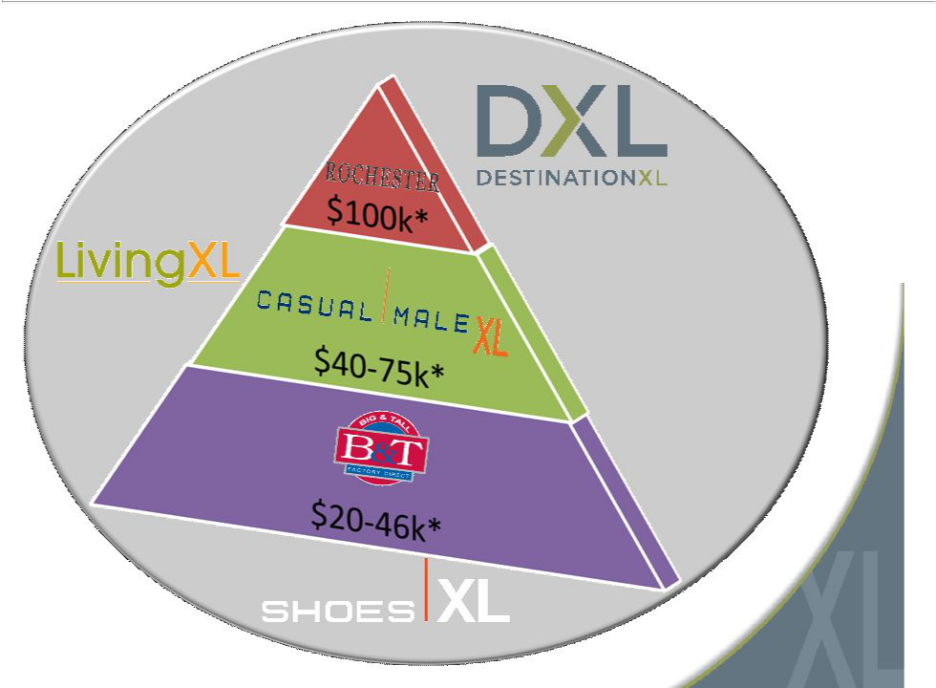

*Average household income
9

Today’s Casual Male

- Dominant market position in unique niche

- Positioned across demographically diverse, loyal customer base

- Efficient infrastructure to manage numerous sizes, multiple lifestyles and diverse customer base

- Strong balance sheet and cash flow

- Opportunity to grow long-term market share and accelerate financial returns

10

Strong New Growth Opportunities

- Capture higher wallet share of existing loyal customers

– Currently capture around 50% of total apparel spending of average active customer

- Develop the 42”-46”business segment

– Accounts for 65% of the overall men’s B&T market but only 20% of our business

- Further leverage direct to consumer business

– Targeting 30% of total sales from the current 20% level

11


Hybrid Stores Test

Goal:Broaden the target market and improve store-level profitability by combining Casual Male and Rochester stores in five markets

Results:

•Maintained high customer retention •Created attractive cross-selling environment

– 50% increase from average CMXL store ticket

•Dramatic turnaround in cash flow

– From breakeven in the converted stores to 16%

12

Destination XL™(DXL™) Stores

- Combination of Casual Male XL, Rochester Clothing, B&T Factory Direct and Shoes XL

- Average size 10,000-12,000 square feet

- Concept appeals to a larger base of customers

- Offers extensive selection of products in one location

– Good, better, best assortment

– 2,000 styles compared to 600 for an average Casual Male store

– Twice the number of brands

- Strong survey and focus groups scores

– Requesting bigger store, aisles and dressing rooms

– In store tailor

– Willing to drive 1 hour

13

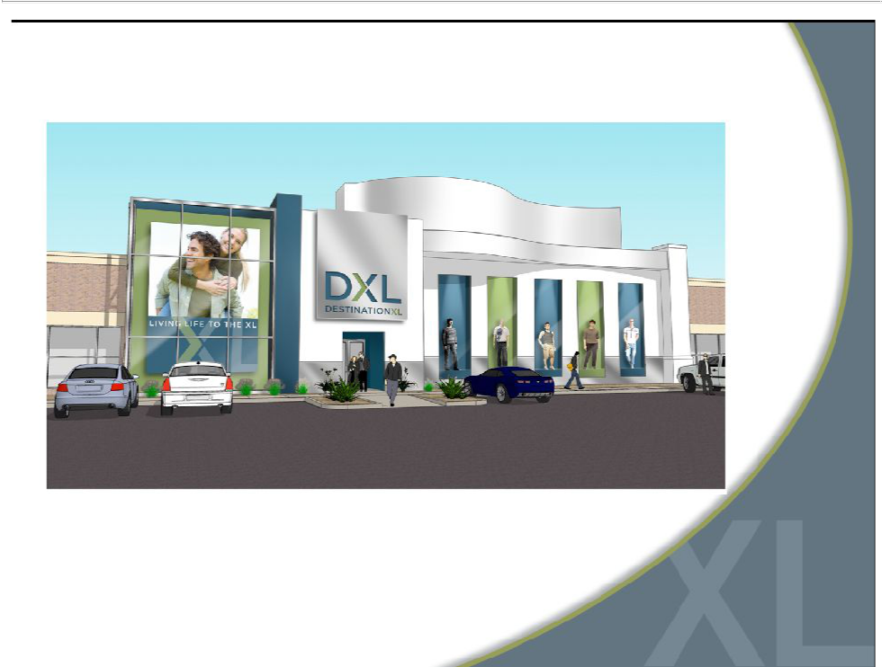
DXL Storefront

14

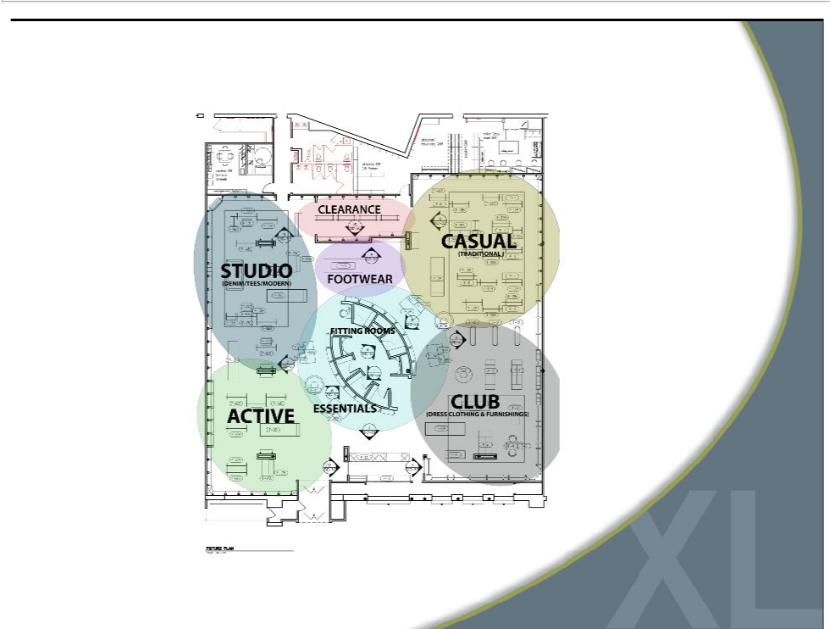
DXL Layout

15

Compelling DXL Returns

- Expect greater store productivity and profitability

– Capture greater percentage of customer’s clothing budget

– Better leveraging of expensesoccupancy,-- labor productivity and local/district management

- Projecting higher 4-wall profits than combined profits of individual stores

– Targeting between 30%-35% store operating margin

- Potential to capture additional market share

– Attract new customers (42”-46”waist)

– Better cross-selling environment to capture greater share of apparel wallet from existing customers

16

DXL Impact

- Consolidate metropolitan locations

- Total merchandise assortment/brands increase while total inventory across market decreases

– DXL to carry up to 2,000 styles compared to 600 for an average CMXL

- Neutral to square footage and inventory

- Lower operating occupancy costs

- Incremental to existing 4-wall profitability

- Greater potential to increase market share

17

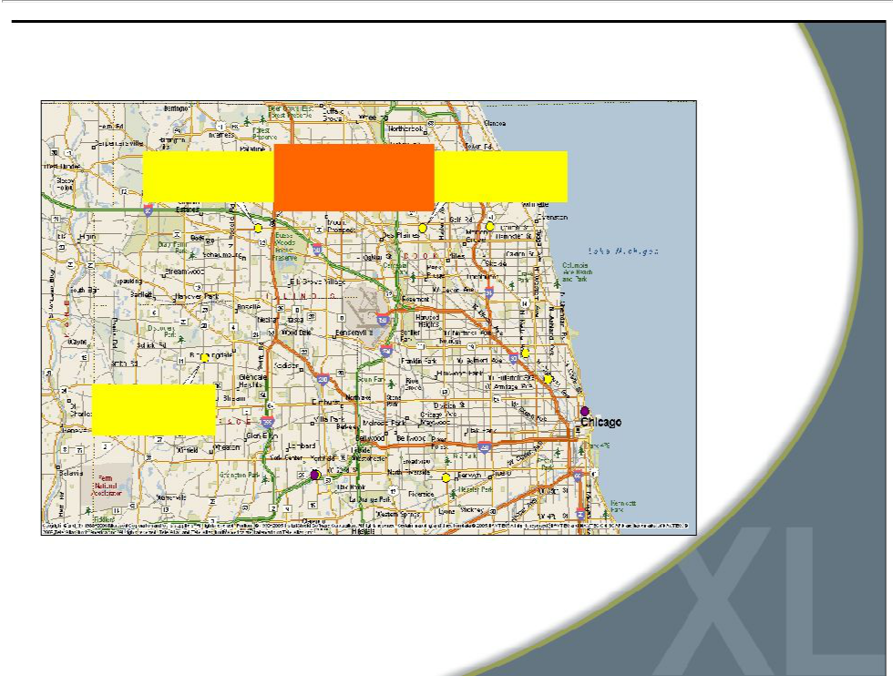
Chicago

9451 Schaumburg, ILDXL | 9183 Niles, IL
Schaumburg, IL | 11.4 miles
0.9 miles

9512 Bloomingdale, IL

11.2 miles

18

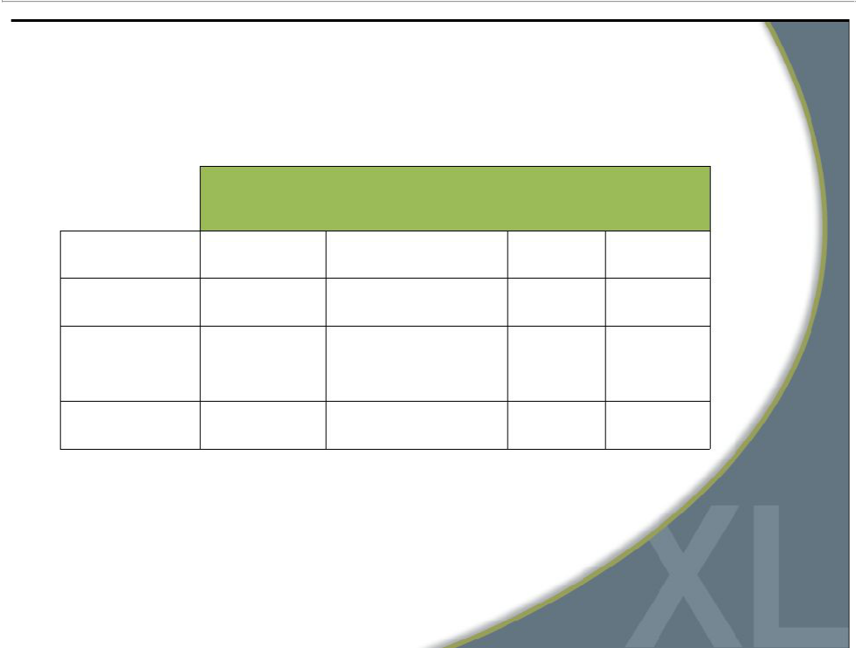
DXL Timeline2010-

Store Openings

Location

Size

Type

Store

ClosingsOpening

Schaumburg, IL 11,967 Sq Ft New store location

3 stores

Summer

Memphis, TN 9,758 Sq Ft Convert CM XL store 2 stores

Add 4,500 sq ft to

existing Rochester

Houston, TX 11,027 Sq Ft store and convert 2 stores

Summer

Summer

Las Vegas, NV 13,206 Sq Ft New store location 2 stores

Fall

19


DXL Multi Channel Solution

• DXL website launch first

quarter 2011

• Customer is able to

shop by concept, brand,

lifestyle or price point in

one simple, easy

location

www.destinationxl.com

20

Long-Term Margin Growth

- Long-term operating margin potential of 8%-12%

– Recover $70M in lost sales as economy improves

– Increase the amount spent by existing customers

– Appeal to the 42”-46”waist size market segment

– Grow the direct business to 30% of sales

21


Investment Highlights

- Dominant niche positioning

- Strong and growing market

- Clean balance sheet

- Positive free cash flow

- Long-term market share opportunities

- Accelerating financial returns

22

Financial Performance

23

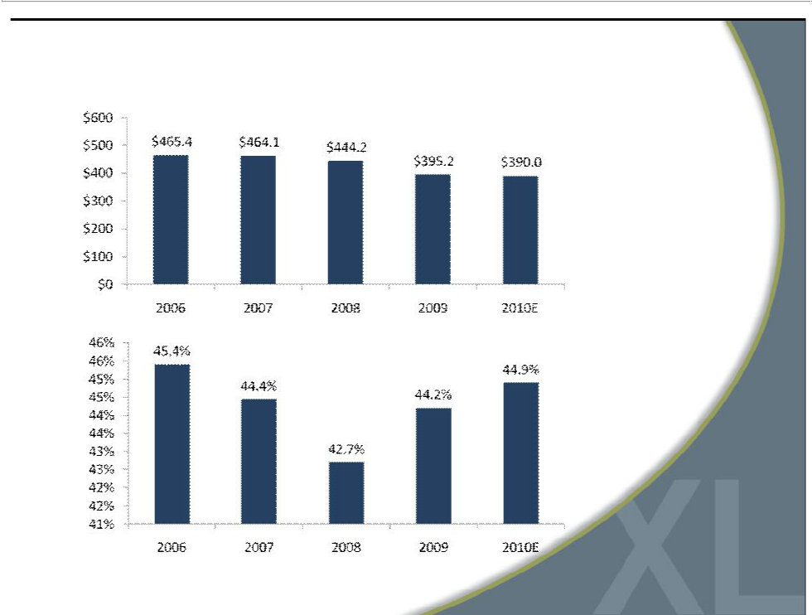
Sales and Gross Margin

(In millions)

24

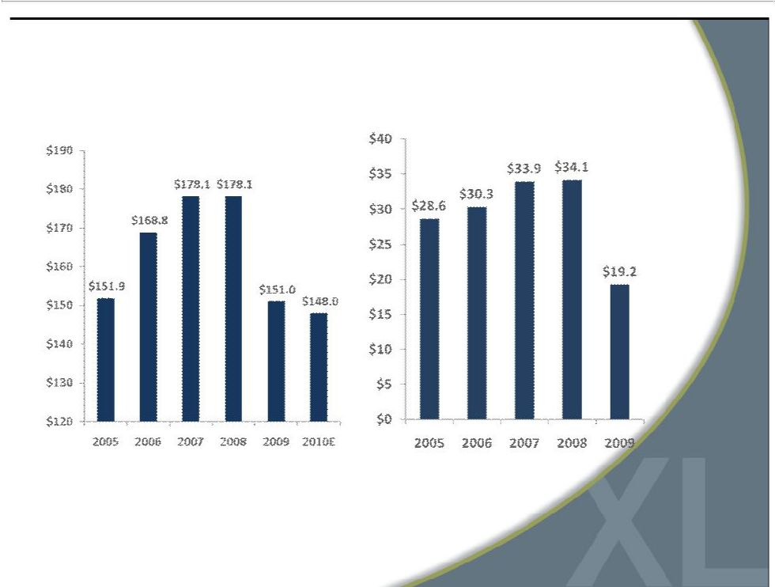
Expense Management

(In millions)

(In millions)

SG&A Marketing Expense

25

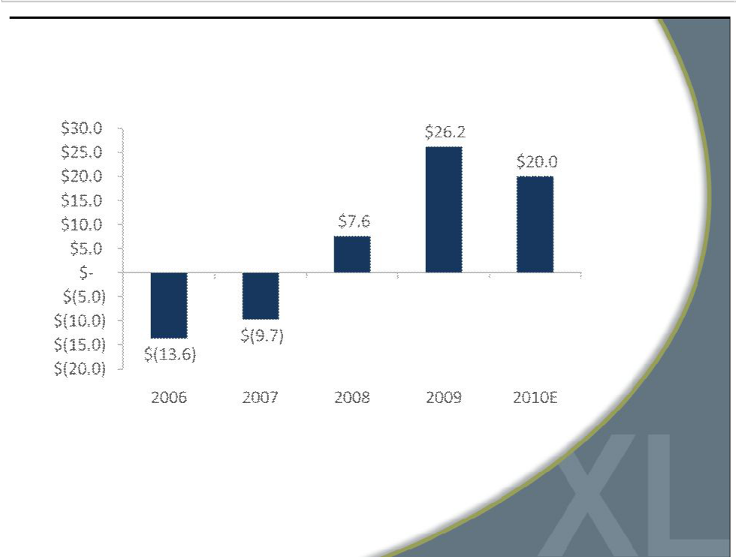
Free Cash Flow

Free cash flow is defined as cash flow from operating activities, less
capital expenditures and discretionary store asset acquisitions. | 26

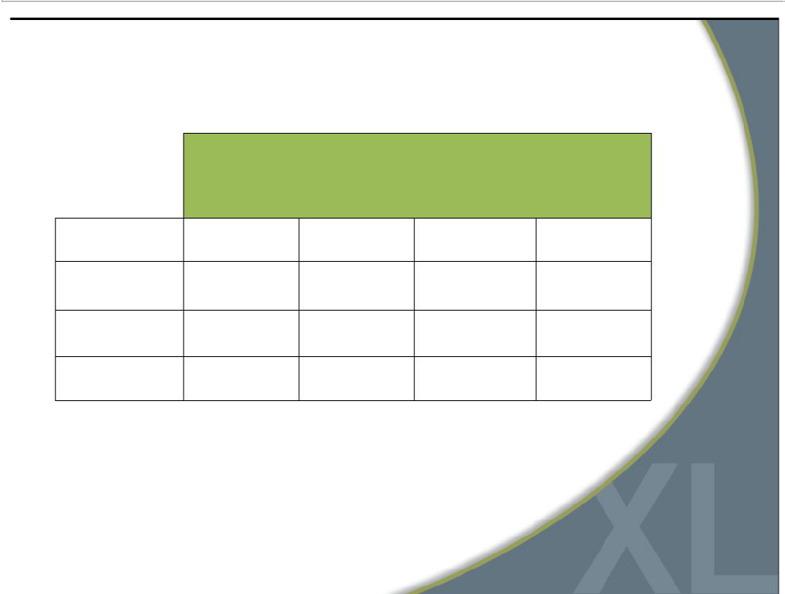
Balance Sheet

 | 2010
 | Projected
 | Year End | 2009 | 2008 | 2007
Inventory | $85.0M | $90.0M | $98.6M | $117.8M
Borrowing
under revolver | 0 | $3.5M | $38.7M | $41.0M
Cash on hand | $10-15M | 0 | 0 | 0
Fixed term loan | $3.0M | $7.6M | $12.5M | $17.3M

27

Strong Capital Structure to Support Growth

- Current $110M loan facility expires October 2011; $57.8M available at end of 2009

- Expect to be debt free in 2010 with credit availability approaching $70M

- Approximately $20M free cash flow expected to be generated in 2010 to reduce indebtedness and support growth

28



For additional information:

Jeffrey Unger

Casual Male Retail Group, Inc.

V. P. Investor Relations

561-482-9715 Office

561-543-9806 Cell

jeffunger@usa.net

jeffunger@tmo.blackberry.net

www.casualmalexl.com

www.destinationxl.com

29

