UNITED STATES

SECURITIES AND EXCHANGE COMMISSION
WASHINGTON, D.C. 20549

FORM 8-K

CURRENT REPORT

Pursuant to Section 13 or 15(d) of

The Securities Exchange Act of 1934

Date of Report (Date of earliest event reported): March 21, 2013

DESTINATION XL GROUP, INC.

(Exact Name of Registrant as Specified in its Charter)

Delaware

01-34219

04-2623104

(State or Other Jurisdiction

of Incorporation)

(Commission

File Number)

(I.R.S. Employer

Identification No.)

555 Turnpike Street, Canton, Massachusetts

02021

(Address of Principal Executive Offices)

(Zip Code)

(781) 828-9300

(Registrant’s telephone number, including area code)

Check the appropriate box below if the Form 8-K filing is intended to simultaneously satisfy the filing obligation of the registrant under any of the following provisions (see General Instruction A.2. below):

- Written communications pursuant to Rule 425 under the Securities Act (17 CFR 230.425)

- Soliciting material pursuant to Rule 14a-12 under the Exchange Act (17 CFR 240.14a-12)

- Pre-commencement communications pursuant to Rule 14d-2(b) under the Exchange Act (17 CFR 240.14d-2(b))

- Pre-commencement communications pursuant to Rule 13e-4(c) under the Exchange Act (17 CFR 240.13e-4(c))

Item 7.01 -Regulation FD Disclosure

Destination XL Group, Inc. (the “Company”) will be presenting a slide presentation to various investment groups at upcoming investor conferences. A copy of the slides to be presented at those conferences is attached to this report as Exhibit 99.1 and is incorporated by reference herein. A copy of the slides is available on the investor page of the Company’s website at http://investor.destinationxl.com.

The slide presentation contained in the exhibit includes statements intended as “forward-looking statements,” which are subject to the cautionary statement about forward-looking statements set forth in the exhibit. The slide presentation is being furnished, not filed, pursuant to Regulation FD. Accordingly, the slide presentation will not be incorporated by reference into any registration statement filed by the Company under the Securities Act of 1933, as amended, unless specifically identified therein as being incorporated therein by reference. The furnishing of the slide presentation is not intended to, and does not, constitute a determination or admission by the Company that the information in the slide presentation is material or complete, or that investors should consider this information before making an investment decision with respect to the Company.

Presentation of Non-GAAP Measures

The slide presentation includes the discussion of non-GAAP free cash flow on slide 24. Free cash flow is not a measure determined by generally accepted accounting principles (“GAAP”) and should not be considered superior to or as a substitute for net income (loss) or cash flows from operating activities or any other measure of performance derived in accordance with GAAP.

In addition, all companies do not calculate non-GAAP financial measures in the same manner and, accordingly, “free cash flows” as presented in this slide presentation may not be comparable to similar measures used by other companies. The Company calculates free cash flows as cash flow from operating activities less capital expenditures and discretionary store asset acquisitions, if any. We calculate projected free cash flows for fiscal 2016 of $60.0-$70.0 million as estimated cash flow from operating activities of $77.0-$87.0 million, less estimated capital expenditures of $17.0 million (no discretionary store asset acquisitions are anticipated in fiscal 2016). We believe that inclusion of this non-GAAP measure helps investors gain a better understanding of projected performance, especially when comparing such results to previous periods.

Item 9.01 Financial Statements and Exhibits.

- Exhibits

Exhibit

No. Description

99.1 Investor Slide Presentation dated March 2013

SIGNATURE

Pursuant to the requirements of the Securities Exchange Act of 1934, the Registrant has duly caused this report to be signed on its behalf by the undersigned hereunto duly authorized.

DESTINATION XL GROUP, INC.

Date: March 21, 2013 By: /s/ Dennis R. Hernreich

Name: | Dennis R. Hernreich
Title: | Executive Vice President and Chief Financial Officer


Exhibit 99.1

Destination XL Group, Inc. | 1


Safe Harbor

Certain information contained in this presentation, including, but not limited to, cash flows, operating margins, store counts, earnings expectations for fiscal 2012 and estimates through fiscal 2016, constitute forward-looking statements under the federal securities laws. The discussion of forward-looking information requires management of the Company to make certain estimates and assumptions regarding the Company's strategic direction and the effect of such plans on the Company's financial results. Such forward-looking statements are subject to various risks and uncertainties that could cause actual results to differ materially from those indicated.Suchrisksanduncertaintiesmayinclude,but arenot limitedto: the failureto

implement the Company's business plan for increased profitability and growth in the Company's retail stores sales and direct-to-consumer business, the failure to achieve improvementin the Company'scompetitiveposition,changesin or miscalculationof fashion trends, extreme or unseasonable weather conditions, economic downturns, a weakness in overallconsumerdemand,tradeandsecurityrestrictionsandpoliticalor financialinstabilityin countries where goods are manufactured, increases in raw material costs from inflation and other factors, the interruption of merchandise flow from the Company's distribution facility, competitive pressures, and the adverse effects of natural disasters, war, acts of terrorism or threatsof either,or other armedconflict,on the UnitedStatesandinternationaleconomies.

These, and other risks and uncertainties, are detailed in the Company's Annual Report on Form 10-K filed with the Securities and Exchange Commission for the fiscal year ended February 2, 2013 filed on March 15, 2013 and other Company filings with the Securities and Exchange
CommissionDestinationXLGroup,Inc..assumesno dutyto updateor reviseits forward-looking statements even if experience or future changes make it clear that any projected results expressed or implied therein will not be realized.

2

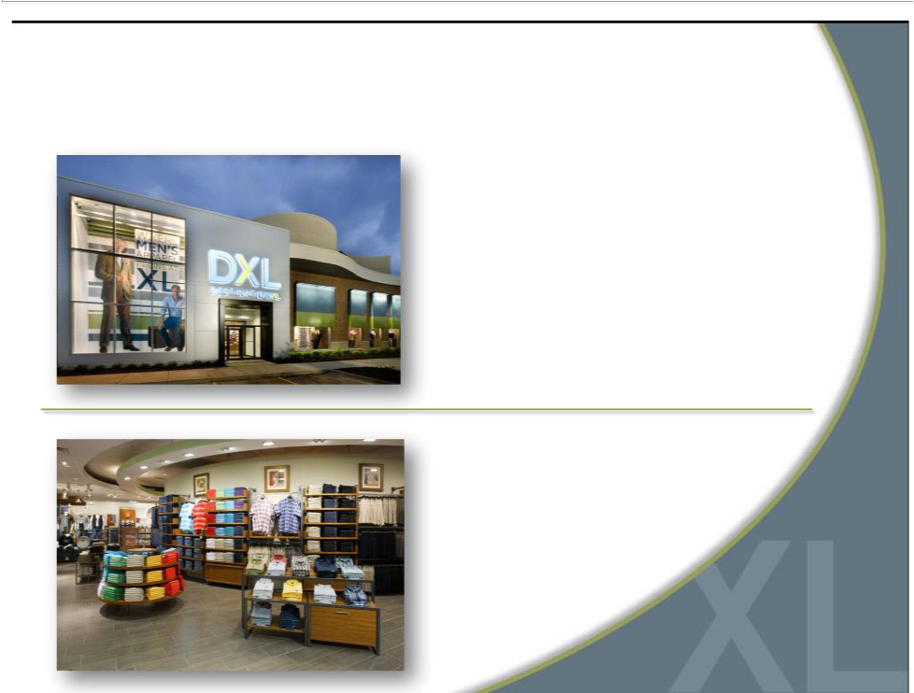
Who is Destination XL Group, Inc.?

Largest multi-channel specialty

retailer in niche men’s big and

tall (B&T) market

Offering unique blend

of wardrobe solutions

Private label & leading

apparel name brands

3

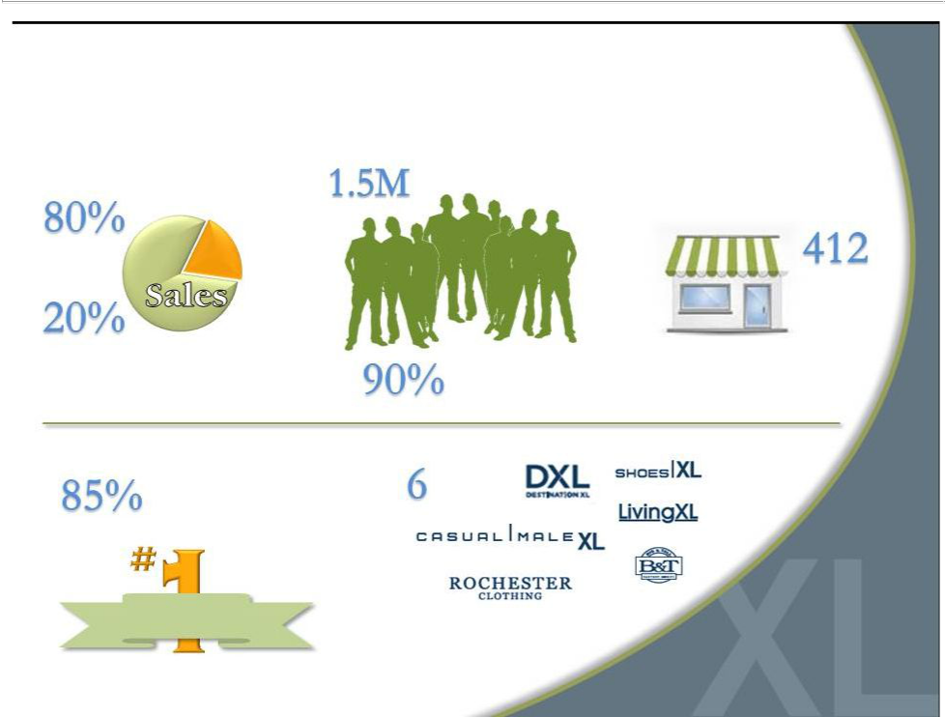
DXLG by the Numbers

Active customers

Retail

Retail Stores

Direct

Enrolled in loyalty program

Highest rated retailer
in 2011 CSI ^{Brands}

Customer Survey

Customer

Satisfaction

4

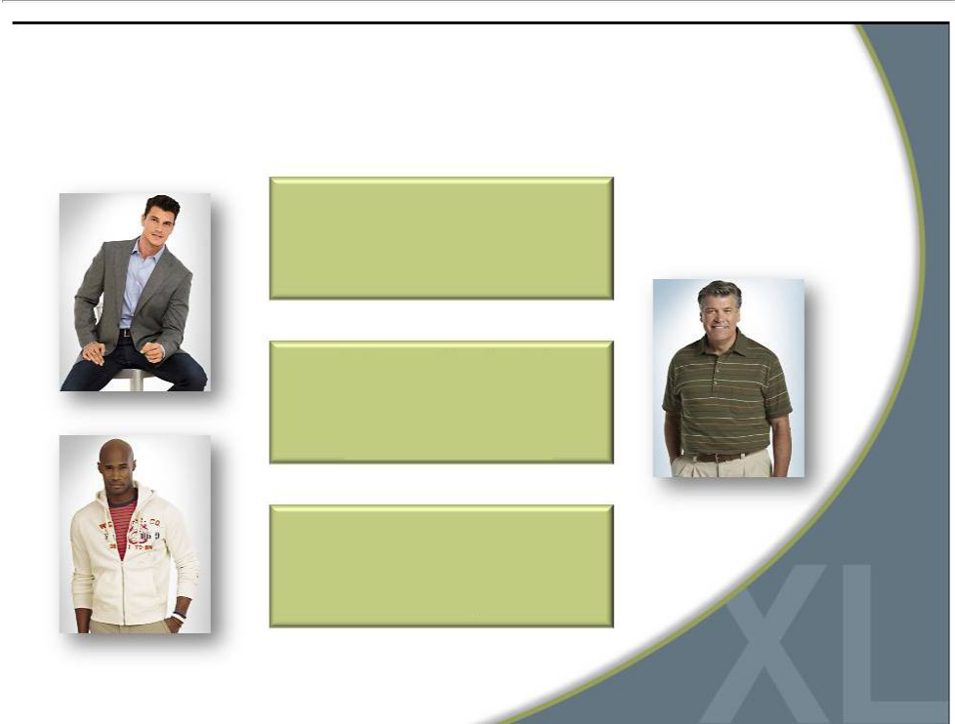
Who is Our Customer?

Males with a waist size 40”and

greater (40M men).

Determined by physical

characteristic, not demographic.

Not dependent on age, income,

race or nationality

Seeking greater selection in size.

Values convenience, selection

and fit over price.

5

Our Current Casual Male XL Stores
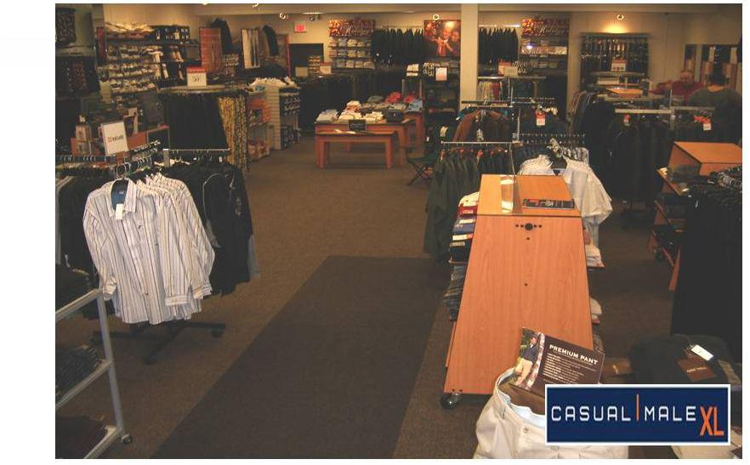

6

What Our Customer Wants

Large | More brand | On-site | Bright
changing | More brand | On-site | Bright
changing | selections | tailoring | atmosphere
rooms | selections | tailoring | atmosphere

Suggested | Wide aisles | One-stop
wardrobe | Wide aisles | shopping
solutions

7

Opened 4 DXL | Opened 32
concept stores | DXL stores

Opened 12 | Expect to Open
DXL stores | ~60 DXL stores

Opportunity for accelerated growth and profitability

8

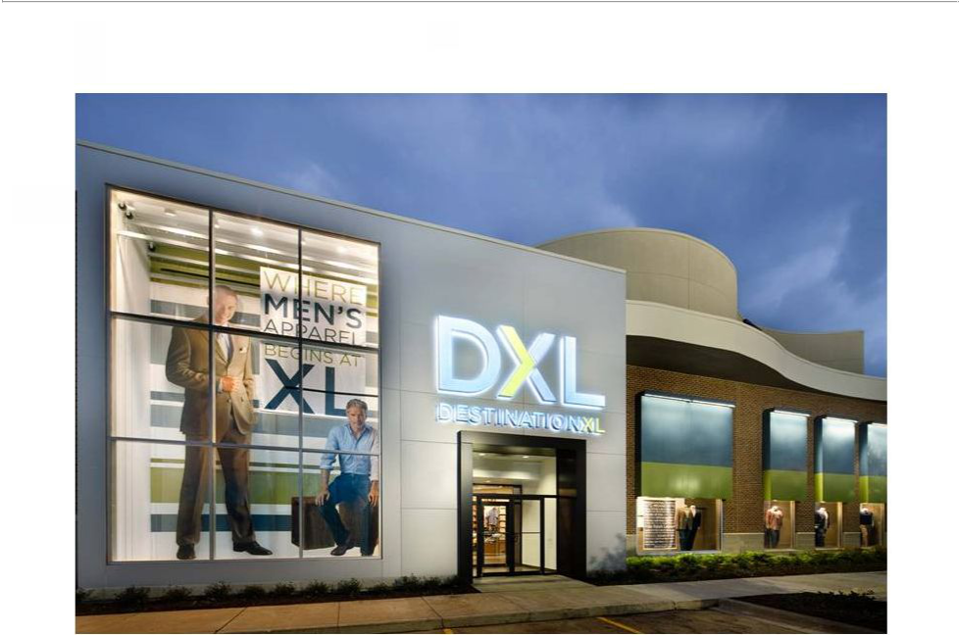
*

*

*

*

9

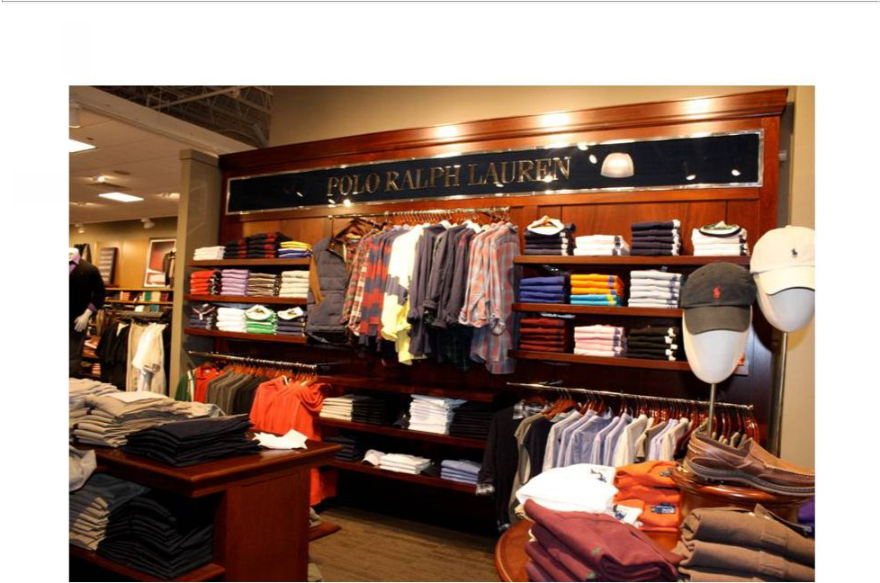

10

*

*

*

*
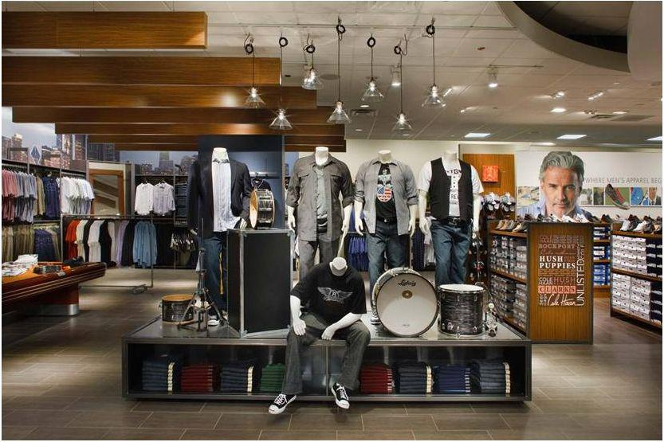

****

11

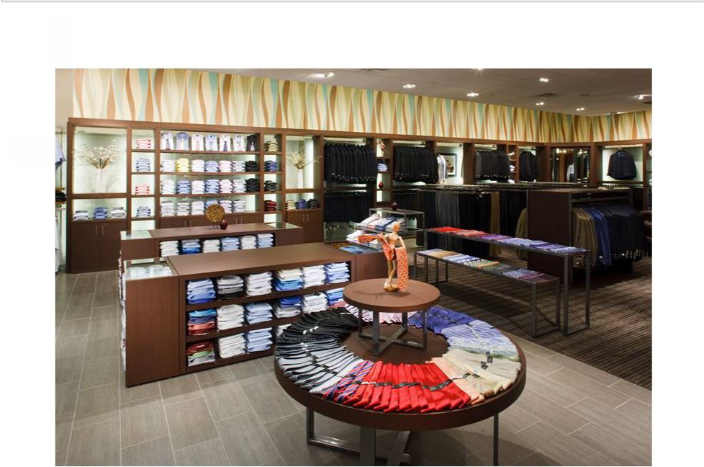
*

*

*

*

12

*
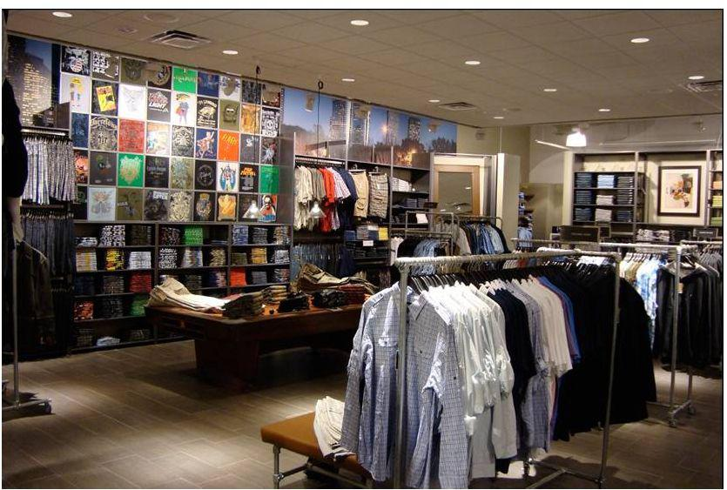

13

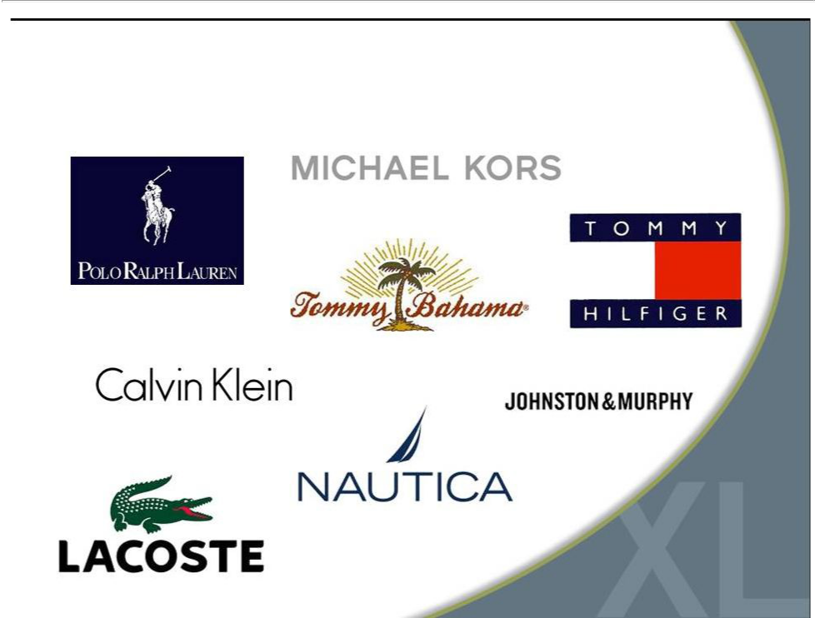
Large Selection of Name Brands

14

Average

Store size

Sales per sq. ft.

Build out costs

Occupancy costs

Dollars per

transaction

Style choices

Private label brands

Name brands

3,600 sq. ft. | 8,400 sq. ft.
$172 | $147 ($230 by 2016)
$50 | $70
$30 | $30
$97 | $137
600 | 2,000
10 | 15
8 | 30
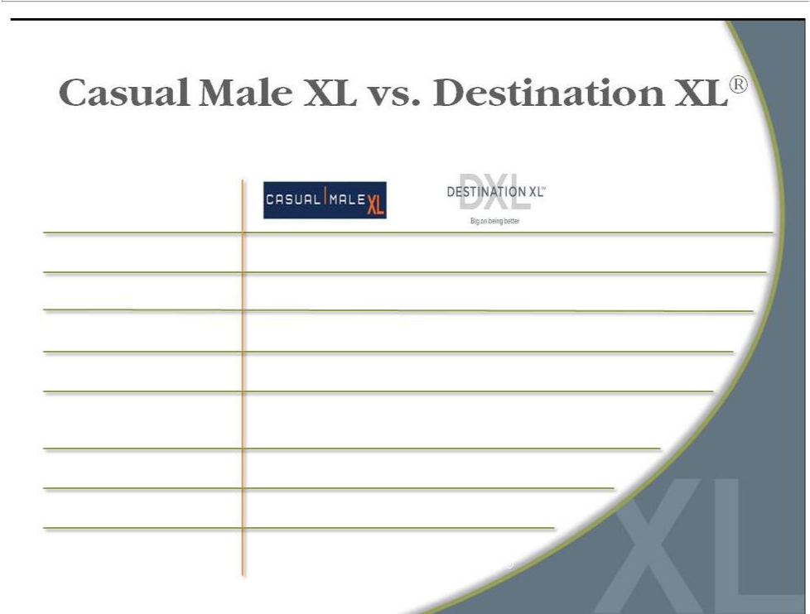

15

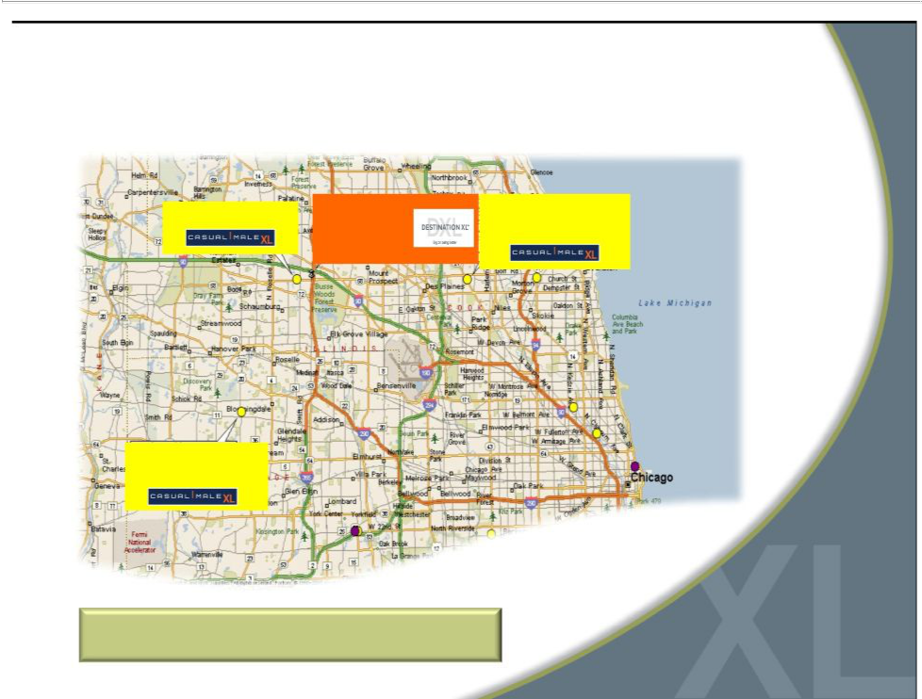
Market Consolidation to DXL

9451 Schaumburg, IL | DXL | 9183 Niles, IL
9451 Schaumburg, IL | Schaumburg, IL | 9183 Niles, IL
 | Schaumburg, IL | 11.4 miles
 | 0.9 miles | 11.4 miles

Chicago Metro

9512 Bloomingdale, IL

11.2 miles

Customers are willing to drive up to 20 miles

16

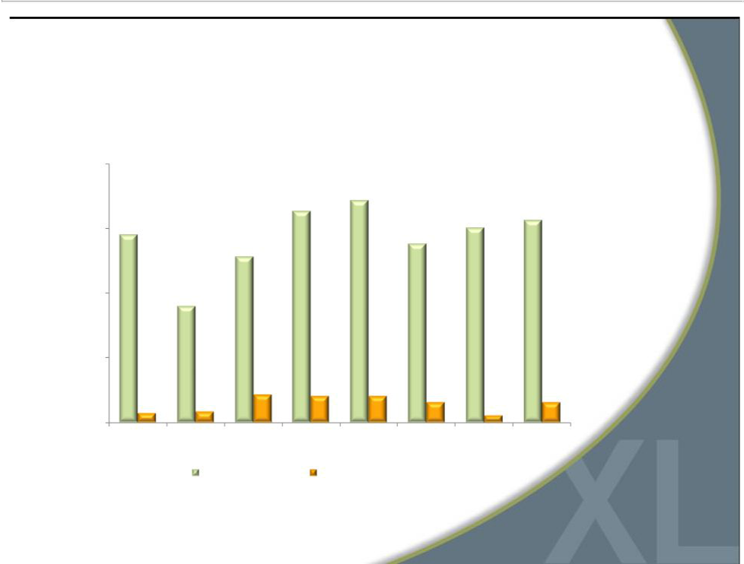
DXL Comps Reflect Growth Opportunity

20.0%
 |  | 16.3% | 17.1%
 |  | 16.3% | 15.0%* | 15.6%
 | 14.5% |  | 15.0%* | 15.6%
15.0% | 14.5% |  | 15.0%*
15.0% | 14.5% |  | 13.8%
 |  | 12.8% | 13.8%
10.0% |  | 9.0%

5.0%
 | 2.1% | 2.0% | 2.0% | 1.5% | 1.5%
0.7% | 0.8% |  |  | 1.5% | 1.5%
0.7% | 0.8% |  |  |  | 0.5%
0.0%
Q3 2011 | Q4 2011 FY 2011 Q1 2012 |  | Q2 2012 Q3 2012 |  | Q4 2012 FY 2012
 | DXL Comparables | Total DXLG Comparables**
* The 16 DXL stores opened for more than 1 year produced a 7.6% comp in Q4 2012
** Total DXLG Comparables consist of all stores, including DXL stores and
direct channel |  |  |  |  | 17

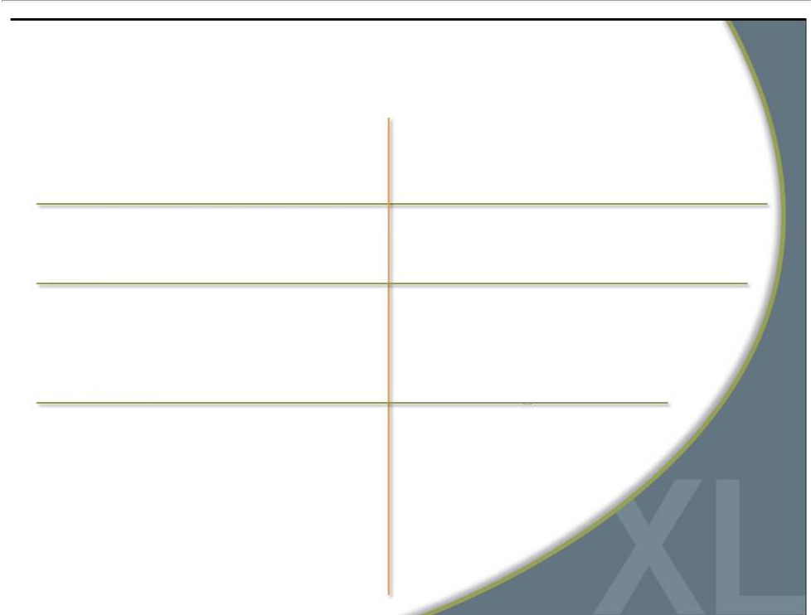
Compelling DXL Returns

Expect greater store productivity

and profitability

Projecting higher 4-wall profits than combined profits of individual stores

Potential to capture additional market share

Opportunity to improve operating margins

Better leveraging of expenses -- occupancy, labor productivity and local/district management

Targeting between 25%-30% store operating margin

Attract new customers

Better cross-selling environment to capture greater share of apparel wallet from existing customers

Expect to increase margins significantly after the transition to DXL is complete

18

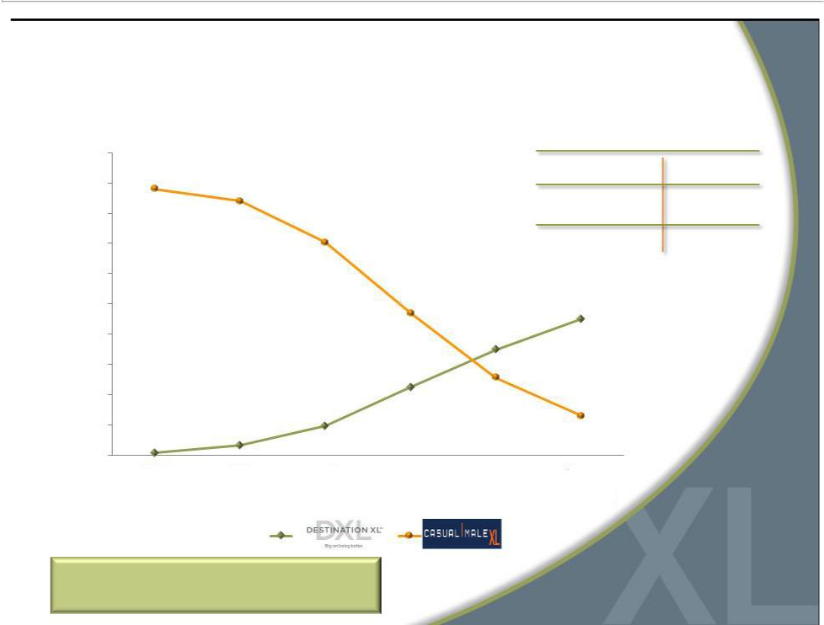
Accelerated DXL Openings

500 |  |  |  |  |  | 2015 Store Count Target
500 |  |  |  |  | Destination XL® |  | 215-230
450 |  |  |  |  |  |  | 215-230
450 |  |  |  |  |  | Casual Male XL
400 |  |  |  |  |  | Casual Male XL | ~60
400 |  |  |  |  |  | Outlet | ~60
350 |  |  |  |  | Rochester Clothing |  | 3-4
300
250
200
150
100
50
0
 | 2010 | 2011 | 2012 | 2013 | 2014 | 2015
Total Stores: | (460) | (450) | (412) | (348-358) | (308-318) | (283-298)

Accelerated rollout based on
success of DXL stores in 2011 | 19

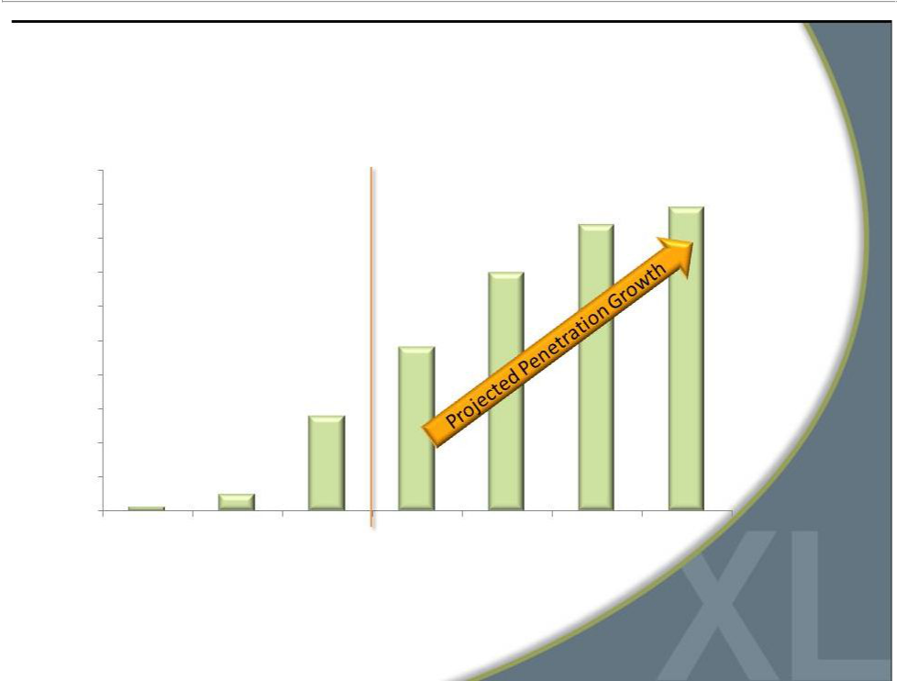
DXL Sales Increase as % of Total Revenue

100%

89%
90% |  |  |  |  | 84%
80%
70% |  |  |  | 70%
60%
50% |  |  | 48%
40%
30% |  | 28%
20%
10% | 5%
1%
0%
2010 | 2011 | 2012 | 2013 | 2014 | 2015 | 2016

* DXL sales include direct sales via the DestinationXL.com website. | 20

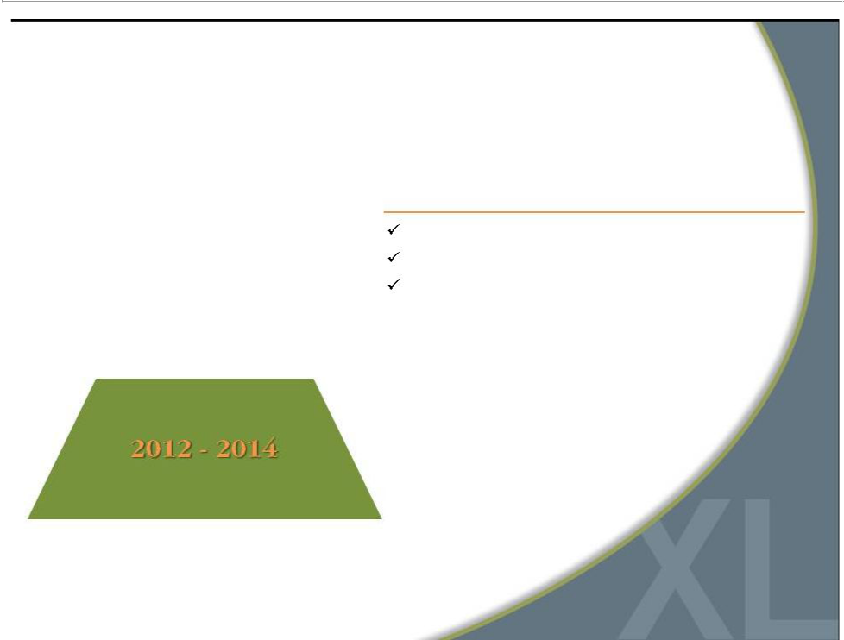
Accelerated Rollout of DXL

2012

Opened 32 DXL stores / Closed 70 stores

Operating margins were approximately3.5%

CapEx was $32.4M

21

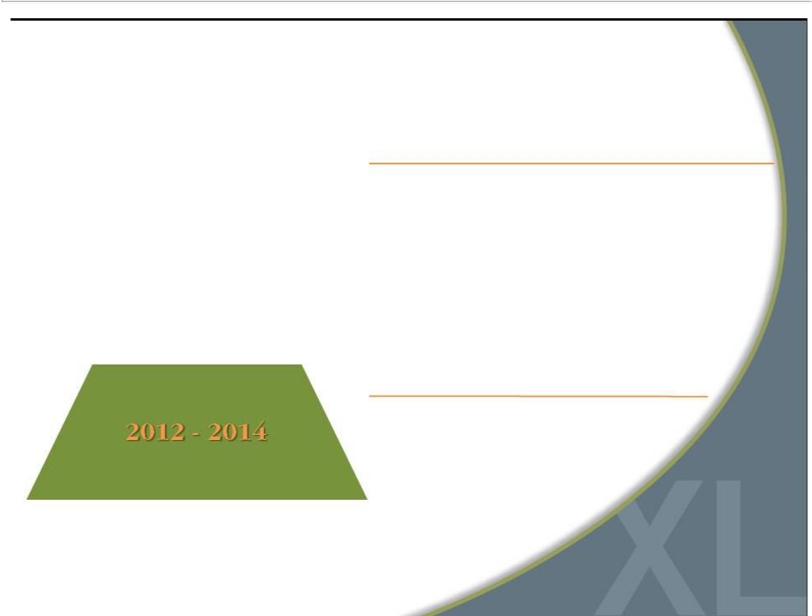
Accelerated Rollout of DXL

2013

Open 57- 64 DXL stores / Close 110-119 stores

Salesof $415 - $420M

Expected borrowing levelof $10 - $15M at year end

Commence new marketing strategywith incremental $10M spend

Leaseexit and asset impairment charges in the range
of $3-$4M ¹

Operating margins of ~ breakeven to 0.5%

CapEx expected to peak at $45M ²

- Net of subleases

- Net of expected tenant allowances

2014

Open 60 DXL stores / Close 99 stores

Annualsalesgrowth of ~ 10% - 15%

Expected borrowing levelof $10 - $15M
at yearend

Leaseexit and asset impairment | 1
chargesin the range of $3-$4M | 1
Operating margins of ~4%
CapEx expected to
be $40M | 22

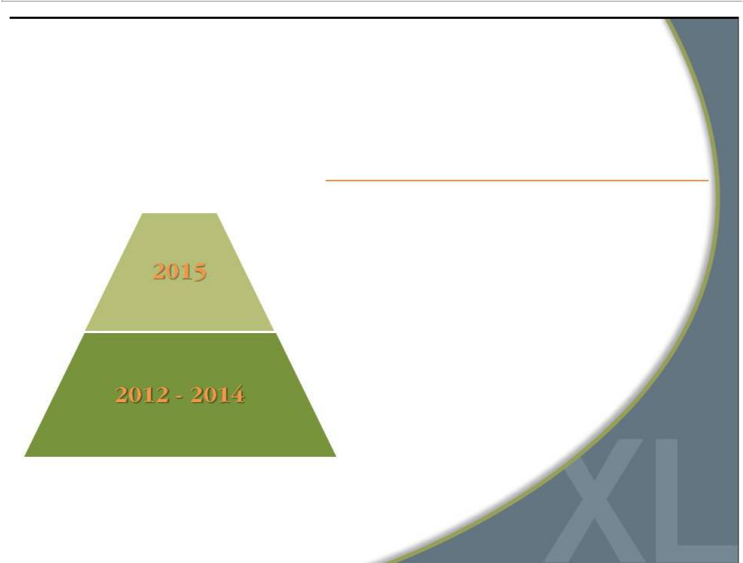
Accelerated Rollout of DXL

2015

Complete rollout with 215 - 230 opened DXL stores and

Closure of remaining 63 Casual Male XL anchor stores

Annual sales growth of ~10% – 15%

Operating margins gain traction and increase to ~8%

(from 4.2% in ‘11)

Expected ending cash balance of $5 - $10M

CapEx expected to be approximately $38M²

Lease exit and asset impairment charges in the range

of $2-$3M¹

1 | Net of subleases | 23
2 | Net of expected tenant allowances | 23

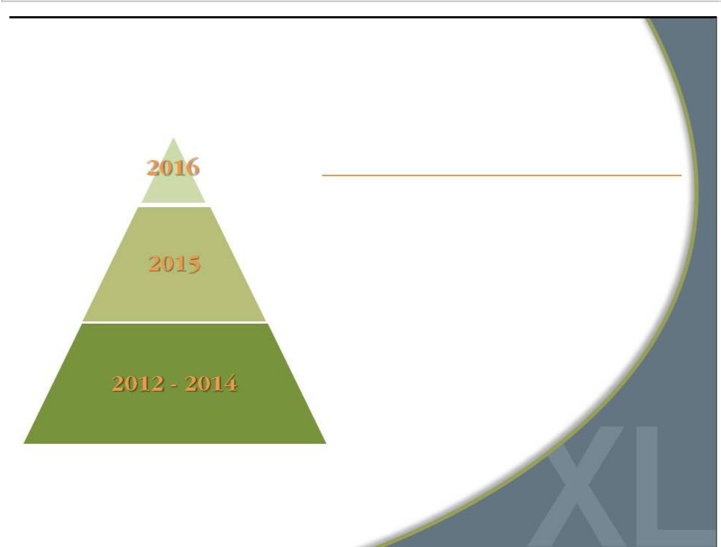
Accelerated Rollout of DXL

2016

Fullbenefit of DXL conceptdrives revenue>$600M

Open averageof 10 DXL stores per year

Operatingmargins>10%

Generating freecash flowin the rangeof $60 - $70M

24

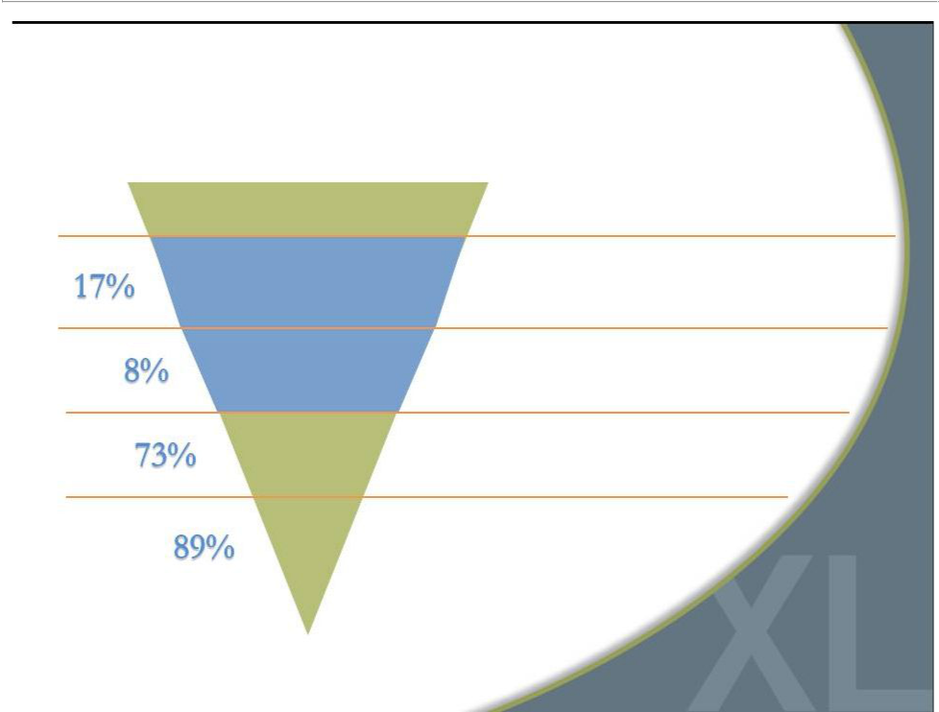
Increased Awareness = Opportunity

DXL Customer Purchase Funnel*

Addressable Population

Aware of DXL

Visiting DXL

Purchasing

from DXL

Repeat

DXL’s addressablemarket is primarilymen with over 40” waist

Awareness of DXL is low across its markets, directly impacting ability to attract new customers

Of those aware of DXL, only 8% are visiting the store

73% of those that visit the store make a purchase

89% of those that make a purchase

intend to return

*Based on consumers’stated responses per L.E.K’s survey within DXL markets | 25
Source: L.E.K analysis | 25

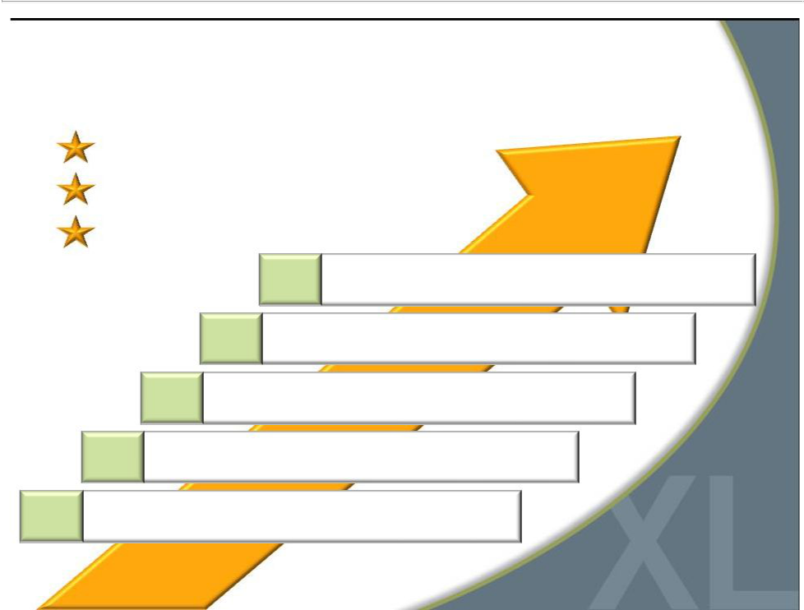
Opportunity to Grow Market Share

Addressable Market = 40M Customers

1.5M Currently Active Customers

Goal = Grow Customers by 40% Over 3 Years

Capture greater wallet share with DXL concept

Attract a broader customer audience with one-stop-shop

Target “end-of-rack” customers

Paradigm shift in marketing improves awareness

Grow direct business with new website

26

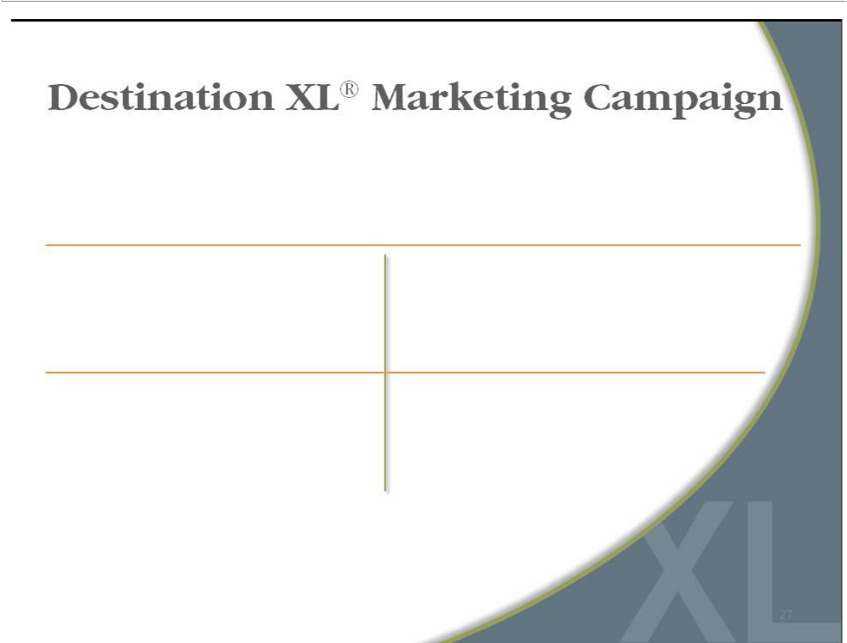

Launched test campaign in 5 markets:

Memphis, Minneapolis, Denver, Atlanta and Oklahoma City

Increased awareness by 100%

in new markets & 38% in established markets

Built Stronger Brand

to Attract and Serve

Customers

“End-of-rack” customer base grew by 38%

Results Demonstrate

Ability to Grow

Market Share

27

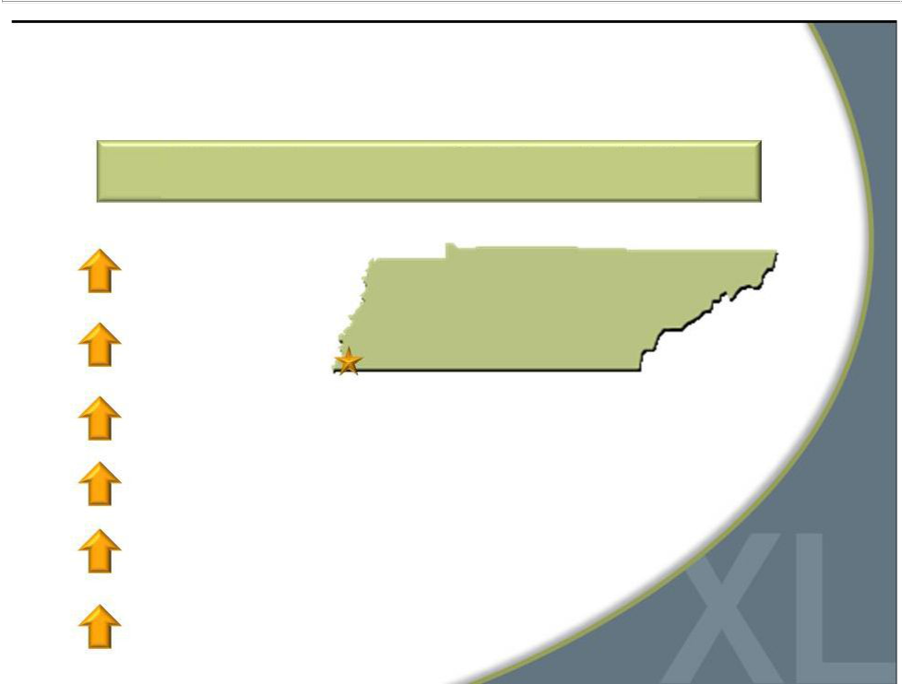
Established Effective Marketing Mix

6-Week Test Demonstrated TV, Radio and Digital is Most Effective Marketing Combination

15% sales | Established Market
 | Memphis DXL Opened in 2010
24% traffic

64% new customer purchases

38% market awareness

84% web traffic

7% web sales
28

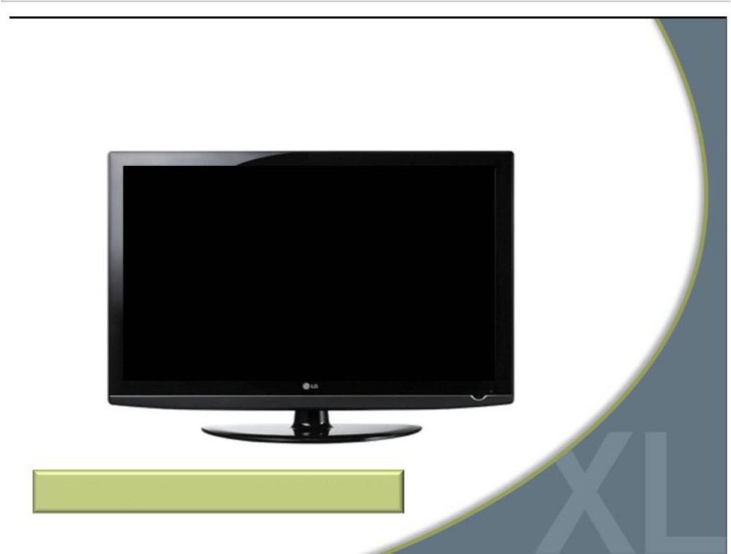
DXL Test TV Commercial

Marketing to Customers in “No Man’s Land”

29

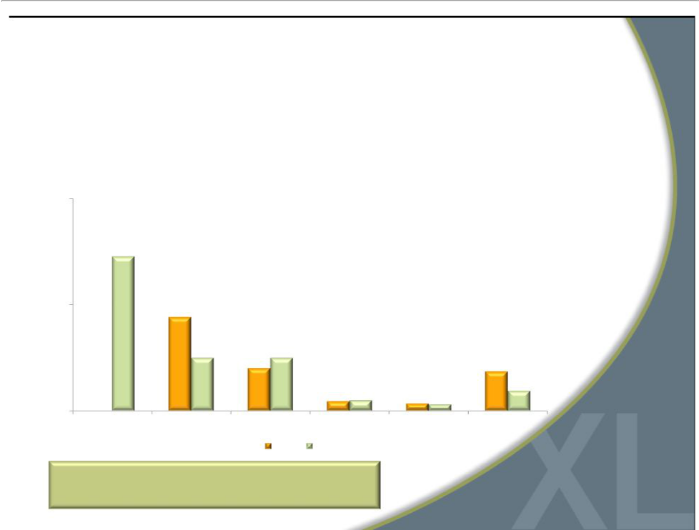
2013 Marketing Spend

- Increase marketing spend as percent of sales from 4.6% to 6.7%

- Launch national DXL Media marketing campaign in spring 2013

$M

20

10

0

DXL Media Direct Digital Visual Loyalty Other

2012 2013

Total 50% Increase YOY
to Drive DXL Awareness

30



Financial Performance

31


Q4 2012 Results

•

•

•

•

•

Comparable sales increased 0.5% and total sales were $114.9M

DXL stores represented 18% of comparable retail sales

Comp sales for Casual Male XL stores decreased 2.3%

U.S. direct e-commerce sales increased 13%

Income from continuing operations was $4.2 million, or $0.09 per diluted share

32

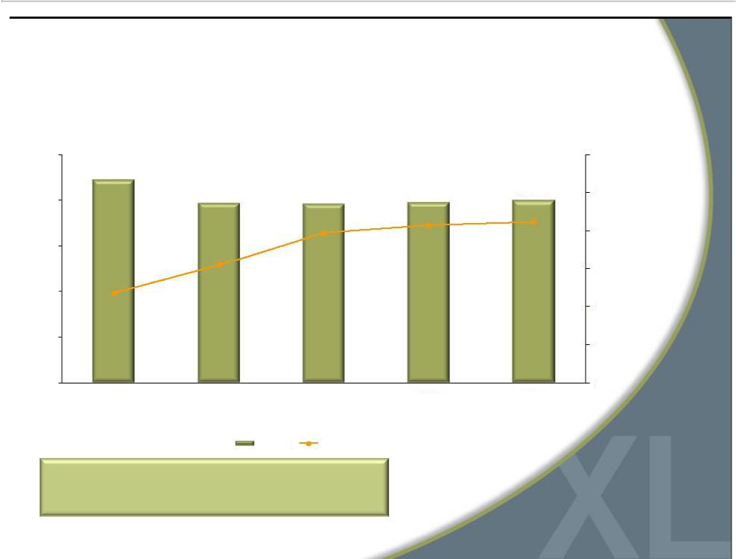
Sales and Gross Margin

Revenue ($ mm)
$500
$443.9
$400 | $393.9 | $392.0 | $395.9 | $399.6
$400 |  |  | 46.3% | 46.5%
 |  | 45.9% | 46.3% | 46.5%

$300 | 44.2%
$200 | 42.7%
$100

$0

2008 | 2009 | 2010 | 2011 | 2012
 | Revenue | Gross Margin

Strong gross margins provide opportunity for

significant sales leverage

50%

48%

46%

44%

42%

40%

38%

33

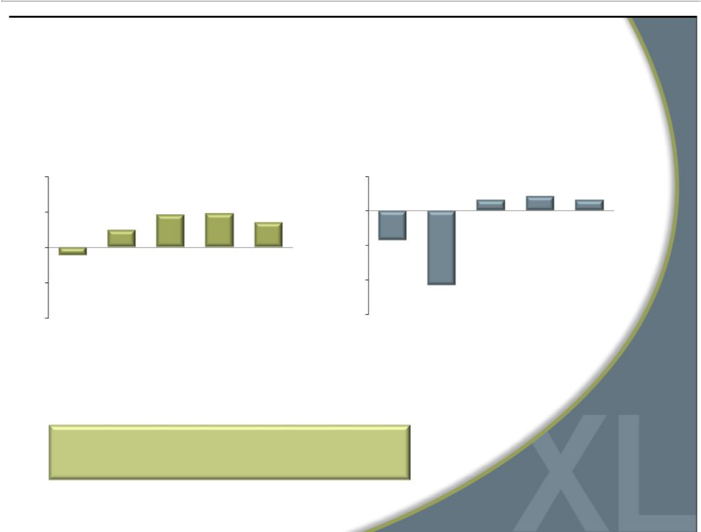
Operating Margin & Comparable Sales

(continuing operations)

CMRG Annual Historic Operating Margin |  |  |  | CMRG Historical Annual Comp Sales
10% |  |  | 5% | 1.5% | 2.1% | 1.5%
5% | 4.6% | 4.7% | 0%
2.4% |  | 3.5%
0% |  |  | (5%) | (4.3)%
(1.1)% |  | (10%)
(5%)
 |  | (15%) |  | (10.8)%
(10%)
2008 2009 | 2010 | 2011* 2012 |  | 2008 20092010 | 2011 2012

* Before impairment charge of $23.1m

Focus on improving operating margins

through greater DXL sales

34

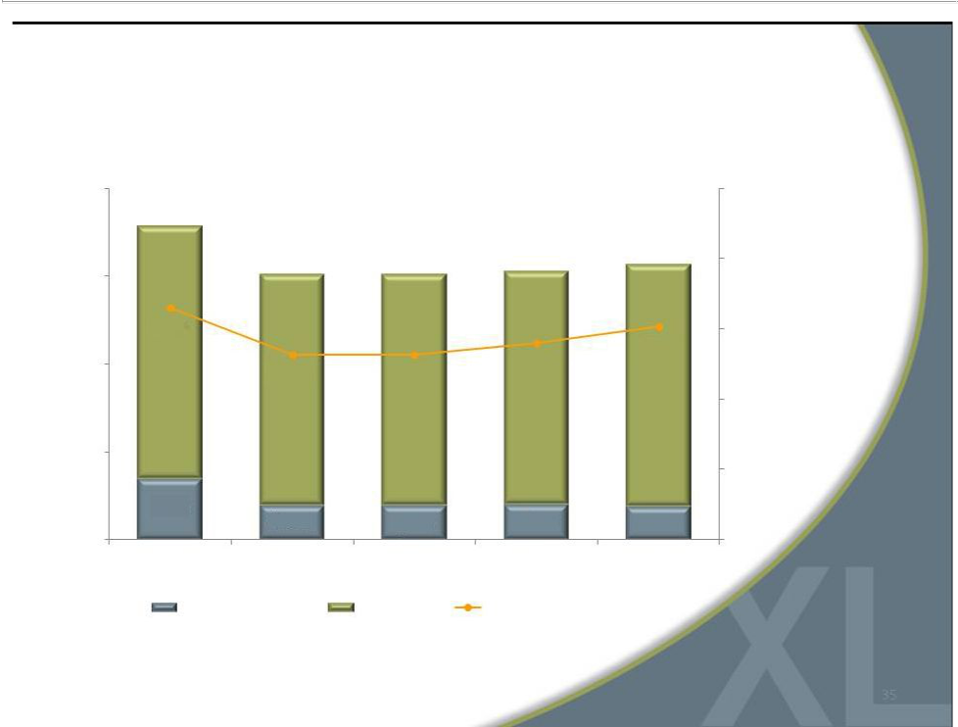
Strict Expense Management

($ mm)

$200

$177.3
 | $149.2 | $148.4 | $152.0 | $156.4
$150 | $149.2 | $148.4 | $152.0
39.9%
$100 |  |  | 38.4% | 39.1%
$100 | 37.9% | 37.9% | 38.4%
$50
$34.1 | $19.1 | $19.0 | $19.6 | $18.5
$0
2008 | 2009 | 2010 | 2011 | 2012
Marketing Expense |  | Total SG&A | SG&A as a Percentage of Sales

45%

42%

39%

36%

33%

30%

35

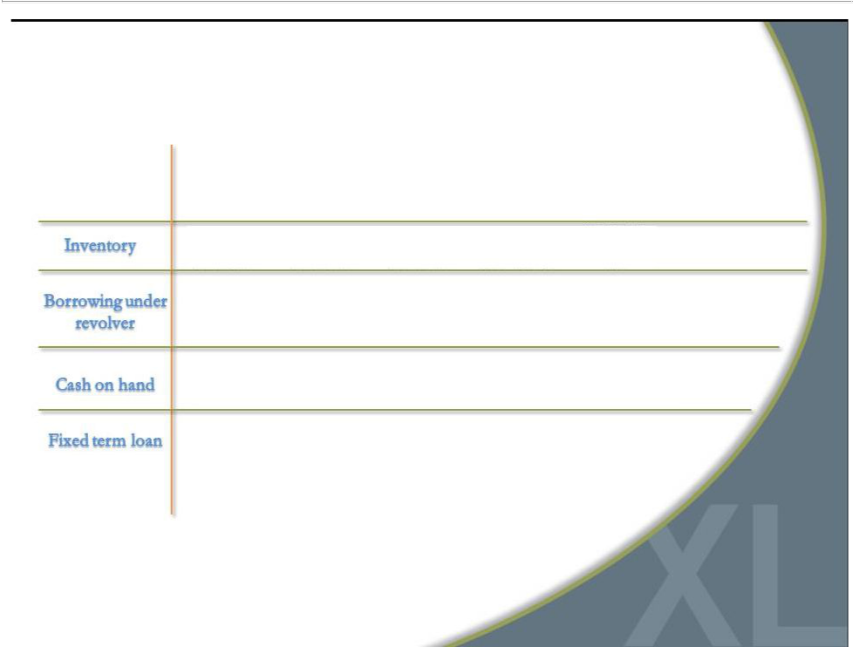
Strong Debt-Free Balance Sheet

2008 | 2009 | 2010 | 2011 | 2012
$98.6M | $90.0M | $92.9M | $104.2M | $104.2M
$38.7M | $3.5M | $0 | $0 | $0
$5.0 | $4.3 | $4.1M | $10.4M | $8.2M
$12.5M | $7.6M | $0 | $0 | $0

36

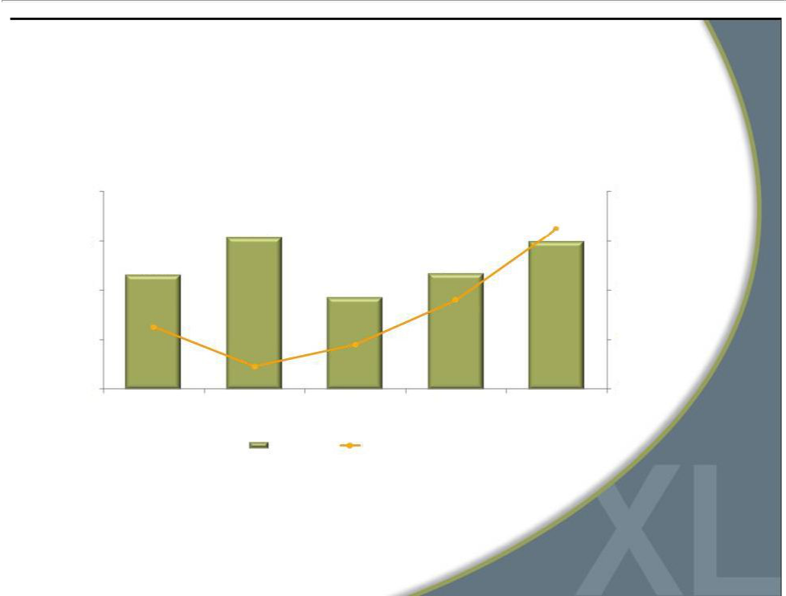
Cash Flow and Capital Expenditures

 | ($ mm)
$40 |  |  |  |  | $40
 | $30.8 |  |  | $32.4
$30 | $30.8 |  |  | $29.9 | $30
$23.2 |  |  | $23.4
$20 |  | $7.6 |  |  | $20
$12.6 |  |  | $18.0
$10 | $4.6 | $9.0 |  |  | $10
$0 |  |  |  |  | $0
2008 | 2009 | 2010 | 2011 | 2012
 | Cash Flow | CAPEX

37


Why Invest in DXLG?

Accelerated conversion to DXL concept creates compelling investment opportunity

Strong gross margins; Ability to greatly improve operating margins

Significant market share/sales growth opportunity

Leader in large and growing

B&T market

Three-year $150M investment in DXL rollout to be funded primarily by free cash flow and deferred tax benefits

Strong balance sheet

with borrowing capacity

38



For additional information:

Jeffrey Unger

Destination XL Group, Inc.

V. P. Investor Relations

561-482-9715 Office

561-543-9806 Cell

jeffunger@usa.net

www.destinationxl.com

39

