UNITED STATES

SECURITIES AND EXCHANGE COMMISSION
Washington, D.C. 20549

FORM 8-K

CURRENT REPORT

PURSUANT TO SECTION 13 OR 15(d) OF THE

SECURITIES EXCHANGE ACT OF 1934

Date of Report (Date of earliest event reported): April 14, 2010

01-34219

(Commission File Number)

CASUAL MALE RETAIL GROUP, INC.

 | (Exact name of registrant as specified in its charter)
Delaware | 04-2623104
(State of Incorporation) |  |  | (IRS Employer Identification Number)
 | 555 Turnpike Street, Canton, Massachusetts 02021
 | (Address of registrant’s principal executive office)
 | (781) 828-9300
 |  | (Registrant’s telephone number)

Check the appropriate box below if the Form 8-K filing is intended to simultaneously satisfy the filing obligation of the registrant under any of the following provisions (see General Instruction A.2. below):

- Written communications pursuant to Rule 425 under the Securities Act (17 CFR 230.425)

- Soliciting material pursuant to Rule 14a-12 under the Exchange Act (17 CFR 240.14a-12)

- Pre-commencement communications pursuant to Rule 14d-2(b) under the Exchange Act(17 CFR 240.14d-2(b))

- Pre-commencement communications pursuant to Rule 13e-4(c) under the Exchange Act(17 CFR 240.13e-4(c))

ITEM 7.01 - Regulation FD Disclosure

The Company has updated its investor slide presentation as filed via Form 8-K on January 11, 2010 to include four slides which have been updated to reflect actual results for fiscal 2009 and projected financial results for fiscal 2010. In addition, the Company has added a new slide discussing its projected Destination XL store openings for fiscal 2010. A copy of each new slide is attached to this report as Exhibit 99.1, and is incorporated by reference herein. The updated slide presentation will be presented at upcoming meetings with various investment groups.

The slide presentation contained in the exhibit includes statements intended as “forward-looking statements,” which are subject to the cautionary statement about forward-looking statements set forth in the exhibit. The slide presentation is being furnished, not filed, pursuant to Regulation FD. Accordingly, the slide presentation will not be incorporated by reference into any registration statement filed by the Company under the Securities Act of 1933, as amended, unless specifically identified therein as being incorporated therein by reference. The furnishing of the slide presentation is not intended to, and does not, constitute a determination or admission by the Company that the information in the slide presentation is material or complete, or that investors should consider this information before making an investment decision with respect to the Company.

Presentation of Non-GAAP Measures

The slide presentation includes the discussion of non-GAAP free cash flow on slide 4. Free cash flow is not a measure determined by generally accepted accounting principles (“GAAP”) and should not be considered superior to or as a substitute for net income (loss) or cash flows from operating activities or any other measure of performance derived in accordance with GAAP.

In addition, all companies do not calculate non-GAAP financial measures in the same manner and, accordingly, “free cash flows” as presented in this slide presentation may not be comparable to similar measures used by other companies. The Company calculates free cash flows as cash flow from operating activities less capital expenditures and discretionary store asset acquisitions, if any. We calculate projected free cash flows for fiscal 2010 of $20.0 million as estimated cash flow from operating activities of $30.0 million, less estimated capital expenditures of $10.0 million (no discretionary store asset acquisitions are anticipated in fiscal 2010). Free cash flow for fiscal 2009 of $26.2 million was calculated as cash flow from operating activities of $30.8 million less capital expenditures of $4.6 million. There were no discretionary store asset acquisitions in fiscal 2009. Free cash flow for fiscal 2008 of $7.6 million was calculated as cash flow from operating activities of $23.2 million less capital expenditures of $12.6 million and less $3.0 million for discretionary store asset acquisitions. Free cash flow for fiscal 2007 of $(9.6) million was calculated as cash flow from operating activities of $11.7 million less capital expenditures of $21.3 million. There were no discretionary store asset acquisitions in fiscal 2007. During the second quarter of fiscal 2009, we changed our method of calculating free cash flow to include, as a deduction, the use of cash for discretionary store asset acquisitions, if any. Accordingly, free cash flow for fiscal 2008, which was previously defined as cash flow from operating activities less capital expenditures, was restated to include, as a deduction, the cash used for discretionary store asset acquisitions of $3.0 million, for the Company’s acquisition of Dahle Big & Tall stores.

We believe that inclusion of this non-GAAP measure helps investors gain a better understanding of our performance, especially when comparing such results to previous periods

ITEM 9.01 - FINANCIAL STATEMENTS AND EXHIBITS

(d) Exhibits

Exhibit

No. Description

99.1 New Slides to Investor Presentation.

SIGNATURES

Pursuant to the requirements of the Securities Exchange Act of 1934, the registrant has duly caused this report to be signed on its behalf by the undersigned, thereunto duly authorized.

CASUAL MALE RETAIL GROUP, INC.

By: | /s/ DENNIS R. HERNREICH
Name: | Dennis R. Hernreich
Title: | Executive Vice President and Chief Financial Officer

Date: April 14, 2010

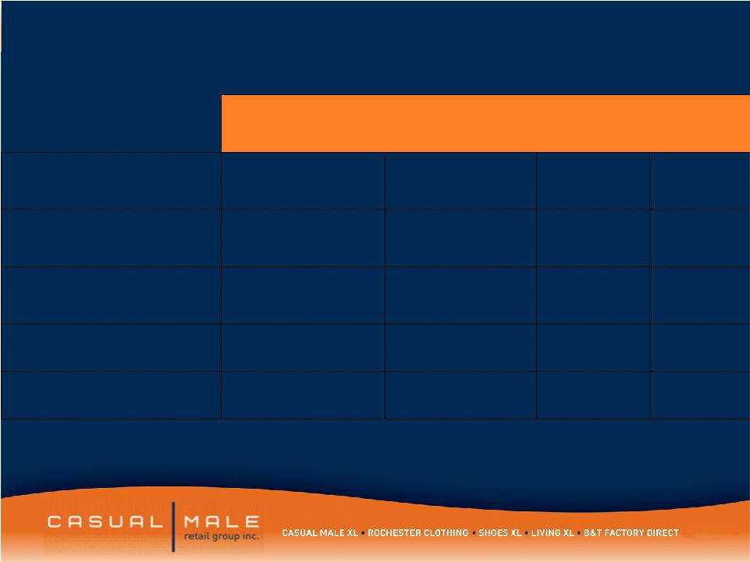
Exhibit 99.1

Selected Income Statement Information

 | 2010 Projected | 2009 | 2008 | 2007
 | Year End | 2009 | 2008 | 2007
Sales | $385-$395m | $395.2m | $444.2m | $464.1m
SG&A | $148m | $151.1m | $178.1m | $178.1m
Gross Margin | 44.6%-45.2% | 44.2% | 42.7% | 44.4%
Interest Expense | $.5m | $1.1m | $3.0m | $4.3m
Free Cash Flow | $20m | $26.2m | $7.6m | $-9.6m

- Free Cash Flow is defined as cash flow from operating activities, less capital expenditures and discretionary store asset acquisitions.

4

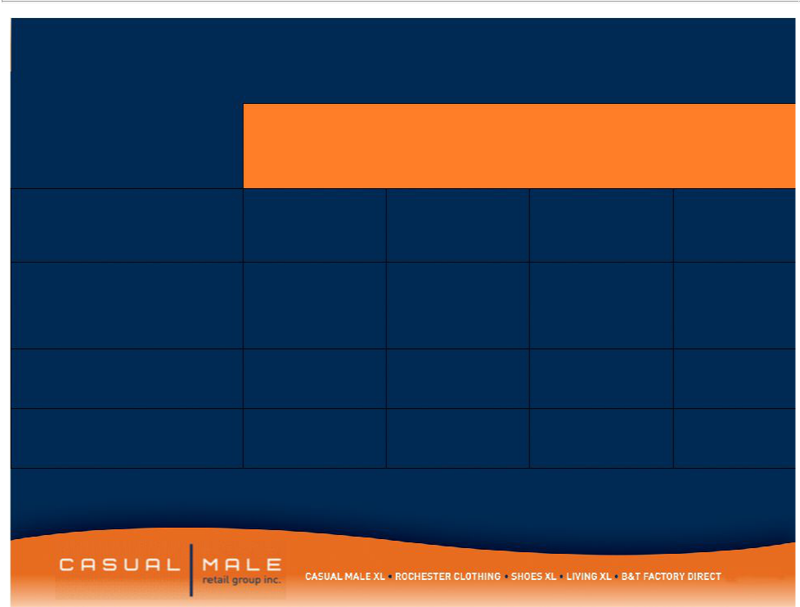
Selected Balance Sheet Information

2010
Projected
Year End | 2009 | 2008 | 2007

Inventory | $85.0 m | $90.0m | $98.6m | $117.8m
Borrowing Under
Revolver | 0 | $3.5m | $38.7m | $41.0m
Cash on Hand | $10-15m | 0 | 0 | 0
Fixed Term Loan | $3.0m | $7.6m | $12.5m | $17.3m

- Reduction in Revolver is partially due to the September 2009 sale of stock from a shelf registration which generated approximately $12.5m in net proceeds.

5

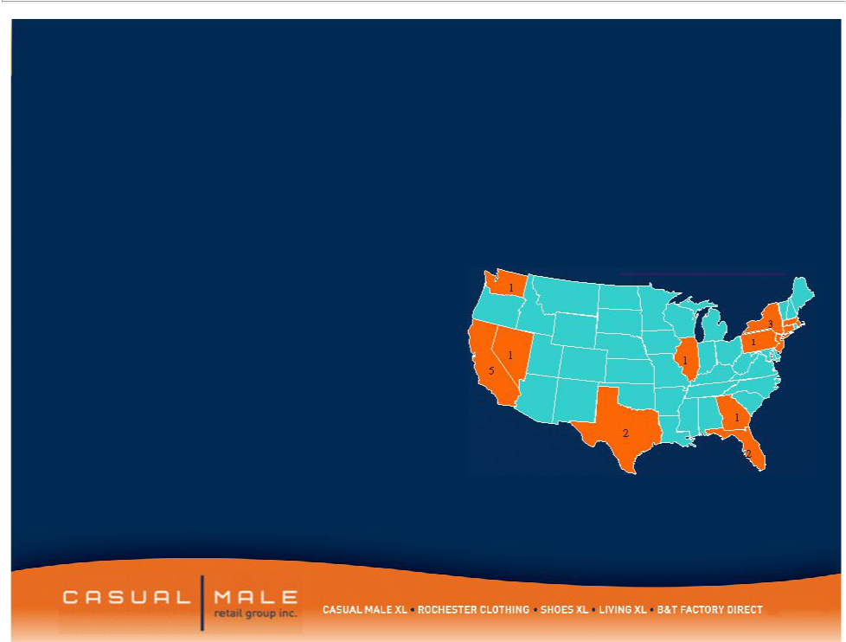

- Targets the higher income consumer within the big and tall market

– $100,000 per year average salary

- 20 store locations in downtown major metropolitan areas and upscale suburbs

- Average store size: 8,156 square ft

- Average sales / square foot: $239

– Stores carry higher-end designer product

– Average transaction size: $300

Rochester

Locations

Ma-1

DC-1

Rochester

* 1 London, United Kingdom

8

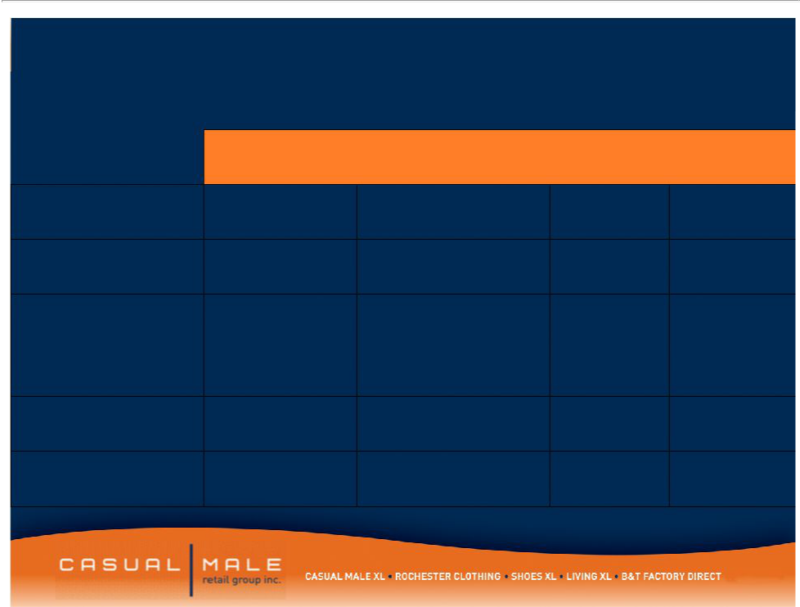
Destination XL

Projected Store Openings 2010

 |  |  | Store
Location | Size | Type | Closings | Opening
Schaumburg, IL |  | New Store
Schaumburg, IL | 11,967 Sq Ft | Location | 3 stores | Summer
Memphis, TN |  | Convert CM XL
Memphis, TN | 9,758 Sq Ft | Store | 2 stores | Summer
 |  | Add 4,500 sq ft
 |  | to existing
Houston, TX |  | Rochester store
Houston, TX | 11,027 Sq Ft | and Convert | 2 stores | Summer
Las Vegas, NV |  | New Store
Las Vegas, NV | 13,206 Sq Ft | location | 2 stores | Fall
Los Angeles, CA | Under | New Store
Los Angeles, CA | negotiation | Location | 1 store | Fall

17

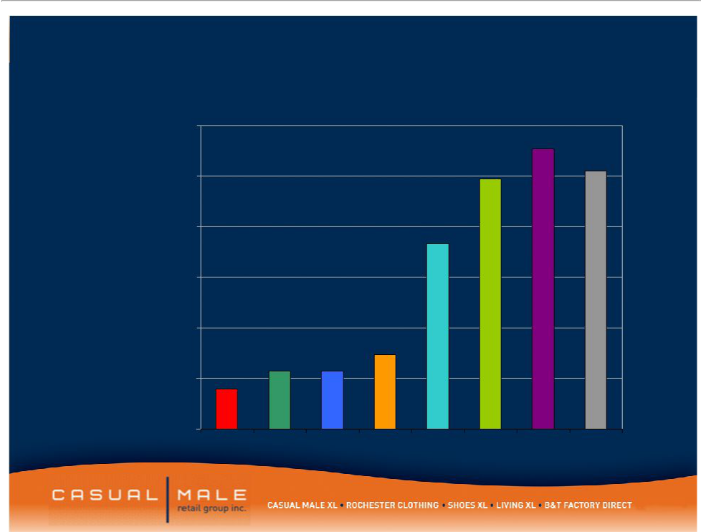
CMRG Internet Sales by Year

$60,000,000

$50,000,000

$40,000,000

$30,000,000

$20,000,000

$10,000,000

$0

2002 2003 2004 2005 2006 2007 2008 2009

25

